Managing Enterprise
– BMSW4011 –

Module Lecturer: Melanie Squire

Student name: Lucian Mihai Ilie
Student id: 2126669

Table of Contents
Task 1 – Business Plan for Romanian Delight Food Truck 3
1. Product/Service Proposition 3
2. Name of Business and Type of Ownership 4
3. Mission Statement, Aims, Objectives, and USP 5
4. Physical Location and Rationale 6
5. Human Resources 6
6. Marketing Activities 7
7. Market Research and Findings 12
8. Financial Resources 15
9. SWOT Analysis and Key Threat 17
Reflection 18
What? 18
So What? 18
Now What? 19
Reference List 20

Task 1 – Business Plan for Romanian Delight Food Truck

1. Product/Service Proposition
Romanian Delight is a mobile food truck featuring authentic Romanian street food such as traditional pasta, donuts (gogoși), pancakes, pretzels (covrigi), traditional pizza, coffee, and soft drinks. The whole idea of starting this business was as a matter of bringing Romanian flavors to the streets of Bucharest. This concept was seeded by the owner’s childhood memories of eating homemade Romanian delicacies whenever he could, and his intention is for this warm comforting tasting to be experienced by busy people in the city centre. The food truck provides quality, freshly prepared food using traditional recipes, available to locals and tourists seeking authentic street food to taste Romania’s rich culinary heritage (Untravelled Path, 2021).
The reason they are different in the competitive street food market is that the business provides authentic Romanian recipes, so everyone has been a loved and precise dish. The company will be aimed at customers interested in enjoying more than only just a fast meal, but an experience to associate with Romanian tradition (Baron and Hmieleski, 2018).
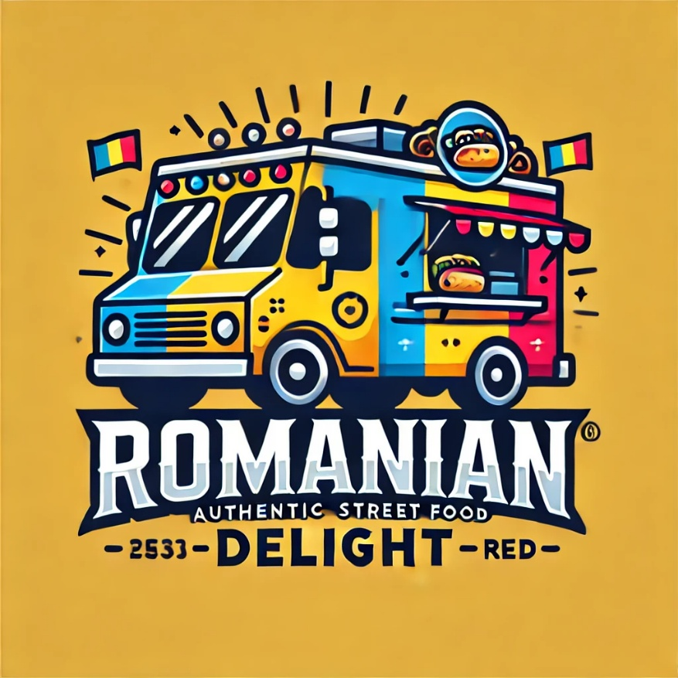
Figure 1 Business Logo

2. Name of Business and Type of Ownership
Business Name: Romanian Delight
Type of Ownership: Limited Liability Partnership (LLP)
The need to protect personal assets and allow for shared decision making within the family was the key to the decision to form an LLP. The advantage of an LLP structure is that partners can share in the profit, responsibilities, and risks while at the same time limiting personal liability (Barringer and Ireland, 2022). Additionally, this structure is flexible to business operations and can easily transition in the case of business expansion in order to acquire a second food truck that is the long-term business goal. Although LLPs are comparatively easy to set up compared to major corporations, LLPs embody a formal tool for settling partner disputes (Reuer et al., 2019). The family-run model of the business fosters a strong sense of commitment and responsibility among the partners.
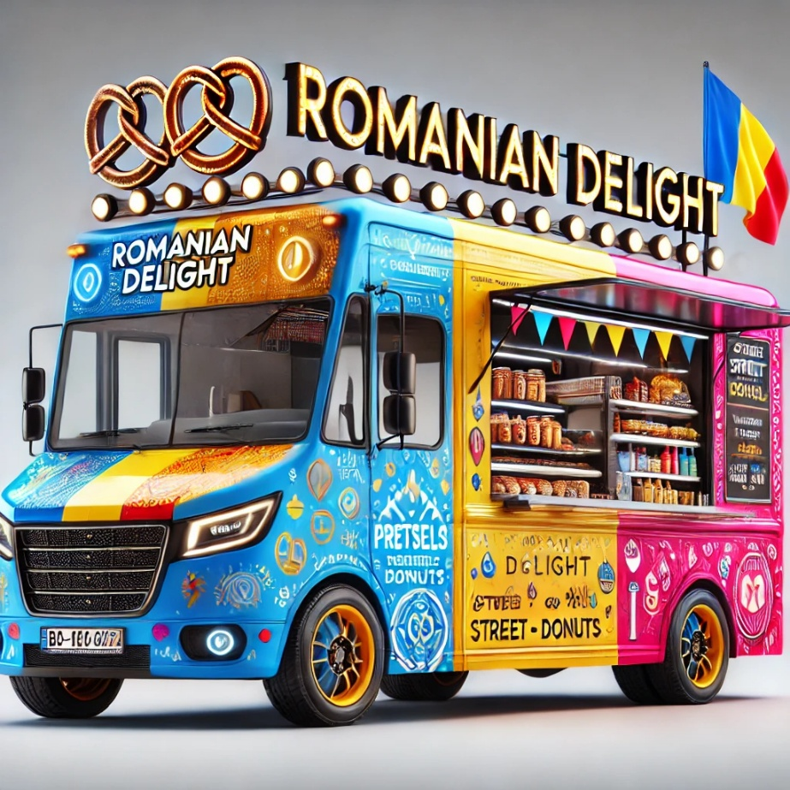
Figure 2 Food Truck

3. Mission Statement, Aims, Objectives, and USP
Mission Statement: "To bring people together over authentic Romanian food, offering a delightful street food experience that evokes the flavors of home."
Aims:
- Build a strong customer base in the heart of Bucharest.
- Expand the business by introducing a second food truck in the first year.
Objectives:
- Achieve £100,000 in revenue within the first year.
- Increase sales by 10% annually for the next three years through customer retention and new customer acquisition (Williams, 2021).
Unique Selling Proposition (USP): Romanian Delight is USP comes from its authentic Romanian street food items serving a need that the modern urban world has been expanding for traditional, homemade flavors. Food truck provides not only a meal, but an experience, based on quality ingredients, that is prepared careful and rests on a warm, welcoming atmosphere (Armstrong et al., 2023).

4. Physical Location and Rationale
The food truck location will be specifically based in Central Bucharest, close to major office buildings, tourists’ attractions and places with high foot traffic. With its convenient location, this place is ideal for catching the attention of busy professionals during their lunch break and tourists who may attend the city. The number of daily pedestrians in this area is quite high, so the circulation of potential customers is constant (Cushman and Wakefield Echinox, 2019).
The prime location also puts Romanian Delight in front of locals and tourists due to the increasing trend of street food (Statista, 2024) in Bucharest. In the future, the business will strive to expand by purchasing another food truck which will allow them to attract to other busy areas of Bucharest including Piata Unirii where there is a high footfall (Whittington et al., 2019).
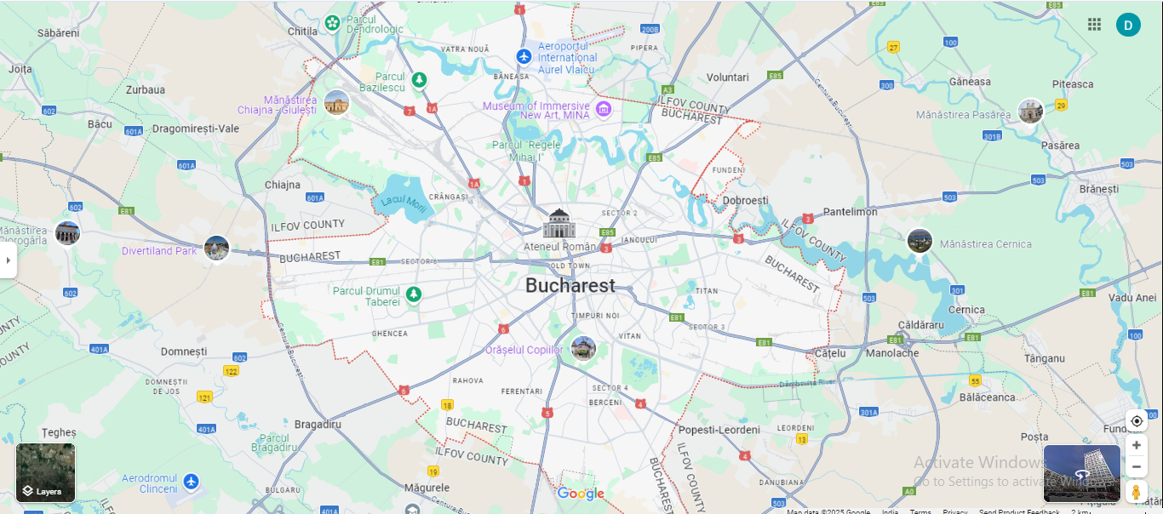
Figure 3 Google Map

5. Human Resources
The family will wholly manage the operation of Romanian Delight at the beginning.
Director – The owner and cousin will both be involved in the organization’s decision-making and execution of management tasks.
Head Chef – The owner’s wife will be tasked with preparing food and making certain it meets the company’s standard.
Accountant: The owner’s mother will manage accounting and record-keeping, providing accurate records for taxes.
Front Desk Seller – The owner’s sister will also oversee managing orders and responding to customer inquiries.
Delivery and Logistics – The father and the brother-in-law will add qualitative value to the business through their primary responsibility of handling deliveries, stock among other logistical issues (Barrow et al., 2018).
Therefore, hiring more employees for operational needs may be required as the business expands, especially if the owner does not have the necessary skills to manage the new activities. Firstly, the family business management structure will help to minimize overhead costs further to their dedication and supervision (Baron and Hmieleski, 2018).
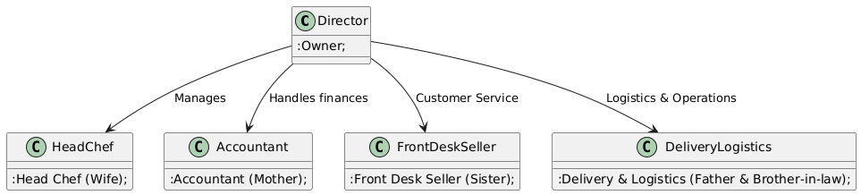
Figure 4 Organisational Chart

6. Marketing Activities
Marketing Plan
7Ps | Details
Product | Authentic Romanian street food, including gogoși, pretzels, donuts, and coffee (Untravelled Path, 2021).
Price | Affordable pricing, 20-40 RON (£5-£10) per meal, catering to various budgets (Kotler et al., 2021).
Place | Located in high-traffic areas of Bucharest, with plans for further expansion (Cushman and Wakefield Echinox, 2019).
Promotion | Social media ads, flyers, influencer partnerships, and loyalty programs (Armstrong et al., 2023).
People | Friendly, family-run team ensuring great customer service and consistent quality (Barrow et al., 2018).
Process | Efficient ordering, online reservations, fast service to minimize wait times (Hooley et al., 2020).
Physical Evidence | Food truck design reflecting Romanian culture, clean and inviting environment (Baron and Hmieleski, 2018).

Both online and offline tactics will be used in the marketing strategy to reach a wide audience. The food offerings will come with social media promotions via Instagram, Facebook, and TikTok while paying ads to get reach customers in Bucharest (Armstrong et al., 2023). Advertising flyers and business cards will be distributed in areas in which there is a high traffic of customers (business district and tourist spot), in order to attract different customers (Hooley et al., 2020). Furthermore, repeat customers will receive discounts or free items as a part of the loyalty program to promote retention (Finch, 2022).
Food Truck's PR Initiatives: Local influencers and food bloggers will be associated with the business through online reviews, feature articles, and social media collaborations (Dumitras et al., 2021). In addition, special opening events and promotions will be staged to deliberately attract attention.
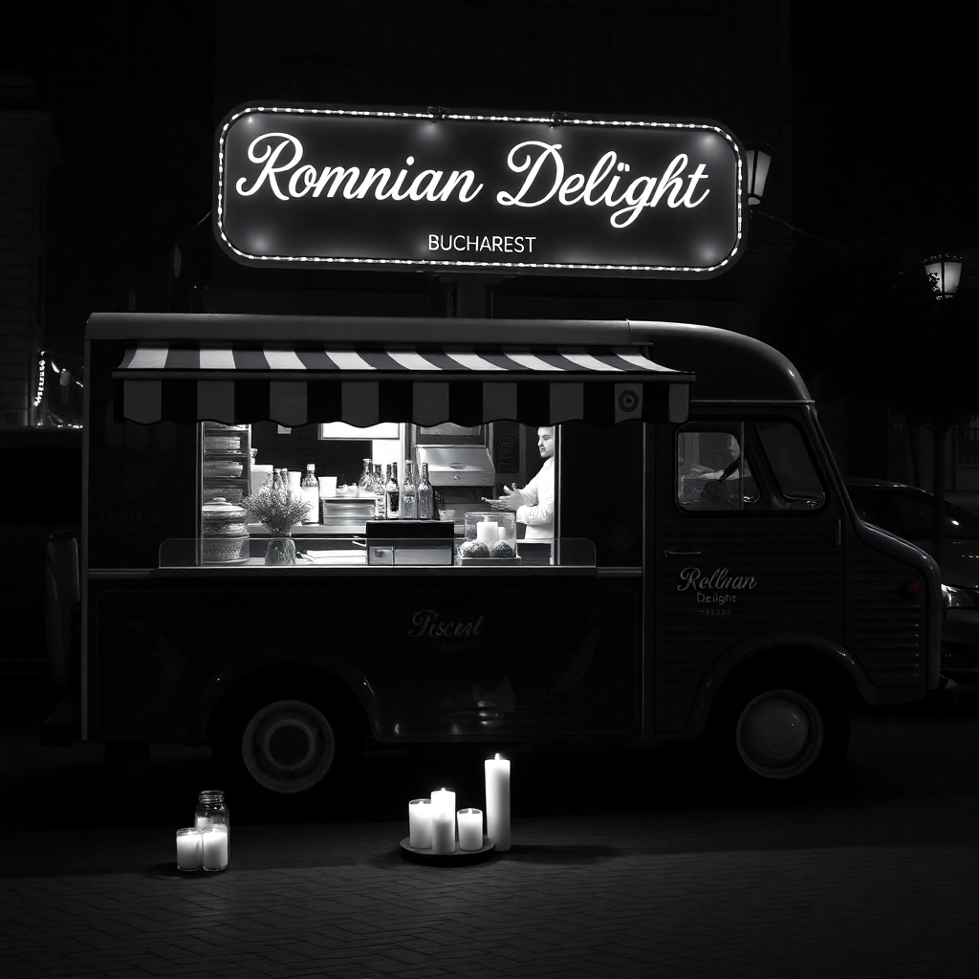
Figure 5 Facebook Post
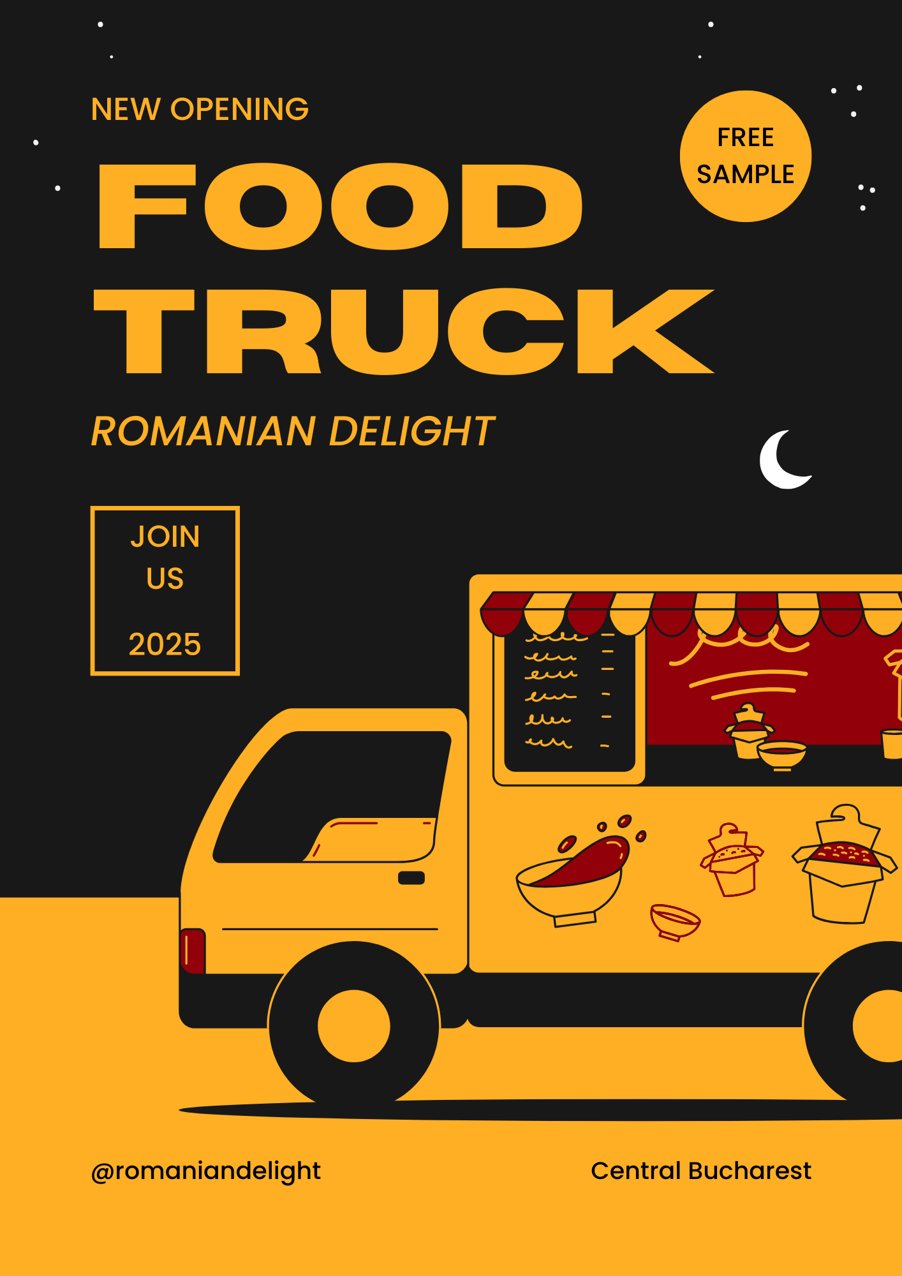
Figure 6 Flyer
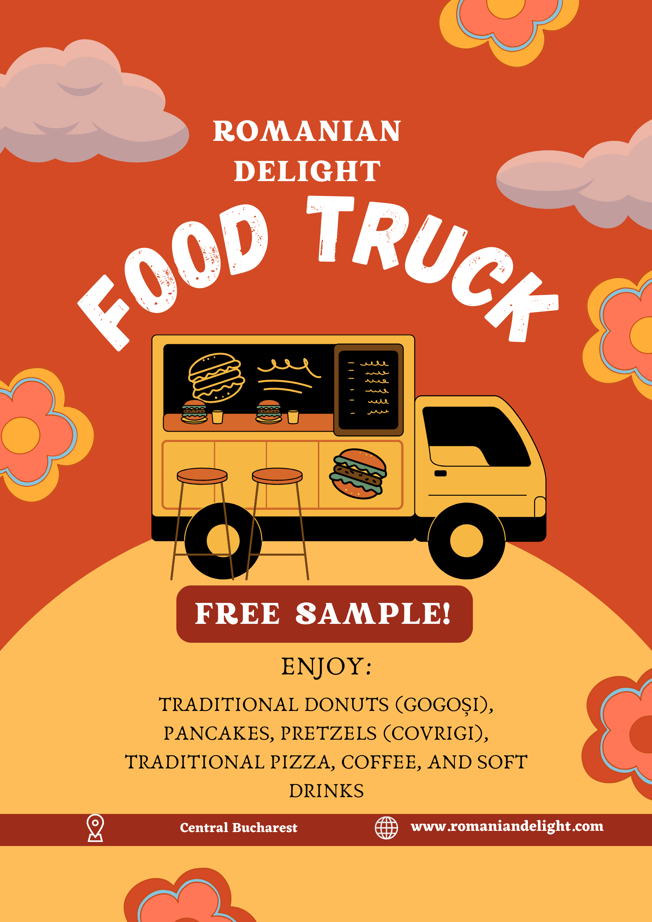
Figure 7 Poster

7. Market Research and Findings
Primary Research
The main research showed a big demand for traditional Romanian street food, as 40% of respondents would like traditional meals if buying from food trucks, 45% cared about meals goodness and 50% about its authenticity meaning that clients are willing to pay a bit extra for top quality authentic Romanian flavours. Furthermore 70 % of the answers indicated that they would like to taste traditional Romanian street food from food truck. The most preferred range given was £5- £10, with 30% being willing to spend within this bracket. The findings reveal a very big market for affordable, high quality Romanian cuisine in Bucharest’s street food market.
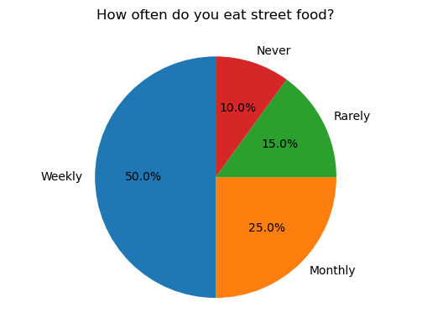
Figure 8 Graph 1
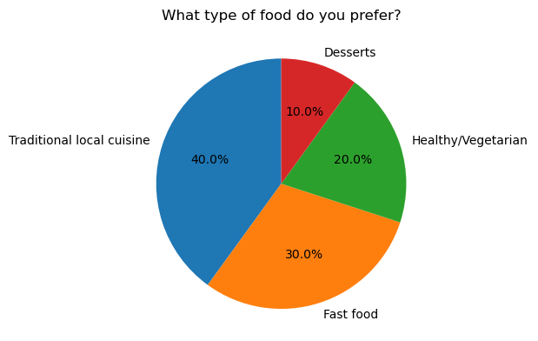
Figure 9 Graph 2
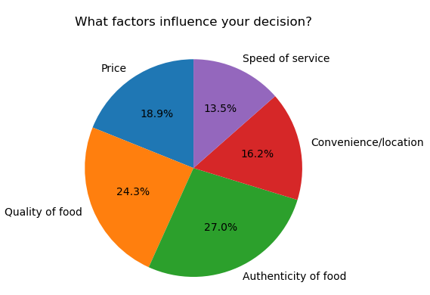
Figure 10 Graph 3
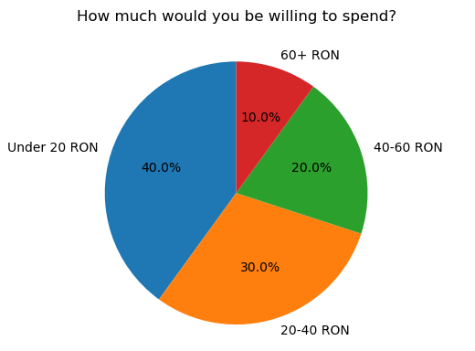
Figure 11 Graph 4
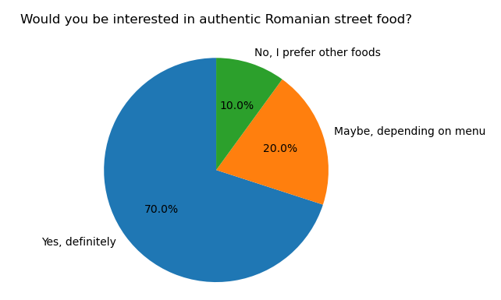
Figure 12 Graph 5
Secondary Research
Romania’s street food market is booming and is expected to have revenues of €5 billion in 2023, with a 5.35% annual growth from 2025 to 2030 (Cushman and Wakefield Echinox, 2019). Some popular street foods include pretzels (covrigi), doughnuts (gogoși) and chimney cake (kürtőskalács) that are in demand especially in Bucharest (Untravelled Path, 2021). According to Statista (2024), the Romanian food market, including street food, is estimated to be US$63.96 billion by 2030. Moreover, consumer choice is directed towards traditional foods and preferential authentic experience (ResearchGate, 2019). Additionally, there is increased demand for healthier versions of classic dishes (Voinea et al., 2019).
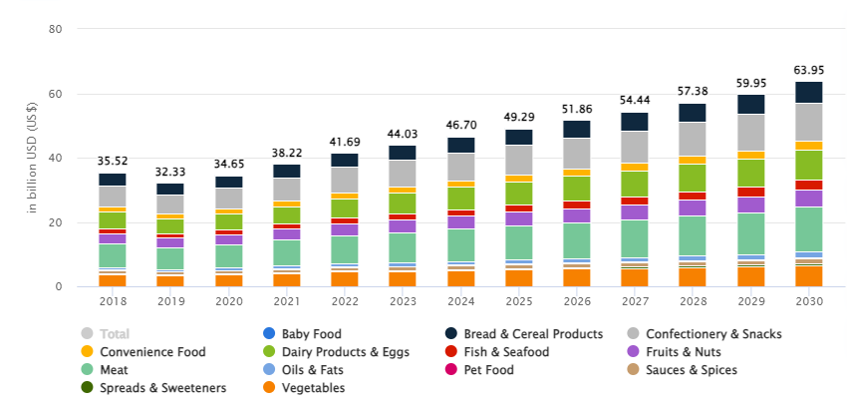
Figure 13 Graph 6

8. Financial Resources
Costs of Running the Business
Cost Item | Amount per Month (£) | Amount per Year (£)
Food Truck Lease | 1,500 | 18,000
Licensing and Council Fees | 1,500 | 18,000
Supplies and Ingredients | 6,000 | 72,000
Staff Wages | 6,000 | 72,000
Insurance | 500 | 6,000
Marketing and Advertising | 1,500 | 18,000
Miscellaneous (Utilities) | 500 | 6,000
Total Monthly Costs | 17,000 | 204,000
Sources of Finance
Source of Finance | Amount (£)
Owner’s Investment | 50,000
Family Contributions | 30,000
Bank Loan | 20,000
Total Finance | 100,000
Expenses
Expense Item | Amount per Month (£) | Amount per Year (£)
Rent | 1,500 | 18,000
Staff Wages | 6,000 | 72,000
Supplies and Ingredients | 6,000 | 72,000
Marketing and Advertising | 1,500 | 18,000
Insurance | 500 | 6,000
Miscellaneous Costs | 500 | 6,000
Total Monthly Expenses | 15,500 | 186,000
12-Month Cash Flow Forecast
Month | Income (£) | Expenses (£) | Net Cash Flow (£) | Cumulative Cash Flow (£)
January | 30,000 | 15,500 | 14,500 | 14,500
February | 32,000 | 15,500 | 16,500 | 31,000
March | 34,000 | 15,500 | 18,500 | 49,500
April | 36,000 | 15,500 | 20,500 | 70,000
May | 38,000 | 15,500 | 22,500 | 92,500
June | 40,000 | 15,500 | 24,500 | 117,000
July | 42,000 | 15,500 | 26,500 | 143,500
August | 44,000 | 15,500 | 28,500 | 172,000
September | 46,000 | 15,500 | 30,500 | 202,500
October | 48,000 | 15,500 | 32,500 | 235,000
November | 50,000 | 15,500 | 34,500 | 269,500
December | 52,000 | 15,500 | 36,500 | 306,000

The starting costs to run Romanian Delight are estimated to be around the lease of the food truck, supplies, staff wages, and in marketing costs (Kotler et al., 2021). Funds of finance which include personal investment, family contributions and a bank loan (Barringer and Ireland, 2022). The cash flow forecast for 12 months is realistic, with steady growth of the cash flow and profitability (Cushman and Wakefield Echinox, 2019).

9. SWOT Analysis and Key Threat
SWOT | Details
Strengths | Authentic Romanian food, high-quality ingredients, family-run business (Untravelled Path, 2021).
Weaknesses | Limited brand awareness, dependence on foot traffic (Armstrong et al., 2023).
Opportunities | Market growth in street food, expansion to new locations and catering services (Cushman and Wakefield Echinox, 2019).
Threats | Intense competition from other food vendors and changing consumer preferences (Voinea et al., 2019).

Threat: Intense competition from other food vendors in high-traffic areas.
Strategy: To differentiate by providing unique, high quality Romanian food and build a strong brand identity. Run loyalty programs and partner locally to gain customer loyalty and reduce dependence on foot traffic (Barringer and Ireland, 2022).

Reflection

What?
While creating the Romanian Delight business plan, I have learnt a few important things. Preparation of cash flow forecast is a key learning area. This has advised me as I need to understand how to estimate costs, track income and manage expenses to make the business feasible.
I also furthered my market research skills. I did primary research and conducted secondary research on, analysing the customer preferences, identifying the market trend and competition. Using this knowledge, I developed the targeted marketing strategy for the food truck so that it will have an impact on the right segment of the audience.
In the process of business planning, I also learned how to select the appropriate business structure. I chose to use an LLP to help me appreciate how the structure of a business affects liability, decision making, and profit sharing, which I will find valuable in future decisions for the business.

So What?
Determination is one of my strongest entrepreneurial strengths. Once I set my mind to something, I do everything I can to see the goal through, which I did regarding my approach to the business plan. This would allow me to know how to overcome the hurdles and remain committed to the long-time success of this business.
Another is my strategic thinking. I have learnt to set short term and long-term goals for the business to ensure that the business is in accordance with the overall vision. I chose where the food truck shall be placed next, high traffic, I did this to show that I can plan for things, in days at least so that the business be front runners in the market.
I am also really good at communication and during the process of developing the marketing strategy for Romanian Delight, I already used my good communication skills. The skills would be clear messaging and interacting with customers via social media to build relationships and attract a loyal customer base.

Now What?
Risk management is one trait that I am to develop. When it comes to making bold decisions, which could affect the business a great deal, I tend to be on the fence. I ask whether I can improve my ability to make confident decisions under uncertainty, whether expanding to new locations, or investing in major projects. I want to get this trait by getting mentorship from experienced entrepreneurs who are able to teach me to make smarter, calculated decisions.
I will also work on scenario planning to assess possible outcomes associated with key decisions which I will make. This will enable me to evaluate risks more objectively and thus build confidence to undertake actions that will be beneficial to the business.

Reference List
Armstrong, G., Kotler, P., and Opresnik, M.O., 2023. Marketing: an introduction. 15th edn., Global edn., Harlow, England: Pearson.
Baron, R.A. and Hmieleski, K.M., 2018. Essentials of entrepreneurship second edition: Changing the world, one idea at a time. Edward Elgar Publishing.
Barringer, B.R. and Ireland, R.D., 2022. Successfully launching new ventures. Pearson UK.
Barrow, C., Barrow, P. and Brown, R., 2018. The Business Plan Workbook: A Step-By-Step Guide to Creating and Developing a Successful Business. Kogan Page Publishers.
Cushman and Wakefield Echinox. (2019). ROMANIANS’ GROWING APPETITE FOR RESTAURANTS AND CAFES WILL LEAD THE MARKET TO OVER 5 BILLION EUROS IN REVENUES - Cushman and Wakefield Echinox. [online] Available at: https://cwechinox.com/romanians-growing-appetite-for-restaurants-and-cafes-will-lead-the-market-to-over-5-billion-euros-in-revenues/.
Dumitras, D.E., Harun, R., Arion, F.H., Chiciudean, D.I., Kovacs, E., Oroian, C.F., Porutiu, A. and Muresan, I.C., 2021. Food consumption patterns in Romania during the COVID-19 pandemic. Foods, 10(11), p.2712.
Finch, B., 2022. How to write a business plan: win backing and support for your ideas and ventures (Vol. 162). Kogan Page Publishers.
Hooley, G.J., Piercy, N. and Nicoulaud, B., 2020. Marketing strategy and competitive positioning. Pearson Education.
Kotler, P., Armstrong, G., and Opresnik, M.O., 2021. Principles of Marketing. 18th edn., Global edn., Harlow, Essex; New York, NY: Pearson Education Limited. Total pages: 728 pages.
Reuer, J.J., Matusik, S.F. and Jones, J. eds., 2019. The Oxford handbook of entrepreneurship and collaboration. Oxford University Press.
Statista (2024). Food - Romania | Statista Market Forecast. [online] Statista. Available at: https://www.statista.com/outlook/cmo/food/romania.
Untravelled Path (2021). An Introduction to Street Food in Bucharest. [online] untravelledpaths.com. Available at: https://untravelledpaths.com/blog/introduction-street-food-bucharest.
Voinea, L., Vrânceanu, D.M., Filip, A., Popescu, D.V., Negrea, T.M. and Dina, R., 2019. Research on food behavior in Romania from the perspective of supporting healthy eating habits. Sustainability, 11(19), p.5255.
Whittington, R., Regnér, P., Johnson, G., Angwin, D. and Scholes, K., 2019. Exploring strategy. Pearson UK.
Williams, S., 2021. FT Guide to Business Start Up 2021-2023. Pearson UK.

