UWTSD
WISA



Motorcycle Geometry Analysis and Dynamic Handling Investigation
ACHA4003

Daniel Briggs
2312568
29/11/24

Contents
1 Introduction 1
1.1 Justification 1
1.2 Aims 1
1.3 Objectives 1
2 Centre of Gravity. 1
2.1 Ducati Panigale 1199 S (2012) 1
2.2 Bucci Moto 20 SM 3
3 Gearbox Calculations. 5
3.1 Ducati Panigale 1199 S (2012) 6
3.2 Bucci Moto 20 SM 8
4 Characteristics. 11
5 Section 4 12
5.1 Suzuki GSX 1300 Hayabusa (2023) 12
5.2 Yamaha Tenere 700 (2019) 14
6 Improvements for the Handling. 16
7 References 17

Figure 1 (shows the dimensions of the Ducati). 1
Figure 2 (shows the Centre of gravity, Rake and Trail Calculations of the Ducati). 2
Figure 3 (shows the Bucci Moto 20 SM). 3
Figure 4 (shows the Bucci dimensions of the Bucci). 3
Figure 5 (shows the Centre of gravity, Rake and Trail Calculations of the Bucci). 4
Figure 6 (This Graph shows the Driving force from the Ducati). 6
Figure 7 (This graph shows the power Curve for the Ducati). 7
Figure 8 (This graph shows the Resistance to motion for the Ducati (the blue line is power and the orange line is drag). 8
Figure 9 (This graph shows the Resistance to motion for the Bucci (the blue line is for power and the orange line is for drag). 10
Figure 10 (Suzuki GSXR 1300 Hayabusa (2023) [Motobank.co.uk. (2024)]. 12
Figure 11 (shows the Bucci dimensions of the Suzuki). 13
Figure 12 (shows the Centre of gravity, Rake and Trail Calculations of the Suzuki). 13
Figure 13 (shows the Yamaha Tenere 700 (2019) [Datocms-assets.com. (2024)]. 14
Figure 14 (shows the Bucci dimensions of the Yamaha). 15
Figure 15 (shows the Centre of gravity, Rake and Trail Calculations of the Yamaha). 15

Table 1 (shows the centre of gravity of the Ducati). 2
Table 2 (shows the centre of gravity of the Bucci). 4
Table 3 (This table shows the gearbox ratio for the Ducati). 6
Table 4 (shows both the on-road and off-road versions of the Bucci) [Buccimoto.com. (2024)]. 11
Table 5 (shows the Centre of Gravity for the Suzuki GSXR 1300 Hayabusa (2023) 12
Table 6 (Yamaha Tenere 700 Centre of Gravity). 14

Introduction

Justification

Aims
This technical report is to show an understanding of motorcycle geometry and dynamic handling

Objectives
Look at four different motorcycles two I have access to and two other motorcycles I don’t have access to but will research into them.

Centre of Gravity.

Ducati Panigale 1199 S (2012)
Figure 1 (shows the Ducati Panigale S 1199).
Figure 1 (shows the dimensions of the Ducati).
Table 1 (shows the centre of gravity of the Ducati).
Figure 2 (shows the Centre of gravity, Rake and Trail Calculations of the Ducati).
Use the formulas below to work out the centre of gravity for the motorcycle without the rider.
$$\frac{Rear Wheel Weight*Wheel Base}{Weight Of Bike}=X Center of Gravity$$
$$\frac{(Wheel Base*(Rear Wheel Weight-Rear Wheel Weight Lifted)}{Weight Of Bike*TAN(Lifted Angle)}+RAV=Y Centre of Gravity$$

Bucci Moto 20 SM
Figure 3 (shows the Bucci Moto 20 SM).
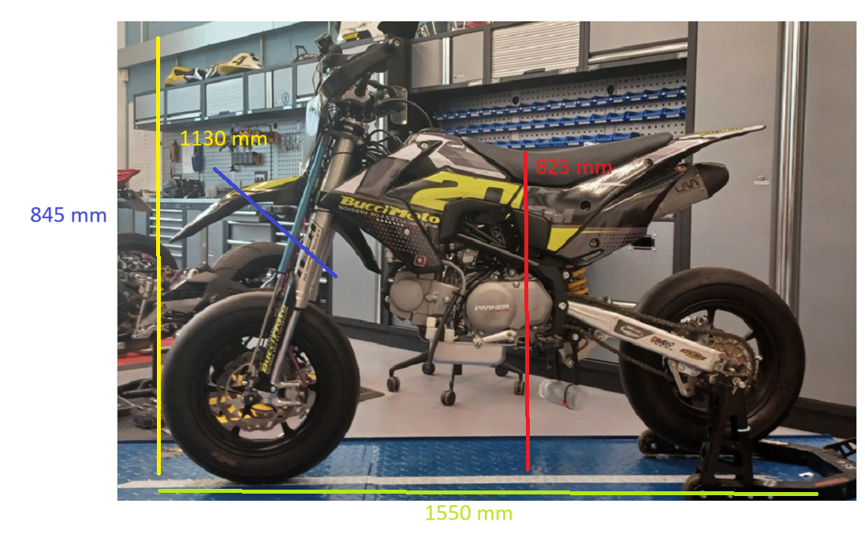
Figure 4 (shows the Bucci dimensions of the Bucci).
Table 2 (shows the centre of gravity of the Bucci).
Figure 5 (shows the Centre of gravity, Rake and Trail Calculations of the Bucci).
Use the formulas below to work out the centre of gravity for the motorcycle without the rider.
$$\frac{Rear Wheel Weight With Rider*Wheel Base}{ Weight Of Bike+Weight of Rider}=X Center Of Gravity$$
$$\frac{(Wheel Base*(Rear Wheel Weight With Rider-Rear Wheel Weight Lifted With Rider)}{(Weight Of Bike+Weight Of Rider)*TAN(Lifted Angle)}+RAV=Y Centre Of Gravity$$

Gearbox Calculations.
Using the formulas below I calculated the gearbox and the forces acting with and against the motorcycles.
$$\left(\frac{RPM*60*\frac{Main}{Counter}*\frac{Primary In}{Primary Out}*Wheel Diamiter*PI}{1000}\right)*\frac{Front Sprocket}{Rear Sprocket}=Speed$$
This formula needed to be repeated for each Gear.
$\frac{\left(\left(\left(\left(\frac{Width}{25.4}\right)*\left(\frac{Aspect Ratio}{100}\right)+\left(\frac{Rim Size}{2}\right)\right)*2*PI\right)*\frac{25.4}{PI}\right)}{1000}$ = Rear Diameter

$$RPM*\left(\frac{Current Main}{Current Counter}\right)*\left(\frac{Next Main}{Next Counter}\right)=Next Gear RPM$$

$$0.5*\left(Number of Links- 0.5*\left(Front Sprocket Teath+Rear Sprocket Teath\right)\right)*25.4*\left(Chain size\right)-Distance From Sprocket To Pivot Point=Length Of Swingarm$$

$$\frac{Mass*Velocity^{2}}{Radius}= Centrifugal Force$$

Ducati Panigale 1199 S (2012)
Table 3 (This table shows the gearbox ratio for the Ducati).
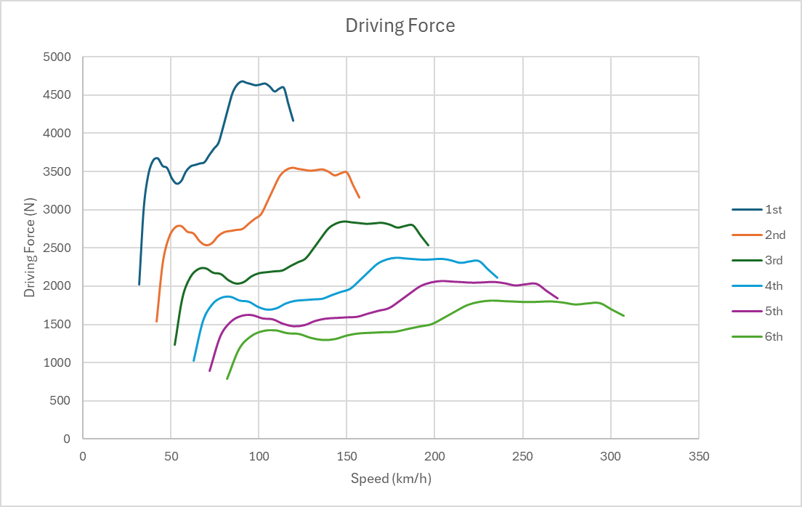
Figure 6 (This Graph shows the Driving force from the Ducati).
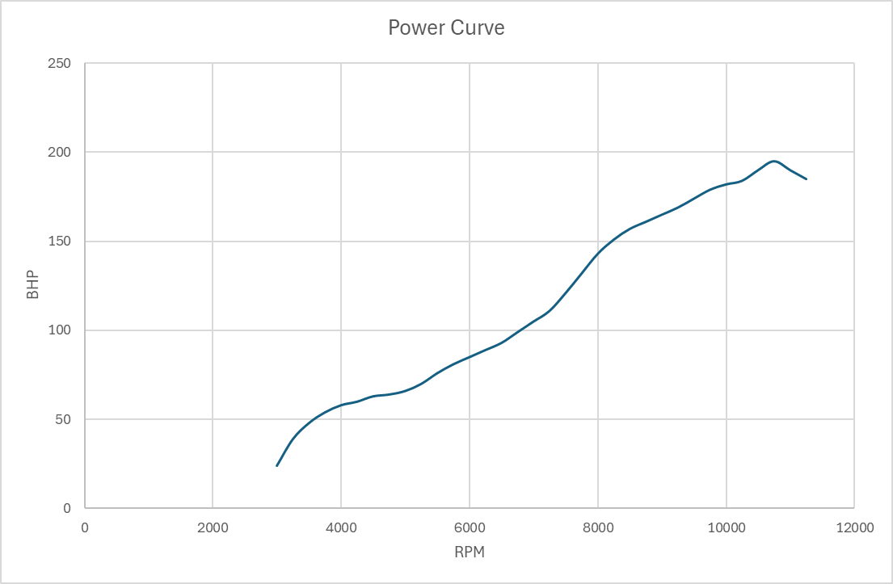
Figure 7 (This graph shows the power Curve for the Ducati).
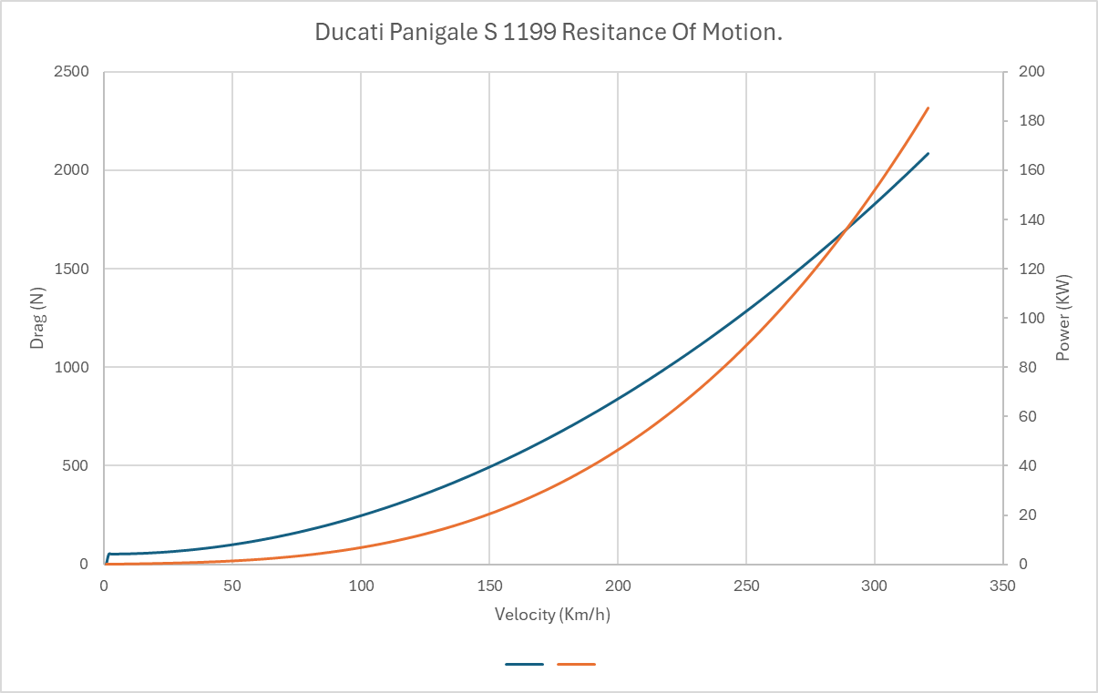
Figure 8 (This graph shows the Resistance to motion for the Ducati (the blue line is power and the orange line is drag).
Looking at the graphs and the information obtained the Ducati doesn’t reach its max speed because its hypothetical power level shows it could reach 315Km/H instead of achieving speeds of 294Km/H.

Bucci Moto 20 SM
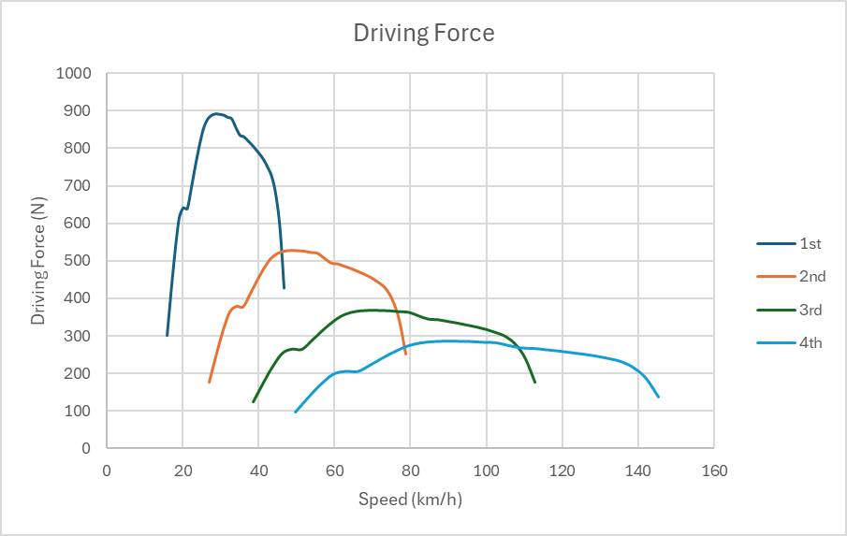
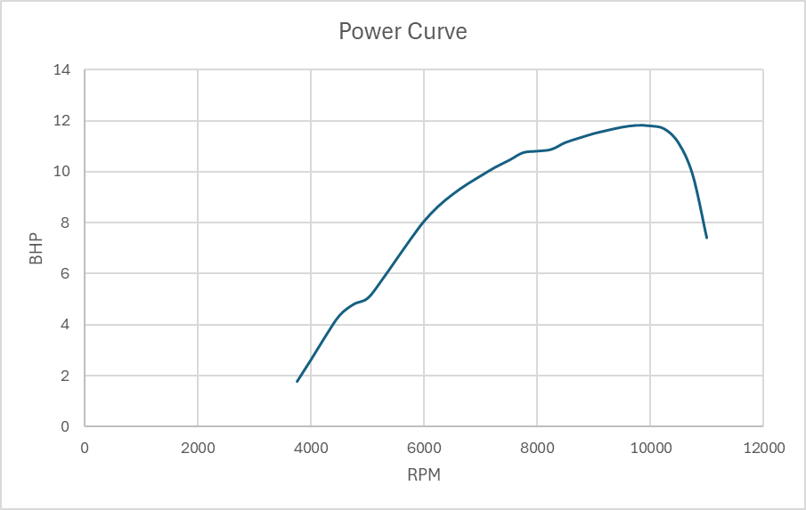
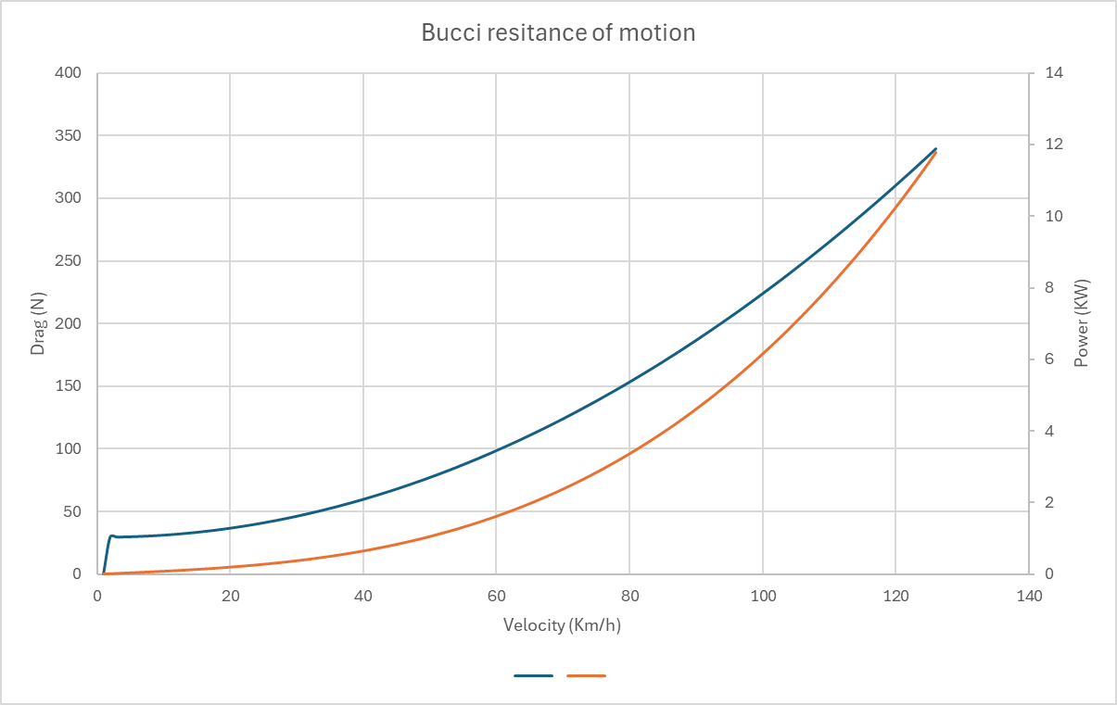
Figure 9 (This graph shows the Resistance to motion for the Bucci (the blue line is for power and the orange line is for drag).

Looking at the graphs and the information obtained the Bucci reaches its max speed of 88Km/H as the gears will not allow the bike to go much faster.

Characteristics.
The Ducati is a road bike that also can go on tarmac race tracks however the Bucci is a pit bike which means with some adjustments to the suspension and a change of wheels to off-road wheels the Bucci will be able to handle some off-road racing and road racing.
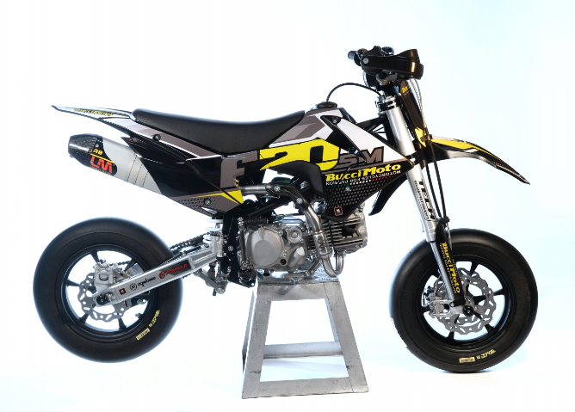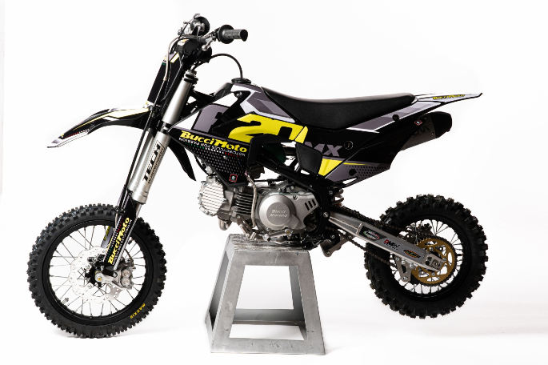
Table 4 (shows both the on-road and off-road versions of the Bucci) [Buccimoto.com. (2024)].

The Ducati has a larger and more powerful engine which means it will be able to reach speeds much faster than the Bucci however the Bucci is much lighter. The Ducati handles the best on the road at high-speed cornering and excels on the straight compared to the Bucci which handles well at low-speed cornering due to the short length of the wheelbase compared to the Ducati.

Section 4

Suzuki GSX 1300 Hayabusa (2023)
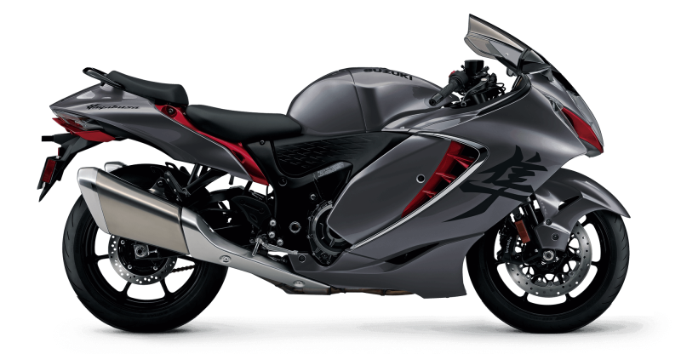
Figure 10 (Suzuki GSXR 1300 Hayabusa (2023) [Motobank.co.uk. (2024)].
Table 5 (shows the Centre of Gravity for the Suzuki GSXR 1300 Hayabusa (2023)
Figure 11 (shows the Bucci dimensions of the Suzuki).

Figure 12 (shows the Centre of gravity, Rake and Trail Calculations of the Suzuki).
The Suzuki Hayabusa is a large and heavy motorcycle, but it is very quick in both acceleration and top speed. This is due to the aerodynamic shape and powerful engine.

Yamaha Tenere 700 (2019)

Figure 13 (shows the Yamaha Tenere 700 (2019) [Datocms-assets.com. (2024)].
Table 6 (Yamaha Tenere 700 Centre of Gravity).
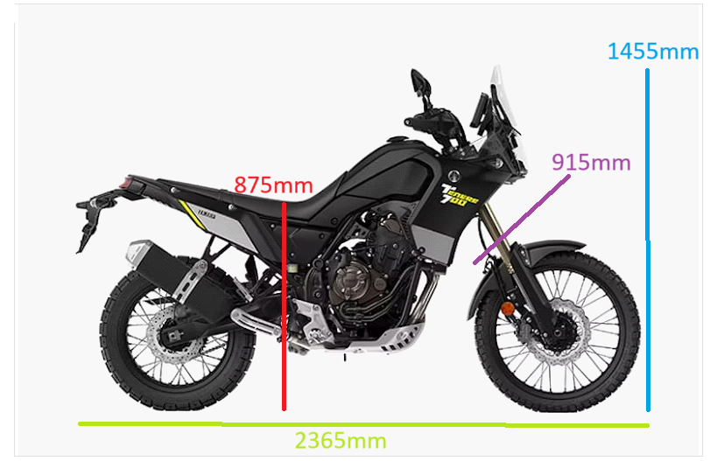
Figure 14 (shows the Bucci dimensions of the Yamaha).
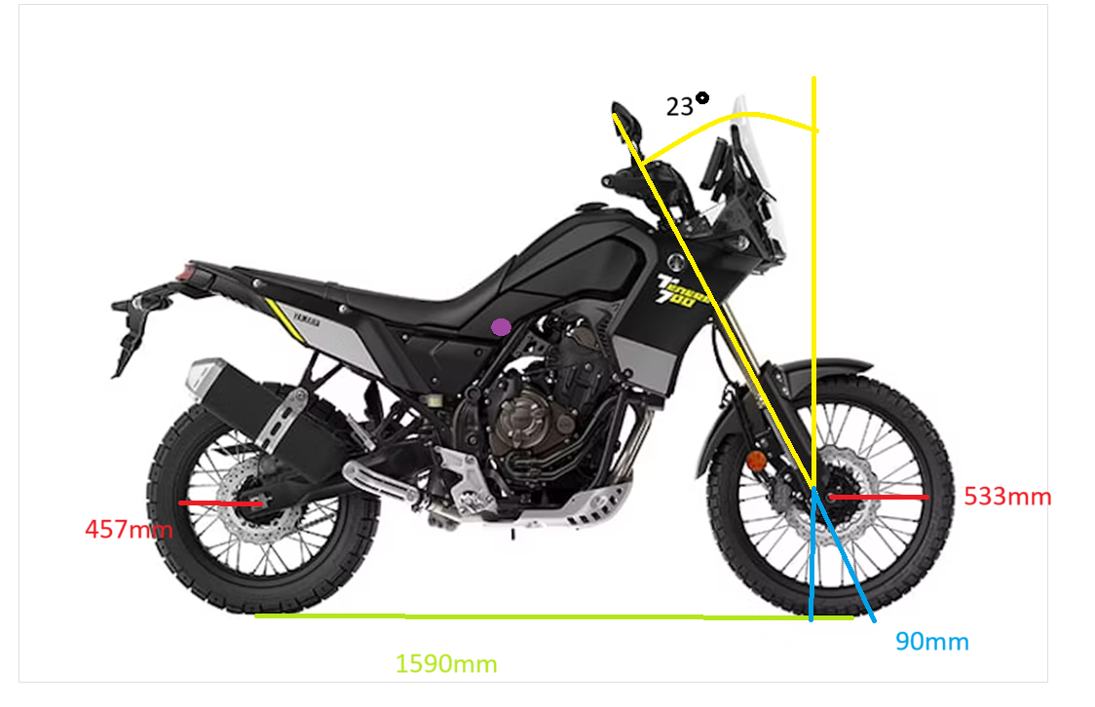
Figure 15 (shows the Centre of gravity, Rake and Trail Calculations of the Yamaha).
The Yamaha Tenere is a versatile motorcycle both on and off-road. This is due to the suspension, wheels and how the frame was set up to accommodate the different terrain, from deserts to jungles and on the streets the tenere handling is a very competent motorcycle.

Improvements for the Handling.

There are many different ways to improve the handling of a motorcycle here are a couple of recommended improvements for the Ducati Panigale 1199 S
- Aerodynamic wings to help keep pressure on the front wheel and also reduce the wheel leaving the tarmac.
- Dropping the suspension height will reduce the drag.
- Upgraded suspension from using normal spring suspension to using electro-magnetic suspension.
- Increase the size and type of the brakes.

References

Buccimoto (2022). F20SM Motard 2022 Bucci Moto, pit bike and mini gp on sale. [online] Buccimoto.com. Available at: https://www.buccimoto.com/en/f20sm-motard-2022/752/d/
Buccimoto.com. (2024). Available at: https://www.buccimoto.com/wedit/uploads/prodotti/750/001.jpg
Buccimoto.com. (2024). Available at: https://www.buccimoto.com/wedit/uploads/prodotti/752/025.jpg
Correia, A. (2005). 2012 Ducati 1199 Panigale. [online] Motorcyclespecs.co.za. Available at: https://www.motorcyclespecs.co.za/model/ducati/ducati_1199_panigale%2012.htm
Correia, A. (2005). 2019 Yamaha Tenere 700. [online] Motorcyclespecs.co.za. Available at: https://www.motorcyclespecs.co.za/model/yamaha/Yamaha_tenere_700_19.html
Correia, A. (2005). 2023 Suzuki GSX 1300R Hayabusa. [online] Motorcyclespecs.co.za. Available at: https://www.motorcyclespecs.co.za/model/suzu/suzuki-gsxr1300r-23.html
Datocms-assets.com. (2024). Available at: https://www.datocms-assets.com/119921/1714116342-black.jpg?auto=format&w=800
Motobank.co.uk. (2024). Available at: https://bikes.motobank.co.uk/storage/suzuki/hayabusa-gsx-1300r-1224/i/photo-1224-9663.jpg

‌

