L4 Learning in the Digital Era (ACCA4025)
Rhys Davies
Student id: 2008896
Course: Computing (Software Engineering)

Assignment 1: E-Portfolio

Contents
E-Portfolio. 2
Task 1 – Written Summary. 3
Task 2 – Mind Map. 4
Task 3 – Video Presentation. 5
Task 4 – Academic Poster. 6

E-Portfolio.

1.A link to the e-portfolio homepage. https://sites.google.com/view/uwtsde-portfolio-2008896/home
2. A screenshot of the e-portfolio homepage.
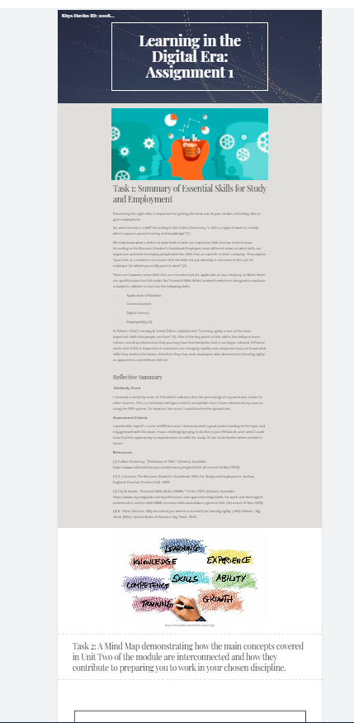

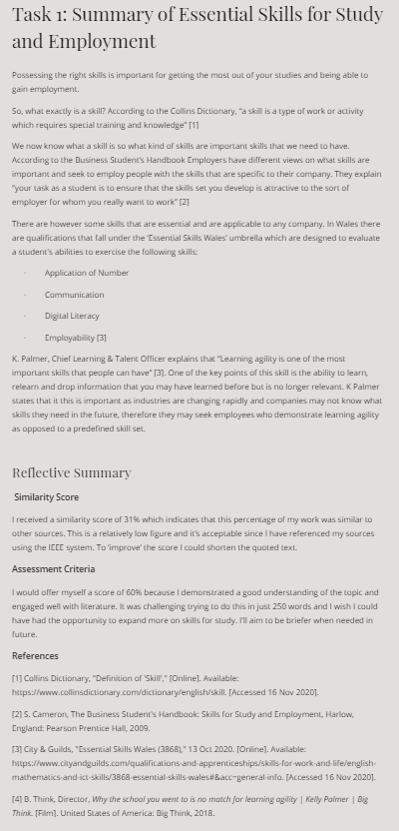
Task 1 – Written Summary.
1. A link to the Task answer in the e-portfolio. https://sites.google.com/view/uwtsde-portfolio-2008896/home
2. A screenshot of the task answer either in the e-portfolio.

Task 2 – Mind Map.
1. A link to the Task answer in the e-portfolio* and if available, a link to the Mind Map in its original Online Application. https://sites.google.com/view/uwtsde-portfolio-2008896/home
2. A screenshot of the task answer either in the e-portfolio or in its Application.
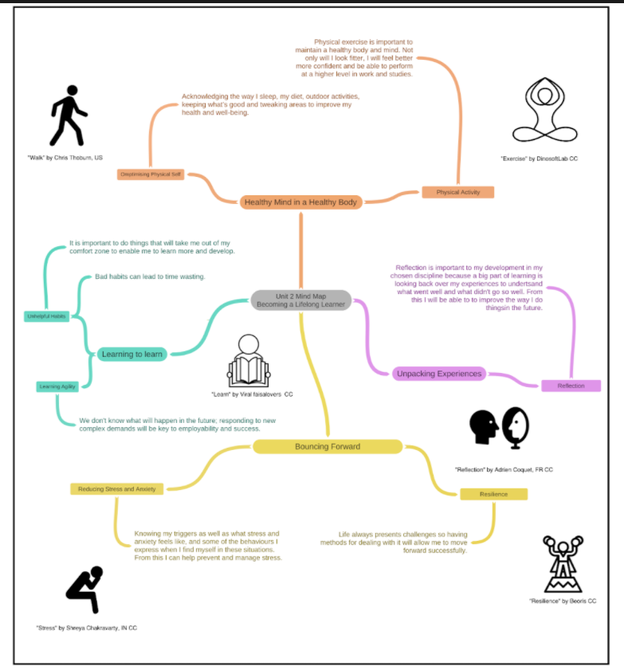
Task 3 – Video Presentation.
1. A link to the Task answer in the e-portfolio* and if available, a link to the Video presentation in its Online Cloud Streaming Service. https://youtu.be/XhzqVh9mk_s
2. A screenshot of the task answer either in the e-portfolio or in its Cloud Streaming Service.

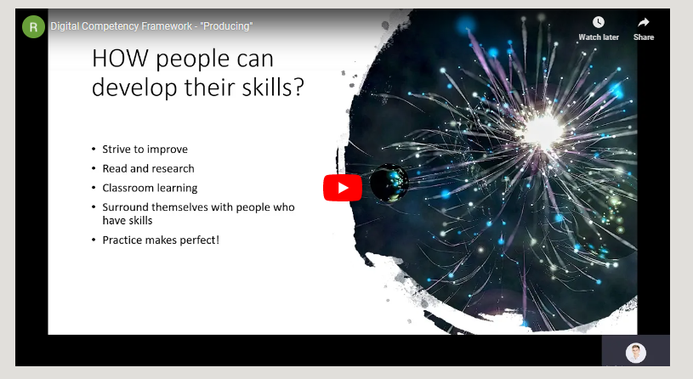
Task 4 – Academic Poster.
1. A link to the Task answer in the e-portfolio* and if available, a link to the Poster in its Online Storage location. https://sites.google.com/view/uwtsde-portfolio-2008896/home
2. A screenshot of the task answer either in the e-portfolio or in its Application.


