Using one of the establishments visited, how easy is it to gain a sense of what constitutes Welsh culture?

How Welsh culture is and expressed in Pembrokeshire and how it is observed by the rest of Wales.

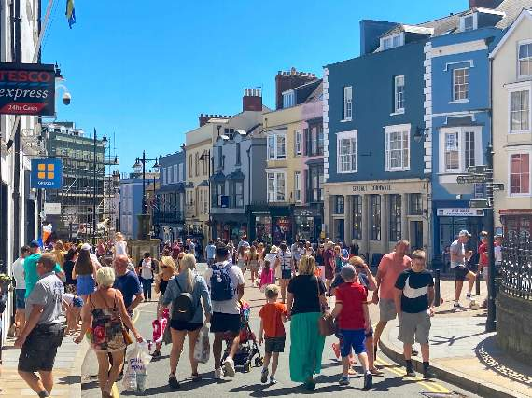
A busy Tudor Square in Tenby on Monday afternoon (Observer, 2020)
Hannah Lee Chapman

Table of contents

Introduction 2
………………………………………………………………………………………………………………

Little England beyond Wales 2
………………………………………………………………………………………………………………

Second homeowners’ impact on the local population 3
………………………………………………………………………………………………………………

Tourism towns 4
………………………………………………………………………………………………………………

Case study: Cwm-yr-Eglwys 5
………………………………………………………………………………………………………………

Conclusion 6
………………………………………………………………………………………………………………

Reference list 7
………………………………………………………………………………………………………………

Introduction
The purpose of this report is to comprehend how Welsh culture is perceived in Pembrokeshire. The report will explore the idea of what constitutes Welshness in communities that appear to be void of any explicit representation of the Welsh culture; How tourism and second homeowners can negatively affect areas of low incomes, and what happens when they unintentionally change the culture of the locations they have decided to live in.

Little England beyond Wales
“Little England beyond Wales” is a common nickname for south Pembrokeshire and the South-West of Carmarthenshire; It was first (and still is) used to specifically identify the predominantly English-speaking parts of South Pembrokeshire (Watkin, 1960). The saying above originates from the 16th century, coined by William Camden (1586) but he was using it to reference the cantref of Rhos and the Flemish population in Pembrokeshire (Camden, 1586). It was George Owen of Henllys who took this term and applied it to refer to the whole of Pembrokeshire (Austin, 2005). The history behind this name is long and complex; this series of historical occurrences led to Pembrokeshire, and the people of Pembrokeshire, not being deemed “Welsh enough”.
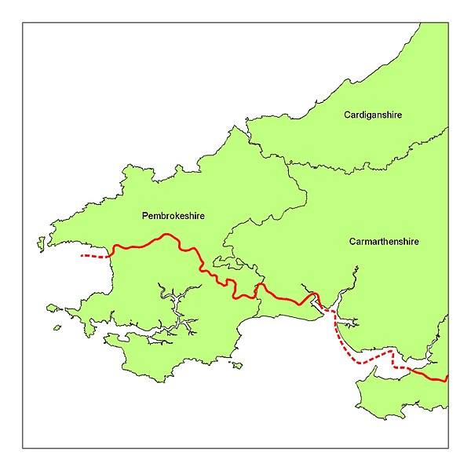
The separation between South Pembrokeshire and the rest of Wales started at approximately the time of the Norman conquest, when this area of Wales started to be colonized by Anglo-Normans, Flemish and English people of all classes (Austin, 2005). Pembrokeshire is surrounded by the sea on three sides, and this naturally opens up the area to immigrants from Ireland, the rest of the United Kingdom and Europe respectively. The immigrants’ reasoning for moving to South Pembrokeshire was that the area was promising and offered many opportunities for establishing new homes as well as acquiring large amounts of land (Austin, 2005). Along with the new immigrants came their ideas, relating to economics, agriculture, government, and language. The impact of the English language on the area should not be underestimated, as it also prompted change in the culture itself. These changes split Pembrokeshire into two halves and helped distance the people living there even more from the rest of “Welsh” Wales. The English Language and English ideals alone could have been enough to drive the remaining Welsh families away from the area as they may have felt, understandably, out of place, unwelcome and possibly even like outcasts. Welsh culture and customs may well have departed with them as they moved to other parts of Wales.
The Landsker Line (1901). (Moore, 2006)
The ‘landsker line’, is often used in conjunction with the term Little England beyond Wales, as this concept is used by people to separate English-speaking Wales from Welsh-speaking Wales. Despite this line being a cultural and language divider, an unseen geological divider unintentionally separates the two (George and Williams 2020). The geological line goes from Narberth to Newgale on the shore of St. Brides Bay; it runs east to west (George and Williams, 2020), which is roughly where the proposed cultural divider is supposed to be. Welsh as a language is used in Pembrokeshire, but not nearly as much as it is discussed in the rest of Wales. The population of Welsh speaker has increased consistently throughout Pembrokeshire in recent years. According to Stats Wales, in March 2011 the Welsh speaking population of Pembrokeshire was at 17.6 percent, compared to March 2021, where the population of Welsh speakers has risen to 32 percent (Stats Wales, 2011-2021).

Second homeowners’ impact in the local population
As it stands at present, Pembrokeshire is struggling to house the local people who are in desperate need of council housing. As of October 2020, there was a total of 5,647 council housing stock, with a current waiting list of 5,200 people (Gaynor, 2021). This is a deceptive statistic because much of this housing stock is currently occupied. The number of households who have ended council tenancies since October 2020 is 160; by the end of 2021 the numbers will be 320 (Gaynor, 2021), which is the lowest amount of people ending tenancies in the last 4 years. The decrease in numbers shows there a need for housing more than ever for local people.
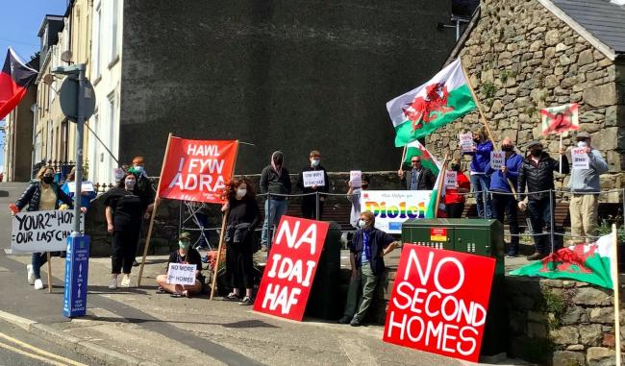
There has been a substantial increase of people applying for council housing, not just because of the current pandemic and loss of income, but because it is becoming increasingly difficult for local people to rent private housing and almost impossible for people to buy houses. A large number of people have therefore be forced to live in council housing, as it is considered to be consistently stable with no threat of eviction, as there would be in private rented properties.
Demonstration in Nefyn on Saturday, May 1 against the rising issue of second home ownership in the area. (Williams, 2021)
When Counsellor Mike Evans was asked to comment about the rising house prices around the coastal areas due to holiday and second homes, he described the second home crisis as being, “almost social purging of the indigenous population. Locals and their children are being driven out of communities due to housing costs” (Jenkins, 2021). He continued: “It’s absolutely horrendous what is happening at the moment to families and children who aren’t in the elite, highest earnings in Pembrokeshire and without action there’s going to be more problems.” (Jenkins, 2021). It is to note that one in ten homes in Pembrokeshire are some form of holiday let or seconds home (Clements, 2021).
It seems that the locals are being made to wait and are being treated as second class citizens while the housing market panders to second homeowners and the tourism sector instead. Even during the pandemic, second homeowners are still impacting local people. Instead of applying council housing tax, they have been applying for business rates instead of allowing them to take advantage of a loophole that allows them to apply for the £10,000 business grant that is part of the Welsh government £1.1 Billion package (Duggan, 2020). They can apply for this if a house is empty and available to let for 140 days and let for at least 70 days (BBC Wales). This loophole is another way for second homeowners to abuse their situation and polarising small scale local businesses.
The situation now is strikingly similar to the issue almost 1000 years ago, when the Normans initially decided to settle in Pembrokeshire, wanting to establish new homes because they discovered the opportunity to do so. Notably, the position Pembrokeshire has been put in is consistent and relentless, almost as if its purpose is to satisfy the needs of paying consumers rather than the local population.

Tourism Towns
It has been evident that there is a world widespread tendency that in areas attracting high numbers of tourists, there is a consecutive reduction in genuine indigenous culture (Shahzalal, 2016). These tourist areas resort to fabricating what they consider to be existing ideas of their culture, in a way that is more marketable as tourist mementos. Granted, the impact that mass tourism is far more harmful to less developed countries (Pi-Sunyer and Oriol, 1982) thanto places such as Wales, but the harmful effects are still evident.
Tourism towns in the summer are vibrant and constantly busy, but in the winter, more often than not, the towns seem dead. Many businesses either close or have reduced opening hours, limiting what the local population can and cannot do.
In Pembrokeshire there are a multitude of shops filled with “Welsh” themed items and knick-knacks such as:
- Welsh lady dolls in traditional clothing
- Love spoons
- Tea towels
- Post cards
- Magnets
- Flags
- Dragon plushies
- Mugs
- Slate tea coasters
These items portray an accepted idea of what Welsh culture is, giving the observer the impression of what is Welsh and what is not. Just because something is presented as ‘Welsh’, this does not mean it is authentic. Many local people consider these trivialised signifiers of Welshness something they do not themselves identify with; others accept them wholeheartedly.
Case study: Cwm-yr-Eglwys
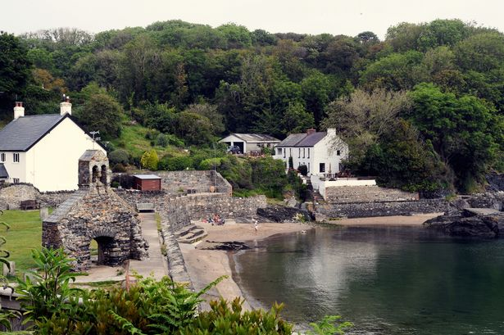
In North Pembrokeshire, there is a village called Cwm-yr-Eglwys. In the summer, the village attracts countless tourists as it is located next to the beach, with the Pembrokeshire Coastal Path running through it. The main problem with this village is that out of the 50 homes, only two of them are permanently lived in all year round (Garside, 2021); one of the houses is on sale (as of the writing on the article) for 1.3 million pounds (Garside, 2021). The rest of the houses are second homes or rented out during the summer through Airbnb (Clements, 2021). Norman Thomas, one of the two permanent villagers in Cwm-yr-Eglwys, is an 88-year-old man and is the only Welsh speaker who lives there. His concerns are that the last genuine Welsh connections to the village will be lost after he is gone. He also commented on how upset he was that the locals no longer live there, how dead the town was in the winter and how his son would like to move back to the village but cannot afford to move back since the house prices are far too high. He said, "All those houses through the valley have been sold to English people," he continued. "I'm not against them - they bring work here. I get on with them all. But it's sad that the Welsh can't afford these houses. That house over there is on the market for £1.3m. It's ridiculous. The government should have stepped in and stopped these high prices." (Garside, 2021). Which is true; The average salary for people in Pembrokeshire is £27,551, as of September 2021 (Adzuna, 2021), it would therefore be impossible for someone on this salary to afford a house price at £1.3 million.
The village of Cwm-Yr-Eglwys in Pembrokeshire, with the remains of Eglwys Sant Brynnach Church which was destroyed by a storm in 1859. (Williams, 2020)
By contrast, the other permanent residents are a couple named Elizabeth and Harry, who are also in their 80's. They are English, originally from Lancashire, deciding to permanently move to the area 20 years ago (Garside, 2021). They first visited Cwm-yr-Eglwys for the first time in the 1960s and thought it was a beautiful area. Both Harry and Elizabeth express no problems with the number of holiday homes in the area; they consider living there a positive investment for the future. Elizabeth is quoted saying, "Our family would like to keep it, but it comes down to pounds, shillings and pence. We are sitting on a goldmine here, no question about it. Very few houses come for sale here so they're pretty sought after." Despite living in Pembrokeshire for over twenty years, the English couple appears to have none of the same fears that their neighbour, Norman Thomas, has.
Rachel Garside’s BBC article that is referenced here is the epitome of how Pembrokeshire is negatively affected by second homeowners and their unforeseen consequences on culture. These homeowners have such a significant impact on culture because when they migrate to an area, they do not attempt to assimilate if there is no intent or encouragement to do so. Tourism towns are the perfect reason not to as they have everything they would need already; due to the fact they are already catered to.

Conclusion
There is a disconnect between the people who live in Pembrokeshire and Welsh culture because the idea of Welsh culture is a primarily manufactured commodity, almost a caricature of what Welsh Culture is as nearly everything seems like it is oversimplified and geared towards everyone but the people who live there. It is evident that the divide has been there far too long; it has a reputation now as not being Welsh enough. The whole idea of ‘Little England beyond Wales’ itself further re-enforces the disjunction between Pembrokeshire and the rest of Wales. It is reasonable to say Pembrokeshire’s culture is determined by how the rest of Wales perceives it.

Reference List
Austin, D. (2005). ‘Little England Beyond Wales: Re-defining the Myth’, Landscapes. 6(2), pp 30-62. Available at: https://doi.org/10.1179/lan.2005.6.2.30 (Accessed September 28th 2021)
BBC News. (2020). ‘Coronavirus: Welsh Government announces £1.1bn funding’ BBC News. Available at: https://www.bbc.co.uk/news/uk-wales-politics-52085642 (Accessed October 2nd 2021)
Camden, W. (1586) Britannia: A Chronological Description of Great Britain and Ireland together with the Adjacent Islands, London.
Clements, L. (2021). ‘The beautiful village which became the centre of Wales' second home debate’ Wales Online. Available at: https://www.walesonline.co.uk/news/wales-news/pembrokeshire-cwm-yr-eglwys-sale-20836166 (Accessed October 2nd 2021)
Duggan, C. (2020). ‘Coronavirus: Second-home owners 'use loophole' to claim grants’ BBC News. Available at: https://www.bbc.co.uk/news/uk-wales-52316003 (Accessed October 2nd 2021)
Garside, R. (2021). ‘Pembrokeshire village has more holiday homes than residents’ BBC News, 2nd June. Available at: https://www.bbc.co.uk/news/uk-wales-57322524 (Accessed September 27th 2021)
Gaynor, T. (2021). Email to Hannah Chapman, 29th September.
George, G, and Williams B. (2020). ‘The Red Rocks of South Pembrokeshire’ GEOExPro, 17(6). Available at: https://www.geoexpro.com/articles/2020/12/the-red-rocks-of-south-pembrokeshire (Accessed October 2nd 2021)
Jenkins, K. (2021). ‘Second homes creating 'almost social purging' in Wales’ South Wales Argus, 19th April. Available at: https://www.southwalesargus.co.uk/news/19241737.pembrokeshire-second-homes-creating-almost-social-purging-locals-coastal-areas/ (Accessed September 27th 2021)
Laws, E. (1888). The history of Little England beyond Wales and the non-Kymric colony settled in Pembrokeshire. London : George Bell. Available at: https://wellcomecollection.org/works/autwz26k (Accessed September 28th 2021)
Moore, D. (2006). The Landsker Line (1901). [Image]. Available at: https://commons.wikimedia.org/wiki/File:LandskerMap1901.jpg (Accessed 3 October 2021).
Observer. (2020). A busy Tudor Square in Tenby on Monday afternoon. [Photograph]. Available at: https://www.tenby-today.co.uk/article.cfm?id=128054&headline=Call%20for%20more%20control%20to%20strike%20a%20balance%20between%20public%20health%20and%20welcoming%20tourism%20back%20to%20Tenby&sectionIs=news&searchyear=2020 (Accessed 3 October 2021).
Owen, H. ed. (1892: 1603) George Owen of Henllys: The Description of Penbrokshire, Cymmrodorion Record Series, vol. 1, London.
Pi-Sunyer, Oriol. (1982). ‘The Cultural Cost of Tourism’ Cultural Survival. Available at: https://www.culturalsurvival.org/publications/cultural-survival-quarterly/cultural-costs-tourism (Accessed October 2nd 2021)
Shahzalal. (2016). ‘Positive and Negative Impacts of Tourism on Culture: A Critical Review of Examples from the Contemporary Literature’ Journal of Tourism, Hospitality and Sports, 20, pp 30-34. Available at: https://core.ac.uk/download/pdf/234696865.pdf (Accessed October 2nd 2021)
Thomas, N. (2021). ‘Welsh Government urged to act on second homes & holiday lets’ South Wales Argus, 18th March. Available at: https://www.southwalesargus.co.uk/news/19171452.welsh-government-urged-act-second-homes-holiday-lets/ (Accessed September 27th 2021)
Watkin, I, M. (1960). Viking Sttlement in Little England Beyond Wales: Abo Blood-Group Evidence. Man. 60, pp 148–153. Available at: https://doi.org/10.2307/2797058 (Accessed September 30th 2021)
Welsh Government. (2021). People aged 3 or more who say they can speak Welsh, by Welsh local authority. Available at: https://statswales.gov.wales/Catalogue/Welsh-Language/Annual-Population-Survey-Welsh-Language/annualpopulationsurveyestimatesofpersonsaged3andoverwhosaytheycanspeakwelsh-by-localauthority-measure (Accessed September 28th 2021)
Williams, G, W. (2021). Demonstration in Nefyn on Saturday, May 1 against the rising issue of second home ownership in the area. [Image]. Available at: https://www.northwaleschronicle.co.uk/news/19276952.parties-challenged-tackle-second-homes-crisis-wales-hits-polls/ (Accessed October 2nd 2021)
Williams, R. (2020). The village of Cwm-Yr-Eglwys in Pembrokeshire, with the remains of Eglwys Sant Brynnach Church which was destroyed by a storm in 1859. [Image]. Available at: https://www.walesonline.co.uk/news/wales-news/pembrokeshire-cwm-yr-eglwys-sale-20836166 (Accessed October 2nd 2021)

