

An Investigation into the use of Android Applications to aid Communication for Motor Neurone Disease Patients.

By
Steve Llewellyn (186430)

Supervisor: Jeanette Adams
Second Marker: John Williams

Project submitted as part of the requirements for the award of BSc (Hons) Computing & Information Systems.

DECLARATION

I, Steven Lee Llewellyn declare that I am the sole author of this Project; that all references cited have been consulted; that I have conducted all work of which this is a record, and that the finished work lies within the prescribed word limits.

This work has not previously been accepted as part of any other degree submission.

Signed: 

Date: 22/04/2018

FORM OF CONSENT

I, Steven Lee Llewellyn hereby consent that my Project, submitted in candidature for the B.Sc.(Hons) Computing & Information Systems degree, if successful, may be made available for inter-library loan or photocopying (subject to the law of copyright), and that the title and abstract may be made available to outside organisations.

Signed:

Date: 22/04/2018

Abstract

This investigation has looked at the current research into the current communication methods, technology, tools and applications to help with Motor Neurone Disease. The literature review gives a general overview of the disease, the types, symptoms and the communication issues that arise from the disease. The literature review also investigates any device that can help with MND communication issues. This application has been built to help people who live with MND to communicate easily and clearly with friends and family. The development method used will be centred around the evolutionary prototype method. The requirements are a communication application that will speak the entered words or phrases. After completion of the project, it has been found that this project did meet all the requirements.

Contents
1. Abstract 3
2. Abbreviations 5
3. Introduction 6
4. Research and Review of Literature 7
4.1 Introduction 7
4.2 What is Motor Neurones disease? 7
4.3 What are Motor Neurones? 8
4.4 Types of and symptoms Motor Neurone Disease 11
4.5 Communication issues in MND Patients 13
4.6 Current communication methods and technology available 16
4.7 Current communication tools and applications available 21
4.8 Research Ethics 29
4.9 Critical Review 31
5. Research and Development Methodology 33
6. Design and Implementation 46
7. Evaluation 61
8. Conclusions and Recommendations 63
9. Reflection 66
10. References 68

Abbreviations

Explanation of acronyms

SLT – Speech Language Therapist
AAC – Alternative and Augmentative Communication
MND – Motor Neurones Disease
MNDA – Motor Neurones Disease Association
ALS – Amyotrophic Lateral Sclerosis
PBP – Progressive Bulbar Palsy
PMA – Progressive Muscular Atrophy
PLS – Primary Lateral Sclerosis
ACAT – Assistive Context-Aware Toolkit
NHS – National Health Service
BSL – British Sign Language
SDK – Software Development Kit
IoT – Internet of things
TTS – Text-to-Speech
DPA – Data Protection Act
SDLC – System Development Life Cycle
IDE – Integrated Development Environment
API – Application Programming Interface
VB – Visual Basic

Introduction

This investigation paper will study the research relating to the development of software to help with communication issues that arise from Motor Neurones disease (MND).
Motor Neurone Disease is a fatal and uncommon neurodegenerative and progressive disease. It will affect the neurones in your brain, resulting in the brain stopping signals being sent. Once these signals stop, the body will slowly waste away muscles and will become steadily weaker. When the muscles weaken, the person living with MND could be left with aches and pains in their muscles, slurred speech, a weakened grip and joint stress. This disease is often misdiagnosed, this leaves the person to suffer needlessly. As the disease progresses people who live with MND will find basic everyday tasks harder, these include, walking, gripping, speaking and even breathing. Not all people will suffer the same symptoms. Some people have reported losing their communication skills and some keep this but lose their ability to walk.
The reason that this disease affects people the way it does, is their upper and lower motor neurones. The human nervous system is made of two sets of nerves. Each of these will control different muscles movement within the body, one group will control senses, the second group is the motor neurones. It is the second group of nerves which will be affected by MND.
This investigation has researched communication issues with regards to MND. What were the causes and what were the results found? There are many factors in communication issues in MND, some are more severe than others. One of the more severe issues was a speech problem called Dysarthria. There are many different devices that can help people to communicate when they live with MND. All these have been covered in this report, again some are more useful than others, but it will depend on the diagnosis that has been given.
Communication methods, tools and applications have been looked at to see what is currently available and if they could be improved upon. The title of the investigation “An Investigation into the use of Android Applications to aid Communication for Motor Neurone Disease Patients” will look at how people who live with MND communicate via portable Android apps.
The objective will then be to use research and development methodologies to design and implement an application to help with their needs. The application will be designed once the requirements are found and then implemented to meet the requirements. The overall aim will be to develop a communication application that will help people who live with MND easily and confidently communicate to other people.
The following report will explain all about MND, their symptoms and the different forms. It will look at the many different types of communication tools, methods, technologies and applications, each will come with their advantages and disadvantages. The research methodologies will also be analysed to select the correct method to proceed with this investigation.

Research and Review of Literature

4.1 Introduction

A critical review of printed work in the areas linked to this investigation provided an essential understanding into communication issues, communication tools, methods, applications and technology available that is linked to Motor Neurone Disease (MND).

4.2 What is Motor Neurones disease?

Motor neurone disease (MND) is a fatal and uncommon neurodegenerative and progressive (meaning the condition gets worse over time) condition that causes degeneration in the upper and lower part of the motor system, mainly affecting the nervous system (1). The disease affects the nerves in the brain and spinal cord, these are the nerves that control the muscles in the body. The disease causes the nerves (motor neurones) to slowly stop sending signals to the muscles from the brain and spinal cord, the results are weakening and wasting of the muscles (2), which can leave people trapped within their bodies. MND is not generally a painful disease but often people can suffer from uncomfortable stiffness, painful cramps, aches in their muscles, slurred speech, a weakened grip and joint stress. There is medication available to help with joint pain, muscle stiffness and muscles cramps. If these medications do not work a doctor recommends the use of physiotherapy to ease the pain (3). MND has the misfortune of regularly being misdiagnosed, this sometimes leads to undue pain, suffering and diagnosis dilemma (4). Generally, intelligence, recollection, vision, hearing, touch and taste remain intact, unless a person is affected by frontotemporal dementia (5).
People who live with MND will live their life with some or all their main muscle functions decreasing and will find some activities such as walking, gripping, breathing, speaking and swallowing increasingly difficult (6). Not everyone one who has MND will be affected by these symptoms, some people could lose their mobility but keep their communications skills and vice versa. There have been studies to show that over a 15-year period, more men than women will have MND (7).
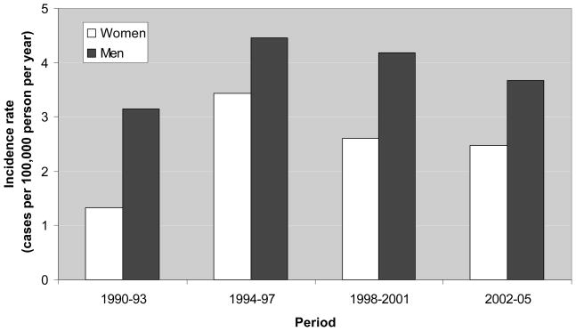
Fig 1:
Graph showing the number of men and women who had MND in a 15-year period 1990-2005 (7)

For an unknown reason, more men have MND over women. The ratio of men who are diagnosed with MND is higher compared to women, 3 men compared to 2 women are diagnosed every year (8). The rate of MND in men was 54% higher than in women. Lifetime risk is also higher for men, 1 in 350 for men and 1 in 472 (9).
Statistically, MND can affect any adult person at any age, but people are usually diagnosed when they are over 40, and most likely between the ages of 50 – 70. Being a fatal disease 1/3 of people who live with MND will die within 1 year of being diagnosed and more than half will die within 2 years of diagnosis. An average person’s lifetime risk is around 1 in 400 people in the UK and currently there are around 5000 people who live with the disease, with no current cure. More than 80% of people with MND will have some form of communication issues and some can lose their voice completely (10). Between 5-10% of people who have MND will show some symptoms of frontotemporal dementia (FTD). FTD is an uncommon type of dementia which affects the frontal lobes of the brain, just behind the forehead. This part of the brain will deal with behaviour, emotions, planning, problem-solving and speech (11). Every day around 6 people will die from the disease and the same number of people will be diagnosed with the disease (10).
Jean-Martin Charcot, the father of neurology and the most influential neurologist of the 1800s, he first discovered ALS in 1874. He discovered several conditions affecting the lateral horn of the spinal cord (12).
When further investigated, a disease was isolated was found which resulting in killing off motor neurones. This was then referred to as MND in the UK. The US named the disease as ALS, which the UK uses as a form of the disease (13).

4.3 What are Motor Neurones?

Motor neurones are separated into lower and upper, each control different muscle movements. The nervous system is made of two main groups of nerves. The first group will control the senses, these are sensory nerves and the second group are the motor neurones. This second group are the nerves that are affected by MND (14).
The rudimentary working component of the nervous system is a cell called a neuron. The human brain contains about 100 billion neurones. Each neurone consists of cells that contain nuclei, dendrites and axons. Motor neurons communicate messages from the brain to control voluntary movement (15). Motor neurones are nerve cells that control vital voluntary muscle activity. These muscles control important muscle movement including walking, speaking, swallowing and breathing (15). Messages from these nerve cells in the brain (Upper motor neurones) are sent to other nerve cells in the brain stem and spinal cord (Lower motor neurones) and then sent on to the muscles that need to be used.
There are 3 different neurones, each of these will perform a slightly different function within the body (16):
- Sensory neurones
  - These sensory neurones will carry signals from receptors to the spinal cord and the brain

- Relay or Interneurons neurones
  - Relay neurones carry messages from one part of the CNS (central nervous system) to the other part of the CNS

- Motor neurones
  - These carry signals from the central nervous system to effectors (a small cell that acts as stimulus)
The below image shows how the muscles wastes and shrinks, the axon sends messages to the muscles from the nerve cells.
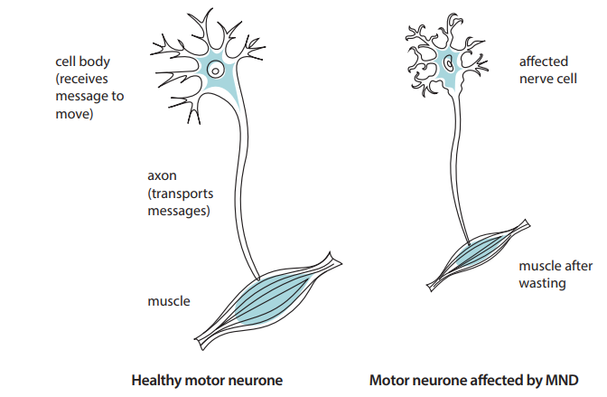
Fig 2: Healthy Neurones V Neurones affected by MND (17)

Lower Motor Neurones

These neurones are in the anterior grey column, anterior nerve roots or the cranial nerve nuclei of the brainstem (18). All voluntary movement is linked to the spinal lower motor neurones which act as a link between upper motor neurones and muscle movement. The lower motor neurones control muscle movement for the below-listed features and many more (19):
- Eyes
- Face
- Tongue
- Arms
- Legs
- Chest
- Throat
These motor neurones will no longer carry messages to the muscles which will result in weak and floppy muscle. As the progression gets worse, it will cause a loss of mobility and movement, and difficulties with speech, swallowing and breathing.

Upper Motor Neurones

As opposed to the lower motor neurones, these originate either in the motor region of the cerebral cortex or in the brain stem and carry motor information down to the lower motor neurones via the spinal cord. The fibres of the upper motor neurons pan out from the primary motor area, ending in the brain stem, where they will intersect within the lower medulla oblongata to form the lateral corticospinal tract (pathway) on each side of the spinal cord (20).
A lesion in this area will result in several different health issues including MND, stroke and multiple sclerosis. The upper motor neurones direct the lower motor neurones to produce certain movements such as walking or chewing. Once these motor neurones are damaged it will result in stiff and weak muscles (21).

4.4 Types of and symptoms Motor Neurone Disease

The symptoms are widespread from the onset of the disease, but it usually starts by only affecting a single limb or motor function. The disease can be divided into 4 forms of MND and each has their own symptoms, each type will be diagnosed depending on the pattern of the motor neurones and which limb is affected first within the body. Due to the terminal nature of MND, many people will try unproven drugs and or treatment and therapies. This has sometimes accelerated the muscle weakness of the disease (22).
Signs and symptoms of MND vary depending on what side of the brain the motor function is linked to. Lower motor neurones will signify a lesion in either the cranial nerve, anterior nerve or anterior grey column of the brain. Lower motor neurons are usually characterised by increased muscle tone, muscle weakness and increased muscle reflexes. Upper motor neurones will signify a lesion is in the motor region of the cerebral cortex of the frontal lobe. Upper motor neurones are usually characterised by decreased muscle tone, wasting and weakness of the muscles and fasciculation’s (muscle twitching) (23).
- Amyotrophic lateral sclerosis (ALS)
  - ALS tends to be the most common form of MND, this form will affect both upper and lower motor neurones. ALS symptoms first begin in the arms, hands, legs and swallowing muscles. After the disease has progressed to a certain point, the diaphragm and chest muscles will fail, and the person will lose the ability to breathe unaided. This will lead to respiratory failure and the person will die within 3 to 5 years of the symptoms beginning (24). ALS is often diagnosed only by ruling out other diseases (25). ALS has two different causes, sporadic and inherited (from parents), around 90-95% of cases are sporadic, meaning the causes are unknown (26).

- Progressive bulbar palsy (PBP)
  - PBP involves the muscles linked to swallowing, chewing and speech, these muscles are controlled by nerves in the bulb of the brain, the medulla region. Limb muscles are affected later during the progression of the disease. People with PBP will have weakened jaw and facial muscles and are prone to random outbursts of laughter and crying (emotional lability) (27). People who live with PBP could have symptoms that include, paralysis of the tongue, persistent dribbling, paralysis of the facial muscles, exaggerated facial and jaw reflexes and slurred speech (28).
- Progressive muscular atrophy (PMA)
  - PMA results in mainly muscle wastage and losing muscle mass, also known as atrophy. PMA will begin in the arms or legs for many years before spreading and will affect the lower motor neurones (29). This type of the disease affects fewer people than ALS but as the disease progresses the person may show signs of upper motor neurones; the person may then be diagnosed with ALS (30). People who live with PMA will survive longer than those with the ALS or PBP form of the disease.
- Primary lateral sclerosis (PLS)
  - The rarer of the forms, this will affect the upper motor neurones of the face, legs and arms (24). This form of the disease is not fatal but will drastically affect the life of a person who has PLS. It will first affect the legs and spread to other limbs, it will influence the muscle linked to speech and will leave the person with slow and slurred speech (31).
It is clear to see that the disease will affect people in different ways and not everyone will have the same symptoms and the disease will not affect people in the same way or in the same order (32). Many times, the symptoms of MND have been mistaken for other diseases and unrelated conditions, it can take up to 4 years to get a definitive diagnosis. It will mainly affect middle age or elderly people but can sometimes affect younger people (33).
As previously mentioned there is no cure for MND and there is little medication that can help with MND directly, only some pain medication for crams or joint pain. There is only one recommended medication to help with MND, Riluzole. This is a licensed drug and is freely available on the NHS for people who have been diagnosed with MND. This drug will slow down the progression of the disease and will usually add 2-4 months onto a person’s life expectancy (34), the progression is different in each person, and the drug is not guaranteed to work with every case.
Although not a form of MND, Kennedy’s disease is very similar and is often misdiagnosed as MND or MND is misdiagnosed as Kennedy’s disease. Kennedy’s disease mainly affects men, very little women are affected but they do carry the defective gene (35).

4.5 Communication issues in MND Patients

MND can and will cause issues that will affect a person’s ability to speak and communicate. Their speech will become non-existent or will become slurred and unclear. This is a result of a weakness in the vocal cords, lips and tongue (36). These are what is known as bulbar muscles, which are lower face and throat muscles. Around 90% of people who live with MND will be affected by communication issues. Facial expressions will also become affected and this will leave the person who is unable to communicate adequately to feel frustrated, isolated, a lack of confidence and generally feel unhappy (37). A person who is unable to communicate their wishes may also be left in a state of depression (38).
There are some methods that people with MND can use to communicate easier, this, in turn, will help them feel more comfortable with communicating with family, friends and caregivers. These include speaking slower, emphasising words, using shorter sentences and using keywords (37).
As the disease progresses the issue will be more and more prominent and increasingly tiring and difficult for the person. It will also become harder for others to understand, again this will leave the person more frustrated and feeling alone. Speech therapists can help with techniques such as slowing the speech rate, exaggerating articulation and improving respiratory efficiency (39).
There are many health professionals working in the health and social care sector. These professionals are trained specially for people who have communication issues and needs.
- Specialist respiratory teams
- Speech and language therapist (SLP)
- Occupational therapists
- Rehabilitation engineers
- Care workers
These teams or individuals can help produce plans which will enable the user to gain a better understanding of what will happen to their voice and speech. They will then offer help with speaking techniques and AAC devices (40). Effectively managing their respiratory needs will have a positive impact on their communication.
AAC pathways is a guidance and structure of the services that MNDA (Motor Neurone Disease Association) can offer for the good practice of people who live with MND. The pathway is broken into sections that will clearly help the user understanding what will happen in the process (41).

AAC pathways:

- Diagnosis: Diagnosis of MND
  - When a person has been diagnosed with MND they are automatically eligible and referred for an assessment with the SLT

- Referral: Initial speech and language therapy assessment
  - During this assessment, it will be decided if the specialised local SLT can manage their AAC needs. This will be based on the type and progression of the disease.

- Assessment: Local assessment & Specialist assessment
  - Advice will be offered on what type of AAC is best suited. Communication ability, physical, sensory, speech, language and cognitive abilities will be assessed to form a basis. Once an AAC service is agreed, the user will be transferred to the AAC specialist.

- Trial: Equipment trial
  - The user and AAC specialist will agree on an appropriate AAC method and it will be trialled for up to 2 weeks. Once a method or device is successful, talks will be made to make it permanent.

- Provision: Funding report & support services
  - A funding report will be generated to decide if the user is eligible for funding or if the device will be self-funded. An application can be made through the NHS or MNDA

- Training and support: Equipment provision and training & Servicing and repair
  - All equipment supplied through the NHS or MNDA will come with full training from the SLT or specialist AAC provider. Equipment supplied will be maintained and repaired as and when needed.

- Review: Review
  - The management of their communication needs and equipment is an on-going process and will be review regularly by the SLT during the progression of the disease. This will be more important during the latter part of the disease where the needs of the user could change dramatically and other methods of AAC needed.

- Return: Return of equipment (If needed)
  - When equipment is no longer needed, the equipment is returned to the appropriate service (NHS or MNDA) to be reused by another person.
Every local authority or NHS trust will have their own version of an AAC pathway which they will follow. The above is that of the MNDA.
West Midlands AAC care pathway includes the assessment of the user along with a general assessment of the user, including how well they can communicate and an outline of the user’s goals and what they hope to achieve by using an AAC device (42).
If there are no AAC pathways available to be used when being assessed, there are many other published frameworks that can be used

Dysarthria:

A common speech problem that occurs with MND is known as Dysarthria. Generally, people with dysarthria will have a slurred, slow nasally sounding speech. This is sometimes excessively quite or even excessively loud. They are left with an uneven and rapid speech volume which is difficult to understand when they speak. This is down to having difficulty moving their tongue or facial muscles when they speak. As a result, people who have dysarthria will be more difficult to understand. Dysarthria will not affect any other intelligence or will enable the person to not understand what is being said (43).
Some of the biggest issues that can occur with dysarthria are not the complications with communicating, it is the social difficulties with the lack of communicating with friends and family. This could affect relationships, make social situation challenging and could lead to depression or social isolation (44). Causes of dysarthria are disorders that are linked to the nervous system (neurological). These include stroke, brain injuries, brain tumours and conditions that cause paralysis and cause weakness that affects the muscle tone around the throat, lips and tongue (45).
As with most disorders dysarthria has serval types (46):
- Flaccid dysarthria
  - Lower motor neurone, damage to the cranial nerves and/or regions in the brain stem

- Spastic dysarthria
  - Upper motor neurone, damage to motor regions in the cortex, on both sides of the brain

- Ataxic dysarthria
  - Upper and Lower motor neurone, damage to pathways that connect the cerebellum with other regions in the brain

- Hypokinetic dysarthria
  - This form is linked to Parkinson’s disease

- Hyperkinetic dysarthria
  - Damage to the basal ganglia (responsible for involuntary movements)

Dysarthria affects 80% of people with motor neurones disease. The most common dysarthria disorder to have with MND is a mixture of flaccid and spastic (47). It will weaken the lower motor region neurones, tongue and facial muscles. At the same time, it will impact the upper motor neurones, chewing and jaw muscles (48).
To help combat these communication issues, there are several strategies which can be implemented that will help the person communicate and for other to understand them easier. It is also vitally important that they find communicating easier with the strategy in place if not, the person with MND will still be left feeling secluded, alone and possibly depressed.

4.6 Current communication methods and technology available

Communication methods differ when dealing with people who live with MND. Some people find using basic hand gestures or writing tools very tiring to use (49). They use a tablet or computer keyboard as they find them easier and less tiring. As standard, a Windows-based computer will include some accessibility options that can be adjusted to meet the user’s needs. These could be simple tasks (50):
- Slowing the mouse speed
  - This will make the mouse pointer more accurate

- Speeding up the mouse speed
  - This will make it less tiring for the user

- Increasing the size of the icons or Windows objects
  - Larger icons will be easier to focus on and easier to navigate to

- Decreasing the keyboard repeat rate
  - This option will reduce repetition errors

- Enabling the sticky keys
  - Sticky keys will enable the user to use 2 or more keys with a single hand, the keys will be locked so a user can press CTRL then C.

- Enabling the Filter keys
  - Reduces errors made by striking the wrong keys

- Enabling the slow keys
  - Reduces errors made by striking the wrong keys

Augmentative and alternative communication (AAC) methods

“Technology is a friend to people with MND.” (51)
Around 84% of people who live with MND use an AAC (Augmentative and alternative communication) device to help with their communications (52). Every day people use AAC as part of their daily lives while communicating, waving, pointing or giving a thumb’s up is considered an AAC action (53). An AAC communication tool could be an iPhone or Android application which has been downloaded and installed on a phone or tablet. It is not just applications that are helpful, by using a PC or laptop with Windows operating system, a user would also have access to other programs written in Visual Basic or C# (C sharp), and many helpful features within Windows itself. Technology is playing a life-changing part in the MND community, without it, many people would be left unable to communicate.
AAC will not only help people who have MND, autistic children greatly benefit from the image and visual stimulus that is associated with AAC (54). Cerebral palsy, stroke, head or brain injuries and people with learning difficulties also greatly benefit from using an AAC device.
Struggling with communication is common, but under-recognised, disorder. An estimated 1 in 100 people have significant communication problems and may be helped by some method of AAC. Being able to communicate will help people have a more meaningful life experience and make friendships, relationship easier and offer more independence (55). AAC is a part of clinical practice that tries to compensate, either temporarily or permanently for the damage and disability of persons with severe a communication disorder (56).
At first, people who live with MND can adapt their speech to make it easier to communicate more clearly, but it will soon become evident that they need more help communicating, this is where an AAC adaptation will greatly help.
“If I cannot say as much as I used to say, I have to say it better. So, the choice of words becomes crucial.” (37)
AAC is an umbrella term that covers communication methods that are used to help replace writing and speech impairments. These communication methods can include sign language, picture boards and electronic devices, and cover many kinds of impairments and diseases (57). AAC represents an additional feature of the written or verbal communication that will help compensate for an impairment (58).
AAC devices can including many different types of communication aids. MND organisations and Charites will often customise a device and loan this out to help with any communication difficulties (59). For an item like this to be loaned, first, an arrangement will be made with an SLT (speech-language therapist) to offer an assessment.
Some of the methods available will be unsuitable for people with MND, sign language will be extremely difficult for some people due to the weakness in their hands and fingers, but not impossible.
AAC can comprise low and high-tech products. Low tech will involve gestures, signing/signal, picture books and even pen and paper. High-end tech products will include voice output and written input devices like phone or tablet applications and communication aided devices.
Using an AAC product will greatly benefit people with MND. It will help and support their communication needs while they interact with family, friends and caregivers. People with MND keep their cognitive capacity so can use more complex AAC applications (60).
By selecting the right product early in the diagnosis will greatly help the person who lives with MND. Many people are unprepared for the disabling loss of their communication skills. This is sometimes due to the inconsistency of MND and their symptoms. People will function better with an AAC already in place.

Social media

Social media is part of everyday lives for billions of people worldwide, including those who live with MND. This is not just used as an instant communicating tool to deliver shared content (images & videos) but to also interact with other users and people who have MND (61). There are many MND forums and blogs that offer help and advice to diagnosed people, family and their friends. Also, this form of chat room will give an immediate form of help and can answer many questions for a newly diagnosed user, their friends or families. The official MND forum will offer help with care needs, medication, local support, technology and finances available (62). A common challenge for those with MND is a lack of quality knowledge and understanding when learning about their AAC needs (63).
The MND association have regional Facebook and Twitter pages. These are used to deliver support and help to any person living with MND, their family or friends (64).
The MNDA recommends serval social media platforms that can help with many aspects of MND (64). There are multiple sites or pages available to offer advice and help:
- Facebook
- Twitter
- Pinterest
- YouTube
- Flickr
- Forums
- Blogs
Online help is a powerful tool and will provide ample networking opportunities to connect with other people. Social media has many advantages, it can help people who live with MND by offering the person a way to easily communicate and share resources and information with friends and family without the need for them to feel under pressure to communicate quickly or clearly with the way they normally would via their methods or tools (65). As easy as communicating via social media could be at the start, it will be slightly more difficult as the disease progresses, and more muscle weakens. People are often bullied and victimised when they have any sort of disability and they use social media.
“We don’t drive or have a car, so I use my laptop to stay in touch with the outside world. I also use it to speak to others affected by MND on the MND Association forum, as well as stay in touch with my family in Poland.” Max, living with MND (SAME AS BELOW QUOTE)

ACAT Software

One of the most well-known cases of MND is Professor Stephen Hawking. He has lived with MND for 55 years dying aged 76 in 2018, even though most people who have been diagnosed with MND live for only 2/5 years. He was diagnosed with the disease when he was 21 and given 2/3 years to live but ended living with the disease for 55 years (66).
He is known as one of the world’s most prolific theoretical physicists. He once said, “Intelligence is the ability to adapt to change” (67) he and his equipment adapted frequently when his condition worsened (68).
Professor Hawking uses a very complex technology system to communicate. When Professor Hawking had movement in his hands he used a text-to-speech application, this application would speak whatever he wrote and an electronic notepad. Now nearly all his body has lost the ability to move, he now uses a computer which will detect muscle movement in his cheek and face (69).
Professor Hawking’s uses an open source software from Intel called Assistive Context-Aware Toolkit (ACAT). In 2012 Intel started designing a new communication software to improve on Hawking’s current set up and help the MND community (70). That was EZ Keys, this used a camera mounted to his glasses that detected pulses in his cheek. With his muscles slowly weakening in his cheeks, a replacement was needed. In 2014 they had the software finished and ready to be released, it doubles Hawking’s current input speed. He is still using his cheek muscles to operate the software until a camera can be attached to pick up his eye movements. This has helped around 3 million users worldwide to communicate when they have the most severe form of MND, quadriplegia and many other physical disabilities (71).
“My old system was over 20 years old and I was finding it very difficult to communicate effectively. This new system is life changing for me and I hope will serve me well for the next 20 years.” Professor Stephen Hawking (66).
ACAT which is installed on a windows tablet. The software picks up his cheek and muscle movement from a camera mounted in his glasses, a cursor moves around the keyboard, he can choose when to stop the cursor on any given letter. As he types, he will be offered full words from another software called SwiftKey (72). This a predictive messenger keyboard available on any IOS, Android or Windows touchscreen device. This software has been loaded with all his previous lectures and, notes and books. This makes what he wants to type and say, easy and continuously available (73). This software helps him write lectures and speeches which he can deliver with the help of his communication software.
The layout is very simple, a selection of words will appear once a user begins to type. These words are selected and added to the talk windows to form sentences and then be spoken.
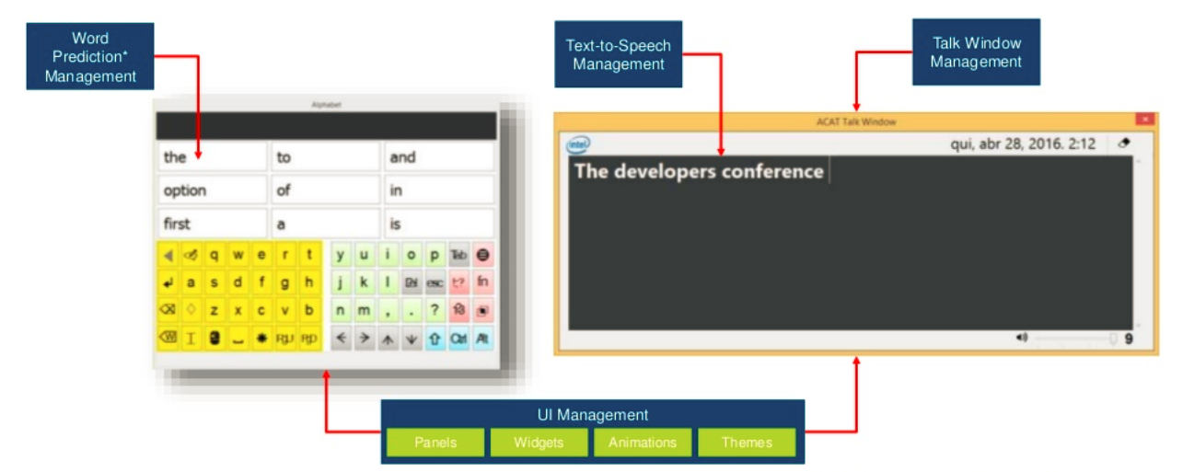
Fig 3: ACAT layout (74)
There are many advantages to using this software. People will see that it is being used by Stephen Hawking and automatically want to use it. The program itself has many different features that the user can use (75):
- ACAT app
  - This is the full version of the software. Uses facial gestures to create words, sentences and then speak them

- ACAT talk
  - Scaled down version of ACAT with just a talk window which converts anything that is typed into speech window

- ACAT try out
  - This will let the users use the switch mechanism to interact with ACAT (Switch – are large buttons that users push to be activated)

- ACAT vision
  - A webcam can recognise facial gestures and interpret them into triggers to drive the ACAT user interface
The software can be adjusted to meet the needs of the user and many different layouts are available. There are many guides and FAQ’s to help the users get the most from this software, there is also an introduction video from Professor Hawking’s (70).
There are some disadvantages to using this software, even though the software is free it is only available on a Windows-based laptop or PC. The Windows must also be a 64-bit version, if the user has a 32-bit version it will need to be upgraded and will come usually with an upgrade cost (76). The user will also need a separate webcam or sensor to detect facial muscle movements (77).

4.7 Current communication tools and applications available

Augmentative and alternative communication (AAC) tools

Depending on the type of diagnosis that is given, there are several devices that will help the user communicate more clearly and confidently.
AAC devices or techniques are usually categorised into 2 groups aided and unaided and then aided is split further into low tech and high tech:
- Unaided communication
- No tech or Low-tech communication aids
- High tech communication aids
Again, an SLT will help decide the course of action which will be best suited for the situation after discussing with their various teams and colleagues, the user and his or her family. Depending on their needs, if they have some hand and arm movement they can begin with unaided communication and see how it help with their communication needs.
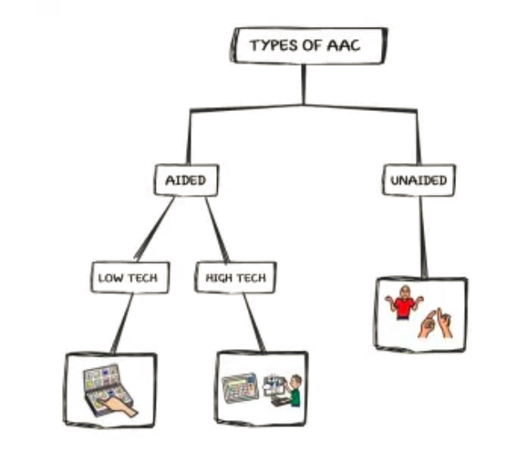
Fig 4: Types of ACC (78)

- Unaided communication

Unaided communication consists of nonverbal means of natural communication and techniques that involve body movement or language, gestures, sign language, facial expressions, head or eye movements and pointing (79). When a person uses unaided AAC, they are just communicating using their body. These forms can work well until the muscles break down and weaken. Once this happens, depending on their symptoms they will need a new form of communicating tool or technique to help (80). This is good for older people who may not like and may not want to use modern technology. As been previously mentioned, they may lose the ability to speak but may have full control over their hands and be able to sign and use British sign language (BSL), point or signal. If this happens then they may be more than happy to continue this, but a downfall to signing would be other people (especially friends and family) would also need to be able to sign to have a conversation (81).

- No tech or Low-tech communication aids

No tech communication aids are the most basic of tools that offer no technology within them and are as simple as a pen and paper, whiteboard or images in a book. A user exchanging pictures or images with another person is a form of no tech communication. A user can even pass an object to another person to signify they want something, a toothbrush being passed over could indicate the user would like to brush their teeth, a cup would indicate a drink is needed. These basic tools will require no batteries or power for the person to use them. Paper and white board’s offer easy to use communication while their writing is legible (82).
Similarly, to the unaided communication, these tools are fine until the person can no longer use them and then they need to move to low or high-tech communication. Low tech communication aids are basic technologies tools that require a low powered power input or battery, these have low technology within them and are as simple a laser pointer, switch buttons (can produce a single message or do a simple action), or audio books or toys (83).

- High tech communication aids

High tech communication aids are designed to offer help with communicating even when it is very hard to do so. Some AAC devices will work even if all hand and arm movement are lost. Eye gaze controllers are eye trackers that are designed to sit atop of a laptop or monitor and the user can navigate the mouse to control the laptop or PC. This is controlled by the user blinking or just stopping on an icon for a certain period (84).
Another AAC device is a mouse emulator. These are hands-free alternatives where similarly to eye gaze units, a unit will sit on the laptop or monitor and use a camera to monitor head movements. A reflective dot will be needed to be positioned on the forehead of the users and is continuously monitored for movement. Selections are made by timed spaces of inactivity or by the user clicking a large button, this could be banged with hand or feet. These are large buttons and require no precision movement (84).
“I use a computer with eye gaze, not just to communicate, but to do online shopping, use social media and even make art, something I’ve been passionate about my whole life.” Sarah, living with MND (10)

- Advantages and Disadvantages of using AAC

There are several advantages and disadvantages to using unaided and aided AAC tools and techniques. Once a person who has MND starts to degenerate quickly they will need a different tool or technique, this will result in the user needing to quickly learn this new system. British sign language is an easily recognised form of communication in the UK but may change in different countries, but for the user to use this regularly their friends and family must be able to sign as well. The basic writing technique will suffice some people, being taught at a young age most people will understand reading and writing worldwide. This technique will only be used when the user has legible writing.
Low-end technology can be learnt quickly and be a very effective way to communicate. Can be built up from picture cards and progress on to other techniques. Low tech is less costly and less complicated than a high-tech option. The low end will offer a basic communication option but may be suitable for many users.
High-end communication tools offer the highest quality of communication. These systems have been designed to offer easier communication with minimal effort. One of the main advantages to a person with MND using a high-end communication tool is that they will have a voice, this will boost their confidence and offer a sense of independence. These devices can also be linked to an Internet of Things (IoT) device like Google home or Amazon Echo (Alexa), these devices can then control the users home. The lights, heating and power can all be controlled by these IoT devices, they can also order online shopping and goods.
Although there are several high-tech adaptive devices available, many of them require extensive user training for the user, their caregiver and families. There have been several complaints with eye gaze and similar AAC products since the tools are inaccurate when selecting smaller objects on the screen, are difficult to master, hard to calibrate and expensive to acquire. Several other factors will also complicate the use of these systems, blurred vision, cataracts and wearing contact lenses (85).

Android, Apple & Windows

Technology is ever evolving; modern technology is now smarter and able to do more everyday actions. This is especially useful for people that have MND. There are several applications and programs that have been designed to help people to live their lives to the fullest (86). These mobile applications are designed to look after certain parts of your life, some apps can plan and manage their care needs, health and communication needs.
The two main type of applications that can help with communication needs is text-to-speech and voice banking. Most applications will offer the ability to offer either Text-to-Speech or voice banking, but not both.

- Text-to-Speech (TTS)

This application will let you write sentences and then by pressing a button the app will speak exactly what is written in a human or synthetic voice. This can usually be programmed with pre-defined words or sentences. It will use predictive text to try and guess words or sentences, this will save the user time and it will form what is needed to be spoken quicker. The user can select letters with a variety of tools, keyboard, mouse pointer, adapted mouse, joystick, switch, facial muscles or eye tracking.

There are numerous text-to-speech programs available for Windows, Microsoft Office Speak, Read Out Loud, Word Talk, Orato and Microsoft Word has a feature called Read Aloud (87).

There are even more available for iOS and Android, the majority are free for iOS but there are very few free for Android (86).

There are many benefits for individuals with MND to use the text-to-speech software in any format, Windows, iOS or Android. With it, they can have a voice to clearly and confidently communicate. By having a TTS on a mobile device, they can communicate wherever they go, but a downfall is that the device will need to have a charged battery. To overcome this the user can purchase a separate portable battery charger, a 26800mAh charger will distribute around 6-8 full charges before the battery being depleted (88), this can last around 5 days before needing a recharge.

TTS software has changed the lives of millions of people worldwide by helping them communicate, it revolutionised the way Professor Stephen hawking communicated. The advantages far outweigh the disadvantages.

“For a time, the only way I could communicate was to spell out words letter by letter, by raising my eyebrows when someone pointed to the right letter on a spelling card. It is pretty difficult to carry on a conversation like that, let alone write a scientific paper.”
Professor Stephen Hawking (89)

- Voice or message Banking

Depending on how progressive the speech issues are, it may be possible to record your own voice, which can then be used to create a synthetic speech or record your own voice and have it playable in their own voice on a computer, tablet or mobile smartphone. The user can record phrases or single words that can be listened to in the future or the user can make sentences or paragraphs that can be read out (90). These will need to be recorded before they lose the ability to do so. It usually involves speaking between 600 and 3500 phrases, recorded via a computer program. Usually, an SLT will help with voice banking and depend on the severity of the voice only a handful of phrases may be recorded.

The reason that people with MND want to use their own voice for these recording is that without it, they may feel they will lose their identity if they have a synthetic voice permanently speaking for them. If they, unfortunately, have passed away, their loved ones will still have the phrases and words that have been spoken and recorded, these can then be replayed (90).

The stronger and clearer your speech is when being recorded, the higher quality the banked voice will be. The sooner their voice is reordered, the better. Voice banking is more
effective if the phrases are recorded before their voice has been significantly affected by
MND. A person’s voice can still be recorded if MND has affected their voice, but the quality of the recording will be slightly compromised (91).

The US company Build-A-Bear offer a service that will give a stuffed bear a voice which has been pre-recorded, sometimes these have been recorded by a family member who has a terminal illness (92). These are given usually to children when a parent or loved one who has passed away or is unable to communicate any longer.

A downfall is that some professional services from CereVoice Me are currently charging £499 to record a person’s voice, then give it as a download to use in text-to-speech software. Even though this is an expensive service it is done via a professional recording service, so the quality will be the highest possible. There are cheaper alternatives and more expensive option available, ranging from £80 - £2000 (93). These services can be modified depending on what the user needs, quality of the recording, quality of the downloading and what software will be required (if any). One of the biggest advantages of using voice banking is that the person will feel they have more of an identity if they can speak in their own voice. Losing their voice will be one of the hardest things that they will have to come to terms with, often they will feel isolated and alone.

“Knowing that my voice was probably going to be lost spurred me on to look at voice banking.” A person living with MND (90)

- Applications

There are currently no recommended free Android communication applications which are recommended by the Motor Neurone Disease Association (94). The type of applications which are available for communication are very diverse, most do not cater to a single disease or illness, the reason for this is that there are many different communication issues that arise. The applications available are not purely designed just for MND, these mobile applications can help people who live with autism, cerebral palsy, down syndrome, speech apraxia and any communication-related illness or disability.
“I haven’t needed to use my created voice for general communication yet, but it has been banked and can be installed on a range of devices for when I do need it.” Lee, living with MND (95)
These are the Applications that are currently recommended by the Motor Neurone Disease Association (MNDA) to help with communication. These applications are available on either the Google Android and Apple iOS app stores.
- COMM Boards
- Grid Player
- Sounding Board
- Verbally

- COMM Boards

An image-based app that uses different symbols to help the user communicate their everyday needs and hold a conversation. Most of the communication boards are pre-defined but can be customised if needed. An Android-only app which is available from the Google Play store for £8.99. Mainly designed for children in mind but is simple enough for all people to understand and use.
Images are clicked and the words from the images are sent to a sentence maker, when the sentence is ready, it can be read out. The sentences are basic but will clearly convey their needs.

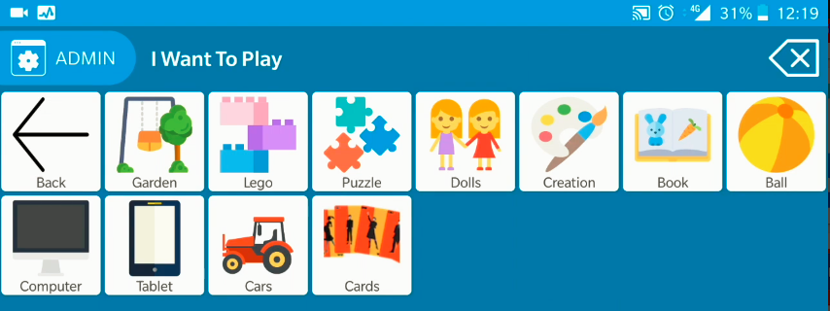
Fig 5: COMM Board screenshot

- Grid Player

A communication tool that will build sentences using pre-programmed phrases and will let the user type their own to be read out. An iOS only app which is available for free from the App Store. A very similar app to COMM board, a user selects images and sentences are made.
The boards can be customised, and the voices can also be changed to use male/female and child/adult’s voices.
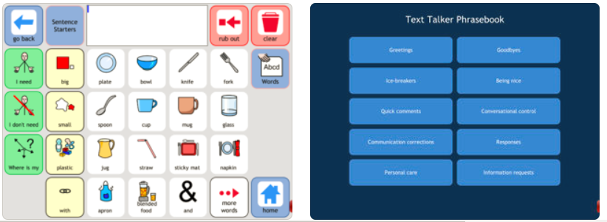
Fig 6: Grid Player screenshot

- Sounding Board

Another soundboard application this will let the user customise boards as needed, again mainly aimed at younger children or users with less intelligence. A free iOS application available from App store but in-app purchases like additional voices are 99p.
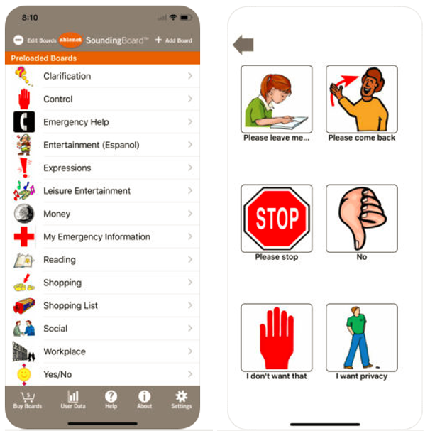
Fig 7: Sounding Board screenshot

- Verbally

This free iOS-only application is aimed at adults and is designed for real and easier communication. The two tabs available are words and phrases and each bank are customisable for every user. Sentences can be made in the speak box and spoken by pressing a button. There are no grids or images needed to be learned to communicate with this app. Extra voices are again available for a fee.
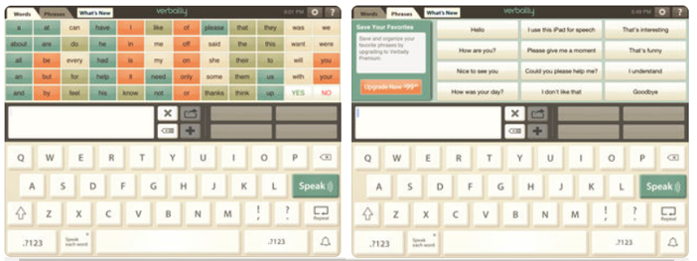
Fig 8: Verbally screenshot

There are plenty more communication applications available on the market, for Android, iOS and Windows portable devices. These are just the 4 that have been offered by the MNDA. None of the Android offerings is strictly designed with adults in mind, with NMD most of the diagnosed are adults over the age of 40 (10). An adult user would need a more focused application, they would need structured phrases and sentences. The app will need to be a simple, intuitive design.

“I have a smartphone and haven’t looked back. I intend to get a tablet later, to ensure it is the most up to date.” (86) A person living with MND

4.8 Research Ethics

Research ethics are a set of rules that govern how other people and ourselves should act and behave. There are some ethical principles that should be followed:
- Minimising the risk of harm
No harm should come to anyone involved in the research of this investigation. Harm could include mental and physical harm. The risk factor must also be analysed for the investigation. Risk must be minimised by obtaining consent from anyone involved, protecting their confidentiality and avoiding deception (96).
- Obtaining informed consent
Any participants in this investigation must understand what they are taking part in and what is required of them. The participant must know what the purpose of the research is, the methods which will be used, the outcome of the research and any other demands or inconveniences they may face (97).
- Protecting anonymity and confidentiality
A participant of any research investigation will be willing volunteer information of a private nature if the person or persons organising the investigation agrees to hold such information in the strictest confidence. Once any form of data has been collected it must be treated as confidential. Data can only be shared with the full consent of the volunteer and then must still be treated as confidential (98).
- Avoiding deceptive practice
This again is an important factor but something a practice that is used, with permission. Sometimes people act differently if they know they are being studied or watched, covert deception is used to hide the fact it may not be feasible to let people know what the researcher is doing, or it may alter the research in some way. However, the research should avoid any kind of knowingly deceptive practices towards the participants (99).
- Providing the right to withdraw
Whoever helps with a research investigation has the right to withdraw from the process. This right can be used at any time and for any reason, they must not be coerced or forced in any way to try and stop them from withdrawing (100).

Data Protection Act

There are several considerations to think about when designing and coding an application. The 1998 Data Protection Act (DPA) states that all data and information being used or kept must be (101):
- Used fairly
- Used lawfully
- Used in an accurate way
- Not kept for longer than is needed
- Kept safe and secure
- Not transferred outside the European Economic Area without adequate protection

The DPA has been designed to protect any individuals' privacy.
This author will design the application in a way that will hold no user’s personal data or information, there will be no login in or registration pages. This way the only data that will be held will be single words or small sentences which the user can input for use while communicating.
Even though this app will not hold the user’s personal details, a unique identifier can also be classed as an IMEI number, this unique identifier and can be classed as personal data. The app will have to deal with this in the correct manner (102).

4.9 Critical Review

During this investigation, this author has learned that MND is an uncommon neurodegenerative and progressive life-ending disease. The condition causes degeneration of the motor system. The disease causes the nerves or motor neurones to slowly stop sending signals to the muscles from the brain and spinal cord, the results are weakening and wasting of the muscles which may leave a person trapped in their bodies and unable to communicate with their friends, family or caregivers.
The nervous system is made up of 2 groups of nerves. One group controls the sensory nerves and the other group are the motor neurones. Motor neurones control muscles movement including walking, speaking and breathing. Lower motor neurones control voluntary movement. These are muscles including, eyes, face, tongue, arms and legs. The upper motor neurones will produce a movement like walking or chewing. Motor neurone disease occurs when specialist nerve cells in the brain and spinal cord called motor neurones stop working properly. This is known as neurodegeneration.
There are many types of MND, with ALS being the most common form in the UK and PLS being the rarer of the 4. Each form will have their own symptoms and symptoms vary depending on the diagnosis given.
The biggest issues to affect people who live with MND is their need to communicate clearly. As the condition progresses, MND will affect some people in a way that will stop, slow and gradually break down their communication skills and they will find communicating increasing difficult.
Dysarthria is a common speech problem that occurs with people who live with MND. Dysarthria will lead to slurred, slow nasally speech. This is a result of having difficulties moving their tongue or facial muscles. Dysarthria can lead to other issues like social difficulties. People with Dysarthria find it hard to communicate to friends and family and this can lead to depression or social isolation.
Medicine is making slow progress to find a cure but through modern technology, people who live with MND can still live a more comfortable life through easier communication. There are many different techniques available to help people communicate, the different techniques all depend on the severity of their MND. There are now many health professionals available to help with MND and the communication needs associated with it. The teams can recommend plans to help a user communicate easier and more clearly. An AAC device, tool or method can be implemented for this reason.
There seems to be an increased amount of applications that can help with communications needs. Some offer the ability to form a sentence with pre-determined words and images or with the user forming their own with a keyboard and some offer the ability to a record a voice, to record a message or sentence. These could be Windows-based so can be used with a PC or laptop or Android or iOS portable for phone and tablet.
This author will design and build an android application with the ability to offer text-to-speak and use a voicebank to record their voices as messages for communication purposes. This app will have the ability to replay a message that has previously been recorded. The person who lives with MND can then listen to this and hear their own voice, which they may not have heard for many weeks, months or even years. The reason Android has been chosen is that there are no free recommended applications on an Android device listed on the MNDA website.
The application will relieve some care needs and allow the person to convey their needs more clearly and leave the person to have a more independent life and feel less alone and isolated.

Research and Development Methodology

Research Methodology

Introduction

Research is an important study to improve or develop new methods and technologies to help with everyday life. This could be to prevent, treat, diagnose or help with a specific problem. This could be a disease, disorder or an everyday problem. Research is important since it contributes to know knowledge and will help develop the answers to the given problem.

The Research Onion

Developed by Saunders et al (Research Methods for Business Students Paperback – 2 Apr 2009), the research onion is a layered methodology where the problem lies in the centre and the several layers are peeled away by working their way to the centre. Each layer represents a detailed research layer which forms the basis of the research methodology. Collis and Hussey recognised methodology as the “overall approach to the entire process of the research study” (103).
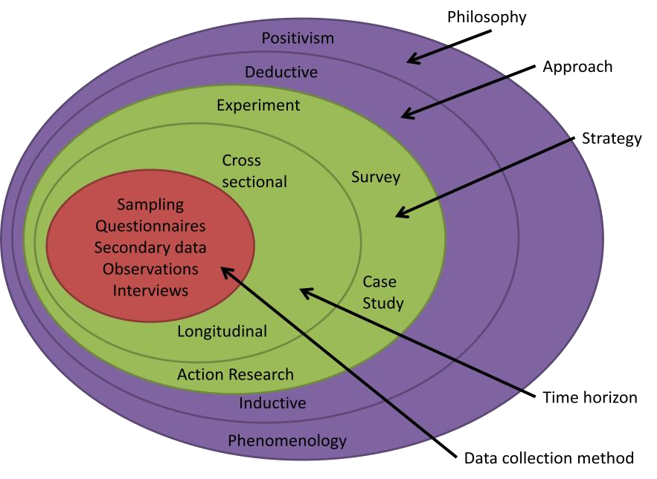
Fig 9: The Research Onion (104)

Philosophy

Positivism relies on scientific or mathematical evidence such as experiments and statistics. Positivism divides all statements into three categories: true, false, and meaningless (neither true nor false) (105). Positivists are almost always strong realists, they believe that what we experience as reality, is out there in the world. In other words, they believe in objective truth. Positivism generates hypotheses (or research questions) that can be tested and allows explanations that are measured against the accepted knowledge of the world we live in (106).
A theoretic viewpoint closely related to objectivism is positivism which argues that realism exists external to the investigator and must be investigated through the hard process of technical investigation. In contrast, constructivism discards this view of human knowledge. Positivism upholds that social methodical knowledge must continuously be subject to proof through experiential research (107).
Auguste Comte the founder of positivism, viewed humans as a phenomenon who should be studied scientifically (108).
The reasons this author has chosen a positivism method are:
- The research will be objective and detached

This research will be objective so will not be influenced by personal feelings or personal opinions and will also be detached from any other feelings, opinions and other research (109).

- Structured

Positivism follows a well-defined structure throughout studies and research. This structure also gives little room for adjustment and severe variable changes, thus making the study or research more accurate (110).

- Well defined approach to the study

The research will be clear in the approach being used.

- Minimum room for errors

They way positivism is supposed to be followed, it is very rigid and inflexible. This way there are fewer errors being made.

Table 1: Potential problems and solutions using the Positivism philosophy (111) (112)

PROBLEM | SOLUTION
Human Behaviour. | Human behaviour and emotional responses can change while being observed. For this reason, no observations will take place. Even though it goes against the principles of Positivism, Karl Popper argues that people perform differently when being observed.
Inflexible. | Since positivists believe everything can be measured and calculated, they tend to be inflexible. To counter this the progress of the research will be regularly checked and then amended if necessary to stay on track.

Approach

The deductive approach or “top-down approach or logic”. The deductive approach will develop a hypothesis built on a previously existing theory, then plan an approach to test the hypothesis (113). Deductive approach is concerned with deducting assumptions from premises or plan.
Deductive enquiry approach explores a known option or phenomenon and examines if that possibility is valid in the given surroundings. It has been noted by Snieder and Larner that “The deductive approach follows the path of logic most closely. The logical thinking starts with a theory and principal to a new hypothesis. This hypothesis is put to the test by confronting it with observations that either leads to a substantiation or a rejection of the hypothesis” (114).
THEORY - HYPOTHESIS – OBSERVATION/TEST – CONFIRMATION/REJECT
The reasons this author has chosen a deductive approach are:
- An abundance of sources

There will be many different sources of information which will be readily available for the research.

- Short time to complete the study

The timescale is an immense issue with regards to completion of this research study.

- More efficient use of a time

Due to the small timescale, time will be used more effectively.

- No observations required

No observations are required for use with a deductive approach.

- The reasoning is based on the fact

Being linked with Positivism, deductive reasoning will gain true (valid) or false (invalid) answers.

Strategy

A case study is an extensive look at a single experience. A case study implies a single analysis of an event or a technology and will offer in-depth explorations and understanding of a complicated issue in a real-life setting (115).
“A detailed account of a company, industry, person, or project over a given amount of time” (116).
Yin defines the case study research method “as an empirical inquiry that investigates a contemporary phenomenon within its real-life context; when the boundaries between phenomenon and context are not clear; and in which multiple sources of evidence are used.” (117)
The reasons this author has chosen a case study are:
- A large amount of data is available

The research data is readily available online and is available in mass quantities.

- A better understanding of real-world situations

By using case studies, it will help solves problems, help decision making and understand how others have used them when faced with challenging research.

- High validity & Rich data

The validity of a case study is enhanced by using a structured approach. The data will be logically sound and of a high quality.

- Less costly

High-quality data for this research is freely available online and in libraries.

Table 2: Potential problems and solutions using a Case Study strategy

PROBLEM | SOLUTION
The researcher can exercise little control over the case study. | The researcher will need to be clear about what is being investigated and must not get side-tracked. The project will be closely monitored by myself and the project coordinator to keep it on track.
Large amounts of data could be confusing.

Time Horizon

The 4th layer of the onion is the time horizon layer. This indicates the time scale of the project completion. According to Saunders et al. (118) time-horizons continue to be needed for the research design, independent of the research methodology used. There are two kinds of time horizons, longitudinal and cross-sectional. Longitudinal are recurring studies over an extended period. Cross-sectional studies are the opposite, they are confined to a specific time frame.
The data within this research will be gathered over a short period of time, this could be days, weeks or months (119). Due to the timescale of this project, the author will use cross-sectional study.

Data Collection

The final stage of the research onion is where the data collection methodology is defined. Primary or secondary data will be selected as the main collection method. Primary data is non-numerical data and cannot be measured is known as qualitative data. Secondary data will consist of both quantitative and qualitative data. Saunders et al. (118) state that interviews will help the researcher to gather valid and reliable data that will be relevant to their research.
Secondary data will be used for this project, the reason behind this is that the data is already out there and will be freely available. Secondary data has been collected by another individual and will be used to formulate and generate ideas. The data will be rich and unique so that it can be analysed and re-analysed if needed (120). Bryman and Bell (121) state that using secondary data helps the research by structuring ideas, developing new concepts and approaches to the data research.

Evaluation and Success Criteria

The evaluation and success criteria will be measured against the previous work completed in the project proposal (122).
That proposal stated that:
- A literature review to research Motor Neurones Disease was needed
- To investigate Motor Neurones Disease and the available Android applications to help communication issues that arise from the disease
- To deliver a working Text-to-Speech prototype with the above research, which will offer the ability for the user to record their voice.
Not stated in the project proposal but equally important:
- Development methodology
- Select a suitable IDE for development
- Select a suitable programming language for development
- Usability and interface

Development Methodology

Introduction

There are many different software development methodologies or frameworks available to be used to develop and test software. These have been designed to meet the objectives needed and be within time and cost expectations. As with methodologies, there are also many different programming languages and platform, each will have their own benefits and drawbacks and will cater to different needs.

Methodologies
Evolutionary Prototyping methodology has been adopted since it aims to develop a system through several prototype iterations, each prototype will have refinements added (123). Evolutionary or Rapid prototyping is an agile SDLC method comparable to the spiral model, the most important features are developed first, followed by the lower priority requirements. Evolutionary prototyping involves both incremental development and evolutionary system development. Evolutionary prototyping is a method that will allow movement in the software development process so that it can adapt to varying structural backgrounds (124).
The idea of the Prototype model is that a prototype system is built, which will understand the requirements and what is needed. The prototype is then developed on the information and data that is currently available. Since a prototype is built, it can be given to the user or client to test, the development team can then add or remove any features as and when they are needed (125). This way the user or client can better understand the requirements and what is needed in their system. The prototype system is typically not finished and numerous features are not built in the prototype. The goal is to deliver a system with general functionality (126). It is then repeatedly revised till the prototype is confirmed, then this will be developed for the product. Prototyping is an iterative process (127), meaning each iteration should need to be accepted by the end user before progressing to the next stage.

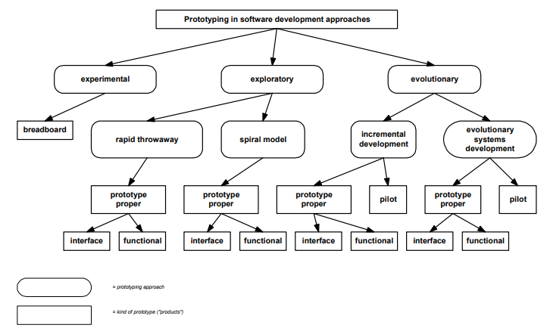

Fig 10: Prototyping Approaches in Software development (124)

Evolutionary Prototyping Stages are as follows (124):
- Requirement identification
The developers must have a basic understanding of the user requirements. More precise details like performance, security and databases can be ignored for this Stage.
- Develop the initial prototype
Once understood, a working model can be developed. These features will undoubtedly change as the development progresses.
- Review the prototype
The completed prototype is then given to the user/client or any other important stakeholder to gain any vital feedback.
- Revise and enhance if needed
Any feedback that has now been received will be analysed and discussed with the user/client and developers. Any changes will depend on time and budget constraints. If major changes are made, the whole cycle will be repeated.
It must be made clear to the user/client that the prototype or prototypes is not a finished product, until it is signed off and delivered as finished.
Any feedback that has now been received will be analysed and discussed with the user/client and developers. Any changes will depend on time and budget constraints. If major changes are made, the whole cycle will be repeated.
“A software prototype is an executable model of a proposed software system that accurately reflects chosen aspects of the system, such as display formats, the values computed, or response times. Software prototyping is an approach to software development that uses prototypes to help both the developers and their customers visualize the proposed system and predict its properties in an iterative process.” (128)
Table 3: Potential problems and solutions using the Evolutionary prototype methodology

PROBLEM | SOLUTION
Users may think the prototype is the finished product. | It must be made clear that the prototypes are not the finished product.
Risk of inadequate requirements due to too much dependency on the prototype. | The requirements must be checked and changed (if needed) throughout the entire development process.
Due to the iterative and rapid nature, handling the prototype process is a difficult task. | The project will be closely monitored by myself and the project coordinator to keep it on track.

Integrated development environment

Due to this being an Android application, it could be created in many different Integrated development environments (IDE) using development plugins. Many of these are free open source development kits.
- Visual Studio C# using Xamarin (Android)
With Visual Studio IDE and the Xamarin plugin, cross-platform mobile applications can be developed quickly and easily. The code can be written in C#. A completed application can be ported to be used on Apple, Android or Windows devices. (129)
Strengths | Weaknesses
Xamarin Native application building | Limited Support, especially HTML5
Xamarin Cross-Platform application building | The Xamarin plugin it sometimes tricky to get working
Easy user interface
Cost effective to build
Can code in C# for 3 different cross-platform O/S
A very large plugin library

- Android studio
Very much like Visual Studio, Android Studio code editor and IDE will let the user create powerful applications for use with Android devices. Android studio can use both Java or Kotlin as programming languages (130)
Strengths | Weaknesses
Android Native application building | Adverts being displayed in-app
Growing rapidly for app building | Confusing and inconsistent documentation
Owned by Google, which offers cheaper cloud storage and deployment of built apps | Takes too long to compile
Android app is very customisable | Can pick up viruses from Android market

- Java Studio (NetBeans) using Android (SDK) Software development kit
NetBeans is the official IDE for Java, NetBeans offers an editor analyser and converters to quickly and smoothly upgrade applications. The SDK is a plugin to let NetBeans develop Android native applications (131).

Strengths | Weaknesses
Many integrated development modules | Slow to load the IDE
Easy to use GUI | Takes a lot of memory in use
Auto Completes code | Multiple plugins required
Integrated software tools
Can create Android applications

- Java Studio (NetBeans) using Eclipse Integrated Development Environment
The most widely used Java IDE, the Eclipse plugin will produce programs written in Java, C, C++, C#, Ruby, Python, PHP and many others (132).
Strengths | Weaknesses
Cross Platform | Multiple plugins required
Most developers have an Eclipse plugin | Slow to load the IDE
Debugging tools | Takes a lot of memory in use

- Kivy using Python
Kivy is an open source library cross-platform framework of code available for Python developing. Kivy can develop an app for iOS, Mac OS, Android, Linux, Pi and Windows platforms. The same code can be run on all supported platforms (133).
Strengths | Weaknesses
Very large library | No UI designer
Kivy framework is written in Python, works well together | Basic layout
Clear and organised code | Tricky to work with API’s
Python is easy to learn | Poor performance
Cross platform | Messy documentation

- RhoMobile using Ruby
Another open source library framework. This set of development tools is cross-platform and will allow native (apps which are written for a specific platform) mobile applications to be developed using Ruby’s Application Programming Interface (API) (134).
Strengths | Weaknesses
Cross-platform | Poor GUI
Native application building | Not a popular framework, not a lot of support yet
Ruby is easy to learn

Programming Languages

The Application can be written in many different languages using the above IDE’s.
The different program languages include:
- Kotlin
This language has only been around 6 years and is now the official language of Android (135). A combination of object-oriented and functional programming. Based on the Java language, it is focused on interoperability. It uses C# type classes or objects but with a Java language base. Can be used within the Android Studio IDE via a plugin for developing Android native applications (136).
Strengths | Weaknesses
Official Android language | Very different to Java
Lots of support | Slower at compiling
Large libraries | Still limited resources
Powerful language
Based on Java
Open source

- C#
A Microsoft object-oriented programming language. Derived from the C language, C# is used with Visual Studio, .Net framework. By adding the Xamarin plugin, native and cross-platform applications can be written. C# can be used to create Windows client applications, XML Web services, distributed components, client-server applications, database applications and more (137).
Strengths | Weaknesses
Good for many different types of applications | Complex to learn C#
Fast, efficient, scalable, and powerful | C# is less flexible than VB & C++
Can share codebases | Native only to Visual Studio
Easy to use GUI | Visual Studio is a large download
Fully supported by Microsoft

- Java
A general-purpose object/class programming language developed in 1995, many applications, programs and website that will not work without Java installed (138). Java can be used with the NetBeans IDE to create powerful Android cross-platform applications.
Strengths | Weaknesses
Easy to use | Slower than the C languages (C, C#, C++)
Open Source | Memory-consuming
Platform-Independent | Poor GUI
Very secure | Poor compiler compared to C#
Multiple API’s available

- Python
An interpreted, object-oriented, high-level programming language. Python has an easy to learn syntax. This language can be used with many IDE’s and plugins to create native or cross-platform applications. With its non-complier, the debug cycle is very fast. Applications written in Python use less code than other languages like Java or C# (139).
Strengths | Weaknesses
Easy to learn | Weak for mobile applications
Large libraries | Can be slow
Easy integration | Not a good for memory intensive tasks or applications
Cross-platform | Has limitations with database uses
Can develop with less code
Open source

- Visual Basic (VB)
Visual Basic (VB) is an event-driven programming environment from Microsoft, fast and easy to learn. Sometimes used to prototype applications before being written in a more efficient programming language (140). Many plugins are available for this language to aid in programming. Often used with the RAD methodology for fast application development.
Strengths | Weaknesses
Simple structure | Native only to Visual Studio
Good for GUI design | VB programs will not port very well to another O/S
Not just a language but also an IDE | Now showing signs of age against newer languages
Quick to develop with, especially prototyping
Easy to learn
A powerful language

- Ruby
Ruby is an open source, dynamic, flexible, object-oriented programming language. It supports numerous different programming paradigms, including functional, object-oriented, and imperative. Similarly, to Python, this is a simple yet powerful language and can be used to code many kinds of application and programs with the right IDE, especially with the Ruby on Rails framework (141).
Strengths | Weaknesses
Easy to learn | Slow runtime speed
Large libraries | Poor documentation
Open source | Not very flexible
Fast to develop
Simple and powerful language

Usability and the interface
One of the most important features of this type of development is the user interface and the usability of the software. User interface principles will be used when designing the prototype to ensure the user interface will have easy to understand elements and the layout is simple to understand and use (142).
There are numerous types of guidelines when designing any kind of software system. These are called 'heuristics', these are more usability guidelines rather than set rules. The 3 main guidelines are Jakob Nielsen’s 10 Heuristics (143), Ben Schneiderman’s 8 Golden Rules (144) and Don Norman’s 7 Principles (145).
Conclusion

The evolutionary prototyping methodology permits you to design a working prototype at an early stage so that the user can offer regular feedback.
The prototype is built after the developer looks at the requirements, it is then given to the user to be reviewed, then the prototype is revised if needed. This process is repeated until the prototype is complete and the user is happy. This process will only be repeated if the budget and time constraints allow.
There are many different programming languages and IDE’s to choose from, each will offer something different to the others. Some work better at native application building and some work better using cross-platform application building.
There were many strength and weaknesses when choosing an IDE and a programming language. The reason Visual Studio and Visual basic were chosen is that VB offers a very simple and powerful GUI and it has a simple to use syntax. VB is especially good when building quick prototypes for end users to quickly test and examine. Visual Studio as a complete IDE and VB is just a small part of the languages on offer. The same VS build can be reused for a future build using Xamarin if needed.
The user interface must be simple to use and easy to understand, the user will not continue to use the application if it is let down by poor interface design.
The advantages of using prototyping are it will improve the overall user participation in the development process, with the many possible changes the result is quickly implemented. It is a more flexible design and development process and it will reduce cost and time however it must be made clear to the user/client that the prototype or prototypes is not a finished product, until it is signed off and delivered as finished.

Design and Implementation

Introduction
The previous chapter of this project has explained about and gone in detail of development methodologies, what they are and why they should be used.
It has been determined that Evolutionary prototyping will be used for the development process. A preliminary model will be built using the requirements. This system will then be tested, and changes will be made as needed.
There are several stages in the Evolutionary prototype method. These stages are often repeated and are sometimes are looped and altered as and when needed. This process will keep evolving until completion.
- Design
- Build Prototype
- End-user tests
- Feedback
- Refine prototype
- Final Product
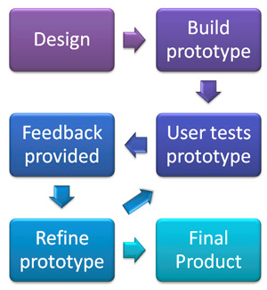
Fig 11: Prototype process (146)

Requirements

The system will need to be able to help someone who cannot communicate to communicate easily and clearly. For this to happen the application must be able to speak what has been entered in.
The requirements are:
- Must be able to communicate
- Must be able to enter words to speak
- Must be able to select from a word or phrase from a bank

Design & Implementation

The problem this application will help solve is an important one. Everybody needs to communicate. This could be talking to loved ones or asking for help, a drink or a meal. The design will be easy to understand and use by all users and ages.
The Evolutionary prototype process will produce a working application and new features will be added or modified as and when needed, to go with the wishes of the user. This process has been altered to be split into separate iterations and each prototype will add something new towards the finished product. This has changed to make sure the design and build of the application are true and correct in every section. Each Stage of the prototype will add on from the last.
The Text-To-Speech software gets the text from the text boxes as the main input and then an algorithm called a Text-To-Speech engine will analyses the text via recognition, it will then pre-process the text and synthesises it into speech via digital signal processing. The Text-To-Speech engine will generate the sound data in an audio format as the output.
The function input/output process will be as follows.
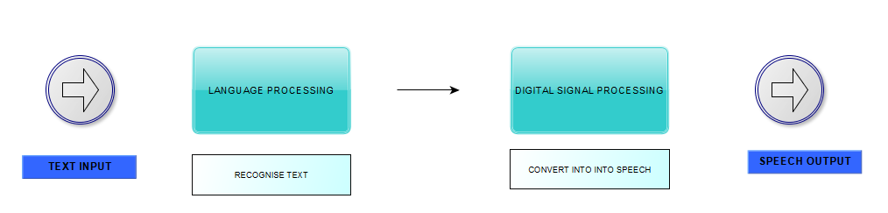
Fig 12: Input/Output process
The text will be entered in the text box and a special plugin for Visual Basic called Vox (Speech Lib) will convert anything into a digital output. This is how the application will perform the text-to-speech translation (147).
The Vox plugin will convert the text into spoken words, it does this by analysing and processing the text into synthesised speech which is a representation of the entered text.
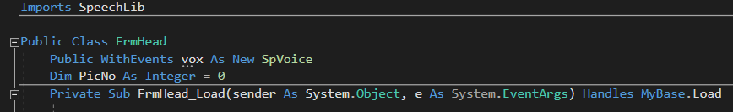
Fig 13: Vox Speech plugin
Stage 1

The first design was a prototype to show a working communication device. This needs to be able to communicate anything that was typed in. This design did not show any of the visuals or correct layout, it was just to try the communication process.
An important factor in this design was to use large buttons within the application, this is so it will be easier for the user to hit the button the first time to communicate (148). The easier it will be to use, the better the user will feel when they use it.
The text and speak boxes must also be large enough to be seen clearly.
This prototype will speak whatever is typed into the box. Once “say” is pressed, it will speak what is entered.
This Stage of the build worked as it should have, with no errors. This was tested with a laptop since no keyboard was on this prototype.

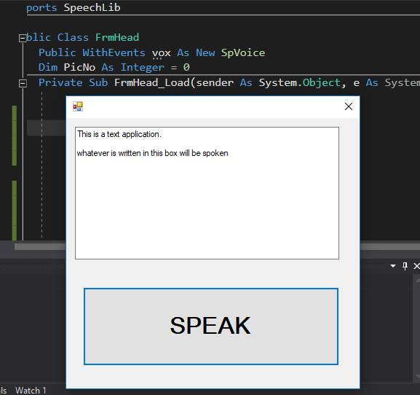
Fig 14: Stage 1 test
Stage 2

The Stage 2 prototype was to add a keyboard. This keyboard needed to have buttons large enough for users to press, even when they may not have full movement in their wrists or hands.
A keyboard is an important feature to add for people with communication issues and many other impairments (149). A user for this app will not have the ability to use a mouse so will solely rely on a keyboard. The keyboard needs to be able to input words into the text boxes.
Then like the previous prototype, this will speak what is typed into the speech box.
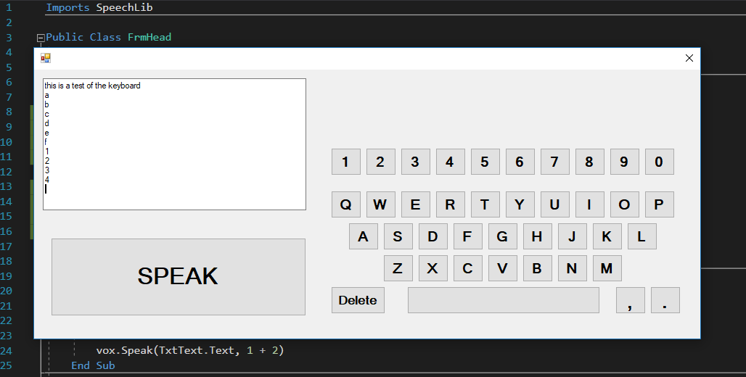
Fig 15: Stage 2 test

The keyboard type chosen was QWERTY over many others including DVORAK layout. The QWERTY keyboard is an internationally known layout. This is the same layout for laptops, PC’s and downloadable keyboard addon’s for Android, Windows or iOS mobile devices.
Dvorak users reported faster, more accurate typing and reduced keyboard clashes (150), but QWERTY is still the standard to use, worldwide.

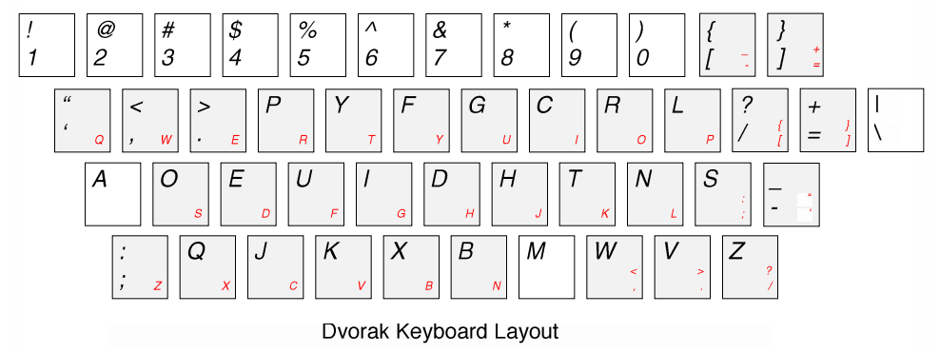
Fig 16: Dvorak Keyboard layout

Stage 3

Stage 3 is where the phrase and word banks are added. This is one of the requirements that was needed at the start of the design process.
The word banks are not kept in a database, they are simple text “dat” files. These “dat” (data) files can be edited and viewed in a text editor like Notepad, these files can usually only be opened by the programs which created them (151).
Dat files have been chosen because unlike a database, these files will not need to be queried. The text file can be edited to add new words or phrases and then added back to the program. The data being used do not need any structure or integrity. The code being implemented will look for words or phrases which contain letters that are being searched. No relationships are needed.
The “StreamReader” or text reader will look in the dat file for any word in this list. There are 2 separate dat files, words and sentences.

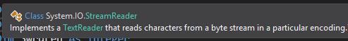
Fig 17: VB Stream Reader
Sentence.dat
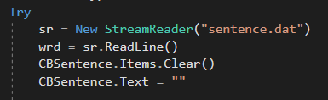
Fig 18: Sentence Dat
Words.dat
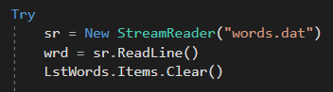
Fig 19: Words Dat

The word entered in the text box will appear in a list box, the user can then select this word and add it to be spoken. The stream reader will scan the entire dat file and display any words containing the letters.

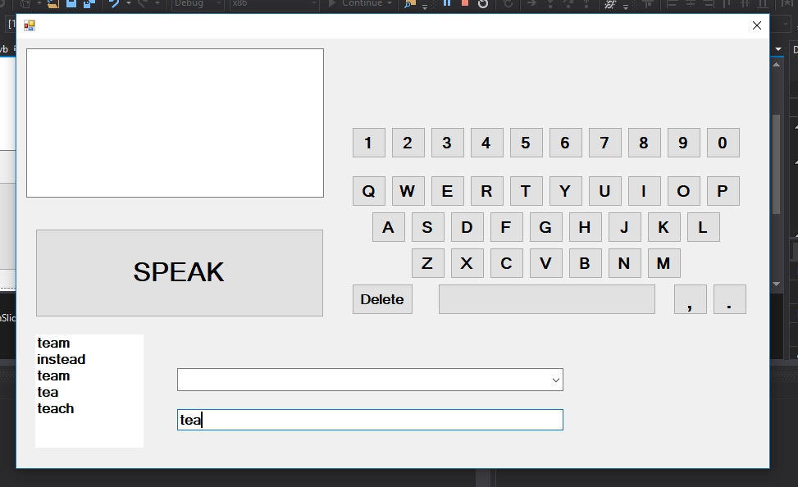
Fig 20: Testing the stream reader

There is a drop-down menu for the users to select phrases. This is just a small selection now, but more will be added, and they will be more relevant to the user.
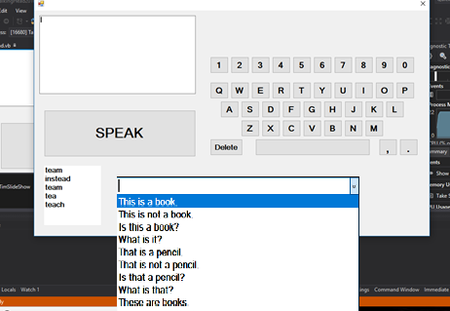
Fig 21: Selecting the phrases
After the main design was briefly tested and every aspect worked as it should have, it also did what the requirements needed it to do, it was time to move on to the implementation aspect of the project.
Again, using Visual Basic in the Visual Studio IDE. Much of the same code will be used. The difference to the implementation will be that this will now produce a final prototype for testing. Most of the main work for this project has already been done in the design process.
The new dat files have been uploaded to the bin-debug folder. The new files have 1133 words and 174 sentences.
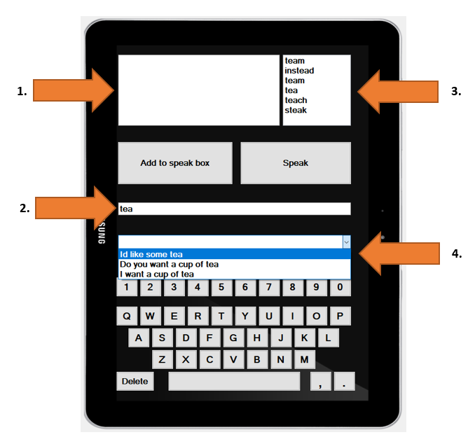
Fig 22: Overall layout

1. This is the speak box. Whatever is in this book will be spoken
2. This is the textbox that will let users input their own typed word, it is also the search box for the pre-defined words and phrases
3. List box showing the pre-defined words
4. Combo box showing the pre-defined sentences

Testing

Unfortunately, no user testing was available. All tests have been performed by myself.

TEST | PROCESS | PURPOSE | EXPECTED RESULTS | RESULTS
1. ADD TO SPEAK BOX | Whatever words are in the text box, this add button will move them to the speak box | TEST | Add the words from the main text box into the speak box | As expected
2. TYPE INTO TEXT BOX | Type words into the text box | TEST | Will allow words to be typed into the text box | As expected
3. SEARCH VIA TEXT BOX (words) | The words in the text box will find words in the ‘words’ list box | Read from the dat file | When words are typed into the text box, it will automatically search in the words box | As expected
4. SEARCH VIA TEXT BOX (sentence) | The words in the text box will find words in the ‘sentence’ combo box | Read from the dat file | When words are typed into the text box, it will automatically search in the sentence box | As expected
5. SPEAK | Press the speak button and it will speak the words listed in the ‘speak box’ | TEST | When pressed it will speak whichever words are in the speak box | As expected
6. Keyboard buttons | Each button should display the given letter in the text box | TEST | Every button types the correct letter or number into the text box | As expected

TEST NUMBER: | 1 | REVIEW AND ACTION:
PROCESS: | Whatever words are in the text box, this add button will move them to the speak box | REVIEW:  The ‘add to speak box’ button moves the words into the speak box  ACTION: None
PURPOSE: | Test
EXPECTED RESULTS: | Add the words from the main text box into the speak box
ACTUAL RESULTS: | Works as expected
TEST EVIDENCE:

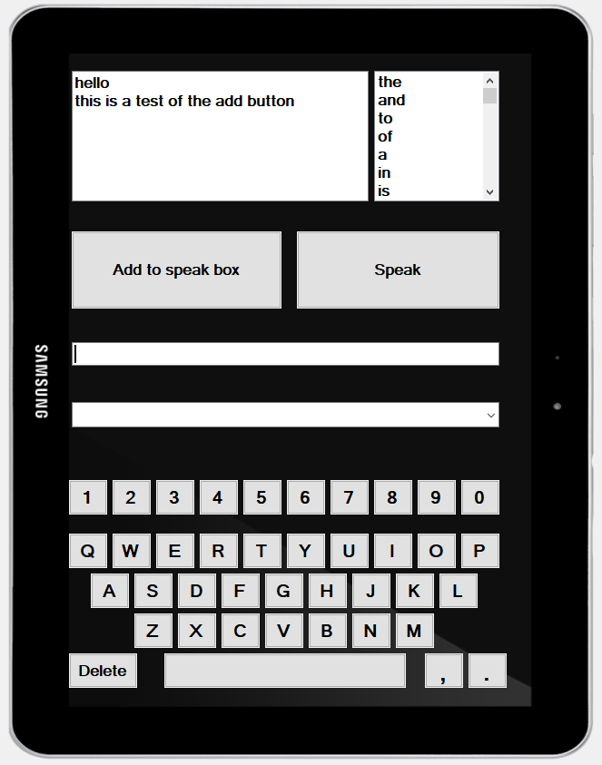
TEST NUMBER: | 2 | REVIEW AND ACTION:
PROCESS: | Type words into the text box | REVIEW:  Shows the words that have been entered into the textbox  ACTION: None
PURPOSE: | Test
EXPECTED RESULTS: | Will allow words to be typed into the text box
ACTUAL RESULTS: | Works as expected
TEST EVIDENCE:

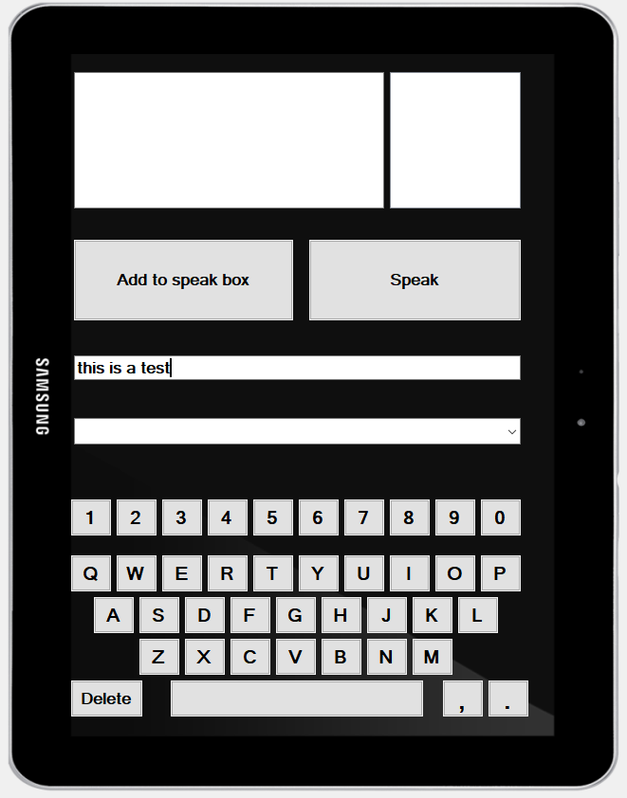

TEST NUMBER: | 3 | REVIEW AND ACTION:
PROCESS: | The words in the text box will find words in the ‘words’ list box | REVIEW:  The words written in the textbox will also search in the words list box (top right)  ACTION: None
PURPOSE: | Read from the dat file
EXPECTED RESULTS: | When words are typed into the text box, it will automatically search in the words box
ACTUAL RESULTS: | Works as expected
TEST EVIDENCE:

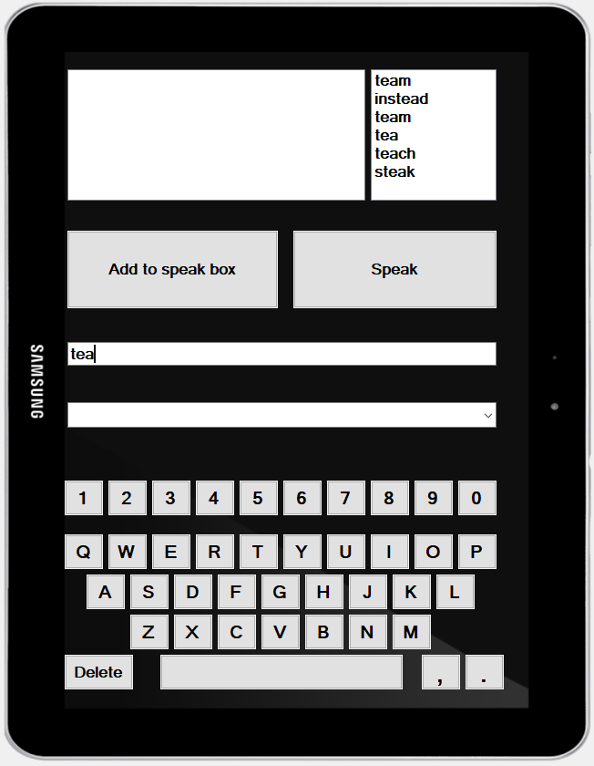
TEST NUMBER: | 4 | REVIEW AND ACTION:
PROCESS: | The words in the text box will find words in the ‘sentence’ combo box | REVIEW:  The words written in the textbox will also search in the sentence combo box (highlighted drop-down menu)  ACTION: None
PURPOSE: | Read from the dat file
EXPECTED RESULTS: | When words are typed into the text box, it will automatically search in the sentence box
ACTUAL RESULTS: | Works as expected
TEST EVIDENCE:
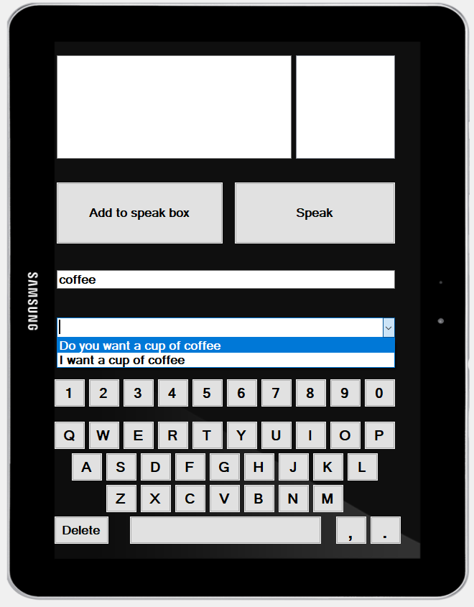
TEST NUMBER: | 5 | REVIEW AND ACTION:
PROCESS: | Press the speak button and it will speak the words listed in the ‘speak box’ | REVIEW:  The speak button will read what is written in the speak box  ACTION: None
PURPOSE: | Test
EXPECTED RESULTS: | When pressed it will speak whichever words are in the speak box
ACTUAL RESULTS: | Works as expected
TEST EVIDENCE:
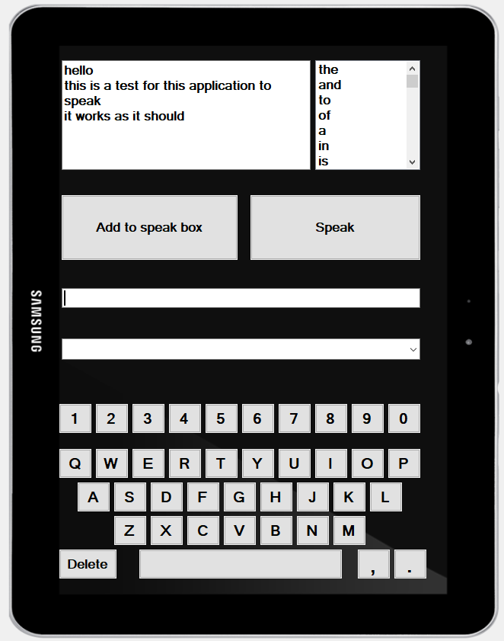
TEST NUMBER: | 6 | REVIEW AND ACTION:
PROCESS: | Each button should display the given letter in the text box | REVIEW:  ACTION: None
PURPOSE: | Test | REVIEW:  ACTION: None
EXPECTED RESULTS: | Every button types the correct letter or number into the text box | REVIEW:  ACTION: None
ACTUAL RESULTS: | Works as expected
TEST EVIDENCE:
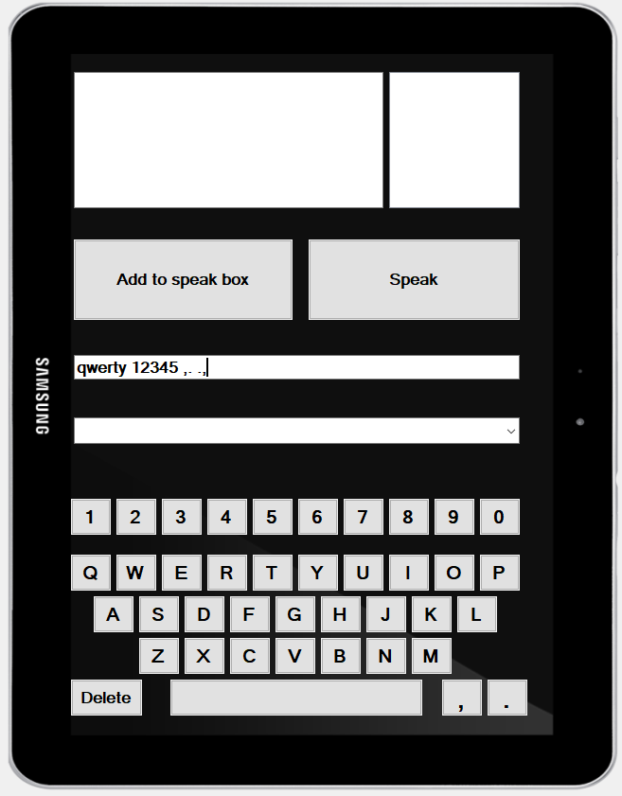

Evaluation

This investigation was proposed to look at the current Android applications with the ability to help people communicate who live with MND. The literature review looked at all the current methods, tools and technologies with regards to Android communication applications. It found that there was a lack of free recommended applications being offered by the MNDA. Some requirements were produced to create a working prototype following certain research methodologies.
This evaluation has used the success criteria previously stated above. This prototype application and research investigation have met most of the criteria that were needed.
- A literature review has successfully been competed to investigate Motor Neurones Disease
- The literature review also investigated Android applications to aid in communication issues that arise form MND
- A working Text-to-Speech prototype has been delivered
- Unfortunately, the application did not have the ability for the user to record their own voice.
- A suitable methodology was chosen
- A suitable IDE was chosen
- A suitable programming language was chosen
- The interface is user-friendly and is easy to use
Looking back at the design and the requirements, this prototype has been successfully implemented and has delivered the needed requirements and has been fully tested for functionally, everything worked as it was designed to do.
The requirements were:
- Must be able to communicate
- Must be able to enter words to speak
- Must be able to select from a word or phrase from a bank
The prototype can communicate text into speech, it does this as a simple and easy to use application. It can select pre-defined words and phrases from 2 separate word banks. It will also allow the user to enter their own words, this will result in any sentence being created then spoken.
There are a few things that can be built upon if this investigation was to be repeated. This investigation was only seen from my point of view, it should have been user tested by people who live day in day out with MND. Even though the investigation was done, my knowledge of what was needed was poorly lacking. Users should have been interviewed and surveyed about their needs and what they wanted in a communication application. With this knowledge and information, a more well-rounded and complete application would have been built.
There are some questions that need an answer to find out if this investigation was worthwhile.
- Does this system work as needed and is easy to use and understand?
Yes, this system does what the investigation set out to achieve. It gives the required results and speaks what is needed. It is clear to understand and easy to use in my opinion.
- Does this system meet the system requirements?
Yes, the prototype that has been build meets the system requirements. The requirements started out needed to do 3 things, to communicate, enter words or phrases to speak and be able to select words from a bank. The system does all 3.
- Does this system meet the success criteria?
The system has met 7 out of the 8 factors needed to meet the success criteria. The literature review of MND, investigation into Android communication applications and a working Text-to-Speech prototype have all meet delivered. The needed methodology, IDE and programming language were selected. It will offer a simple and easy to understand interface. Unfortunately, it does not have the ability to have the user record their own voice for future playback.
- Is this system better than what is currently available?
Being as this system is still only a prototype, that question cannot be answered fully. This prototype does do the same as many of the other communication applications available on the market. That question can only be truly answered if this prototype is ever created in a fully built downloadable application.

Conclusions and Recommendations

This investigation has explored Motor Neurones Disease, the symptoms and how it will affect people who live with the disease, especially their communication skills.
The literature review research what is Motor Neurones Disease, it was discovered to be an uncommon neurodegenerative and progressive condition that will affect the upper and lower part of the nervous system. MND will cause the nerves or motor neurones to stop sending signals to the muscles from the brain and spinal cord, the results are weakening and wasting of the muscles. When this happens, it will sometimes leave people trapped in their bodies, unable to move or communicate.
There are two separate motor neurones, upper and lower. Each of these neurones will control a different kind of body movement. The nervous system in the body is made up of two groups of nerves. One group controls the sense and the other groups are the motor neurones.
There are 4 types of MND, each form has their own unique set of symptoms. The most common form in the UK is Amyotrophic lateral sclerosis (ALS). There is currently no cure for MND this disease, each diagnosis will affect people in different ways.
One of the biggest issues that people who live with MND is the fact they may struggle to talk and communicate with their friends and family. This common problem will affect around 90% of diagnosed people. If a person can communicate easier and clearly, they have less chance of becoming depressed and social isolation. There are many tools, techniques, methods and applications available to help in this situation.
One of the main causes of communication failure in people who live with MND is Dysarthria, a common speech problem that results in slurred, slow nasally sounding speech. Around 80% of people that have MND will suffer from Dysarthria.
There are many forms of communication help and strategies available. The most commonly known for is Augmentative and alternative communication (AAC), this could be something simple like a pen and paper or something more advanced like a communication application or program.
There are many platforms available for such a communication device, Android, iOS and Windows. These can be a portable application designed for mobiles and tablets or PC based Windows programs. The main communication device being a Text-to-Speech application. There are many to choose from, each having a different layout and advantages and disadvantages.
After completion of the literature review, the investigation moved onto the methodologies. These methodologies were researched, analysed and compared to choose the best to suit. Positivism and a deductive approach or “top-down approach or logic” was chosen since these offered a structured, well-defined approach to the study. The deductive approach had an abundance of sources and was used since there was a short time to complete this study. The case study was the strategy to be used since it was a large amount of free data readily available and offered a better understanding of real-world situations regarding MND. Due to having a short period of time for the research to be gained, a cross-sectional study will be selected. Since the data is already freely available, secondary data collection method will be used.
Development methodologies have also been selected to help in this process. After looking at different methods available, evolutionary prototyping was chosen. The reason being that it does not follow any strict rules like other methodologies and there were very few requirements at the start of the process. Once the development methodology was chosen, it was time to select a suitable programming language and IDE for deployment. Many were looked at and each had their own advantages and disadvantages. Ultimately since this was an evolutionary prototyping process and this application would not be deployed, Visual Basic and Visual Studio were selected.
After designing and implementing this project, it was realised that there should have been some interviews or observations. This project was only seen from my point of view, I see now that I cannot understand or see how a person with MND communicates. If there had been interviews and observations, this project would have turned out differently I believe. It would have been easier for the design and implementation process to be completed if I had known exactly what was needed and wanted by the person who lives with MND, not what I have read or guessed.

Recommendations

Suggestions for future work for this project is to build the application in Visual Studio using the Xamarin plugin, using C# as the programming language. Next time I would learn how to use Xamarin fully before trying to complete a project. The research would also be changed to include observations and interviews with people who live with MND. This way, the application will be built to their needs.
If it was to be built again or changed in the future, it would only be a success in my opinion if it was offered as a recommended application on the MNDA webpage.
There were a few features that can be recommended to improve this application.
- Voice banking
One of the criteria that were used to mark this project a success was also to implement an option for the user to record their own voice messages for future playback. Unfortunately, this was not implemented due to time constraints and my own lack of ability to code this feature into the application.
- Record messages
A user can record a message or greeting. This can then be listened to at any time by the user or their loved one.
- Save messages
Once the messages are recorded, they could be easily saved as an audio file.
- Play pre-recorded messages
Another feature would be the ability to listen to these pre-recorded messages. These could be displayed in a message bank, like the banks that have previously been used. They could be saved with memorable file names for easier selection.
These features would make the application a more personal item, the user can record and save messages in the bank ready for when their voice deteriorates. These messages can be used for many years after the voice has gone or the user has passed away. Their family can still hear them speak on a daily occurrence.

Reflection

I am using Gibb’s reflective cycle as a model for this reflection. The main reason for using reflective writing is to gain knowledge to achieve the best outcomes through learning from everyday experiences. Reflective writing enables a person to learn from professional or non-professional experiences regardless of whether it has a positive or negative result. The purpose is to improve the overall outcome and prevent any mistakes happening again or having the ability to manage them more successfully. While some professionals have agreed that reflective writing is helpful and has a positive effect, Kornblith (2012) states that reflection is a waste of time, and entirely unbeneficial to anybody and that a person’s own judgment on a situation is often untrustworthy.

Description

This reflection has been written after finishing my research and investigation into an Android application to help with communication issues that arise from MND. After I started to read about MND I quickly realised what a fatal, uncommon and degenerative disease it is. I have heard about the disease before bet never really knew what it was or the hardship that people who live with MND and their family and friends suffer with.

Feelings

After finding out about the disease it would be heart-breaking for me, if I was to see anyone living through it, this could be friends, family or myself. The research has shown me how much their lives could change for the worse, their communication skills could become non-existent and they could live being trapped in their bodies until the disease takes over and ends their life. When I first started the research, it went well with the programming and I realised I was unprepared and my skills were lacking in using Xamarin/C#.

Evaluation

I felt the research and investigation went very well and I was confident going in to build the prototype until I started having issues with Xamarin. I had to quickly think of another route for designing and building the application. I chose VB and I felt more at ease using this language since I have used it before. There was extensive quality research around which helped with the main investigation into the Android communication application. I also learned more about the layers of the research onion which will hopefully also help when I progress to my master, later this year. The knowledge gained from the methodologies will greatly help in the future.

Analysis

After this investigation had finished, it was clear to me that I should have designed and built an improved prototype. I feel that if I have involved someone who has a direct association with MND that it would have been altogether a better and different application. I feel I would have had a better outcome by using Xamarin as the program would be a native application build. Although I feel the outcome I have currently worked well, there is room for improvement and to be evolved into a fully working application.

Conclusion

In retrospect, there are many aspects of the investigation I would have altered. I should have included someone who has a direct link to MND in some way to have gained an insight into their experiences and knowledge. However, this investigation has made me realise that I would like to finish this application after I finish this degree and hopefully get it recognised by the MNDA.

Action plan

In the future, I would ensure that while researching this topic I gain first-hand knowledge of the disease from someone within the MND community. It would also be beneficial to have a working Xamarin environment to easily program in C#. The Xamarin environment is a powerful tool which I did not get to utilise properly. I would like to aim to have the application built and ready to test very shortly. Once the final prototype is ready, it can be tested by a sample group of non-verbal users not just in the MND community. With an end goal of having the application available on the Play store as a free download to help anyone who is unable to verbally communicate.

References

1. Motor neurone disease [Internet]. nhs.uk. 2017 [cited 20 April 2018]. Available from: https://www.nhs.uk/conditions/motor-neurone-disease/
2. Motor neurone disease | Brain & Spine Foundation [Internet]. Brainandspine.org.uk. 2017 [cited 20 April 2018]. Available from: https://www.brainandspine.org.uk/motor-neurone-disease
3. Pain in MND [Internet]. mndassociation.org. 2018 [cited 20 April 2018]. Available from: https://www.mndassociation.org/forprofessionals/mndmanagement/pain/
4. Brohi H, Ahmed N, Khatri R: Delay in diagnosis of motor neuron disease [Internet]. Ecommons.aku.edu. 2014 [cited 20 April 2018]. Available from: https://ecommons.aku.edu/cgi/viewcontent.cgi?referer=https://www.google.co.uk/&httpsredir=1&article=1054&context=pjns
5. Mackenzie L, Bhuta P, Rusten K: Communications Technology and Motor Neuron Disease [Internet]. ncbi.nlm.nih.gov. 2016 [cited 20 April 2018]. Available from: https://www.ncbi.nlm.nih.gov/pmc/articles/PMC5454550/
6. First symptoms of MND | Topics, Motor Neurone Disease (MND), Nerves & brain, People's Experiences | healthtalk.org [Internet]. Healthtalk.org. 2017 [cited 20 April 2018]. Available from: http://www.healthtalk.org/peoples-experiences/nerves-brain/motor-neurone-disease-mnd/first-symptoms-mnd
7. Alonso A, Logroscino G, Jick S, Hernán M: Incidence and lifetime risk of motor neuron disease in the United Kingdom: a population-based study [Internet]. 2017 [cited 20 April 2018]. Available from: https://www.ncbi.nlm.nih.gov/pmc/articles/PMC3093130/
8. Motor Neurone Disease A problem solving approach for general practitioners and allied health professionals [Internet]. Glasgow: MND Scotland; 2018 [cited 20 April 2018]. Available from: http://citeseerx.ist.psu.edu/viewdoc/download;jsessionid=0946BD3E3FD6DBFD4BB9328332923874?doi=10.1.1.694.8602&rep=rep1&type=pdf
9. Alonso A, Logroscino G, Jick S, Hernán M: Incidence and lifetime risk of motor neuron disease in the United Kingdom: A population-based study [Internet]. University of Minnesota. 2009 [cited 20 April 2018]. Available from: https://experts.umn.edu/en/publications/incidence-and-lifetime-risk-of-motor-neuron-disease-in-the-united
10. Motor Neurone Disease Association Key messages and core information September 2017 [Internet]. 2017 [cited 20 April 2018]. Available from: https://www.mndassociation.org/wp-content/uploads/MND-Association-Key-Messages-2017.pdf
11. Society A. Frontotemporal dementia - Alzheimer's Society [Internet]. Alzheimer's Society. 2017 [cited 20 April 2018Available from: https://www.alzheimers.org.uk/info/20007/types_of_dementia/11/frontotemporal_dementia
12. Kumar D, Florence A, Hale S. Jean-Martin Charcot: The Father of Neurology [Internet]. National Centre for Biotechnology Information. 2011 [cited 20 April 2018]. Available from: https://www.ncbi.nlm.nih.gov/pmc/articles/PMC3064755/
13. Prize4Life - ALS [Internet]. Prize4life.org. 2014 [cited 20 April 2018]. Available from: http://www.prize4life.org/page/als
14. Wong P. Motor Neuron Disease - an overview | ScienceDirect Topics [Internet]. Sciencedirect.com. [cited 20 April 2018]. Available from: https://www.sciencedirect.com/topics/medicine-and-dentistry/motor-neuron-disease
15. Neurons - National Library of Medicine - PubMed Health [Internet]. PubMed Health. [cited 20 April 2018]. Available from: https://www.ncbi.nlm.nih.gov/pubmedhealth/PMHT0024269/
16. Types of neurons [Internet]. Queensland Brain Institute. [cited 20 April 2018]. Available from: https://qbi.uq.edu.au/brain/brain-anatomy/types-neurons
17. Living with motor neurone disease [Internet]. Mndassociation.org. 2016 [cited 20 April 2018]. Available from: https://www.mndassociation.org/wp-content/uploads/2015/07/living-with-mnd.pdf
18. Clinical Neuroanatomy Guide [Internet]. Vanat.cvm.umn.edu. [cited 20 April 2018]. Available from: http://vanat.cvm.umn.edu/mLocLesGui/clinAnat.html#LMN
19. Knierim J. Disorders of the Motor System (Section 3, Chapter 6) Neuroscience Online: An Electronic Textbook for the Neurosciences | Department of Neurobiology and Anatomy - The University of Texas Medical School at Houston [Internet]. Nba.uth.tmc.edu. [cited 20 April 2018]. Available from: http://nba.uth.tmc.edu/neuroscience/s3/chapter06.html
20. McCarthy P. Upper Motor Neuronal Tracts [Internet]. Csuchico.edu. 2014 [cited 20 April 2018]. Available from: https://www.csuchico.edu/~pmccaffrey/syllabi/CMSD%20320/362unit10.html
21. Eating, swallowing and breathing with MND | Topics, Motor Neurone Disease (MND), Nerves & brain, People's Experiences | healthtalk.org [Internet]. Healthtalk.org. [cited 20 April 2018]. Available from: http://www.healthtalk.org/peoples-experiences/nerves-brain/motor-neurone-disease-mnd/eating-swallowing-and-breathing-mnd
22. Kiernan P, Vucic PhD S, TurnerPhD M. Amyotrophic lateral sclerosis [Internet]. 2011 [cited 20 April 2018]. Available from: https://ac.els-cdn.com/S0140673610611567/1-s2.0-S0140673610611567-main.pdf?_tid=7738f48a-c7f2-11e7-a051-00000aacb35f&acdnat=1510523165_29cef68ee2c1a413215ca4d1a1caaeae
23. Surgery M. Upper versus lower motor neurone signs [Internet]. Ole.bris.ac.uk. 2017 [cited 20 April 2018]. Available from: https://www.ole.bris.ac.uk/bbcswebdav/institution/Faculty%20of%20Health%20Sciences/MB%20ChB%20Medicine/Year%203%20Medicine%20and%20Surgery%20-%20Hippocrates/Neurology%20-%20Presenting%20complaints/page_29.htm
24. Motor Neuron Diseases Fact Sheet | National Institute of Neurological Disorders and Stroke [Internet]. Ninds.nih.gov. 2017 [cited 20 April 2018]. Available from: https://www.ninds.nih.gov/Disorders/Patient-Caregiver-Education/Fact-Sheets/Motor-Neuron-Diseases-Fact-Sheet
25. What is ALS? [Internet]. ALSA.org. 2017 [cited 20 April 2018Available from: http://www.alsa.org/news/public-awareness/als-awareness-month/2016/what-is-als.html
26. Reference G. amyotrophic lateral sclerosis [Internet]. Genetics Home Reference. 2017 [cited 20 April 2018]. Available from: https://ghr.nlm.nih.gov/condition/amyotrophic-lateral-sclerosis#definition
27. Progressive bulbar palsy | Genetic and Rare Diseases Information Centre (GARD) – an NCATS Program [Internet]. Rarediseases.info.nih.gov. 2017 [cited 20 April 2018]. Available from: https://rarediseases.info.nih.gov/diseases/10928/progressive-bulbar-palsy
28. Bulbar and Pseudobulbar Palsy. What is Bulbar Palsy? Info [Internet]. Patient.info. 2017 [cited 20 April 2018]. Available from: https://patient.info/doctor/bulbar-and-pseudobulbar-palsy
29. Progressive muscular atrophy (PMA) [Internet]. 2017 [cited 20 April 2018]. Available from: https://www.mndassociation.org/wp-content/uploads/02D-Progressive-muscular-atrophy.pdf
30. An introduction to motor neurone disease (MND) [Internet]. 2017 [cited 20 April 2018]. Available from: https://www.mndassociation.org/wp-content/uploads/2015/02/an-introduction-to-mnd-booklet.pdf
31. Primary lateral sclerosis (PLS) [Internet]. Mndassociation.org. 2017 [cited 20 April 2018]. Available from: https://www.mndassociation.org/wp-content/uploads/02c-primary-lateral-sclerosis.pdf
32. Symptoms of the disease [Internet]. MND. 2017 [cited 20 April 2018]. Available from: http://mnd.rcnlearning.org.uk/what-is-motor-neurone-disease/symptoms-of-the-disease/
33. Diagnosis and management of motor neurone disease [Internet]. 2017 [cited 20 April 2018]. Available from: https://www.ncbi.nlm.nih.gov/pmc/articles/PMC2270983/
34. Riluzole [Internet]. Mndassociation.org. 2017 [cited 20 April 2018]. Available from: https://www.mndassociation.org/wp-content/uploads/2015/07/05a-riluzole.pdf
35. What is motor neurone disease? [Internet]. MND. [cited 20 April 2018]. Available from: http://mnd.rcnlearning.org.uk/what-is-motor-neurone-disease/
36. Speech and communication | MND Association [Internet]. MND Association. 2017 [cited 20 April 2018]. Available from: https://www.mndassociation.org/about-mnd/living-with-mnd/speech-and-communication/
37. Speech and communication support [Internet]. 2017 [cited 20 April 2018]. Available from: https://www.mndassociation.org/wp-content/uploads/07c-speech-and-communication-support.pdf
38. Bebbington M. Communication and Swallowing Issues in Patients with Motor Neurone Disease: The Role of Speech and Language Therapy [Internet]. Www1.essex.ac.uk. [cited 20 April 2018]. Available from: https://www1.essex.ac.uk/journals/estro/documents/issue9/vol-9-no-8.pdf
39. The use of International Classification of Functioning, Disability and Health in motor neurone disease rehabilitation [Internet]. Citeseerx.ist.psu.edu. 2011 [cited 20 April 2018]. Available from: http://citeseerx.ist.psu.edu/viewdoc/download;jsessionid=16BD43A04DA5DE2E530BF2D173AB2B6A?doi=10.1.1.1013.6637&rep=rep1&type=pdf
40. Communicating with a person with MND [Internet]. mndassociation.org. [cited 20 April 2018]. Available from: https://www.mndassociation.org/forprofessionals/careworkers/communicating-with-a-person-with-mnd/#
41. AAC Pathway for MND [Internet]. mndassociation.org. [cited 20 April 2018]. Available from: https://www.mndassociation.org/forprofessionals/aac-for-mnd/aacpathway/
42. West Midlands AAC care pathway: Birmingham Community Healthcare [Internet]. Bhamcommunity.nhs.uk. [cited 20 April 2018]. Available from: http://www.bhamcommunity.nhs.uk/patients-public/rehabilitation/act/west-mids-aac-care-pathway/
43. Dysarthria (difficulty speaking) [Internet]. nhs.uk. 2016 [cited 20 April 2018]. Available from: https://www.nhs.uk/conditions/dysarthria/
44. Dysarthria - Symptoms and causes [Internet]. Mayo Clinic. [cited 20 April 2018]. Available from: https://www.mayoclinic.org/diseases-conditions/dysarthria/symptoms-causes/syc-20371994
45. Dysarthria - Symptoms and causes [Internet]. Mayo Clinic. [cited 20 April 2018]. Available from: https://www.mayoclinic.org/diseases-conditions/dysarthria/symptoms-causes/syc-20371994
46. Dysarthria - National Aphasia Association [Internet]. National Aphasia Association. [cited 20 April 2018]. Available from: https://www.aphasia.org/aphasia-resources/dysarthria/
47. Tomik B, Guiloff R. Dysarthria in amyotrophic lateral sclerosis: A review [Internet]. Pdfs.semanticscholar.org. 2010 [cited 20 April 2018]. Available from: https://pdfs.semanticscholar.org/2f0c/5e6cb224737e63bda027c773eaa22a445ba5.pdf
48. Mixed Dysarthria [Internet]. Unm.edu. [cited 20 April 2018]. Available from: http://www.unm.edu/~atneel/shs531/duffy10.pdf
49. Motor Neurone Disease - Better Living Through Technology [Internet]. Better Living Through Technology. 2016 [cited 20 April 2018]. Available from: https://bltt.org/motor-neurone-disease/
50. Mouse Tremors [Internet]. Better Living Through Technology. [cited 20 April 2018]. Available from: https://bltt.org/accessibility/winxp/mouse_tremors.htm
51. Life with MND [Internet]. The University of Edinburgh. 2017 [cited 20 April 2018]. Available from: https://www.ed.ac.uk/alumni/services/news/news/life-with-mnd
52. Mackenzie L, Bhuta P, Rusten K, Devine J, Love A, Waterson P. Communications Technology and Motor Neuron Disease: An Australian Survey of People with Motor Neuron Disease. 2017.
53. What is AAC? | Communication Matters [Internet]. Communicationmatters.org.uk. [cited 20 April 2018]. Available from: https://www.communicationmatters.org.uk/page/what-is-aac
54. 10 things you should know when considering an iPad as a communication tool for your autistic child - Better Living Through Technology [Internet]. Better Living Through Technology. 2015 [cited 20 April 2018]. Available from: https://bltt.org/10-things-ipad-communication-autistic-child/
55. What is AAC [Internet]. Communicationmatters.org.uk. 2015 [cited 20 April 2018]. Available from:https://www.communicationmatters.org.uk/sites/default/files/downloads/focuson/What%20is%20AAC.pdf
56. Augmentative and Alternative Communication [Internet]. Asha.org. [cited 20 April 2018]. Available from: https://www.asha.org/NJC/AAC/
57. Augmentative/Alternative Communication (AAC) [Internet]. Alsphiladelphia.org. 2017 [cited 20 April 2018]. Available from: http://www.alsphiladelphia.org/document.doc?id=832
58. Helal A, Mokhtari M, Abdulrazak B. The Engineering Handbook of Smart Technology for Aging, Disability and Independence. Hoboken: John Wiley & Sons; 2008.
59. Communication Aids [Internet]. Mndscotland.org.uk. 2018 [cited 20 April 2018]. Available from: http://www.mndscotland.org.uk/how-we-can-help/communications-aids/
60. The Benefits of Alternative and Augmentative Communication: A Quality of Life Issue [Internet]. Nsuworks.nova.edu. 2017 [cited 20 April 2018]. Available from: http://nsuworks.nova.edu/cgi/viewcontent.cgi?article=1586&context=ijahsp
61. What is social media? [Internet]. UCL. [cited 20 April 2018]. Available from: https://www.ucl.ac.uk/cam/what-is-social-media
62. Motor Neurone Disease Association Forum [Internet]. Forum.mndassociation.org. [cited 20 April 2018]. Available from: http://forum.mndassociation.org/forum.php
63. Social Media: A Powerful Tool for AAC Learning and Networking [Internet]. 2017 [cited 20 April 2018]. Available from: https://leader.pubs.asha.org/article.aspx?articleid=2600872
64. Using Social Media [Internet]. Mndassociation.org. [cited 20 April 2018]. Available from: https://www.mndassociation.org/wp-content/uploads/using-social-media.pdf
65. Osterrieder A. The value and use of social media as communication tool in the plant sciences [Internet]. 2013 [cited 20 April 2018]. Available from: https://www.ncbi.nlm.nih.gov/pmc/articles/PMC3716900/
66. About Stephen [Internet]. Stephen Hawking. [cited 20 April 2018]. Available from: http://www.hawking.org.uk/about-stephen.html
67. Stephen Hawking Biography | [Internet]. Biography Online. [cited 20 April 2018]. Available from: https://www.biographyonline.net/scientists/stephen-hawking.html
68. Intelligence is the ability to adapt to change | [Internet]. Htcs.org.uk. [cited 20 April 2018]. Available from: http://www.htcs.org.uk/wp-content/uploads/2012/01/Hawking-House-Page-1.pdf
69. Making communication possible for people with MND | Ability Net [Internet]. Abilitynet.org.uk. 2017 [cited 20 April 2018]. Available from: https://www.abilitynet.org.uk/blog/making-communication-possible-people-mnd
70. Assistive Context-Aware Toolkit (ACAT) [Internet]. 01.org. [cited 20 April 2018]. Available from: https://01.org/acat
71. Stephen Hawking's improved speech software is now free to download - Better Living Through Technology [Internet]. Better Living Through Technology. 2015 [cited 20 April 2018]. Available from: https://bltt.org/stephen-hawkings-improved-speech-software-is-now-free-to-download/
72. Stephen Hawking - the tech helping him talk and write revealed [Internet]. SwiftKey Blog. 2014 [cited 20 April 2018]. Available from: https://blog.swiftkey.com/swiftkey-reveals-role-professor-stephen-hawkings-communication-system/
73. The Computer [Internet]. Stephen Hawking. 2017 [cited 20 April 2018]. Available from: http://www.hawking.org.uk/the-computer.html
74. Pedroso. Assistive Context-Aware Toolkit (English) [Internet]. Slideshare.net. 2016 [cited 20 April 2018]. Available from: https://www.slideshare.net/felipe_pedroso/assistive-contextaware-toolkit-english
75. ASSISTIVE CONTEXT-AWARE TOOLKIT (ACAT) [Internet]. 01.org. [cited 20 April 2018]. Available from: https://01.org/sites/default/files/documentation/acat_user_guide.pdf
76. Evans S. Download ACAT ⋆ Free Software Downloads [Internet]. Senteacher.org. 2015 [cited 20 April 2018]. Available from: http://www.senteacher.org/download/97/Stephen-Hawking-AAC-SGD.html
77. McHugh M, McHugh M, Goode L, Staff W, Camp J, Camp J et al. You Can Now Use Stephen Hawking's Speech Software for Free [Internet]. WIRED. 2015 [cited 20 April 2018]. Available from: https://www.wired.com/2015/08/stephen-hawking-software-open-source/
78. Types of AAC [Internet]. 2015 [cited 20 April 2018]. Available from: http://www.discoveraac.org/discover-aac/types-of-aac/
79. Dressler R, Bland L, Baumgartner M. [Internet]. Nsuworks.nova.edu. 2016 [cited 20 April 2018]. Available from: https://nsuworks.nova.edu/cgi/viewcontent.cgi?referer=https://www.google.co.uk/&httpsredir=1&article=1586&context=ijahsp
80. Speech and communication with MND | Topics, Motor Neurone Disease (MND), Nerves & brain, People's Experiences | healthtalk.org [Internet]. Healthtalk.org. [cited 20 April 2018]. Available from: http://www.healthtalk.org/peoples-experiences/nerves-brain/motor-neurone-disease-mnd/speech-and-communication-mnd
81. 1. Flemming H, Hendricks D. Autism Q & A: Introduction to Alternative and Augmentative Communication [Internet]. Vcuautismcenter.org. [cited 20 April 2018]. Available from: https://vcuautismcenter.org/resources/factsheets/printView.cfm/1076
82. AAC Options for MND [Internet]. 2018 [cited 20 April 2018]. Available from: https://www.mndassociation.org/forprofessionals/aac-for-mnd/what-are-the-common-aac-options/#
83. AAC Devices | USSAAC [Internet]. Ussaac.org. [cited 20 April 2018]. Available from: http://www.ussaac.org/aac-devices
84. Types of communication aids [Internet]. Mndscotland.org.uk. 2018 [cited 20 April 2018]. Available from: http://www.mndscotland.org.uk/how-we-can-help/communications-aids/types-of-communication-aids/
85. Evidence-Based Principles for Selecting Eye Gaze AAC Technology [Internet]. Ctdinstitute.org. [cited 20 April 2018]. Available from: https://www.ctdinstitute.org/sites/default/files/file_attachments/EvidenceBasedPrinciplesSelectingeyeGazeTech_Hill_KatyaUPittsburgh_dateYear.pdf
86. Free or Low-cost apps [Internet]. [cited 20 April 2018]. Available from: https://www.mndassociation.org/about-mnd/information-resources/free-or-low-cost-apps/#
87. Text-to-Speech [Internet]. Callscotland.org.uk. [cited 20 April 2018]. Available from: http://www.callscotland.org.uk/information/text-to-speech/
88. RavPower [Internet]. Amazon.co.uk. 2018 [cited 20 April 2018]. Available from: https://www.amazon.co.uk/RAVPower-26800mAh-Portable-Charger-Battery-Black/dp/B012V9H3WA/ref=sr_1_1_sspa?ie=UTF8&qid=1522009833&sr=8-1-spons&keywords=portable+battery+charger&psc=1
89. Making communication possible for people with MND | AbilityNet [Internet]. Abilitynet.org.uk. 2013 [cited 20 April 2018]. Available from: https://www.abilitynet.org.uk/blog/making-communication-possible-people-mnd
90. Voice banking [Internet]. Mndassociation.org. [cited 20 April 2018]. Available from: https://www.mndassociation.org/wp-content/uploads/07D-Voice-banking.pdf
91. Voice Banking [Internet]. mndassociation.org. 2018 [cited 21 April 2018]. Available from: https://www.mndassociation.org/forprofessionals/aac-for-mnd/voice-banking/
92. Build-A-Bear Workshop - Voice Express [Internet]. Voice Express. [cited 21 April 2018]. Available from: http://www.voice-express.com/case-study/build-a-bear/
93. Voice banking for people with MND [Internet]. Mndassociation.org. [cited 21 April 2018]. Available from: https://www.mndassociation.org/wp-content/uploads/voice-banking-information-sheet-for-professionals.pdf
94. Free or low-cost apps | MND Association [Internet]. MND Association. 2017 [cited 20 April 2018]. Available from: https://www.mndassociation.org/about-mnd/information-resources/free-or-low-cost-apps/
95. Making the most of life with motor neurone disease [Internet]. Mndassociation.org. [cited 21 April 2018]. Available from: https://www.mndassociation.org/wp-content/uploads/Making-the-most-of-life-with-MND.pdf
96. Assessing and minimising risk — University of Leicester [Internet]. Www2.le.ac.uk. [cited 21 April 2018]. Available from: https://www2.le.ac.uk/institution/ethics/guidance/planning/minimising-risk
97. Consent [Internet]. Ethicsguidebook.ac.uk. [cited 21 April 2018]. Available from: http://www.ethicsguidebook.ac.uk/Consent-72
98. Anonymity and Confidentiality [Internet]. Eprints.ncrm.ac.uk. [cited 21 April 2018]. Available from: http://eprints.ncrm.ac.uk/423/1/0206_anonymity%2520and%2520confidentiality.pdf
99. Research Ethics: Deception [Internet]. Psc.dss.ucdavis.edu. [cited 21 April 2018]. Available from: http://psc.dss.ucdavis.edu/sommerb/sommerdemo/ethics/deception.htm
100. Do participants have a right to withdraw consent? - Economic and Social Research Council [Internet]. Esrc.ac.uk. [cited 21 April 2018]. Available from: http://www.esrc.ac.uk/funding/guidance-for-applicants/research-ethics/frequently-raised-questions/do-participants-have-a-right-to-withdraw-consent/
101. Data Protection Act 1998 [Internet]. Legislation.gov.uk. 2017 [cited 21 April 2018]. Available from: http://www.legislation.gov.uk/ukpga/1998/29/contents
102. Privacy in mobile apps Guidance for app developers [Internet]. Ico.org.uk. 2017 [cited 21 April 2018]. Available from: https://ico.org.uk/media/for-organisations/documents/1596/privacy-in-mobile-apps-dp-guidance.pdf
103. Business Research [Internet]. Google Books. [cited 21 April 2018]. Available from: https://books.google.co.uk/books/about/Business_Research.html?id=awLOPAAACAAJ
104. Adams J. Introduction to Research Methods. Presentation presented at; 2018; NPTC Group, Neath.
105. Positivism [Internet]. Philosophy Terms. 2017 [cited 21 April 2018]. Available from: http://philosophyterms.com/positivism/
106. Outside of the Onion [Internet]. Onion.derby.ac.uk. 2017 [cited 21 April 2018]. Available from: https://onion.derby.ac.uk/onion.pdf
107. Gray D. DOING RESEARCH in the REAL WORLD [Internet]. Pdfs.semanticscholar.org. [cited 21 April 2018]. Available from: https://pdfs.semanticscholar.org/39c0/db7f578c3765d1b7bf60cd470b57c3b1e5d2.pdf
108. Bourdeau M. Auguste Comte [Internet]. Plato.stanford.edu. 2014 [cited 21 April 2018]. Available from: https://plato.stanford.edu/entries/comte/

109. Fiss O. The Varieties of Positivism [Internet]. Pdfs.semanticscholar.org. 1981 [cited 21 April 2018]. Available from: https://pdfs.semanticscholar.org/3be9/e8c25e20666858505955526fa05b381e013e.pdf
110. Aliyu A, Bello M, Kazim R, Martin D. [Internet]. 2014 [cited 21 April 2018]. Available from: http://www.bing.com/cr?IG=3DC7DF49C35A4511905760419B0A99CC&CID=2134D30729006A322A58D8DF28AF6BCD&rd=1&h=ow01Ui7WbM84nRrpCbKMxu2ko_SkwNI8hpPSI_I6qQ4&v=1&r=http%3a%2f%2fwww.ccsenet.org%2fjournal%2findex.php%2fjms%2farticle%2fdownload%2f39893%2f22135&p=DevEx.LB.1,5131.1
111. Johnson S. Advantages & Disadvantages of Positivism | Synonym [Internet]. Classroom.synonym.com. [cited 21 April 2018]. Available from: https://classroom.synonym.com/advantages-disadvantages-positivism-12088541.html
112. Popper K. Realism and the aim of science. [Place of publication not identified]: Routledge; 2015.
113. Soiferman L. Compare and Contrast Inductive and Deductive Research Approaches [Internet]. Files.eric.ed.gov. 2017 [cited 21 April 2018]. Available from: https://files.eric.ed.gov/fulltext/ED542066.pdf
114. Snieder R, Larner K. The art of being a scientist. Cambridge: Cambridge Univ Pr; 2009.
115. Crowe S, Cresswell K, Robertson A, Huby G, Avery A, Sheikh A. The case study approach [Internet]. 2017 [cited 21 April 2018] Available from: https://www.ncbi.nlm.nih.gov/pmc/articles/PMC3141799/
116. Writing reports [Internet]. Learn.solent.ac.uk. [cited 21 April 2018]. Available from: https://learn.solent.ac.uk/mod/book/tool/print/index.php?id=232731&chapterid=36551
117. Yin R. Case study research. Los Angeles, Calif. [u.a.]: Sage Publ.; 1984.
118. Saunders M, Lewis P, Thornhill A. Research methods for business students. 5th ed. Pearson Education; 2009.
119. Cross-sectional Studies [Internet]. Health Knowledge. 2017 [cited 21 April 2018]. Available from: https://www.healthknowledge.org.uk/public-health-textbook/research-methods/1a-epidemiology/cs-as-is/cross-sectional-studies
120. UK Data Service » Secondary data analysis [Internet]. Ukdataservice.ac.uk. 2017 [cited 21 April 2018]. Available from: https://www.ukdataservice.ac.uk/use-data/secondary-analysis
121. Bryman A, Bell E. Business Research methods. Oxford: Oxford University Press; 2015.
122. Llewellyn S. Project Proposal: An Investigation into the use of Android Applications to aid Communication for Motor Neurone Disease Patients. [Degree]. NPTC Group, Neath; 2017.
123. Evolutionary Prototyping [Internet]. Sqa.org.uk. 2018 [cited 21 April 2018]. Available from: https://www.sqa.org.uk/e-learning/IMAuthoring01CD/page_10.htm
124. Prototyping and Software Development Approaches [Internet]. Pdfs.semanticscholar.org. [cited 21 April 2018]. Available from: https://pdfs.semanticscholar.org/0b05/add730e04843e234937a070f24b19efaadc3.pdf

125. Prototyping [Internet]. Umsl.edu. [cited 21 April 2018]. Available from: http://www.umsl.edu/~sauterv/analysis/prototyping/proto.html
126. Prototyping in Systems Analysis [Internet]. Umsl.edu. [cited 21 April 2018]. Available from: http://www.umsl.edu/~sauterv/analysis/488_f01_papers/Hammer/term_paper_body.htm
127. Benefits of Prototyping [Internet]. Sqa.org.uk. [cited 21 April 2018]. Available from: https://www.sqa.org.uk/e-learning/IMAuthoring01CD/page_06.htm
128. Ralston A, Hemmendinger A. Encyclopaedia of computer science. Hoboken, New Jersey. 2003. Cited April 2018
129. Part 1 – Understanding the Xamarin Mobile Platform - Xamarin [Internet]. Docs.microsoft.com. 2018 [cited 21 April 2018]. Available from: https://docs.microsoft.com/en-us/xamarin/cross-platform/app-fundamentals/building-cross-platform-applications/understanding-the-xamarin-mobile-platform
130. Get the Android Studio Preview | Android Studio [Internet]. Developer.android.com. 2018 [cited 21 April 2018]. Available from: https://developer.android.com/studio/preview/index.html
131. NetBeans IDE - Overview [Internet]. Netbeans.org. 2018 [cited 21 April 2018]. Available from: https://netbeans.org/features/
132. Guindon C. Eclipse desktop & web IDEs | The Eclipse Foundation [Internet]. Eclipse.org. 2018 [cited 21 April 2018]. Available from: https://www.eclipse.org/ide/
133. Kivy: Cross-platform Python Framework for NUI [Internet]. Kivy.org. 2018 [cited 21 April 2018]. Available from: https://kivy.org/#home
134. Rhomobile Documentation [Internet]. 2018 [cited 21 April 2018]. Available from: http://docs.rhomobile.com/en/5.4/home
135. Statically typed programming language for modern multiplatform applications [Internet]. Kotlin. 2017 [cited 21 April 2018]. Available from: https://kotlinlang.org/
136. Native Kotlin [Internet]. Kotlin. 2018 [cited 21 April 2018]. Available from: https://kotlinlang.org/docs/reference/native-overview.html
137. Introduction to the C# Language and the .NET Framework [Internet]. Docs.microsoft.com. 2018 [cited 21 April 2018]. Available from: https://docs.microsoft.com/en-us/dotnet/csharp/getting-started/introduction-to-the-csharp-language-and-the-net-framework
138. What is Java and why do I need it? [Internet]. Java.com. 2018 [cited 21 April 2018]. Available from: https://www.java.com/en/download/faq/whatis_java.xml
139. Comparing Python to Other Languages [Internet]. Python.org. 2018 [cited 21 April 2018]. Available from: https://www.python.org/doc/essays/comparisons/
140. Computer Prototyping [Internet]. Groups.csail.mit.edu. 2018 [cited 21 April 2018]. Available from: http://groups.csail.mit.edu/graphics/classes/6.893/F03/lectures/L8.pdf

141. Ruby Programming Language [Internet]. Ruby-lang.org. 2018 [cited 21 April 2018]. Available from: https://www.ruby-lang.org/en/
142. User Interface Design Basics | Usability.gov [Internet]. Usability.gov. 2018 [cited 21 April 2018]. Available from: https://www.usability.gov/what-and-why/user-interface-design.html
143. 10 Heuristics for User Interface Design: Article by Jakob Nielsen [Internet]. Nielsen Norman Group. 1995 [cited 21 April 2018]. Available from: https://www.nngroup.com/articles/ten-usability- heuristics/
144. Ben Schneiderman [Internet]. Cs.umd.edu. [cited 21 April 2018]. Available from: https://www.cs.umd.edu/users/ben/goldenrules.html
145. Norman’s 7 principles [Internet]. Nptel.ac.in. [cited 21 April 2018]. Available from: http://nptel.ac.in/courses/106103115/16
146. Teach-ICT A2 Level ICT OCR exam board - The System Life Cycle, prototyping, rapid application development, RAD [Internet]. Teach-ict.com. [cited 21 April 2018]. Available from: http://www.teachict.com/as_a2_ict_new/ocr/A2_G063/331_systems_cycle/prototyping_RAD/miniweb/pg3.htm
147. Free Speech... Recognition (Linux, Windows and Mac) - voxforge.org [Internet]. Voxforge.org. [cited 21 April 2018]. Available from: http://www.voxforge.org/
148. 7 rules for mobile UI button design – UX Planet [Internet]. UX Planet. [cited 21 April 2018]. Available from: https://uxplanet.org/7-rules-for-mobile-ui-button-design-e9cf2ea54556
149. The Importance of Keyboard Skills for Computer Access for Users with Visual Impairments - American Foundation for the Blind [Internet]. Afb.org. 2018 [cited 21 April 2018]. Available from: http://www.afb.org/info/living-with-vision-loss/using-technology/using-a-computer/part-i-access-for-the-novice-computer-user-with-a-visual-impairment/the-importance-of-keyboard-skills/12345
150. Why do we all use Qwerty keyboards? [Internet]. BBC News. [cited 21 April 2018]. Available from: http://www.bbc.co.uk/news/technology-10925456
151. File D. DAT File Extension - What is a .dat file and how do I open it? [Internet]. Fileinfo.com. [cited 21 April 2018]. Available from: https://fileinfo.com/extension/dat

