

Data Analysis and Visualizations

ACCB4002

Assignment 2

BSc Cloud Computing
London Campus
Koushik Modak
By Roxana Bostiog
Student ID:1914974
Level 4 Term 1
3th of September 2021

Contents
Introduction 2
More details on the t-Test 2
What is a hypothesis and how is it developed? 2
Appropriate set of testable hypotheses 2
Testing the hypothesis at a significance level of 0.01 2
Testing the hypothesis at a significance level of 0.02 2
Testing the hypothesis at a significance level of 0.1 2
Graphical analysis of the data. 2
Other factors that may not have been considered. 2
Conclusion 2
References Error! Bookmark not defined.

Introduction
The student’s t-test is one of the types of inferential statistics that is used to establish whether the differences is significant the means of 2 sets of data. This inferential statistic does an operation to compare the means of the 2 groups to test hypothesis such as determining whether the difference between the 2 is significant. In this paper we shall analyse infection rates among the white and BAME communities.

More details on the t-Test
Student’s t-test is one of the types of inferential statistics that is used to establish whether 2 sets of data is very different than mean. This inferential statistic does an operation to compare the means of the 2 groups to test hypothesis such as determining whether the difference between the 2 is significant. This is a tool used to test a hypothesis. The hypothesis tested is either 2 sets of data is very different than means of the 2 groups of data or that there is a significant difference between them. The assumption that there isn’t a significant difference between them is usually referred to as null hypothesis while the assumption that there is a significant difference between them is referred to as the alternative hypothesis [1].
To perform this operation, the t-statistic, the degrees of freedom and the t-distribution with an aim of determining the statistical significance. Where there isn’t a significant difference between the 2 groups of data, it can be inferred that they come from the same population. The operation involves taking a sample from the 2 sets of data, establishing the problem statement which assumes the 2 means are equal i.e., the null hypothesis. The t-test then uses applicable formulas to calculate certain values and compares them against the standard values to make the decision whether to accept the null hypothesis or reject it [2].
In the present case, the prevalence of Covid-19 between white people and members of the BAME community in the UK is to be analysed for any statistical differences. The T-test will be used to perform this test to determine whenever is a significant difference to the mean infection rate of white people and members of the BAME community in the UK. It has been identified through the BBC news, that there is a difference in the infection rate between the 2 communities. A t-test will be used to affirm or disapprove this assumption.
It is performing a t-test, several assumptions are made. First, it is assumed that the scale of measurement that has been used has followed an ordinal or continuous scale. Secondly the samples used are just random and that the data has been collected from a randomly selected portion of the population and is therefore representative of the total population. The third assumption is that the data assumes a normal distribution when plotted i.e., a bell-shaped distribution curve. The final assumption is with regards the homogeneity of variance. It is assumed that the 2 groups of data have equal variances and therefore the standard deviations of the 2 samples are also equal.
The t-distribution table can either be one-tail or two-tail. The one-tailed test is used to test cases which have a range or fixed value with a clear direction which can either be in the positive direction or negative. For instance, one can test whether the mean of a population based on the sample data is greater than say 6. The 2 tailed test determines whether the parameter falls between 2 points. For instance, on can test whether the mean of a given population based on the sample data falls between 5 and 10. [2]

What is a hypothesis and how is it developed?
In general terms, a hypothesis is a proposition, claim or explanation that has been made based on limited evidence and acts as a starting point for further investigation. In research, a hypothesis refers to a statement or expectation that will be proved or disapproved by research or statistical tests. Hypothesis testing in research refers to an operation whereby the statistician tests the veracity of an assumption regarding a parameter of the population based on sample data. The type of operation chosen by the analyst usually depends on the nature of the data and the purpose of the analysis [4]. As mentioned earlier, testing of a hypothesis is meant to assess the plausibility of the hypothesis by analyzing the sample data by providing evidence that can be used to prove or disapprove the hypothesis. To test a hypothesis, a random sample must be generated from the population [5]. From this random sample, 2 types of hypothesis are usually tested. These are the null hypothesis and the alternative hypothesis. The null hypothesis is a hypothesis of equality between the parameters of the population being tested. For instance, a null hypothesis might state that the population mean of 2 samples of data is equal i.e., the difference between the mean of 2 population is zero hence the name “null” hypothesis [6]. The alternative hypothesis on the other hand suggests that there is a difference between the parameters being tested and therefore the difference between these 2 parameters is not 0. The difference in the parameters can either be 0 or not 0 and hence the 2 hypotheses are mutually exclusive: only one of them can be true and one of them must be true [7].
Several steps are usually followed in the hypothesis testing process. The first step involves stating what the 2 hypotheses are based on the population parameters being tested [8]. The second step is the formulation of the analysis plan which is an outline of the evaluation of the data. The third step involves execution of the plan whereby the sample data is analyzed based on the plan. The fourth step involves obtaining the results of the analysis and analyzing them. Based on the analysis of the results, the null hypothesis is either rejected or declared plausible based on the data available [9].

Appropriate set of testable hypotheses
Null hypothesis: there is no significant difference between the mean of the Covid-19 infection rate among the white community and the BAME community in the UK.
Alternative hypothesis: there is a significant difference between the mean infection rate of the Covid-19 pandemic among the white community and the BAME community in the UK.

Testing the hypothesis at a significance level of 0.01
The table below represents the results of the t-test performed in Excel at a significance level of 0.01
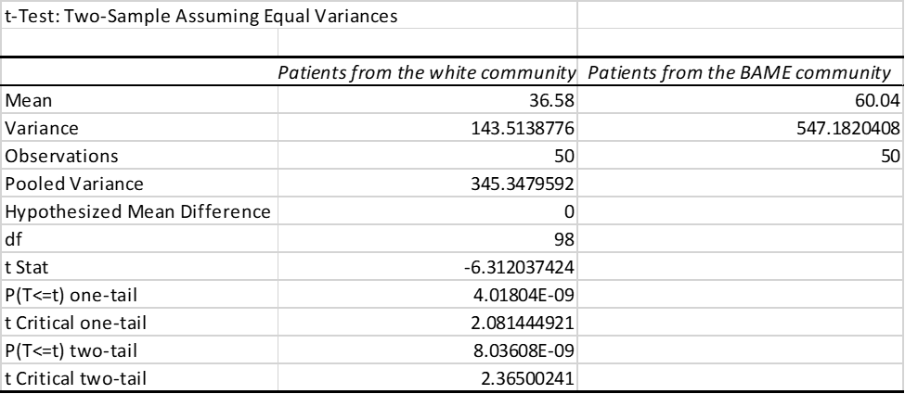
Analysis of the results
The mean infection rate of the sample has been calculated as 36.58 with a standard deviation of 11.98 for the white patient and 60.04 with a standard deviation of 23.39 for BAME. The pooled variance of the 2 data sets is 345.35. The t statistic calculated is -6.3 while the t critical is 2.63. The p value of the 2 tail test is significantly lower than 0.01 as shown in the above table.
Decision: Reject the null hypothesis since the P value is significantly lower than the significance level.
Inference: At 99% confidence level, there is a significant difference between the infection rate of Covid-19 in the white community and BAME. The mean infection rate in the BAME community is significantly higher than the white community.
Testing the hypothesis at a significance level of 0.02.
The table below represents the results of the t test at a significance level of 0.02
The t-statistic calculated is -6.3 compared to a t critical of 2.37. The p value of this finding is significantly less than the significance level of 0.02
Decision: On the above basis, reject the null hypothesis
Conclusion: At a confidence level of 98%, there exists a significant difference between the infection rate of Covid-19 in the white community and BAME. The mean infection rate in the BAME community is significantly higher than the white community.

Testing the hypothesis at a significance level of 0.1
The table below represents the results of the t test at a significance level of 0.1

The t-statistic calculated is -6.31 compared to a t critical of 1.66. The p value of this finding is significantly less than the significance level of 0.1
Decision: On the above basis, reject the null hypothesis
Conclusion: At a confidence level of 90%, there exists a significant difference between the infection rate of Covid-19 in the white community and BAME. The mean infection rate in the BAME community is significantly higher than the white community.

Graphical analysis of the data.
The graph below is a histogram representing the infection rate in the white community
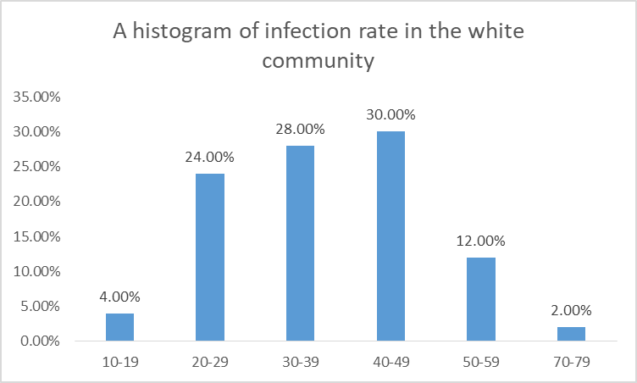
The histogram above shows that most of the white patients fall at an infection rate of between 30 and 49. 2% fall in the 70-79 bin and no patients fall above this bin.
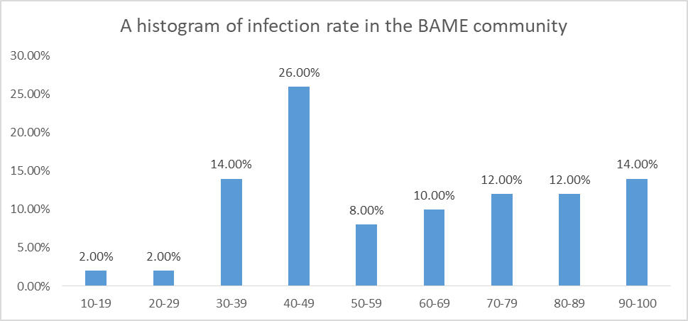
The histogram above shows that the infection rate in the BAME community is spread out from 20 to 100. However 40-49 bin is the largest at 26%. Compared to the white community, infection rate in the BAME community is spread out in more bins. Moreover, a significant proportion falls in 80-89 and 90-100 bins unlike the white community which does not have bins beyond 79.

Other factors that may not have been considered.
The income level of the participants needs to be taken into consideration as these determines their social class. The economic power of the individuals determines their capability to adopt preventive measures and thus directly determines the infection rate. It also determines the type of neighborhoods such people are likely to live in. low income neighborhoods are likely to be densely populated with people living very close to each other and thus a patient from such an environment is likely to have a higher infection rate.
Another factor that could affect the outcome is the type of occupation of the respondents. Empirical data shows that some occupations are more susceptible to contracting Covid-19. These occupations mostly consist of frontline health workers who get into direct contact with Covid-19 patients. If respondents from the BAME community mostly come from such occupations then the outcome is likely to be skewed.
To control these factors, the sample data needs to be truly random and simple from the same population. This is meant to ensure that patients, whether white or BAME come from across the income spectrum so as to ensure such factors do not influence the outcome.

Conclusion
According to the sample data provided, it would be safe to infer that indeed the assertion posited by the BBC news is true; there are variations in the infection rate of white patients and those in the BAME community. According to the t test performed herein, there is a significant difference in the infection between the 2 groups. Further, according to the evidence the mean infection rate of patients in the BAME community is higher than that of the white community. Moreover, there is a higher variance in infection rate among the BAME community than the white community. This indicates that there is a higher dispersion from the mean within the BAME community than the white community.

References

[2] | S. Vergura, Descriptive and inferential statistics for supervising and monitoring the operation of PV plants, London: IEEE, 2008, p. 56.
[3] | V. Amrhein, "Inferential statistics as descriptive statistics: There is no replication crisis if we don't expect replication," The American Statistician, vol. 1, no. 1, p. 106, 2019.
[4] | P. Sahu, Estimation and inferential statistics, Chicago: Springer, 2015, p. 55.
[6] | N. Chukhrova, "Fuzzy hypothesis testing: Systematic review and bibliography," Applied Soft Computing, vol. 1, no. 2, p. 45, 2021.
[7] | F. Emmert-Streib, "Understanding Statistical Hypothesis Testing: The Logic of Statistical Inference," Machine learning and knowledge extraction, vol. 1, no. 3, p. 54, 2019.
[8] | O. Sheffet, "Locally private hypothesis testing," International conference on Machine Learning, vol. 4, no. 1, p. 64, 2018.
[9] | L. Pfister, Debates—Hypothesis testing in hydrology: Theory and practice, London: Wiley Online LIbrary, 2017.
[10] | T. Kim, "T test as aparametric statistic," Korean journal of anesthesiology, p. 654, 2015.
[11] | R. Lowry, Concepts and applications of inferential statistics, Chicago: Wiley and sons, 2014.

