BMSW4002
Effective Team Working and Communication
Lecturer: Timothy Hopkins
Student name: Alexandra Maria Dinu
Student ID: 2020980

Table of Contents
Introduction 3
Models of communication 4
Shannon and Weaver linear model 4
Schramm Model 5
Berlo’s S-M-C-R model 6
Similarities and Comparison of Theories 7
Communication Skills & Method 8
Verbal Communication method 8
Non - Verbal Communication 9
Listening 9
Active Listening / Empathetic Listening 9
Communication between Management and Employees 10
Case Study 11
Conclusion 11
Reference 12

Section 1

Introduction
Communication models describe the relationship between the communication process and components to make effective communication (McQuail and Windahi, 2015). This report aspires to exhibit the concept of communication very first and then reveal different communication theories on which the communication method has developed. Finally, it aims to show the similarities and differences in communication models and their effectiveness. Though the word communication seems to be a more straightforward process because of its one sender and one receiver, the method or methodology is complex (West et al.,2012). Communication needs at least one sender and one receiver, and this transmission process is affected by many things such as place, environment, culture, skills etc. Communication is a means where sender and receiver convey information, message or ideas using some elements. The word communication derives from a Latin word that means ‘to share’. Communication can define as the social intercourses of words, letters, messages, or ideas that must be understandable to the receiver (Ruscher, 2017). Bad communication proves dangerous in many cases, as the case study above has demonstrated. Communication barriers include barriers in sending messages and receiving messages or information, and these barriers can be substantial or maybe technical, emotional, or cultural (Raman and Sharma, 2015).

Section 2

Models of communication
Communication models illustrate the communication and communication frameworks within which human contact occurs (Miller, 2015). There are three communication models established till now. That is (1) Shannon and Weaver linear model, (2) Schramm model (3) Berol’s S-M-C-R model. These three models are broadly discussed below-

Shannon and Weaver linear model
Shannon & Weaver’s communication model is considered as the mother of all models in communication as it covers almost every concept under communication such as information source, transmitter point, noise, communication channel, and coding. In this model, communication is one-way and linear where the sender sends a message and the receiver only receives the message through a channel that first encodes the sender’s message and then decodes it before sending it to the recipient. The specific features of Shannon and Weaver’s communication model are that the outer noise can interrupt and change the message, and the feedback is not well-weighted (Al-Fedaghi, 2012).
This primary communication model is also known as a one-way communication model because the sender sends the message, but there is no feedback from the receiver (Phutela, 2015). This model is appraised by many for being hampered by noise, and it has no feedback issue. This communication model explains that a sender may send messages through television, then the receiver will receive the news, but there is no way to express immediate reaction or feedback. In a simple language, there is no way that sender can examine the input of the receiver and sometimes, this communication is hampered by noise (Physical or technical) (Kubota, 2019).
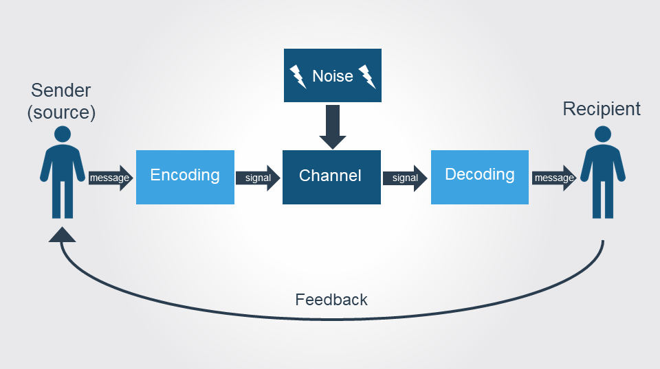
Figure 1: Shannon & Weaver's Communication Model (Al-Fedaghi, 2012).
This model is a clear illustration of Maria and Pedro’s case study. In the case study, it has been shown Pedro, due to noise in the construction site, failed to respond to maria’s message. As a result, there appeared some miscommunication between them. This communication model can be applied to my personal life too.
Our superior often calls a meeting in the morning and in our office, we have different countries people, and some are not well acquainted with English. However, when the superior assigned us any particular mission, he just finished those so quickly that most of us failed to listen sometimes and adequately; he promptly finished speaking and left the room. We actually cannot respond appropriately and was unable to complete the assigned job. It is a clear example of miscommunication. If our superior reacts to our feedback, we may be able to avoid miscommunication.

Schramm Model
Schramm's communication model was innovated in 1948 which is mainly focused on the communication process of the encoder and decoder. It is a two-way communication process where people interpret the message using their experience and knowledge. The communication is reciprocal and circular in this model where one sends an encoded message and the other decodes it by interpreting, these are the major features of Schramn’s model and differences from Shannon & Weaver’s one (Schramm, 2014).
Schramm has accentuated two essential communication elements that are encoding and decoding. According to him, unless the receiver party decode the information or message that the sender wants to send, the communication is unfruitful. He also added that the communication process has no value if the receiver does not send any feedback to sender messages (Miller, 2015).
This model is circular, not linear and depends on both sender and receiver, where one sends the message and the other through interpreting the letter. To demonstrate Schramm’s model adequately, we can go through the case study of the professor and the village people. Though the professor sends a signal to help him but lacks communication skills, the villagers failed to respond.
In the case study of the professor and the villagers, the communication demonstrates this model where the professor sends an encoded message, but the villagers could not interpret the message by decoding the message due to a lack of experience and knowledge. So, the communication did not work, and they failed to understand the professor’s cry for help.
An example can clarify the concept of this model. Suppose, Rosey asks her friend Jonny to go on a holiday trip. In response, Jonny didn’t say anything, and when it was a holiday, Rosey found that Jonny is busy with other work. As Jonny didn’t answer Rosey’s message, that brings miscommunication, and this cannot be called effective communication.
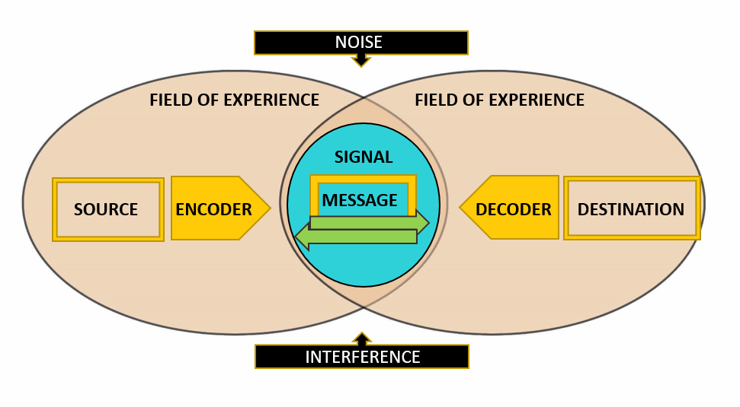
Figure 2: Schramms' Communication Model (Schramm, 2014)

Berol’s S-M-C-R model
Berlo's SMCR model is also linear communication, here the SMCR emphasizes the sender, message, channel, and receiver of a communication process. This model shows that communication can be impacted by some components such as communication skills, attitude, knowledge, the content of the message, etc (McQuail and Windahi, 2015). The main feature of this model is it pays importance to the encoding and decoding method for effective communication.
SMCR model where S= Source M= Message C= Channel R= Receiver and this model is much more updated and accepted by all because the source or sender communicates with others through a particular channel and the receiver can express its reactions immediately (Maude, 2011). But the important thing is the sender must have communication skills because until he utilises the skills, he may not properly encode messages.
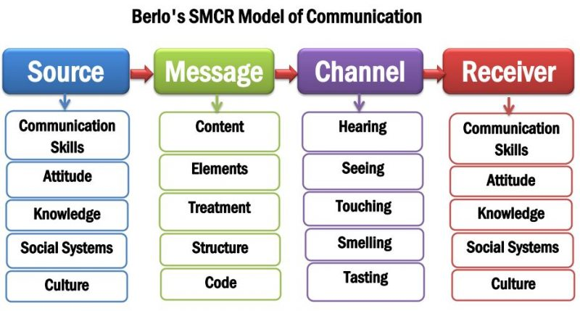
Figure 3: Berlo's SMCR Communication Model Components (McQuail and Windahi, 2015).
In the case study of the professor and villagers, a slight demonstration of this model has been reflected. Where due to a lack of communication skills and knowledge the villagers could not decode the professor’s message and ultimately failed to help him. According to the model, he had to use understandable language for communication.

Similarities and Comparison of Theories
Although the three communication theory models developed the communication process, the three approaches are not the same. Linear model theory is always evaluated because of noise. The Schramm model doesn’t work for mass communication, and Berol’s communication theory doesn’t explain any noise or channel, and it is not two-way communication. In Berol’s communication model, the receiver and sender can be on the same level as Schramm’s model is free from this critique. The similarities are in the three models, the sender has got high underscored, and if the sender has no communication skills, the communication cannot be effective.

Section 3

Communication Skills & Method
Most people consider communication a medium of verbal communication that is only incurred through speaking or listening where one party speaks. But except verbal communication, there exists non-verbal communication, which includes body language, signals, written or through any corporal appearances (Hinde and Hinde,2012). When a person may say something but his body language and gesture show another speaking, this demonstrates a conflict and is partly known as a mixed communication medium (Cornelissen, 2020). The method of communication is explained broadly below-

Verbal Communication method
Talking face to face using video chat or phone call is a new way to express the information and a new form of verbal communication. Verbal communication is the use of words to express feelings, emotions, ideas, or whatever. It is called personal communication, as a person can most of the time communicate face-to-face (Castells, 2013). Oral and written communication mediums are together consisted of the verbal communication method.
Oral communication: Effective oral communication depends on individuals word choice, speaking capability, speech clarity, tone, speed and volume (Carlson, 2012).
Written communication method: This method is most popular in the corporate world because sometimes it is comfortable and safe to communicate the words through a documented process using, for example, Email, digital messages etc.

Non - Verbal Communication
Speaking and face-to-face interactions are necessary. Still, communication builds up on non-verbal communication methods because everything from body language and expression to gestures is an essential part of communication that reflects our interactions every day (Broadbent, 2013). The non-verbal communication method can explain through the below theory –
Proxemics theory: Proxemics deals not only with communication space; instead, it also reveals an individual’s orientation of behaviour and corporeal gestures when they appear in a new environment (Baran et al., 2012).
Kinesics theory: Kinesics is a non-verbal communication behaviour that refers to communication through any body language, gestures, facial expression or any non-verbal way (West, 2012).
Personal awareness: This illustrates individuals’ attention, thoughts, or behaviours that might affect others in the communication process.

Listening
Listening in communication refers to whether a person is paying attention to the others person’s saying. It simply illustrates if the person is attentively paying head to others saying and properly understand or not and if he can interpret the message (Castells, 2013). Attentive listening makes a communication process effective. If the person failed to make attentive to others saying, then the news can create misunderstanding, which ultimately makes the other party annoyed.

Active Listening / Empathetic Listening
Active listening is a kind of technique to listen cautiously and perceive the non-verbal nods so that observer may respond, understand and use them to solve conflict or train others (Miller, 2015). Empathetic listening expounds a listener attentiveness and responds to others saying or during any communication process. Active listening theory can be explained through the S.O.L.E.R theory.
S.O.L.E.R communication theory: A non-verbal theory where S = Squarely means the body language must have to prove to listen. O = Open postures mean the correct body language at communication, L = Lean, expressing the interest to other parties’ message. E= Eye contact is a crucial part. Indicate the appeal and whether or not the person is listening. R= Relaxed means if comfortability exists in communication (Holliday et al., 2021).

Communication between Management and Employees
Communication between management and employees refers to sharing information, ideas, or feelings related to business. When both parties communicate, they must care about communication methods and verbal and non-verbal skills. For example, if the manager always speaks with employees or subordinates in a heavy or high tone, they will be afraid to express their emotions or ideas. Moreover, if the manager chooses to communicate in a native language, suppose in French, employees from other countries with different languages will not understand it. When there might be a formal meeting, the body language and gestures must match the situation; otherwise, it may bring miscommunication. So, both the managers and employees must give to awareness of such small things.

Case Study
My immediate supervisor speaks most of the time in French, and as I have come from London to work in France, I failed to understand what he conveys to me. As a result, most of the time, I was unable to report timely. When he speaks English, and it is so fast, I quickly could not express my feelings and never find a way to clarify, and my supervisor is always in a hurry and never tries to understand whether I understand. That is an example of lousy communication practice in the workplace.

Conclusion
The communication process should be done very carefully using proper methods skills, and the communicator must have the appropriate knowledge and other skills that will help implement effective communication. In day-to-day life, people communicate with one another using various mediums, and here people must be conscious of which communication medium to use.

Reference
Al-Fedaghi, S. (2012). A conceptual foundation for the Shannon-Weaver model of communication. International Journal of Soft Computing, 7(1), pp.12-19.
Baran, S.J., Davis, D.K. and Striby, K. (2012). Mass communication theory: Foundations, ferment, and future.
Broadbent, D.E. (2013). Perception and communication. Elsevier.
Carlson, A.B. (2012). Communication system. Tata McGraw-Hill Education.
Castells, M. (2013). Communication power. O.U.P. Oxford.
Cornelissen, J. (2020). Corporate communication: A guide to theory and practice. Sage.
Hinde, R.A. and Hinde, R.A. eds. (2012). Non-verbal communication. Cambridge University Press.
Holliday, A., Hyde, M. and Kullman, J. (2021). Intercultural communication: An advanced resource book for students. Routledge.
Kubota, M. (2019). What is “Communication”?―Beyond the Shannon & Weaver’s Model―. International Journal, 13(1), pp.54-65.
Maude, B. (2011). Managing cross-cultural communication: Principles and practice. Macmillan International Higher Education.
McQuail, D. and Windahl, S. (2015). Communication models: For the study of mass communications. Routledge.
Miller, K. (2015). Communication theories. U.S.A.: Macgraw-Hill.
Phutela, D. (2015). The importance of non-verbal communication. I.U.P. Journal of Soft Skills, 9(4), p.43.
Raman, M. and Sharma, S. (2015). Technical communication: Principles and practice. Oxford University Press.
Ruscher, J.B. (2017). Prejudiced communication. In Oxford Research Encyclopaedia of Communication.
Schramm, W. (2014). How communication works. 1954, pp.3-26.
West, M.A. (2012). Effective teamwork: practical lessons from organisational research. John Wiley & Sons.
West, R.L., Turner, L.H. and Zhao, G. (2012). Introducing communication theory: Analysis and application (Vol. 2). New York, NY: McGraw-Hill.

