Networks and Cyber Security Essentials
Module Code – ACCA4024 Student – Ethan Shellem-Prince : 2109509

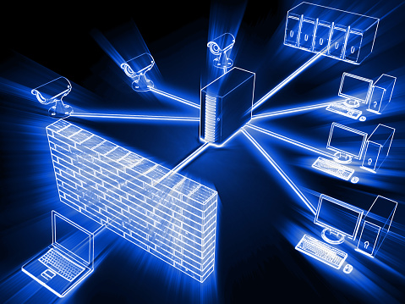

Table of Contents
Table of Figures ………………………………………………………………………………………………………………………… 1
Abstract ……………………………………………………………………………………………………………………………………. 4
Possible Security Breaches ……………………………………………………………………………………………………….. 4
Phishing ……………………………………………………………………………………………………………………….. 4
Disgruntled Employees …………………………………………………………………………………………………. 4
Malware Attacks …………………………………………………………………………………………………………… 5
Importance of Cyber Security ……………………………………………………………………………………………………. 5
Threats, Vulnerabilities and Attacks ………………………………………………………………………………………….. 5
Threats …………………………………………………………………………………………………………………………. 5
Vulnerabilities ………………………………………………………………………………………………………………. 6
Attacks …………………………………………………………………………………………………………………………. 6
.Rekt File Format ………………………………………………………………………………………………………….. 6
Packet Tracer 10 Hour Course …………………………………………………………………………………………………… 7
Physical and Logical Topology …………………………………………………………………………………………………… 8
Batman’s Textiles Current Connection …………………………………………………………………………………….. 8
Additional Security Devices ………………………………………………………………………………………………………. 9
Company Cyber Security Guidelines …………………………………………………………………………………………. 9
Cyber Security Software ………………………………………………………………………………………………. 9
Service Portal ………………………………………………………………………………………………………………. 9
IT Technician ……………………………………………………………………………………………………………….. 9
Employee Cyber Security Guidelines ………………………………………………………………………………………… 9
Employee – Private Wi-Fi Access …………………………………………………………………………………. 10
Employee Education ……………………………………………………………………………………………………. 10
Password Protection ……………………………………………………………………………………………………. 10
Links and Documents ………………………………………………………………………………………………….. 10
Customer Cyber Security Guidelines ………………………………………………………………………………………… 10
Conclusion ……………………………………………………………………………………………………………………………….. 11
References ……………………………………………………………………………………………………………………………….. 11

Table of Figures
Figure 1 ……………………………………………………………………………………………………………………………………… 4
Figure 2 ……………………………………………………………………………………………………………………………………… 4
Figure 3 ……………………………………………………………………………………………………………………………………… 5
Figure 4 ……………………………………………………………………………………………………………………………………… 7
Figure 5 ……………………………………………………………………………………………………………………………………… 7
Figure 6 ……………………………………………………………………………………………………………………………………… 8
Figure 7 ……………………………………………………………………………………………………………………………………… 8

Abstract
I am writing this piece of coursework due to the attacks made on ‘Batman Textiles’. This attack was made on the company’s important documents/services. These files were encrypted with a .rekt file format. This document will suggest how to protect the company’s data from any further attacks. I will outline possible reasons for the attacks and suggest appropriate solutions to Bruce.
Possible Security breaches
Possible Security Breach 1: Phishing
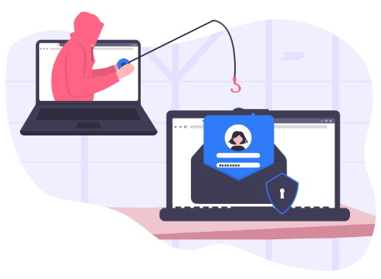
In the above scenario it was clearly stated that Alfred the ‘Head of Marketing’ had a task of increasing the business income by 30%. To achieve this he introduced ‘Complimentary’ high-speed Wi-Fi to all customers in the attached restaurant. The same Wi-Fi connection was also used by Alfred himself, this means that data was vulnerable to attacks at any time.
Figure 1
Phishing is a common tactic used by scammers to gain private information. The scammers contact targets via email, phone, text or even pretend to be an official institution to intise there targets into trusting them. The targets can be lured into giving away sensitive data as card or bank details, social media passwords or in this case Employee passwords that can be used to access the company’s workstations.
Phishing Scams were accelerated in 2020 due to COVID-19. People were using the internet a lot more to do important tasks such as purchase products, apply for loans and much more. During 2020 it is estimated cyber crime was increased by 600%. Refer to this link for more information - Why Phishing is More Dangerous Than Ever, and How to Protect Yourself - EZComputer Solutions [1]
Phishing could have been used to install RektLocker onto the workstation. Scammers could of gained one of the employees workstation log in details using a phishing technique and automatically installed the software.

Possible Security Breach 2: Disgruntled Employees
Figure 2

The scenario suggested that one of the Sale Heads who had recently lost his job was not happy about Alfred’s decision. It was suggested that he thinks of disrupting the operations that take place in ‘Batman Textiles’. This comment clearly suggests he is a ‘Disgruntled Employee’.
Disgruntled Employees are employees are clearly showing they are unhappy. Mostly all companies have at least one unhappy employee. There are many behaviour signs of disgruntlement in the workplace,
- They have been passed over for promotion too many times.
- They are facing redundancy when—in their view—poorly performing employees are being retained.
- They feel they’re being taken advantage of.
- They don’t feel valued by their employer—or even visible and noticed.
For more information refer to this link: Why Disgruntled Employees Are CyberSecurity’s Worst Nightmare – CloudSavvy IT [2]
The Sale Head had a motive to disrupt the company’s operations. He could of easily installed the RektLocker software onto the workstation himself using his access to all documents.

Possible Security Breach 3: Malware Attack
Figure 3

Important documents and services were encrypted with a .rekt file format. This file extension comes from a ransomware software called RektLocker. Malware attacks are based of malicious software such as RektLocker. Hackers deploy software to gain access to a targets workstation in order to install ransomware such as RektLocker. In this case Alfred used the same Wi-Fi connection as the customers in the attached restaurant. This opened up opportunities to hackers to gain access and information about Alfred’s security details and deploy RektLocker.
There are many different Anti-Malware software available to purchase. ‘Total AV’ Malware protection is rated the best for 2022. These software protect your machine from malicious software embedding themselves into your machine with the main aim of causing damage.
For more information about Anti-Malware software please refer to this link - Free Malware Removal 2022 - Review of the Top Free Malware Removal Software (trustedantiviruscompare.com) [3]

Importance of Cyber Security
Cybersecurity is essential to any businesses. With the acceptable measures in place you will be able to identify most attacks made towards you or your company before they have done any significant damage. With the technology we face in todays age attacks have adapted to basic security systems making it effortless to pass them. It is key to invest into a reliable Cybersecurity system that has many walls of defence to prevent this from happening.

Threats, Vulnerabilities and Attacks
Threats
A threat is something that can directly harm you or your company. There are many different threats that can be directed to your company, the most likely being a cybersecurity threat. A Cyberthreat can attempt to damage a workstation or network system.
Examples of Cyber threats
- Malware Attacks
- Password Attacks
- Phishing
- Emotet
Threats made on a network can result in data being destroyed forever. It is very important to report all known threats as soon as possible to prevent unrecoverable damage.

Vulnerabilities
There are many different factors that can make your network vulnerable to attacks. The first being out of date or unreliable protection software. Virus protection software is an essential basic means of data protection. Without this any attacker will have easy access to important files within the network.
Another vulnerability is your employees accidently leaking sensitive data. This can allow attackers to breach a network. Attackers can disguise themselves as an employee. Insider threats are very difficult to track down due to the employees actions running up to the attack to be legitimate and will not raise any worries at the given time. To get around this I would recommend investing in network access control.
Attacks
In my opinion the main network attacks that can occur to your business are a Social Engineering attacks or a simple Computer Virus. These attacks are simple but very effective.
For example someone may deploy a Trojan Horse attack Virus, this is a type of malware that is able to download onto your workstation disguised as an official program. The attacks may be able to make changes to any file on the database, download and send any confidential data and even delete files. The .rekt extension could have been added to your files this way.
A Computer virus can be deployed onto your machine with ease, this is because Alfred uses the same public network as the customers. An attacker can send a notification to come through on the workstation due to the network. If clicked this can trigger a virus to be installed on the computer. Computer viruses are normally circulated via email. The attacker could of found each employees email and send different virus to each member of staff.
.rekt file format
.rekt is a RektLocker Ransomware affected file. When the RektLocker is installed it will have all files encrypted using a AES encryption and therefor apply the .rekt format to them.
Ransomware is a type of malicious software designed to destroy and block access to machines, files and important documents until a sum of money is paid. In this case RektLocker asks for 1 BTC (Bitcoin) to be paid in order for the software to be removed. Currently the value of 1 bitcoin sits around £35,000.
I suggest to use the Michael Gillespie's Hidden Tear Brute Force to try and get the decryption key for their files as suggested here - .REKT File Extension - How do I open it? (whatext.com) [4]

Packer Tracer 10 hour Course
Figure 4
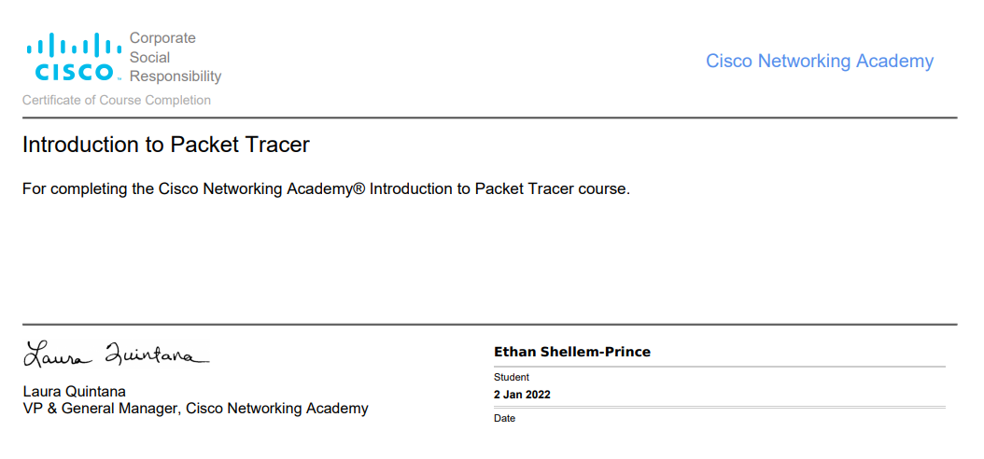
Figure 5
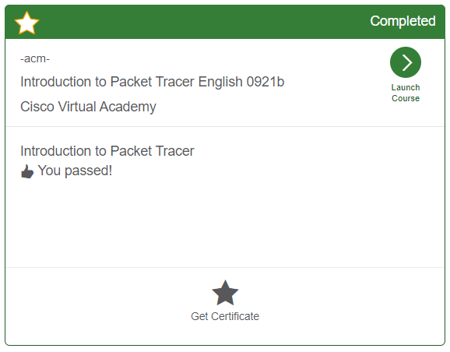

Physical and Logical Topology
Figure 6
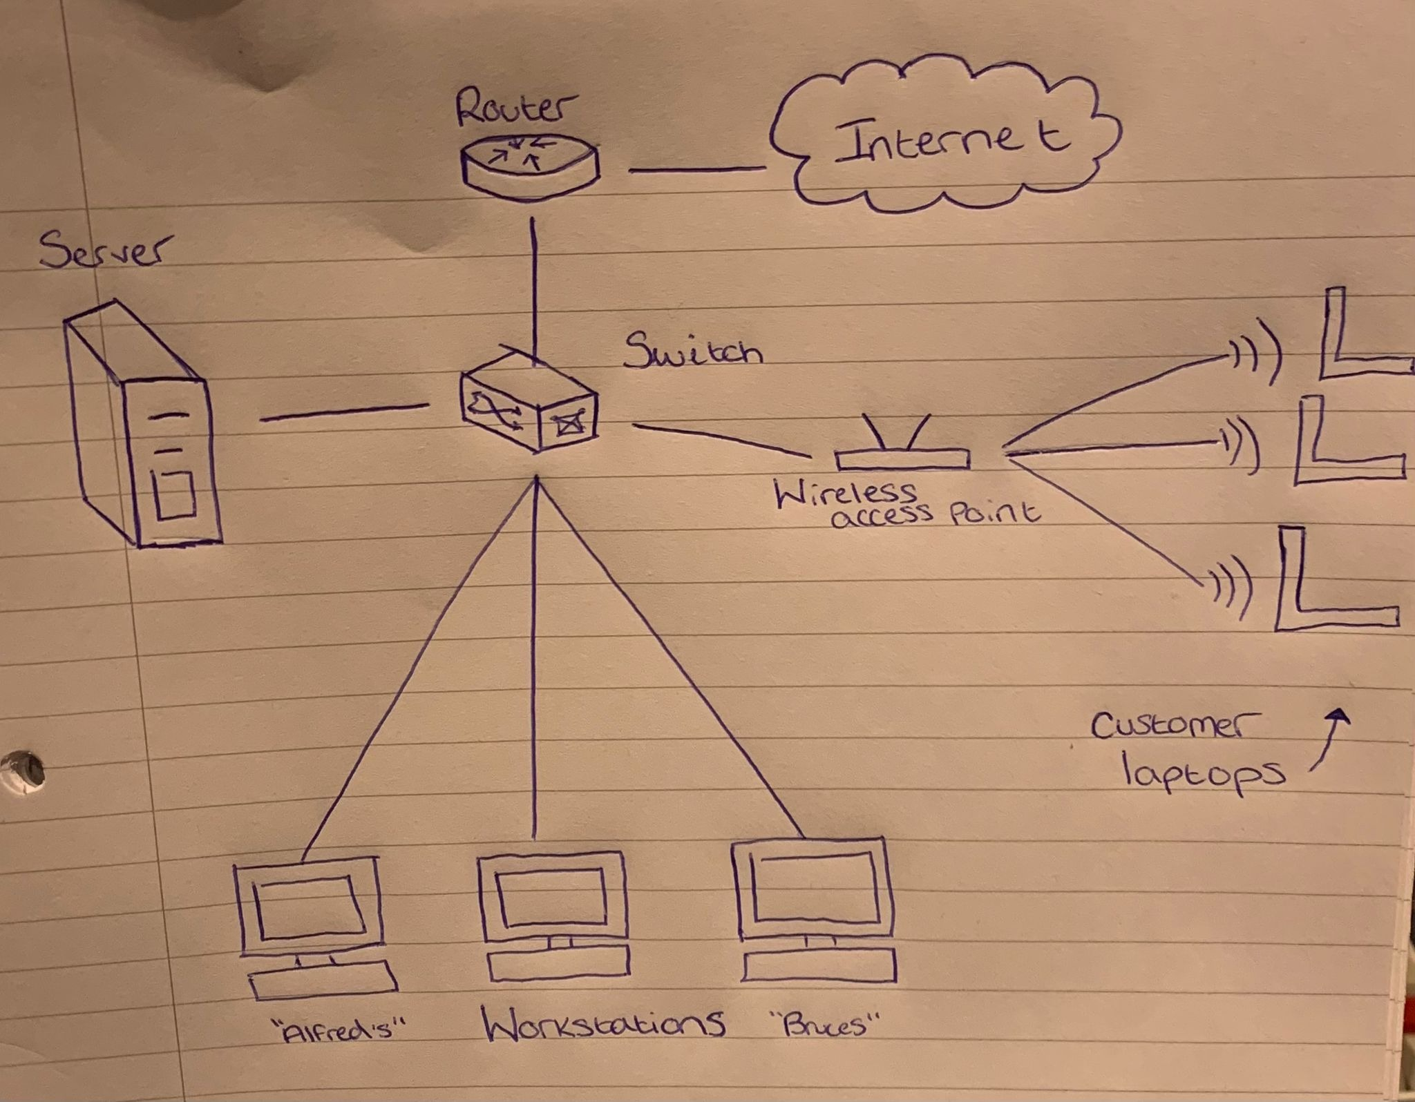
Batman’s Textiles Current Connection
Figure 7
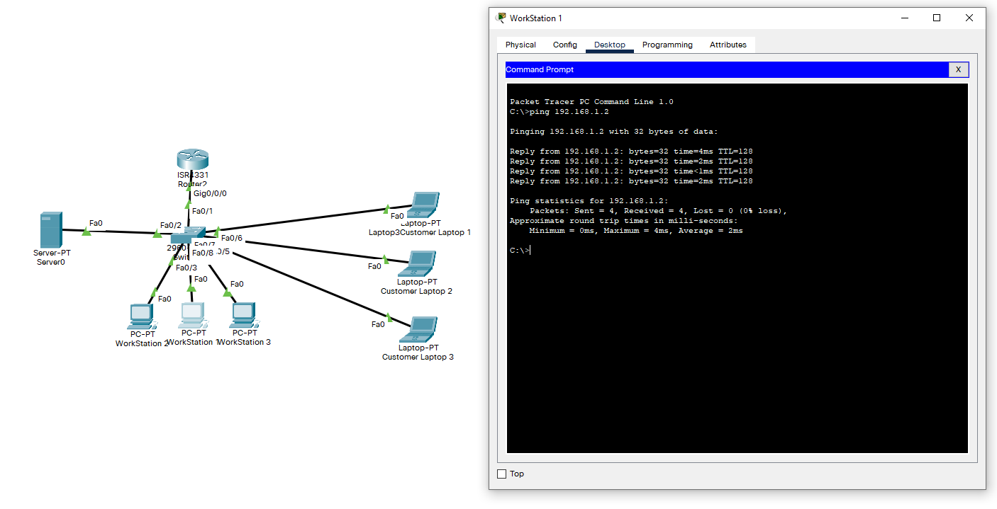

Additional Security Devices that could be added for more security
Firewalls are a well-known additional security measure that will improve your networks security. A firewall sits between a local network and another network, for example a Workstation and Internet access. The firewalls job is to control incoming and outgoing traffic. If a firewall is not included this could risk unwanted traffic being transmitted around the network such as a virus.

Company Cybersecurity Guideline
Cyber Security Software
It is essential to have a security system in place, I would recommend choosing a well-respected cyber security company such as Total AV. Here are just some of the utilities Total AV offers,
- Remove Malware
- Web Protection
- Blocks Phishing Websites
- Manage Passwords
Network security is a growing problem, nearly 73% of reported cyberattacks are done for a monetary gain or otherwise known as ransomware. There are approximately 4000 ransomware attacks that happened on a daily basis.
Service Portal
A Service portal will be put in place in order to record any IT problems that may occur. This will include incidents such as Documents Loss, Software request, Password Changes, User Access requests. It is very important to keep a digital trail of request and incidents just in case something did go wrong we will have a receipt of the leading events.
IT Technician
I would recommend the hire of a IT technician, this way you will be able to trust them with any IT issue and protection. They will be able to handle security procedures in order to prevent any future attacks. The average IT Technician earns a salary of £21,000 per year. This is an investment in the company due to the fact is attacked by a ransomware product you may have to pay much more to have it removed.

Employee Cybersecurity Guideline
In order to increase safety when using Batman’s Textiles network please follow the below guidelines in order to restore security in the business.

Employee - Private Wi-Fi Access
From now on you will need to be connected to a private Wi-Fi system that is not related to the customer free Wi-Fi. This will reduce the risk of attacks on the company. A private Wi-Fi system will require a passkey to access which I recommend being changed every 6-8 weeks, this will stop any customers joining the same internet connection as the employees.
Employee Education
It will be essential for all employees to have the basic knowledge on how to stay safe when connected to a network. In order to achieve this I have supplied a 5 hour free Networking Security Course. This can be completed in blocks or all at once – please find the link to the course here: Cyber Security Full Course for Beginner - YouTube
Password Protection
All Employees will require to have a password to log into there workstation. This password will require to include at least;
- 8 Characters
- One Uppercase
- One number
- One Symbol (!”$%^&*?)
This will make it near impossible for someone to guess your password. The password will require to be changed every 10-12 weeks.
Links and Documents
Please ensure when accessing links and documents they are coming from a secure place, If you are unsure of a link please do not click it. Ensure you are familiar with the sender before accessing any document as it could result in threatening malware being installed onto your machine.

Customer Cybersecurity Guideline
Customer – Wi-Fi Access
Please access the Wi-Fi Password from the counter, we are not adding a password to stop non-customers from joining. When browsing the internet please access trusted websites. Do not click on any pop ups or email links that you don’t know aren’t official. Finally if you are completing work using this Wi-Fi please regularly save your work to prevent any loss.

Conclusion
Overall this document clearly outlines the company’s network vulnerabilities to attacks. I have given different ways a breach can happen and have outlines ways to improve safety in the business. I have supplied Bruce with guidelines to follow in order to improve his networks safety.

References

[1] | EZ Computer Solutions , "Why Phishing is More Dangerous Than Ever, and How to Protect Yourself," EZ Computer Solutions, 2 December 2020. [Online]. Available: https://www.ezcomputersolutions.com/blog/why-phishing-is-dangerous/. [Accessed 2 Janurary 2022].
[2] | D. Mckay, "Why Disgruntled Employees Are CyberSecurity’s Worst Nightmare," 18 November 2020. [Online]. Available: https://www.cloudsavvyit.com/7285/the-disgruntled-employee-and-the-damage-they-can-do/. [Accessed 2 Janurary 2022].
[3] | Trusted Antivirus Compare, "Top 10 Best Anti-Malware Programs (2022)," Trusted Antivirus Compare, 1 Janurary 2022. [Online]. Available: https://www.trustedantiviruscompare.com/best-free-malware-removal?msclkid=5e574a979a901d2fdcae2b456c68a64c. [Accessed 2 Janurary 2022].
[4] | Whatext, "What is an .REKT file," Whatext, 12 June 2020. [Online]. Available: https://whatext.com/rekt. [Accessed 2 Janurary 2022].

