

Student Name: Neboh Celsius
Student Number: 2434221
Module: Changemaker – Creativity and Value Creation
Module Code: BMHP5014
Assignment Title: Set of Exercises (Online Portfolio)
Lecturer: Raheela Shaikh
Sunday 8th November 2026
Word count: 2000

Task 1

Title: Concept Map
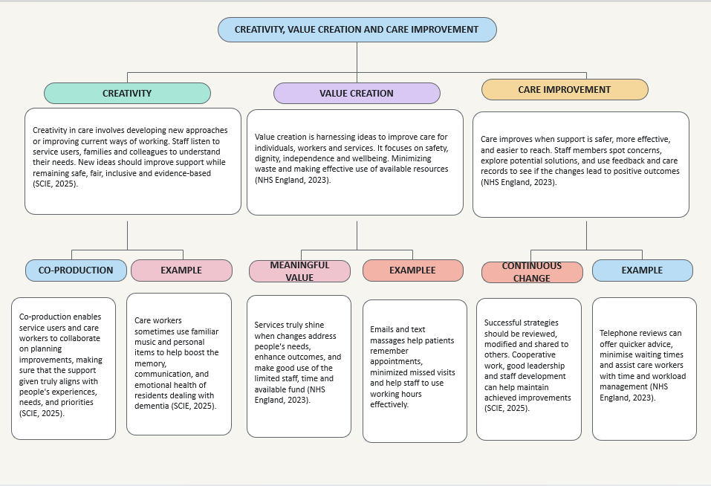

Task 2

Title: Paperclip Activity Reflection Using Gibbs’ Reflective Cycle
Using Gibbs’ Reflective Cycle to think back on the activity and connecting my finding to health and social care practice (Gibbs, 1988).
Description:
During the activity, our group explored different ways the object could be useful, including as a bookmark, key holder, hook and SIM-card opener. Sharing ideas helped me think differently. This relates to health and social care, where creative thinking and teamwork can help meet individual needs.
Feelings:
Initially, I thought the activity would be easy. However, I soon noticed that finding different uses required imagination and creative thinking. I became more certain as everyone brought ideas and supported each other. Creative activities can help people explore different possibilities and develop new ways of thinking (Abraham, 2016).
Evaluation:
Collaborative working helped us create more ideas by sharing different views. Some suggestions were less practical, so discussing them helped me understand why safety, usefulness and durability should be considered before deciding.
Analysis:
The paperclip activity helped me to understand that there can be many ways to handle the same challenge. Trying different ideas can encourage creativity and lead to useful solutions (Abraham, 2016). This is valuable in UK health and social care, where staff may need to change their approach, consider each person’s circumstances and collaborate with other professionals to deliver appropriate, individualized care.
Conclusion:
I learned that teamwork, communication and open-minded thinking can support creativity and problem-solving care practices.
Action Plan
Going forward, I will share my ideas confidently, listen respectfully to others, remain open and consider different possibilities that are safe before deciding on the most suitable solution.
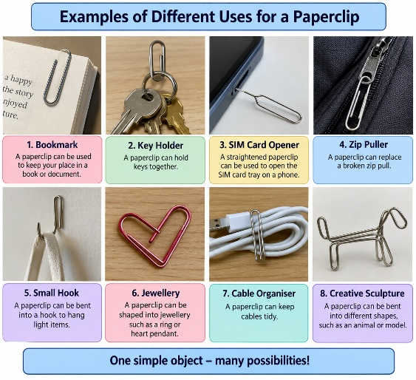

Task 3

Title: Case Study of a UK innovation (NHS @home – managing heart failure at home)
Introduction
Managing heart failure at home allows patients to manage their health with the support of NHS staff. With careful monitoring, tailored care plans, and collaboration among professionals, individuals can get correct needed advice. Patients and their caregivers are encouraged to stay alert for any symptoms and ask for help immediately. This process keeps people healthy and minimizes unnecessary hospital visits (NHS England, n.d.).
Main body: creativity and innovation
The project transformed how individuals can get help at home while staying in touch with NHS workers. It helps them notice changes in their symptoms and seek early help. Sometimes, digital tools help them to check health readings and share them with their care team. This process combined personalized care, remote monitoring, and collaboration among services (NHS England, n.d.).
Home monitoring can give staff a better understanding of patients’ health between check-ups. For example, sudden weight gain or increased breathlessness might trigger further evaluation. Creativity therefore encompasses reorganizing care as well as introducing technology (NHS England, n.d.).
Good communication among hospital teams, GP practices, and community staff makes the process more effective. Patients have clear information about their care and know who to reach out to. They could play an active role in decisions concerning their support if they understood their situation. NHS England (n.d.) highlights that home monitoring should be tailored to everyone and their specific clinical situation.
Nevertheless, home monitoring needs regular review. Lyndon, Viney and Slade (2025) observed that while patients valued care at home, sometimes equipment and connection difficulties created barriers. This highlights the need to consider patients’ experiences when assessing services. Creativity means combining monitoring with clear advice and practical support, while checking whether the approach suits individual needs and helps people feel safe and supported.

Impact and value
Patients using the program reported experiencing better life quality, noticeable improvements in their symptoms, and felt more equipped to manage their heart failure. Interestingly, their visits to primary care also reduced (NHS England, n.d.). Individually, Cornwall’s ward patients described feeling safe and supported at home despite technological difficulties (Lyndon, Viney and Slade, 2025). These findings suggest value through convenient, person-centered support, while showing why services must evaluate outcomes and address barriers rather than assume everyone benefits equally.

Task 4

Title: UK Teenage obesity: the issue and its causes
Teenage obesity is a serious challenge to the UK health and social care practices. Studies suggest that lots of food outlets and emotional difficulties significantly affect the weight of young people. By recognizing these factors, practitioners understand the reason behind the situation and offer personalized support to teenagers and their families (Libuy et al., 2024; Putra, Daly and Robinson, 2025).
Using the Millennium Cohort Study, Libuy et al. (2024) examine children in UK aged seven to fourteen. They noticed a concerning link between living near fast-food outlets and weight gain, especially among kids whose mothers are less educated. Also, the study emphasized that children who struggled with emotional regulation were even more at risk. It suggests that easy access to fast food, social factors, and emotional difficulties might all play a role in influencing weight. As the study focused on younger children and adolescents, we should be careful when applying these findings to older teenagers (Libuy et al., 2024).
Putra, Daly, and Robinson (2025) did a study with the UK participants who initially had a healthy weight and discovered that those who faced mental health challenges at the age of eleven were more likely to end up overweight or obese by seventeen. Behavioral problems and bullying at eleven were also identified as possible risk factors. This points to early adolescence being a key period for recognizing emotional difficulties and offering help. However, it’s important to remember that these links don’t necessarily mean that mental health issues directly lead to obesity, as there could be other influencing factors at play (Putra, Daly, and Robinson, 2025).
Both studies highlight the importance of considering teenagers' emotional wellbeing and their local environment. Practitioners can team up with families, schools, and community services to enhance access to healthier food, address bullying, and provide mental health support (Libuy et al., 2024; Putra, Daly and Robinson, 2025).

Task 5

Title: Podcast
Record a two-minute Podcast introducing your idea for component 2 using https://www.rev.com/onlinevoicerecorder The MP3 audio must be downloaded and embedded as a file (see guidance video on how to do this here: https://www.youtube.com/watch?v=D21isId0agw) or an accessible OneDrive link if using a Chromebook (make accessibility – anybody) before inserting into your portfolio. Check the accessibility of the link before submitting.

(Please double clink and open).

Task 6

Title: NHS Leadership Framework Analysis
1. Summary of the NHS Leadership Framework
The NHS Leadership Framework is a helpful resource for health and care professionals looking to expertise in their leadership abilities and deliver exceptional care. It highlights seven important areas that help staff to streamline teamwork, make sound decisions, and centralized the patients (NHS Institute for Innovation and Improvement, 2011).
Demonstrating personal qualities is all about acknowledging your strengths, accepting your responsibilities, learning from your missteps, and being truthful. When working with others, it’s important to treat your coworkers with respect, foster trust, and collaborate as a cohesive team. Managing services means planning out daily tasks, supporting your team, using resources wisely, and evaluating how well those services are performing. Improving services encourages leaders to identify areas that need work and discover more efficient ways to operate.
Setting Direction is understanding key issues and finding the necessary steps to tackle them. Creating Vision implies communicating clearly the objectives so that everyone comprehends the team’s goals. Delivering the Strategy is about executing those plans and evaluating whether they’re hitting the target.
These seven areas, when combined, help leaders to support their teams, enhance decision-making, and grow from their experiences. By putting them into practice, organizations can boost teamwork, measure care qualities, and provide dependable and safer services.
2. Improving Services: Encouraging Creativity and Innovation
The Improving Services domain is helping NHS leaders in identifying issues and discovering more effective ways to provide care (NHS Institute for Innovation and Improvement, 2011). For example, a ward manager might reach out to nurses and healthcare assistants to gather their thoughts on advancing handover practices. The staff could suggest implementing a checklist to ensure that all necessary information about each patient is communicated clearly.
The manager might consider gathering feedback from the staff, while keeping an eye on any communication errors and shifts in patient safety. This would check whether the new approach is effective. According to Kirkpatrick, Altanlar, and Veronesi (2024), hospitals with more senior doctors in management roles tend to achieve better patient experience scores and lower infection rates. This shows the benefits of including clinical staff in leadership decisions. By actively listening to employees and monitoring the outcomes, managers can foster innovative ideas, implement thoughtful changes, and maintain patient safety.

Task 7

Title: Self-Reflection Journal Entry
Looking back on this module, I can see how my understanding of creativity and value creation has progressed. Usually, I thought of creativity as just coming up with new ideas. But now, I see it as an important part of problems solving, enhancing services and improving patients’ care. Creativity sparks ideas, but its innovation puts them into action to enhance care and outcomes (NHS England, 2023).
Gibbs’ reflective cycle has really helped me in my learning journey and how I can improve my future practice (Gibbs, 1988). I've come to realize that creating value in healthcare means showing respect, focusing on person-centred care, and using resources wisely. Telemedicine is a fantastic option for those who find it hard to travel for appointments, but it's important that these services remain safe and accessible for everybody (Department of Health and Social Care, 2025).
Week 9 really opened my eyes to the value of teamwork, leadership and learning from others. I need to be confident in sharing ideas and exploring different solutions. The NHS Leadership Academy (2024) highlights responsible leadership.
In future, I will listen carefully, reflect on my actions and seek practical ways to improve care. Overall, this module has strengthened my commitment to person-centred practice, continuous learning and creating meaningful value for individuals.

List of references
Abraham, A. (2016) ‘Gender and creativity: An overview of psychological and neuroscientific literature’, Brain Imaging and Behavior, 10(2), pp. 609–618. Available at: DOI: 10.1007/s11682-015-9410-8 (Accessed 2 October 2026).
Department of Health and Social Care (2025) A guide to good practice for digital and data-driven health technologies. Available at: https://www.gov.uk/data-ethics-guidance/a-guide-to-good-practice-for-digital-and-data-driven-health-technologies Accessed 22 October 2026).
Gibbs, G. (1988) Learning by Doing: A Guide to Teaching and Learning Methods. Oxford: Further Education Unit, Oxford Polytechnic (Accessed 2 October 2026).
Gibbs, G. (1988) Learning by doing: A guide to teaching and learning methods. Oxford: Further Education Unit.
Google AI Picture.
Kirkpatrick, I., Altanlar, A. and Veronesi, G. (2024) ‘Doctors in leadership roles: consequences for quality and safety’, Public Money & Management, 44(6), pp. 515–522. Available at: https://doi.org/10.1080/09540962.2023.2217344 (Accessed 20 October 2026).
Libuy, N. et al. (2024) “Fast food proximity and weight gain in childhood and adolescence: Evidence from Great Britain,” Health economics, 33(3), pp. 449–465. Available at: https://doi.org/10.1002/hec.4770 (Accessed 10 October 2026).
Lyndon, H., Viney, T. and Slade, V. (2025) ‘A service evaluation of virtual wards in Cornwall, UK’, Oxford Open Digital Health, 3, article oqaf008. Available at: https://doi.org/10.1093/oodh/oqaf008 (Accessed: 4 October 2026).
NHS England (2023) Co-production and quality improvement – a resource guide. Available at: https://www.england.nhs.uk/long-read/co-production-and-quality-improvement-a-resource-guide/ (Accessed 2 October 2026).
NHS England (n.d.) Managing heart failure @home. Available at: https://www.england.nhs.uk/nhs-at-home/managing-heart-failure-at-home/ (Accessed: 4 October 2026).
NHS Institute for Innovation and Improvement (2011) Leadership framework. Available at: https://www.nwpgmd.nhs.uk/sites/default/files/NHSLeadership-Framework.pdf (Accessed 20 October 2026).
NHS Leadership Academy (2024) Our Leadership Way. Available at: https://www.leadershipacademy.nhs.uk/organisational-resources/our-leadership-way/ (Accessed 22 October 2026).
Public Health England (2017) Health matters: obesity and the food environment. Available at: https://www.gov.uk/government/publications/health-matters-obesity-and-the-food-environment (Accessed: 15 October 2026).
Putra, I.G.N.E., Daly, M. and Robinson, E. (2025) ‘Psychosocial factors and the development of childhood overweight and obesity: a UK cohort study’, Pediatric Research, 98(6), pp. 2132–2138. Available at: https://doi.org/10.1038/s41390-025-04113-x (Accessed 10 October 2026).
Social Care Institute for Excellence (2025) Shaping change together: co-producing innovation in social care. Available at: https://www.scie.org.uk/co-production/shaping-change-together-report/ (Accessed 2 October 2026).

