What is the diversity of birds in a typical Swansea garden compared to more rural areas?

Introduction
For my bird survey I want to measure the biodiversity of birds in a typical Swansea garden. Gardens are an essential place for song birds such as robins due to the availability of food and materials for nest building. It is important to monitor the population of bird species in developed or soon to be developed areas as this allows us to assess and take action to protect these species. (Gregory, Gibbons, & Donald, 2004) The site I want to survey is typical Swansea gardens. In order to do this, I will use a number of participants gardens around the Swansea area in order to collect a larger sample size. These are the areas I plan on surveying;
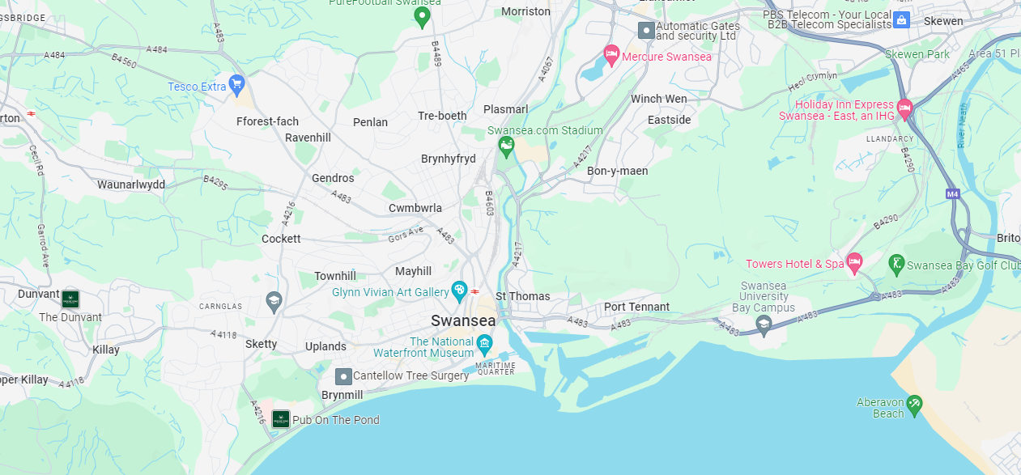
(Google Maps, 2023)
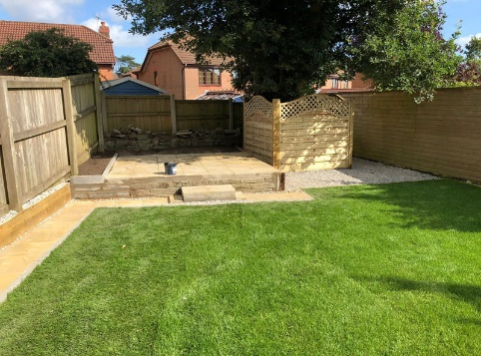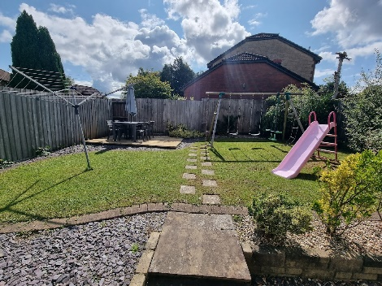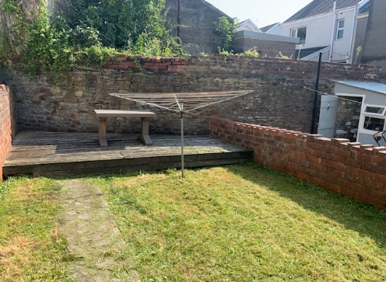
Swansea is on the southwest coast of Wales near the Gower. Swansea has lots of industrial buildings such as Swansea docks and the Port Talbert steel works just around the coast so will allow an interesting look into the levels of biodiversity compared to more rural and natural areas. As it is near the sea it may also allow for some sea birds. (Weather Spark, 2023)
For the rural area I’d like to use to compare I chose 5 gardens in the Rhondda Cynon Taff area. This will allow for comparison between a more rural area compared to the more urbanized landscape of Swansea. These are the areas I plan on surveying.
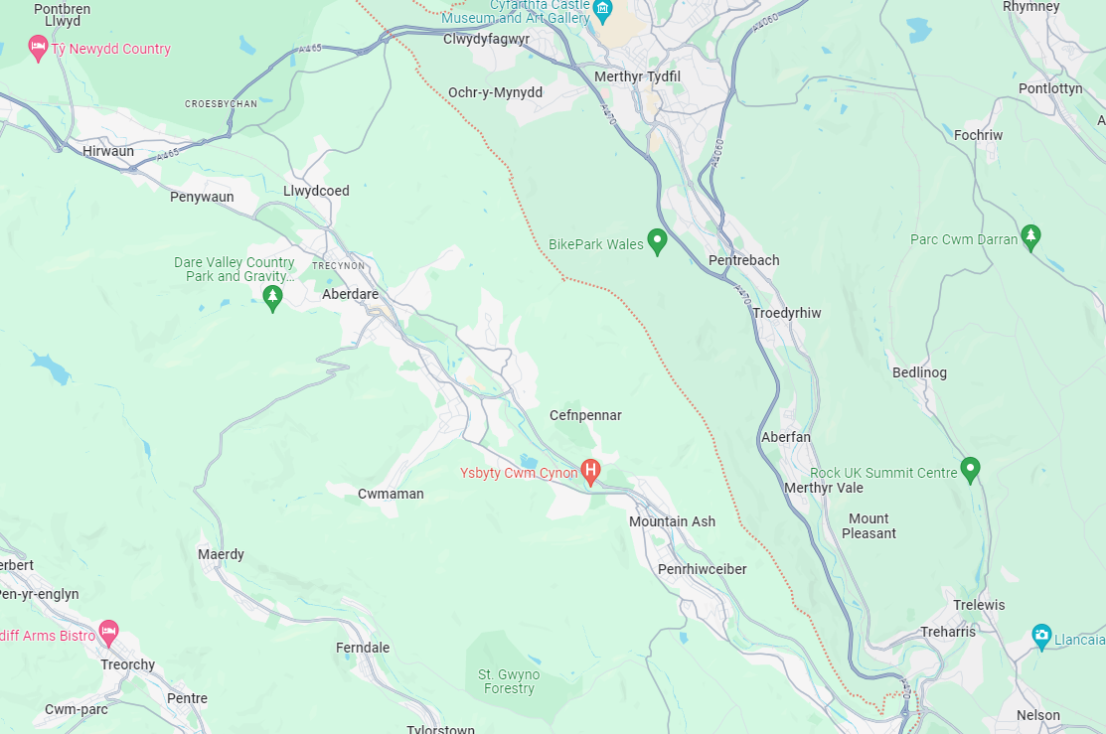
(Google Maps, 2023)
Research Aims and Objectives
The aim of this survey is to measure the biodiversity of birds in the Swansea area as well as the changes of diversity throughout the day. This will help us see how diverse Swansea is as an area and allows us to compare these results with other areas. Throughout the survey I hope to answer these 3 questions.
- What is the biodiversity of a typical Swansea Garden?

- How does the diversity change throughout the day?

- How does this compare to more rural areas?

Proposed Protocol
There are many different methods that I could use to collect the data I need. These methods include passive and non-passive methods of data collection which both have their pros and cons. Here are a few different methods of data collection;

Passive Techniques
- Traces and Nests
This method is where you are observing traces left by the organism. This can be food left, dropping and feathers left behind. You can also use nests to determine how many animals are in the area. Using this method there is little to no interaction with the animal so very low chance of disturbing them. It’s also very cheap to do and is a great method for surveying nesting birds. One down side is there is limited data that can be collecting using this method

- Group Based Counts
This method involves surveying large flocks of birds all at once. This can be easy as large number of birds are hard to miss. Birds that congregate in roosts or colonies tend to stay in one location so is easier to get a count, however bird flocks tend to move around so is a lot harder to get an accurate count. This technique also won’t work on more solitary or territorial birds.

- Territory Mapping
This is where you survey individual territories of specific birds. This allows you to measure the density of territorial birds and is one of the most effective ways of measuring population density of these specific types of birds compared to point counts. (Newell, 2013) Some potential downsides to this survey method is it is very time consuming and only applies to territorial species.

- Point Counts
Point counts involve watching a specific area and counting the number of birds and the species that arrive at that area. This can be very effective as it is low cost and can be easily done with a camera and a bird identification guide. These kinds of surveys can also be done on a large scale with a large number of participants. Some potential downsides are that without a bird identification guide it can be difficult for inexperienced people to identify individual species. Outside factors such as weather can also disrupt results. (Mulvaney, 2020)

- Area Searches
This method involves you searching in a specific set area for the wildlife. This method allows you to find more shy species that you might not find in point count surveys but has the downside of disturbing the birds. As you are walking through the area you are surveying you are more likely to spook the birds, causing them to fly off. If you are not fast enough to get a picture or identify the bird, then you won’t be able to note the species.

Passive survey methods tend to be a lot cheaper and require less experience and equipment which can be useful when budgets are tight. However, these methods can collect limited data and make it harder to survey more shy birds. Alternatively, you can use non-passive survey techniques. These usually involve collecting data by disturbing the birds. This can allow the collection of more in-depth data but means that more training and experience is required. Here are a few examples of non-passive survey techniques and their pros/cons;

- Playback
Playback is where you play a recording of another bird to attract the species you are trying to survey. This could be the noises of a rival bird to attract a territorial bird or a potential mate. This survey method allows you to survey birds you may not otherwise be able to, meaning you will be able to survey more individuals of a species. (Warren, 2018) It’s also a hands-off method so you don’t need to catch or handle the birds. However, this method has the potential to cause emotional stress to the bird you are trying to survey. Some countries also require a license to use this technique.

- Catching Birds
When catching birds you are able to collect large amounts of data on the birds you are surveying. This includes species, sex, age and breeding success. (Gregory, et al., 2004) These results can be used in a large range of studies. However, there are some ethical concerns with the survey method. Mainly the safety of the birds caught. As long as the people handling the birds have training then the risk to the birds is low. This can also cause the birds stress depending on the method used.

- Mist Netting
Mist netting is a capture method that involves using a large thin net that birds struggle to see. Using this method you can capture a large number of birds that get caught in the net. It is very useful for capturing smaller more nimble birds such as songbirds. This can also be a downfall as it isn’t as effective at surveying larger or high-flying birds. (Dunn & Ralph, 2004). This method also requires a lot of training in order to remove the bird safely without harm. Some birds may also learn areas nets are commonly used and so may avoid those areas, effecting the recapture rate.

- Cannon Netting
This method involves using a net gun to capture multiple birds at once. This method is best used against flocking birds where there will be a large number of birds in one place. This means that with one shot you can collect multiple birds to survey. When using a net cannon you must have multiple trained handlers to collect and process the birds caught. This is both to make sure the birds are safe and are in the net for as short a time as possible. Once the birds have been removed and processed they should be released as soon as possible so that they can rejoin the flock. (Victorian Wader Study Group, 2020)

- Noose Traps
Noose traps are made of thin wire and are used to capture birds. How they work is you take some thin wire or fishing line, tie a small loop on one end and feed the other end through, creating a noose. You then add another knot to stop the wire from getting to tight around the bird. (Harrity & Conway, 2020) These are more often used on flightless birds as it is significantly harder to capture birds that can fly in these. As this is essentially a snare this does have the potential to harm the bird that gets caught either due to the bird struggling or exposure so must be used with the upmost care.

There are multiple different options available for me to use in this survey but some are a lot more effective than others for the data we are trying to collect.
Technique | Is it suitable?
Traces and Nests | This method would be useful as birds could make nests in gardens and means you can collect data from any traces left in a Garden.
Group Based Counts | This would be harder to do in gardens as flocks don’t tend to land in gardens as one but it isn’t impossible. We would be unlikely to use this method.
Territory Mapping | You could measure a single birds territory if that lay in our set viewing area but this doesn’t help answer our 3 questions.
Point Counts | This is possibly the most useful technique we can use. It’s cheap to do and allows us to get sufficient data to answer our questions. This will allow us to monitor the area at set times during the day to count how many birds come to the set area and what different species are there.
Area Searches | This method most probably won’t work for this survey as our set area is fairly small and so means any attempt to search the area means we are either going to scare off any birds already there or keep any other birds away.
Play Back | Play back would be a poor choice to use in this kind of survey as it would either keep certain birds out of the area due to territorial reason or would attract other birds looking for a mate. Either way it would skew our results.
Capturing Birds | In a survey like this, capturing birds is just unnecessary and could interfere with our results. Our objective is to view what birds arrive at the garden and how many. This can be done passively and does not require capture. There is very little useful data we could use in this survey from capture.

After careful consideration I have decided that the most appropriate survey method for my specific survey is point counts. This allows us to measure the amount of birds in a specific area as well as identifying the species which is all we need for this survey. Other passive methods such as using bird traces don’t allow us to collect enough data. Using non-passive methods would allow us to collect more data but a lot of this data isn’t useful for this survey and requires a lot more time, resources and money than is necessary. It could also skew our results such as using play back. This would attract birds to the garden which would mean there would be more birds recorded than there normally would be.
Anticipated Data
In order to answer the questions we aim to answer in this survey we need to measure certain parameters. The first thing we need to measure is what species are arriving on our sites and how many different types. This allows us to compare the 2 areas and measure the biodiversity. We also need to measure the time of day we are collecting the results. This means we can measure what species are abundant at what time of day.
I expect the results of my survey will look similar to this graph;

We also can measure how many of each species arrive at each site. This data is valuable because it allows us to measure the biodiversity a lot more accurately than just using the amount of species we encounter. Here’s an example of how we could present this data;

References
Dunn, E. H. & Ralph, C. J., 2004. USE OF MIST NETS AS A TOOL FOR BIRD. Studies in Avian Biology No. 29.
Google Maps, 2023. RCT Area. [Online]
Available at: https://www.google.com/maps/place/Rhondda+Cynon+Taff/@51.7064325,-3.4670525,12.5z/data=!4m6!3m5!1s0x486e3dd83bf04bdf:0x30d8b23d499a1f0!8m2!3d51.6490207!4d-3.4288692!16zL20vMDF6OGtq?entry=ttu
Google Maps, 2023. Swansea Area. [Online]
Available at: https://www.google.com/maps/@51.6287065,-3.9300079,13z?entry=ttu
Gregory, R. D., Gibbons, D. W. & Donald, P. F., 2004. Bird census and survey techniques. [Online]
Available at: https://www.ebcc.info/wp-content/uploads/2020/06/gregory-bird-census-and-survey-techniques.pdf
Harrity, E. J. & Conway, C. J., 2020. Noose Carpets: A Novel Method to Capture Rails. Wildlife Society Bulletin, pp. 15-22.
Mulvaney, J. M., 2020. The effectiveness of point counts and mist-netting in surveying Afrotemperate forest bird community structure in South Africa. Emu - Austral Ornithology, pp. 103-113.
Newell, F. L., 2013. Comparison of point counts and territory mapping for detecting effects of forest management on songbird. Journal of Field Ornithology, pp. 270-286.
Victorian Wader Study Group, 2020. Cannon Netting. [Online]
Available at: https://vwsg.org.au/waders/wader-monitoring/cannon-netting/
Warren, P., 2018. Comparing call-playback to an observation-only method to survey Grey Partridge Perdix perdix on hill farms in northern England. Bird Study, pp. 225-231.
Weather Spark, 2023. October Weather in Swansea. [Online]
Available at: https://weatherspark.com/m/37763/10/Average-Weather-in-October-in-Swansea-United-Kingdom

Appendix
Number of Species found
Garden | 7AM | 12PM | 5PM | 10PM
Swansea Garden | 12 | 10 | 11 | 4
RCT Garden | 15 | 13 | 12 | 3

