Student id 2111826

Student name Maria Arman Digital Skills

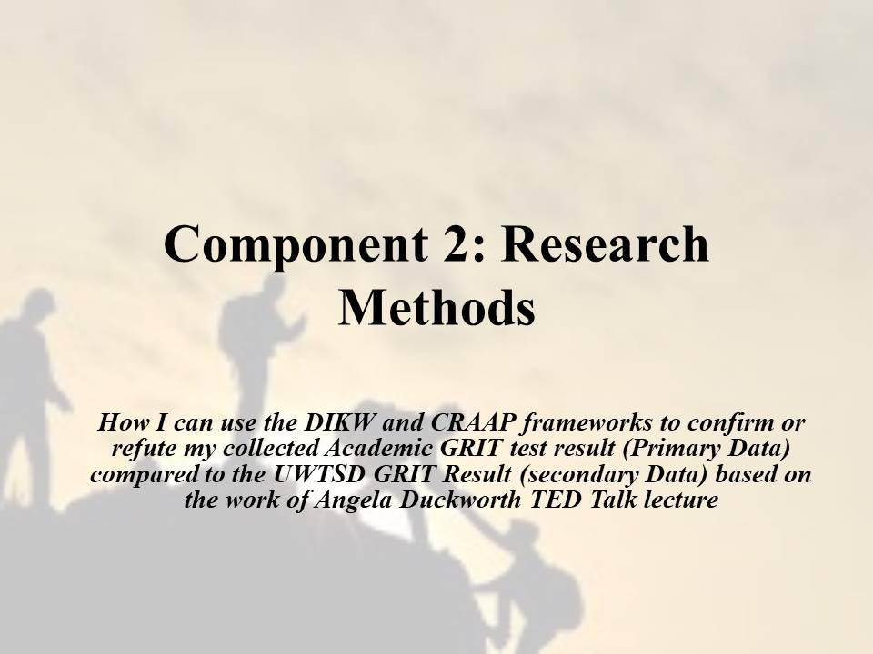

Component 2: Research Methods
“How I can use the DIKW and CRAAP frameworks to confirm or refute my collected Academic GRIT test result (Primary Data) compared to the UWTSD GRIT Result (secondary Data) based on the work of Angela Duckworth TED Talk lecture”
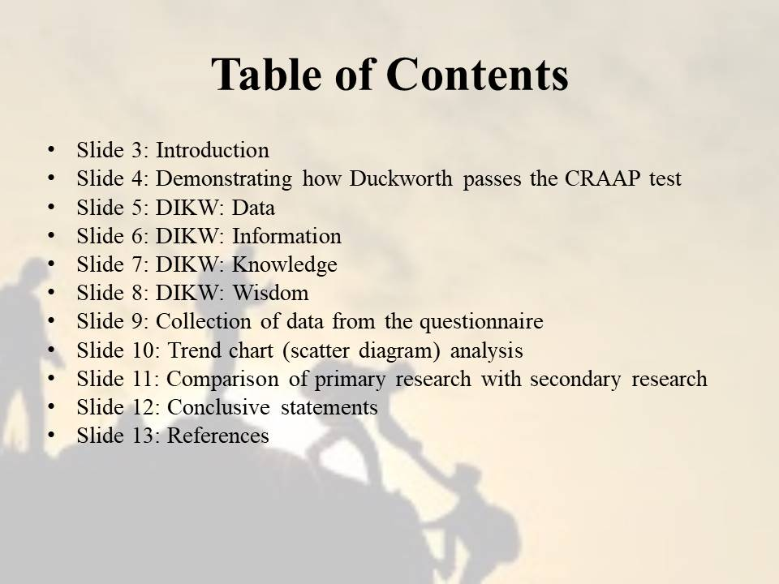

Slide 3: Introduction
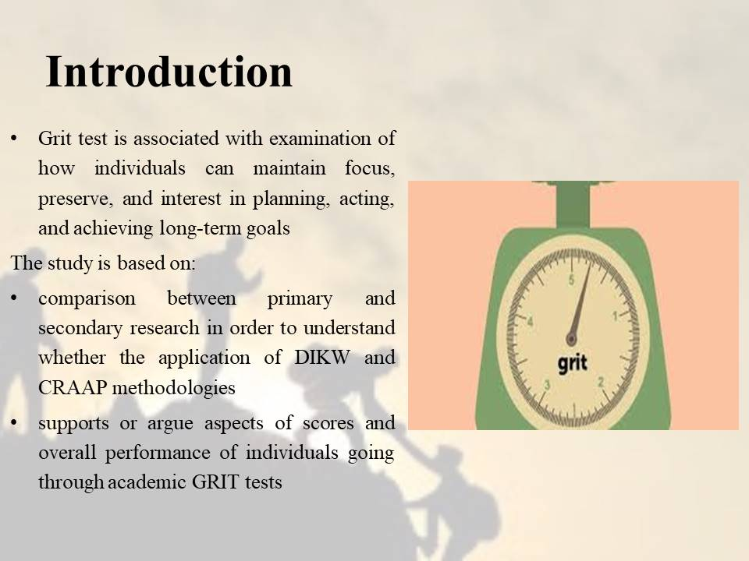
Speaker Note:
Grit test is associated with examination of how individuals can maintain focus, preserve, and interest in planning, acting, and achieving long-term goals. The framework is essential for academic students, as they can identify measures with which they can bring changes in their traits and competence so that in the future they become capable of achieving respective long-term goals. The study is based on comparison between primary and secondary research in order to understand whether the application of DIKW and CRAAP methodologies supports or argue aspects of scores and overall performance of individuals going through academic GRIT tests.

Slide 4: Demonstrating how Duckworth passes the CRAAP test
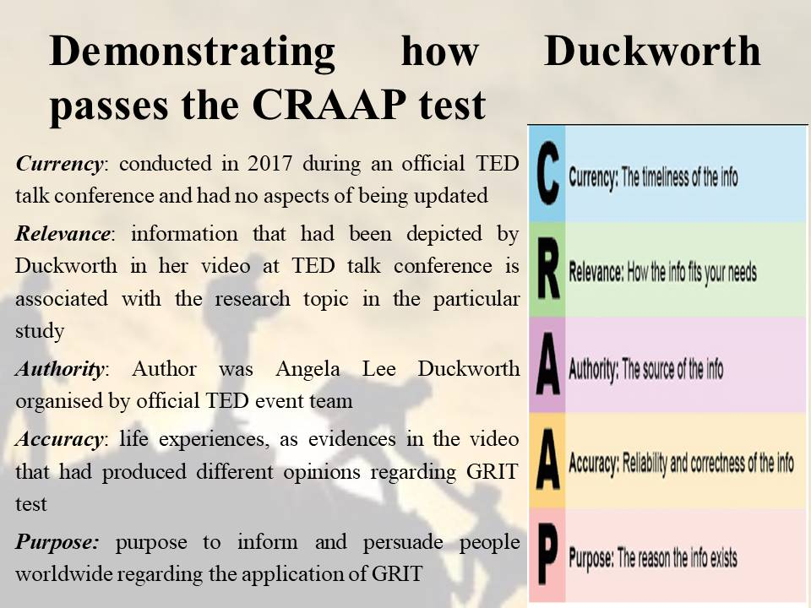
Speaker Note: Angela Lee Duckworth had conducted a seminar in official TED talk conference, which was based on her perception regarding “grit” as a predictor of success. In order to check the overall reliability of information and opinions stated by Angela Lee Duckworth during her session in TED talk, a CRAAP test is necessary, which is as follows:
Currency:
The seminar was conducted in 2017 during an official TED talk conference and had no aspects of being updated, as the information was delivered to public present at the conference and viewers across the globe in the form of video that was posted on TED’s official websites.
Relevance:
The information that had been depicted by Duckworth in her video at TED talk conference is associated with the research topic in the particular study, which is based on identifying how CRAAP and DIKW frameworks is linked with academic GRIT test. The audience for the video conference were people that had been invited in-person during the event as well as people all across the globe that have access to internet and willingness to watch the video. The video included aspect where Duckworth shared her experiences on GRIT, passion, and perseverance thus, do not have any aspect of reference or secondary source. However, a written transcript of the video was prepared by Joseph Geni, which was further reviewed by Morton Bast. The extent of information depicted in the written transcript as well as the video provided details that can be used to carry out the particular research.
Authority:
The author for the video conference session titled as “GRIT: The power of passion and perseverance” was Angela Lee Duckworth, which was organised by official TED event team. Duckworth is a math teacher of seventh grader students in New York public school (Duckworth, 2017). TED that had organised the video conference event is a non-profit company that started as a one-off conference event enterprise, which gained popularity as a brand that creates viral video phenomena worldwide (Ted.com, 2021). TED was the official publisher of the information that had been delivered by Duckworth through her video during the conference.
Accuracy:
Duckworth presented her life experiences, as evidences in the video that had produced different opinions regarding GRIT test and its role in developing passion and perseverance within individuals. Moreover, while transcribing a written transcript of the video refers to the extent of measures undertaken to determine accuracy of information presented by Duckworth. Moreover, concepts of “growth mind-sets” from Caro Dweck, who is a professor in Stanford University, were used as evidence of opinions presented by Duckworth in her video (Duckworth, 2017).
Purpose:
The purpose of the video conference titled as “GRIT: The power of passion and perseverance" had the purpose to inform and persuade people worldwide regarding the application of GRIT to develop extent of passion and perseverance in oneself. From the aspect stated above, it can be said that authors clearly intended to state her opinions regarding the topic by justifying statements based on her experiences and concepts derived from Carol Dweck.

Slide 5: DIKW: Data
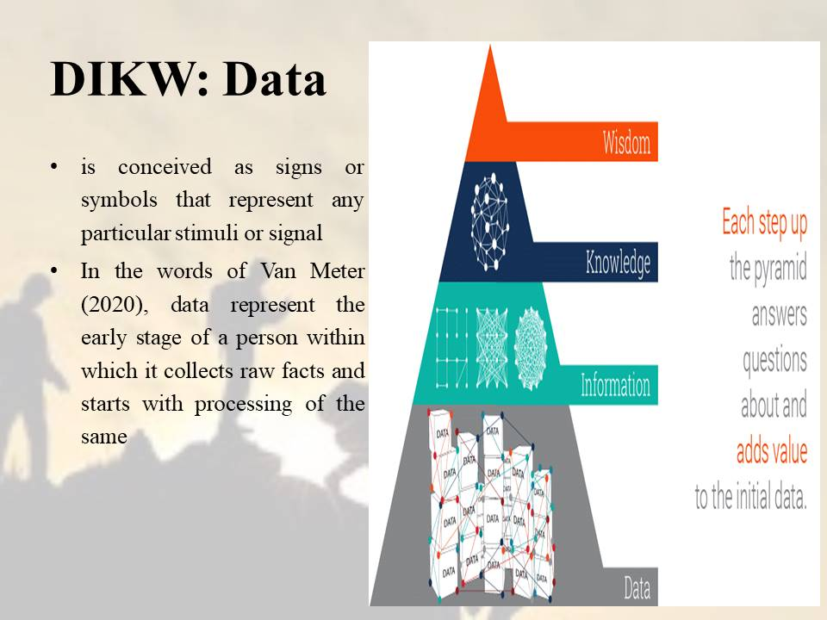
Speaker Note: Data within the DIKW pyramid that is also known as DIKW knowledge pyramid is conceived as signs or symbols that represent any particular stimuli or signal. Data in the path of managing knowledge can be in the form of fact, signal, and symbol that are developed from perception of observing things happening around different environments. In the words of Van Meter (2020), data represent the early stage of a person within which it collects raw facts and starts with processing of the same in order to progress in the path of knowledge management.

Slide 6: DIKW: Information
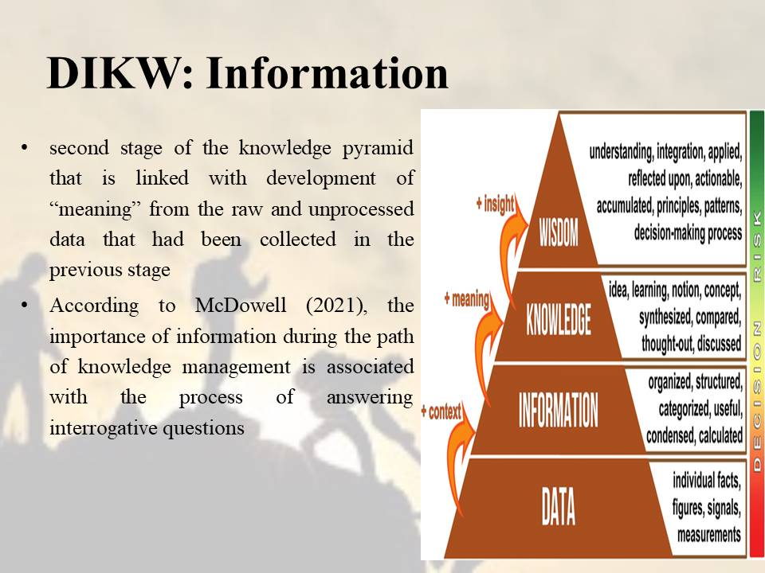
Speaker Note: Information is the second stage of the knowledge pyramid that is linked with development of “meaning” from the raw and unprocessed data that had been collected in the previous stage. According to McDowell (2021), the importance of information during the path of knowledge management is associated with the process of answering interrogative questions such as what, why, how, and so on in order to develop meaning against the collected raw signs or facts developed in the “data” stage. Information that can be developed by individuals during the course of attaining knowledge can be structural or functional as well as objective or symbolic.

Slide 7: DIKW: Knowledge
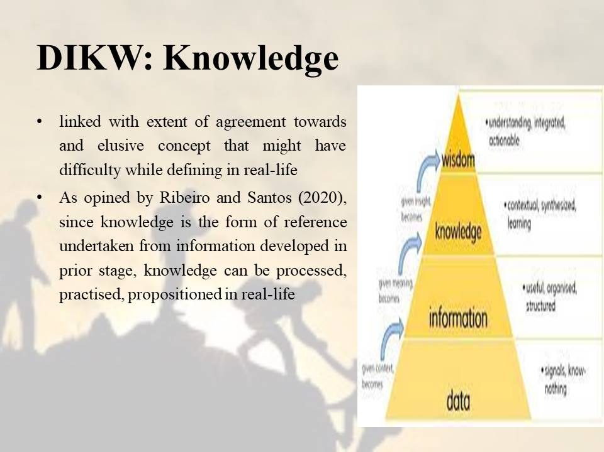
Speaker Note: The knowledge component is linked with extent of agreement towards and elusive concept that might have difficulty while defining in real-life. In accordance to DIKW pyramid knowledge can be developed or rather defined with reference to information. As opined by Ribeiro and Santos (2020), since knowledge is the form of reference undertaken from information developed in prior stage, knowledge can be processed, practised, propositioned in real-life. When an individual reaches the stage of knowledge during its path of managing information and data throughout its life, the individual is said to reach a state where it can developed justified beliefs based on logical, scientific, or mathematical aspects.

Slide 8: DIKW: Wisdom
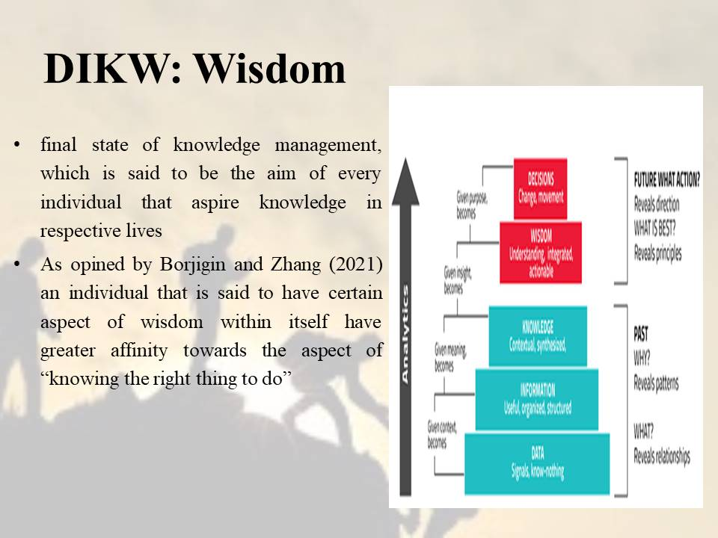
Speaker Note: Wisdom is the final state of knowledge management, which is said to be the aim of every individual that aspire knowledge in respective lives. In the DIKW pyramid, wisdom represents development of “insights” that is a continuous process of learning and making decisions from data, information, and knowledge collected so far in the path of managing knowledge. As opined by Borjigin and Zhang (2021) an individual that is said to have certain aspect of wisdom within itself have greater affinity towards the aspect of “knowing the right thing to do” since at this stage it is supported with higher aspect decision-making competence, which it had be collecting, interpreting, and developing data, information, and knowledge respectively.

Slide 9: Collection of data from the questionnaire
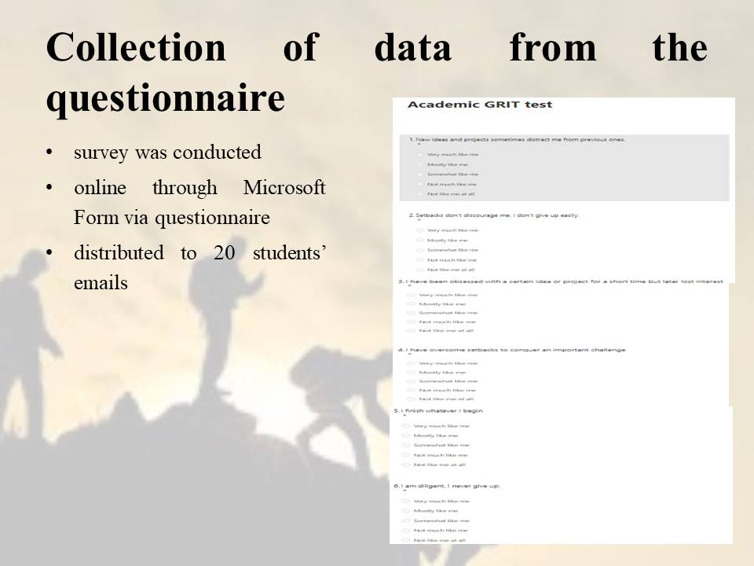
Speaker Note: The survey was conducted through online through Microsoft Form via questionnaire, which was distributed to 20 students’ emails. Responses were collected from the stated samples against the questions prepared for assessment of GRIT test.

Slide 10: Trend chart (scatter diagram) analysis

Speaker Note:

Slide 11: Comparison of primary research with secondary research
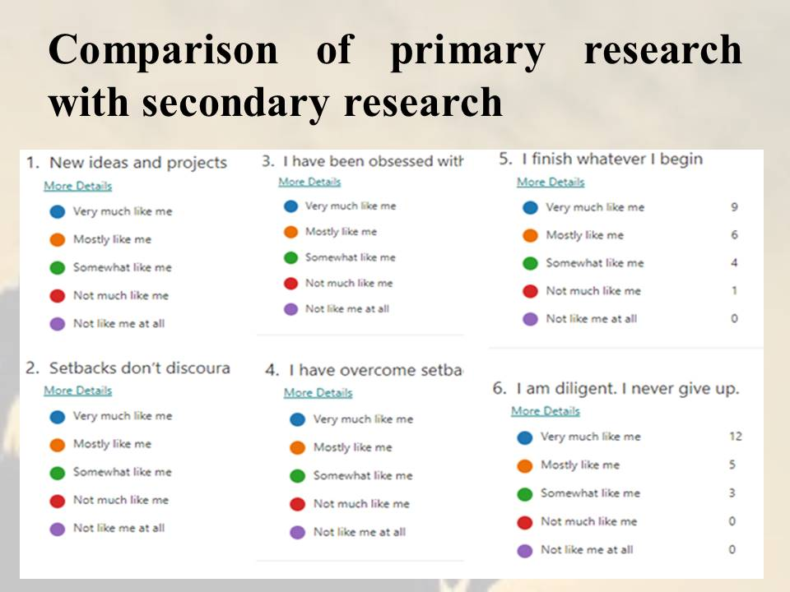
Speaker Note:
From figure 1, it can be seen that most of the respondents are found to be become distracted towards previous projects or ideas when they are assigned with new projects. It depicts that the rate of perseverance shown against an idea, project, or activity is said to be less within people in terms of determination or rather grit. The secondary findings from the Duckworth’s TED video support the fact that people tend to deviate their interests from previous concepts when being indulged in new environment (Duckworth, 2017). She states that this is why education provided to student might focus on better understanding of students and learning from motivational perspective so that they do not deviate from the path of achieving long-term goals as well as staying determined throughout one’s life.
The second figure depicts opinions from students regarding how they feel towards setback experienced in respective lives. In response to the question, majority of respondents stated that setbacks do not discourage them within their respective lives. Most of the respondents shows lack of “giving up” attitude thus, it can be said that the particular attitude is necessary for individuals to develop and cherish lifelong in order to become determined or rather develop higher extent of grit. The aspect can be supported from the opinions of Duckworth where she stated that she want to become a part of most demanding job due to which she switched from regular job in management consulting to teaching profession. She spent several years in teaching math to students of seventh grade however; she was not able to come with the answer of attaining success in life (Duckworth, 2017). The setback of not finding the answer to the above aspect did not demoralised her, as she pursued to become a psychologist by undertaking her graduate degree and finally developed conclusions that supported the fact never giving up and staying determined by nature helps individuals to reach higher extent of success.
The third figure enumerates that how individuals show different level of behaviours of remaining obsessed with any task for short period of time and soon lose interest within the same as the time passes. Students during the survey stated that they are very much likely to lose interest in scenario stated above. It can be due to the fact of limited determination or rather losing patience while carrying out a project for longer duration. It is evident that with time, if the expected completion period of a particular project increases, individuals might procrastinate and finally lose interests within the same. It has been argued by secondary thoughts from Duckworth stating that in order to remain determined in lives and reach higher excellence of success, it is necessary to complete goals planned at initial levels (Duckworth, 2017). If individuals procrastinate and lose the motivation to complete a task, it is not possible for them to plan and achieve goals that they might be developing in the future.
The next figure is associated with the aspect of how people use the experience of overcoming setback in lives as a medium of tackling challenges that they feel to be significant at individual’s end. From the result, it can be seen that higher ratio of students during the survey process consider using learning attained pervious failures or setbacks as a source to develop strategies to tackle challenges in the future. The positive attitude from the end of majority of respondents supports the aspects stated by Duckworth, where she thinks or rather believes grit is sticking with future irrespective of experienced failures and setbacks by developing high endurance, passion, and perseverance levels (Duckworth, 2017).
The last two figures are associated with the never giving up attitude in human beings within which it has been seen that majority of students have positive opinions regarding themselves of never giving up on respective lives. As mentioned above, grit cannot be developed by showing lower level of diligence or perseverance. In order to plan, act accordingly, and achieve long-term goals, Duckworth entitles that it is necessary to show higher patience level during initial learning phases in lives and these developed successful experience will fuel in the path of achieving long-term vision (Duckworth, 2017).

Slide 12: Conclusive statements
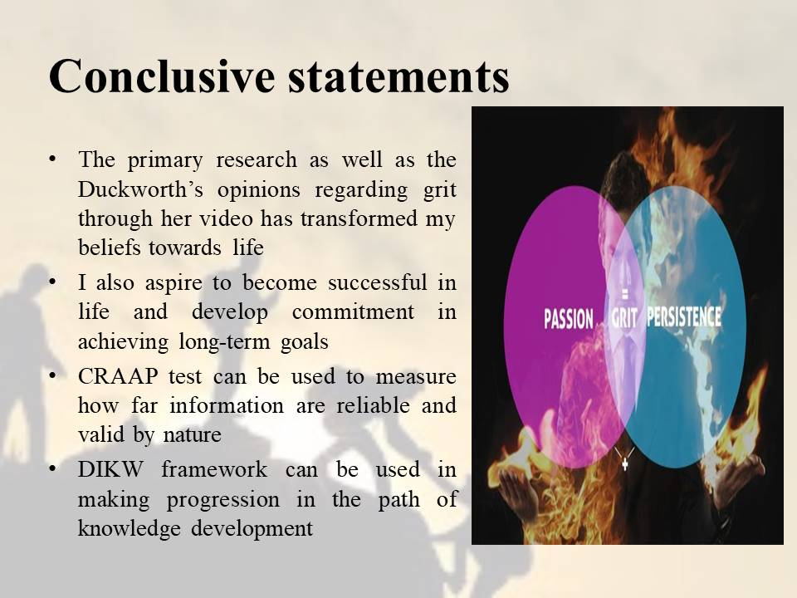
Speaker Note: From the above aspects, I can say that the primary research as well as the Duckworth’s opinions regarding grit through her video has transformed my beliefs towards life. From now on, I shall be focusing not only to develop passion and perseverance towards activity but will also come up with strategies to maintain them. It is because I also aspire to become successful in life and develop commitment in achieving long-term goals. The CRAAP test and the application of DIKW framework can be used to measure how far information are reliable and valid by nature and how it can be used in making progression in the path of knowledge development.

Slide 13: References
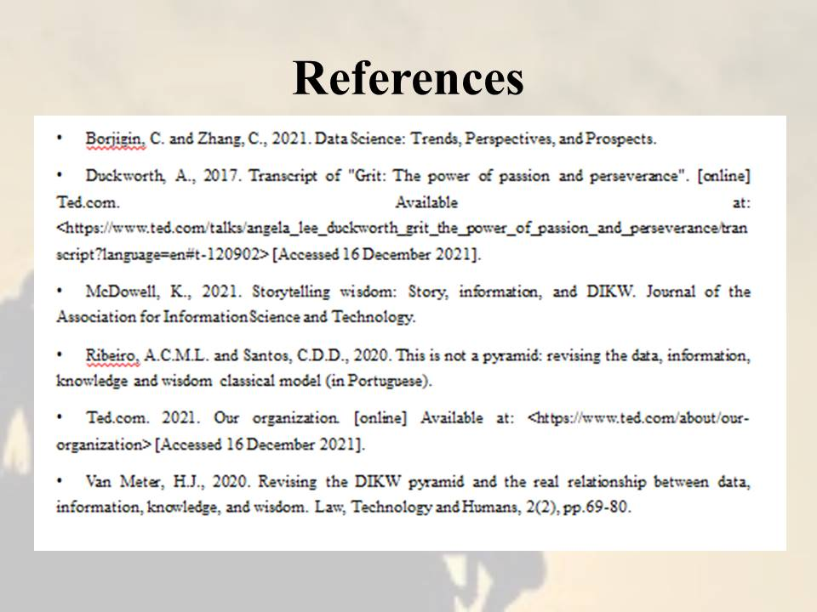
Speaker Note:
Borjigin, C. and Zhang, C., 2021. Data Science: Trends, Perspectives, and Prospects.
Duckworth, A., 2017. Transcript of "Grit: The power of passion and perseverance". [online] Ted.com. Available at: <https://www.ted.com/talks/angela_lee_duckworth_grit_the_power_of_passion_and_perseverance/transcript?language=en#t-120902> [Accessed 16 December 2021].
McDowell, K., 2021. Storytelling wisdom: Story, information, and DIKW. Journal of the Association for Information Science and Technology.
Ribeiro, A.C.M.L. and Santos, C.D.D., 2020. This is not a pyramid: revising the data, information, knowledge and wisdom classical model (in Portuguese).
Ted.com. 2021. Our organization. [online] Available at: <https://www.ted.com/about/our-organization> [Accessed 16 December 2021].
Van Meter, H.J., 2020. Revising the DIKW pyramid and the real relationship between data, information, knowledge, and wisdom. Law, Technology and Humans, 2(2), pp.69-80.

