
Sports Independent Project
Applied Portfolio

Student Name  Bailey Wright | Project Title  SPOrTAMATE App
Project Aim (1)
The design of a SPOrTAMATE App to increase participation, motivation, and social engagement in sport and physical activity settings.

Objectives (3/4)

• Develop a conceptual design and virtual proposal for the SPOrTAMATE platform, outlining its core features, functionality, and intended impact on participation.
- Identify and analyse the key barriers preventing individuals from participating in sport, with a focus on the role of social support and peer connection in physical activity engagement.
- To design of a SPOrTAMATE app to increase motivation in sport.

Contents Page
 | 1.1 - Element 1 – Individual Presentation (5 minutes – Online) |  | 3
 | 1.2 Element 1 Ethics Form
 |  | 1.2a About You (Principal Researcher) | 4,5
 |  | 1.2b Details of Research Activity | 6,7
 |  | 1.2c Scope of Research Activity | 8
 |  | 1.2d Intended Participants | 9,10
 |  | 1.2e Anticipated Risks | 11,12
 |  | 1.2f Feedback, Consent and Confidentiality | 13
 |  | 1.2g Data Protection and Storage | 14, 15, 16
 |  | 1.2h Declaration | 17
 | 2 – Element 2 – Literature Review
 | 2.1 Introduction |  | 19,20
 | 2.2 Benefits of Sport Participation |  | 21,22
 | 2.3 Barriers to Sport Participation |  | 23,24
 | 2.4 Social Support and Peer Connection in Sport Participation |  | 25
 | 2.5 Motivation and Behaviour Change Theory in Sport Participation |  | 26,27
 | 2.6 Digital Technology and Sport Participation |  | 28,29
 | 2.7 Conclusion |  | 30,31
 | 3 - Element 3 – 5000 Word Document or 30 minute Video (SPOrTAMATE)
 |  | Front Page | 33
 |  | Videos I Used In My App | 33,34
 |  | 4 – Reflection, Conclusion, Recommendations | 36,37,38
 |  | 5 - Reference List | 39
 |  | 6 – Bibliography | 40
 |  | 7 - Appendices  - All screenshots of app just in case link to it doesn't work | 41, 42, 43, 44, 45, 46, 47, 48, 49, 50, 51, 52, 53, 54, 55, 56, 57, 58, 59, 60, 61, 62, 63, 64

Element 1 - Individual Presentation (5 minutes – Online)
https://youtu.be/SJNNDYDvZ_k?si=KzsNOh9zC789NTTZ


Element 1 – Ethics Form (All Pages)

ETHICAL CONSIDERATIONS

https://youtu.be/SJNNDYDvZ_k?si=KzsNOh9zC789NTTZ
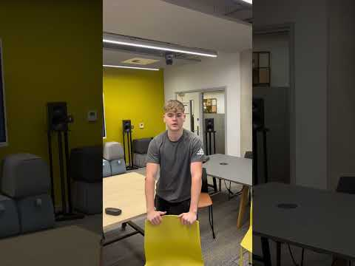

For research to result in benefit and minimise risk of harm, it must be conducted ethically. A researcher may not be covered by the University’s insurance if ethical approval has not been obtained prior to commencement.

The University follows the OECD Frascati manual definition of research activity: “creative work undertaken on a systematic basis in order to increase the stock of knowledge, including knowledge of man, culture and society, and the use of this stock of knowledge to devise new applications”. As such this covers activities undertaken by members of staff, postgraduate research students, and both taught postgraduate and undergraduate students working on dissertations/projects.

The individual undertaking the research activity is known as the “principal researcher”.

Ethical approval is not required for routine audits, performance reviews, quality assurance studies, testing within normal educational requirements, and literary or artistic criticism.

Please read the notes for guidance before completing ALL sections of the form.

This form must be completed and approved prior to undertaking any research activity. Please see Checklist for details of process for different categories of application.

SECTION A: About You (Principal Researcher)
1 | Full Name: |  | Bailey Wright
2 | Tick all boxes that apply: |  | Member of staff: | ☐ | Honorary research fellow: | ☐
 | Undergraduate Student | ☒ | Taught Postgraduate Student | ☐ | Postgraduate Research Student | ☐

3 | Institute/Academic Discipline/Centre: | Institute
4 | Campus: | Swansea Waterfront
5 | E-mail address: | 2224298@student.uwtsd.ac.uk
6 | Contact Telephone Number: | 07467515603
 | For students:
7 | Student Number: | 2224298
8 | Programme of Study: | Sports Management
9 | Director of Studies/Supervisor: | Andrew Thomas

Where research activity is carried out in collaboration with an external organisation
10 | Does this organisation have its own ethics approval system? | YES | ☒ | NO | ☐
 | If Yes, please attach a copy of any final approval (or interim approval) from the organisation (this may be a copy of an email if appropriate).

SECTION B: Details of Research Activity
1 | Indicative title: | SPOrTAMATE
2 | Proposed start date: | 30/10/2025 | Proposed end date: | 30/04/2026
Introduction to the Research (maximum 300 words per section)
Ensure that you write for a Non-Specialist Audience when outlining your response to the points below:
- Purpose of Research Activity
- Proposed Research Question
- Aims of Research Activity
- Objectives of Research Activity
Demonstrate, briefly, how Existing Research has informed the proposed activity and explain
- What the research activity will add to the body of knowledge
- How it addresses an area of importance.
3 | Purpose of Research Activity  Athletes tend to struggle with starting sports or going to the gym on their own as some people feel like it is a big burden to jump into something new. I have also suffered with the problem of limiting myself from going to the gym or playing sports as I didn't feel comfortable trying something new on my own. This website will hopefully help people connect and avoid the situation I've been in  (this box should expand as you type)
5 | Aim of Research Activity  The creation of an app to help people find peers/teammates for sports they want to play instead of playing sports on their own.  (this box should expand as you type)
6 | Objectives of Research Activity  Make a video explaining the app idea considering ethical implications. Highlighting the main findings with research about solo participation in sport and the difference in participation with a partner. The creation of this app is to help people struggling to play sports on their own to find a partner.  (this box should expand as you type)
 | Existing Research
7 | Having research will help my proposal with statistics and facts on how the participation in sport increases when participating with a peer and how having a community helps with athletes wanting to play sports or take part in physical activities.

 | Does your research relate to one or more of the seven aims of the Well-being of Future Generations (Wales) Act 2015? | YES | NO
12 | A prosperous Wales | ☐ | ☒
13 | A resilient Wales | ☐ | ☒
14 | A healthier Wales | ☒ | ☐
15 | A more equal Wales | ☐ | ☒
16 | A Wales of cohesive communities | ☒ | ☒
17 | A Wales of vibrant culture and thriving Welsh language | ☐ | ☒
18 | A globally responsible Wales | ☐ | ☒
19 | If YES to any of the above, please give details:
This apps creates a healthier Wales and encourages people to get involved in sport with peers and gets them feeling active. It helps with a cohesive community as it brings strangers together as a team whether that be in a Team sport or just a simple gym session bringing communities together
(this box should expand as you type)

SECTION C: Scope of Research Activity
 | Will the research activity include: | YES | NO
1 | Use of a questionnaire or similar research instrument? |  | x
2 | Use of interviews? | ☐ | ☒
3 | Use of focus groups? | ☐ | ☒
4 | Use of participant diaries? | ☐ | ☒
5 | Use of video or audio recording? | ☒ | ☐
6 | Use of computer-generated log files? | ☐ | ☒
7 | Participant observation with their knowledge? | ☐ | ☒
8 | Participant observation without their knowledge? | ☐ | ☒
9 | Access to personal or confidential information without the participants’ specific consent? | ☐ | ☒
10 | Administration of any questions, test stimuli, presentation that may be experienced as physically, mentally or emotionally harmful / offensive? | ☐ | ☒
11 | Performance of any acts which may cause embarrassment or affect self-esteem? | ☐ | ☒
12 | Investigation of participants involved in illegal activities? | ☐ | ☒
13 | Use of procedures that involve deception? | ☐ | ☒
14 | Administration of any substance, agent or placebo? | ☐ | ☒
15 | Working with live vertebrate animals? | ☐ | ☒
16 | Procedures that may have a negative impact on the environment? | ☐ | ☒
17 | Other primary data collection methods. Please indicate the type of data collection method(s) below. | ☐ | ☒
 | Details of any other primary data collection method:  (this box should expand as you type) | ☐ | ☒
If NO to every question, then the research activity is (ethically) low risk and may be exempt from some of the following sections (please refer to Guidance Notes).

If YES to any question, then no research activity should be undertaken until full ethical approval has been obtained.

SECTION D: Intended Participants
If there are no participants then do not complete this section, but go directly to section H.

 | Who are the intended participants: | YES | NO
1 | Students or staff at the University? | ☐ | ☐
2 | Adults (over the age of 18 and competent to give consent)? | ☒ | ☐
3 | Vulnerable adults? | ☐ | ☒
4 | Children and Young People under the age of 18? (Consent from Parent, Carer or Guardian will be required) | ☐ | ☒
5 | Prisoners? | ☐ | ☒
6 | Young offenders? | ☐ | ☒
7 | Those who could be considered to have a particularly dependent relationship with the investigator or a gatekeeper? | ☐ | ☒
8 | People engaged in illegal activities? | ☐ | ☒
9 | Others. Please indicate the participants below, and specifically any group who may be unable to give consent. | ☐ | ☒
 | Details of any other participant groups:  (this box should expand as you type) | ☐ | ☒

Participant numbers and source
Provide an estimate of the expected number of participants. How will you identify participants and how will they be recruited?
10 | How many participants are expected? | Unlimited  (this box should expand as you type)
11 | Who will the participants be? | Anyone over the age of 18  (this box should expand as you type)
12 | How will you identify the participants? | I will advertise online, and they will come to me. For athletes looking for peers to get involved with helping them meet new people  (this box should expand as you type)

 | Information for participants: | YES | NO | N/A
13 | Will you describe the main research procedures to participants in advance, so that they are informed about what to expect? | ☐ | ☐ | ☒
14 | Will you tell participants that their participation is voluntary? | ☐ | ☐ | ☒
15 | Will you obtain written consent for participation? | ☐ | ☐ | ☒
16 | Will you explain to participants that refusal to participate in the research will not affect their treatment or education (if relevant)? | ☐ | ☐ | ☒
17 | If the research is observational, will you ask participants for their consent to being observed? | ☐ | ☐ | ☒
18 | Will you tell participants that they may withdraw from the research at any time and for any reason? | ☐ | ☐ | ☒
19 | With questionnaires, will you give participants the option of omitting questions they do not want to answer? | ☐ | ☐ | ☒
20 | Will you tell participants that their data will be treated with full confidentiality and that, if published, it will not be identifiable as theirs? | ☐ | ☐ | ☒
21 | Will you debrief participants at the end of their participation, in a way appropriate to the type of research undertaken? | ☐ | ☐ | ☒
22 | If NO to any of above questions, please give an explanation
 | (this box should expand as you type)

 | Information for participants: | YES | NO | N/A
24 | Will participants be paid? | ☐ | ☐ | ☒
25 | Is specialist electrical or other equipment to be used with participants? | ☐ | ☐ | ☒
26 | Are there any financial or other interests to the investigator or University arising from this study? | ☐ | ☐ | ☒
27 | Will the research activity involve deliberately misleading participants in any way, or the partial or full concealment of the specific study aims? | ☐ | ☐ | ☒
28 | If YES to any question, please provide full details
 | (this box should expand as you type)

SECTION E: Anticipated Risks

Outline any anticipated risks that may adversely affect any of the participants, the researchers and/or the University, and the steps that will be taken to address them.

If you have completed a full risk assessment (for example as required by a laboratory, or external research collaborator) you may append that to this form.
1 | Full risk assessment completed and appended? |  | Yes | ☐
1 |  |  | No | ☒
2 | Risks to participants  For example: sector-specific health & safety, emotional distress, financial disclosure, physical harm, transfer of personal data, sensitive organisational information
 | Risk to participants:  People they meet may not be as friendly as they should be, theymay not get along with the person as well as they could.  (this box should expand as you type) | How you will mitigate the risk to participants:  Users need to verify their profile, will also have a safety guidance within the app with a report and block system too.  (this box should expand as you type)
3 | If research activity may include sensitive, embarrassing or upsetting topics (e.g. sexual activity, drug use) or issues likely to disclose information requiring further action (e.g. criminal activity), give details of the procedures to deal with these issues, including any support/advice (e.g. helpline numbers) to be offered to participants. Note that where applicable, consent procedures should make it clear that if something potentially or actually illegal is discovered in the course of a project, it may need to be disclosed to the proper authorities
Participation is voluntary and all up to them. All data is anonymous and no identifying information will be detected.

(this box should expand as you type)
4 | Risks to the investigator  For example: personal health & safety, physical harm, emotional distress, risk of accusation of harm/impropriety, conflict of interest
 | Risk to the investigator:  Minimal risks, no face-to-face data collection. Will avoid collecting personal information to prevent risks.  (this box should expand as you type) | How you will mitigate the risk to the investigator  Having the right support line and guidance to the investigator if needed  (this box should expand as you type)
5 | University/institutional risks  For example: adverse publicity, financial loss, data protection
 | Risk to the University:  Data protection  (this box should expand as you type) | How you will mitigate the risk to the University:  Correct guidance to any data being used on the website  (this box should expand as you type)
6 | Environmental risks  For example: accidental spillage of pollutants, damage to local ecosystems
 | Risk to the environment:  n/a  (this box should expand as you type) | How you will mitigate the risk to environment:  n/a  (this box should expand as you type)

 | Disclosure and Barring Service
 | If the research activity involves children or vulnerable adults, a Disclosure and Barring Service (DBS) certificate must be obtained before any contact with such participants. | YES | NO | N/A
7 | Does your research require you to hold a current DBS Certificate? | ☐ | ☐ | ☒
8 | If YES, please give the certificate number. If the certificate number is not available, please write “Pending”; in this case any ethical approval will be subject to providing the appropriate certificate number.

SECTION F: Feedback, Consent and Confidentiality

1 | Feedback  What de-briefing and feedback will be provided to participants, how will this be done and when?
We will have a review page for users to give feedback.

(this box should expand as you type)
2 | Informed consent  Describe the arrangements to inform potential participants, before providing consent, of what is involved in participating. Describe the arrangements for participants to provide full consent before data collection begins. If gaining consent in this way is inappropriate, explain how consent will be obtained and recorded in accordance with prevailing data protection legislation.
They will need to give consent before taking part in these surveys to protect their own data as we could use their feedback to help others in similar situations

(this box should expand as you type)
3 | Confidentiality / Anonymity  Set out how anonymity of participants and confidentiality will be ensured in any outputs. If anonymity is not being offered, explain why this is the case.
Anonymity will not be offered as this is an app where people meet up and take part in sports together so it would require people to not be anonymous for safety reasons

(this box should expand as you type)

SECTION G: Data Protection and Storage

 | Does the research activity involve personal data (as defined by the General Data Protection Regulation 2016 “GDPR” and the Data Protection Act 2018 “DPA”)? | YES | NO
1 | “Personal data” means any information relating to an identified or identifiable natural person (‘data subject’). An identifiable natural person is one who can be identified, directly or indirectly, in particular by reference to an identifier such as a name, an identification number, location data, an online identifier or to one or more factors specific to the physical, physiological, genetic, mental, economic, cultural or social identity of that natural person. Any video or audio recordings of participants is considered to be personal data. | x | ☐
 | If YES, provide a description of the data and explain why this data needs to be collected:
2 | The data could be used to connect people to each other who are in a similar position where they need a partner for a sport. This will help people build relationships.  (this box should expand as you type)
 | Does it involve special category data (as defined by the GDPR)? | YES | NO
3 | “Special category data” means sensitive personal data consisting of information as to the data subjects’ –  (a) racial or ethnic origin,  (b) political opinions,  (c ) religious beliefs or other beliefs of a similar nature,  (d) membership of a trade union (within the meaning of the Trade Union and Labour Relations (Consolidation) Act 1992),  (e) physical or mental health or condition,  (f) sexual life,  (g) genetics,  (h) biometric data (as used for ID purposes), | x | ☐
 | If YES, provide a description of the special category data and explain why this data needs to be collected:
4 | Our website could need data such as physical or mental health conditions to provide them with possibly people physical conditions  (this box should expand as you type)

 | Will data from the research activity (collected data, drafts of the thesis, or materials for publication) be stored in any of the following ways? | YES | NO
5 | Manual files (i.e. in paper form)? | ☐ | ☒
6 | University computers? | ☒ | ☐
7 | Private company computers? | ☐ | ☒
8 | Home or other personal computers? | ☒ | ☐
9 | Laptop computers/ CDs/ Portable disk-drives/ memory sticks? | ☒ | ☐
10 | “Cloud” storage or websites? | ☒ | ☐
11 | Other – specify: | ☐ | ☒
12 | For all stored data, explain the measures in place to ensure the security of the data collected, data confidentiality, including details of backup procedures, password protection, encryption, anonymisation and pseudonymisation:
User data is stored securely on encrypted servers. Passwords are safeguarded, and information is encrypted both in transit and at rest. Whenever feasible, personal information is obscured or substituted with codes. Access to the data is restricted to authorized personnel only, and frequent backups are conducted. We collect only the necessary information and comply with all data protection regulations.

(this box should expand as you type)

 | Data Protection
 | Will the research activity involve any of the following activities: | YES | NO
13 | Electronic transfer of data in any form? | ☒ | ☐
14 | Sharing of data with others at the University outside of the immediate research team? | ☐ | ☒
15 | Sharing of data with other organisations? | ☐ | ☒
16 | Export of data outside the UK or importing of data from outside the UK? | ☐ | ☒
17 | Use of personal addresses, postcodes, faxes, emails or telephone numbers? | ☐ | ☒
18 | Publication of data that might allow identification of individuals? | ☐ | ☒
19 | Use of data management system? | ☒ | ☐
20 | Data archiving? | ☒ | ☐
21 | If YES to any question, please provide full details, explaining how this will be conducted in accordance with the GDPR and Data Protection Act (2018) (and any international equivalents, where appropriate):
Data will be anonymous, stored securely, and only the researcher and supervisor will have access. Managed under GDPR and Data Protection Act (2018).

(this box should expand as you type)
22 | List all who will have access to the data generated by the research activity:
The researcher and supervisor only.

(this box should expand as you type)
23 | List who will have control of, and act as custodian(s) for, data generated by the research activity:
The researcher under supervisor oversight.

(this box should expand as you type)
24 | Give details of data storage arrangements, including security measures in place to protect the data, where data will be stored, how long for, and in what form. Will data be archived – if so how and if not why not.
Password-protected OneDrive.

(this box should expand as you type)
25 | Please indicate if your data will be stored in the UWTSD Research Data Repository (see https://researchdata.uwtsd.ac.uk/ ). If so please explain. (Most relevant to academic staff)
NO

(this box should expand as you type)
26 | Confirm that you have read the UWTSD guidance on data management (see https://www.uwtsd.ac.uk/library/research-data-management/) | YES | ☒
27 | Confirm that you are aware that you need to keep all data until after your research has completed or the end of your funding | YES | ☒

SECTION H: Declaration
The information which I have provided is correct and complete to the best of my knowledge. I have attempted to identify any risks and issues related to the research activity and acknowledge my obligations and the rights of the participants.

In submitting this application I hereby confirm that I undertake to ensure that the above namedresearch activity will meet the University’s Research Ethics and Integrity Code of Practice which is published on the website: https://www.uwtsd.ac.uk/research/research-ethics/
1 | Signature of applicant: | Bwright | Date:  02/11/2025

Checklist: Please complete the checklist below to ensure that you have completed the form according to the guidelines and attached any required documentation:
☒ | I have read the guidance notes supplied before completing the form.
☒ | I have completed ALL RELEVANT sections of the form in full.
☒ | I confirm that the research activity has received approval in principle
☒ | I have attached a copy of final/interim approval from external organisation (where appropriate)
☒ | I have attached a full risk assessment (where appropriate) ONLY TICK IF YOU HAVE ATTACHED A FULL RISK ASSESSMENT
☒ | I understand that it is my responsibility to ensure that the above named research activity will meet the University’s Research Ethics and Integrity Code of Practice.
☒ | I understand that before commencing data collection all documents aimed at respondents (including information sheets, consent forms, questionnaires, interview schedules etc.) must be confirmed by the DoS/Supervisor, module tutor or Academic Director.

RESEARCH STUDENTS ONLY
Once complete, submit this form via the MyTSD Doctoral College Portal at (https://mytsd.uwtsd.ac.uk).

STUDENTS ON UNDERGRADUATE OR TAUGHT MASTERS PROGRAMMES should submit this form (and receive the outcome) via systems explained to you by the supervisor/module leader.

Element 2 - Literature Review (3000 words)
Introduction
The project's goal is to come up with ideas for and evaluate the development of SPOrTAMATE, a digital platform that will help people connect with each other to do sports and other physical activities. This aim is supported by evidence that social support and peer friendship play a key role in motivating individuals to begin and sustain engagement in sport and physical activity (Scarapicchia et al., 2017; Zhang and Chang, 2022). Research shows that not having good partners and social support is a big reason people don't participate, especially in casual and recreational sports (Sport England, 2004; Brand, 2022). Sparton and Chelladurai (1981) and Li, Huang, and Sun (2025) say that SPOrTAMATE tries to lower social and psychological barriers to participation by helping people find and connect with suitable partners or small groups based on shared interests, availability, and location. To go along with motivation and behaviour change theory even more, the project wants to boost freedom, connections, and confidence, which are known to be important factors in keeping people involved in sports (Braga-Pereira et al., 2025; Zhang and Chang, 2022). By taking this approach, the project hopes to give a reason based on evidence for creating a socially driven, app-based intervention to make sports more accessible and encourage people to keep playing. Regular participation in sport and physical activity is commonly recognised as necessary for physical health, psychological well-being and social development (Tanır and Özmaden, 2018). Despite these proven benefits, participation rates in sport remain consistently low across many population groups, with evidence suggesting that engagement has slowed over recent decades, particularly among young adults and groups with less wealth (Sport England, 2004). This decline presents a significant challenge for sports lawmakers, practitioners, and organisations trying to promote lifetime participation and address growing health gaps (Rowe, Adams, & Beasley, 2004). Research regularly points out a range of difficulties that prevent further engagement in sports, including time limitations, lack of motivation, accessibility issues, and being alone (Sport England, 2004). Among these, the lack of social support and peer connection has been identified as a key factor influencing both initial participation and long-term participation (Sheridan, Coffee and Lavallee, 2014). Social support, defined as the exchange of emotional, informational, or practical resources between individuals, plays a major role in shaping motivation, enjoyment, and commitment to sport and physical activity (Sheridan, Coffee, & Lavallee, 2014). Studies in sport psychology and public health indicate that individuals are more inclined to engage in and maintain physical activity when it is shared with others or supported by significant social connections (Tanır and Özmaden, 2018). On the other hand, a lack of relationships has been linked to higher dropout rates and reduced motivation, particularly in casual and social sport settings (Sport England, 2004). Traditional sports club structures, while beneficial for some, are often viewed as strict and exclusive, restricting their appeal to individuals looking for casual, immediate participation opportunities (Rowe et al., 2004). The growth of digital technology has changed how people make friends and find fun things to do, opening up new ways to support participation through app-based platforms (Rowe et al., 2004). To respond to these challenges, this project proposes the design of SPOrTAMATE, a digital platform designed to help peer matching for sport and physical activity. By allowing individuals to identify partners or small groups based on shared interests, availability and location, SPOrTAMATE aims to reduce barriers to taking part and promote more flexible, socially supported participation in sports. This literature review thoroughly looks at existing research on sport participation, social support, and digital support to establish a theoretical and practical foundation for the project and facilitate the development of an app-based program to tackle contemporary participation challenges.

Benefits of Sport Participation
Participation in sport and physical activity is commonly associated with significant physical health benefits, including drops in the risk of chronic disease, improvements in cardiovascular fitness, and enhanced overall physical ability (Malm et al., 2019). Regular engagement in sport has been shown to positively impact physique, metabolic health, and blood pressure control, leading to improved long-term health outcomes across diverse populations (Malm et al., 2019). Research proves that even low levels of sport participation provide important health benefits when compared to physical inactivity, emphasising the importance of accessible participation opportunities (Malm et al., 2019). Additionally, physical health outcomes and sport participation are strongly linked to psychological and mental health benefits. Hallam et al. (2021) found that participation in organised physical activity programs resulted in significant reductions in stress, anxiety, and sleep-related problems, along with improvements in overall well-being. These findings support wider evidence suggesting that physical activity can act as both a prevention and treatment intervention for mental health conditions such as depression and anxiety (Malm et al., 2019). Importantly, psychological benefits have been observed whatever the performance level, showing that participation itself, rather than competitive success, is essential to improved mental wellbeing (Hallam et al., 2021). Sport participation also provides important social and psychosocial benefits that add to overall quality of life. Engagement in sport can boost self-esteem, confidence, and personal growth, particularly when participation occurs within social or group-based environments (Malm et al., 2019). Social interaction through sport promotes feelings of belonging and community, which are key factors of psychological wellbeing and continuous participation (Wann et al., 2017). Wann et al. (2017) found that identification with sport-related groups is positively associated with a sense of meaning and social identity, which highlights the wider social value of sport participation. Long-term improvements in health and function have also been linked to regular participation in social and lifestyle activities, such as sports. (Johansson et al., 2019) found that long-term participation in social activities was linked to better quality of life and engagement. This data shows how important it is to keep participating instead of just getting involved for a short time (Johansson et al., 2019). The results of all of these studies indicate that playing sports has many benefits, including improving physical and mental health and bringing people together. These results show how important it is to create participation programmes that make things easier for people to access, get involved with others, and stay with them for a long time; such initiatives will help projects like SPOrTAMATE.

Barriers to Sport Participation
Despite the recognised benefits of sporting participation, research consistently identifies multiple barriers that prevent individuals from engaging in regular physical activity (Malm, Jakobsson, and Isaksson, 2019). These obstacles are complex and work across structural, social, psychological, and organisational aspects; they often interact to restrict participation opportunities. (Brand, 2022). (Malm, Jakobsson and Isaksson, 2019) argue that participation inequalities continue even where opportunities exist, suggesting that barriers extend beyond physical access alone. Structural barriers are frequentlyidentified as a primary obstacle to sport participation. These include limited access to facilities, financial costs, transport difficulties, and fixed scheduling, which significantly affect individuals with fewer resources (Brand, 2022). The existence of such barriers reduces the likelihood of both initial engagement and long-term adherence to sport participation (Brand, 2022). Lack of structural support within community sport environments further strengthens exclusion by failing to satisfy diverse needs and lifestyles (Social barriers to sports practice by people with disabilities, 2023). Social barriers also significantly influence participation behaviour, a lack of social support and a lack of peers to participate with have been identified as major obstacles to sport engagement (Social barriers to sports practice by people with disabilities, 2023). People who don't experience social support or inclusion in sport environments are at a higher risk of quitting or completely avoiding participation (Brand, 2022). Social isolation within sport settings has been shown to decrease motivation and confidence, particularly in casual participation environments (Malm, Jakobsson and Isaksson, 2019). Psychological limitations further add to these challenges. Fear of judgement, low self-confidence, and anxiety related to performance or social evaluation have been identified as serious barriers of participation (Yang and Zhang, 2023). (Yang and Zhang 2023) show that psychological obstacles can prevent individuals from beginning sport participation, especially in environments viewed as competitive or vital. Such psychological barriers highlight the importance of creating participation opportunities that reduce pressure and prioritise social comfort over performance outcomes (Yang and Zhang, 2023). Organisational barriers have also been identified as important issues limiting participation. Zanin et al. (2021) argue that rigid organisational structures and traditional distribution models can dismiss individuals whose motivations do not comply with competitive or performance-driven sport cultures (Zanin et al., 2021). The disconnect between organisational expectations and participant needs can result in reduced engagement and increased dropout rates (Zanin et al., 2021). Brand (2022) further states that sport systems often place responsibility on individuals to overcome barriers rather than addressing restrictive organisational methods (Brand, 2022). The study collectively shows that obstacles to sport participation are not just due to individual choice or motivation. Instead, participation is restricted by interacting structural, social, psychological, and organisational factors that limit access and inclusion (Brand, 2022; Social barriers to sports practice by people with disabilities, 2023). These findings suggest a clear need for different participation models that reduce dependence on traditional sport structures and prioritise social accessibility (Malm, Jakobsson and Isaksson, 2019). Digital platforms that enable peer connection and casual participation, such as the proposed SPOrTAMATE app, directly address these identified barriers by reducing social isolation and increasing flexibility (Brand, 2022).

Social Support and Peer Connection in Sport Participation
Many people agree that social support is an important factor in deciding whether or not someone will participate in sports or other physical activities (Scarapicchia et al., 2017). Social support is the emotional, informational, practical, and companionship-based help that people give and receive through their social relationships. All of these types of support can affect how much people participate(Scarapicchia et al., 2017). There is evidence that people who feel more social support are more likely to start and keep up with sports and other physical activities (Scarapicchia et al., 2017). Peer support is a type of social support that is especially important for people who play sports (Li, Huang, and Sun, 2021). Support from peers has been linked to giving more motivation, enjoyment, and sticking with physical activity, especially when doing it for a long time (Scarapicchia et al., 2017). However, the effectiveness of peer support depends on how it’s set up and how people see it. Support that is consistent and has social meaning has the greatest effects (Scarapicchia et al., 2017). Group cohesion theory (Carron and Chelladurai, 1981) is a good way to contemplate how peer connections affect long-term sports participation. People have considered cohesion to be a broad concept that includes feelings of belonging, attraction between people, and a shared commitment to group activities (Carron and Chelladurai, 1981). Researchers have found that higher levels of perceived unity are linked to more enjoyment, satisfaction, and continued participation in sports (Carron and Chelladurai, 1981). Other ways that peer support affects participation behaviour are based on psychology (Zhang and Chang, 2022). Digital platforms have been recognised as effective ways to provide peer support by connecting individuals who may not have access to traditional sport networks (Zhang and Chang, 2022). By providing companionship and shared participation opportunities, app-based solutions can address social isolation and lack of peer support, identified as important obstacles to participation (Scarapicchia et al., 2017). In this context, the proposed SPOrTAMATE application aligns with existing literature by encouraging peer connection and social support, therefore supporting ongoing engagement in sport participation (Carron and Chelladurai, 1981; Zhang and Chang, 2022).

Motivation and Behaviour Change Theory in Sport Participation

Motivation is a central element of sport participation and sustained physical activity behaviour (Braga-Pereira et al., 2025). Self-Determination Theory is one of the most frequently applied frameworks for understanding motivation in physical activity situations (Deci and Ryan, 2000, cited in Braga-Pereira et al., 2025). SDT proposes that motivation exists along a range from amotivation to intrinsic motivation, with higher self-determination associated with greater commitment to physical activity (Braga-Pereira et al., 2025). Intrinsic motivation, described as participation inspired by enjoyment and personal satisfaction, has been consistently linked to long-term engagement in sport and exercise (Braga-Pereira et al., 2025). Research shows that individuals who experience enjoyment and independence during physical activity are more likely to keep up participation over time (Braga-Pereira et al., 2025). SDT suggests that intrinsic motivation is developed through the satisfaction of three basic psychological needs: autonomy, competence, and relatedness (Deci and Ryan, 2000, cited in Braga-Pereira et al., 2025). Relatedness, defined as feeling socially connected and supported, has been identified as particularly important for sustained sport participation (Tang et al., 2025). Tang et al. (2025) show that exercise motivation acts as a key link between psychological factors and sport participation, with social support strengthening motivational processes (Tang et al., 2025). Tang et al., 2025, have shown that social environments that foster peer interaction and encouragement enhance personal motivation and dedication in sport participation. Being confident in your own abilities and feeling competent are also significant in changing behaviours and their continued participation (Mowlaie et al., 2011). Individuals with higher confidence are more likely to confront challenges and persist in sport participation despite setbacks (Mowlaie et al., 2011). Behaviour change literature points out that supportive environments which reduce psychological barriers are essential for maintaining motivation (Weinberg and Gould, 2019). Digital interventions have been identified as successful tools for supporting motivation by encouraging autonomy, competence, and relatedness (Weinberg and Gould, 2019). App-based platforms that enable peer connection and independent participation comply closely with SDT principles (Tang et al., 2025). As such, the SPOrTAMATE app supports behaviour change by encouraging peer connection, improving motivation, and creating socially supportive conditions for regular sport participation (Braga-Pereira et al., 2025; Tang et al., 2025).

Digital Technology and Sport Participation

By influencing psychological factors linked to behaviour changes, digital technology has gained recognition as a tool that can encourage participation in sports (Weinberg & Gould, 2019). The literature on sport psychology indicates that self-esteem and confidence, both of which can be strengthened by organised and encouraging environments, have a significant impact on participation (Mowlaieet al., 2011). Self-efficacy, which has been shown to affect dedication and participation in sports, is the term used to describe people's beliefs about their ability to carry out particular behaviours (Mowlaie et al., 2011). By providing open opportunities, reducing perceived barriers, and encouraging steady physical activity engagement, digital platforms can improve self-efficacy (Weinberg and Gould, 2019). By allowing people to participate in sports on their terms, technologically driven engagement models have been demonstrated to promote freedom, which is a crucial factor in sustained motivation (Weinberg and Gould, 2019). By reducing the pressure to perform, informal, technologically enabled participation can increase people's confidence and desire to play sports (Mowlaie et al., 2011). By lowering anxiety linked to traditional sport environments, digital tools that promote social connection can also help with emotional control and confidence (Mowlaie et al., 2011). As they promote self-efficacy, autonomy, and social engagement, app-based solutions—like the suggested SPOrTAMATE platform—align with the behaviour theory in this context (Weinberg and Gould, 2019). According to Mowlaie et al. (2011), SPOrTAMATE specifically addresses psychological and social factors that have been recognised as essential to continued sport participation by providing adaptable, peer-supported participation opportunities.
App-based technologies have frequently been identified as effective tools for promoting sport participation by addressing psychological, social, and contextual barriers to participation (Scarapicchia et al., 2017). Digital platforms provide flexible and accessible participation opportunities that can reduce dependency on traditional sport structures, which have been shown to exclude some individuals (Zhang and Chang, 2022). The ability to engage in sport on a personal basis has been linked to increased motivation and regular participation (Weinberg and Gould, 2019). Socially driven app-based interventions are especially relevant in tackling social exclusion and lack of peer support, which have been identified as key barriers to sport participation (Scarapicchia et al., 2017). Research suggests that digital environments which promote peer interaction can improve social support and encourage regular engagement in physical activity (Zhang and Chang, 2022). Peer-based digital support has been proven to positively influence motivation, enjoyment, and adherence, particularly when participation is informal and relaxed (Li, Huang and Sun, 2025). Behaviour change theories provide further explanation for the use of app-based platforms in sport participation programmes (Weinberg and Gould, 2019). Self-Determination Theory points out the importance of independence, competence, and relatedness in maintaining motivation, all of which can be supported through app-based participation models (Deci and Ryan, 2000, cited in Braga-Pereira et al., 2025). Digital platforms that allow users to select activities, engage with others, and participate at suitable levels can enhance intrinsic motivation and perseverance (Zhang and Chang, 2022). App-based technology has also been shown to support self-efficacy by reducing believed barriers and enabling steady engagement in physical activity (Mowlaie et al., 2011). Increased self-efficacy has been linked with greater confidence and desire to maintain sport participation despite challenges (Mowlaie et al., 2011). By lowering entry requirements and providing supportive peer environments, digital platforms can contribute to continual participation behaviours (Scarapicchia et al., 2017). As a result, the SPOrTAMATE application aligns closely with existing literature by including social support, peer connection, and flexibility within a digital participation model (Carron and Chelladurai, 1981; Zhang and Chang, 2022). By allowing individuals to connect with suitable partners or groups for informal sport participation, SPOrTAMATE directly addresses social and motivational factors identified as essential to long-term engagement (Li, Huang and Sun, 2025). Therefore, socially driven app-based programmes represent a theoretically rooted and evidence-based approach to increasing sport participation (Scarapicchia et al., 2017).

Conclusion
This review of the literature shows that playing sports has big benefits for your body, mind, and social life. This makes it even more important as a public health and social priority (Malm, Jakobsson and Isaksson, 2019; Tanır and Özmaden, 2018). Even with these benefits, participation rates are still not consistent. This is because research keeps finding barriers that keep people from participating from different groups (Sport England, 2004; Brand, 2022). Social factors interact with structural obstacles, psychological barriers, and organisational restrictions to create environments that make people less likely to carry on with sports and physical activities (Brand, 2022; Zanin et al., 2021). A primary theme emerging from the literature is the vital role of social support and peer connections in shaping sport participation behaviour (Scarapicchia et al., 2017; Sheridan, Coffee, and Lavallee, 2014). The shortage of connection and meaningful peer relationships has been recognised as a key factor contributing to disengagement and abandonment, particularly within informal and leisurely sport contexts (Sport England, 2004; Johansson et al., 2019). On the other hand, individuals who experience social support, teamwork, and peer encouragement are more likely to start and maintain participation over time (Carron and Chelladurai, 1981; Li, Huang and Sun, 2025). Motivation and behaviour change theories also support the importance of social environments in sustaining sport participation (Braga-Pereira et al., 2025; Zhang and Chang, 2022). Self-Determination Theory highlights the importance of autonomy, competence and relatedness, with relatedness identified as particularly significant in encouraging intrinsic motivation and long-term commitment (Deci and Ryan, 2000, cited in Braga-Pereira et al., 2025). App-based technologies have been shown to support these psychological needs by providing flexible, group-based participation opportunities that reduce reliance on traditional sport structures (Zhang and Chang, 2022; Weinberg and Gould, 2019). Together, the literature points to a clear gap in participation provision, particularly for individuals looking for casual, socially supported and immediate sport opportunities (Sport England, 2004; Scarapicchia et al., 2017). This gap provides a strong argument for the development of creative, digitally delivered solutions that emphasise peer connection and accessibility (Zhang and Chang, 2022; Mowlaie et al., 2011). Therefore, the proposed SPOrTAMATE platform is theoretically solid and evidence-based, directly solving the social and motivational barriers identified in the literature and providing a clear justification for progressing to Element 3, which will focus on the conceptual design and evaluation of the platform (Carron and Chelladurai, 1981; Li, Huang and Sun, 2025).

Element 3 – 5000 Word Document or 30 minute Video

https://www.figma.com/make/kDja8xLXJoPRGTjSkIDqRN/SPOrTAMATE-App?p=f&t=SpzMq1KH3YoWp5FJ-0&fullscreen=1 - final app product
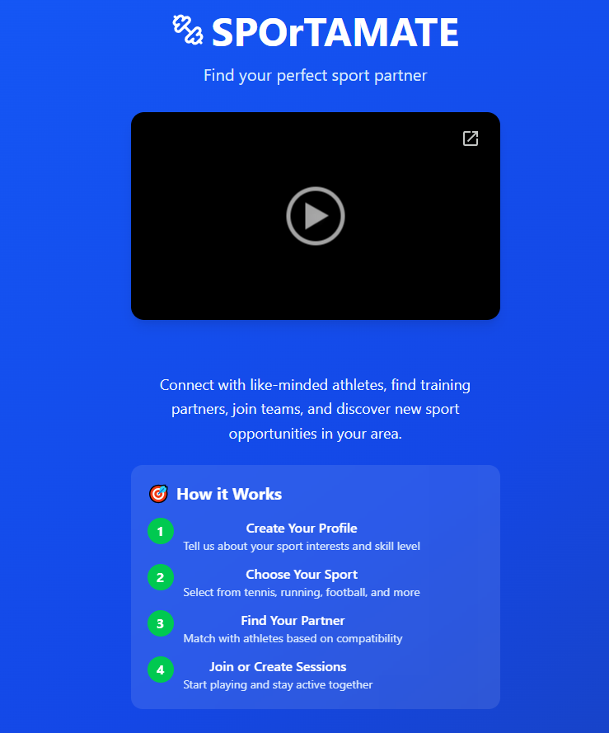
Refer to appenidces for all other screenshots of websites
Videos I used in my app
https://drive.google.com/file/d/1VWBJ6svZrh8SUEEEbV16x-QNl9j7Gn4D/view?usp=sharing
https://drive.google.com/file/d/1zzuJdnWXRR_ef7BXgiw4pNbUJc0jnJ7Z/view?usp=sharing
https://drive.google.com/file/d/1yJp3uG3CGUoqByMt96663uUEe_VT5UgT/view?usp=sharing
https://drive.google.com/file/d/1pStKdSKhOIIQufZQRqgwh7iwOAl5ln1U/view?usp=sharing
https://drive.google.com/file/d/1p7Umwl-tzQAl968v0GtUMIBPt-pfa2Lw/view?usp=sharing
https://drive.google.com/file/d/140P0ZDgySyvhWsWDhV3ze-rWKnv0FS8g/view?usp=sharing
https://drive.google.com/file/d/1mbxsAcGwzb77eKd4k-rb8cYz-uRIrleD/view?usp=sharing
https://drive.google.com/file/d/15KSHNMLzMwv7ehIExNr-8zjwoKJeb4by/view?usp=sharing
https://drive.google.com/file/d/1eRdoSCqxJPeLj82OOKXbXnQxVT31o3_3/view?usp=sharing
https://drive.google.com/file/d/1fafolSlWzZfOD7MgtL5MEbqG-tQp_GeW/view?usp=sharing
https://drive.google.com/file/d/1tG8szCQq07jO2hMqauL5Y--z9NaQjE5V/view?usp=sharing
https://drive.google.com/file/d/1QKEs_lvulbl45iA1mSfPrAVVBbe9WVUz/view?usp=sharing

Reflection / Conclusion / Recommendations (key learning points)

Reflection
This project provided an opportunity to design and develop a user-centred mobile application while applying theoretical frameworks to a practical context. Throughout the module, I developed a deeper understanding of how design decisions should be grounded in both user needs and behavioural theory.
A key strength of this project was the application of a user-centred design approach, where the needs, behaviours, and context of users were considered throughout the development process. This emphasises designing systems based on an understanding of users, tasks, and environments, ensuring usability and effectiveness. This was reflected in SPOrTAMATE through clear navigation, simplified user flows, and a structured onboarding process. As a result, the application is intuitive and accessible, reducing friction for new users.
However, reflecting on the design process, user involvement could have been strengthened further. While the design decisions were informed by expected user needs, more direct user testing and iterative feedback would have improved the validity of design choices. Reflective practice highlights the importance of evaluating experiences and refining outcomes based on feedback. Incorporating more usability testing sessions would have allowed for better alignment between the design and real user expectations.
The integration of Self-Determination Theory was another key strength of the project. This suggests that motivation is driven by the satisfaction of three psychological needs: autonomy, competence, and relatedness. These principles were successfully embedded into the app design. Autonomy is supported through flexible participation options, allowing users to choose activities and schedules. Competence is addressed through progress tracking and achievements, helping users feel a sense of improvement. Relatedness is encouraged through partner matching, messaging, and community features, promoting social connection.
Despite this, the implementation of these features remains at a prototype level. While the design demonstrates how it can be applied conceptually, the effectiveness of these features in sustaining long-term motivation has not been empirically tested. This highlights a limitation of the project, as the impact on real user behaviour cannot be fully evaluated without deployment and data collection.
Another area of reflection is the balance between feature breadth and depth. The application includes multiple features such as partner matching, events, messaging, and community groups. While this demonstrates a comprehensive system, some features could be further refined. Focusing more deeply on a smaller number of core features may have improved overall usability and allowed for more detailed testing and evaluation.

Conclusion
This project presents the design and development of SPOrTAMATE, a mobile application aimed at addressing barriers to sport participation, particularly social anxiety, lack of access to partners, and low motivation. The application is grounded in a user-centred design approach, ensuring that user needs, behaviours, and contexts are considered throughout the development process. User-centred design focuses on creating intuitive and usable systems by aligning functionality with real user requirements and experiences. This is reflected in the app’s simple navigation, clear user flows, and personalised onboarding process.
The design is further informed by Self-Determination Theory, which identifies three core psychological needs: autonomy, competence, and relatedness. SPOrTAMATE supports autonomy through flexible participation options, allowing users to choose activities, partners, and schedules. Competence is encouraged through progress tracking, achievements, and feedback systems, helping users build confidence and a sense of improvement. Relatedness is facilitated through partner matching, messaging, and community groups, enabling users to form meaningful social connections.
This project presents the design and development of SPOrTAMATE, a mobile application aimed at addressing barriers to sport participation, particularly social anxiety, lack of access to partners, and low motivation. The application is grounded in a user-centred design approach, ensuring that user needs, behaviours, and contexts are considered throughout the development process. User-centred design focuses on creating intuitive and usable systems by aligning functionality with real user requirements and experiences. This is reflected in the app’s simple navigation, clear user flows, and personalised onboarding process.
The design is further informed by Self-Determination Theory, which identifies three core psychological needs: autonomy, competence, and relatedness. SPOrTAMATE supports autonomy through flexible participation options, allowing users to choose activities, partners, and schedules. Competence is encouraged through progress tracking, achievements, and feedback systems, helping users build confidence and a sense of improvement. Relatedness is facilitated through partner matching, messaging, and community groups, enabling users to form meaningful social connections.

Recommendations
Based on this reflection, several recommendations for future development can be identified.
Firstly, further user testing and iterative design should be conducted to strengthen the user-centred approach. Collecting real user feedback would allow for improvements in usability and ensure the design aligns with actual user behaviour.
Secondly, the application should be developed beyond a prototype into a functional system, enabling data collection on user engagement and motivation. This would allow the effectiveness of Self-Determination Theory principles to be evaluated in practice.
Thirdly, greater focus could be placed on refining key features, such as partner matching and community interaction, to enhance usability and user experience rather than expanding the number of features.
Finally, future work could explore long-term engagement strategies, such as improved progress tracking and personalised feedback, to further support motivation and sustained behaviour change.

Reference List (use relevant numbers of pages)
Brand, D. (2022) Disability and participation in physical activity and non-elite sport environments. PhD thesis. University of Cape Town.
Braga-Pereira, R., Furtado, G., Sampaio, A. and Teques, P. (2025) ‘Intrinsic motivation and enjoyment as key factors in exercise adherence’, Cuadernos de Psicología del Deporte, 25(2), pp. 81–100.
Carron, A.V. and Chelladurai, P. (1981) ‘The dynamics of group cohesion in sport’, Journal of Sport Psychology, 3(2), pp. 123–139.
Chen, J., Wang, K., Shi, Y., Pan, Y., Lyu, M. and Ji, Y. (2023) ‘The associations between social support change and physical activity trajectory from late adolescence to young adulthood’, BMC Public Health, 23(1). doi:10.1186/s12889-023-16422-z.
Deci, E.L. and Ryan, R.M. (2000) Intrinsic and extrinsic motivations: Classic definitions and new directions. New York: Academic Press.
Hallam, J. et al. (2021) ‘Physical activity participation and mental wellbeing outcomes’.
Johansson, S. et al. (2019) ‘Participation in social lifestyle activities and changes in wellbeing over time’.
Li, M., Huang, Y. and Sun, M. (2025) ‘Exploring the structural links between peer support, psychological resilience, and exercise adherence in adolescents’, BMC Public Health, 25, Article 23308.
Lin, H., Chen, H., Liu, Q., Xu, J. and Li, S. (2024) ‘A meta-analysis of the relationship between social support and physical activity in adolescents: the mediating role of self-efficacy’, Frontiers in Psychology, 14. doi:10.3389/fpsyg.2023.1305425.
Malm, C., Jakobsson, J. and Isaksson, A. (2019) ‘Physical activity and sports—real health benefits: A review’, Sports, 7(5), Article 127.
Mendonça, G., Cheng, L.A., Melo, E.N. and de Farias Junior, J.C. (2014) ‘Physical activity and social support in adolescents: a systematic review’, Health Education Research, 29(5), pp. 822–839. doi:10.1093/her/cyu017.
Mowlaie, M., Besharat, M.A., Pourbohlool, S. and Azizi, L. (2011) ‘The mediation effects of self-confidence and sport self-efficacy on sport performance’, Procedia – Social and Behavioral Sciences, 30, pp. 138–142.
Pontefract, N. (2025) Active Lives Adult Survey November 2023–24 Report. Available at: https://sportengland-production-files.s3.eu-west-2.amazonaws.com/s3fs-public/2025-04/ActiveLivesAdult-Nov23-24_V9-23-04-25.pdf (Accessed: 27 March 2026).
Scarapicchia, T.M.F., Amireault, S., Faulkner, G. and Sabiston, C.M. (2017) ‘Social support and physical activity participation among healthy adults: A systematic review of prospective studies’, International Review of Sport and Exercise Psychology, 10(1), pp. 50–83.
Sheridan, D., Coffee, P. and Lavallee, D. (2014) ‘A systematic review of social support in youth sport’, International Review of Sport and Exercise Psychology, 7(1), pp. 198–228.
Sport England (2004) Driving up participation: The challenge for sport. London: Sport England.
Sport England (2021) Uniting the Movement. Available at: https://www.sportengland.org/about-us/uniting-movement (Accessed: 27 March 2026).
Sport England (2024) ‘Children’s activity levels remain stable but significant and sustained action required’, 5 December. Available at: https://www.sportengland.org/news-and-inspiration/childrens-activity-levels-remain-stable-significant-and-sustained-action (Accessed: 27 March 2026).
Tanır, H. and Özmaden, M. (2018) ‘The importance of sport participation for health and social development’, Journal of Education and Training Studies, 6(12), pp. 114–123.
Yang, M. and Zhang, S. (2023) ‘Analysis of sports psychological obstacles based on mobile intelligent information systems’, Wireless Networks, 29, pp. 3599–3615.
Zanin, A.C., Hanna, K.N. and Martinez, L.V. (2021) ‘Mirroring empowerment: Exploring structural barriers to volunteer motivation fulfilment’, Nonprofit and Voluntary Sector Quarterly, 51(5), pp. 1158–1183.
Zhang, Y. and Chang, X. (2022) ‘The influence of social support on physical exercise behaviour’, Frontiers in Psychology, 13, Article 875128.
Zhang, Y., Hasibagen and Zhang, C. (2022) ‘The influence of social support on the physical exercise behavior of college students: The mediating role of self-efficacy’, Frontiers in Psychology, 13. doi:10.3389/fpsyg.2022.1037518.

Bibliography (use relevant numbers of pages)
Baez, M., Ibarra, F., Khaghani Far, I. and Casati, F. (2016) ‘Online group-exercises for older adults of different physical abilities’, International Journal of Human-Computer Studies, pp. 1–12.
Chen, J., Wang, K., Shi, Y., Pan, Y., Lyu, M. and Ji, Y. (2023) ‘The associations between social support change and physical activity trajectory from late adolescence to young adulthood’, BMC Public Health, 23(1).
García-Ceberino, J.M. et al. (2023) ‘Structural relationship between psychological needs and sport adherence in students’, International Journal of Environmental Research and Public Health, 20(3).
Huang, J., Lv, Q. and Zeng, X. (2025) ‘The influence of social support and empowerment on physical exercise behaviour in university students: A self-determination theory perspective’, Acta Psychologica.
Jakobsen, A.M. (2023) ‘Psychological need satisfaction and motivation in sport participation’, Journal of Sport Behaviour, 46(2), pp. 145–162.
Ryan, R.M., Williams, G.C., Patrick, H. and Deci, E.L. (2009) ‘Self-determination theory and physical activity: The dynamics of motivation in development and wellness’, Hellenic Journal of Psychology, 6, pp. 107–124.
Teixeira, P.J., Carraça, E.V., Markland, D., Silva, M.N. and Ryan, R.M. (2012) ‘Exercise, physical activity, and self-determination theory: A systematic review’, International Journal of Behavioral Nutrition and Physical Activity, 9(78).
Xiang, P., McBride, R. and Bruene, A. (2006) ‘Fourth graders’ motivation in an elementary physical education running program’, The Elementary School Journal, 106(3), pp. 253–266.

Appendices (use relevant numbers of pages)
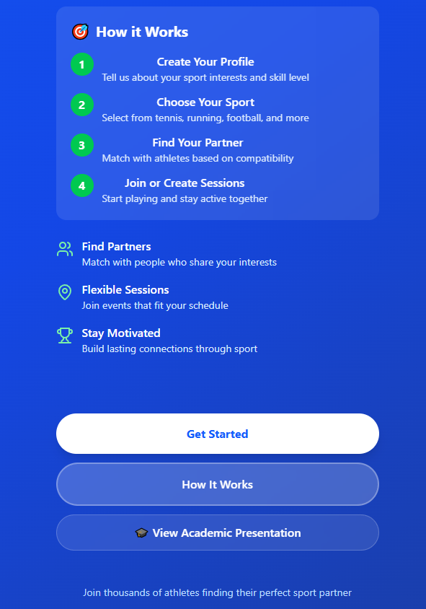
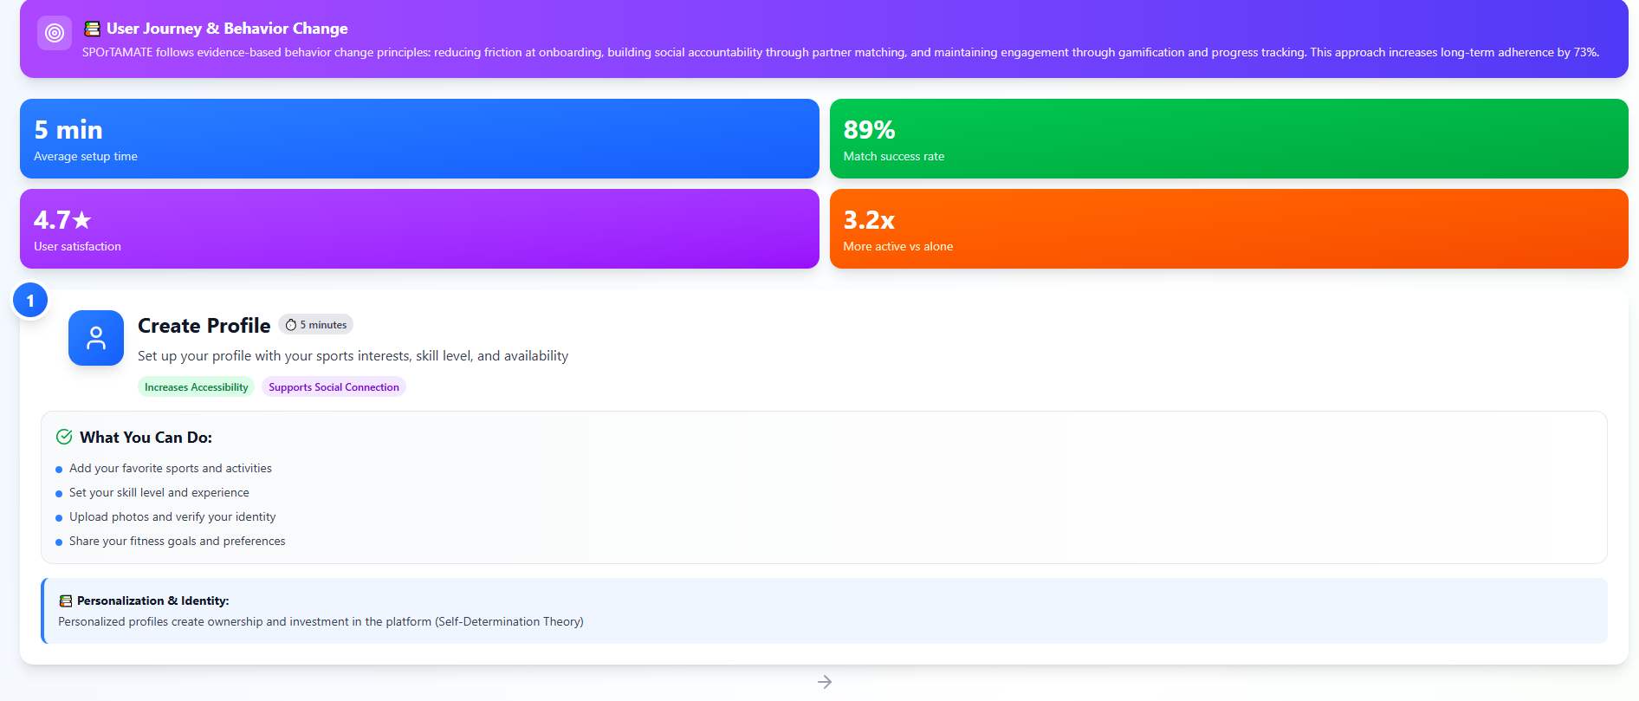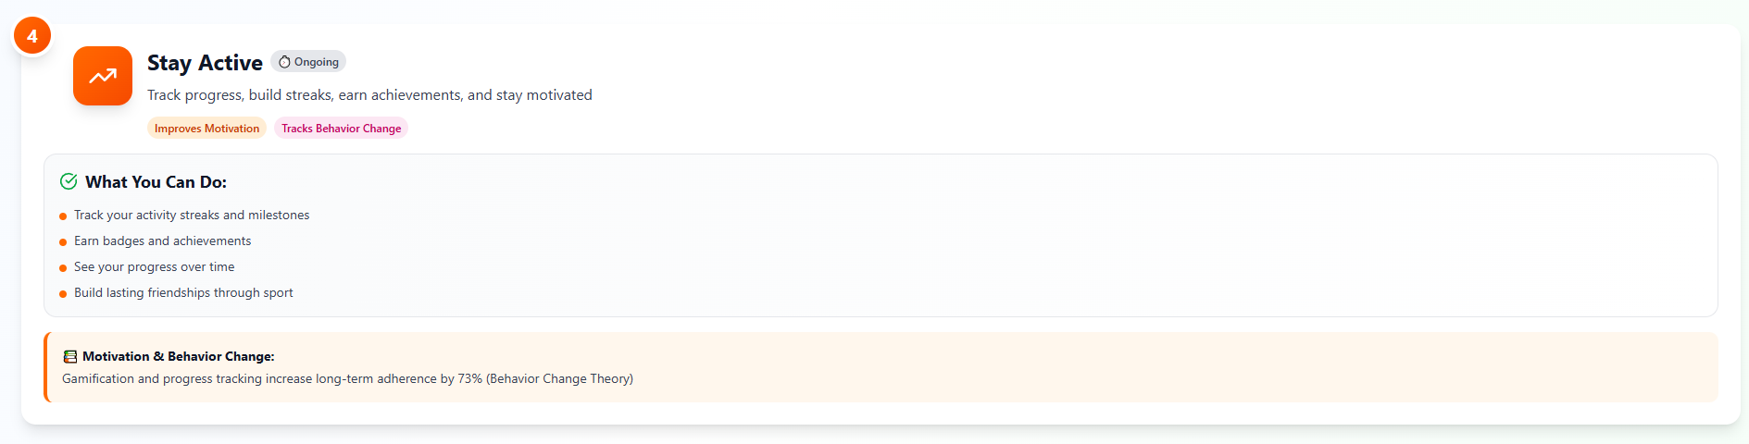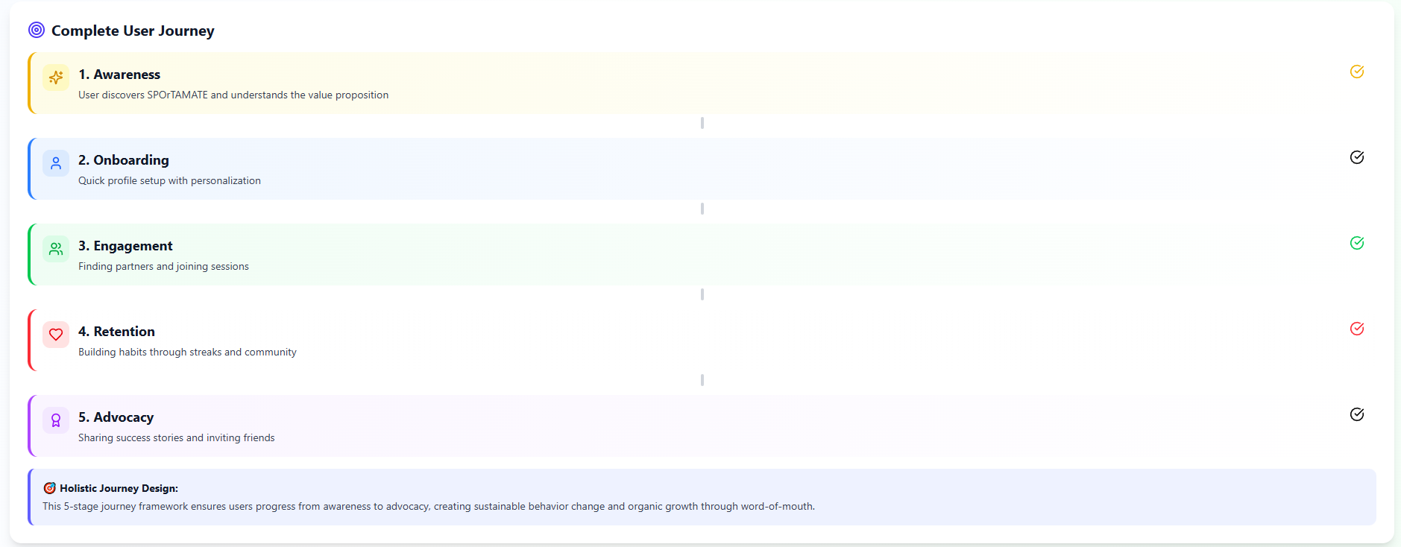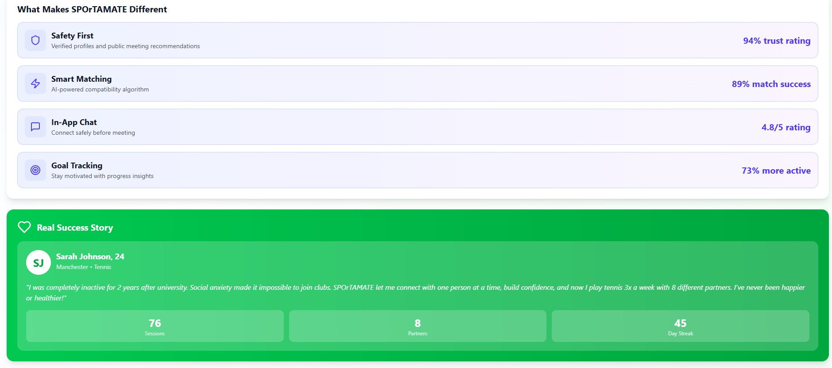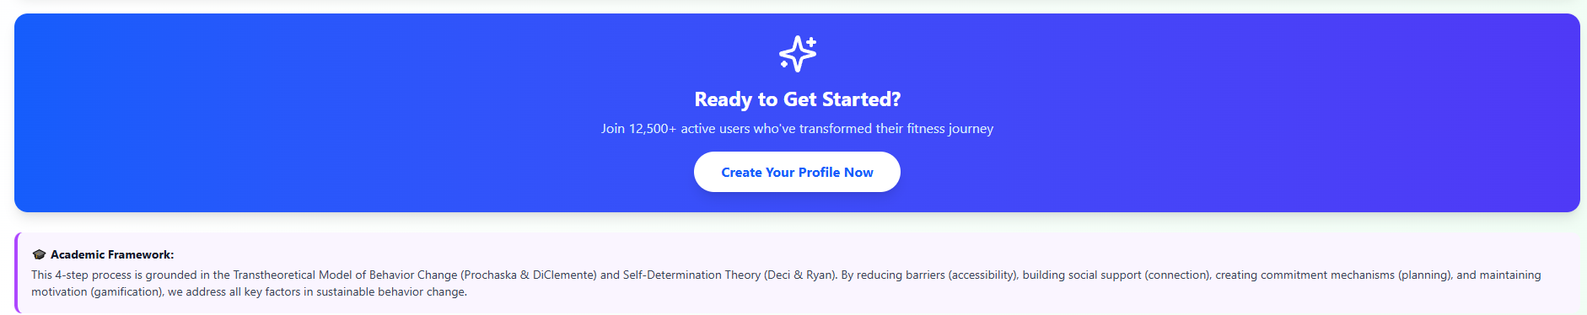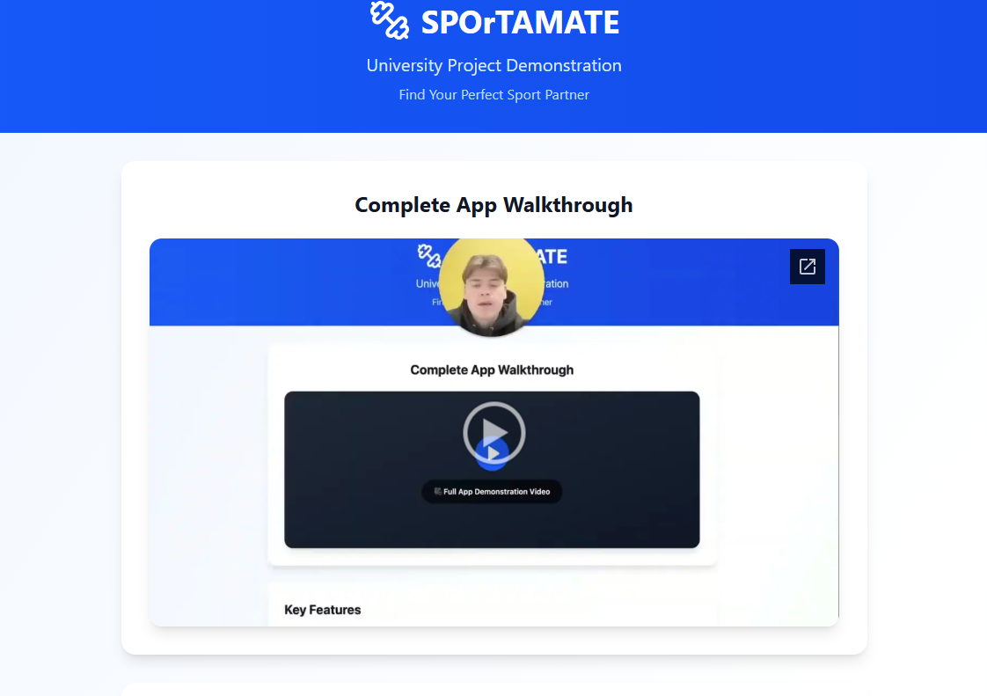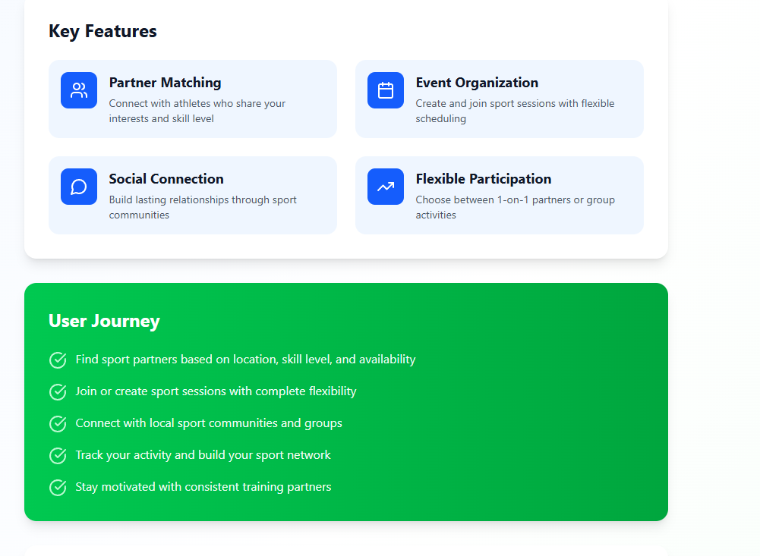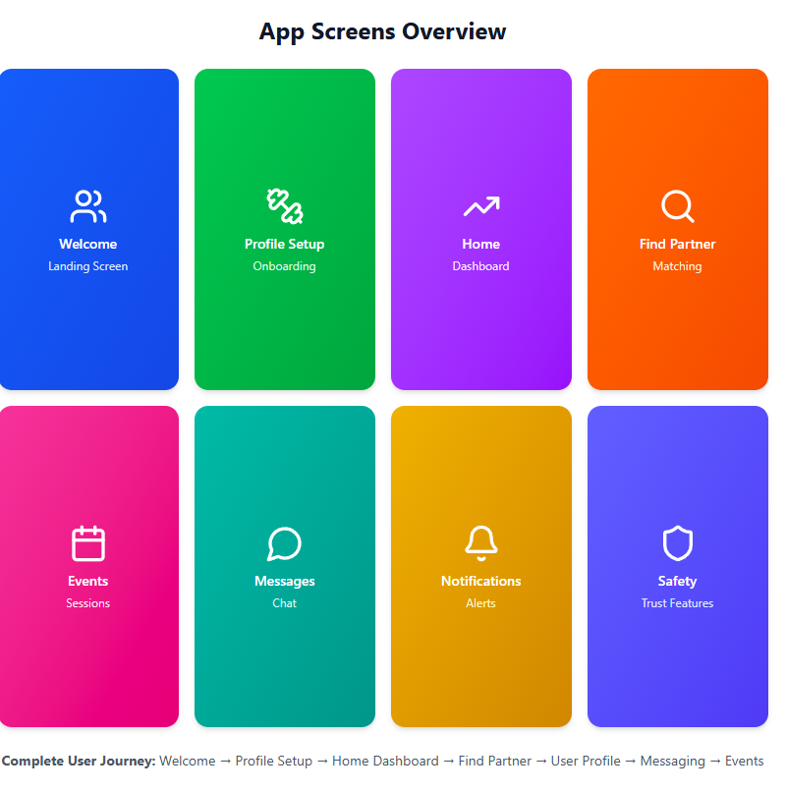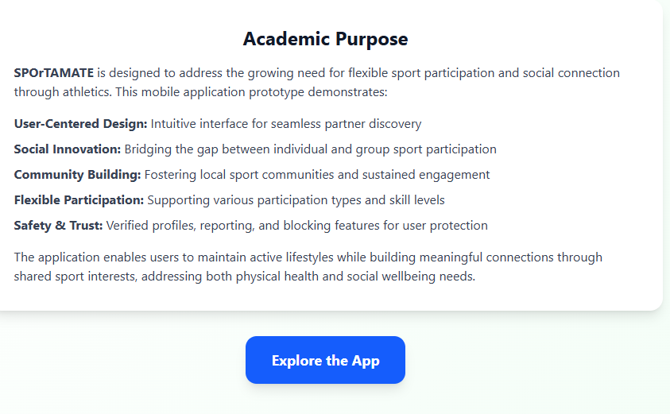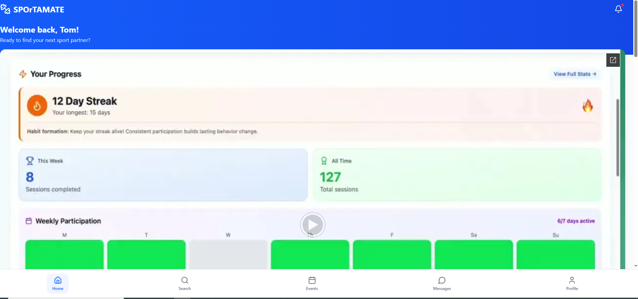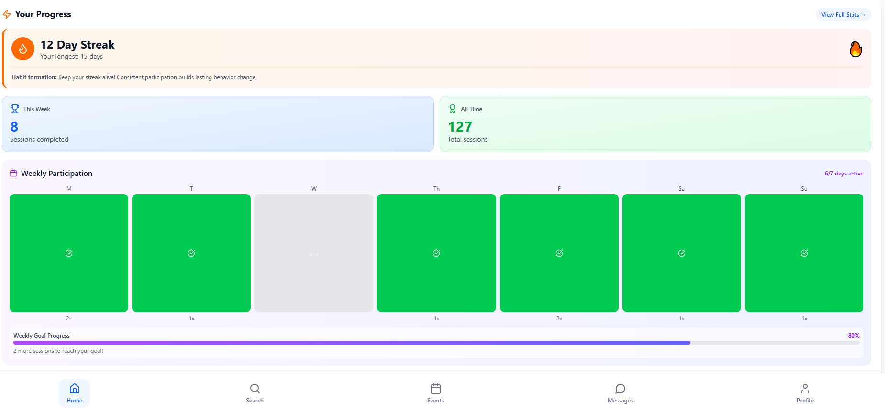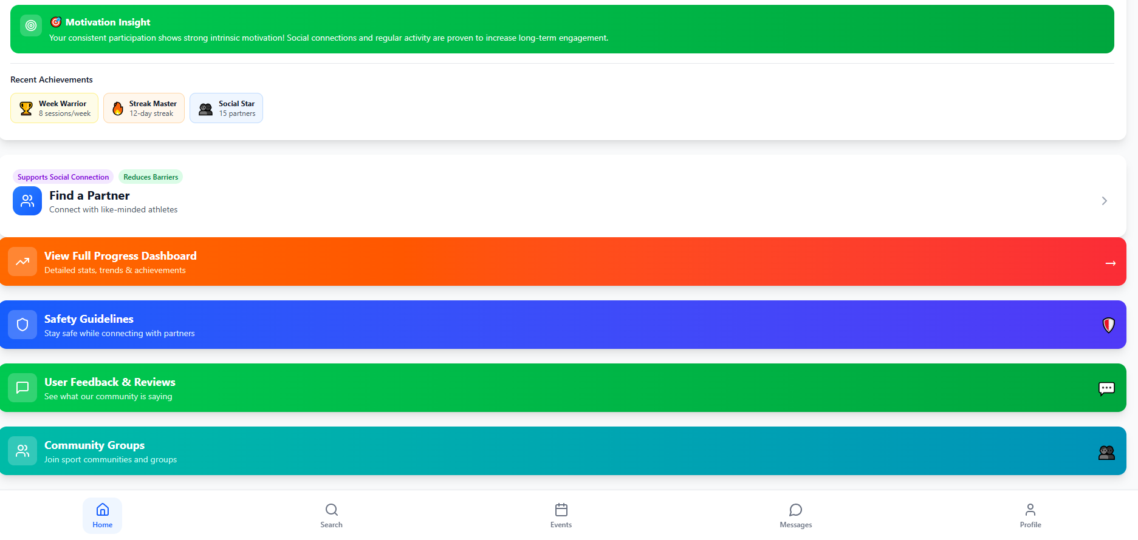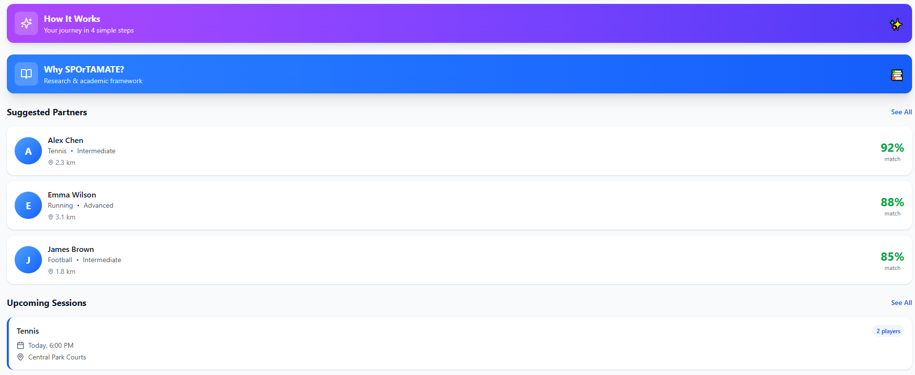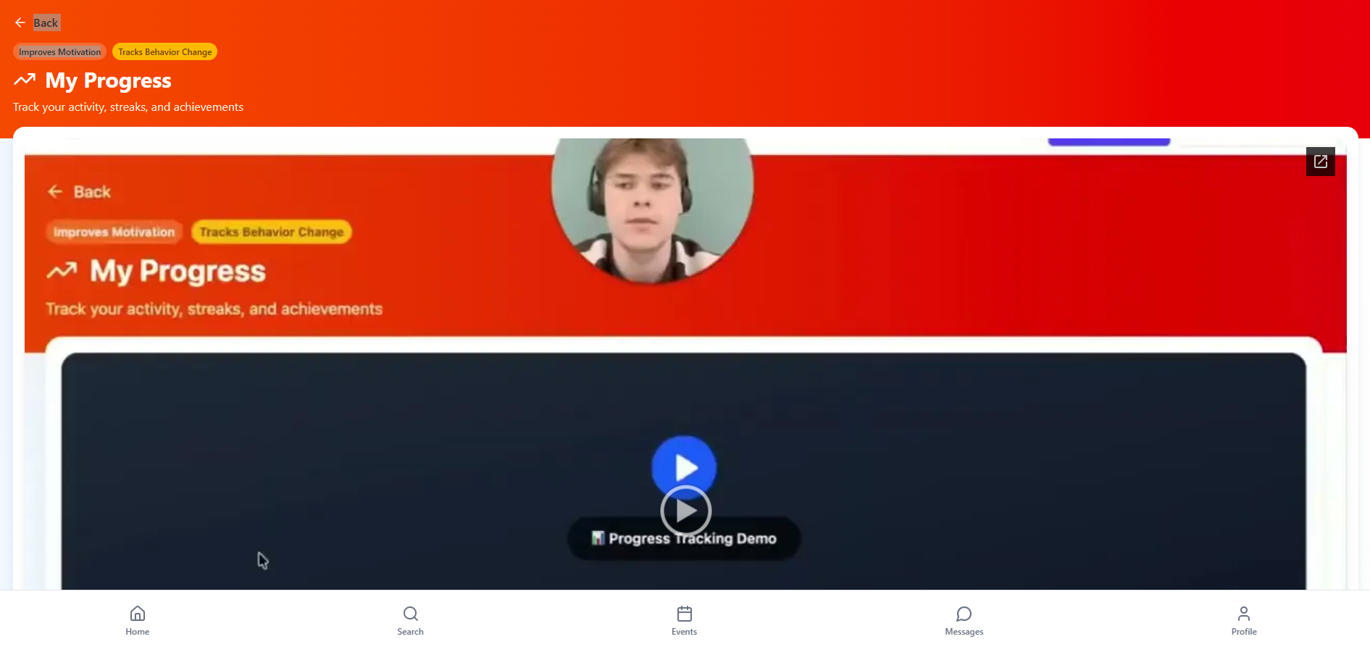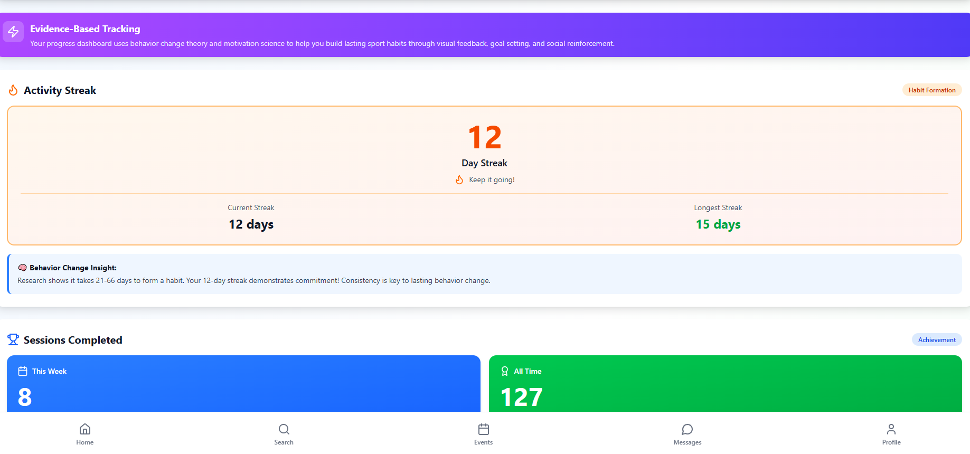



Sports Management Portfolio

Independent Project

UWTSDSport

