Land South of Quicksie Hill, Wendens Road, Arkesden, Essex
Introduction
A programme of archaeological investigation was conducted between 2019 and 2021 in Arkesden, Essex, prior to residential development. The project was prompted by a brief for a trial-trench evaluation from Essex County Council (Havis 2019), following a desk-based assessment (Baljkas 2018). It comprised an initial trial-trench evaluation (Short and Bingham 2019), proceeding with an open-area excavation (Lloyd-Smith 2021). As will be made clear, the project did not adhere to the conventional ‘life-cycles’ outlined in guidance by CIfA (2020a), Historic England (2015), or indeed ALGAO (2015). The project, as such, represents a fitting example to assess against its research design. Paradata related to the project is notably limited; however, pertinent email communication and personal correspondence has informed the following analysis.
Evaluation: Project Design
A written scheme of investigation (Murray 2019) for an evaluation was produced in response to the initial archaeological brief. The WSI summarised the known archaeological evidence in the area and outlined the pertinent research questions, which are reproduced in Appendix 1. Likely due to the identification of significant evidence for medieval occupation in proximity to the site within the desk-based assessment (Baljkas 2018), the summary was limited to the principal medieval assets nearby – despite the noted moderate potential for prehistoric activity. Specifically, it noted the proximity of a 13th century church on the site of a Norman predecessor (EHER 3947; Pevsner and Bettley 2007: 54-55), a deserted medieval village (EHER 3939), and the cropmarks of a motte and bailey (EHER 18361). The WSI subsequently identified the relevant medieval research topics highlighted within the regional research frameworks (Glazebrook 1997; Brown and Glazebrook 2000; Medlycott and Brown 2008; Medlycott 2011). It, however, did not specifically relate them to the Quicksie Hill site and its surrounding historic landscape (Appendix 1.3 - 1.6). The resultant research aims were not exhaustive as the extent and significance of the potential remains was thereto unclear (Appendix 1.7).
Excavation Project Design and Results
Five trenches were excavated across the site in order to determine the extent, character, condition, and significance of any archaeological features present. The evaluation (Short and Bingham 2019), the results of which are reproduced in Appendix 2, confirmed the presence of medieval remains (Fig.1). The necessity of a programme of excavation, explicitly in the southern portion of the site where the densest area of activity was revealed, was agreed on-site with the archaeological curator (Lloyd-Smith 2022 pers.comm). Subsequently, a second WSI was produced and approved that specified for an open-area investigation (Murray 2020). Despite the insightful data recorded during the evaluation, the research aims were not expanded upon, and particular methodologies related to intricacies of the site were not defined. The methodological processes outlined within the WSI were somewhat generic, and were not tailored to answer the specific research questions or topics highlighted as significant within the regional research frameworks. Indeed, although a generic methodology was detailed with regards to environmental sampling, the palaeoenvironmental discussion within the evaluation report noted that a specific strategy of sampling Saxo-Norman to medieval features would recover remains able to shed greater light on the local arable economy (Summers 2019). Such a strategy, if enacted, could have more suitably informed topics related to agriculture and the rural economy highlighted in the regional research agendas (e.g. Appendix 1.3 – 1.6), and may have provided information on shifts following the imposition of Norman rule. While the ultimate quality of the research outputs of this project will be assessed below, the compilation of the second WSI should have been utilised as an opportunity to refine the research design and methodology to better address topics of interest.
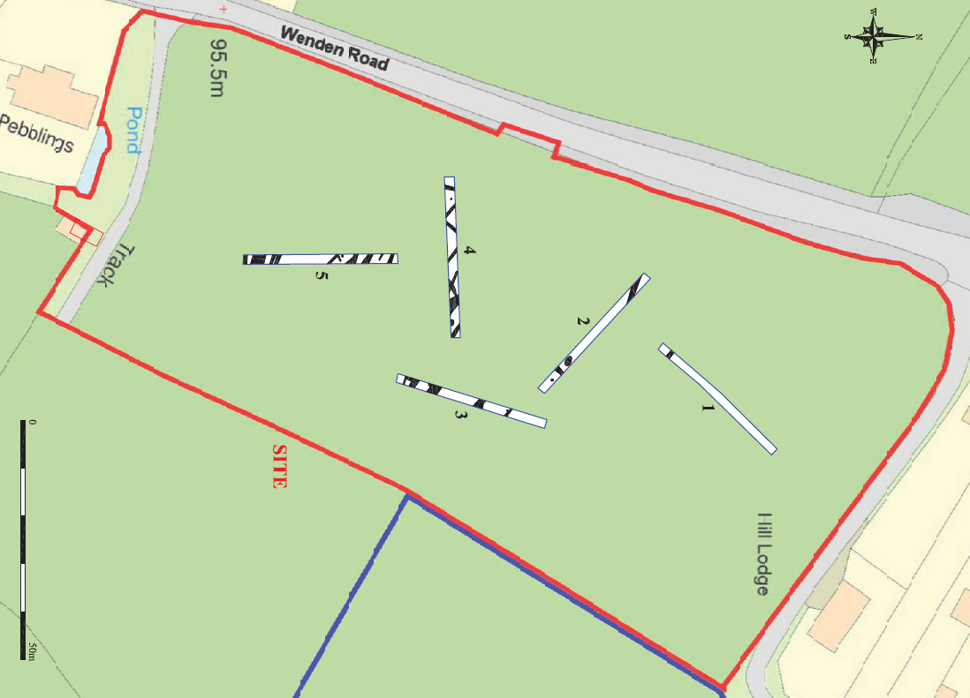
Figure 1: Trial-trench plan from Quicksie Hill, Arkesden (Short and Bingham 2019)
Excavation and Output
In summary, the excavation revealed a particular concentration of features dating to the 10th to 12th century (Fig.2) (Lloyd-Smith 2021). Two cremations were also encountered which, despite the moderate potential for prehistoric remains (Baljkas 2018), was somewhat unexpected. Upon communication of the findings to the project manager, in agreement with the planning archaeologist, it was decided that the two cremations would be block-lifted and excavated within the in-house finds processing facility. This methodology was not outlined within the project design but a change in approach was necessary, especially as the cremations were fragile and this method is widely recommended in this context (McKinley and Roberts 1993; Milner et al 2010: 4-6; Historic England 2018). Likely due to the detailed excavation within a controlled environment – which should be seen as a pragmatic methodological success – it was possible to deduce that the cremations were housed within a basket or another type of round organic vessel such as a wooden or bark casket (Lloyd-Smith 2021: 29).
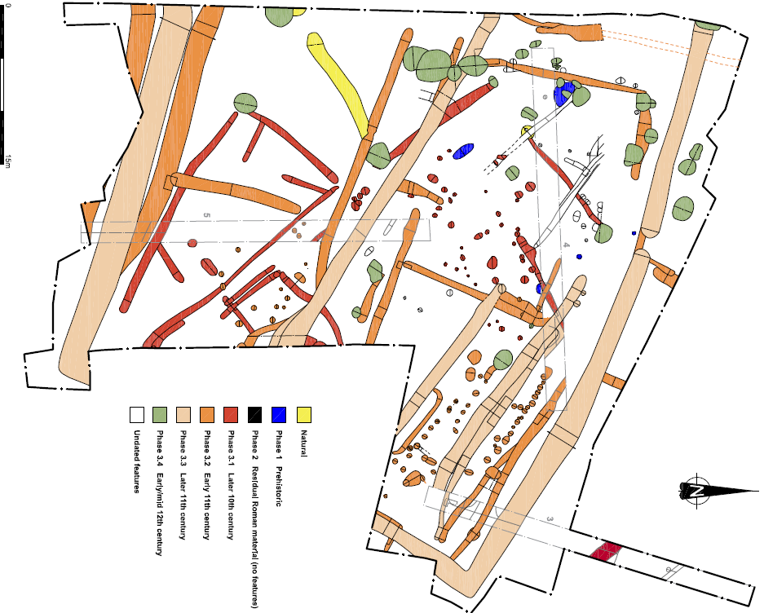
Figure 2: Phased plan of the features identified at Quicksie Hill, Arkesden (Lloyd-Smith 2021: 315)

It was at the initial reporting stage that the investigation diverged from the normal project ‘life-cycle’ promoted by CIfA (2020a) and ALGAO (2015), and specified within MoRPHE guidelines (Historic England 2015). Despite the WSI for the excavation specifying that such a report would be compiled following fieldwork (Appendix 3; Murray 2020), no Post-Excavation Assessment (PXA) or Updated Project Design (UPD) was produced. Paradata related to the project is limited and it is hereto unclear how this significant omission occurred; however, it appears that the decision to bypass this stage was not taken in collaboration with the archaeological curator (Lloyd-Smith 2022 pers.comm). Although this oversight occurred during a period of turbulent transition, during the takeover of the archaeological unit, this is a failure of the project management team.
The purpose of a UPD is to outline proposals for the analytical work necessary to deliver the research design, and to review and supplement the original research aims in view of new findings. The omission of the UPD is particularly pertinent when considering the analysis of the two prehistoric, but imprecisely dated, cremations. The original research design, though generically aiming to identify ‘evidence relating to earlier occupation of the site’ (Murray 2020), did not make specific reference to prehistoric remains. Lloyd-Smith (2021: 114), within the eventual Research and Archive Report (RAR), noted that the chronology of the cremations could have been refined by a programme of radiocarbon dating. The production of a UPD may have outlined the research benefits of, and set out a strategy for, conducting such a programme of radiocarbon dating – especially as several Iron Age cremations (EHER 45567; EHER 45582; Wade 1980) and probable settlement activity (EHER 6638; EHER 45581; EHER 45583) have been recorded in the surrounding landscape. On the whole, this appears to have been a missed opportunity to improve the research output and to potentially assist in addressing topics surrounding prehistoric burial within the research frameworks (Glazebrook 1997; Brown and Glazebrook 2000; Medlycott and Brown 2008; Medlycott 2011; RFN 2021). Nevertheless, there may not have been scope within the budget to commission such scientific analysis.
The Research and Archive Report
Despite the inherent issues resulting from the lack of a UPD, and the amorphous research aims outlined in the WSI (Murray 2020), a thorough and insightful RAR was produced that presented the findings and interpretations in a clear and structured format. A brief summary of the findings is reproduced in Appendix 4. The research aims of the investigation (Appendix 1) were restated within the report and were all addressed in proportionate depth (Lindsay-Smith 2021).
Significantly, with regards to the cropmarks of a ‘shrunken medieval village’ to the south of the site (EHER 3939), the evidence suggested that its interpretation as such should be reassessed. The course of an early 11th century curvilinear trackway at the southern end of the site appeared to respect the northern arm of a hypothesised moat, which was evidenced by extant ponds and a sizable linear cropmark (Fig.3). The identification of the probable moat immediately north of an early ecclesiastical site, strongly suggested it represented an early medieval manor with a proprietary church (Lindsay-Smith 2021). In a wider context, the RAR goes on to assess the development and ‘fluctuating fortunes’ of the early medieval farmstead at Quicksie Hill as part of the wider historical landscape. It provides a considered narrative of the farmstead initially representing a late Saxon growth of the village (Phase 3.1), which witnessed significant reorganisation when the aforementioned manorial complex was established (Phase 3.2). The structure of the landscape and the farmstead changed dramatically again in the second half of the 11th century (Phase 3.3); a change that was interpreted as being related to the imposition of Norman rule in the decades following 1066. Significantly, the orientation of the sizable Phase 3.3 ditches corresponded to the cropmarks surrounding the probable Norman ‘motte and bailey’ ringwork site of Plash Wood to the east (Fig.3).
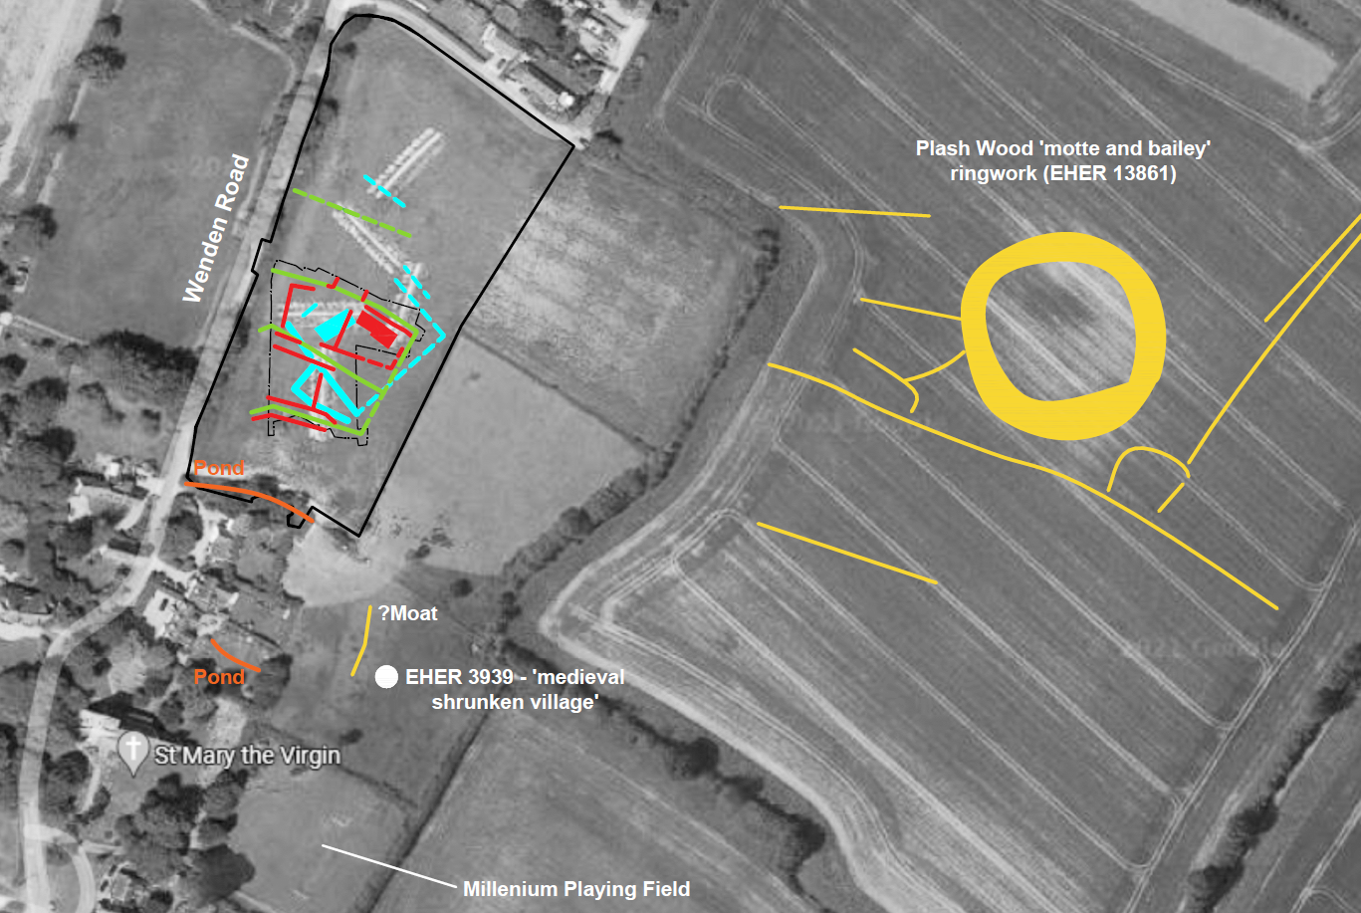
Figure 3: The medieval context of the Quicksie Hill site (Lloyd-Smith 2021: 324)
These findings directly addressed the pertinent research questions highlighted in the project design and consecutive regional research agendas related to the changes and developments in Saxon and medieval settlements over time (Medlycott 2011: 57-59); the changes in land-use and organisation in relation to the impact of colonists (Brown and Glazebrook 2000: 23-26); and the study of the Saxon to medieval landscape in relation to field systems, enclosures, roads and trackways (Brown and Glazebrook 2000; Medlycott 2011: 70). Much like the research aims and objectives, the relevant research agenda topics were restated within the RAR and prefaced the discussion element of the report (Lindsay-Smith 2021: 110-111).
Report and Archive: Project Success?
The archaeological curator was overwhelmingly pleased with the eventual results of the project – evidenced by an email received following review of the RAR (Appendix 5). No complaints or reprimand over the lack of a PXA/UPD was forthcoming. Despite their positive reaction, there are undoubtably issues that in retrospect may have benefitted from an alternative approach. The decision to skip the UPD ‘review stage’ of the project is a rather egregious omission. An archaeological curator, or indeed the authors of the hypothetical UPD, may have highlighted the well-preserved earth-fast and post-built structures as a topic of particular interest. The identification of five Saxo-Norman to medieval structures on the relatively small site, some exhibiting evidence of extension, is unusual in Essex. At this point it may have been proposed to compile a thematic analysis of the buildings. The paucity of excavated medieval houses in the east of England, particularly in association with rural settlements such as Quicksie Hill, has been consistently highlighted (Wade 2000; Martin 2012; Luke 2016). This, regardless of the positive research outcome of the RAR, could potentially be seen as a missed opportunity.
The planning archaeologist, noting that this type of site is particularly rare in this part of Essex and has significantly contributed to our understanding of the past in the area, stated that a journal article would be expected to be submitted to Essex Archaeology and History. A journal article was submitted to Essex Archaeology and History on the 1st February 2022; however, there has since been no notification of receipt or recommendations for edits (Lloyd-Smith 2022 pers.comm). In addition to fulfilling the request of the archaeological curator, although hereto unpublished, the publication would fulfil a requirement of the excavation WSI (Murray 2020; Appendix 3.1).
Of equal, or perhaps greater importance, is the project archive. In line with the WSI (Murray 2020: 10), and CIfA guidelines (CIfA 2020b), the project archive was deposited at the Saffron Walden Museum. The archive includes selected artefacts and the on-site documentary and digital records; however, the pertinent paradata related to the project was not included. Such paradata may have provided insight into the processes through which people conducted the project, which could have led to later reinterpretations and review (Huvila 2012). Although in accordance with the project design, the project archive was not deposited with a publicly accessible digital repository such as the Archaeological Data Service. This is a clear shortcoming of the project design, especially when considering the importance of public access and shared knowledge in the context of ‘preservation by record’ (Swain 2012).
The historic environment record (HER) arguably represents the principle means of disseminating and accessing archaeological information (Illsley 2019). The excavation WSI (Murray 2020: 8) clearly states that submission to the Essex HER, including copies of the reports, was a requisite of the project. Significantly, while the results of the trial-trench evaluation are summarised within the Essex HER, the results of the excavation are not hereto listed. Nonetheless, an Essex HER summary form has been submitted and the project has been entered into the OASIS database (Lloyd-Smith 2022 pers.comm).
Conclusion
Despite purportedly following the MoRPHE research project management processes (Appendix 3.2), the Quicksie Hill investigation did not adhere to its clearly defined project management model. Indeed, the output of a UPD, which was specified for within the project design, was not delivered. Without the UPD to reappraise the original project objectives and to set out strategies to be used in the analysis of the evidence, the eventual outcome may well have not been positive under differing circumstances. Nevertheless, thorough and regionally significant findings – directly addressing the pertinent regional research frameworks and predetermined project aims and objectives – were relayed in a coherent report and are currently in the process of being published in a regional journal.

Bibliography
Association of Local Government Archaeological Officers (ALGAO) (2015) Advice Note for Post-Excavation Assessment, Association of Local Government Archaeological Officers.
Baljkas, G. (2018) Land south of Quicksie Hill, Wenden Road, Arkesden, Essex: Archaeological Desk-based Assessment, Thames Valley Archaeological Services .
Chartered Institute for Archaeologists (CIfA) (2020a) Standard and Guidance for Archaeological Excavation, Reading: Chartered Institute for Archaeologists.
Chartered Institute for Archaeologists (CIfA) (2020b) Standard and guidance for the creation, compilation, transfer and deposition of archaeological archives. Reading: Chartered Institute for Archaeologists.
Glazebrook, J. (1997) 'Research and Archaeology: A Framework for the Eastern Counties', East Anglian Archaeology Occasional Papers 3.
Glazebrook, J. and Brown, N. (2000) 'Research and Archaeology: A Framework for the Eastern Counties', East Anglian Archaeology Occasional Papers 8.
Havis, R. (2019) Brief for Trial Trenching & Excavation at Land South Quicksie Hill, Wendens Road, Arkesden. Place Services .
Historic England (2015) Management of Research Projects in the Historic Environment: The MoRPHE Project Managers' Guide. Swindon: Historic England.
Historic England (2018) Historic England Excavation Recording Manual. Swindon: Historic England.
Huvila, I. (2012) 'The Unbearable Complexity of Documenting Intellectual Processes: Paradata and Virtual Cultural Heritage Visualisation', in Bentkowska-Kafel, A., Denard, H., and Baker, D. (eds.) Paradata and Transparency in Virtual Heritage. London: Routledge, pp. 97-110.
Illsley, W. R. (2019) 'Problematising the Historic Environment Record: Comments on Persistent Issues in England and Sweden', Conservation and Management of Archaeological Sites, 21(2), pp. 113-134.
Lloyd-Smith, L. (2021) Land South of Quicksie Hill, Wenden Road, Arkesden, Essex: Research and Archive Report, Wardell Armstrong LLP.
Luke, M. (2016) 'Close to the Loop: landscape and settlement evolution beside the Biddenham Loop, west of Bedford'. East Anglian Archaeology 156.
Martin, E. (2012) 'Norfolk, Suffolk and Essex: Medieval Rural Settlement in "Greater East Anglia"', in Christie, N., and Stamper, P. (eds.) Medieval Rural Settlement. Britain and Ireland, AD 800-1600. Oxford: Windgather Press, pp. 225-248.
McKinley, J. I. and Roberts, A. C. (1993) 'Excavation and post-excavation treatment of cremated and inhumed human remains', IFA Technical Paper. Reading: Institute of Field Archaeologists.
Medlycott, M. (2011) 'Research and Archaeology Revisited: A Revised Framework for the East of England', East Anglian Archaeology Occasional Papers 24.
Medlycott, M. and Brown, N. (2008) 'East Anglian Regional Archaeological Research Frameworks', East Anglian Archaeology.
Milner, N., Hadley, P., Hall, A., Needham, A., Taylor, M., Taylor, B., and Conneller, C. (2010) 'To Block Lift or not to Block Lift? An Experiment at the Early Mesolithic Site of Star Carr, North-East Yorkshire, UK', Internet Archaeology 28. https://doi.org/10.11141/ia.28.2
Murray, J. (2019) Land South of Quicksie Hill, Wendens Road, Arkesden, Essex: Written Scheme of Investigation for an Archaeological Trial Trench Evaluation. Archaeological Solutions.
Murray, J. (2020) Land South of Quicksie Hill, Wendens Road, Arkesden, Essex: Written Scheme of Investigation for an Archaeological Excavation, Archaeological Solutions.
Pevsner, N. and Bettley, J. (2007) The Buildings of England: Essex. London: Yale University Press.
Research Frameworks Network (RFN) (2021) East of England Regional Research Framework.
Available at: https://researchframeworks.org/eoe/ (Accessed: 1 March 2022).
Short, A. and Bingham, K. (2019) Land South of Quicksie Hill, Wendens Road, Arkesden, Essex: Archaeological Trial Trench Evaluation. Archaeological Solutions.
Summers, J. (2019) 'The Environmental Samples' in Short, A., and Bingham, K. (eds.) Land South of Quicksie Hill, Wendens Road, Arkesden, Essex: Archaeological Trial Trench Evaluation. Archaeological Solutions, pp. 32-36.
Swain, H. (2012) 'Archive Archaeology' in Skeates, R., McDavid, C., and Carman, J. (eds.) The Oxford Handbook of Public Archaeology. Oxford: Oxford University Press.
Wade, K. (1980) 'A settlement site at Bonhunt Farm, Wicken Binhunt, Essex' in Buckley, D.G (ed.) Archaeology in Essex to AD 1500. London: Council for British Archaeology, pp. 96-102.
Wade, K. (2000) 'Anglo-Saxon and Medieval (Rural)' in Brown, N., and Glazebrook, J. (eds.) Research and Archaeology: a framework for the Eastern Counties - research agenda and strategy. East Anglian Archaeology 8, pp. 23-26.

