University of Wales Trinity Saint David
School of Engineering

Design & Analysis of Extended Surfaces
Advanced Thermofluid Mechanics
ACMA6011

Richard Parker
1902504
01/04/22
Contents
1 Introduction 1
2 Review of Extended Surface Heat Exchangers 2
2.1 In Automotive Design 2
2.2 In Microprocessor Technology 4
3 Relationship between Optimum Fin Length, $Q∞$ and $Qfinite$ 7
4 Analysis of pin heat exchangers of different materials 9
4.1 Methodology 9
4.2 Analysis Using Infinite Length Boundary Condition 9
4.3 Optimum Lengths for Each Material 10
4.4 Lengths Needed to Achieve Maximum Realistic Heat Transfer 12
5 References 13
6 Appendices 15
6.1 MATLAB code for proving relevance of optimum fin length 15
6.2 MATLAB code for analysis of different materials 16

Introduction
In the design of any heat transfer system, an increase in surface area is often one of the most straightforward and significant ways to increase heat transfer – this has led to the implementation of extended surface heat exchangers and the continuous development of them throughout modern engineering. This report reviewed this use and development, specifically in the fields of automotive engineering and microprocessor technology, where advancements in cooling systems have enabled sustained progression.
The report then considered a simple pin fin arrangement, to assess four materials in terms of heat transfer rate and also temperature distribution. Finally, optimum lengths for each material were calculated and compared.

Review of Extended Surface Heat Exchangers

In Automotive Design
Since the earliest days of automotive design, cooling the engine has been a concern. As cars could not incorporate the static water supplies that the engineers of the day used in their industrial engines, other options were needed. The earliest car engines relied simply on water feeds directly cooling the piston through evaporation, and others used coils of copper pipe as a way of increasing surface area; but the Mercedes 35 – often seen as the first modern car – featured the closed-loop water radiator that is seen on car engines to this day (MyAutoWorld.com, 2022). Seen in Figure 1, Wilhelm Maybach’s design from 1901 featured a grid of 8070 square pipes, arranged so that air would flow through the hollow centre of the pipes, cooling the water contained within the walls of the structure. Placed at the front of the car, assisted by a fan directly behind it and the cross-flow cooling effect within the vessel, the vast surface area given by the radiator was sufficient to cool the 35hp 5.9l engine (Mercedes-Benz Group Media, 2022).
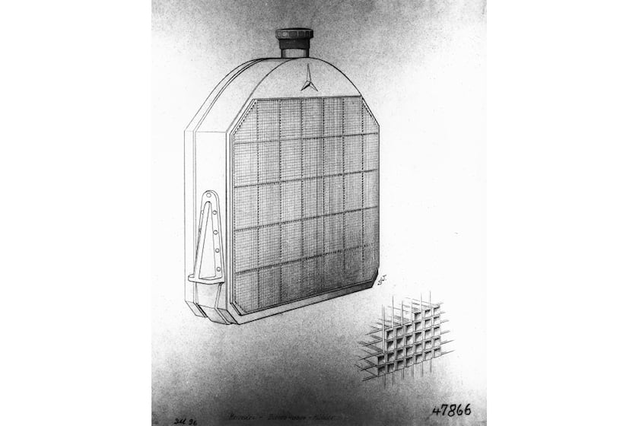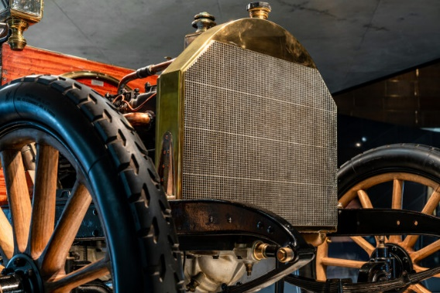
Figure 1 - Sketch of Mercedes 35’s honeycomb radiator Figure 2 – Photo (Mercedes-Benz Group Media, 2022)
Although the brass tubes soldered onto the walls of the vessel performed relatively well, they were prone to leaks, slow to manufacture and more conductive materials were required for further development. Modern car radiators generally feature aluminium fins, brazed onto aluminium tubes – as aluminium is significantly more conductive and also lighter than brass; and the tubes now run perpendicular to the car’s front face rather than parallel to it.
Modern cars now produce too much power to be efficiently cooled without liquid coolant, but this is not the case for smaller displacement engines such as low-performance motorbikes and quadbikes. The engines of these are also directly exposed to the atmosphere, so have a significantly higher air flow around them than car engines, meaning the lighter and cheaper option of air cooling is still feasible. For this to be done, the pistons are simply covered in an array of fins; and as the engine blocks are generally cast from aluminium, these fins are incorporated into the mould for this so that no additional manufacturing processes are necessary.
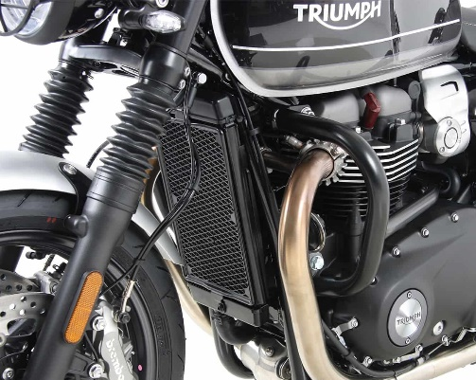
Figure 3 Motorbike with radiator and also fin array on engine block (Hepco-Becker, 2022)
The most recent advances in design of fins in automotive design have come from the capability to utilise FEA and optimise parameters such as fin geometry, tube count, tube geometry and radiator size or placements; coming as a result of more widespread access and understanding of FEA and numerical optimisation techniques. In the past these would have been decided through iterative design development with some manual calculations, but this rarely leads to true optimisation of a design.
With the rise of electric vehicles, the demand for cooling in these cars is reduced massively. While the batteries still need cooling, they need less than ICEs and therefore the radiator sizes can be reduced – hence the distinctive streamlined front bumper of an EV.

In Microprocessor Technology
One of the fundamental limitations and areas for past advancement of microprocessor technology has been the method and rate of power dissipation. The millions, or often billions, of miniature transistors that are continuously switching on/off generate heat within the silicon semiconductor, along with the increases in gate count and speed demands, have forced increases in the power that needs to be dissipated (History Computer, 2021) (Azar, 2000). Moore’s law states that every two years, the number of transistors per unit area doubles; and Figure 4 illustrates the effect of this exponential rise. As instantaneous computing demands fluctuate, heat generated is not constant, so the thermal mass must be sufficient to absorb energy - hence the referral to the electronics heat exchangers such as that seen in Figure 5 as ‘heat sinks.’
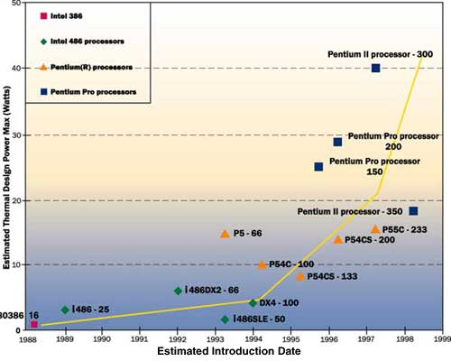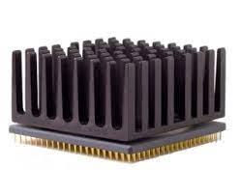
Figure 4 - Power demands across time (Colwell, 1999) Figure 5 - Example of heat sink (Allitwares.com, 2022)
For every 1 °C above its limit temperature, a chip’s reliability reduces 5% and its life span also reduces – so proper heat transfer to the ambient air ensures a microprocessor remains functional (H. E. Ahmed, 2018). There may also be a significant proportion of heat transfer by radiation if the heat system’s natural frequency is not properly accounted for in its design (Y. Li, 2019).
A heat sink must be designed to rapidly transfer energy to the ambient air within the confines of a dense electronics package – and as designs have become more efficient and reliable at keeping microprocessors below their limits of around 90°C, this has brought advances in further packaging densification (R. Mahajan, 2006). However, this brings thermodynamic concerns as it restricts airflow and increases ambient temperature local to the heat sink, forcing even further design improvement.
A microprocessor’s heat sink may be either passive or active, in that it makes use of natural convection or features an in-built fan to force convection and improve the Reynolds number of the fluid flow around the surface. Despite being simple to implement and cost-effective, this technology has reached some limits however, as air has a low heat capacity, and restrictions on packaging size and also noise demands have forced development elsewhere (Wei, 2008).
Another way to increase the Reynolds number is to use a more dense fluid, hence the advent of water-cooled microprocessors which make use of fin arrays within a closed-loop cooling system. Figure 6 shows that one of the key ways to improve such a system is to optimise the arrangement of the inlet and outlet positions to maximise heat transfer performance. Air-cooled systems can be optimised in a similar way by designing the fin shape and arrangement to optimise fluid flow velocity and coverage.
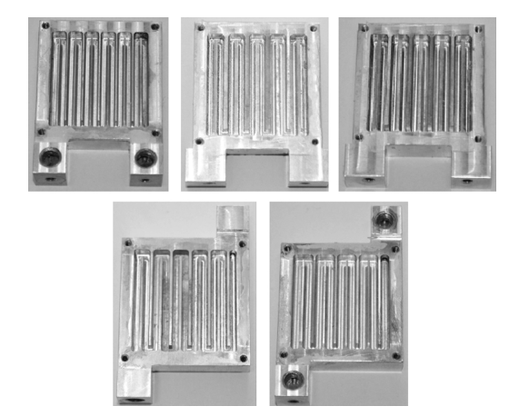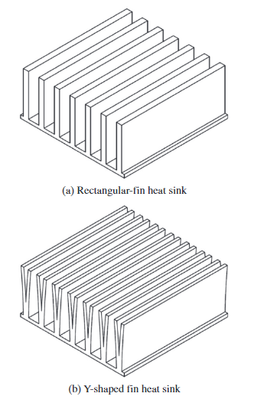
Figure 6 - Inlet and Outlet configurations (Y. Chen, 2014) Figure 7 - Shape optimisation of fins (Kim, 2014)
Aluminium has been the material of choice for electronics heat sinks historically, as it has a high cost-conductivity ratio and is low density, it can be anodised which improves heat transfer through radiation, and there were issues with reactivity between the copper structure and materials within the semiconductor (R. Mahajan, 2006). As these interface problems have been overcome, copper has been used more widely, as its higher conductivity helps to reduce hotspots across a microprocessor caused by ongoing miniaturisation (Wei, 2008).
Prismatic rectangular finned structures are the most common method of microprocessor cooling as they are fast and simple to produce, therefore low cost, and they often perform sufficiently. However, Figure 7 shows just one of the many other geometric configurations which would bring improvements to the design, in this case the implementation of Y-branch fins which decreased the thermal resistance of the heat sinks by 30% (Kim, 2014).
Another interesting recent development has been the use of metal foams, which have a vast surface area open to fluid flow within the low-density porous structure. The porosity can be specified at the so as to meet thermal mass specifications while also optimising convective heat transfer (H. E. Ahmed, 2018). To compound this, the fluid becomes turbulent within the structure, increasing convective heat transfer and also improving localised fluid mixing, ensuring better local heat removal (H. E. Ahmed, 2018). The addition of fins within the metal foam heat sink, seen in Figure 8, can also improve heat transfer when used in conjunction with forced air flow – in this case by a factor of 1.5 to 2.8 (S. S. Feng, 2014). This may be because it prevents the stagnation of air within the foam, as well as conducting heat through the fins away from the base, increasing the temperature difference between metal and air at the outer edge thus increasing local heat transfer rate.
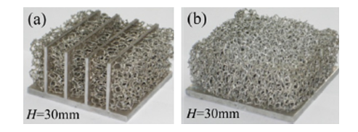
Figure 8 - Metal Foam Heat Sink, with and without fins (S. S. Feng, 2014)

Relationship between Optimum Fin Length, ${\dot{Q}}_{∞}$ and ${\dot{Q}}_{finite}$
When analysing fins to investigate their Heat Transfer Rates, $\dot{Q}$, there are two boundary conditions that can be used. The first considers the fin to be of infinite length, where the heat transfer rate can be expressed by:
$$\dot{Q}= \sqrt{hPkA_{c}} \left(T_{b}- T_{∞}\right)$$
Where $T_{b}$ is the base temperature, $T_{∞}$ is the ambient temperature, h is the convective heat transfer coefficient, P is the perimeter at its cross section, k is the fin material’s thermal conductivity, and A_{C} is its cross-sectional area.
For a fin of known length with an adiabatic tip, heat transfer rate is given by:
$$\dot{Q}= \sqrt{hPkA_{c}} \left(T_{b}- T_{∞}\right)tanh⁡(mL)$$
Where m is given by:
$$m^{2}= \frac{hP}{kA_{c}}$$
To prove and demonstrate that the optimum length occurs when mL = 2.65, ${\dot{Q}}_{∞}$ and ${\dot{Q}}_{finite}$ were plotted against a graph of mL, as seen in Figure 9. This was done using MATLAB, the code shown in Appendix 1. As both equations share the term $\sqrt{hPkA_{c}} \left(T_{b}- T_{∞}\right)$ , it can be considered equal to 1.

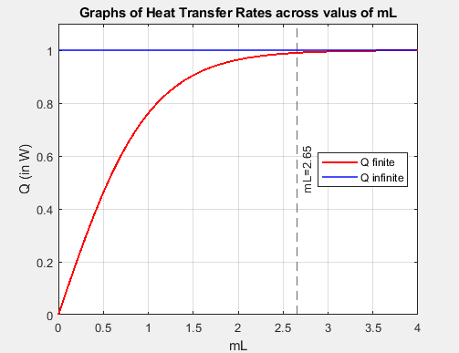
Figure 9 - Comparison of Heat Transfer Rates across values of mL
As can be seen on the graph, ${\dot{Q}}_{finite}$ shows a logarithmic increase for all values of mL; where for mL < 2.65 heat transfer is significantly below maximum, but for mL > 2.65 any gains are marginal. When considering the design of a heat exchanger, cost is of course a factor, and the improvements in heat transfer for any added material in the fin’s length must outweigh the cost of this extra material and any manufacturing cost implications it may incur; this is generally not true for values of mL greater than approximately 2.65.

Analysis of pin heat exchangers of different materials

Methodology
Materials will differ in thermal conductivity, k, and also convective heat transfer coefficient, h, as the surfaces of different materials differ in how they interact with the air or any other fluid in contact with it. Four different metals were assessed in order to find out how they compare in terms of heat transfer rates and optimum length – they are listed in Table 1. All analysis was done using MATLAB, the codes for which given in Appendix 2.
Table 1 - Material Properties
Material | h (W/m²K) | k (W/mK)
2024 Aluminium alloy | 30 | 186
Brass (70 Cu/30 Zn) | 30 | 99
Copper | 15 | 398
304 Stainless Steel | 7.5 | 16

Analysis Using Infinite Length Boundary Condition
For the first analysis, the length was assumed to be infinite, and the temperature distribution along each considered, using the equation below:
$$T\left(x\right)= T_{∞}+ (T_{b}- T_{∞})e^{-mx}$$
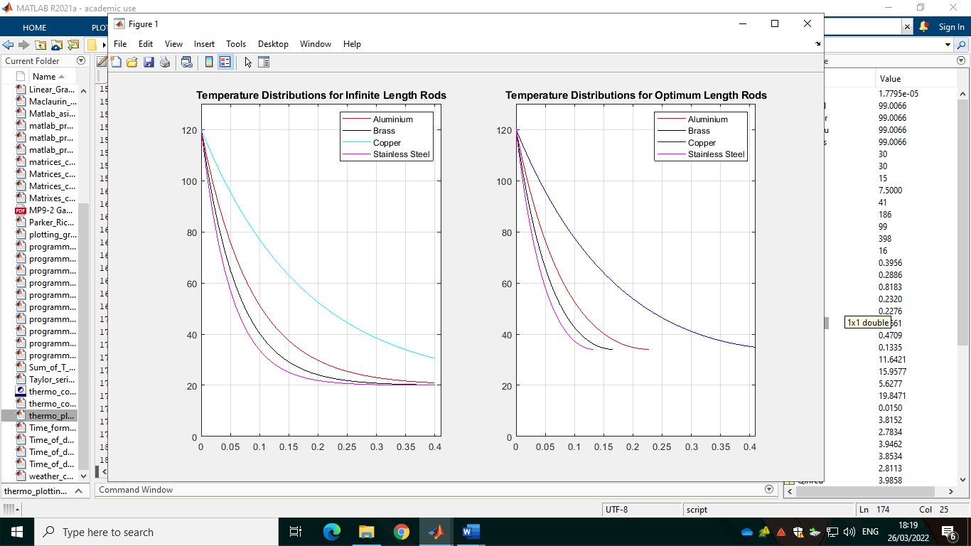
Figure 10 - Temperature distribution for infinite length rods
For each of the materials, m was calculated, then used to find T(x) at all points of x from 0 to 400mm in increments of 10mm. The results are displayed in Figure 10. All rods showed a large drop in temperature near their base, with the gradient of this temperature drop decreasing further along its length. The copper rod, which had by far the highest thermal conductivity, unsurprisingly showed the highest temperature at the end of the sample range at approximately 30°C; in contrast to the others which were all marginally over the ambient temperature of 20°C.
To properly compare them, the heat transfer rate, $\dot{Q}$, for each was calculated using the equation below. The results are given in Table 2. Again, Copper had the highest value, as its high conductivity meant that more of the rod had a greater temperature difference to the air it contacts, so it can release energy at a higher rate. Aluminium’s $\dot{Q}$ value was 96% of Copper’s, as its higher h value meant it transferred energy to the air more effectively at its surface than the copper did, almost making up for its conductivity deficit. Brass performed reasonably, while Stainless Steel was observed to only transfer 14% of what Copper did.
$$\dot{Q}= \sqrt{hPkA_{c}} \left(T_{b}- T_{∞}\right)$$
Table 2 - Heat Transfer Rates for Infinite Length
Material | ${\dot{Q}}_{∞}$ (W)
2024 Aluminium alloy | 3.85
Brass (70 Cu/30 Zn) | 2.81
Copper | 3.99
304 Stainless Steel | 0.56

Optimum Lengths for Each Material
The optimum length for a pin can be found using:
$$L_{OPTIMUM} =\frac{2.65}{m}$$
Table 3 shows this optimum length for each of the four materials. As Copper is so conductive, it can be seen that adding extra length bring significant increases in heat transfer all the way to a maximum of 0.47m, whereas Stainless Steel is only 0.13m.
Table 3 - Optimum Length for Each Material
Material | $L_{OPTIMUM}$ (m)
2024 Aluminium alloy | 0.23
Brass (70 Cu/30 Zn) | 0.17
Copper | 0.47
304 Stainless Steel | 0.13

Using the adiabatic tip equation, the heat transfer rates for each rod of optimum length were then found, results given in Table 4. As each material went through the same calculations, it should be no surprise that each value for ${\dot{Q}}_{finite}$ was 99% of its value for ${\dot{Q}}_{∞}$.
Table 4 - Heat Transfer Rates for Optimum Lengths
Material | ${\dot{Q}}_{finite}$ (W)
2024 Aluminium alloy | 3.82
Brass (70 Cu/30 Zn) | 2.78
Copper | 3.94
304 Stainless Steel | 0.56

Again, the temperature distributions were calculated, this time using the adiabatic tip boundary condition, given by:
$$T\left(x\right)= T_{∞}+ (T_{b}- T_{∞})\frac{cosh⁡[m\left(L-x\right)]}{cosh⁡(mL)}$$
Figure 11 shows these distributions. Due to them all using the same definition of optimum length, they all displayed the same tip temperature of just over 30°C, with the exception of Copper which is assumed to reach that value soon after the end of the 400mm sample. Other than the tip temperature being higher, the curve of temperature distribution for each was of the same nature as it was in the first analysis, and all materials compared to each other as they did previously.
Figure 11 - Temperature Distributions for Optimum Length Rods

Lengths Needed to Achieve Maximum Realistic Heat Transfer
From the temperature distribution for a pin with an adiabatic tip, the length needed to achieve a tip temperature 1% greater than ambient temperatures can be found by:
$$e^{-mL} <0.01$$
This length was calculated for each, the results shown in Table 4. As with the optimum length calculations, each material shows the same relationship between the two calculated lengths, such that $L_{OPTIMUM}$ is 57% of its value for $L_{MAXIMUM REALISTIC}$.
Material | $L_{MAXIMUM REALISTIC}$ (m)
2024 Aluminium alloy | 0.40
Brass (70 Cu/30 Zn) | 0.29
Copper | 0.82
304 Stainless Steel | 0.23

References
A. E. Biermann, H. H. E. J., 1939. THE DESIGN OF FINS FOR AIR-COOLED CYLINDERS. National Advisory Comittee for Aeronatuics, 28 06, pp. 401-424.
Allitwares.com, 2022. Allitwares.com. [Online]
Available at: http://www.allitwares.com/company/product_detail-Processor-Heat-Sinks-796.html
[Accessed 03 04 2022].
Azar, K., 2000. Electronics Cooling. [Online]
Available at: https://www.electronics-cooling.com/2000/01/the-history-of-power-dissipation/
[Accessed 03 04 2022].
Colwell, R., 1999. CPU Power Challenges. San Diego, International Symposium on Low Power Electronics and Design.
Fernie, M., 2016. Car Throttle. [Online]
Available at: https://www.carthrottle.com/post/air-cooling-why-its-a-thing-of-the-past/
[Accessed 03 04 2022].
H. E. Ahmed, B. S. A. K. M. A., 2018. Optimization of thermal design of heat sinks: A review. International Journal of Heat and Mass Transfer, Volume 118, pp. 129-153.
Hepco-Becker, 2022. hepco-becker.de. [Online]
Available at: https://www.hepco-becker.de/en/engine-protection-bar-black-for-triumph-speed-twin-2019.html
[Accessed 03 04 2022].
History Computer, 2021. History-computer.com. [Online]
Available at: https://history-computer.com/microprocessor/
[Accessed 03 04 2022].
Kim, D.-K., 2014. Thermal optimisation of branched-fin heat sinks subject to a parallel flow. International Journal of Heat and Mass Transfer, 278-287(1), p. 77.
Lamarque, P. V., 1943. The Design of Cooling Fins for Motor-Cycle Engines. Automobile Research Committee, 37(2), pp. 309-312.
Mercedes-Benz Group Media, 2022. group-media.mercedes-benz.com. [Online]
Available at: https://group-media.mercedes-benz.com/marsMediaSite/en/instance/ko/The-first-modern-automobile-the-35-hp-Mercedes.xhtml?oid=9909453
[Accessed 03 04 2022].
MyAutoWorld.com, 2022. MyAutoWorld.com. [Online]
Available at: https://myautoworld.com/mercedes/history/cars1886/1886/1886.html
[Accessed 03 04 2022].
R. Mahajan, C.-p. C. G. C., 2006. Cooling a Microprocessor Chip. Proceedings of th IEEE, Volume 8, pp. 1476-1486.
Ruian Sherrock Radiators, 2021. Ruinsherrockradiators.com. [Online]
Available at: https://www.sheradiatortank.com/a/technology/Knowledge/2021/0302/INVENTION_OF_THE_CAR_RADIATOR.html
[Accessed 03 04 2022].
S. S. Feng, J. J. K. T. W. T. J. L. K. I., 2014. International Journal of Heat and Mass Transfer. An experimental and numerical study of finned metal foam heat sinks under impinging air jet cooling, 77(1), pp. 1063-1074.
Saunders, L. P., 1936. Radiator Development and Car Cooling. SAE Transactions, 31(1), pp. 496-516.
Wei, J., 2008. Challenges in Cooling Design of CPU Packages for High-Performance Servers. Heat Transfer Engineering, 29(2), pp. 178-187.
Y. Chen, B. X. H. G. X., 2014. Fast approach of Pareto-optimal solution recommendation to multi-objective optimal design of serpentine-channel heat sink. Applied Thermal Engineering, 20(1), pp. 263-273.
Y. Li, H. Z. J. W. H. L. A. Z. P. W., 2019. Research on Radiation Emmision of CPU Thermal Design. 12th International Workshop on the Electromagnetic Compatability of Integrated Circuits (EMC Compo), pp. 147-149.

Appendices

MATLAB code for proving relevance of optimum fin length

Variables:

MATLAB code for analysis of different materials
Note – this task was treated as a coding exercise, so the code is significantly longer than it needs to be functional.
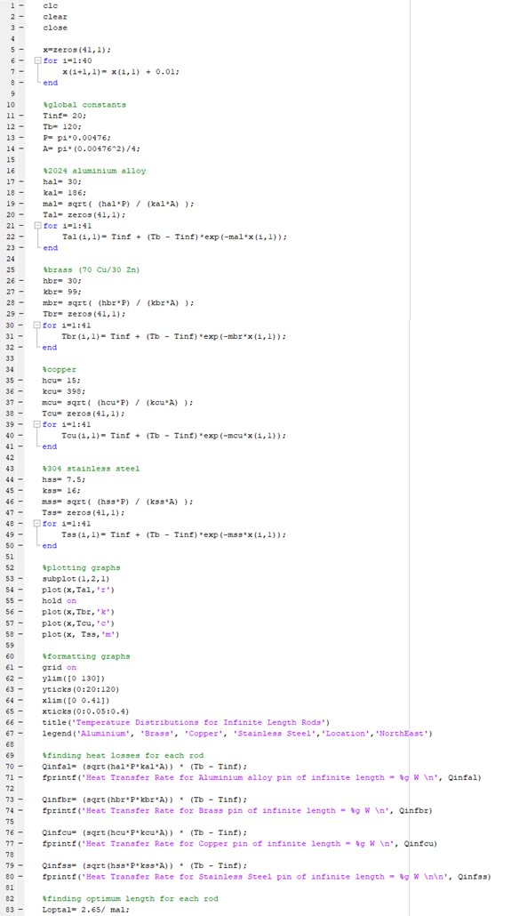
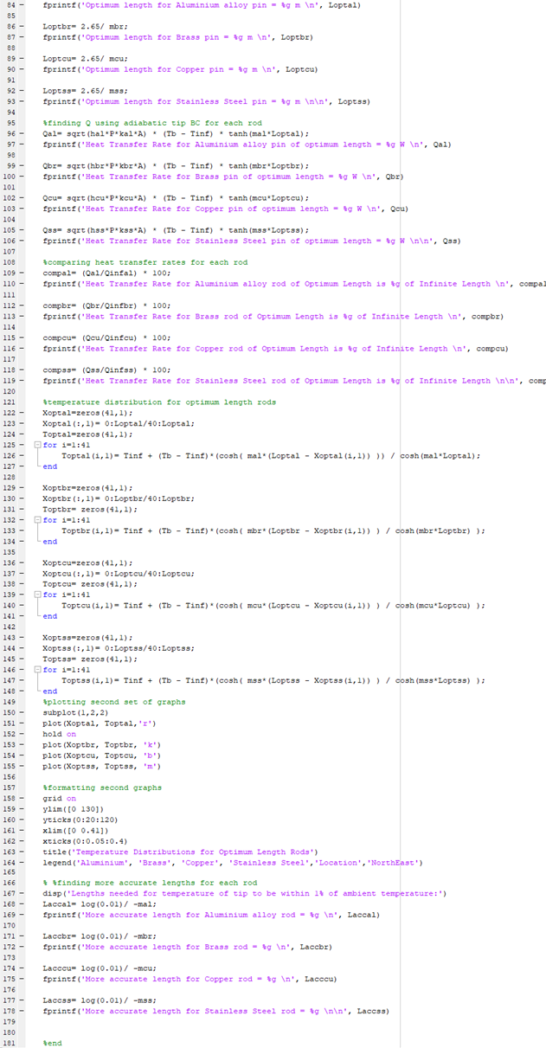

Variables:

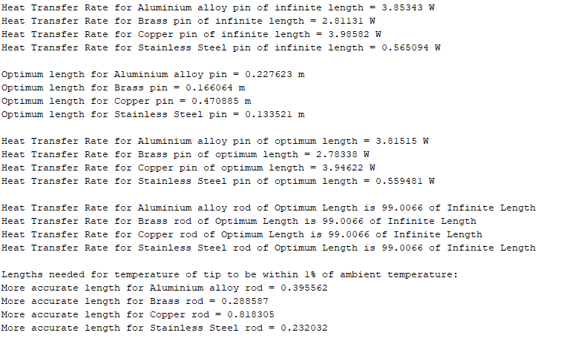
Results:

