Performance Analysis of the Honda VTEC 1.6L Engine: Efficiency, Power, and Fuel Consumption

ACHA4004_12
Motorsport and Vehicle Technology
Oscar Price
30/03/25

Contents
- Introduction…………………………………………………………………..
- Testing Equipment and Methodology………………………………….
- Data Analysis and Results………………………………………………..
3.1 Specific Fuel Consumption (SFC) vs. Engine Speed…………
3.2 Torque vs. Engine Speed……………………………………………..
3.3 Brake Power vs. Engine Speed……………………………………..
- Discussion and Interpretation…………………………………………..
- Conclusion…………………………………………………………………….
- Evaluation and Recommendations…………………………………….
- References…………………………………………………………………….

Introduction
The goal of this research is to examine the performance characteristics of a Honda VTEC 1.6-liter engine utilising dynamometer (dyno) data. The study is focused on essential performance metrics such as brake power, torque, brake mean effective pressure (BMEP), specific fuel consumption (SFC), and thermal efficiency. Understanding these aspects allows you to gain insight into the engine's operational efficiency at various speeds and estimate the best performance range. This study also looks at how environmental variables and combustion efficiency affect engine power. The results will be used to evaluate the engine's tuning requirements and potential areas of efficiency improvement. (Tufail et al., 2009)

Testing Equipment and Methodology
The engine performance tests were carried out with an engine dynamometer, which gives real-time readings of important performance indicators. The dynamometer system measured torque, fuel consumption, and power production at different engine speeds in a controlled testing environment. Barometric pressure, ambient temperature, and humidity were measured to apply conventional correction factors to assure appropriate data interpretation.
The Honda VTEC 1.6L engine was tested at progressive RPM levels, with torque and power output recorded at each stage. The fuel flow rate and air-fuel ratio were used to calculate combustion efficiency. Brake Power, SFC, and BMEP were then computed using standard engineering equations and then put into an excel sheet for graphs to be created. The collected data has been plotted to visualise trends in engine behaviour, showing differences in efficiency and power output (Stuhldreher et al., 2018).

Data Analysis and Results

Specific Fuel Consumption (SFC) VS Engine Speed
SFC, which measures the amount of fuel burned per unit of power produced, is an important efficiency metric. The investigation found that SFC first falls as engine speed increases, eventually reaching an ideal range where combustion efficiency is maximised. This tendency is attributable to improved fuel atomisation, better air-fuel mixture distribution, and lower heat losses. However, at higher RPMs, SFC begins to increase as frictional losses rise, partial combustion occurs owing to shorter ignition periods, and additional cooling requirements arise.
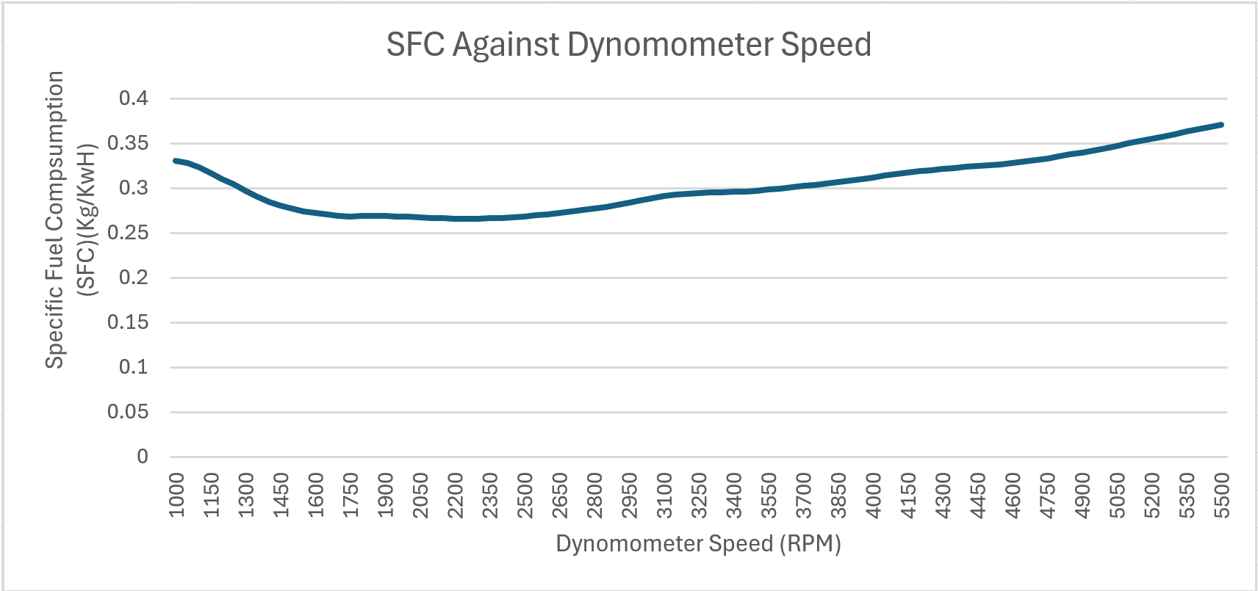
The statistics reveal that SFC is lowest at mid-range RPMs, typically between 4000 and 5000 RPM, when the engine performs the most effective fuel conversion. Beyond this point, turbulence and increased friction cause inefficient combustion, increasing fuel demand per unit of power generated (Stuhldreher et al., 2018).
Figure 1: SFC against Dyno Speed Graph

Torque vs. Engine Speed
Torque is the rotational force produced by the engine and is critical in determining acceleration and drivability. The torque curve for the Honda VTEC 1.6L engine follows a conventional pattern, with a steady increase from low RPMs, a peak at mid-range speeds, and a progressive decrease at higher RPMs. The increase in torque at lower speeds is due to higher volumetric efficiency, which allows for better air intake and fuel combustion. Peak torque is obtained in a specified RPM range in which cylinder filling is optimised. Beyond this limit, torque declines due to higher internal resistance, inefficient valve timing, and a fall in volumetric efficiency as intake and exhaust flows become less effective at extremely high speeds.
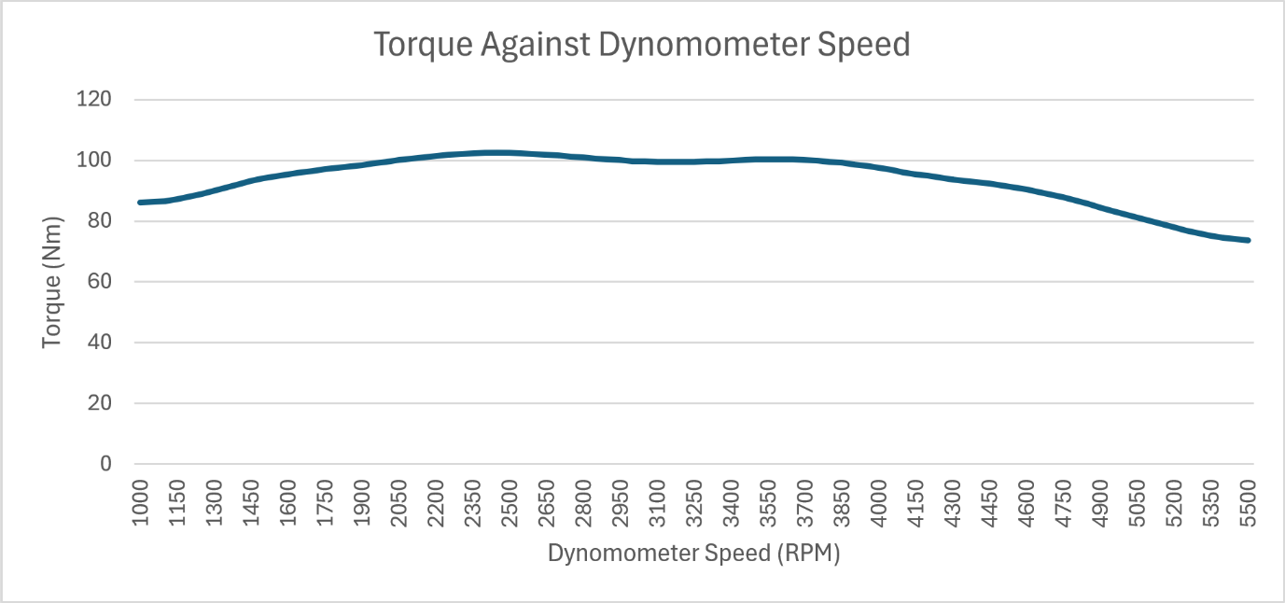
The Honda VTEC technology is crucial for torque delivery. At lower RPMs, the engine uses conservative valve timing to optimise fuel economy and driveability. As RPM rises, the VTEC system activates to transition to a high-performance camshaft profile, which increases valve lift and duration to maximise airflow. This produces a significant increase in torque while keeping a broad and useful powerband. However, at extremely high RPMs, air turbulence and intake inefficiencies cause torque to diminish, highlighting the necessity of maintaining ideal engine speeds during performance driving (Carl et al., 2021).
Figure 2: Torgue vs Dynamometer Speed

Brake Power vs. Engine Speed
Brake power, or useable power given to the crankshaft, is a direct result of both torque and engine speed. The power curve shows a consistent increase in power production as RPM increases, reaching a peak before progressively declining at too high speeds. The decline at high RPMs is caused by diminishing torque and the increasing influence of friction and heat losses. This pattern demonstrates that while greater speeds may contribute to increased power output initially, excessive RPMs lead to decreasing returns as mechanical inefficiencies become prominent (Ferguson and Kirkpatrick, 2016).
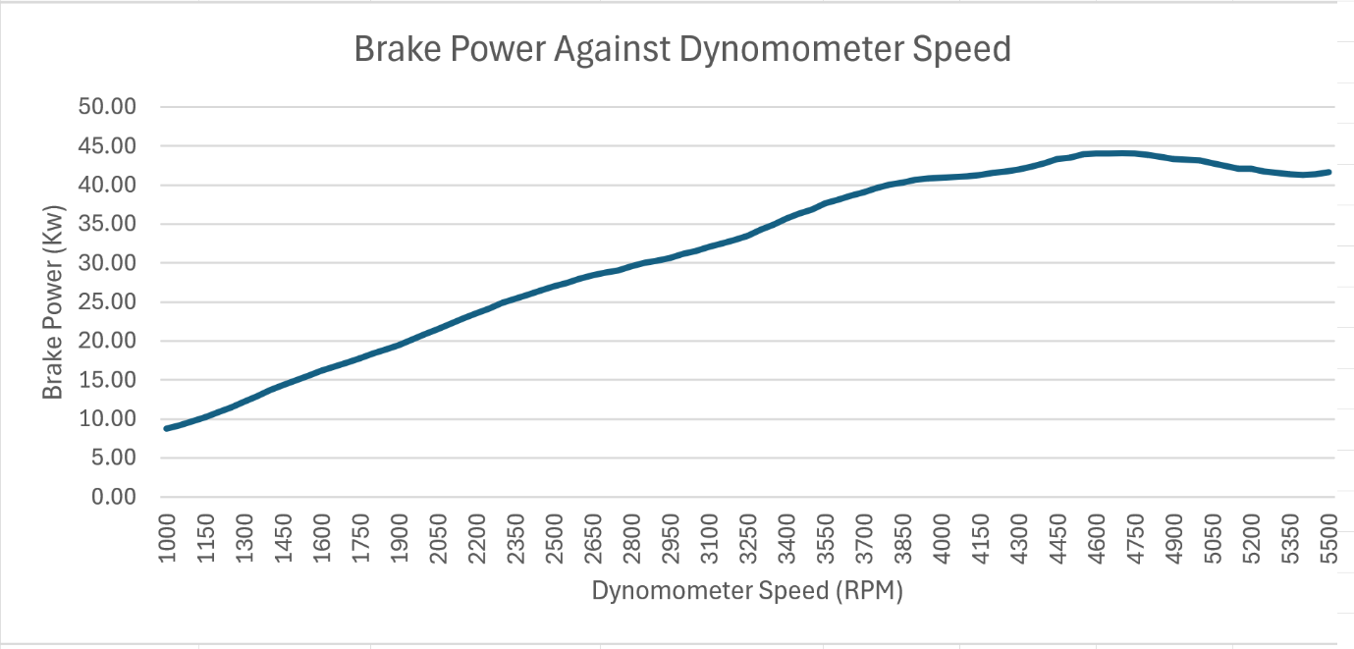
The study shows that maximum Brake Power occurs between 6000 and 7000 RPM, where torque is still somewhat strong and heat and frictional losses have not yet much affected engine efficiency. After this, more power output improvements are prevented by engine stress and the fuel-air mixture's restrictions. This implies that to maximise acceleration and prevent needless wear on engine components, the ideal shifting points for performance driving should be placed within this range.
Figure 3: Brake Power vs Dynamometer Speed

Discussion and Interpretation
The analysis of the Honda VTEC 1.6L engine performance emphasises the importance of maintaining an ideal operating range for both efficiency and power delivery. The engine performs best at the mid-range RPMs, where torque is maximised and SFC is minimised, resulting in the optimal balance of power production and fuel efficiency. Running the engine at extremely high speeds causes greater fuel consumption without a commensurate increase in power, making it inefficient for continuous operation at high RPMs.
Environmental factors have a considerable impact on engine performance. Barometric pressure and ambient temperature influence air density, which affects the air-fuel ratio and combustion efficiency. These were considered in the calculations to ensure that the results were consistent across all testing settings. Furthermore, maintaining an optimal air-fuel ratio is critical for increasing combustion efficiency. Deviations from the optimal lambda value can result in increased emissions, fuel waste, and possible engine banging (Heywood and Welling, 2009).

Conclusion
The dynamometer results demonstrate that the Honda VTEC 1.6L engine is most efficient at mid-range RPMs, where torque and power output are optimised while fuel consumption stays low. As engine speed exceeds this limit, combustion inefficiencies and greater mechanical resistance result in a decrease in overall performance. These findings imply that fine-tuning ignition time, valve timing, and fuel injection can improve overall efficiency and power delivery. Implementing technologies such as variable valve timing (VVT) and direct fuel injection could give significant gains by optimising combustion over a broader range of operating circumstances (Kim et al., 2021).

Evaluation and Recommendations
To improve future engine performance tests, real-time air-fuel ratio adjustment is advised, ensuring precise combustion efficiency analysis. Testing under different load situations would provide a more complete picture of engine behaviour in real-world applications. Additional research could concentrate on transient response analysis, which examines the engine's performance under abrupt acceleration and deceleration settings. Increasing the data collecting sample rate improves the precision of performance curves, allowing for a better understanding of efficiency losses at higher speeds. Incorporating thermal imaging and in-cylinder pressure analysis would also help to better estimate heat losses and combustion efficiency. Advanced computational fluid dynamics (CFD) simulations may also be utilised to anticipate airflow behaviour and optimise intake and exhaust system designs (Cerri, D’Errico and Onorati, 2013).

References

Tufail, K., Winstanley, T., Karagiorgis, S., Hardalupas, Y. and Taylor, A.M.K.P. (2009). Characterisation of Diesel Engine Transient Pumping-loss and Control Methodology for Transient Specific Fuel Consumption (SFC). SAE Technical Paper Series. doi:https://doi.org/10.4271/2009-01-2748.
Stuhldreher, M., Kargul, J., Barba, D., McDonald, J., Bohac, S., Dekraker, P. and Moskalik, A. (2018). Benchmarking a 2016 Honda Civic 1.5-Liter L15B7 Turbocharged Engine and Evaluating the Future Efficiency Potential of Turbocharged Engines. SAE International Journal of Engines, 11(6), pp.1273–1305. doi:https://doi.org/10.4271/2018-01-0319.
‌Carl, J., Quiros, E.N., Gabriel, J. and Rodgers, P.L. (2021). Fuel Economy Results From Diesel Engine Tuning for Steady Speed and Drive Cycle Operation. doi:https://doi.org/10.1115/es2021-62572.
‌Ferguson, C.R. and Kirkpatrick, A. (2016). Internal combustion engines : applied thermosciences. Chichester, West Sussex, United Kingdom: John Wiley & Sons, Inc.
‌Heywood, J.B. and Welling, O.Z. (2009). Trends in Performance Characteristics of Modern Automobile SI and Diesel Engines. SAE International Journal of Engines, [online] 2(1), pp.1650–1662. doi:https://doi.org/10.2307/26308497.
‌ Kim, S., Park, C., Jang, H., Kim, C. and Kim, Y. (2021). Effect of boosting on a performance and emissions in a port fuel injection natural gas engine with variable intake and exhaust valve timing. Energy Reports, 7, pp.4941–4950. doi:https://doi.org/10.1016/j.egyr.2021.07.073.
‌Cerri, T., D’Errico, G. and Onorati, A. (2013). Experimental investigations on high octane number gasoline formulations for internal combustion engines. Fuel, 111, pp.305–315. doi:https://doi.org/10.1016/j.fuel.2013.03.065.
‌

‌

