BMHP5015_BIRM Changemakers: Building your Personal Brand for Sustainable Employment
Component 2 – Report

Student Name: Shagufta Bi
Student Number: 2324572

Introduction
This report looks at the employability skills required of a Healthcare Manager, assesses my existing capabilities and describes how I intend to enhance my personal brand, networks and professional identity to reach this goal. My ambition is to become a Healthcare Manager, a critical job in assuring quality, safety and efficiency in health and social care services. Healthcare Managers oversee leading teams, manage budgets, ensure regulatory compliance and enhancing service outcomes for patients and users. I am driven by a desire to positively impact people's lives through effective leadership and compassionate management. My academic pursuits and placement experiences have fuelled this aim by demonstrating how effective management directly improves care delivery.
Job Advertisement
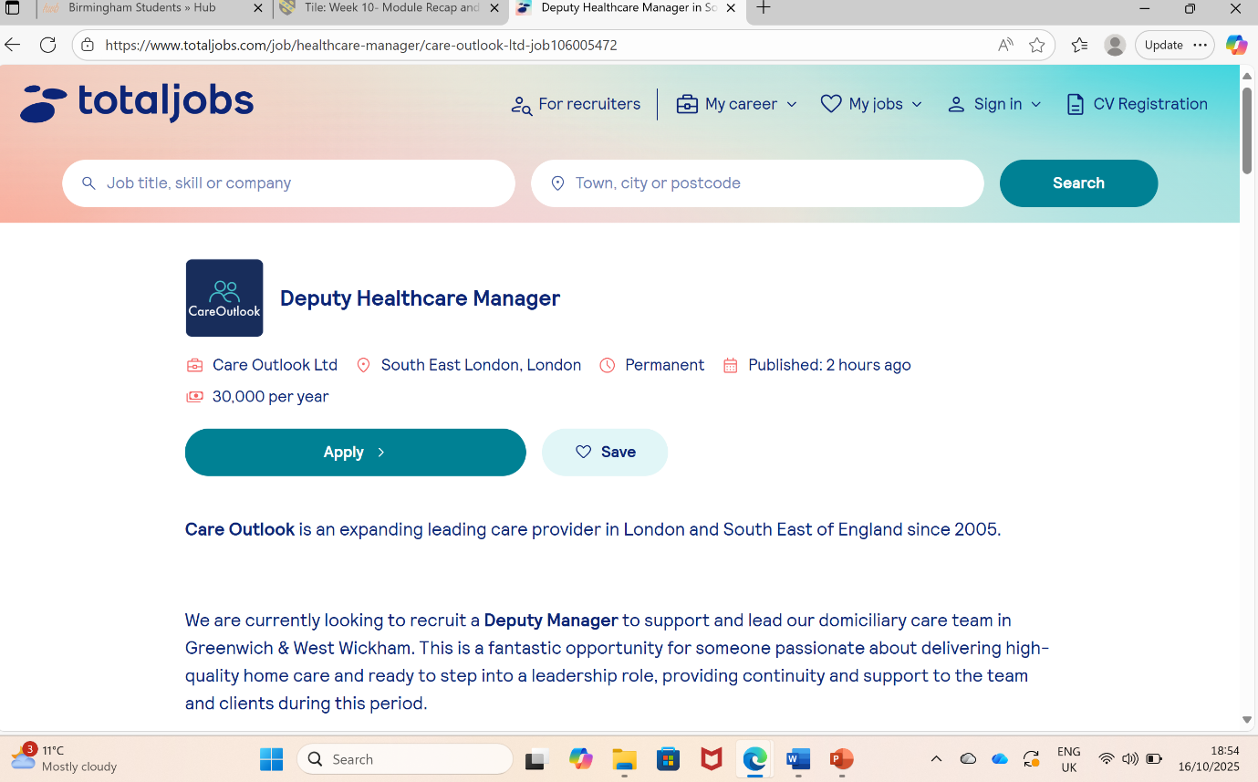
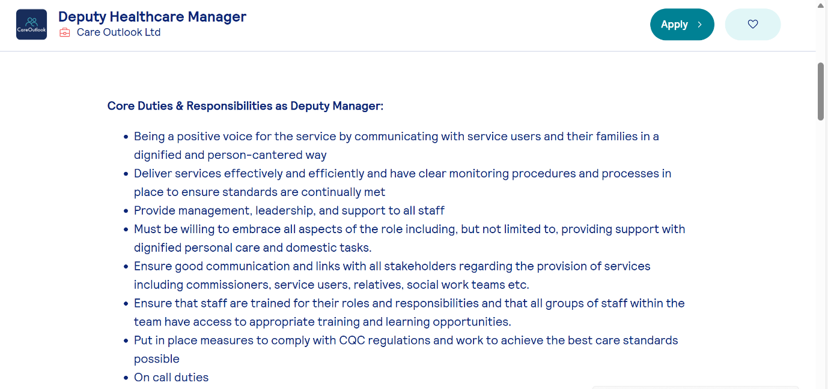
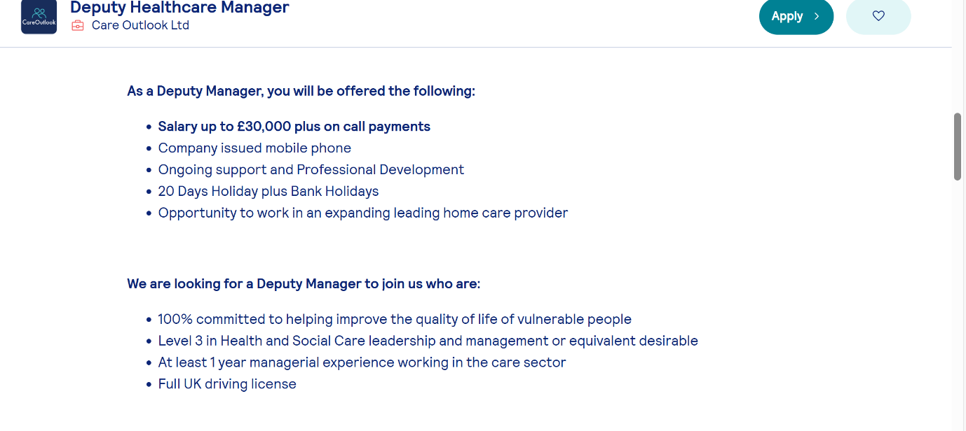
Above I have attached screenshots of the job role I would like to pursue in the future, the role I have chosen is the Deputy Healthcare Manager position advertised by Care Outlook Ltd on Totaljobs (Care Outlook Ltd, 2025).
Job Role Analysis
The Care Outlook Ltd Deputy Healthcare Manager vacancy offers a post that oversees day-to-day domiciliary-care operations, ensures compliance with CQC rules and maintains quality standards throughout services. The advertisement highlights important responsibilities, including:
- Supervising and helping staff to provide person-centred care.
- Coordinate training and growth.
- Manage rotas and respond to on-call obligations.
- Communicating with service users, families, commissioners and other partners.
- Ensure that all practices adhere to legal, ethical and quality standards (Care Outlook Ltd, 2025).
The position requires a Level 3 certificate in Health and Social Care Leadership or comparable experience, one year of supervisory experience and a driver's license. The salary is specified as £30,000, plus on-call payments.
The Deputy Healthcare Manager position at Care Outlook Ltd emphasises numerous key employability skills that are required for success in the home-care sector. According to Goleman (2017), emotionally intelligent leaders exhibit self-awareness, empathy and motivation, allowing ambitious managers to inspire teams, handle complexity and sustain pleasant organisational environments. Strong communication skills are essential to effectively communicate with service users, families and professionals, promoting teamwork and preventing misconceptions (Wilkes, Messum and Jackson, 2011).
A thorough awareness of CQC regulatory compliance is required to maintain quality and safety standards and ensure that services meet inspection criteria (Wilkes, Messum and Jackson, 2011). Furthermore, the ability to offer staff training and development enables managers to instil competence and confidence in their teams, fostering a culture of learning and continuous improvement (van der Baan et.al., 2022).
Strong adaptability and problem-solving skills are also required to respond swiftly to on-call emergencies, workforce shortages and service-user needs (Tushar and Sooraksa, 2023). Moreover, organisational and time management abilities enable managers to properly prioritise competing requests while maintaining service reliability (Messum et al., 2016). These skills are critical in a sector experiencing growing staff demands and financial restrictions.
Collectively, these employability skills have a direct impact on effective managerial performance. They enable healthcare leaders to maintain regulatory compliance, develop worker engagement and provide high-quality, person-centred care in a complicated and changing health and social care environment.
Personal Skills Evaluation
To assess my suitability, I compared my present competencies (acquired through academic study, volunteering and placement) to those necessary for the Care Outlook post.
SWOT Analysis
Strengths  Degree modules provided good theoretical knowledge of safeguarding, ethics and policy.  Excellent communication and teamwork from voluntary work.  A sensitive, reflective and empathetic attitude to care.  Highly motivated and adaptable. | Weaknesses  Limited formal management or budgeting experience.  Unfamiliar with financial and data reporting systems.  Limited networking.  Lack of confidence under pressure.
Opportunities  Home-care industry growth and digital transformation projects.  Access to the IHSCM student membership and leadership events.  Data and leadership training opportunities. | Threats  Competition from experienced employees.  Financial struggles for further studies.  Regular staff turnover impacting stability.

Using Kolb's (1984) four-stage learning cycle, I reflected on my care-home placement, where I oversaw organising daily activities for service users.
- The Concrete Experience entailed personally managing the activity schedule and navigating the challenges of balancing time, staff availability and service-user preferences.
- During Reflective Observation, I explored how inconsistency in planning influenced employee confidence and service delivery.
- Abstract Conceptualisation helped me recognise that clear communication, disciplined planning and successful delegation are critical for teamwork and service reliability.
- Finally, in Active Experimentation, I applied these insights to subsequent group projects by creating specific timetables, defining roles and tracking progress.
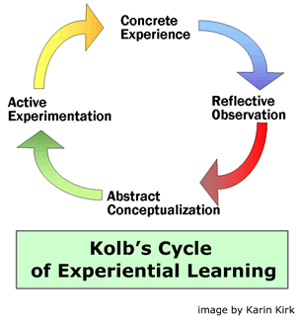
Figure 1: Kolb's Cycle (Carleton College SERC, 2007).
This cycle improved my communication, planning and leadership talents while emphasising the need for more sophisticated project management and time coordination skills (Ghaye, 2011).

Although I have great interpersonal and reflective skills, I need to improve my financial knowledge, data interpretation, and strategic thinking to flourish as a healthcare manager. According to Northouse (2021), self-awareness and transformational leadership assist aspiring leaders in motivating people and managing complexity efficiently. My placement supervisors recognised me as dependable and empathetic, but they suggested that I improve my decision-making confidence in fast-paced settings.

To address these development areas, I intend to seek mentorship, take short leadership and financial courses. Techniques for feedback and continual reflection will help me enhance skills and ensure they meet employer requirements (Jackson, 2016).

Five-Year Action Plan and Timeline

Year | Goal | Development Activities | Resources/ Support Needed | Outcome/ Evidence of Progress
Current Year | Complete Level 5 Diploma in Health and Social Care | Search for placement | University tutors, help updating cv | Reflective journal, updated cv and securing placement
Year 1 | Complete Level 6 in Health and Social Care and obtain degree | Shadow a Senior Carer or Deputy Manager | University tutor and volunteering opportunities | Completing my degree and getting feedback from tutors
Year 2 | Begin full-time employment as a Senior Care Worker | Apply for entry-level leadership positions such as "Introduction to Supervision" course. | CPD funding for online learning platforms | Obtaining a job contract and asking for a performance review
Year 3 | Progress into Deputy Manager or Team Leader | Attend IHSCM networking events and Skills for Care workshops | Mentor guidance and CPD membership | Feedback from Manager
Year 4 | Complete a Post Graduate Diploma in Health and Social Care Leadership | Enrol in a Postgraduate or Leadership program | Employer sponsorship or student loan | Postgraduate qualification certificate, reflective portfolio
Year 5 | Secure a Healthcare Manager position | Mentor junior employees, oversee regulatory audit preparation and create a reflecting blog on leadership experiences | Senior Management mentorship, NHS leadership academy resources | Employment offer, professional portfolio and LinkedIn updates

In the above timetable I have reported the steps I will take to help me achieve my goals over the course of the next five years. Progress will be tracked quarterly using reflective logs linked with Kolb's (1984) model. I will ask university lecturers and line managers to provide feedback to guide modifications. Continuous professional development will align with the NHS Leadership Academy (2020) competences, ensuring improvement in communication, financial knowledge and people management.

Although the development plan is ambitious, it is still possible with dedication, adaptation and strategic planning. Potential roadblocks, such as limited resources, fierce competition for leadership positions and the emotional demands of care work, may impede progress. However, remaining flexible and accepting entry-level supervisory positions or temporary leadership opportunities will provide significant experience and a solid professional foundation. Continuous professional development supports the continued acquisition of important skills and information, whilst reflective practice allows for the critical evaluation of experiences and improvement of professional behaviour.

According to Eraut (2004), informal and experiential learning accounts for a significant portion of employability growth in health and social care, as professionals understand, modify and apply knowledge in real-world settings. This technique promotes self-awareness, resilience and practical competence, all of which are necessary attributes for managerial success. Aligning personal and professional goals with Skills for Care (2024) workforce priorities ensures that development initiatives are responsive to changing sector needs and make a meaningful contribution to service improvement and leadership capability.

Building My Personal Brand

A personal brand expresses professional identity and standards (Shepherd, 2005). In health and social care, reputation is built on authenticity, integrity and trust. Creating a personal brand exhibits self-awareness and confidence in communicating one's professional skills.

Creating an effective professional identity requires ongoing participation, self-reflection and ethical communication. On LinkedIn, I intend to publish views on leadership practices and insights from current CQC reports, as well as actively engage in discussions with professionals to increase exposure and sector awareness (Dijck, 2013). Maintaining a professional portfolio that includes feedback, credentials and evidence of ongoing professional development demonstrates growth and competence. Participating in webinars and networking opportunities provided by the NHS Leadership Academy (2020) and the Institute of Health and Social Care Management would enhance my professional profile.

Maintaining ethical consistency in all methods of communication is critical to preserving trust and professionalism, as well as promoting inclusive and courteous interactions (Banks, 2020). However, while creating a personal brand might help with employability, it must be genuine rather than superficial self-promotion. Genuine credibility is derived from demonstrated expertise, ongoing learning and alignment with professional principles. West et.al (2017) state resilience, compassion and authenticity are crucial characteristics for effective leadership and serve as the foundation for the professional persona I aim to project.

Promoting My Personal Identity
Developing and promoting my professional identity as a future healthcare manager entails purposefully displaying my talents, values and ethical principles in both academic and professional settings. Professional identity in health and social care is defined by self-awareness, moral integrity and alignment with sector values including compassion, responsibility and inclusivity (Adams et.al, 2006). To build this identity, I intend to communicate my leadership philosophy and career aspiration through a well-organised professional portfolio and internet presence. A clear digital identity reflects a commitment to learning and transparency in practice (Labrecque, Markos and Milne, 2011).
I plan to use reflective writing and professional interaction to showcase my talents in communication, teamwork and problem solving, all of which are highly valued in health management. Engaging with practicing educators and mentors will also help me improve my professional presentation, giving me more confidence and credibility. Trede, Macklin and Bridges (2012) define professional identity development as an ongoing process aided by mentorship, reflection and situational learning experiences. Through regular CPD and reflective engagement, I will maintain a professional image in the health and social care area that reflects competence, compassion and leadership preparation.
Building a Network for Successful Employment
Creating and maintaining a professional network is essential for employability and leadership development in health and social care. Networks provide mentoring, knowledge exchange and professional opportunities that help people advance in their careers (Anderson and Jack, 2002). I aim to broaden my professional network by attending leadership courses, care management conferences and health-care webinars. Active involvement in such venues promotes collaboration and visibility while allowing me to learn from more experienced practitioners.
Digital networking, particularly on platforms such as LinkedIn, will allow me to interact with industry leaders, recruiters and professional organisations. According to research, online networking and digital engagement help to promote careers by encouraging lifelong learning and enhancing professional visibility (Neier and Zayer, 2015).
I intend to maintain professional relationships by frequent communication, resource sharing and mutual assistance. By building a varied, supportive professional network, I will improve both my employability and my ability to influence positive change in future healthcare management positions.
Conclusion
This report critically evaluates the employability skills, personal branding and professional development methods required for advancement to the position of Healthcare Manager. According to the Care Outlook Ltd position job post, critical competencies for ensuring safe, effective and person-centred care include leadership, communication, adaptability and regulatory compliance. Reflecting on Kolb's experiential learning cycle allowed me to discover important strengths in empathy, teamwork and planning while also seeing areas for improvement in financial management and data interpretation. The five-year career plan offers a practical and systematic way to improving these abilities through mentoring, ongoing professional development and reflective practice.
Creating a strong and ethical professional identity based on sector principles is crucial to credibility and employability in health and social care. Creating an authentic personal brand and maintaining professional participation on sites such as LinkedIn, IHSCM, and Skills for Care will help you gain exposure and build professional networks. Finally, success in healthcare management requires ongoing education, self-awareness, and resilience. By integrating personal growth with sector priorities while preserving compassion, integrity and reflective leadership, I am confident in my ability to transition from a student into a knowledgeable, successful and compassionate Healthcare Manager in a rapidly changing care environment.

References
Care Outlook Ltd (2025). Deputy Healthcare Manager, Totaljobs. Available at: https://www.totaljobs.com/job/healthcare-manager/care-outlook-ltd-job106005472 (Accessed: 16 October 2025).
Goleman, D (2017). Leadership That Gets Results. Boston: Harvard Business Review Press. Available at: https://hbr.org/2000/03/leadership-that-gets-results (Accessed: 16 October 2025).
Wilkes, L., Messum, D and Jackson, D (2011). ‘Employability Skills: Essential Requirements in Health Manager Vacancy Advertisements’, Asia Pacific Journal of Health Management, 6 (2). Available at: https://www.researchgate.net/publication/269337665_Employability_Skills_essential_requirements_in_health_manager_vacancy_advertisements (Accessed: 16 October 2025).
van der Baan, N., Raemdonck, I., Bastiaens, E and Beausaert, S (2022). ‘Employability Competences of Workers in Health Care and Finance. The Role of Self-directed Learning Orientation and Job Characteristics, International Journal of Training and Development, 26 (3), pp. 427-447. Available at: https://doi.org/10.1111/ijtd.12264 (Accessed: 16 October 2025).
Tushar, H and Sooraksa, N (2023) ‘Global Employability Skills in the 21st Century Workplace’, PubMed Central - National Center for Biotechnology Information. Available at: https://pmc.ncbi.nlm.nih.gov/articles/PMC10637906/ (Accessed: 16 October 2025).
Carleton College SERC (2007). What is experienced based learning? Available at: https://serc.carleton.edu/introgeo/enviroprojects/what.html (Accessed: 18 October 2025).
Ghaye, T (2011). ‘Teaching and Learning Through Reflective Practice: A practical Guide for Positive Action’, Reflective Practice, 12(1), pp.1-6. Available at: https://doi.org/10.4324/9780203833322 (Accessed: 18 October 2025).
Jackson, D (2016). ‘Re-conceptualising Graduate Employability: The Importance of Pre-professional Identity’, Higher Education Research & Development, 35(5), pp. 925–939. Available: https://doi.org/10.1080/07294360.2016.1139551 (Accessed: 18 October 2025).
Shepherd, I.D.H (2005). ‘From Cattle and Coke to Charlie: Meeting the Challenge of Self Marketing and Personal Branding’, Journal of Marketing Management, 21(5-6), pp. 589-606. Available at: https://doi.org/10.1362/0267257054307381 (Accessed: 20 October 2025).
Dijck, V.J (2013). “You Have One identity”: Performing the Self on Facebook and LinkedIn’, Media, Culture & Society, 35(2), pp. 199-215. Available at: https://doi.org/10.1177/0163443712468605 (Accessed: 20 October 2025).
Banks, S (2020). Ethics and Values in Social Work. 5th Edition. London: Red Globe Press. Available at: https://books.google.co.uk/books?hl=en&lr=&id=CfJGEAAAQBAJ&oi=fnd&pg=PP1&dq=Banks,+S.+(2020)+Ethics+and+Values+in+Social+Work.+5th+edn.+London:+Red+Globe+Press.&ots=QcXx0DrcNb&sig=T6lRvkUQxV1OyxszPLgIDsMYlVQ#v=onepage&q=Banks%2C%20S.%20(2020)%20Ethics%20and%20Values%20in%20Social%20Work.%205th%20edn.%20London%3A%20Red%20Globe%20Press.&f=false (Accessed: 20 October 2025).
West, M., Eckert, R., Collins, B and Chowla, R (2017). Caring to Change: How Compassionate Leadership Can Stimulate Innovation in Health Care. London: The King’s Fund. Available at: https://www.kingsfund.org.uk/insight-and-analysis/reports/caring-change (Accessed: 20 October 2025).
Eraut, M (2004). ‘Informal Learning in the Workplace’, Studies in Continuing Education, 26(2), pp. 247-273. Available at: https://doi.org/10.1080/158037042000225245 (Accessed: 20 October 2025).
Adams, K., Hean, S., Sturgis, P and Clark, J (2006). ‘Investigating the Factors Influencing Professional Identity of First-year Health and Social Care Students’, Learning in Health and Social Care, 5(2), pp. 55-68. Available at: https://doi.org/10.1111/j.1473-6861.2006.00119.x (Accessed: 25 October 2025).
Labrecque, L.I., Markos, E and Milne, G.R (2011). ‘Online Personal Branding: Processes, Challenges, and Implications’, Journal of Interactive Marketing, 25(1), pp. 37-50. Available at: https://www.sciencedirect.com/science/article/abs/pii/S1094996810000587 (Accessed: 25 October 2025).
Trede, F., Macklin, R and Bridges, D (2012). ‘Professional Identity Development: A Review of the Higher Education Literature’, Studies in Higher Education, 37(3), pp. 365-384. Available at: https://doi.org/10.1080/03075079.2010.521237 (Accessed: 25 October 2025).
Anderson, A.R and Jack, S.L (2002) ‘The Articulation of Social Capital in Entrepreneurial Networks: a Glue or a Lubricant?’, Entrepreneurship & Regional Development, 14(3), pp. 193-210. Available at: https://doi.org/10.1080/08985620110112079 (Accessed: 25 October 2025).
Neier, S and Zayer, L.T (2015). ‘Students’ Perceptions and Experiences of Social Media in Higher Education’, Journal of Marketing Education, 37(3), pp. 133-143. Available at: https://doi.org/10.1177/0273475315583748 (Accessed: 25 October 2025).

