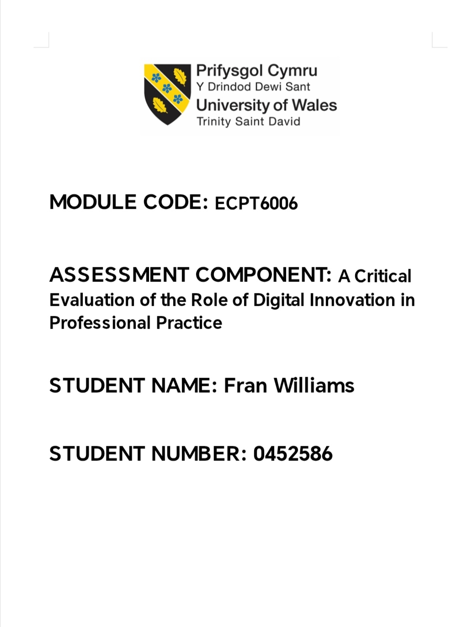
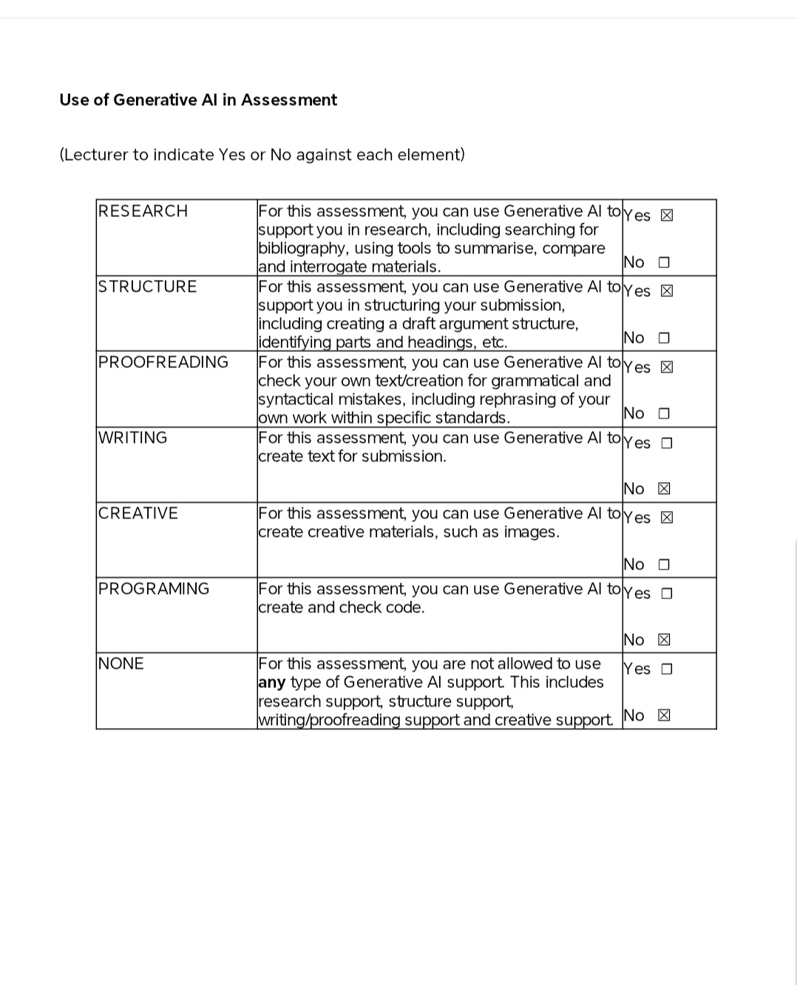
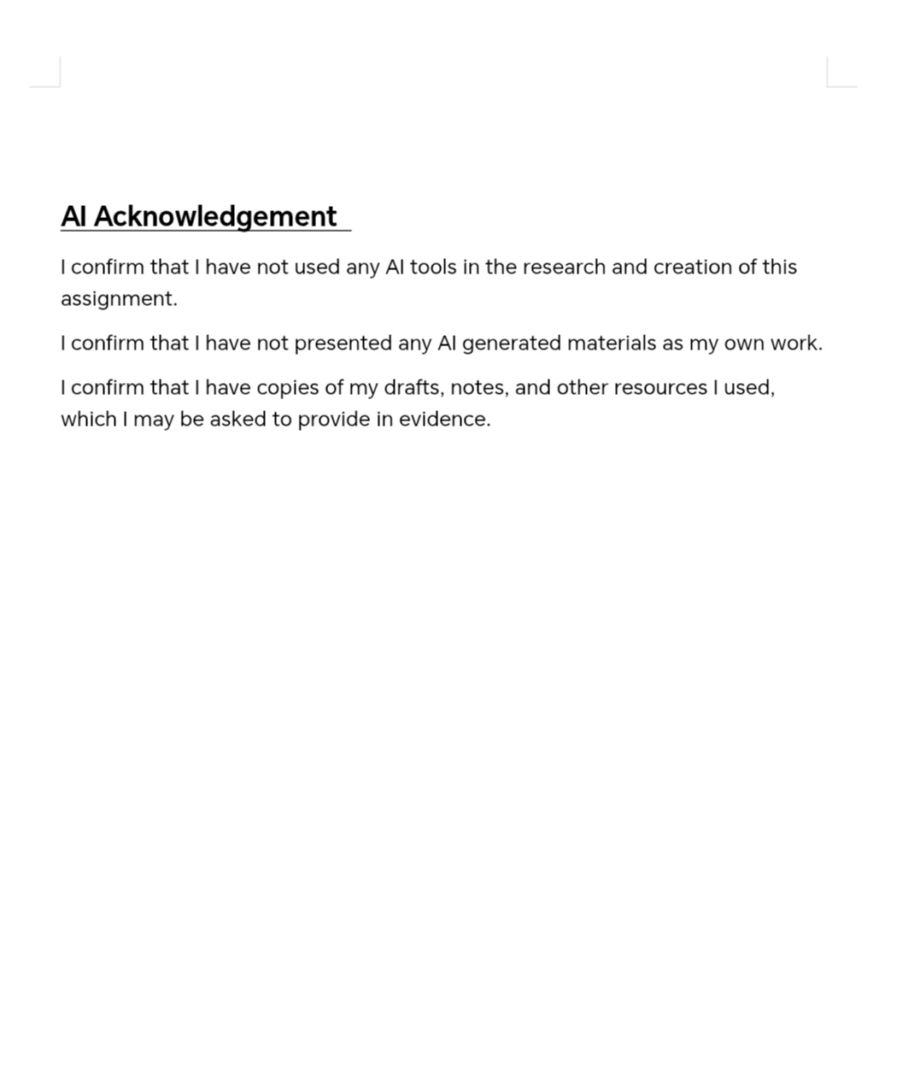

A critical evaluation of the role of digital innovation in professional practice.

Introduction
In an era that is defined by digital technology, research suggests that educational institutions are now the primary navigators for students entering into a world of an ever-evolving technological landscape.
In the following account, I shall critically examine a few of the advantages and disadvantages of integrating digital technology into the teaching of art within the higher education learning environment. Drawing on current and past academic literature and relevant research. Whilst also taking into consideration ideas by learning theorists Donald Schön’s and Lev Vygotsky.
I shall evaluate how digital tools influence professional teaching practice and how they may contribute towards a beneficial learning environment within art and design education.
My discussion shall be informed by a reflective analysis of a recent teaching session where I used a digital learning tool to deliver part of a Level 2 art class. I shall also consider feedback from my HE learners and how they felt about its use within the classroom, and also reflect on the possible limitations it poses for them.
While technologies are often spoken of as drivers of progress within education, important questions arise on this subject regarding its effectiveness, accessibility, and, of course, issues concerning ethics and how we can ensure that our implementing of such technologies within our teaching practice aligns and stays true to our core values as teachers whilst maintaining the code of conduct we agree to within the professional practice standards.
The term ‘digital innovation’ suggests the introduction of innovative technologies could only enhance our experience. Looking at current research and literature, I shall critically compare contrasting ideas and current thinking on this subject, reflecting on how digital technologies are currently shaping art and design education, its effectiveness and impact on creative practice, and whether or not the use of digital technologies within H.E. Art and Design inspires or discourages the learners to engage in the fundamental aspects of their artistic practice.

Literature Review
The increasing integration of digital technologies within HE art and design suggests there may well be a substantial change upon us relating to how art and design is taught. With the vast amount of creative digital learning tools available, and with more being introduced each year, it suggests not just a change in how education shall be received, but a substantial shift within professional pedagogical practice.
Current research suggests that creative digital learning tools are becoming more a part of the everyday teaching environment. Their presence raises some important questions about their impact on student learning engagement and the development or decrease of a student's core artistic skills.
Digital technologies look set to totally reshape how students experience their creative practice. This literature review shall critically evaluate current thinking and established learning theories about digital technologies in HE art and design. I shall critically analyse to which extent digital technologies actually enhance pedagogy within HE art and design.

Building on the discussion of digital technologies and their transformative role in higher education art and design (Zamar, Segura, 2021, p.1) argue that, “In the context of digital design in artistic education, the technological skills acquired act as a competitive advantage over other students who have not yet developed them during their academic process. Hence, education focuses on digital aspects in order to prepare university students to face the uncertain future.” (Zamar, Segura, 2021 p.1)
This perspective suggests digital skills might be essential for those entering the professional arena, suggesting that students who can effectively use technology may have a distinct edge over those who do not possess these skills. However, it is important to consider the assumptions here. The term ‘competitive advantage’ suggests we may find ourselves simply overlooking the qualities and skills more inherent to a creative human being, such as imagination, passion, critical reflection, conceptual and practical exploration, and the ability to reflect on one's artistic practice, in favour of mechanical proficiency with barely any need for the student's emotional or mental participation.
Beyond technical skills, the authors suggest that digital learning tools “represent great interest due to their enormous educational and creative potential” (Zamar, Segura, 2021 p.2). This highlights their capacity to foster creativity and also encourages students to experiment with ideas in ways that traditional studio methods may not always allow.
Zamar and Segura also describe how digital technologies provide experiential learning opportunities, which may allow students to “discover, generate, manipulate, relate, and share ideas quickly and intuitively” (Zamar, Segura, 2021, p.3), which could suggest more ease in understanding abstract conceptual concepts.
Some of these insights appear to be in direct contrast to some of Donald Schön’s theories of reflective practice, where Schön says students are said to learn most effectively through active engagement and reflection on their own work.
Zamar and Segura’s ideas about digital learning tools at first glance seem to mirror Schön’s idea of ‘learning by doing’ where students develop through reflection in action and a dynamic environment. However, Zamar and Segura acknowledge that the impact of digital technologies remains very much dependent on access to resources, pedagogical support, and curriculum design, which might suggest that an over-reliance on such tools could see students becoming quite incapable of thinking for themselves. For example, if these tools are not working correctly, the teacher is not fully trained to use them to their highest potential for learning, as well as the need for the curriculum to be written for the specific use of these tools, there is a chance that these tools could hinder learning and progress.
Taken into consideration some of the points raised in Zamar and Segura’s review, one might argue there is a possibility that by ranking technological skills as vital and as having a “competitive advantage”, it risks prioritising employability and technical proficiency over emotional and conceptual depth and critical dialogue — the basic foundational skills of an artist.
Zamar and Segura’s review highlights the advantages of digital technologies in arts education, particularly the idea that digital skills provide students with a competitive advantage and prepare them for an uncertain future. This positive view is not shared by all scholars. Theorist Clark N. Quinn has a far more direct, one might say brutal, stance on the subject.
In Revolutionized Learning and Development, Quinn argues, “The state of the learning and development industry is failing badly. Overall, learning and development is only doing a fraction of what it could and should be doing, and the part that it is doing, it is doing poorly. The learning and development industry has, by and large, been in denial and a willing participant in complacency. As a consequence, learning and development is on a steady path to extinction” (Quinn, 2014, pg 1).
Quinn’s language is quite clearly strong and urgent. His words could also be interpreted as meaning that educational institutions may be falling short of the professional standards they aim to deliver, such as to ‘Maintain and update knowledge of my subject(s) and how best to teach and assess them.’ One might argue that an educational institute has a duty to ensure its students are educated to the same standard as those from any other institute in any part of the country and, indeed, the world.
Quinn’s tone indicates there is a real problem and therefore a real need to rethink how pedagogy is delivered in the learning and development industry. Maybe the integration of a digital learning environment alongside traditional teaching methods could, in part, be the solution. Quinn argues, “That how we have learners engage is often trivial as well. We may get them to interact with each other or the content, but not both together” (Quinn, 2014, pg.3). This suggests that students are often encouraged to interact either with each other or with the content, but not at the same time. This point seems to highlight a weakness in learning environments, where students might discuss ideas without deeply engaging with the subject matter, or they might work through content alone without any meaningful interaction with others. In art and design education especially, learning often happens through dialogue around creative work. Digital environments could provide online critique spaces, shared documents, collaborative design tools, and digital portfolios, allowing students to discuss and reflect on work together by commenting directly on images, sharing their work via screens, and discussing work and sharing ideas in real time, which suggests that digital technologies could actually connect students more closely to both the content of what they are learning and each other.
Quinn also highlights the potential of digital technology to transform learning, arguing that, “This is not about technology, but technology is the lever. The opening we have needed. Quite simply, we have magic. As Clarke suggests, we can bring anything anywhere we want. Technology capabilities are no longer the barriers. The limits are now between our ears. If we have magic, the question then becomes what are we going to do with it? Before we ask what are we doing, we should be asking ourselves what could we be doing?” (Quinn, 2014, pg.5)
Here, Quinn suggests that technology is not an end in itself, but a powerful tool that removes barriers and expands possibilities for both teaching and learning.
It could be suggested that, in the context of higher education art and design, this ‘magic’ could enable new ways of engaging students with their work, collaborating with peers, and even experimenting creatively.
Rather than focusing on the limitations of these digital tools, Quinn encourages us to consider how we could use technology to rethink pedagogy and explore new directions for student learning and professional practice.
Building on Quinn’s idea that technology is a tool, not an end in itself, recent research shows both the benefits and challenges of digital innovation in art and design education. In 2025 Haiting Jia studied the use of interactive whiteboards (IWBs) in university art classes. Jia suggests, “These boards enhance creativity, interaction, and feedback… providing teachers with a brand-new teaching platform” (Jia, 2025, p.1), claiming that IWBs allow students to show and annotate their work instantly, giving and receiving feedback in real time: “Compared with traditional teaching media, the IWB… can realize immediate feedback and collaborative operation; these capacities have changed teachers’ teaching behaviour and students' learning methods to some extent” (Jia, 2025, p.2).
Jia also notes that IWBs help students understand complex or abstract ideas better than traditional methods: “In traditional teaching, the lack of immediate feedback and dynamic demonstration methods often makes it difficult for students to fully understand abstract concepts.” (Jia,2025, pg.1) This is in stark contrast to some of the theories held by theorist Donald Schön. In his book Reflection in Action, Schön suggests that students learn most effectively when they actually think through problems as they encounter them — hands-on learning, much like an artist working directly with materials in a studio.
While Jia (2025) highlights that interactive whiteboards can help students understand complex ideas more easily, Schön (1983) always maintained that ‘deep learning emerges from practice and reflection’ In his book ‘The Reflective Practitioner’ he wrote “Competent practitioners usually know more than they can say. They exhibit a kind of knowing in practice, most of which is tacit” (Schon, 1983, preface), which would indicate that students develop better understanding through direct engagement with their work, not necessarily benefitting from speed, which is a key feature of digital technology.
Reflecting on these theories and research, one could argue that a digital whiteboard is one step removed from the student’s hands, which could create a sense of distance from their ideas, imaginations, and the feeling of passion one could develop for their subject.

Selection and Justification of Appropriate Teaching Tools/Resources
As part of my module in Digital Innovation, I was asked to select a digital learning tool and use it to teach part of my class.
In the planning of my Level 2 art class, I selected Padlet as the primary digital learning tool.
Padlet is an online digital platform that allows students to post, share, and comment on ideas in real time, creating a collaborative, visual, and interactive learning environment. It allows users to upload images, sketches, notes, and even short videos, making it particularly suitable for visual arts.
My decision to use this particular digital learning tool was informed by pedagogical theory, both past and present, and research on digital learning, whilst taking time to ensure my use of this tool aligned with professional standards within the H.E. sector.
In the context of an art classroom, using Padlet encourages students to develop understanding by actively engaging with their work at the same time and in real time.
I knew I would be teaching a Level 2 class where the majority of the students have ALNs. I felt that Padlet’s aesthetic design and simple interface would suit my learners. It has a visually appealing layout and the use of colour, which made the platform engaging and stimulating, which I feel is a key consideration for an art classroom, where visual presentation matters. The interface is easy to use, which was something I required too. Not being overly fond of or proficient with technology, I wanted to use something that would not require me to take my focus off the students in order to work with it and manage any technical problems that I might encounter. I thought that the students would find the site easy to navigate, as I did. They could post comments and interact with content without feeling overwhelmed. Padlet also assigns each user a random anonymous name, such as “Star Warrior,” which I felt might encourage quieter or less confident students to participate and share their views and feelings about the artwork I would show them.
How we feel when shown a piece of artwork can be a very personal thing. Sharing thoughts and feelings is not always easy when asked to speak; fear of judgement can arise in young learners especially. However, a tool such as Padlet allows learners, if they wish, to have anonymous input in discussions. Their thoughts will be seen on the screen, but no one would necessarily know who had said what. My hope was that the other, more verbally confident members of the group would naturally continue the conversations with myself and other learners about the work I had shown them. This learning platform also allows the use of emoticons, which I felt would be familiar to the students and encourage playful yet still valuable input, which would hopefully inspire more live discussions within the group.
Padlet enables this reflective practice by allowing students to post work-in-progress, receive peer and teacher comments, and revise their ideas during the learning activity. It lets learners decide how to show their ideas. This kind of autonomy could be seen as a contemporary echo of Schön’s ideas on ‘reflection-in-action’ (Schon, 1983) In his book The Reflective Practitioner, Schön states, “The practitioner thinks about what they are doing while they are doing it” (Schön, Preface, 1983).
The way Padlet is designed and what it allows students to do seems to align with Schön’s ideas. The way that students can post work-in-progress and receive feedback immediately seems to align with Schön’s theories on ‘reflection-in-action’ because students can think about their work as they create it, changing their minds and ideas in real time.
Research by Jia (2025) supports the use of interactive digital tools in art and design classrooms, stating that they can improve creativity, collaboration, and feedback. Jia explains that these tools ‘change teachers teaching behaviour and students learning methods’ (Jia,2025,p. 2), meaning that learning becomes more active rather than passive. In a similar way, it is my hope that Padlet will allow my learners to engage with both the content and each other in real time, encouraging discussion, reflection, and shared learning, and leading to a dynamic and fun session where learning comes to life.
After researching this tool, it is my thinking that Padlet may have the potential to support not only the development of practical skills but also help kick-start a deeper understanding and critical thinking within the students, reflecting Jia’s findings about the value of interactive digital tools in creative subjects.
Another learning theorist whose ideas may reflect in Padlet’s user-friendly design is Lev Vygotsky. In his work Thinking and Speech, Vygotsky writes, “The process of concept formation cannot be reduced to the process of association, attention, representation, judgement or determining tendencies; though these functions are indispensable for the complex synthetic process involved in concept formation” (Vygotsky, 1934, pg.5). What appears to be said here is that concept formation is actually a complex, socially cognitive process, not simply a product of basic functions such as attention. It is my feeling that a tool such as Padlet will enable students to externalise their ideas visually and verbally, which supports that complex process, allowing students to go through those steps that Vygotsky speaks of in a visible, structured way by posting ideas, receiving feedback, revising, and reflecting in real time. It is my hope that learners will, if only subconsciously, benefit from the easy step-by-step process that Padlet sets out for them.
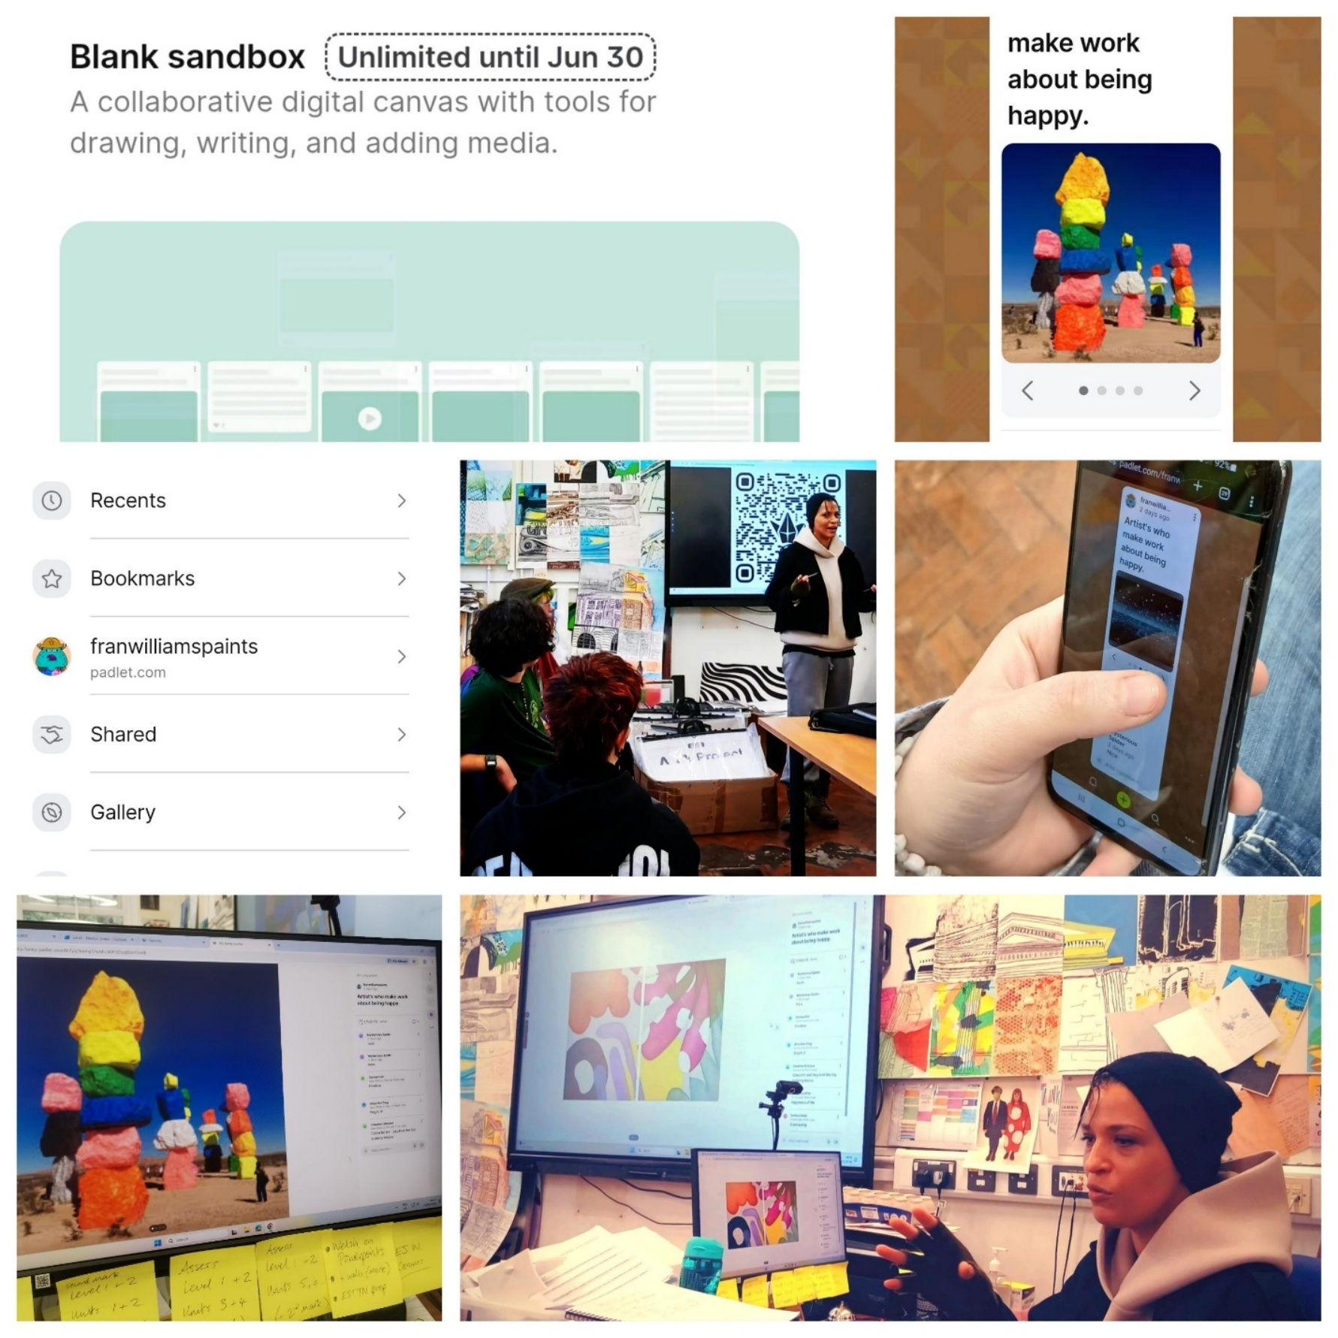
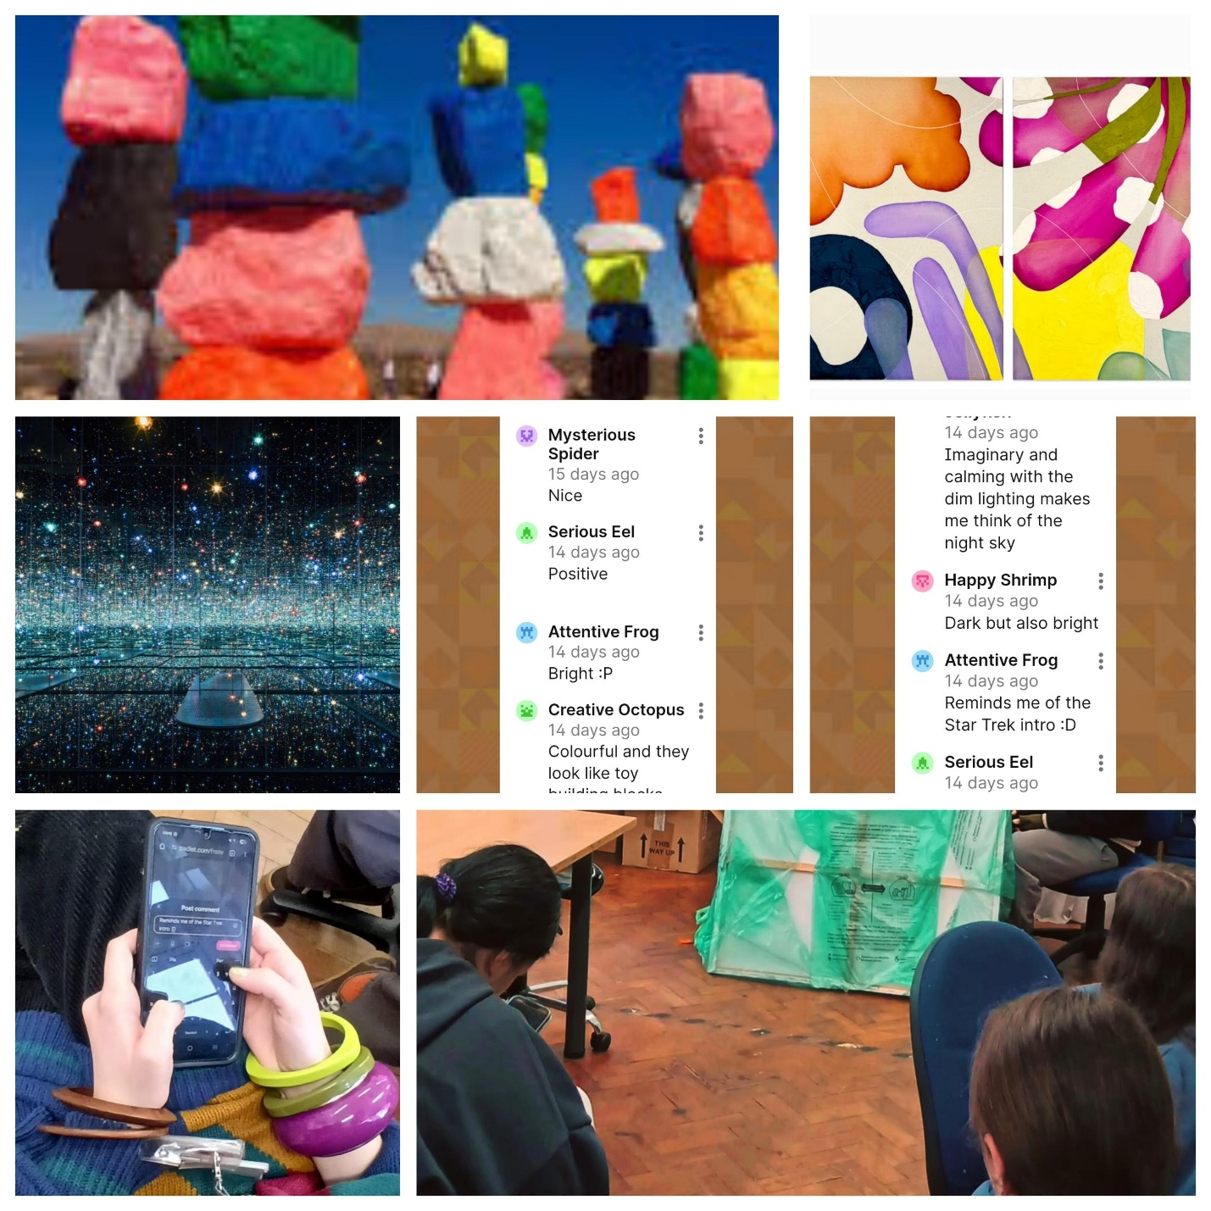
Application of chosen learning tool.
Images 1 – 13 illustrating initial set up of Padlet, assembling of digital learning tool, introducing Padlet to the students.
Students engaging with Padlet, as I show them artwork they look at on their phones and the screen in the classroom. The Padlet session shows images by contemporary artists who make work on the subject of the Happiness, which relates to the module the students are currently studying which is called ‘What makes you happy’.
Students enter their thought’s and opinions on their phones via Padlet, about the images I showed them, which was a great icebreaker and paved the way for a dynamic discussion to follow, about the purpose of art, not only what it can bring to those who view it and enjoy it but more so how a the creation of art itself can bring about a positive change of state and emotion.
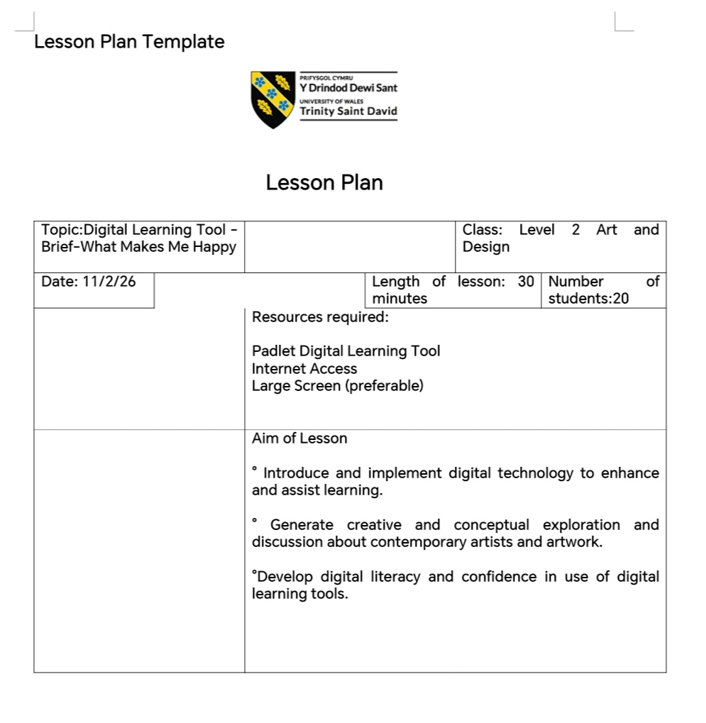
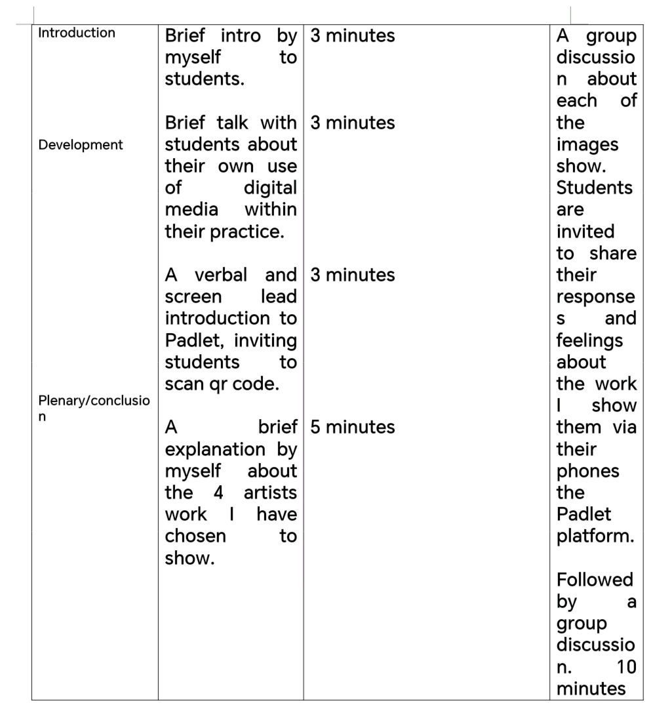
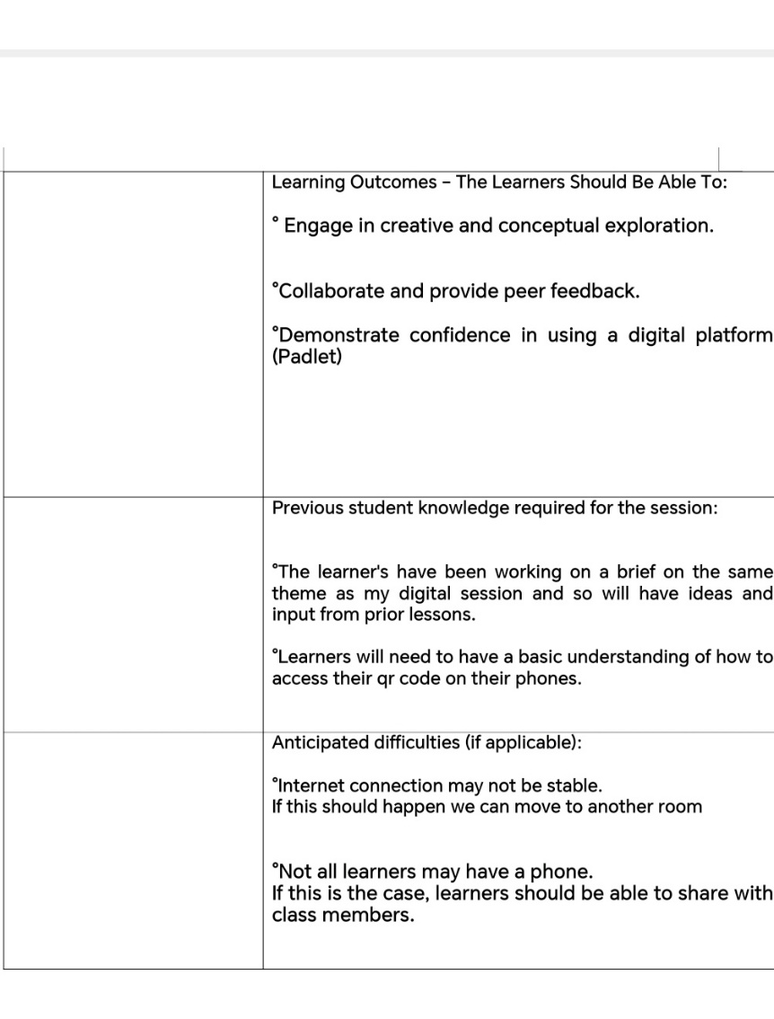

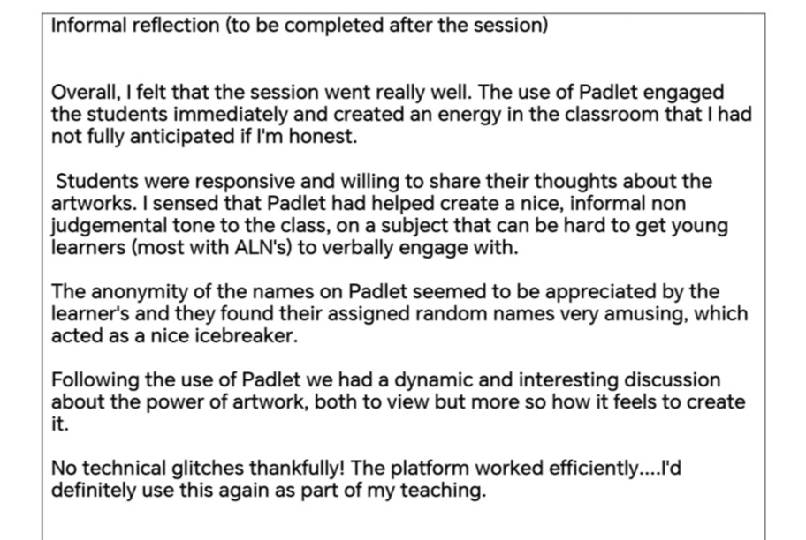
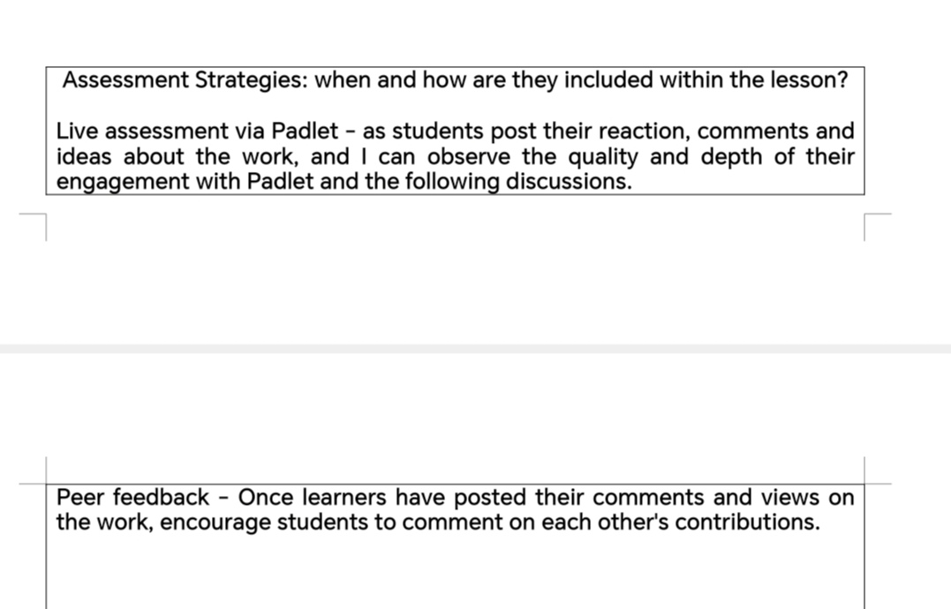

Evaluation and Reflection
Having planned the use of Padlet for a section of my Level 2 art class, I felt a degree of anxiety about introducing technology into the session. My own personal preference leans towards traditional methods in art and design, and I have not always felt confident integrating digital tools into my teaching. I had deliberately selected a tool that was relatively simple and intuitive to use; therefore, I did not feel intimidated by the technology. This apprehension could have impacted how effectively I implemented the tool.
Upon engaging with Padlet in preparation for the lesson, I discovered that it was straightforward and intuitive to use. The simplicity and friendly interface immediately eased my anxiety about using technology to teach and gave me confidence that I could run a visually stimulating, interactive digital session for my students. It was my hope that students would find Padlet visually stimulating, simple, and non-threatening. I anticipated that familiar features such as emoticons, the ability to comment, and anonymous usernames would create a safe space for expression and encourage participation.
During the session, students, most of whom had additional learning needs, responded very positively. Quieter learners who might typically hold back on saying what they thought or felt about an artwork were able to engage confidently by posting ideas and reflections under randomly assigned names like “Star Warrior,” which I now realise also acted as an icebreaker and created a playful, energetic atmosphere in the classroom. One student commented that the tool “brought the class together,” noting that using their phones to share ideas allowed the group to generate natural energy and buzz, making the session feel more dynamic than usual. Another learner highlighted the visual design and simplicity, saying that Padlet was “very fun” and that it encouraged them to voice their opinion because it was easy and anonymous.
I was pleasantly surprised that Padlet was able to act as an unintentional icebreaker, and this session indicates to me that learners with ALNs respond well to simple, fun, and easy-to-use technology. I also realise the importance of creating a good atmosphere in the class, for both the students and myself. After we had used the digital tool to initiate discussions about the artwork, I too felt more at ease engaging with students and asking them questions about their interpretations of the work shown.
I also felt confident introducing Padlet to the students whilst navigating the platform and engaging with them verbally. This was an important consideration for me, as I had initially been unsure whether managing the technology would detract from my ability to connect with the students in person. In practice, I was able to maintain eye contact, stay present, and remain engaged in conversation while operating the tool, which allowed the session to remain dynamic and interactive. This reassured me that digital tools can indeed complement, rather than interfere with, teacher presence and live interaction.
On the day of the session, there were no technical errors, much to my surprise, and the platform performed exactly as I had hoped, fulfilling all intended functions and even exceeding my doubtful expectations. This reliability contributed to a smooth teaching experience and allowed me to focus on engaging with students and teaching, rather than troubleshooting and panicking over technical problems.
Importantly, taking into consideration the way I shall structure my classes from now on, I am very likely to use this kind of simple, user-friendly technology to start a class and create a good learning atmosphere. It will allow me to support students effectively while still facilitating learning, which aligns perfectly with the following professional standard: “Demonstrate commitment to learners, their learning, safety, and well-being.” Padlet helped create an inclusive, safe learning environment where students did not feel judged.
My confidence in using Padlet to teach a portion of my class has inspired me to become proficient in other learning tools that could help foster a dynamic and inclusive learning environment. My desire to now do this would align with the professional standard that states, “Critically reflect on own values, knowledge, and skills to improve practice and learning.” I have come away from this experience with the goal and desire to improve my digital literacy skills to support me in becoming a better teacher.
I now feel more prepared to experiment with and integrate other digital learning platforms into my teaching practice, recognising their potential to actually enhance engagement, collaboration, and some elements of reflective practice. I shall integrate this experience and knowledge into my own teaching practice by becoming familiar with existing and new digital learning tools, teaching myself how to use them efficiently. I sense that knowledge and preparation will once again be key in the successful use of digital media.
Although my experience using Padlet was overall very positive and it clearly enhanced engagement and interaction within the session, I remain conscious of the fine line that teachers, particularly in art and design, must navigate. My reflections are not based solely on personal preference; they are informed and guided by what I have learned through my research and writing. Taking into account the findings of Jia (2025) and the theoretical perspectives of Vygotsky and Schön, I recognise that digital tools can effectively stimulate ideas, discussion, and reflection. In this session, Padlet appeared to support these aspects well.
However, I feel strongly that digital learning tools should be used primarily as a catalyst for creative thought and peer discussion, rather than as a substitute for hands-on, practical work. Regarding the development of students’ technical skills — drawing, manipulating materials, and exploring media directly — I remain doubtful about the effectiveness of digital tools. For these aspects of learning, I would be unlikely to rely on digital media for any substantial practical element. Based on my experience and what I have learnt from theory, it is my view that such tools are most effective when positioned on the peripheral edges of art and design teaching, providing a structure to foster a good atmosphere, encourage reflection, collaboration, and some conceptual exploration, while preserving the central role of direct, tactile, and experiential practice.

References

Zamar.M (2021) Digital Design In Artistic Education: An Overview Of Research In The University Setting. DOI:10.3390/EDUCSCI11040144

Quinn.C (2014) Revolutionize Learning And Development: Performance and Innovation Strategy For The Digital Age. https://quinnovation.com/resources/RevolutionizeLearningAndDevelopmentQuinnSample.pdf

Jia.H (2025) Research on the Effectiveness of Interactive Whiteboard in Art Design Classroom Teaching.
DOI:10.4018/IJWLTT.390497

Schon.D (1983) The Reflective Practitioner https://raggeduniversity.co.uk/wp-content/uploads/2025/03/1_x_Donald-A.-Schon-The-Reflective-Practitioner_-How-Professionals-Think-In-Action-Basic-Books-1984_redactedaa_compressed3.pdf

Vygotsky.L (1934) https://www.marxists.org/archive/vygotsky/works/words/Thinking-and-Speech.pdf

