  Marketing In Practice  Assignment 2 | Strategic Campaign Proposal for the Launch of a Vegan Cooking Box  Manfred Zeka - 2213558  Marketing In Practice

Executive Summary
This is a full marketing plan report about the launching of a vegan cooking box as one of the products in a subscription meal box company. The objective of this campaign is to get 50,000 new enrollments within a time frame of six months with budgetary provisions of up to £500,000. This would be an integrated campaign, where all the channels of communication, including digital media, direct marketing, and public relations, would be interconnected and intertwined to make the maximum outreach and interaction possible. With both traditional and modern media involved, it is envisaged that maximum reach will be derived, sweeping yet well-targeted, hence resulting in maximum consumer acquisition. One fundamental part of the campaign framework will be to continuously apply performance metrics on an ongoing basis with regard to the effectiveness of the promotional activities. Market penetration into the vegan food sector will thus be achieved in order for the brand to have solid positioning and exceed first-year membership acquisition targets.

Table of Contents
Executive Summary 2
Introduction 4
Communication Channels 4
Campaign Ideas – Messaging and Offers 5
Promotional Offers 5
Theoretical Justification 6
Media Scheduling and Budget Split 6
Budget Allocation 6
Allocation Strategy 8
Metrics on Performance 8
Recommendations 10
Conclusion 10
References 12

Introduction
The changing consumer taste and preference towards plant-based diets have encouraged us to expand our subscription meal box service by including a vegan cooking box (Vos et al., 2024). The strategic goal is to tap into increased vegan demand to increase the market base and thus improve brand loyalty. The main objective of the campaign is to get to 50,000 new subscriptions in the next six months, with a budget of £500,000. The scope includes a multifaceted promotion strategy that combines both traditional and digital marketing channels so as to maximize reach and engagement. The venture would thus not only benefit from the ongoing market trend in favour of health-oriented, environmentally sustainable choices but would also position our company at the frontier of innovative culinary solutions. The campaign is set to win over the strategic key opportunities in the nascent vegan market to ensure great growth and competitive advantage.

Communication Channels
The communication channels chosen for the vegan cooking box are strongly taken up with cautious discretion in order to optimize cost-effectiveness, extend the reach of the campaign, and befit our target demographic. It forms a well-integrated set of channels, including digital, traditional, direct marketing, and public relations, to be sure that the touch points of the consumer are well served.
- Online and Digital Media: Digital platforms such as social media, PPCs, and banner ads can largely be effective by their scalability and precision in targeting. Social media sites, such as Facebook, Instagram, and Twitter, offer demographic and behaviour-based targeting; this will be very crucial for this campaign since the target market is the conscious, healthy, and informed younger population (Can and Alatas, 2019). It could be better than PPC campaigns on search engines to capture the high-intent audiences actively seeking solutions for vegan meals. Banner ads will be posted on selective culinary and lifestyle websites to create added brand awareness and to build traffic.
- Traditional Media: Television and radio are chosen because they reach a greater audience. Brand awareness is created at an exponential rate, as compared to other media platforms, reaching a greater audience of the overall targeted demographic (Makrides et al., 2020). Although more expensive compared to other means, this traditional mass media can be an avenue through which the new product line is introduced to a greater set of audiences. The print media that will be targeted to reach the magazines focusing on health and wellness is a segment focusing on the niche market that is interested in vegan lifestyles. This is a tangible touchpoint medium to back up the work done in the digital space.
- Direct Marketing: Email marketing will be conducted while engaging directly with our current customers and with leads expressing interest in vegan products (Siddiqui et al., 2022). Direct email can share in less cost; therefore, messages and offers promoting them can be personalized with this opportunity, providing surety of a higher conversion rate.
- Public Relations: A press release and various sponsorship opportunities will increase the overall level of credibility and authority for the brand (Vrontis et al., 2021). The press release is going to be published to a wide, open audience through the various media outlets, while the sponsorship of health and sustainability events will automatically place the product right in front of eager customers.
- Excluded Media Channels: The campaign will notably exclude Outdoor Advertising and Cinema. The reason to exclude Outdoor is that it is a medium where one can never be too sure of the audiences viewing it, especially for a category that is so sharply targeted (Alavijeh et al., 2019). The same goes for Cinema Advertising, which is usually a highly-priced medium with no guarantee that the target group will be attentive.
The clear strategy and media channel exclusions within this campaign will be aimed at maximum return on investment by picking the best platforms to reach and engage our targeted demographic in ways that drive immediate sign-ups and long-term brand loyalty.

Campaign Ideas – Messaging and Offers
The core message of the vegan cooking box campaign, therefore, can be summarized in: "Purely Plant-Powered Pleasure," or rather, the increase in consumer pull towards health-conscious and environmentally sustainable food choices. The strapline "Delight in Every Dish" lets everyone appreciate all dishes under the vegan food umbrella and savor them with genuine delight: for the vegans and the ones new to plant-based food.

Promotional Offers
- Launch Promotion: 20% off the first box, first month. This is an entry barrier reduction strategy that enhances rates of trial.
- Referral Program: This one offers the referrer, among existing subscribers and a friend, a 15% discount when they purchase together. This is aimed to ride on word-of-mouth marketing, mentioned in academic literature to have high impact on consumer behavior because of the element of trust in personal recommendations.
- Seasonal Specials: Special boxes with seasonal vegetables at discounted prices to ensure interactions continue, as well as encourage renewals for the subscription. For example, one will generally look for variety and newness, which is discussed by consumer behaviour theories (Gordon‐Wilson, 2022).

Theoretical Justification
The promotional strategy is fundamentally based on a few core concepts of marketing theories. The launch offer is based on the theory of the Price Sensitivity Meter by Van Westendorp, which states that consumers are more likely to try a new product if they consider the price to be less than their maximum expected price (Kintler et al., 2023). In fact, the referral program can be explained through the Theory of Planned Behavior since it assumes that social norms and beliefs will largely influence an individual's action, i.e., the advocacy of the box through a recommendation (Ajzen and Schmidt, 2020). Finally, introducing seasonal specials can be further justified as the 'variety seeking' will increase the need for new experiences, based on a consumer behaviour theory, to keep interest and contentment among subscribers going. These offers, therefore, go hand in hand with the strategic marketing theories and are meant to realize the greatest benefits in terms of acquiring and retaining customers and generally satisfying the vegan cooking box campaign.

Media Scheduling and Budget Split
The media schedule for the vegan cooking box campaign is minutely planned so that there is a continuity of contact during the six-month promotional period. The phased rollout across various media is strategically time-tabled to maximize exposure and effect.

Budget Allocation
As follows, this is the total budget: £500,000.
- Digital media (50%, £ 250,000) is leaning towards digital media because it's highly measurable and precise in targeting platforms. This includes £100,000 for social media adverts, £100,000 for PPC, and £50,000 for banner ads. The digital media shall remain flexible in real-time optimization according to the campaign performance to ensure cost efficiency.
- Traditional Media (30%, £150,000): This budget is further divided between TV (£70,000), radio (£50,000) and print (£30,000). Traditional media gives us wide reach and credibility. When launching, the objective of creating broad-scale awareness is met at a higher cost by the media chosen here: TV and radio.
- Direct Marketing (10%, £50,000): Email campaigns will be set to work overtime with actual and potential customers, providing tailored content that drives up conversions.
- Public Relations (10%, £50,000): Part of these funds is utilized in press releases and event sponsorships, without which it would be impossible to establish brand authority and tap into niche markets at important industry events.
Table 1: Budget Allocation for Media Channels
Media Channel | Allocation (£) | Percentage of Total Budget
Digital Media | £250,000 | 50%
Traditional Media | £150,000 | 30%
Direct Marketing | £50,000 | 10%
Public Relations | £50,000 | 10%
Total | £500,000 | 100%

Gantt Chart
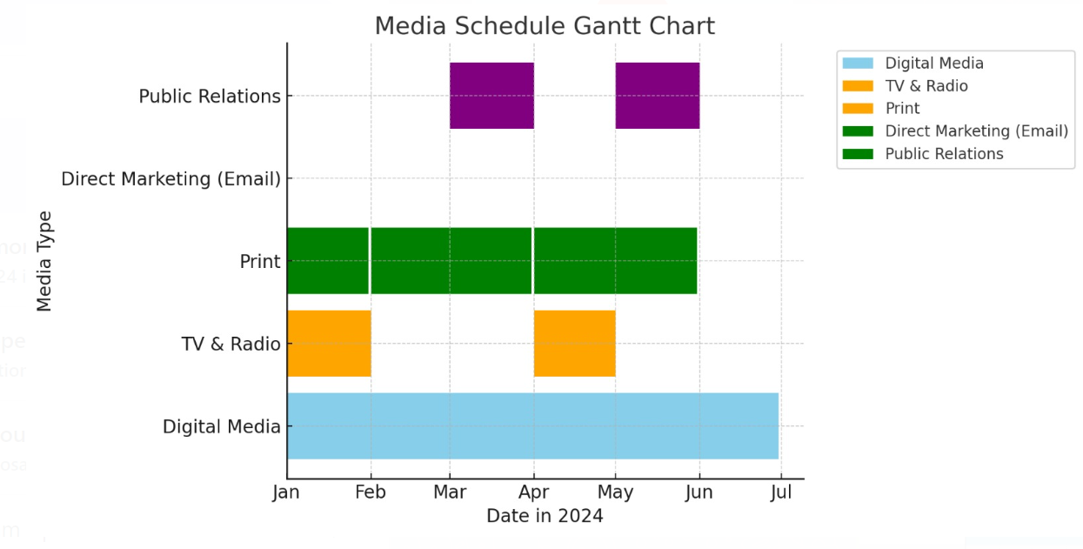
Figure 1: Gantt Chart

Allocation Strategy
The design principles of the strategy are, therefore, based on maximizing the trade-off between reach and specificity. With digital media, the campaign deploys critical consumer analytics in the messaging process for the creation of effective messages that guarantee engagement from the most relevant segments (Czinkota et al., 2021). Traditional media remain critical to the wide-reaching impact of the campaign in the early stages, even when it might be costlier. Direct marketing and public relations enhance customer relations and deep-brand perception. This is strategic placement of the budget that would see use of the strengths of each channel so that every pound spent goes directly into the major goal of the campaign: market penetration and member acquisition on a substantial level.

Metrics on Performance
Key performance indicators have been established to specify the effectiveness of the vegan cooking box campaign across each media channel and to enable the general campaign return on investment assessment. These metrics are, therefore, very important in gauging the success of the marketing activities and, hence, in crafting a good strategy for optimizing performance.
Table 2: KPIs
KPIs
Digital Media | - Click-through Rate (CTR): How effective are the ads in provoking the user to click through to the landing page  - Conversion Rate: Refers to the proportion of people who subscribe once they have clicked on an advertisement (Onie et al., 2023).  - CPA (Cost per Acquisition): The cost of acquiring an individual customer to subscribe through digital means.
Traditional Media | - Reach The number of unique viewers or listeners an advertisement may reach on television and radio.  - Engagement Rate: Measures the effectiveness of a given ad to stimulate immediate inquiry, such as calling an 800 number or visiting the website indicated in the print ad.
Direct Marketing | - Open Rate: The percentage of people who received the email and opened its content.  - Conversion Rate from Emails: It shows the number of achieved subscriptions from the email campaigns.
Public Relations | - Media impressions: A numerical representation of how often press releases and sponsored events are dropped into media outlets.  - Sentiment Analysis: This is a measure of the public response to the activities of PR with a focus on estimating brand sentiment.
Total ROI of the Campaign | - Total Generated Revenue vs. Total Spend: compares the total generated revenue of the new subscriptions to the campaign's spend in assessing financial success.  - Customer Lifetime Value (CLV): An estimate of the net profit that can be attributed to the entire future relationship with acquired subscribers (Kumar and Rajan, 2020).
Tools and Techniques | - Analytical Software: Google Analytics, which is mostly used in the measurement of the performance of emails (Lorente-Paramo et al., 2020).  - Media monitoring services monitor and analyze the reach and effectiveness of public relations campaigns.  - ROI Calculators: Summarize data across multiple channels and calculate the total ROI.

These KPIs and tools will be the base for this strict framework, which has to be under constant assessment of the campaign's performance and at the same time be a tool in detecting effectiveness, above all, to bring valuable information to future strategic readjustment.

Recommendations
- There is scope to refine the targeting criteria into a much more detailed demographic and psychographic profile if the preliminary digital metrics are indicating lower levels of engagement.
- Constantly change ad copy and visuals based on A/B testing results to better resonate with the audience, hence increasing both CTR and conversion rates.
- If early data reveals that influencer partnerships are being well received, expand this strategy with more influencers across different platforms to increase reach.
- Reallocate funds dynamically between channels based on channel performance: scaling up investment where the channel performs and scaling down in low-yield channels.
- Put in seasonal variants of the product or customize marketing messages to fit specific regions according to their reaction and consumer preferences.
- A loyalty program or community-building activities could be developed if it is determined that long-term engagement, based on early retention rates, requires more support.

Conclusion
This is presumed to enhance the reach and build heavy market penetration for the vegan cooking box in the vegan demographic. The campaign will tap public relations, digital, traditional, and direct marketing to better service offerings but also establish a firm niche in the health-conscious consumer category. This structured deployment shall be intended to harness these channels for immediate member acquisition and, in the long term, for the purpose of customer engagement to position the company as a leader in innovative culinary solutions.

References
Ajzen, I. and Schmidt, P., 2020. Changing behavior using the theory of planned behavior. The handbook of behavior change, pp.17-31.
Alavijeh, M.R.K., Foroozan, A. and Afrashteh, A.A., 2019. Identification and prioritisation of effective criteria in the selection of outdoor advertising using the AHP technique. International Journal of Internet Marketing and Advertising, 13(4), pp.359-373.
Can, U. and Alatas, B., 2019. A new direction in social network analysis: Online social network analysis problems and applications. Physica A: Statistical Mechanics and its Applications, 535, p.122372.
Czinkota, M.R., Kotabe, M., Vrontis, D., Shams, S.R., Czinkota, M.R., Kotabe, M., Vrontis, D. and Shams, S.R., 2021. Designing effective promotion and advertising strategies. Marketing Management: Past, Present and Future, pp.553-606.
Gordon‐Wilson, S., 2022. Consumption practices during the COVID‐19 crisis. International Journal of Consumer Studies, 46(2), pp.575-588.
Kintler, J., Remeňová, K. and Kmety, B.M., 2023. Price sensitivity testing as a basic tool for strategic pricing decisions. Strategic Management, 28(1), pp.20-32.
Kumar, V. and Rajan, B., 2020. Customer lifetime value: What, how, and why. In The Routledge companion to strategic marketing (pp. 422-448). Routledge.
Lorente-Paramo, A.J., Hernandez-Garcia, A. and Chaparro-Pelaez, J., 2020. Influence of cultural dimensions on promotional e-mail effectiveness. Technological Forecasting and Social Change, 150, p.119788.
Makrides, A., Vrontis, D. and Christofi, M., 2020. The gold rush of digital marketing: assessing prospects of building brand awareness overseas. Business Perspectives and Research, 8(1), pp.4-20.
Onie, S., Berlinquette, P., Holland, S., Livingstone, N., Finemore, C., Gale, N., Elder, E., Laggis, G., Heffernan, C., Armstrong, S.O. and Theobald, A., 2023. Suicide prevention using Google Ads: randomized controlled trial measuring engagement. JMIR mental health, 10, p.e42316.
Siddiqui, S.A., Khan, S., Murid, M., Asif, Z., Oboturova, N.P., Nagdalian, A.A., Blinov, A.V., Ibrahim, S.A. and Jafari, S.M., 2022. Marketing strategies for cultured meat: A review. Applied Sciences, 12(17), p.8795.
Vos, M., Deforche, B. and Van Lippevelde, W., 2024. Home-delivered meal boxes in a family setting: a qualitative study investigating reasons for use and perceived impact on meal practices. BMC Public Health, 24(1), p.277.
Vrontis, D., Makrides, A., Christofi, M. and Thrassou, A., 2021. Social media influencer marketing: A systematic review, integrative framework and future research agenda. International Journal of Consumer Studies, 45(4), pp.617-644.

