

University of Wales, Trinity St. David
BEng Ordnance, Munitions and Explosives

Harry Grinstead
2221670

Project Penthus – Group Project Portfolio

Module Name: Work-based Group Project
Lecturer: Dave Holley

Academic Year: 2024-2025

© UWTSD 2025. All rights reserved. No part of this publication may be reproduced without the written permission of the copyright owner.

Academic Integrity Declaration
I declare that:
- the thesis submitted has been written by me alone.
- the thesis submitted has not been previously submitted to this university or any other.
- that all content, including primary and/or secondary data, is true to the best of my knowledge.
- that all quotations and references have been duly acknowledged according to the requirements of academic research.
I understand that to knowingly submit work in violation of the above statement will be considered by examiners as academic misconduct.

Keywords
Drone, Reflection, Safety

AI Acknowledgement
I confirm that I have not used any AI tools in the research and creation of this assignment. I confirm that I have not presented any AI generated materials as my own work. I confirm I have copies of my drafts, notes, and other resources I used, which I may be asked to provide in evidence.

Table of Contents
Academic Integrity Declaration i
Keywords i
AI Acknowledgement i
Table of Figures iii
Table of Tables iv
Abbreviations List v
Abstract vi
1 – Introduction 1
2 – Design Project Management 1
2.1 – Initiation 1
2.2 – Planning 2
2.3 – Execution 2
2.4 – Monitoring and Controlling 2
2.5 - Closing 3
3 – Safety Engineer Role 3
3.1 – Concept Phase 3
3.2 – Key interactions 4
3.2.1 - Design 4
3.2.2 - Trials 4
3.2.3 – Manufacturing 5
3.2.4 - Disposal 5
3.3 – Safety Framework/ Hazard Screening Process 5
4 – Creating the Presentation 6
5 – Presentation Feedback 7
6 – Response to Feedback 8
6.1 – Response to Team Feedback 8
6.2 – Response to Individual Feedback: Technical 11
6.3 – Response to Individual Feedback: Presenting 11
7 – Reflection 14
7.1 – Team Performance 14
7.2 – Individual Performance 14
8 – Conclusion 15
9 – References 16
Appendices 18
Appendix A – Presentation Slides 18

Table of Figures
Figure 1 - Penthus Waste Stream 10
Figure 2 - UK Average WPM Map 13
Figure 3 - The Solution: Slide 1 18
Figure 4 - The Solution: Slide 2 19
Figure 5 - The Solution: Slide 3 20
Figure 6 - The Solution: Slide 4 21
Figure 7 - Team Roles Slide 22
Figure 8 - Safety: Slide 1 23
Figure 9 - Safety: Slide 2 24
Figure 10 - Safety: Slide 3 25
Figure 11 - Safety: Slide 4 26
Figure 12 - Safety: Slide 5 27
Figure 13 - Safety: Slide 6 28
Figure 14 - Safety: Slide 7 29
Figure 15 - Safety: Slide 8 30
Figure 16 - Safety: Slide 9 31
Figure 17 - Safety: Slide 10 32

Table of Tables
Table 1 - Safety Criteria 6
Table 2 - Presentation Feedback 7

Abbreviations List
COTS | Commercial, Off the Shelf
DAREO | Dependencies, Assumptions, Requirements, Exclusions and Opportunities
FMEA | Failure Mode Effects Analysis
OME | Ordnance, Munitions and Explosives
QFD | Quality Function Deployment
SE | Safety Engineer

Abstract
Project Penthus is a design solution for a top-level requirement raised by a customer. The customer requires the neutralisation of a hostile communications system on the second floor of an office block.
Penthus proposes the use of a bombardment of one-way drones to disable the communications system.
This report delves into the project management procedures around Penthus’ creation and how the OME team worked together to produce the design with particular focus on the role of the Safety Engineer.
Feedback was provided by the customer on a presentation which proposed the design to them. The feedback is answered in this report as well as the Safety Engineer’s reflections on the project and recommendations for improvements.

1 – Introduction
A top-level requirement was raised by a customer to neutralise a hostile communications system held in the second floor of an office building using an explosive device.
In response, a project team was assembled to develop a design solution to fulfil the requirement. Project team “Penthus” consisted of various Ordnance, Munitions and Explosives (OME) specialists with varying backgrounds including Design, Manufacturing and Safety.
This report will focus on the contributions of the Safety Engineer (SE) for Project Penthus as well as how the team functioned internally and communicated with the customer throughout the project lifecycle. It will also address customer feedback following a presentation of the proposed solution. Finally, the report will include a critical reflection on team performance and outline areas for potential improvement.

2 – Design Project Management
The 5 phases of project management were employed to support this task [1].

2.1 – Initiation
Defining the scope of the project is an essential early step in project management. This determines what comes under the remit of the project and sets the boundaries of what should be worked on.
The scope of Project Penthus revolved around the top-level requirement of neutralising a communications system in the given scenario. This allowed identification of the key stakeholders and a stakeholder map was created to show how they interacted.

2.2 – Planning
During the planning and scheduling phase, the entire project was mapped out from and broken into work packages. Each package had an opening and closing activity to make checkpoints and so that there were as little loose ends as possible before new work commenced. This work schedule was plotted against the timeline for the project to provide the team an idea of when work should be completed by, in what order and which activities were dependent on the others.

2.3 – Execution
The ongoing work of the project was largely split into group work and solo work.
During group work, the team would often split into smaller units to complete smaller tasks where appropriate to complete work more efficiently, work would often be peer reviewed to provide a level of quality control and understanding for all areas of the project.
The majority of solo work took place after the first block which lined up with the completion of Quality Function Deployment (QFD) 2. The schedule was very front loaded to allow the maximum amount of work to be completed while everyone was in person and focused on Penthus.

2.4 – Monitoring and Controlling
In Penthus, the monitoring and controlling was intertwined with the execution. Several tools and practices were used to do this.
A groupchat was set up to allow for efficient communication amongst the team.
A list which held all of the Dependencies, Assumptions, Requirements, Exclusions and Opportunities (DAREO) identified. Each DAREO was given an identification number to allow for tracking throughout the project.
Secondly, a weekly meeting was set up to provide regular updates as to the project’s progress. A meeting record was kept of all meetings. This captured who attended, what was discussed and any actions to be carried out moving forward. An action list was created to record and track the actions raised during meetings.
Finally, a quality management culture was instilled early on. Changes to documents and tracked versions of documents were logged and old versions were archived.

2.5 - Closing
Following the presentation, the team met to discuss the provided feedback to ask any questions that were best suited for a different member to answer. These meetings were recorded in the previously mentioned meeting log.

3 – Safety Engineer Role

3.1 – Concept Phase
Safety was one of the key stakeholders in the project. As a result, requirements were created for safety and they were owned by the SE. During the concept phase, the SE was an integrated part of the design team, acting as the authority on the project’s safety.
Significant contributions were made during the Function Means Analysis when determining what options should be selected to be incorporated into the concept designs and during the Pugh Matrix when choosing a design to present to the customer as safety had authority over the concept’s compliance with the safety requirement set. The SE had an interest in meeting the stretch objective of the customer, reduce all collateral damage so far as was reasonably practicable. This influenced many scores in the Pugh matrix before concluding on the final drone system design. It was not the safest option, however it balanced safety and performance which was acceptable.
The Safety Team was responsible for the Failure Modes Effect Analysis (FMEA) throughout the project. This was decided for multiple reasons, it allowed the safety team to begin considering how the drone works and may fail which would support later hazard screening exercises and get the safety team up to speed on drones as there was not much drone experience. There were 3 FMEAs throughout the project, Functional, Design and Process and all were conducted using ASQ’s methodology [2].

3.2 – Key interactions

3.2.1 - Design
The SE worked with the design engineer to produce a key safety feature.
Inside the explosive capsule there is a component similar to a solenoid unit which activates when the drone system is in a certain proximity of its designated target according to its GPS. When activated, the unit lines up the explosive train and allows for the full attack sequence to occur. Without this feature, the explosive train would always be ready to activate if any insult to the energetics was received.
In an effort to reach the stretch objective, the SE worked with trials to produce an explosive system which reduced the net explosive quantity to as low as was necessary to still neutralise the communications system.
The FFMEA and DFMEA recommendations were also passed onto the design team.

3.2.2 - Trials
There was no trials engineer in Project Penthus, as the team did not have the experience to support it. Hypothetically, the SE would be involved in the arrangements of the trials ensuring adequate measures were taken to protect people, infrastructure and the environment. The primary checks would be around ensuring compliance with DSA 02.OME range regulations [3] and DSA 03.OME Part 3, the MoD guidance on ranges [4]. The outputs of the trials would also involve the SE in relaying any changes back to the design and manufacturing teams.

3.2.3 – Manufacturing
The SE worked with manufacturing to assess their processes against the following regulations: ER2014, COSHH, DSEAR, COMAH and HSAWA1974.
Safety worked alongside manufacturing to produce the PFMEA, recommendations were passed back to manufacturing.

3.2.4 - Disposal
Similarly to trials, the SE’s influence on disposal would revolve around the initial arrangements in compliance with DSA 02.OME regulation OME 211 [3] including the guidance set out in DSA 03.OME Part 2 Chapter 10 [5] concerning quantity distances, ensuring that the disposal site was at a safe distance to any inhabited buildings, infrastructure or wildlife and following the best practice provided by ASEMS [6].

3.3 – Safety Framework/ Hazard Screening Process
This framework was produced using the SE’s understanding of how a safety case is formed.
Firstly, a methodology must be produced as a governance document for how the safety assessments will be completed. This requires 3 things to form; a scope, requirements and legislation/ regulations.
Once a methodology has been laid out, a hazard identification will take place. This is an organised brainstorm involving key stakeholders to talk through a process and what errors may occur in a divergent way of thinking. This produces an initial hazard list.
The next step is hazard screening where hazards are removed based on a lack of severity, likelihood or incorrect scope. This is a convergent way of thinking. This produces a final hazard list.
The hazards are then analysed using deterministic and probabilistic methods to check their compliance with the set baseline of acceptable risk. This allows a safety report to be produced for almost any stage of the CADMID cycle.
Finally, a top-level safety case and environmental report is produced, summarising the safety and compliance from all key areas.

4 – Creating the Presentation
Slides were made to support the introduction of the presentation. Figures 3 – 6 were made to show how the drone’s attack sequence functioned. It was felt that beginning with this would give the audience a solid understanding of the system prior to the presentation on how the system was produced.
Figure 7 was produced to show who the team members were, what their roles were and where their part sat in the process as they were ordered chronologically in line with the CADMID Cycle.
The presentation had an assessment criteria for each pathway, the safety engineer focused on hitting the criteria shown in Table 1 - Safety Criteria.

Table 1 - Safety Criteria
Understanding of the safety requirements for the area selected | Understanding of the legal safety deliverables | Identification of the key hazards in the selected area of operation | Critical analysis of the key hazards | Description of the mitigation required to be included in procedures | Development of the basis of safety

Figures 8 – 17 focus on fulfilling the safety documentation requirement of the project. They show the documentation’s structure and how it linked together, a condensed hazard screening exercise was completed, showing how the hazards we identified were taken through due process to analyse their credibility, understand the threats they posed and the strategies used to mitigate their effects. The HSEs risk management framework was used to create this structure and process [7] as well as models from DSA 03.OME Part 1 DCOP 105 [8].

5 – Presentation Feedback
Table 2 - Presentation Feedback
Team Feedback
- To team. Liaison with drone manufacturer?
- How do you get clearance onto drone? (Vibration, bumping into things?)
- What do you do with returns from Ops?
- Simple slides with a clear layout.
- Good contrast between text and backgrounds for the most part, some slides had white text on pale green, peach and yellow backgrounds which could be difficult to read properly at the back of the room.
- Images are a good size throughout.
- Fairly consistent theme throughout the different sections gives a good cohesive team feeling.
- Some of the slides did deviate from the theme, try and ensure that the slides all conform to the same theme.
- References made to other people’s sections of the presentation and contributions; this shows collaboration.
- Good introduction to participants and roles.
- No real conclusion, a slide summarising key points may have been good.
- No references? Including a reference slide at the end would have been good
Individual Feedback: Technical
- "How do you ensure the COTs drone behaves as it should?
- Do you understand the operating limits of the drone?
- How would the drone / explosive interface be controlled?
- Is your drone “jam free”?
- Hazard screening exercise performed and understood for the explosives.
- May need a safety engineer to work closely with the drone manufacturer to ensure safe operation.
- Fault trees introduced.
- “And” gates described as a mitigation of safety.
Individual Feedback: Presenting
- Presented online as previously agreed.
- Good volume, quite a face paced delivery which could be difficult for people to follow if they are unfamiliar with the topic being presented.
- A fair amount of “umm” and “err”ing, this could come across as being unprepared or lacking confidence but is likely due to nerves.
- Cannot assess body language or audience interaction with voice-over only, having a camera feed may have been beneficial.

6 – Response to Feedback

6.1 – Response to Team Feedback
Upon review of the team feedback, there was mixed feedback on the presentation. The presentation had a clear and largely consistent layout, a good introduction and informed the audience of who the team members were and their roles. However, some images were unclear due to colour choices and the presentation lacked a real conclusion or reference slide.
To ensure the behaviour of the COTS drone meets the standards required by the customer, a quality requirement would firstly be raised. This would be met by assigning quality engineer to liaise with the manufacturer, trials and training to ensure quality standards of all three areas are upheld in line with regulations, best practice and the requirements.
One of the described systems on the drone is its clearance capability, preventing crashes of the drone into rigid objects. The drone achieves this by cameras around itself taking pictures of the surrounding environment and using software to prevent obvious collisions. This system does have limitations in that moving objects such as birds are not able to be protected against.
The customer raised a question in the feedback concerning the process to deal with returned drones. This was previously answered in the presentation questions and suggests there was a misinterpretation as to how the system worked. The drone is a one-way drone, meaning that if it worked as intended, there will be no returns. Alternatively, if the drone is incapacitated mid-air, a self-destruct sequence will mitigate any potential damage caused by a significant failure of the system, also resulting in no returns. In the event, that both of those systems were to fail then the drone would have to be removed by the appropriate authority from the public and added to the disposal process. Our disposal process, shown in Figure 1 - Penthus Waste Stream, does not currently accommodate this but should be amended in the unlikely scenario that it does occur.

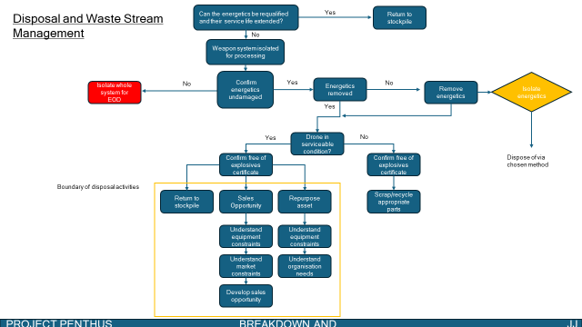
Figure 1 - Penthus Waste Stream

6.2 – Response to Individual Feedback: Technical
Upon review of the individual technical feedback, most of the questions raised were not linked to the subject material discussed by the SE, instead focusing more on the design features and quality control.
The operating limits of the drone are set by the design authority against the customer requirements, determining the lower bound for the key operating limits. The upper bound of the limits may be bound by a technological limitation or by a need to add unnecessary gold standard components to the design. In this scenario, key operating limits would be the range of at least 100m, altitude of at least 15 and payload capability of at least 1kg.
The drone-explosive interface is a design feature, not a safety feature. However, it is physically and electronically connected to the drone, able to be remotely controlled by the operator. The operator is only able to detonate the explosive device when the drone is within a certain proximity of the target using its high accuracy GPS.
The drone is not equipped with a jam-free capability. The customer was directly asked if the target had any defences. The customer stated that there were no defences available to the target. It was determined by the team that there was no requirement to include this feature as it incurs unnecessary expenses.
During the presentation, fault tree analysis was incorrectly described as a mitigation of safety which is incorrect. AND gates can be used to mitigate risk when multiple inputs are present as the effects of an AND gate are multiplicative and therefore reduce the likelihood of fault progression.

6.3 – Response to Individual Feedback: Presenting
As stated in the feedback, the safety engineer’s portion of the presentation was delivered online due to exceptional circumstances. Overall, this was not a benefit to the presenter due to the limited audience engagement and ability to interact with the slides.
Upon review of the presenting feedback, it is mostly critical with some lessons to be learned but also a few points to be challenged.
Key takeaways from this feedback include:
- More rigid practice of the presentation focusing on the removal of filler words, use of que cards to as prompts.
- Provide a visual feed where possible and appropriate.
- Tailor the presentation to the audience, using the appropriate amount of technical language and discussions.
Positive feedback was given on the presenter’s volume during the presentation. However, due to the online medium of delivery, it is argued that this is not a relevant comment as it is not within the control of the presenter and is impingent on the volume control of the audience’s speaker system.
The pace of delivery was commented to be too quick. Whilst this is recognised as a skill to develop, fast delivery is a relative term. Noting that the SE is from the Glasgow area, it can be seen in Figure 2 - UK Average WPM Map [9] that Glaswegians speak 15% faster than average in the UK. It is argued that due to this variance, it is extremely difficult to find a pace which suits every audience perfectly.

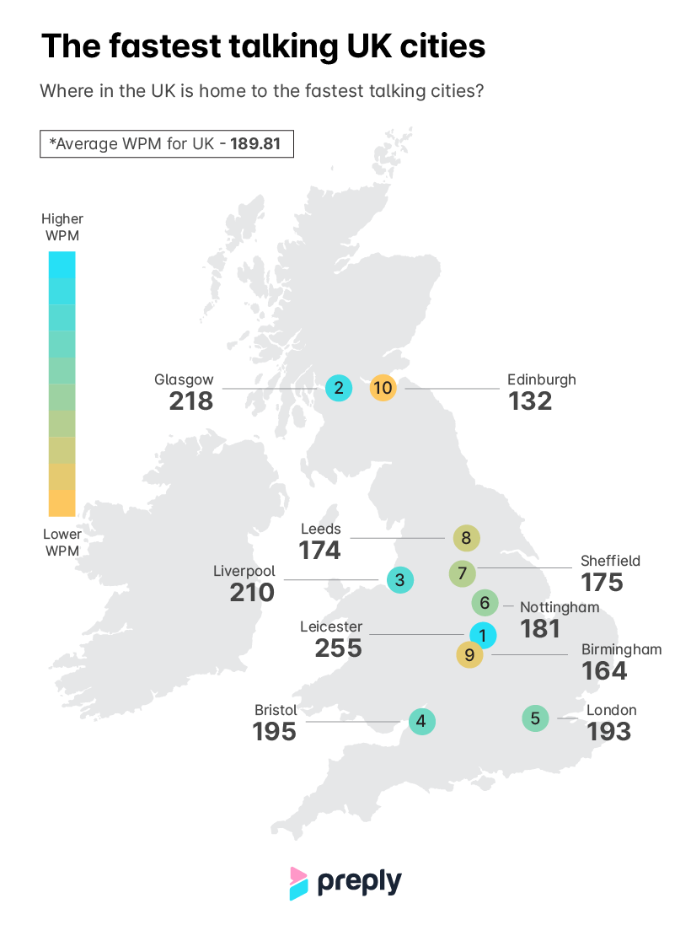
Figure 2 - UK Average WPM Map

7 – Reflection

7.1 – Team Performance
I found the team worked well together, there were no disruptive personalities to be managed and we ran a fairly democratic group. We exploited the strengths of our team, covering a range of disciplines and extra circulars to support the project.
Our key shortfall was after the first block, our work rate fell off significantly due to the difficulty of balancing our work, university and social commitments. This was difficult to combat as university projects do not normally demand so much of our time.
Due to not being present in the second block, I felt that the team did not take the necessary measures to effectively incorporate a remote member. Multiple meetings and decisions were made without my knowledge which was frustrating. To combat this, I should have spoken up to bring my issue to the team as they may not have been aware.
Multiple members of Penthus had neurodivergencies, including myself. This was not poorly managed but could have been better. To utilise the benefits of these differences, the team should have had a discussion surrounding the needs and adjustments required to effectively support its neurodivergent members.

7.2 – Individual Performance
I thought I performed well in this project. I acted as the project manager throughout the task and set up good systems to manage change, quality and record keeping. My teammates praised me for my diplomatic and inclusive nature during group work.
I was slightly hindered due to the exceptional circumstances effecting my personal life and in person time with my team which I find critical to any task.
I faced a few challenges on a personal level. The primary challenge was accountability on deadlines to produce non-essential work for the team post the first two week block. This combined with other commitments at the time made it difficult to produce work as I would often procrastinate from doing the tasks that were not 100% necessary to the project, focusing on optimising the essentials.
The other personal shortfall was that, upon reflection, my presentation focused on a suboptimal area of safety. I should have focused more on the safety features of the design and the manufacturing process as well as the legislation surrounding it in the presentation in order to meet the safety assessment criteria more accurately. I think the content I produced did well to communicate how a safety case is formed, however, that content by nature is obtuse. I was uncomfortable with the OME regulations as I am inexperienced with them as a safety engineer in my career.

8 – Conclusion
Project Penthus was assembled to fulfil a customer requirement to neutralise a hostile communications system using an explosive device. Project management techniques and a Quality Management System were employed to ensure smooth running of the project to manage potential shortfalls such as lack of record keeping or poor version control.
The design solution presentation was created to provide an overview of the proposal and the systems engineering tools used to reach it. It was broken up into various sections by covering each of the OME disciplines to provide easy assessment to the board and a logical flow to the audience.
The safety section focused on the documentation framework and how safety was approached. It was recognised that this may have been a suboptimal approach to pitching the safety of the system and should have focused more on the applicable regulations and specific safety features of the design and process.
Feedback on the individual and team performance was given by the customer and was answered. Reflective of the entire project, some key lessons were learned whilst other points of feedback were challenged or acknowledged but discounted where felt appropriate.
Project Penthus delivered an appropriate design solution to the top-level requirement set by the customer.

9 – References

[1] | Team Kissflow, 3 June 2025. [Online]. Available: https://kissflow.com/project/five-phases-of-project-management/. [Accessed 10 June 2025].
[2] | G. G. Jing, November 2024. [Online]. Available: https://asq.org/quality-resources/fmea?srsltid=AfmBOopf7RiLdwIbmU7K2vyRMt4So195Lq9rKoH-9LRx-6USwsXEnHaA. [Accessed 10 June 2025].
[3] | DSA, July 2024. [Online]. Available: https://assets.publishing.service.gov.uk/media/66e2bed04e4ac20112e6fbe0/DSA02.OME_regulations.pdf. [Accessed 10 June 2025].
[4] | DSA, “gov.uk,” 26 March 2025. [Online]. Available: https://www.gov.uk/government/publications/dsa03-ome-part-3-ranges. [Accessed 10 June 2025].
[5] | DSA, November 2019. [Online]. Available: https://assets.publishing.service.gov.uk/media/5ee8c496d3bf7f1ec11e6124/DSA_03_OME_PART_2__JSP_482__CH_10-02__Nov_19__-_mod_gov_uk.pdf. [Accessed 10 June 2025].
[6] | Ministry of Defence, [Online]. Available: https://www.asems.mod.uk. [Accessed 10 June 2025].
[7] | HSE, “hse.gov,” [Online]. Available: https://www.hse.gov.uk/simple-health-safety/risk/steps-needed-to-manage-risk.htm. [Accessed 10 June 2025].
[8] | DSA, August 2024. [Online]. Available: https://assets.publishing.service.gov.uk/media/673603212469c5b71dbc7b70/DSA_03_OME_Part_1__DCOP_105_-_Safety_Risk_Management.pdf. [Accessed 10 June 2025].
[9] | K. Withana, “preply.com,” 4 April 2024. [Online]. Available: https://preply.com/en/blog/the-fastest-and-slowest-talking-cities-in-the-uk/. [Accessed 09 June 2025].

Appendices

Appendix A – Presentation Slides
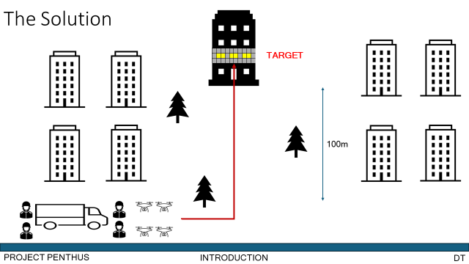
Figure 3 - The Solution: Slide 1

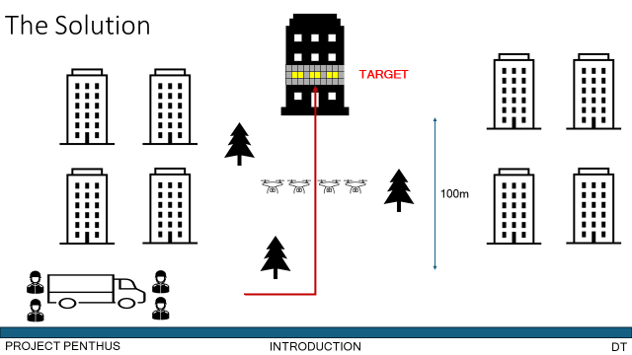
Figure 4 - The Solution: Slide 2
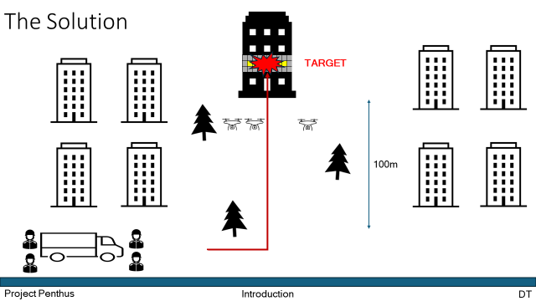
Figure 5 - The Solution: Slide 3
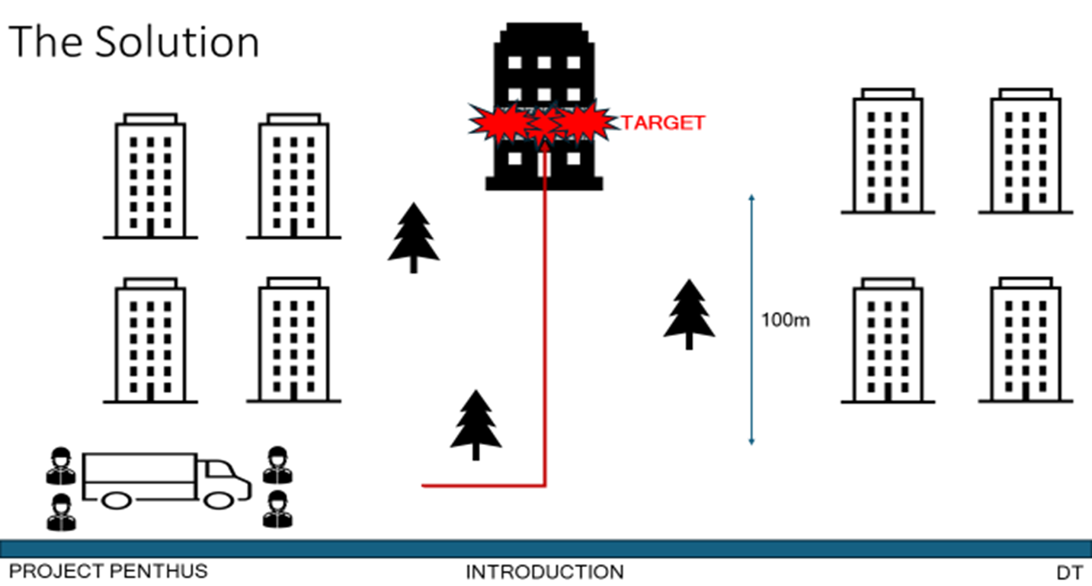
Figure 6 - The Solution: Slide 4

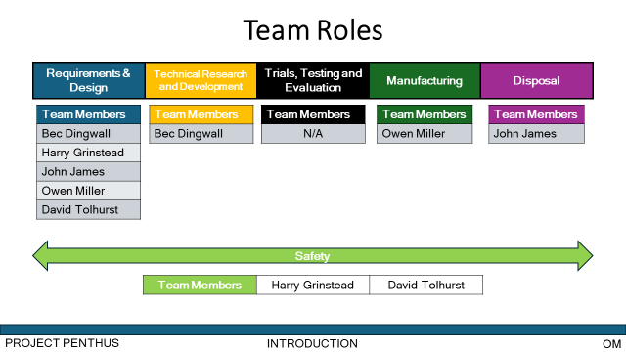
Figure 7 - Team Roles Slide

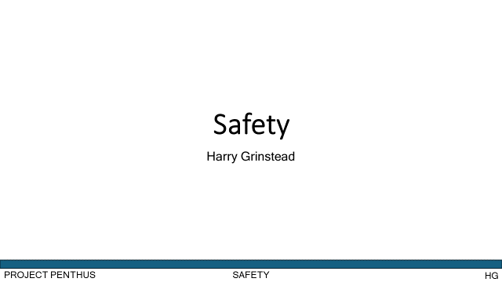
Figure 8 - Safety: Slide 1
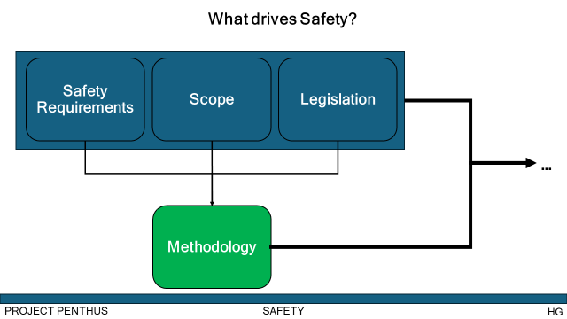
Figure 9 - Safety: Slide 2
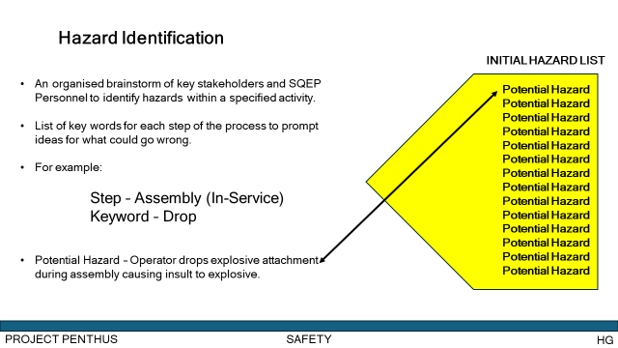
Figure 10 - Safety: Slide 3
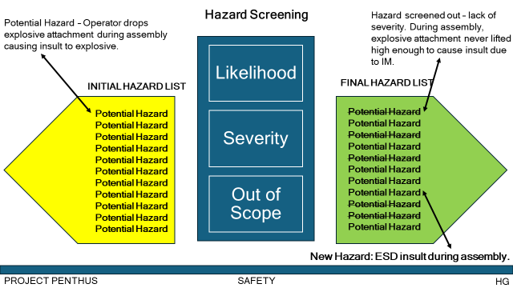
Figure 11 - Safety: Slide 4
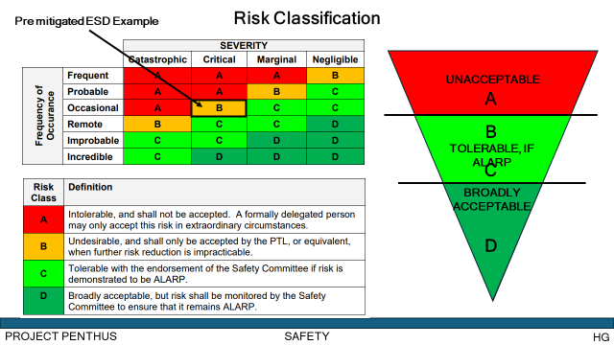
Figure 12 - Safety: Slide 5
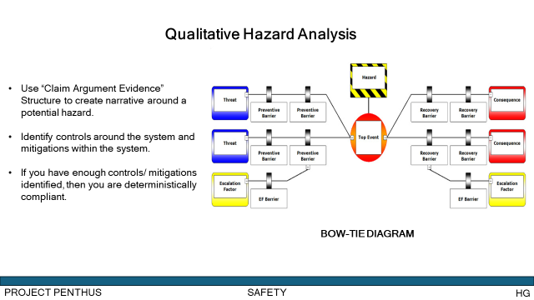
Figure 13 - Safety: Slide 6
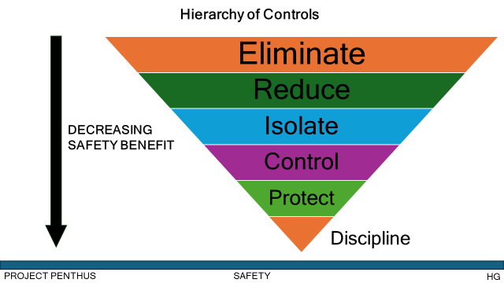
Figure 14 - Safety: Slide 7
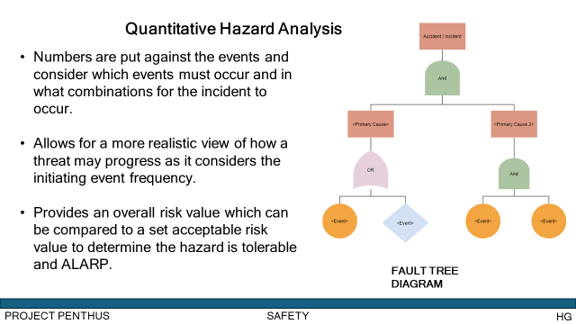
Figure 15 - Safety: Slide 8
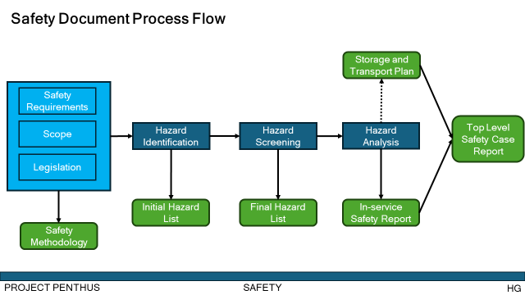
Figure 16 - Safety: Slide 9
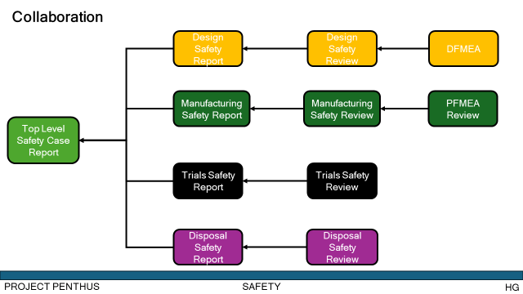
Figure 17 - Safety: Slide 10

