Table of Contents

Executive Summary 2
1. Introduction 2
2. Global Business Environment 3
3. Risk Management Program 4
4. Risk Management Process 6
4.1. Risk Definition (Step 1) 6
4.2. Risk Identification (Step 2) 7
4.3. Risk Analysis (Step 3) 8
4.4. Risk Measurement (Step 4) 9
4.5. Risk Management Strategy Selection (Step 5) 10
4.5.1 Risk Appetite: Risk Averter, Risk Neutral and Risk Seeker 11
4.5.2 Negative risk management strategies (avoid and eliminate threat) 12
4.5.3 Positive risk management strategies (seize and materialize opportunity) 12
4.6. Risk Management Actions Plan Implementation (Step 6) 14
4.7. Risk Management Performance Evaluation (Step 7) 14
5. Crisis management 15
5.1. Stages of Criss Management 15
5.2. Crisis Management Process 17
5.3. Crisis Management Plan 17
5.4. Crisis Management Team 18
5.5. Corrective and Subsequent Preventive Actions 18
6. Business Continuity Plan 19
7. Conclusions 19
8. Recommendations: 20
References 21
Appendix 1 - Risk Management Process 24
Appendix 2 - 15 Factors of Risk Perception Model 29

Executive Summary

Risk can be raised from mistake, accident, robbery, storm or disease etc. and is inherent to everyone and everywhere in our daily lives. However, if it does exist but you don’t mind that it would affect you, you won’t care about it. Same as the business environment, uncertainty will not bother our company if it cannot be measured in terms of probability and severity and such uncertainty does not matter our business objectives and impact our business operations. So, it is important firstly to identify all relevant risks in the past, at present and in the future in order to determine, assess, manage and take appropriate preventive, protective and reactive actions proactively to mitigate those identified risks to an acceptable tolerate level and minimize the potential loss and impact to the T Company (“the Company”), one of the largest processor of chicken, beef and pork, packaging our products in food manufacturing industry.
Further, if we cannot manage and mitigate risks properly and successfully, a higher chance of a crisis or disaster would be coming up and a new risk or even crisis could be raised. Therefore, this report is prepared for the purpose of getting comment and approval from Mr. Peterson, our chairman of the Company, regarding the enclosed contents of internal training on Risk Management Program for our senior management members of global manufacturing facilities around the world.
This risk management program will consist of risk management, business continuity planning and crisis management. For Risk Management, we aim at taking proactive approach to prevent identified risks even they are not happening yet. It is part of the operational controls and those risk management strategies are actioning on and off during and all the way with our normal business operations.
On the other hand, Business Continuity Planning and Crisis Management are designed and aimed at taking a reactive approach to deal with those specific risks and disaster events once they occur. However, both approaches should also be ready before the unfavorable events happened. So our Business Continuity Planning shall involve all the critical and contingent processes and procedures aiming to recover from disaster, emphasizing on keeping the business operations running during and after a disaster.
Further, our Crisis Management will be triggered and launched to handle the crisis when a disruptive outcome of a triggering event is certain and becomes a fact, aiming particularly to facilitate communication between all stakeholders and interaction with media.
Though Risk Management, Business Continuity Planning and Crisis Management are highly interrelated, they are used to deal with different situations and functions of different parts of the whole Risk Management Program with the same objective to mitigate the Company’s negative impacts on corporate objectives, business operations, stakeholders and reputation.

Introduction

This report is intended to develop for the purpose of preparing for a series of internal training for all the senior management members of the Company’s global manufacturing facilities. This training is aiming to provide senior management to comprehend the skills, competence and experience to familiar with the concepts of risk management process at both the corporate and operational levels on an going basis. With a coherent corporate risk management framework to aggregate risk information at corporate level and at the same time to collaborate intelligence and leverage the knowledge on risk management to allow senior management members located in different countries in responding to the increasing risky, dynamic and ever-changing business environment as well as day-to-day business decisions effectively and consistently.
As an international food manufacturing company in food industry, we are one of the largest processor of chicken, beef and pork, packaging our products and are then marketing them to our consumers through thousands of retailers and department stores. This involves logistic stages of transportation, storage, distribution and warehousing. So, the decision to fully utilize the global logistic network of owning the logistic services or outsourcing them to other specialized partnering companies would inherent both risks and opportunities to the Company. Therefore, a set of consistent approach, execution and support throughout the Company is critical to achieve the intelligence gathering and strategic priority setting and resources allocation of our integrated supply chain management globally.

Global Business Environment

There are two factors which are complexity and dynamism will increase the management’s perception of uncertain of the company.
- Complexity: the relationships between the variables which can impact on the company’s business operations are difficult to predicted or understand.
- Dynamism: the business environment is vulnerable and volatile in terms of how the business operations will become out of date rapidly in the industry or the company needs to respond more quickly than its competitors
Globalization can be treated as threat attaching with uncertainties and risks but it can also provide opportunities to those companies with proactive view and well prepared. It increase the complexity and dynamism of running business globally.
Globalization is defined as…
“the intensification of cross-national interactions that promote the establishment of trans-national structures and the global integration of cultural, economic, environmental, political, technological and social processes on global, supra-national, national, regional and local levels” (Martens et al., 2008, p.15).
We are now global with offices, productions, operations and logistics in countries all over the world as shown in the table 1.
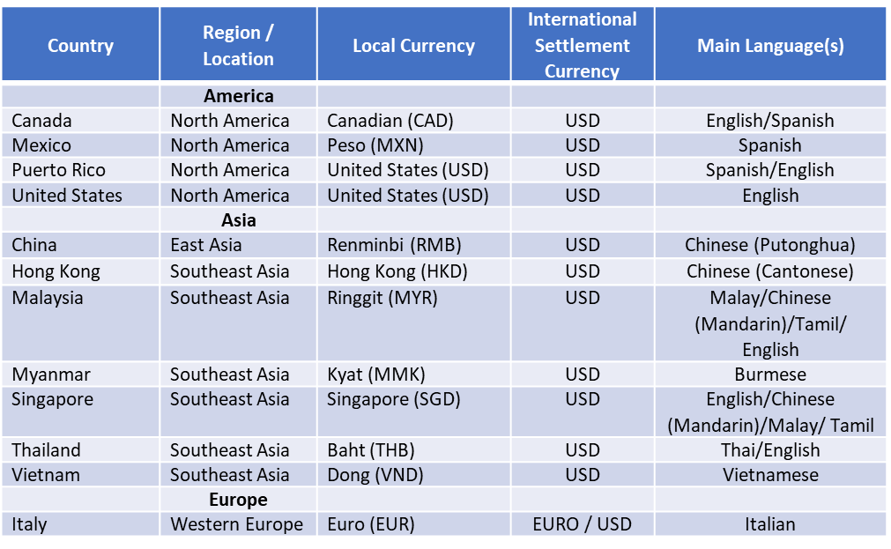
Table 1. Company locations
Source: Extracted from Wikipedia: country data
Companies that want to grow often need to tap international markets. Globalization may mean that workers are more mobilized and talent as well as various risks can come from anywhere. That involves risks of geographical distance, transportation, custom duties, jurisdictions, currency differences as well as language barrier etc. On the hand, there are also opportunities of market diversification, brand loyalty, lower labor cost or tax treaties etc.
One of the identified risks is the currency difference which involves risk of handling payments for vendors and consolidating the cashflow in different currencies. So the local currencies are used to settle the key local vendor payments and running expenses while contracting with key downstream customers with USD as it is the most common and effective trading currency among countries in the world as shown in table 2 below.
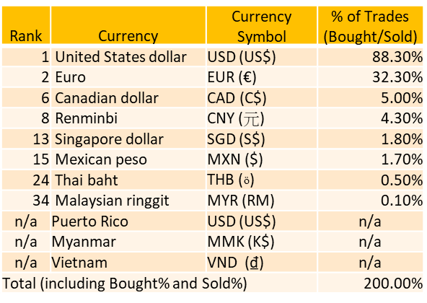
Table 2. Rank of trading currencies
Source: Wikipedia/Currency Par

Risk Management Program

This risk management program will consist of risk management, business continuity planning and crisis management. Although Risk Management, Business Continuity Planning and Crisis Management are highly interrelated, they are used to deal with different situations and functions of different parts of the whole Risk Management Program. Below is a table summarizes the different critical stages of a risk management program.

Summary of Stages of Risk Management Program
Stages | Situation | Risk Management Program | Adverse Outcome (if not managed properly) | Stage of Impacts
Pre-crisis | Within the organization | Risk Management | Acute-crisis | Negative or positive impacts
Acute-crisis | Made aware to the public | Business Continuity Plan | Disaster/ Catastrophe | Relatively less serious negative impacts
Disaster | Made aware to the public | Crisis Management | Catastrophe/ Bankruptcy | Relatively serious negative impacts and in longer term
Catastrophe | Made aware to the public | Crisis Management | New risk raised or even lead to bankruptcy | Extension of current crisis or triggering a new crisis

Table 3 Stages of Risk Management Program

Risk Management Process

A logical, sequential and scientific seven-step approach is proposed. Those steps are “define; identify; analyses; measure; select; implement; and evaluate (DIAMSIE)” (Choy, 2020). It is a cyclic process which involves a series of continuously and repeatedly reassessing and updating process.

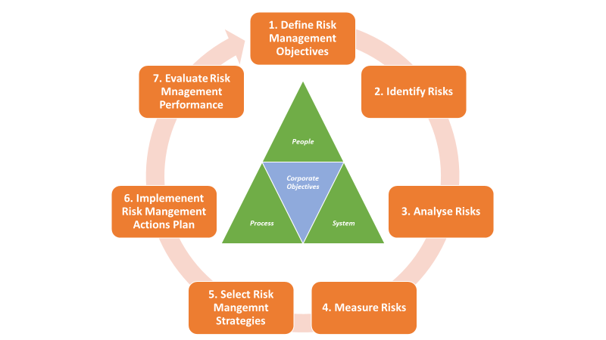
Diagram 1: 7-steps Risk Management Process (DIAMSIE)

Risk Definition (Step 1)
According to the lecture notes, Knight (1921) stated that risk can be defined as quantifiable uncertainties and uncertainties will become risks to a company when they affect the business objectives.
The first step of the risk management process is to determine a clear and well-defined direction and risk management objective of the Company. Our most key objective is the Company’s reputation and image in the public domain. We have different business situations and no simple formula in terms of complexity and dynamism in the past, present and in the future. It is very important to clearly define specific risk management goals (ie. policies and plans) according to our corporate risk attitude and culture (ie. risk aversion, risk seeking and risk neutral). It should also be sure that the objective is actionable, realizable, measurable and with specific time frame. More importantly, the risk management objective must be consistent with the company's sustainable business goals and growth.
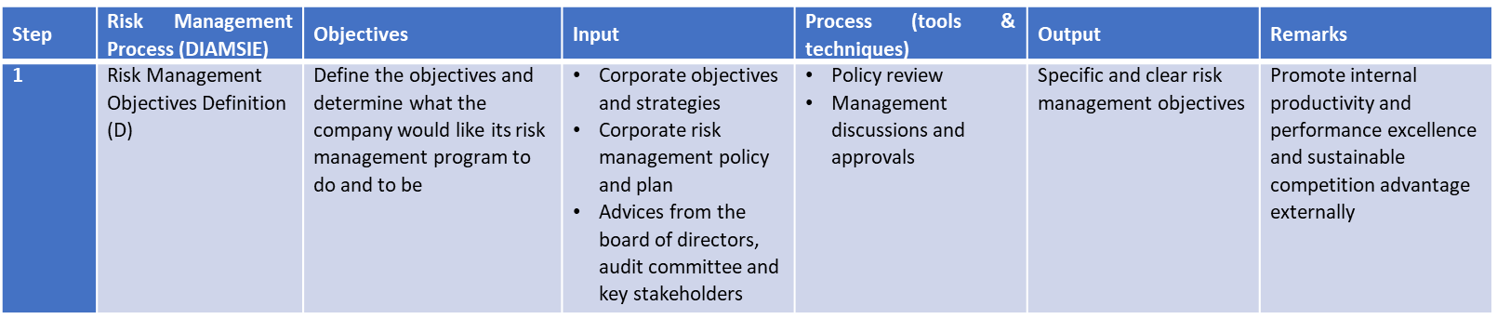
Once risk objective is clearly and unambiguously defined, we can base on the output of step 1 as the input of and move on to Step 2 - Risk Identification.

Risk Identification (Step 2)
An authorized risk management team, comprising of experienced and competent cross-functional heads should be established. In this stage, we have to identify all possible undesirable risk events including major risks (inherent risks) and sub-risks.
Base on Brainstorming and Mind-mapping processes with the sources of internal records, internal and external benchmarking, best practices, external reports, consultants/ experts’ advices, on-site inspection, interviews and surveys with concerned stakeholders to identify all the risks from the regions, categorize them and document in risk profile.
During the risk identification stage, Fishbone Analysis (as shown in the below diagram 2) is applied to get a better understanding and identifying root cause of problems based on the 5Ms1E perspectives which are Man, Materials, Machine, Method and Measurement (internal factors)and Environment (external factor).
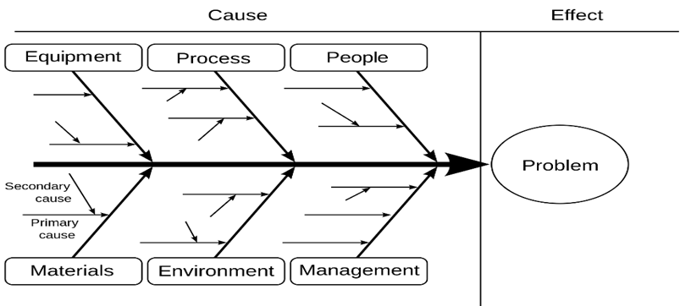
Diagram 2: Fishbone Analysis
Source: Lecture 3 Key Note, p16

We can also take reference from Pareto’s principle of 80:20 rule (see diagram 3) to identify those vita fews which are the major and the significant problems that the Company should focus on and allocate the appropriate resources to manage those vital fews.
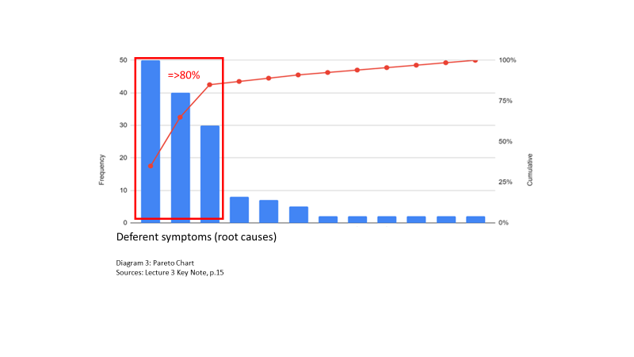
In this stage, it is important to take a logical approach to identify root causes of all the identified risks including sub-risks in detail for taking further analysis and measurement in next steps.
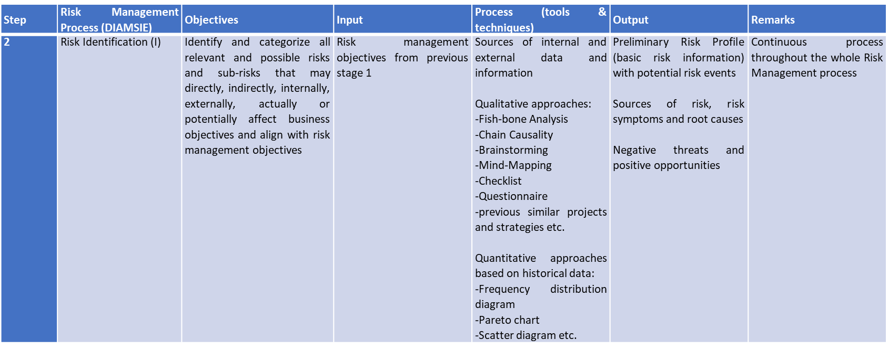

Risk Analysis (Step 3)
In this stage, we will analyze the interlocking relationships (Risk Chain Causality) between the identified risks and sub-risks in step 2. For qualitative analysis, it is according to a more subjective basis on our experience, knowledge, skill, intuition etc. and quantitative analysis is based on a more objective past and accumulated data and records. After the risk analysis in step 3, it should be ready for the probability and severity measurement in step 4.
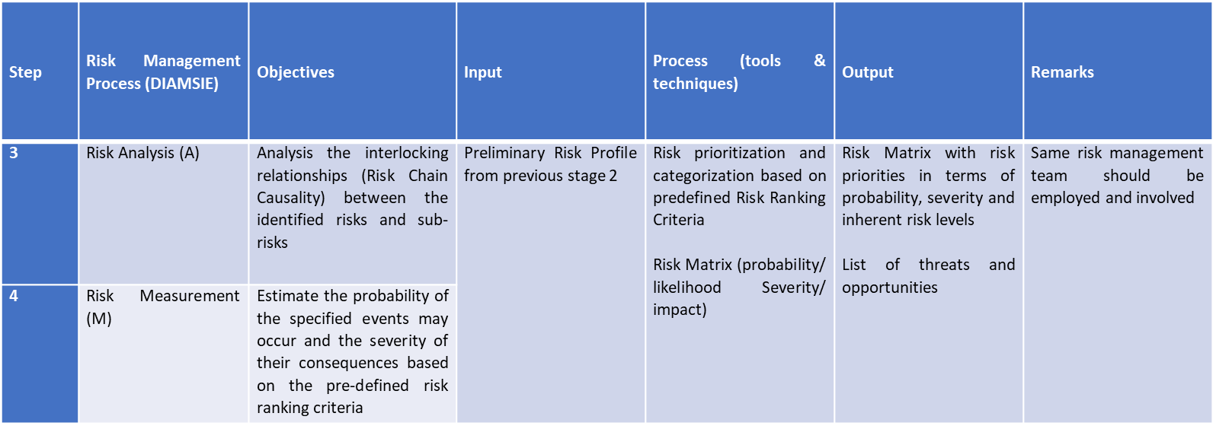

Risk Measurement (Step 4)
In the measuring stage, the identified risks and sub-risks will be prioritized according to the pre-determined ranking criteria (see diagram 4) in terms of probability (likelihood) and severity (consequence) with different risk ranking zones as shown in diagram 5. The ranking results will then be plotted in Risk Matrix as shown in diagram 6 below.
Pamela (2010) expressed risk as an equation as below:
Risk = Probability x Consequence
where risk can may be expressed as the probability (likelihood) and severity (consequence) of an event with the potential effect to the company’s business objectives.
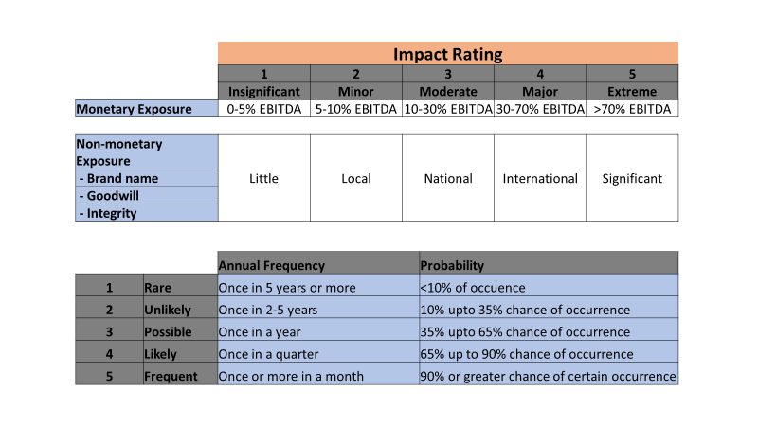
Diagram 4: Risk Criteria Tables

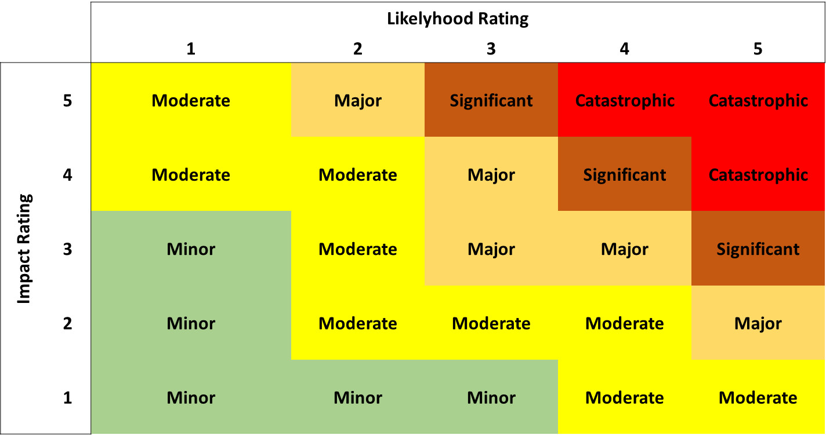
Diagram 5: Risk Ranking Index Table
Diagram 6: Risk Matrix
Source: Lecture 5 Note, p.2

Once the risk prioritization with the probability of identified risks and the corresponding severity of their potential impacts are measured as shown in diagram 4, we can then start the step 5 of the risk management process accordingly.

Risk Management Strategy Selection (Step 5)
During the risk management process, we shall consider risk management strategy in a holistic view with both negative and positive approaches (Choy, 2017).
Risk Matrix can be divided into four quadrants as shown in the diagrams 8 & 9 below which can also represent two risk management strategy selection approaches. They are negative risk management strategies and positive risk management strategies.
Decision can be made consciously adding value to the Company in form of measurable and visible matter with informed decisions with respect to risk tolerance according to the capability and capacity as well as the risk appetite of the Company.

Risk Appetite: Risk Averter, Risk Neutral and Risk Seeker
Risk appetite is defined as ‘the risk of loss that a company is willing to accept for a given risk-award ratio over a specific time horizon at a given level of confidence (Blunden and Thirlwell, 2010).
Perception of risk may vary from person from, culture to culture and society to society. Taking the path of risky (beginner), improving (learned from mistakes and achievements) and inevitable (experts learned and accepted) stages of Duffey and Saull (2008)’s Risk Perception Curve (see diagram 7).

Diagram 7: Risk Perception Curve

Covello et al (2001) Risk Perception Model shown in appendix 1 listed out 15 different factors which can alter perceptions in varying degrees of magnitude.
Risk exposures: physical asset (property), financial asset (price, credit, interest rate, currency exchange and default), human asset (death and health) and intangible asset (brand and reputation) Young and Tippins (2001).

Diagram 7: Risk matrix with negative risk management strategy

Negative risk management strategies (avoid and eliminate threat)
- Risk Avoidance: specific risk exposure will be eliminated by taking specific risk management actions (reconfigured business operations by knowledgeable owners) from risk avoidance quadrant to other 3 quadrants and ultimately to a tolerate level (acceptable value). By dropping specific non-core services or products, regional markets, suppliers or customers.
- Risk Mitigation: additional risk management actions will be taken to reduce the existing level of probability (occurrence) and/or severity (expected monetary value). Cooperation with supply chain partners is one of the mitigation strategies for supply chain risks to improve supply chain visibility. Technology like integrated ERP system can help anticipate for and monitor the potential of delay in delivery, swings in demand, market trends or other disruptive events
- Risk Transfer: the risk management actions are intending to transfer/allocate the risks to third parties who are best able to manage them i.e. insurance company, outsourcing
- Risk Retention: no or minimal action is taken and accept the risk consequences according to the cost and benefit analysis unless there is a tendency of risk increase. A contingency plan for execution in case of the occurrence of the risk event as an active measure or simply accept the expected impact or low profit in a passive approach.

Positive risk management strategies (seize and materialize opportunity)
- Risk Exploitation: proactively explore a way to eliminate the uncertainty attached to the identified opportunities.
- Risk Enhancement: actively analyze and identify the underlaying drivers and success factors behind the opportunities and positively influence each other, trying to make it happened
- Risk Sharing: partnering or merging with other with better expertise to share the identified opportunities with potential uncertainties in a collaborative manner (in term of joint collaboration for risks involving two or more parties in a supply chain
- Risk Acceptance: take no action now and accept the opportunities when they become more appealing and easier to obtain for the time being.

Diagram 8: Risk matrix with positive risk management strategy

Risk management actions like training, standard operating procedures (SOP), policies and procedures, operations manual etc.
Risk management actions to ensure there are sufficient funding to the company paying insurance premium externally to protect and compensate the loss and setting aside the profit under the company’s reserve internally with appropriate provision made.
Risk Control = risk avoidance + risk reduction/mitigation
Risk Sharing/Financing = risk transfer + risk retention
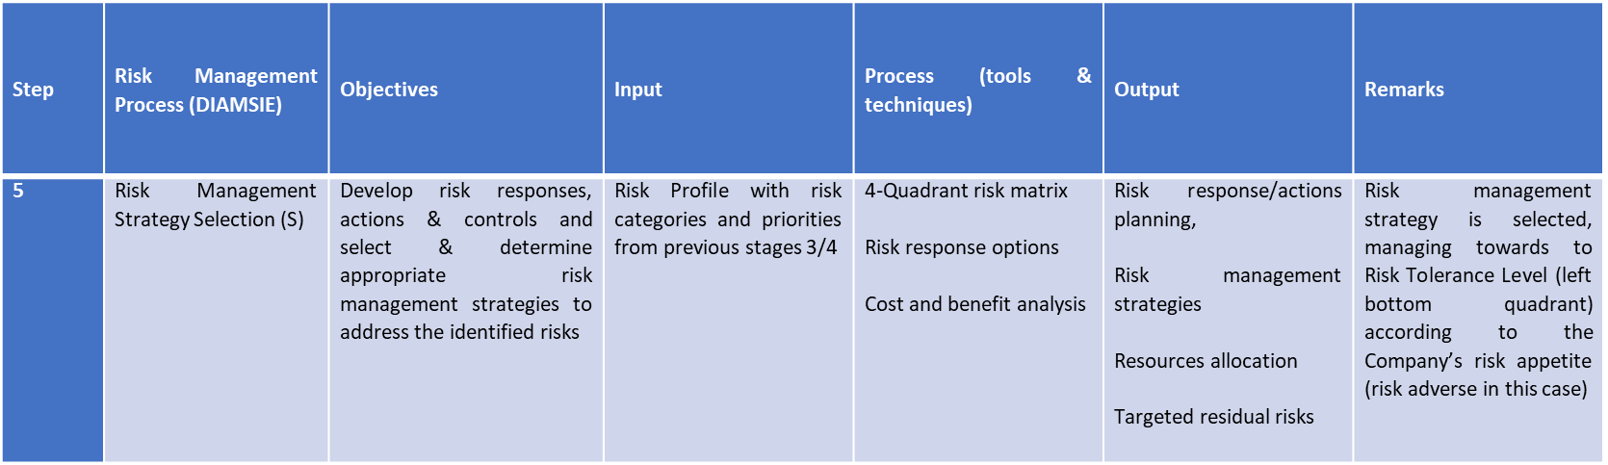

It is also expected to have the outcomes from this stage and they are:
- Risk responses
- Risk management policy
- Risk management actions plan
- Resources allocation and timeframe for implementing the risk management actions plan

Risk Management Actions Plan Implementation (Step 6)
Good response in terms of Hillson (2010) proposed “Seven As” criteria (extracted form Lecture 1 Notes, p.13):
- Appropriate
- Affordable
- Actionable
- Achievable
- Assessed
- Allocated
- Agreed

Key components of the risk management action plan (corrective and management actions)
- Detailed risk management actions description
- Responsible person
- Working schedule
- Required resources
- Expected deliverables
- Specific measurement metrics
- Cost and benefit analysis of the risk management action plan for management approval

Once the risk management actions plan is defined, established and communicated, there is a last step but also a cyclic process which require to be performed on an on-going basis.

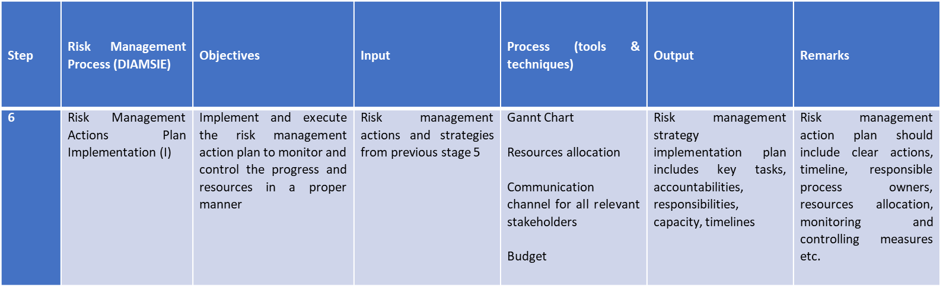

Risk Management Performance Evaluation (Step 7)
Regular reviews (quarterly meeting for progress update and ongoing monitoring control purposes while the annual review for the overall performance during the year) should be planned and conducted to collect feedbacks and to evaluate the effectiveness the risk management actions plan has been properly executed with the expected targets.
Consider not only the risks and threats but also opportunities and favorable chances. There is no reason to consider doing thing with an incurred cost higher than its benefit obtained. Actual post cost and benefit analysis should be also be evaluated to compare the actual costs incurred against with the budget as well as the targeted outcomes.
A follow-up risk management performance evaluation should be prepared and communicated to all the responsible persons, the Risk Management Committee, and the broad of directors.
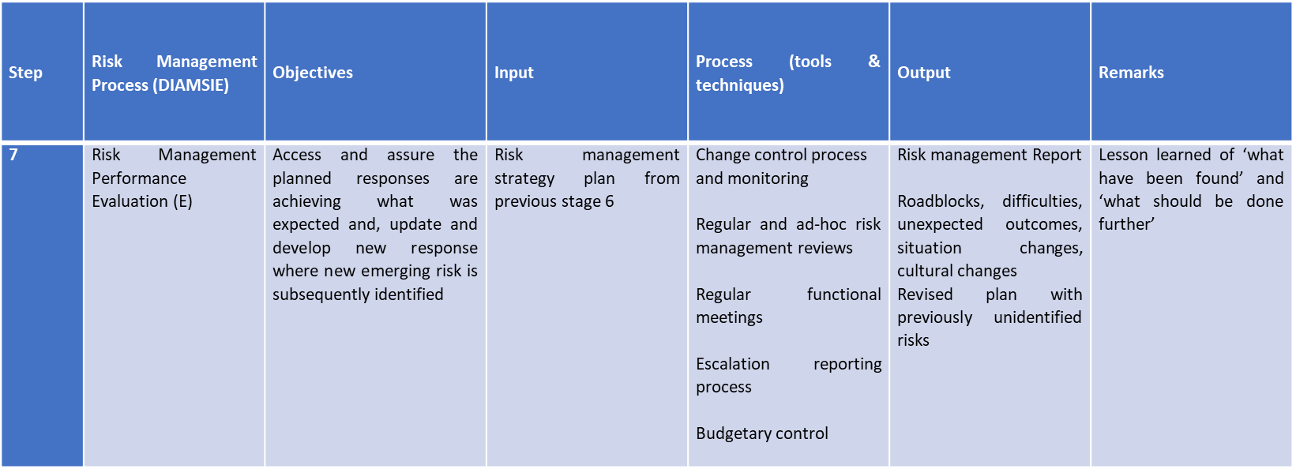
This step is an on-going process risk both regular and ad-hoc review processes specially some risks are dynamic and cyclical in nature with potential higher exposure when new situation comes up. It is also required to bear in mind that we are not dealing with a single problem but interdependent and interlocked risks.

Crisis management

Unlike Risk Management, Crisis Management is a response rather than a preventive action. Once the crisis is triggered, it harms our employees, tarnish the Company’s reputation, damages business operations and negatively impacts the financial perspective and seriously, the Company may go bankruptcy. So a proper crisis management plan should be established well prior to the event is actually happening.
In reality, a business crisis can be caused by internally or externally event and would negatively impact the success of the Company seriously. So, we shall establish our own tailor made Crisis Management Plan well in place to maintain a process of preparing for and managing certain disruptive or unexpected emergency situations. Here are the key tasks to meet the objective of our crisis management plan:
- maintain a good understanding of the team and other employees about their roles and function throughout the crisis
- maintain good relationships and reputation with stakeholders
- ensure high standard of safety and health of stakeholders
- minimize the impacts on operations during and after the crisis
- minimize serious, long-lasting consequences and negative repercussions

Stages of Criss Management

Pre-Crisis stage (save time when an emergency event happens suddenly)
It is a stage that the incident is not happening yet. This helps maintaining awareness and getting prepared for any crisis to be occurred through communication with the team early, honestly and regularly. It involves planning details for the unexpected by brainstorming ideas with the team and selecting the best solution and alternative course of actions. It is critical to ensure that management approval should be obtained before finalizing and implementing plan with a proper delegated team with assigning roles and responsibilities based on specific situations and training team with support with clear directions to ensure the team can execute their tasks accordingly and properly.
- Aim at preventing any potential crisis
- Create crisis a management plan
- Draft crisis communication messages
- Establish and train a crisis management team
- Conduct testing and implement the plan

Response Stage (put the crisis management plan into action)
This is a fight stage with mobilized teams, working in war room, dealing with and responding to both internal and external stakeholders. Communication is the key in this stage to align tone and message across all platforms and languages (empathy, engagement and escalation). The team should keep monitoring the situation especially paying extra attention to address outsider concerns as what the perspectives of external stakeholders such as customers and distributors etc. may be different from the team.
Listen to those concerns would give the team some good hints to calm their nerves. Put the plan into action and get crisis management messages prepared and released instead of hiding away and waiting for the publicity to tell the company the facts. Otherwise, people will make up their own stories and another crisis of misinformation may burden your effort in dealing with actual emergency. So contact external stakeholders and inform them the measures are putting in place as transparent and honest as possible and reassure the team and stakeholders across all essential platforms.
The team shall decide and prioritize the key metrics that matter, focusing on customers satisfaction and reward their brand loyalty to the company, aiming at minimizing the impact of harmful events.
One essential management input is to motivate the team and employees working under pressures and keep them inspiring with emotionally and mentally healthy.
- Complete the crisis management plan prior to crisis
- Aim at dealing with and responding to crisis
- Release initial crisis management messages
- Protect customers, employees, stakeholders and publics

Post-Crisis Stage (lesson learned)
It is not over yet but just moving out of crisis into recovery stage. The team shall remain available to answer questions (manage the staggering noise). Communication is still essential at this stage that we will keep updating the progress to employees, customers and stakeholders but in a more relaxing manner in comparing with the fighting stage.
Finally, the root cause of the crisis must be reviewed, documented and updated. Learn from the lesson and take necessary remedial actions to avoid a similar situation to be happened again in the future or be better prepared to address the crisis confidently in a more controllable and effective manner. Debrief the case and discuss what had gone wrong, gleaning the knowledge to make positive changes, update and incorporate into the crisis management plan.
- Remain in contact with employees, customers and stakeholders
- Remain available to answer
- Send proactive updates to them
- Review and analyze the plan
- Evaluate communication plan
- Rectify any unexpected events
- Integrate lessons learned into the updated plan
- Don’t let the crisis become the signal to the end of the business.

Crisis Management Process
- Dealing with a disruptive or unexpected emergency situation
- Combat and rectify the expected outcomes
- Preventing serious and long-lasting consequences (put you out of business)
- Reputation, safety of those who work for and do business with the Company
- Maintain the productivity during and after crisis (downtime
- Ready for any situation (peace of mind)

Crisis Management Plan
- Identify all possible types of crisis
- Financial
- Personal
- Organizational
- Technological
- Natural
- Determine the impact (threat or catastrophe)
- Company, employees and customers
- Loss of sales
- Customer satisfaction
- Tarnished reputation
- Increase in expenses
- Decrease in customer loyalty
- Consider actions
- Situational Crisis Communication Theory (ready to handle any unforeseeable event)
- Proactive Crisis Management (anticipate a specific type of crisis occurring and proactively prepare for it
- Recovery Crisis Management (BCP)
- Who will be involved
- Carry out the necessary resolution plans and actions
- Employees with expertise in specific areas (HR, PR, IT, Procurement)
- Assistance of lawyers, consultants or first responders
- Develop resolution plans
- Differ based on the specific situation
- Time, tolls, people, customers, cause of the crisis
- Training
- The roles the employees are expected to play
- Informed of the actions of other employees are expected to take
- Revisit and update the Crisis Management Plan
- Changes of the corporate structure, offices, countries operate and number of employees
- Evaluate whether the plan was successful in pulling the Company through
- Update or rework

Crisis Management Team
The Crisis Management Team should consist of regional emergency management team, site emergency response team and business support team. Staff and colleagues are our first line of defense, we shall trust them and share the important messages with them as appropriate and as soon as possible. They are:
- Crisis Manager
- CM Advisor
- Emergency Management Director
- Public Relations Specialist
- HR Advisor
- Legal Advisor
- Advisor

Corrective and Subsequent Preventive Actions
Corrective Action
- On detected nonconformities
- Stop them from ever happening again in the future
- Understand the real defects
- Potential defects
- Fix to prevent a bad outcome form occurring
- Based on solving a problem that has already happened
Preventive Action
- Based on preventing a nonconformance event in the future
- Focused on control
- Making an improvement
- Analyze process or product characteristics
- Alarm to warn
- Process control chart
- Benchmarking
- Training program
- Disaster recovery
- Contingency plan

Business Continuity Plan
Every business should have a strategy put in place as part of the BCP
It is not just about IT disaster recovery

Operational: normal business operatins
Technological: manufacturing errors, software crashes, hacks, data leaks, sever downtime and other system issues
Financial: product or service drops, business starts losing value and becoming harder to pay off debts or operational expenses
Humanitarian: natural and man-made disasters, hurricanes, storms, wildfires, war, floods, tornados
Human Capital: loss an important member or a whole crew of workers, due to misconduct, worker going on strike
Legal: involved in accounting error, intellectual property theft, unethical or illegal conduct, legal proceedings
Reputational: adversely affect the reputation of the company, the customers or the shareholders

Conclusions
There is no absolute strategy that can fit all the companies even they are surviving within the same industry or sector. The trend of companies outsourcing their activities to third party expertise is intending for the company to focus on its core business and let other to do the rests. This is a common supply chain management practice to transfer the potential operational risks to third parties who they are specialized in such activities. But on the other hand, it would create potential uncertainties in terms of delays of materials supply, forecast errors, inventory shortage and cost fluctuations etc.

Risk Management, Business Continuity Planning and Crisis serve for different objectives, require different approaches and skill sets
BCP should not be positioned as synonymous with recovering from IT failure although IT involves critical parts of the BCP but

ERM
To coordinate the assessment of risks and the selection of appropriate risk management strategy and the allocation of adequate resources to mitigate and eliminate risks across all areas of business operations.

Technological advancement
Dynamic and non-controllable business environment
Seizing Positive risk strategy (opportunity) – proactive/preventive rather than reactive

Systematic: Risk ownership and sub-risk owners
Sequential and logical: input /output (fail if not being done precisely and properly)
Scientific: measurable and quantifiable data

Recommendations:
Duty of management to fully understand the business
Authority and Responsibility for each business activity have to be clearly established and communicated
Relevant internal control
Top management and the audit committee’s commitment and resources allocation

References

Journal Article

Argenti, P. (2002). Crisis communication. Lessons from 9/11. Harvard Business Review, 80(12), 103. Retrieved from http://web.b.ebscohost.com.ezproxy.lb.polyu.edu.hk/ehost/pdfviewer/pdfviewer?vid=1&sid=43555346-6bb8-47da-b353-985bf1de98e7%40sessionmgr103

Durst, Susanne, Hinteregger, Christoph, & Zieba, Malgorzata. (2019). The linkage between knowledge risk management and organizational performance. Journal of Business Research, 105, 1-10. https://julac.hosted.exlibrisgroup.com/permalink/f/97ejsn/TN_cdi_gale_businessinsightsgauss_A604892954

Er Kara, Merve, Oktay Fırat, Seniye Ümit, & Ghadge, Abhijeet. (2020). A data mining-based framework for supply chain risk management. Computers & Industrial Engineering, 139, 105570. Retrieved from https://julac.hosted.exlibrisgroup.com/permalink/f/97ejsn/TN_cdi_crossref_primary_10_1016_j_cie_2018_12_017

Hunter, M. G. (2009). Supply Chain Risk Management: Literature Review and Future Research. In (pp. 280-297). IGI Global. Retrieved from https://ebookcentral.proquest.com/lib/polyu-ebooks/detail.action?docID=3310218

Kei Tse, Ying, Hua Tan, Kim, Ho Chung, Sai, & Kim Lim, Ming. (2011). Quality risk in global supply network. Journal of Manufacturing Technology Management, 22(8), 1002-1013. Retrieved from https://www-emerald-com.ezproxy.lb.polyu.edu.hk/insight/content/doi/10.1108/17410381111177458/full/pdf

Martens, Pim, Dreher., Axel, & Gaston, Noel. (2008). Measuring Globalisation (1. Aufl. ed.). New York, NY: Springer-Verlag. (p. 15).

Rajeev, A, Pati, Rupesh K, Padhi, Sidhartha S, & Govindan, Kannan. (2017). Evolution of sustainability in supply chain management: A literature review. Journal of Cleaner Production, 162, 299-314. Retrieved from https://julac.hosted.exlibrisgroup.com/permalink/f/97ejsn/TN_cdi_gale_infotracacademiconefile_A521838205

Tokakis, Vassileios, Polychroniou, Panagiotis, & Boustras, George. (2019). Crisis management in public administration: The three phases model for safety incidents. Safety Science, 113, 37-43. Retrieved from https://www-sciencedirect-com.ezproxy.lb.polyu.edu.hk/science/article/pii/S0925753518310117

Tsang, Y.P, Choy, K.L, Wu, C.H, Ho, G.T.S, Lam, Cathy H.Y, & Koo, P.S. (2018). An Internet of Things (IoT)-based risk monitoring system for managing cold supply chain risks. Industrial Management Data Systems, 118(7), 1432-1462. Retrieved from https://www-emerald-com.ezproxy.lb.polyu.edu.hk/insight/content/doi/10.1108/IMDS-09-2017-0384/full/pdf

Tyler, L. (1997). Liability Means Never being Able to Say You're Sorry. Management Communication Quarterly, 11(1), 51-73. Retrieved from https://journals-sagepub-com.ezproxy.lb.polyu.edu.hk/doi/pdf/10.1177/0893318997111003

Course Presentations and Notes

Choy, P. (2020, July). Course Materials: LGT5073 Risk Management in Operations [Course Presentations and Lecture Notes]. Summer Semester 2019/2020, Department of Logistics and Maritime Studies, Faculty of Business, The University of Polytechnic University. Retrieved from https://learn.polyu.edu.hk/webapps/blackboard/content/listContent.jsp?course_id=_84460_1&content_id=_4201261_1&mode=reset

Blunden, T. and Thirlwell, J. (2010). Mastering operational risk- A practical guide to understanding operational risk and how to manage it. Financial Times, Prentice Hall: Harlow, England, New York.

Bussey, L.E. (1978). The economic analysis of industrial projects. Prentice Hall, Englewood Cliffs, NJ.

Covello, V., Peters, R. and Wojtecki, J. (2001). Risk communication, the West Nile virus epidemic and bioterrorism: Responding to the communication challenges posed by the intentional or unintentional release of a pathogen in an urban setting. Journal of Urban Health: Bulletin of the New York Academy of Medicine, 78(2). 382-391.

Duffey, R. B. and Saull, J.W. (2008). Managing risk: The human element. Wiley, Hoboken, NJ, USA.

Hillson, D. (2010). Exploiting future uncertainty: Creating value from risk. Ashgate Publishing Group, Farnham, Surrey, GBR.

Pamela, F. (2010). Risk and crisis communication. Professional Safety, 55(6), pp. 38-45.

Young, P.C. and Tippins, S.C. (2001). Managing business risk: An organization-wide approach to risk management. AMACOM (American Management Association), New York.

Newspaper

Choy, P. (2017, December 23). How to understand the new paradigm of risk management. SCMP. Retrieved from https://www.scmp.com/print/business/companies/article/2125456/how-understand-new-paradigm-risk-management

Wikipedia

Currency Par
https://en.wikipedia.org/wiki/Currency_pair#:~:text=The%20most%20traded%20currency%20pairs,dollar%2C%20and%20the%20Swiss%20franc.

Appendix 1 - Risk Management Process

A logical, sequential and scientific seven-step approach is proposed. Those steps are “define; identify; analyses; measure; select; implement; and evaluate (DIAMSIE)” (Choy, 2020).
A series of continuously and repeatedly reassessing and updating process (cyclic process)
Step | Risk Management Process (DIAMSIE) | Objectives | Input | Process (tools & techniques) | Output | Remarks
1 | Risk Management Objectives Definition (D) | Define the objectives and determine what the company would like its risk management program to do and to be | - Corporate objectives and strategies  - Corporate risk management policy and plan  - Advices from the board of directors, audit committee and key stakeholders | - Policy review  - Management discussions and approvals | Specific and clear risk management objectives | Promote internal productivity and performance excellence and sustainable competition advantage externally
2 | Risk Identification (I) | Identify and categorize all relevant and possible risks and sub-risks that may directly, indirectly, internally, externally, actually or potentially affect business objectives and align with risk management objectives | Risk management objectives from previous stage 1 | Sources of internal and external data and information  Qualitative approaches:  -Fish-bone Analysis  -Chain Causality  -Brainstorming  -Mind-Mapping  -Checklist  -Questionnaire  -previous similar projects and strategies etc.  Quantitative approaches based on historical data:  -Frequency distribution diagram  -Pareto chart  -Scatter diagram etc. | Preliminary Risk Profile (basic risk information) with potential risk events  Sources of risk, risk symptoms and root causes  Negative threats and positive opportunities | Continuous process throughout the whole Risk Management process
3 | Risk Analysis (A) | Analysis the interlocking relationships (Risk Chain Causality) between the identified risks and sub-risks | Preliminary Risk Profile from previous stage 2 | Risk prioritization and categorization based on predefined Risk Ranking Criteria  Risk Matrix (probability/ likelihood Severity/ impact) | Risk Matrix with risk priorities in terms of probability, severity and inherent risk levels  List of threats and opportunities | Same risk management team should be employed and involved
4 | Risk Measurement (M) | Estimate the probability of the specified events may occur and the severity of their consequences based on the pre-defined risk ranking criteria
5 | Risk Management Strategy Selection (S) | Develop risk responses, actions & controls and select & determine appropriate risk management strategies to address the identified risks | Risk Profile with risk categories and priorities from previous stages 3/4 | 4-Quadrant risk matrix  Risk response options  Cost and benefit analysis | Risk response/actions planning,  Risk management strategies  Resources allocation  Targeted residual risks | Risk management strategy is selected, managing towards to Risk Tolerance Level (left bottom quadrant) according to the Company’s risk appetite (risk adverse in this case)
6 | Risk Management Actions Plan Implementation (I) | Implement and execute the risk management action plan to monitor and control the progress and resources in a proper manner | Risk management actions and strategies from previous stage 5 | Gannt Chart  Resources allocation  Communication channel for all relevant stakeholders  Budget | Risk management strategy implementation plan includes key tasks, accountabilities, responsibilities, capacity, timelines | Risk management action plan should include clear actions, timeline, responsible process owners, resources allocation, monitoring and controlling measures etc.
7 | Risk Management Performance Evaluation (E) | Access and assure the planned responses are achieving what was expected and, update and develop new response where new emerging risk is subsequently identified | Risk management strategy plan from previous stage 6 | Change control process  and monitoring  Regular and ad-hoc risk management reviews  Regular functional meetings  Escalation reporting process  Budgetary control | Risk management Report  Roadblocks, difficulties, unexpected outcomes, situation changes, cultural changes  Revised plan with previously unidentified risks | Lesson learned of ‘what have been found’ and ‘what should be done further’

Appendix 2 - 15 Factors of Risk Perception Model

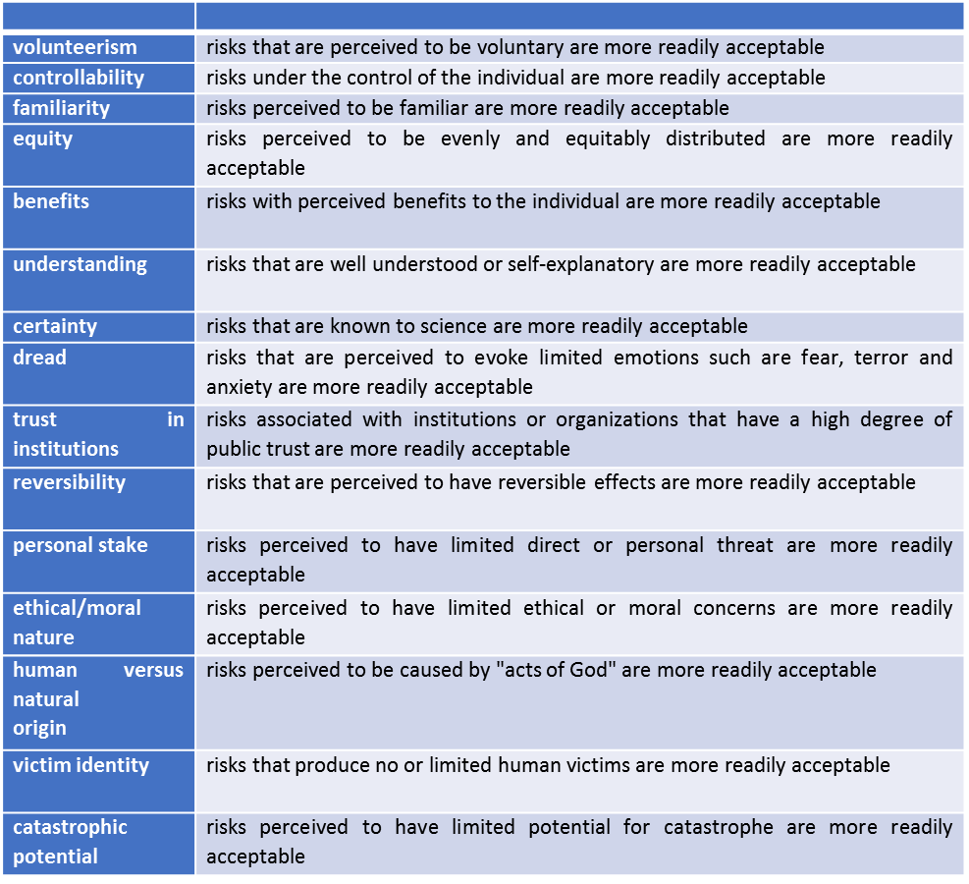
Source: 15 Factors of Risk Perception Model (Covello et al., 2001) extracted from lecture note

