Portfolio about my academic and employability skills
By Ana Barreto – 1818630

In my vision of the future, I see myself in a large organization siting in a cabinet leading the Human Resources team. For long time, different, and multiple reasons I have postponed this future, but now I have decided that is time for me to seek my dream, and to turn it in my goal. To accomplish my goal, I need a Degree in Human Resource Management a (BA), and that is the big challenge after so many years distant from schools. Now I will need to learn and to develop skills which will help me to achieve that.

Now about skills, what do I mean and what do I understand for skills. I understand skills are the ability to do certain thing, can be the ability due to some job, or academic work, or some ability in the playground. There are certain skills you have it naturally without effort or without learn it, otherwise there are skills you will need to learn, even you will need to put some effort to knowledge it, “Learning a skill can sometimes take a matter of hours or sometimes take years – it depends entirely on a range of factors such as how quickly you learn, how you learn, what opportunities you have to practise those skills and the availability of any objective feedback. ” (Morgan, 2017, page 19).

As mentioned before to execute any kind of job it is required employability skills, to be a Human Resource Manager is for sure not different. In the employability skills there are hard and soft skills. Hard skills are the ones required specific for a particular job or position. For Human Resource Management I will need to learn and develop hard skills such as analysis and design of work; human resource planning; recruiting; selection; training and development compensation; performance management and employee relations. (Hogan et al., 2009). Soft skills or transferable skills are those we can use in any work, in “The Business Student’s Guide to Study and Employability” Morgan (2017) explains that the institutions value the employees with proper personal transferable skills, the motivated ones, and those who have fixed skills to accomplish successfully a certain job. For Human Resource Management I will need soft skills such as communication skills oral and writing; decision making; employee relations; organization skills and innovation, among others. (Pope, 2019).

Academic skills are tools that you learn and develop to help you achieve success in your academic life principal in higher education level. There are specific skills, these will be different depending of the curse you are going to do. For Human Resource Management the specific skills required are accounting, finance and marketing; analysing and managing information; global business environment; organizational behaviour; human resource management essentials; reward management; resourcing and talent planning; contemporary employment relations; contemporary developments in human resource management; employment law; global strategic management and human resource analytics. Soft skills in the other hand are transferable and I can tell some we bring from life. “Just as you identified how skills from life can translate into academic skills so you can also consider how academic study develops “soft” skills transferable to employment” (Cottrell, 2013, page 52). As an academic soft skill, I will need time management; communication skills; team working; critical thinking; analytical skills; problem solving; presentation skills; reporting writing; essay writing; research skills. Basically, I am in process of learning all those academic soft skills, my aim for this curse is learn and develop my skills the must and the better I can to be able to finish this curse successfully in order to gain academic support for the next step the degree in Human Resource Management.

Time management is the one of must important skills, not only to the academic life but also in the workplace. “Of course, failing to manage our time well could mean that we really do not perform well” (Morgan, 2017, page 50). For me personally time management is the hardiest skill to achieve. I always have problems managing my time, scheduling my activities and planning in advance. “What we are really talking about here is our ability to use our time effectively”. (Morgan, 2017, page 50). Since I start this curse, we are talking in this module about time management and how important it is. On the week two we did in class the swot analysis that consist in make a self-analysis and identify our strengths, weakness, opportunities and threats, (appendix 1) and even there I identify the time management as a weakness. In the same day as homework we did the personal development plan and the Eisenhower Method (appendix 2, 3 and 4) and I was struggle to do it because of my lack in planning in advance and might be also because on that time I could not understand properly the purpose and the importance of that plan. I feel that over the weeks and especially since I started my essay, I better understand the meaning and the purpose of the personal development plan, anyway time management is definitely one skill I do need to develop and improve. (Fell, 2019).
As an immigrant I feel some difficult and challenge in communication skills, with the development of the weeks these difficulties begin to be fought but I am not over them. In the oral communication because of the language barrier it seems hard to do presentations, very often because of the lack of vocabulary it is hard to make a point or to explain whatever I need to explain and even in the class room sometimes I found myself looking for the body language in the way to fully understand the message the lecture wants to transmit. But more difficult than oral communication is the academic written that I am learning for the first time in higher education scenario and in a language that is not my first one. In order to develop this skill, I am practising paraphrasing to avoid plagiarism, whenever I will need to write other’s ideas or theories without referencing them. “Plagiarism is the use of the work of others without acknowledgement of your source of information or inspiration.” (Cottrell, 2013, page 177). Week four we learnt what a paraphrasing is and how to do it. Basically, it is understanding an idea or theory published by another person and putting it into my own words, using synonyms, changing the word class, changing the structure of the sentence and reference the source. On the beginning I was really struggle with the exercises, but more we were prating in class more understandable it becomes, as a homework we have paraphrasing exercises (appendix 5) which helped me to get more knowledge and practise. In the week after, week five, we did the first in class exercise about Paraphrasing (appendix 6 and 7) I was surprised by the result but I know I still have a lot of work to do in this matter. As mentioned before when doing use of other’s work, we must reference the source of the information and this is another tool of a good academic skill that we learnt in week six. (appendix 8). “In academic writing, it is essential to acknowledge, or ‘cite’ the sources of ideas and information. Such citations allow readers to refer back to the sources for themselves” (Cottrell, 2013, page 179). The references can be from some books we read, on articles, journals, newspapers and websites, for which channel is a different quotation. Other important skill for a good academic writing is summarising. Summarising is withdrawing the importants aspects from a text and by my own words and in a short way rewrite it. In a similar way to paraphrase, to summarise it is also necessary find synonyms, change the word class and change the structure of the sentence, but is not all, a good summarise must be clear, should contain the important information, brief and concise, must identify the Autor of the text, should have topic sentence and supportive sentence, be objective and have conclusion. On the week nine we did the second in class exercise about Summarising (appendix 9). I felt I did really bad in this exercise, because it took me most of the time to paraphrase it and when I realised the time was gone and I had just a few minutes to structure the text I start to rush and I think that in the process I could not be able to write all the relevant information.

Team work is a skill I already have. I believe that people who started working early, quickly develop this skill and that was my case. I always worked with others and in my present job we really have to work as a team if we want to present good results and provide an effective service to our customers, according to Griffiths, B.A. and Dunham, E.B. (2015) teams are a group of individuals that must have some relationship in way to be able to complete their commons goals successfully (page 5). But in academic life we also need to work in team when we have the group assignments. The fact that I have this skill already does not mean there is no space to develop it more and more. According with Cottrell (2017) “As academic work in Higher Education is developed within a learning community, you need to understand how to work alongside others, to give and receive support and share ideas whilst also maintaining the academic integrity of your own work.” (Page 243).

Essay and reports, therefore all the practise and exercises I above referred it would be obvious to believe that by now, it would be easy for me to do it, but the reality is not that simple. To add to all the tools mentioned before about a proper academic writing, we must mention the use of formal language. Cottrell (2013) suggest that after a break, subjects such as academic language and methods begin to be more understandable to the students who at first contact found it hard, (page 2). I truly want to believe in this affirmation, I know I have poor knowledge of English vocabulary and grammar and that makes all the difference in order to write a good or a not so good academic report or essay. “Knowledge of specialised terms and of underlying theories empowers you as a student. It sharpens your thinking, allows you to describe things more accurately, and improves your overall performance.” (Cottrell, 2013, page 2).

Despite the fact that I truly believe that I have made progress in some skills throughout the weeks, I am conscious that I still have plenty of work to do in order to develop them. In the next term I will need to put all my energy and effort in order to make a personal development plan which will help me managing my time in a better way turning all my academic life much easier. Also, to improve my communication skills that I am aware I need practice my reading and my writing, read academic material which will give me more knowledge and guidance during the all process. Practice paraphrase and principal summarise because I still have issues to make it properly. My certainty is that I will succeed because I am 100% committed to it.

APPENDIX: 1
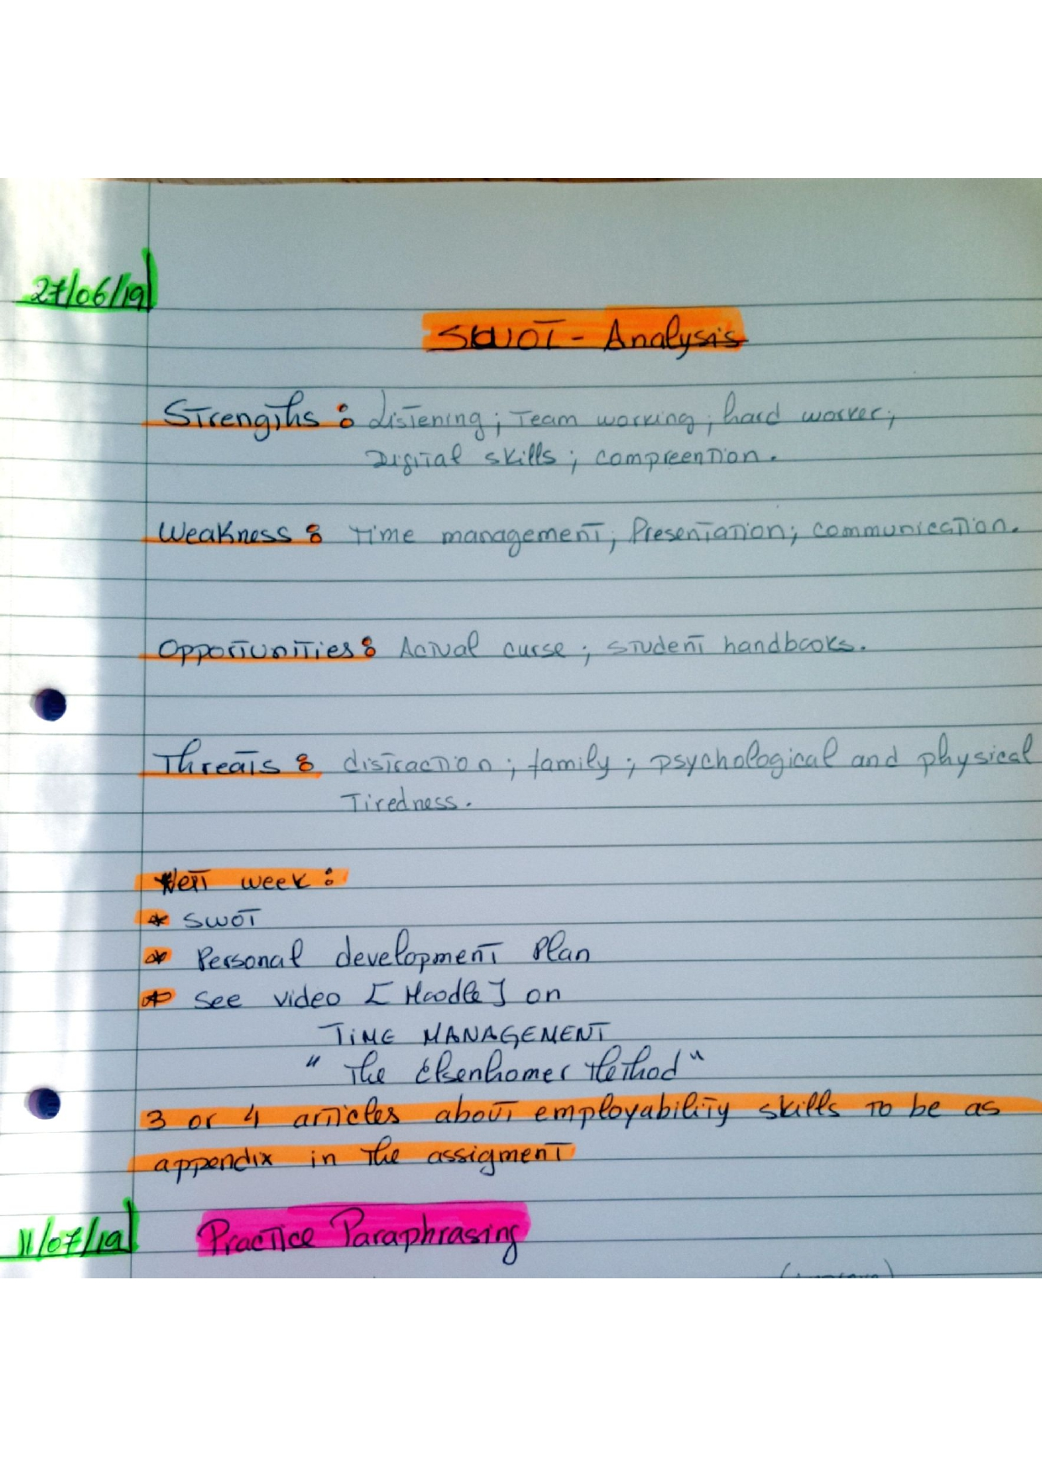
APPENDIX: 2
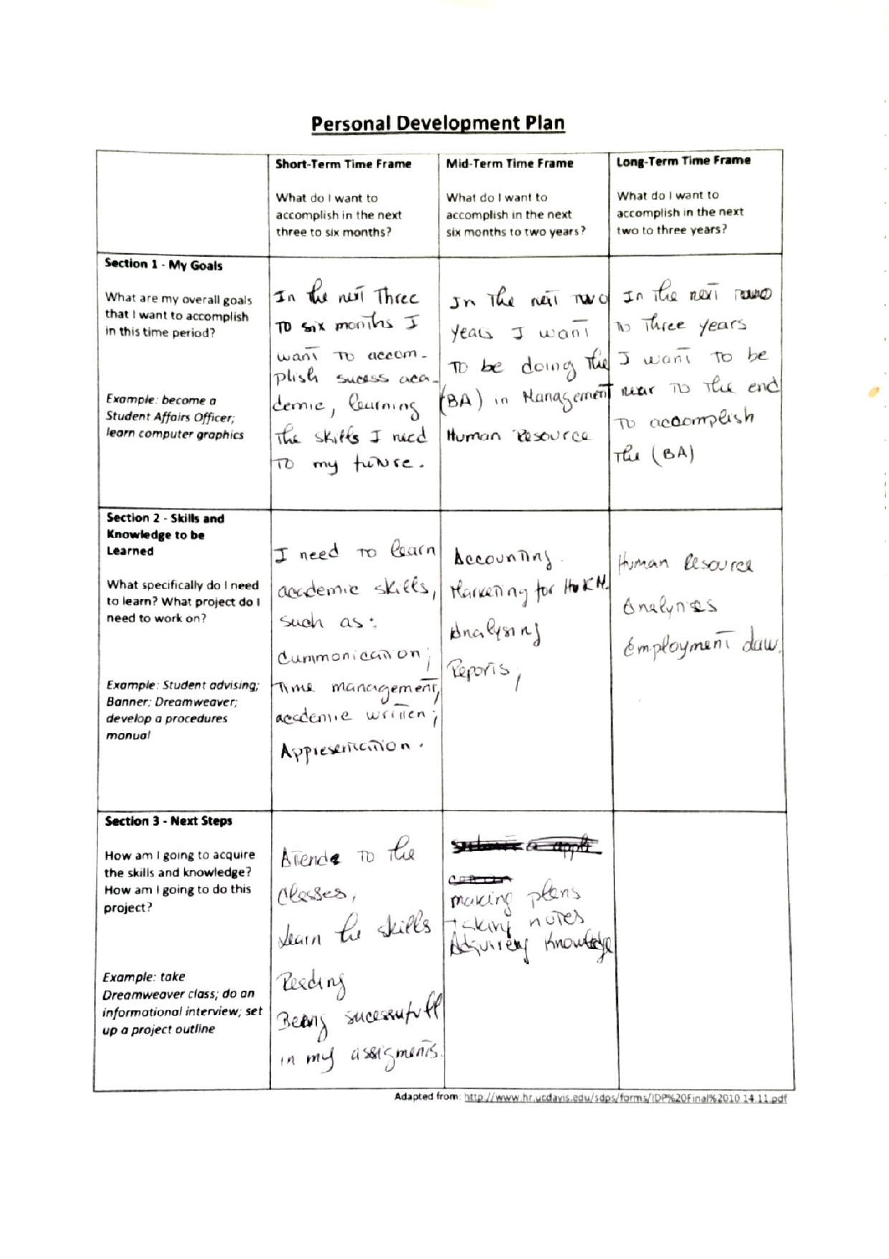
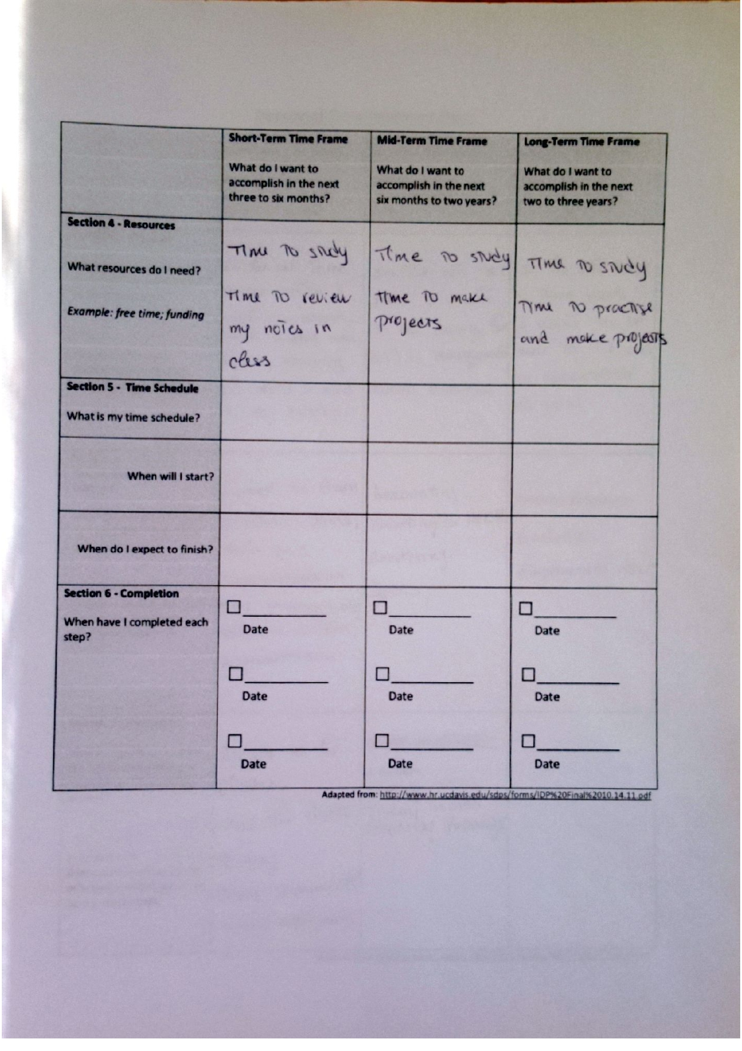
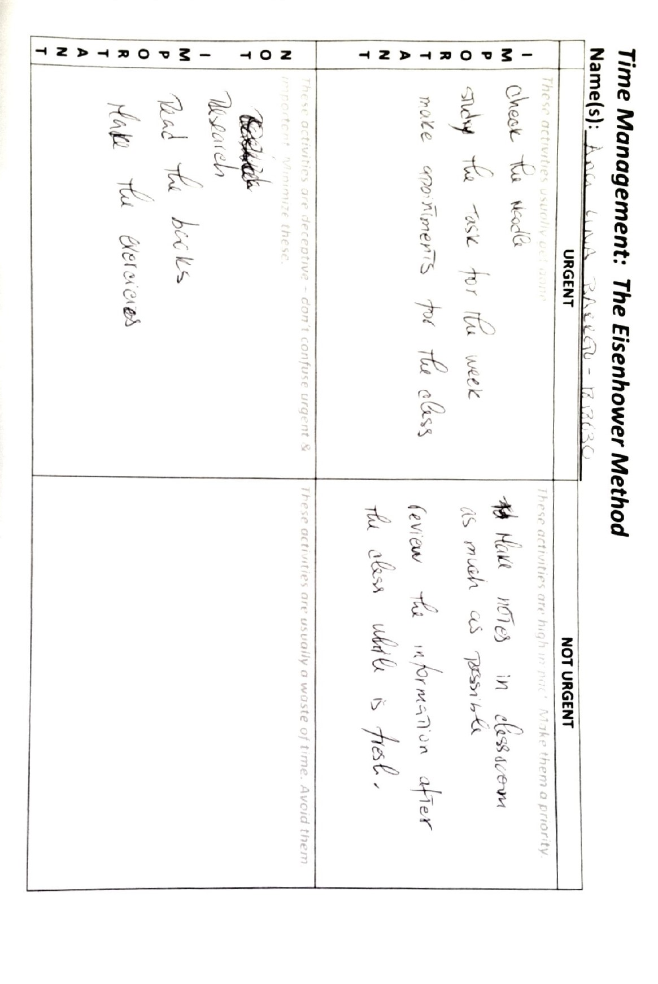
APENDIX: 3
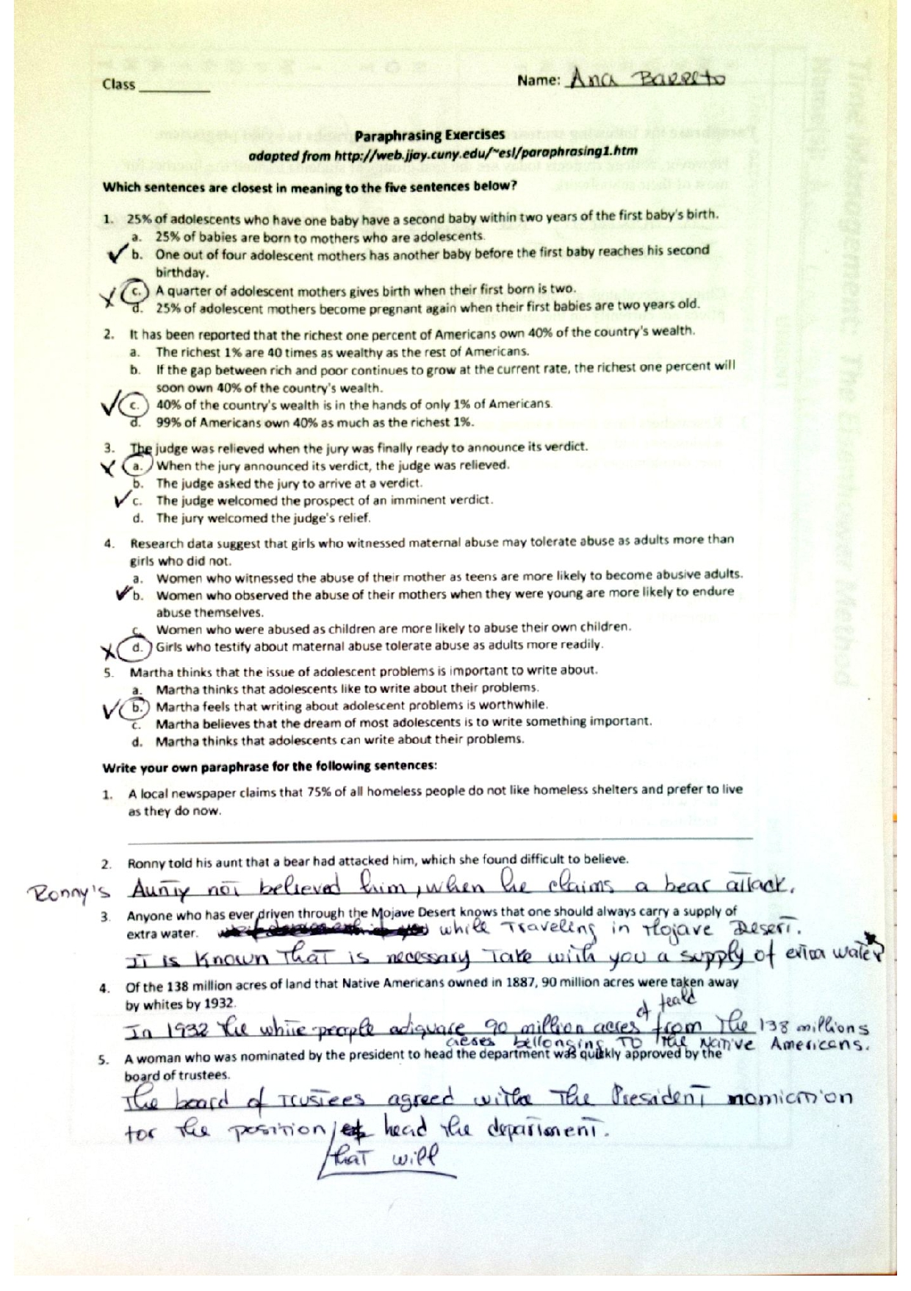
APENDIX: 4
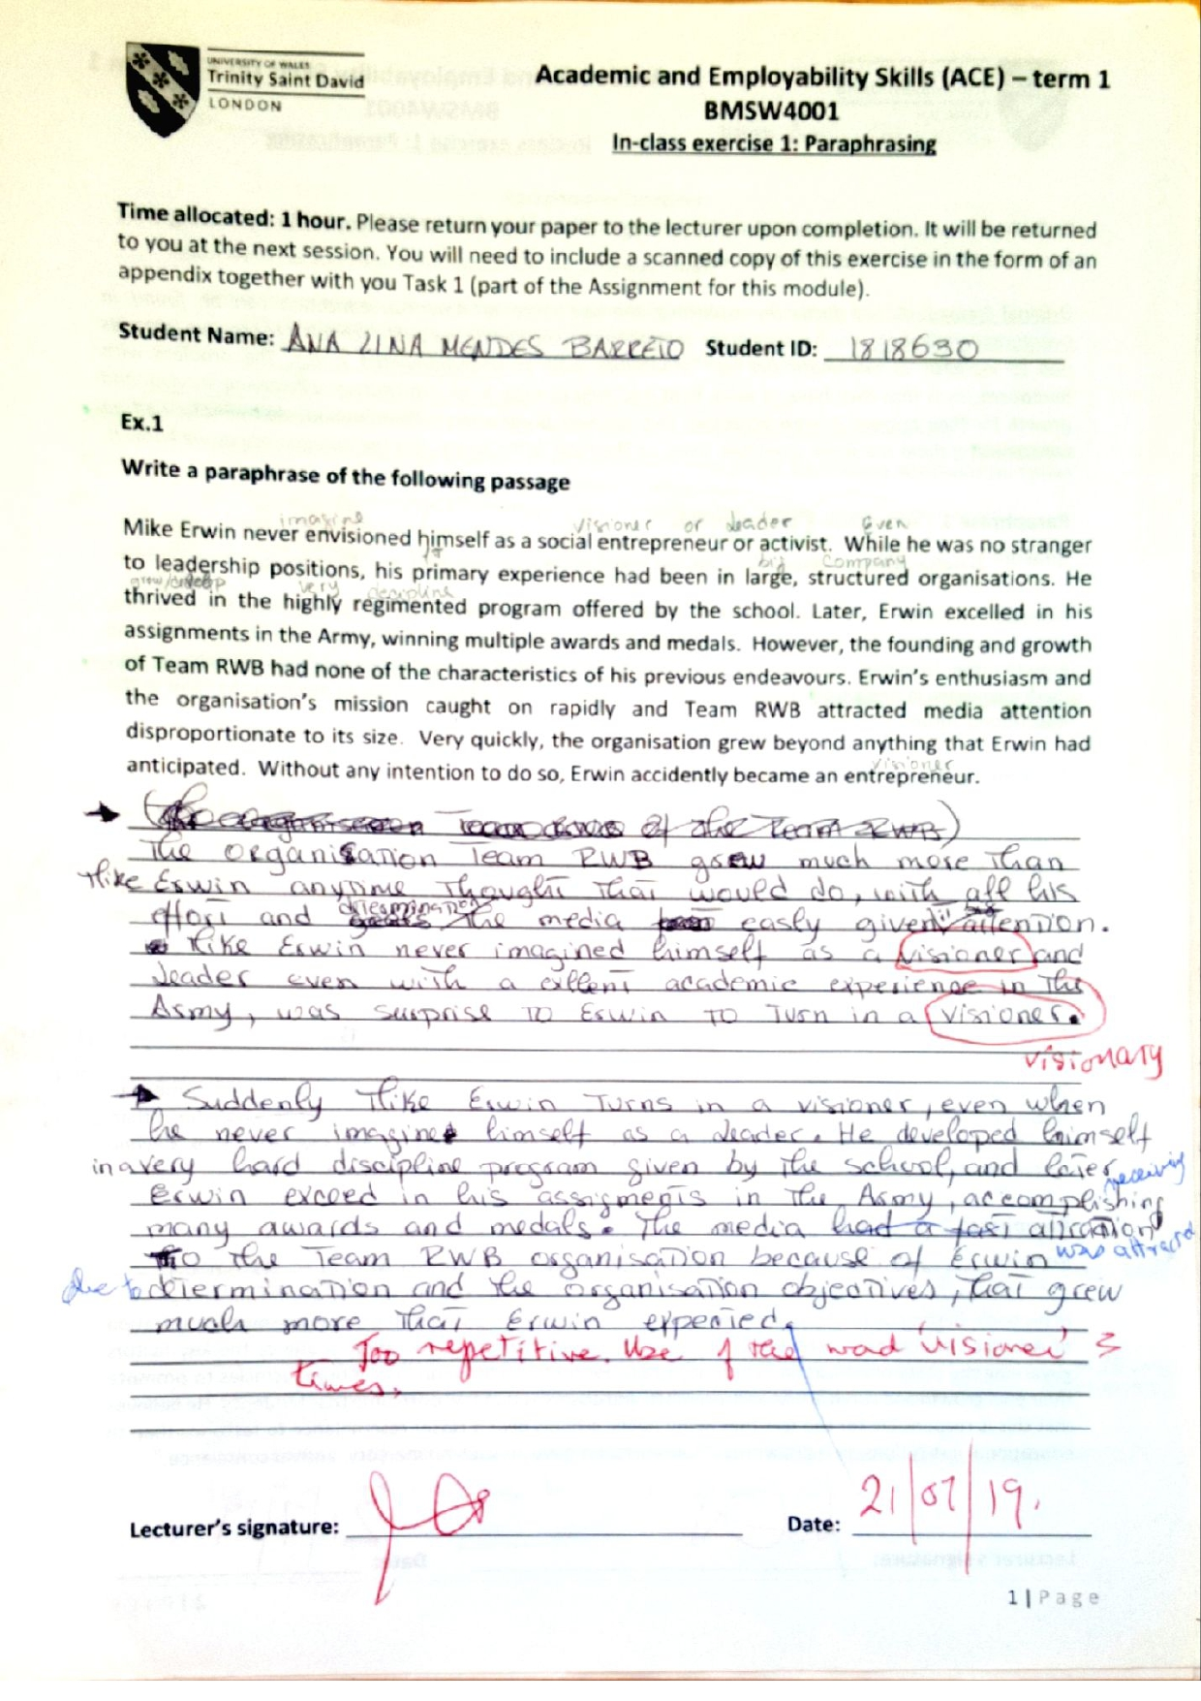

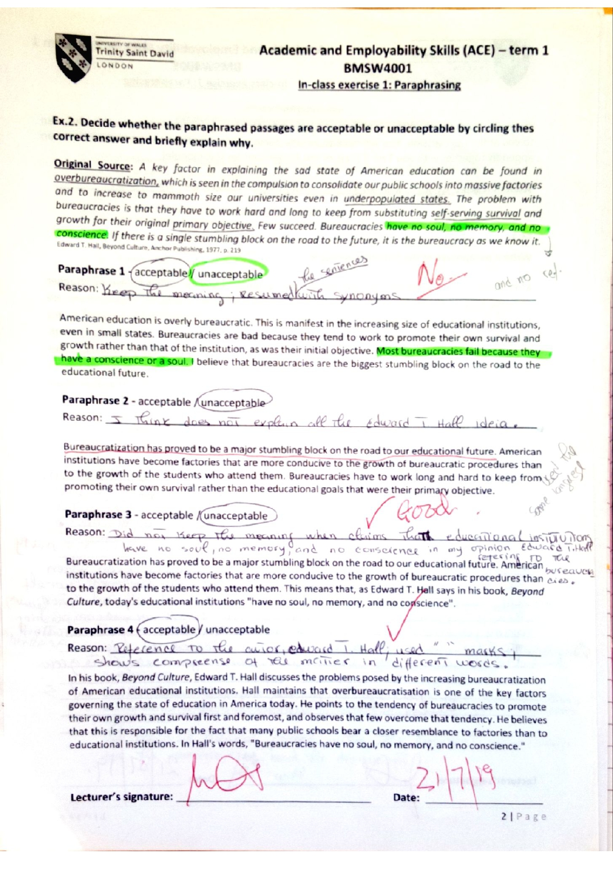
APPENDIX: 5
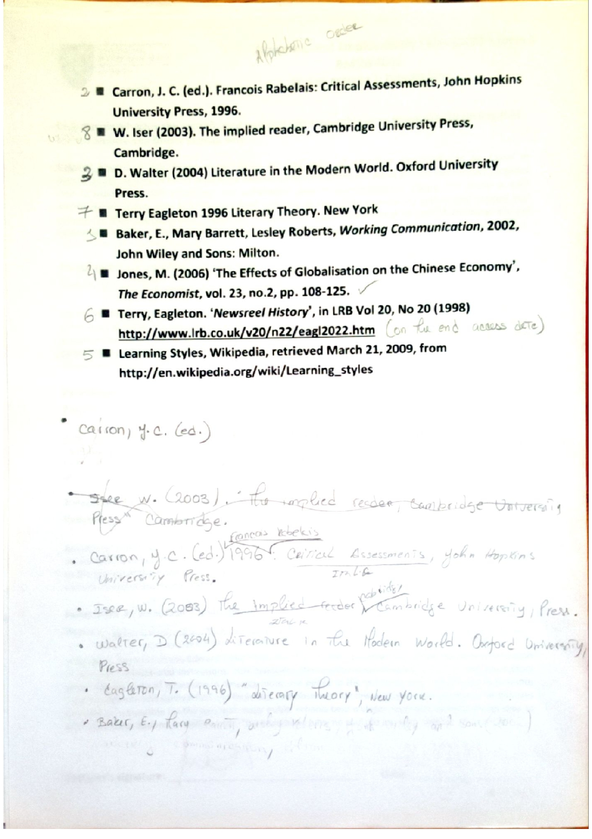
APPENDIX: 6
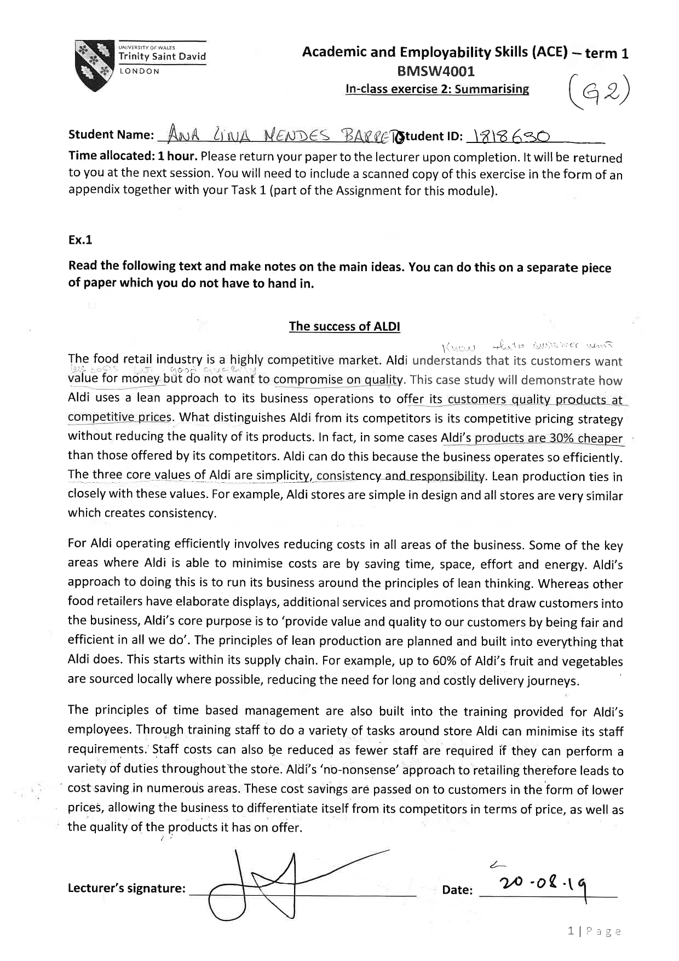

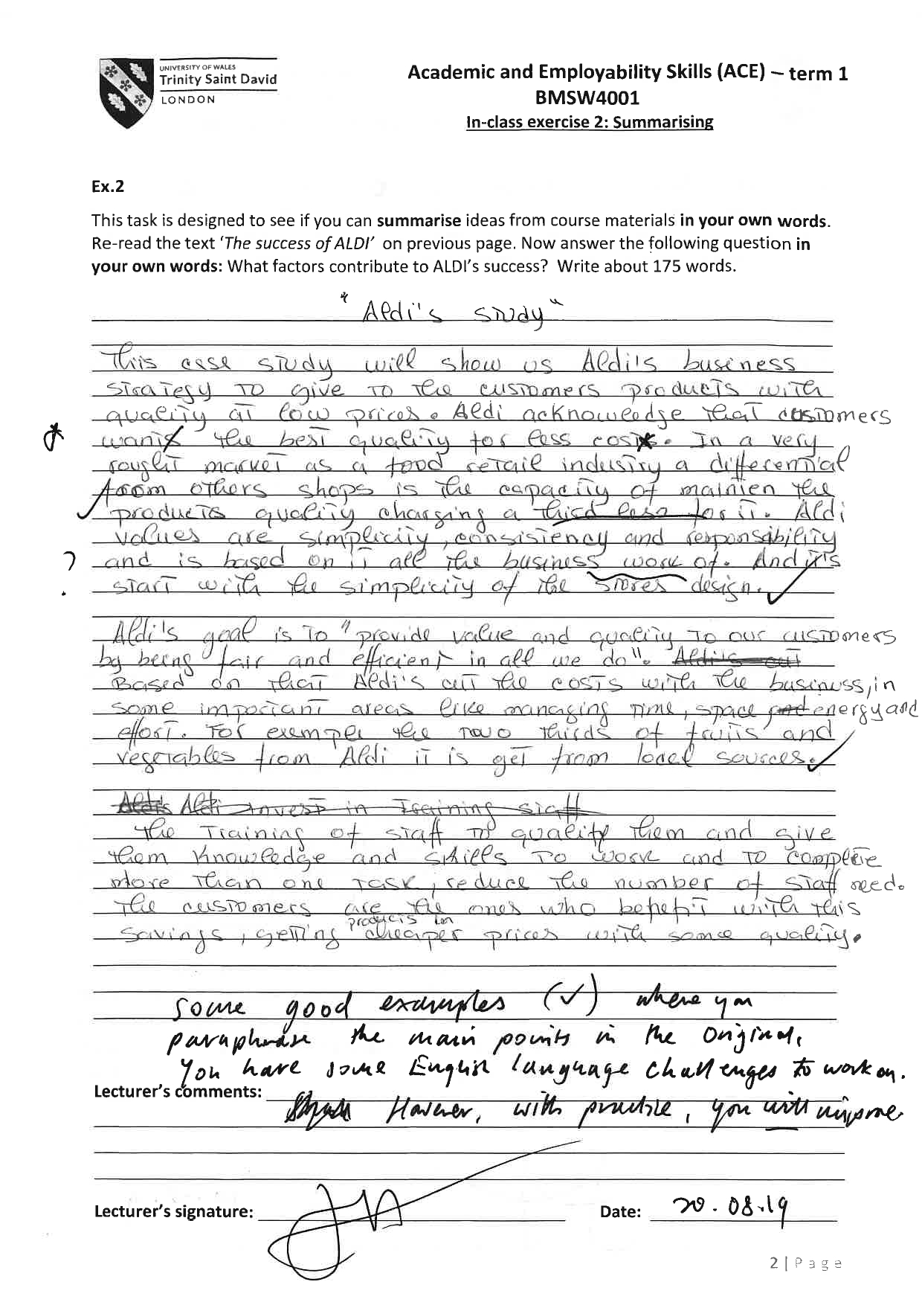

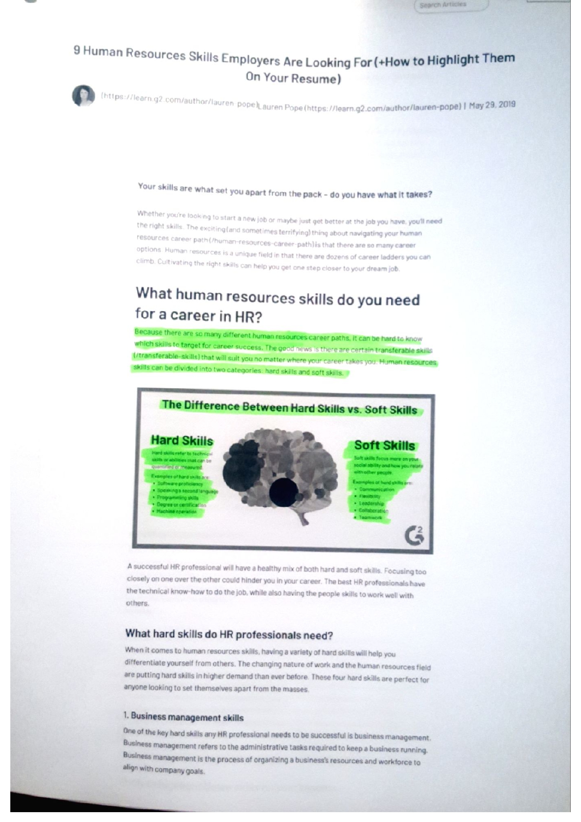

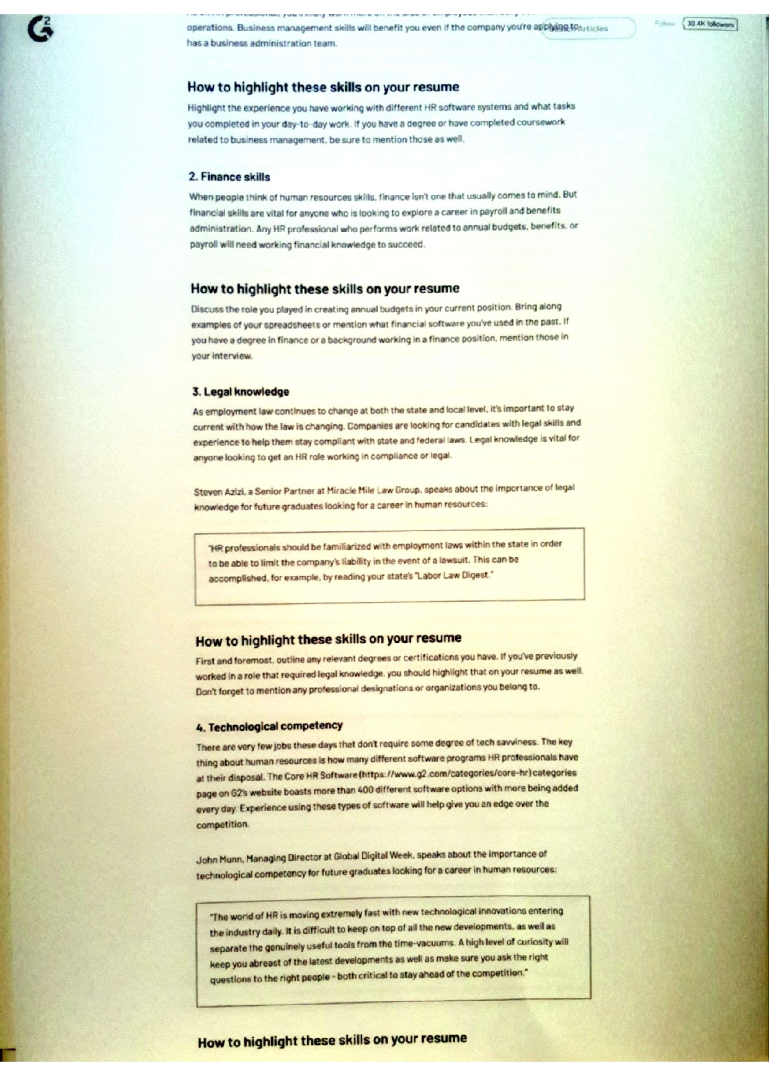

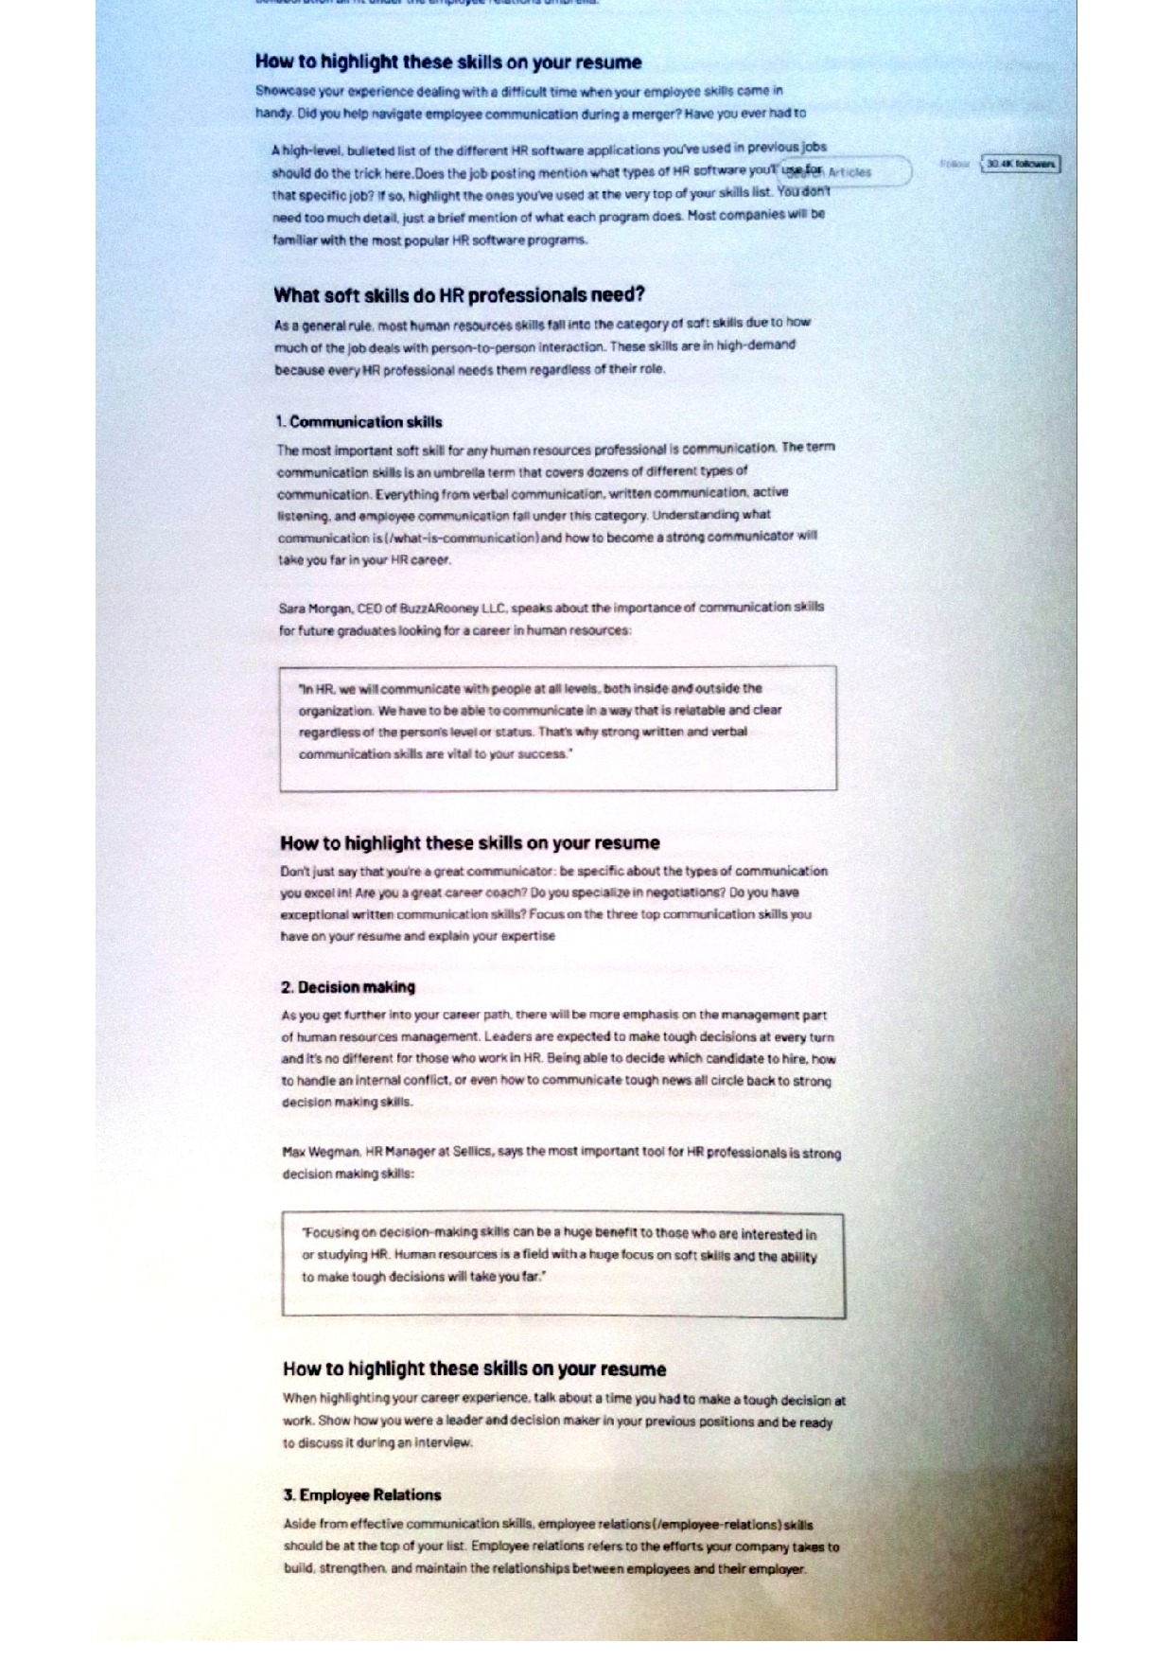

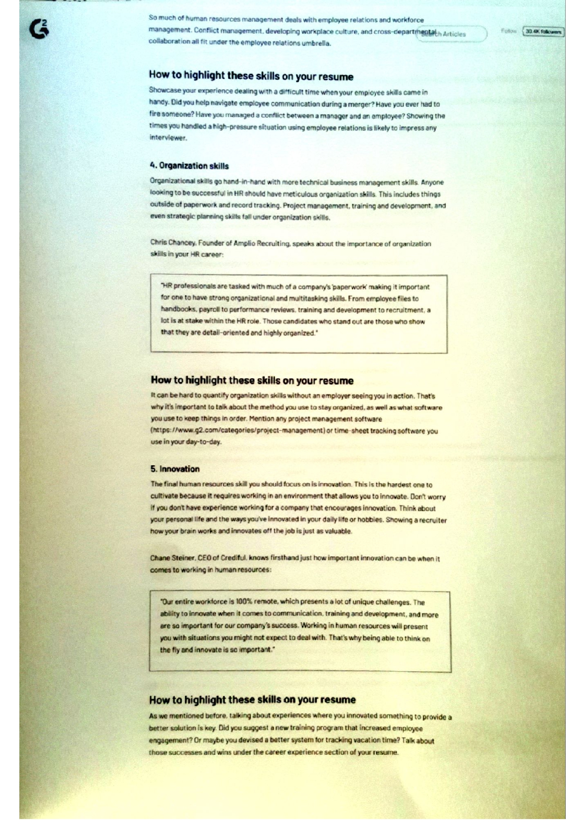

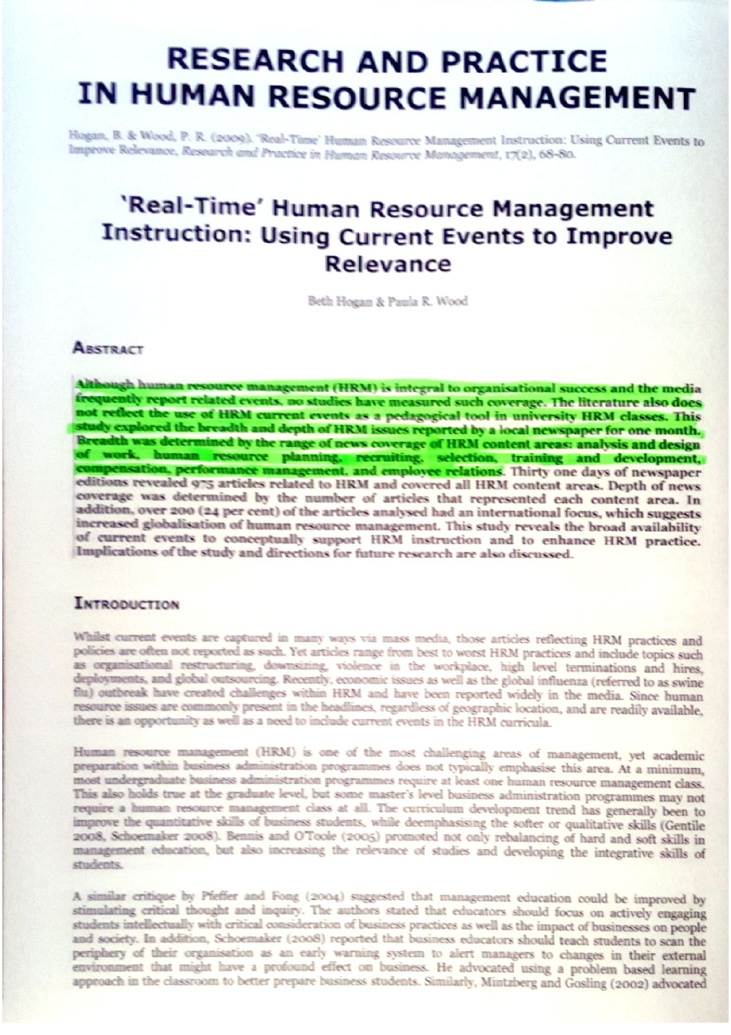

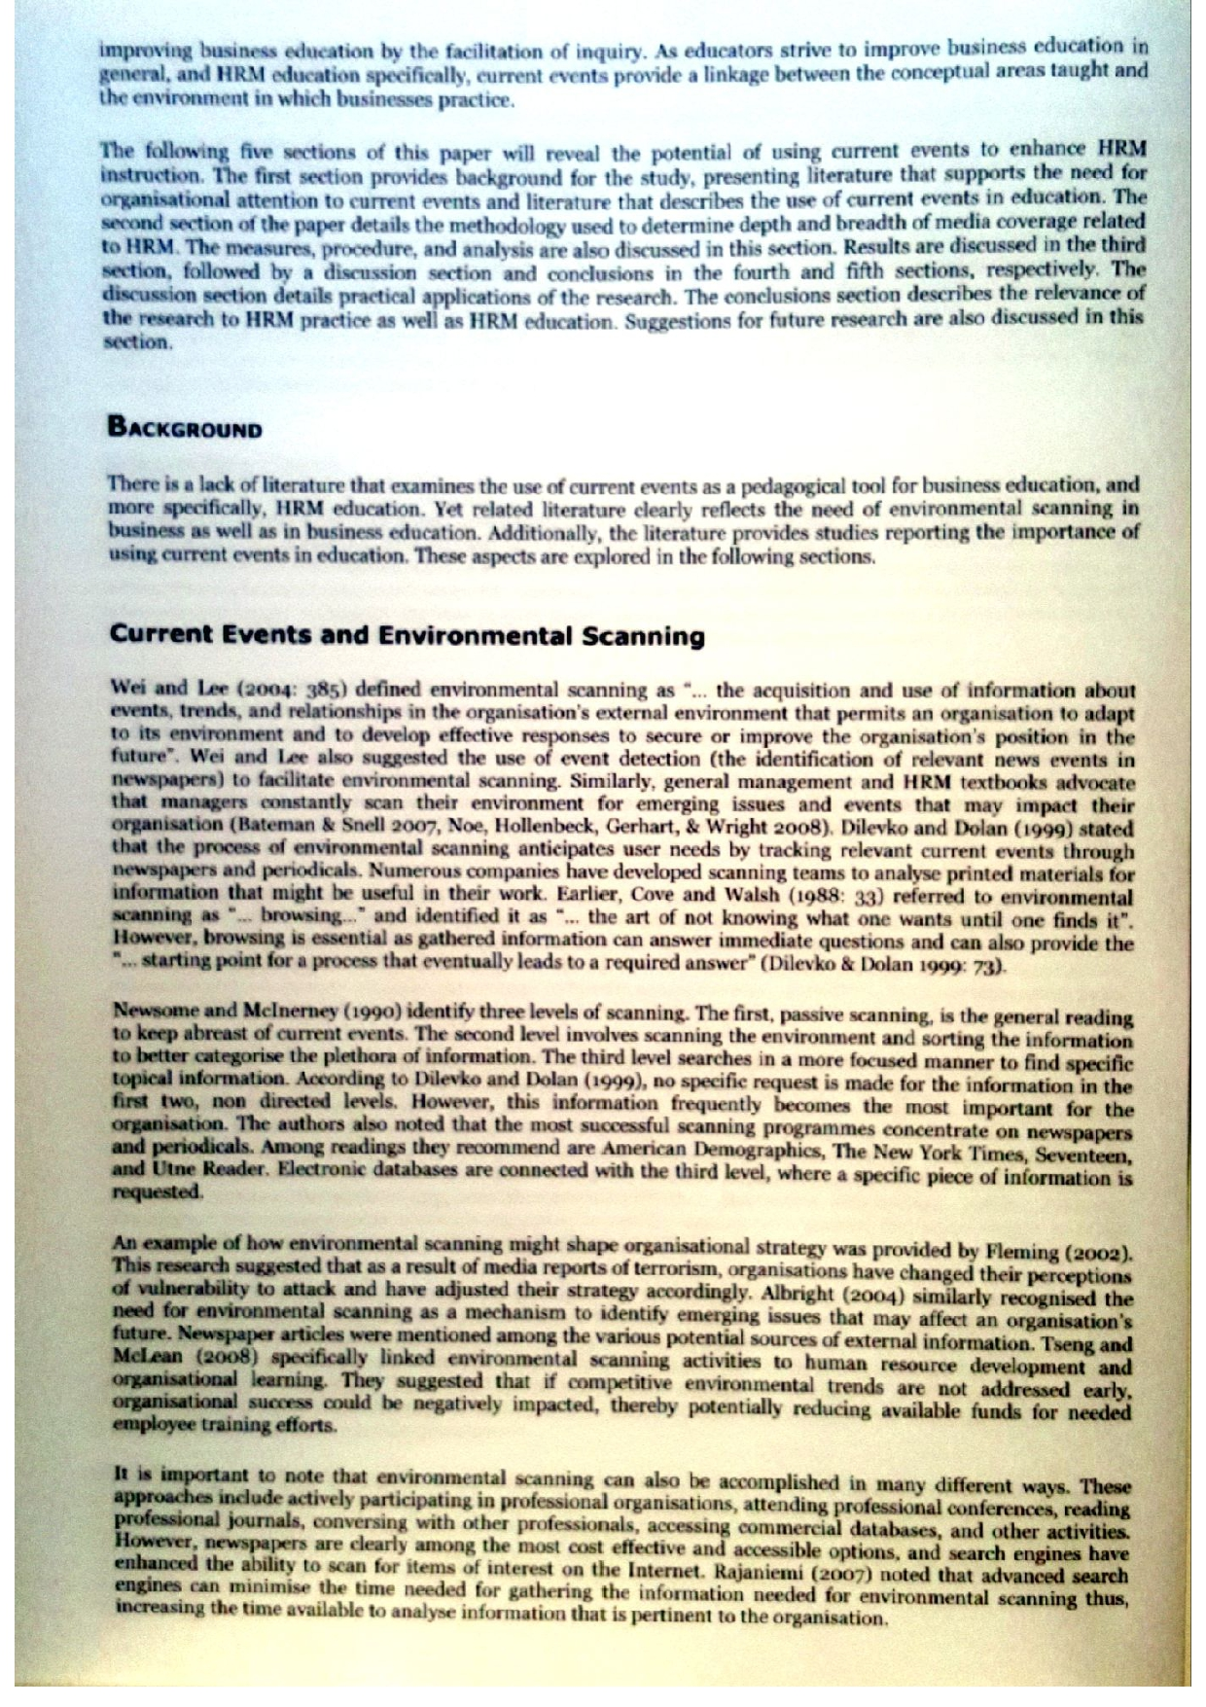

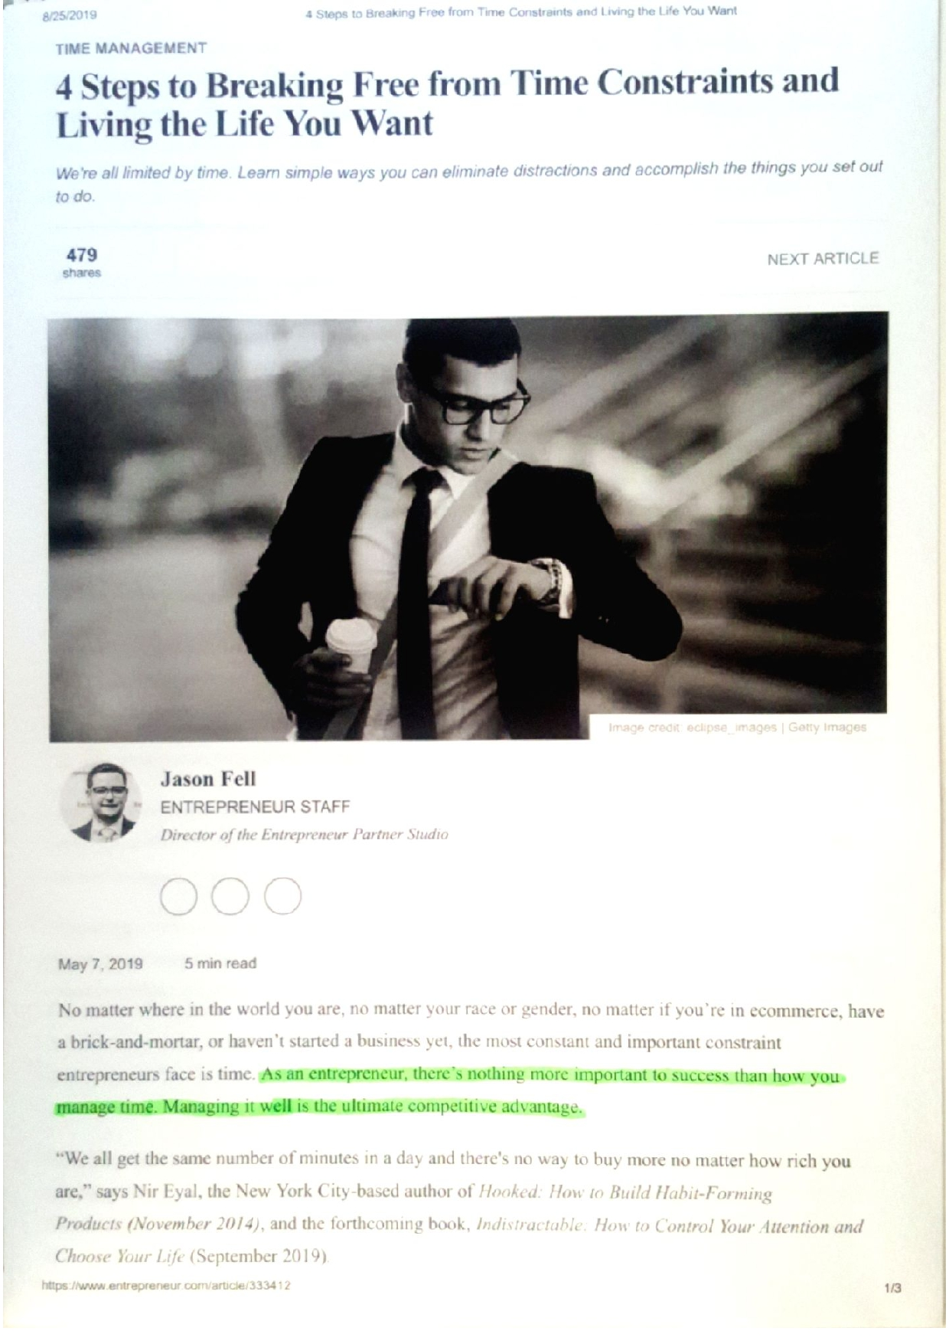

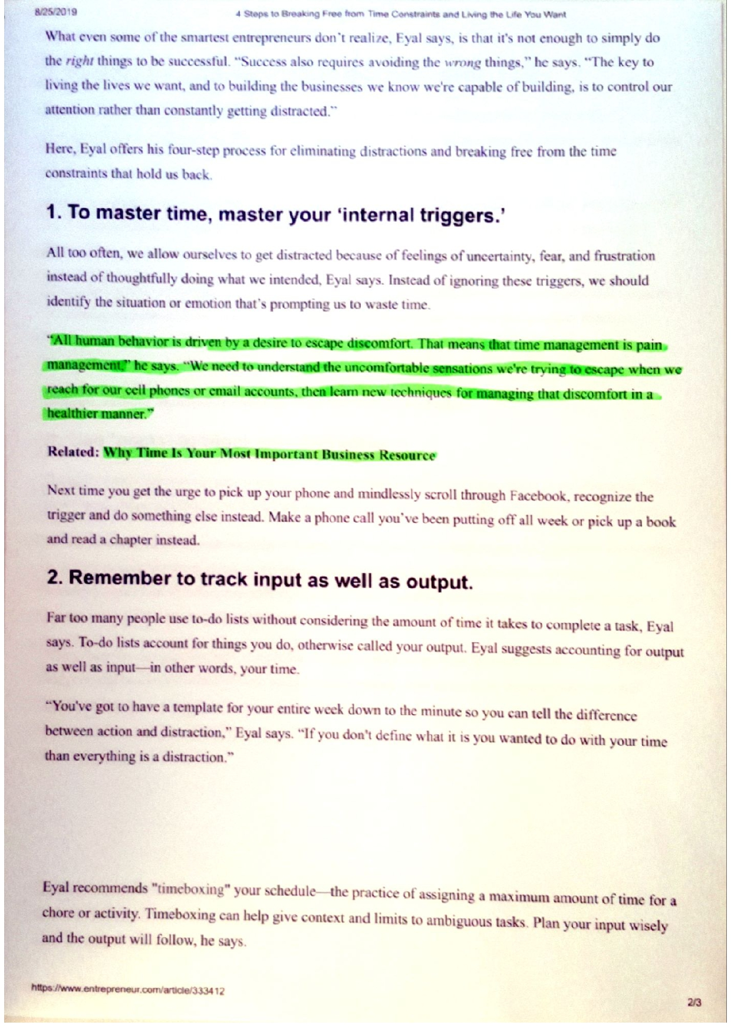

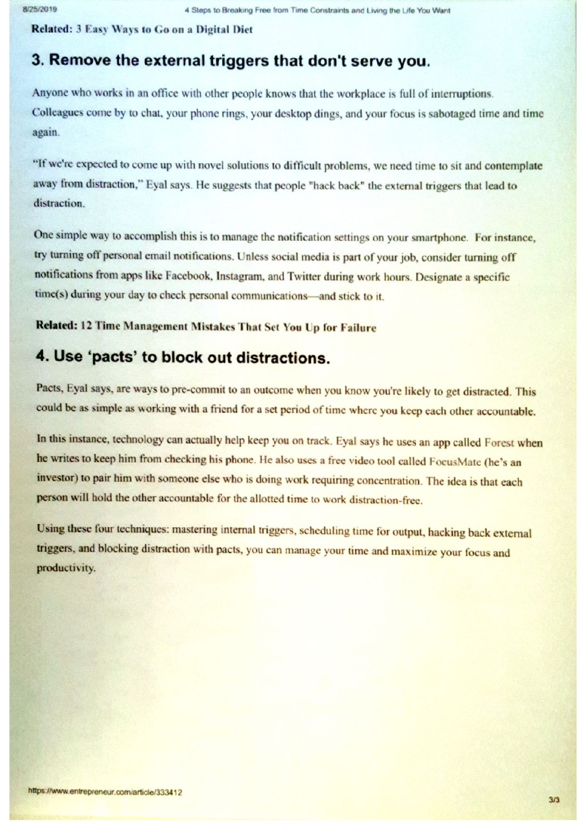

REFERENCES:
Cottrell, S. (2013) The Study Skills Handbook 4th Ed. Basingstoke: Hampshire Palgrave Macmillan.
Fell, J. (2019) 4 Steps To Breaking Free From Time Constrains And Living The life You Want. Available at: https://www.entrepreneur.com/article/333412 (Accessed: 10 July 2019).
Griffiths, B.A. and Dunham, E.B. (2015) ‘Introduction To Teams’, in Maund, A., Schriek, M. and Tinkler, P.K. (ed) Certificate in Higher Education: Skills for the Workplace Student Yearbook. London: Sage
Hogan, B. and Wood, P. R. (2009) “Real-Time” Human Resource Management Instructions: Using Current Events To Improve Relevance, Research & Practice In Human Resource Management, 17(2), pp. 1-11. Available at: https://search-ebschost-com.ezproxy.uwtsd.ac.uk (Accessed: 20 August 2019).
Morgan, P. (2017) The Business Student’s Guide To Study And Employability. London: Sage.
Pope, L. (2019) 9 Human Resource Skills Employers Are Looking For (+ How To Highlight Them On Your Resume).Available at: https://www.learn.g2.com/human-resource-skills. (Accessed: 20 August 2019).

