

BMIH4005
Marketing Essentials

Component 2- Marketing Plan

Lecturer: Dr Jayne Griffith-Parry, Dr Huw Thomas, Neil Dyer, Ruth Taylor-Davies, Deborah Lloyd.

Student Name- Elena-Beatrice
Student ID-

Table of Contents
Introduction 3
Company Overview 3
The marketing mix of Hotel Asaba 3
Creating customer value and engagement 4
Effective use of digital marketing 4
The Marketing environment (micro) 4
The marketing environment (macro) 5
Conclusion 6
References: 7

Introduction
Tourism and hospitality have been redefined with some enthusiastic tourists in this modern era. It is the most influential factor to add to the birth right of humans as the sixth factor, recreation, as it has become a necessary commodity for the people. In this report, the Marketing mix, Customer value and engagement, digital marketing and External, internal analysis has been investigated from the perspective of Hotel Asaba (Cerchione & Bansal, 2020).

Company Overview
Hotel Asaba is a popular premium hotel chain in Japan. It is situated very near to Tokyo. They have lots of facilities including a golf course with 9 and 18 holes, a fishing facility and so on for recreation. They try to provide the most consumer facility for their consumers (Thams et al., 2020).
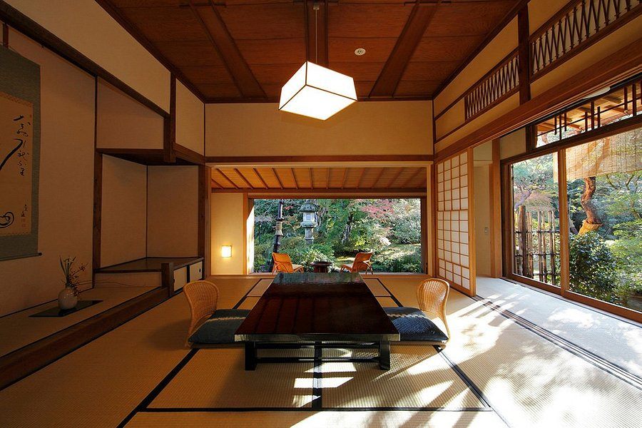
Figuer: Hotel Asaba (Thams et al., 2020).

The marketing mix of Hotel Asaba
The marketing mix is the component of a market offering. A marketing mix has generally four Primary components. Product, price, place and promotion. Those are described in the perspective of Hotel Asaba (Salman et al., 2017).
Product: Hotel Asaba is offering the service of hotel rooms. The room in the hotel has premium facilities. The environment and the quality of service is interesting for the consumer. So, the product is very standardised for them (Sharma et al., 2020).
Price: The price of the service for Hotel Asaba is justified according to the service and value they have provided. So, the price of their service is suitable for their business (Kaur, 2017).
Place: Hotel Asaba has an interesting placement. From the location they can easily attract the customer they target. Apart from that, the transportation system is also suitable for their business (Cerchione & Bansal, 2020).
Promotion: The promotional activities of Hotel Asaba, especially digital marketing has been an outstanding way to attract customer to Hotel Asaba (Kloutsiniotis & Mihail, 2020). From the standpoint of Hotel Asaba, the marketing mix, customer value and engagement, digital marketing, and external, internal analyses have all been explored in this research (Cerchione & Bansal, 2020).

Creating customer value and engagement
The way Hotel Asaba creates customer value and engagement is the quality of service. They not only give what they promise they also provide the more they promise. In our contemporary day, tourism and hospitality have been redefined by certain passionate travellers. Recreation, which has become a vital commodity for people, is the most significant reason to add to the birth right of humans as the sixth component. Here is a glimpse of their service is presented (Thams et al., 2020).
First of all, they have a suitable location. They are away 2.5 km from zero-point Tokyo, the capital of Japan. The macro-environment is the environment that studies a company's external environment. PESTEL analysis is an excellent method for analysing a company's macro environment. They are less than 2 km distance from the airport of Tokyo. Apart from that, they offer an air conditioning room, high-speed internet and a versatile payment system. They also offer versatile recreation mediums as well (Konovalova et al., 2018).

Effective use of digital marketing
Digital marketing has been the biggest advert platform in the world nowadays. The organizations can target the specific characteristics of the customers to make the target of the adverts more accurate. The advertisements can easily attract customers so that they can get to know about the Hotel Asaba (Leite & Azevedo, 2017).
Among digital marketing, Search Engine Optimization and social media marketing are the most popular in the arena. So, Hotel Asaba needs to hire a specialist who can make the search engine optimized so that the name or the website of the Hotel Asaba becomes easy to identify. In this way, Hotel Asaba should be organising the data for the future. They will make people aware of the Hotel and then it will yield a great benefit to them in the long run (Salman et al., 2017).

The Marketing environment (micro)
Microenvironment is a type of environment that can be controlled by the organization itself. So, it creates the organization the identification of strengths, weaknesses, threats and opportunities. The success highly depends on the internal environment of the business. Here the SWOT analysis of Asaba is described (Kloutsiniotis & Mihail, 2020).
SWOT analysis
Strengths | Hotel Asaba has premium quality service, strong marketing ability and a strong attractiveness to make it strong (Konovalova et al., 2018).
Weakness | Hotel Asaba charges a high price and that’s why many customers cannot afford it. So, they need to lower the price during it is not season (Cerchione & Bansal, 2020).
Opportunities | Hotel Asaba has the opportunity to lead the market. They need to serve the market in various locations. Thus, the revenue can be increased. (Thams et al., 2020).
Threats | The economic impact on the people during this pandemic can be a threat to the Hotel Asaba. So, they need to think of inflation and purchasing power reduction seriously (Leite & Azevedo, 2017).

The marketing environment (macro)
The macro-environment is the environment that analyses the external environment of a company. PESTEL analysis is an outstanding tool to analyse the macro environment of a business. Here the PESTEL analysis in the perspective of Hotel Asaba is given below: -
Political: The political environment in Japan is stable and favourable for the hotel and hospitality business. The government has ensured well build infrastructure. So, this factor is favourable for the Hotel Asaba (Zsarnoczky, 2018).
Economic: In the location of Hotel Asaba, the affluent people are sufficient. In this pandemic, the rich got richer. So, the audience of Hotel Asaba should not be affected by this pandemic (Othman et al., 2020).
Social: The social sector and the local people in the region of Hotel Asaba is very helpful and the social norms and etiquette are quite favourable for them and gentle (Salman et al., 2017).
Technological: Hotel Asaba holds many types of Payment systems. Apart from that, they have an online reservation system along with a private database. So, this factor is also favourable for Hotel Asaba (Thams et al., 2020).
Environmental: The act of Hotel Asaba is environment friendly too. They are not doing any act that brings harm to the environment. So, this factor is also favourable (Kloutsiniotis & Mihail, 2020).
Legal: The policy of the government is also suitable for them as they have unity among the hotel owners. But high tax rate and frequent update of policy is a matter of concern for Hotel Asaba (Cerchione & Bansal, 2020).

Conclusion
Tourism is a lucrative sector that makes people relax and calm. It breaks the monotony of routine-driven life. It has become an essential part of human life. So, this report is prepared to improve the business functions and other facilities from the perspective of Hostel Asaba. Their features and functions are also analysed with their product and marketing offerings (Konovalova et al., 2018).

References:
Cerchione, R. and Bansal, H., 2020. Measuring the impact of sustainability policy and practices in tourism and hospitality industry. Business Strategy and the Environment, 29(3), pp.1109-1126.
Kaur, G., 2017. The importance of digital marketing in the tourism industry. International Journal of Research-Granthaalayah, 5(6), pp.72-77.
Kloutsiniotis, P.V. and Mihail, D.M., 2020. High performance work systems in the tourism and hospitality industry: a critical review. International Journal of Contemporary Hospitality Management.
Konovalova, E.E., Yudina, E.V., Bushueva, I.V., Uhina, T.V. and Lebedev, K.A.E., 2018. Forming approaches to strategic management and development of tourism and hospitality industry in the regions. Journal of Environmental Management & Tourism, 9(2 (26)), pp.241-247. F.Zaman
Leite, R.A. and Azevedo, A., 2017. The Role of Digital Marketing: A perspective from Porto Hotels’ Managers. International Journal of Marketing, Communication and New Media, (2).
Othman, B.A., Harun, A., De Almeida, N.M. and Sadq, Z.M., 2020. The effects on customer satisfaction and customer loyalty by integrating marketing communication and after sale service into the traditional marketing mix model of Umrah travel services in Malaysia. Journal of islamic marketing.
Salman, D., Tawfik, Y., Samy, M. and Artal-Tur, A., 2017. A new marketing mix model to rescue the hospitality industry: Evidence from Egypt after the Arab Spring. Future Business Journal, 3(1), pp.47-69.
Sharma, A., Sharma, S. and Chaudhary, M., 2020. Are small travel agencies ready for digital marketing? Views of travel agency managers. Tourism Management, 79, p.104078.
Thams, A., Zech, N., Rempel, D. and Ayia-Koi, A., 2020. An initial assessment of economic impacts and operational challenges for the tourism & hospitality industry due to COVID-19 (No. 2/2020). IUBH Discussion Papers-Tourismus & Hospitality.
Zsarnoczky, M., 2018. The digital future of the tourism & hospitality industry. Boston Hospitality Review, 6, pp.1-9.

