Task 1 Essentials skills for the workplace


There are many skills that are essential for study and employment today. A basic skill that is lacked by much of the population in work/study environments is time management. The ability to effectively manage the time available to them keeping a stable output of work being completed. Being able to manage your time effectively can help one significantly improve their quality of work and identify what takes up their time unnecessarily in their day. This is important for both events in a person’s life during study and work as a project could be related to university and the job they desire. With the goal of becoming a software developer time management is an essential skill. Having this skill will help me better manage my time in completing projects with tight deadlines and keep a stable output of high-quality work. [1] [2]

Figure 1: Time management

Communication is another skill required for study and employment. Communication skills is the ability to connect with another successful without negative backlash. Precise communication skills allow a student/job seeker to accurately express their emotions and goals to their colleagues. Communication skills grant the ability to learn from peers in study and work environments helping push growth in knowledge and confidence. It allows people to be respectful when approaching others. With the right type of communication skills as a future software developer I will be able to convey my intentions/aspirations clearly to my colleagues whilst maintaining a professional standing. [2] [3]

Figure 2: Communication within a group of employees

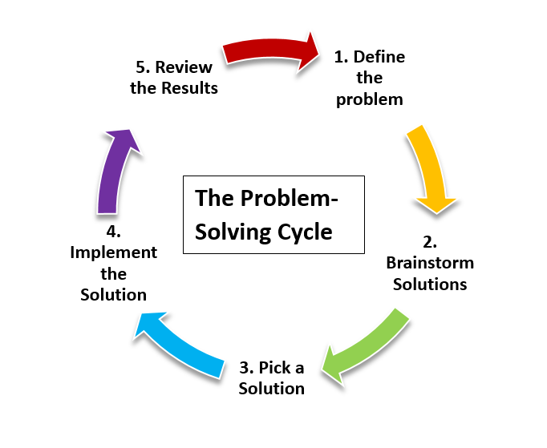
Lastly problem solving, the ability to quickly analyse problems encountered in study or work environment is needed to succeed. Being able to identify the problems present and quickly work towards a solution. Being able to problem solves is not just this but being able to accept the challenge that comes with finding solutions giving way to better understand the path to finding a solution. This is one of the most important skills needed for me to successfully become a software developer as during coding bugs and errors are always found. Knowing what the problem is specifically will allow me to better navigate myself to a solution. [4] [2]

Figure 3: Cycle of problem solving

References

[1] | S. D. R. Bingham, The Guide To Learning And Study Skills: For higher Education And At Work, Farnham: Routledge, 2017.
[2] | R. Needleman, “What are the six essential skills for University Students?,” [Online]. Available: https://www.uniadmissions.co.uk/application-guides/6-essential-skills-for-university-students/. [Accessed 11 July 2024].
[3] | Corsera Staff, “Important Communication Skills and How to Improve Them,” Coursera, 24 July 2024. [Online]. Available: https://www.coursera.org/articles/communication-skills?msockid=0643d7b88cde6f3c2bacc3018df96ec3. [Accessed 25 July 2024].
[4] | A. C. Ornstein, “Problem Solving: What is it? How can we teach it,” NASSP Bulletin, vol. 73, no. 520, pp. 113-121, 1989.

