Title: Marketing Fundamentals Analysis and Evaluation
Module: Marketing Fundamentals
Module code: LCBB4004
Lecturer name: Efua Adams
Student name: Denisa Alexandra Neagu
Student number: 1921119



Blogging refers to self-published online writing, illustration, and other media. Blogging began as an opportunity for people to create personal journal posts and has also been adopted by businesses and companies. Many companies saw marketing opportunities, and the introduction of blogging among the business sector helped to increase the format's popularity further. Frequent updates, informal language, and possibilities for readers to interact and start a discussion are included in blogging. As any other platform, blogs have pros and cons. It is good for SEO, builds rapport with customers, can generate income, and can maintain a communication with customers, but it requires a lot of time to manage it and constantly new ideas.
A blog can keep your marketing strategy in place and organize your relevant content. It helps to represent your business in multimedia, keeps the audience engaged and enhances the company. Blogging and posting valuable content is an extremely beneficial tool to increase traffic to your website and your services.

Businesses work in an industry where data and knowledge are continuously flowing. Everyone is on the same track when business communication is handled correctly. It is important for a company to be aware of and understand businesses communication in in costumer care. Clients feedback needs to be taken seriously and handled with professionalism.



- Product
Amazon.com is the biggest online retailer platform. Amazon websites allow hundreds of millions of products across dozens of types of products to be auctioned by Amazon and third parties. In 2018, approximately 58% of all items sold on Amazon websites were from third-party sellers. Amazon enables sellers from all over the world to sell their products on their website. From its seller services, amazon receives fixed fees from them, which may be a percentage of revenue, per-unit activity fees, interest, or a mix of these. In 2017, more than 300,000 small businesses began selling on Amazon's e-commerce site.

Amazon can offer books, electronics, clothes, music, movies and many other goods and services. Amazon Alexa Echo, is one of the most popular and sold dispositive, created, and sold by Amazon. In recent years, Alexa's success has increased. Customer acceptance of Alexa-enabled products, which are among Amazon's best-selling items, has increased dramatically. A virtual assistant, who is capable of answering questions, streaming podcasts, playing audiobooks, and providing real time information. Alexa can also control different house technology such as light bulbs, Tv’s, stereo music systems. More than 100 million devices have been sold. In 2018, Alexa’s ability of understanding questions and answering was improved by 20%. In recent years, Alexa has had several important improvements including fingerprinting, far-field speech recognition, and spoken language recognition.

Amazon Prime, is one of the most important components of the Amazon empire. Amazon Prime is a paid subscription, who can offer you fast products delivery, entertainment, and savings. In 2017, the number of registered Amazon Prime members reached 100 million. With Prime, the company has delivered over 5 billion products. The shipping is the fastest in the world. You can have same day delivery, if you order in the morning you can get your products by the end of the day. With prime video you can get unlimited movies and tv series and as a special bonus, some of them are exclusively for Amazon.

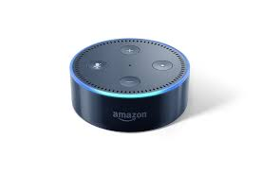

2.Price
Amazon has often prioritized the satisfaction of its customers, whether it be in terms of cost or customer experience. It has continually attempted to make products both available and affordable. Amazon's large volume revenues have resulted in massive net income. Even so, profitability has stayed relatively low. Its profitability has stayed unchanged at around 3% in recent times, with some progress in the last years. While its profit margins are low when compared to other technology or internet firms, its total net profits and income are significant. Amazon's pricing policy is competitive, whether it is in the marketplace, Prime, or AWS. It has, however, generated remarkable revenues and profits. Because of its competitive pricing approach, the brand has been able to generate exceptionally high-volume sales. Its size and complexity have allowed it to reach great volume sales while charging the cheapest cost possible to its customers. Its pricing strategy is indeed an important part in the platform's rising success. Amazon reduce prices on a range of products soon after purchasing the Whole Foods business. As a result, it has remained profitable as well as a customer favorite.



3.Promotion
In today's world, Amazon is a well-known company that requires no introduction. With Amazon Prime and other new features, its success has increased rapidly in recent years. Amazon Web Services' success has grown, resulting in record-breaking revenues and earnings. The marketplace or Amazon website, on the other hand, is Amazon's primary marketing and promotion channel. Customers will quickly locate and choose from millions of items on the company's website. Amazon uses digital platforms for advertising, such as web advertisement and affiliate marketing. It spends a lot of money on marketing and gaining and holding customers. In 2017, it invested more than ten billion dollars on ads, up from 7.2 billion dollars in 2016. From 2016 to2017, the company's marketing costs increased by 39%. Because it is such a well-known brand, it and its developers are often in the press. Amazon Prime has demonstrated its ability to attract and retain customers. Amazon uses innovative advertising strategies because it is an unconventional brand. As it is one of the four biggest tech firms, it is continuously in the news for one reason or another.

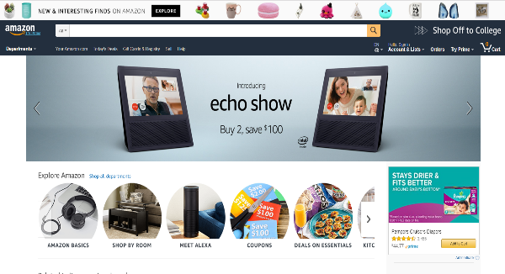

4. Place

Owing to the e-commerce aspect of Amazon's business operations, the company previously did not have physical stores and instead focused on online distribution platforms. Since 2015, the online shopping retailer has concentrated on physical sales, opening a half-dozen bookshops. With a large distribution and fulfillment network, Amazon is truly a global business. The company's offices are based in Seattle, Washington. Besides its global online presence, the organization also reaches consumers all over the world through its vast network of fulfillment centers. These warehouses collect inventory from suppliers, which is then shipped directly to consumers. Amazon operates over 175 distribution centers around the world. Amazon associates will choose, pack, and ship millions of orders from these warehouses, which span more than 150 million square feet. Amazon has more than 75 distribution centers and 110 operational facilities in North America. In North America, Amazon has over 125,000 employees operating in regional warehouses. Amazon has also grown a major market in India. The Indian website of Amazon's marketplace, Amazon.in, has been the country's fastest-growing marketplace. In addition, the e-commerce runs 465 whole foods market stores in North America and seven globally. Its physical presence has expanded thanks to the acquisition of the whole foods business.

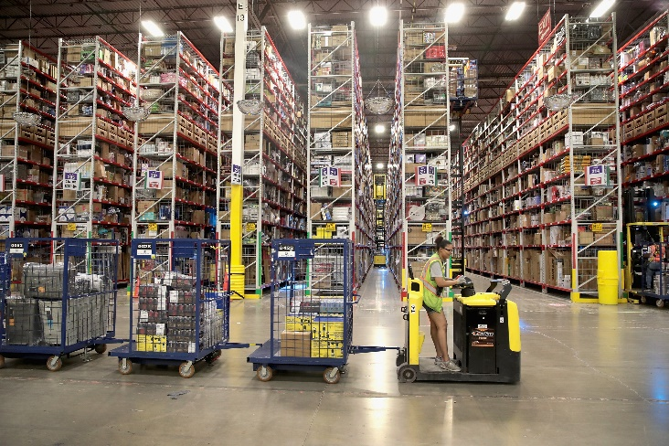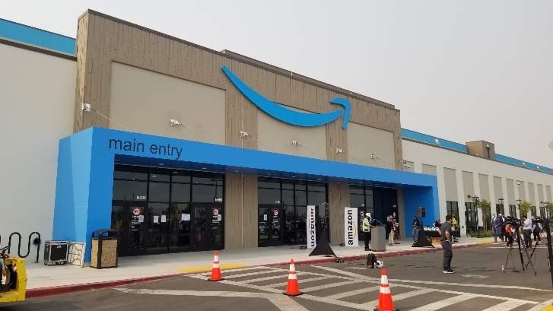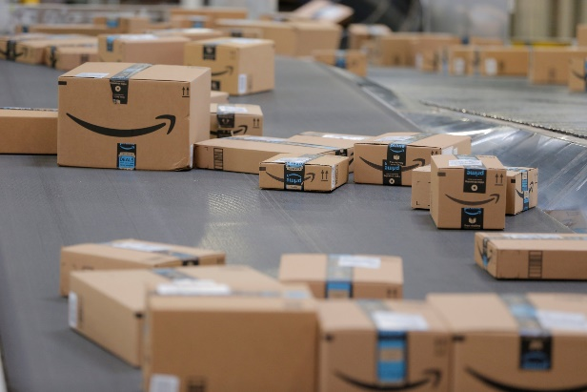

5. People

Amazon is hiring people from all over the world, with all different culture and genders. The company takes diversity as an important factor for the whole system and makes everyone feeling welcomed. Because of it is diversity Amazon can improve the customer service. The principal people who are making things work properly and efficient are the Amazon Warehouse employees and the delivery employees. They are the people who are responsible for the Amazon Prime’s “Same day delivery “.
Amazon uses 7 customer services philosophies (Baldacci 2013) and trains their employees to listen and understand their customers’ needs:
- Do not just listen to your customers, understand them.
- Serve the needs of the customer.
- The empty chair: the most Important person in the room
- Never settle for 99%
- Respect the customer.
- Strive to create a customer-centric company.
- Do not be afraid to apologize.



6. Process
They have to choose the payment method in order to buy the items in their basket. The checkout process consists of five steps, each of which comprises the following tasks:
1. Determine who the customer is.
2. Enter your shipping address and any necessary information.
3. Pick a payment option.
4. Get a summary of your entire order.
5. Confirm your order and place it.
6. You will receive an email confirmation.

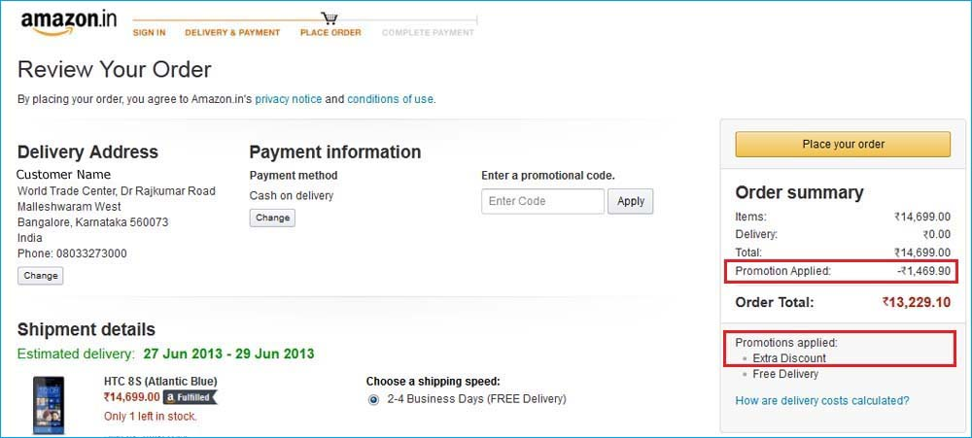

7.Pshycal evidence

The website is Amazon's most noticeable physical presence. Its website and apps, which are very user-friendly and developed with a beautiful and simple concept which can be easy to navigate for everyone. Since it is a online retailer, their website is one of the most important factor for their audience.

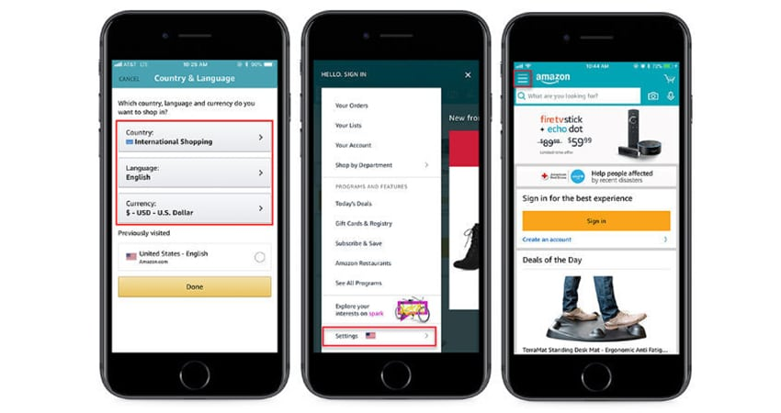

References:

Mandelbaum, A., 2021. The Importance of Business Communication in your Organization. [online] Smbadvisors.com. Available at: <https://www.smbadvisors.com/capabilities/sales-marketing-integration/insights/the-importance-of-business-communication-in-your-organization> [Accessed 28 February 2021].

Research-Methodology. 2021. Amazon Marketing Mix (Amazon 7Ps of Marketing) - Research-Methodology. [online] Available at: <https://research-methodology.net/amazon-marketing-mix-amazon-7ps-marketing-2/> [Accessed 1 March 2021].

Pratap, A., 2021. Marketing Mix of Amazon. [online] noematic. Available at: <https://notesmatic.com/2019/01/marketing-mix-of-amazon/#e> [Accessed 1 March 2021].

The 360 Blog from Salesforce. 2021. 7 Customer Service Lessons from Amazon CEO Jeff Bezos - Salesforce Blog. [online] Available at: <https://www.salesforce.com/blog/jeff-bezos-lessons-blog/> [Accessed 1 March 2021].

