EFFECTIVE TEAM WORKING AND COMMUNICATIONS

By Ana Stefaniu
ID 1921012

Contents
INTRODUCTION 3
1. BUSINESS MEETING AND THE IMPORTANCE OF EFFECTIVE COMMUNICATION 4
2. VARIOUS MODELS OF COMMUNICATION AND THEIR IMPORTANCE 6
3. ISSUES IN THE COMMUNICATION PROCEDURE 9
4. THE SOLUTION TO OVERCOME THE DIFFERENT TYPE OF BARRIERS TO COMMUNICATION 10
CONCLUSION 12
REFERENCES 13

INTRODUCTION
This was identified that communication is one of the most important to procedure at the time of transfer or transmission of some message or detail from one person to another through verbal non-verbal and written symbols or any other method. Communication is an establishment of the staying power of all the well beings. This was also identified that effective communication is one of the most important parts for every association to make a bridge a gap between two different types of individual or area (Bradshaw and Howard, 2018). On the other side, all the different type of business operation of any association will conduct through communication which is one of the most important roles in this competitive market.
This is very important that any association must have to master in the art of communication so that they will easily do a different type of operational activity and able to achieve the desired goal. In this report the discussion will be done related to the importance of effective communication in the various associations as well as the different model of communication will also discuss (Burgoon et al., 2016). Another side due to communication lots of issues which were faced by the association in this competitive market the executive of the company is using the communication process and tries to mitigate them. At the end of the project, the discussion of the channel of communication will be done.
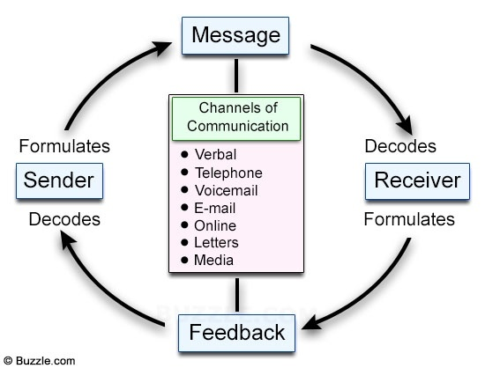

1. BUSINESS MEETING AND THE IMPORTANCE OF EFFECTIVE COMMUNICATION
This was identified that in business meeting different type of tactics are made and decisions are taken which will give lots of benefit to the association. Different type of most important aspects is also discussed which will make the business meeting more essential (Fischer et al., 2016). Effective communication will make sure that all the different type of activities will conduct timely and give exactly detailed in a business meeting for the growth of the corporation. If the business meeting was not to conduct an association then the management is wasted their time due to which they have to face lots of issues. Importance of effective communications are discussed below
SOLVING SOME PROBLEMS
The main motive of the business meeting is to identify different type of issues and conflict which was conducted in business operation. This is essential that they have to interact with their issues effectively in which they will easily able to understand the problem and try to use a different type of strategy so that they will get the best outcome (Fischer et al., 2016). The executive of the company will take some feedback from different workers working in their associations so that they will easily solve issues and also able to increase the probability ratio of the company.
EFFECTIVE DECISION MAKING
This was identified that the success and failure of the company are fully dependent on the decision making by the executive of the associations. Association wants are lots of success in this competitive market then they have to make the right and accurate decision in their association in this competitive market (Manojlovich et al., 2019). Mostly this type of decisions is taken at the time of the meeting of management. On the other side, this is also very important that the company have to tell the most appropriate information with proper communication at the time of taking any season in the association. The detail is a source for making any effective decision so that this must be communicated effectively.

ASSISTANCE TO CORE MANAGERIAL FUNCTION
Different type of planning organising coordinating and controlling are involved in core managerial function. Because of effective communication, the efficiency of all these functions is fully dependent (Manojlovich et al., 2019). In this, all different type of details is needed and transferring of the message and taking feedback on timely is important. This was identified that if effective communication will not be done in any association then all this function will not accurately do their work and also not able to achieve their goals.
SMOOTH WORKING AND INCREASED MANAGER EFFICIENCY
This was identified that communication is one of an integral part of any business operation of the association. Different type of managerial efficiency will be achieved with their roles and responsibility (Manojlovich et al., 2019). This is very important and the executive of the company has to communicate with different employees in a well and proper way so that they will easily achieve their or target goal. If an association and effective communication is done then the manager information sees of the company was increased and the productivity and profitability of the company will also be increased (Samovar et al., 2017).

2. VARIOUS MODELS OF COMMUNICATION AND THEIR IMPORTANCE
Making effective communication various type of model of communication was made. All these models are mostly implemented by the various associations in their business procedure. Few models of communication were highly affected and explain below
1. ARISTOTLE MODEL
This was identified that Aristotle model is the first communication model. in 300 BC this model was generated by the most famous philosophe (Samovar et al., 2017). This model is mainly suggested that the executive of the company have to communicate with their audience so that they will easily influence them and convince them to do a different type of activity according to their instruction. Some associations implement this model by providing an influential speech to them in a different meeting which will help them to motivate each employee and co-ordinate effectively (Samovar et al., 2017).
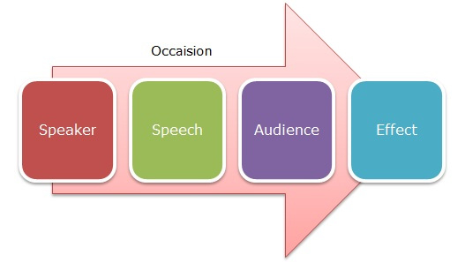
FIGURE 1 ARISTOTLE MODEL OF COMMUNICATION
[SOURCES: Wang and Li, 2017]

2. BERLO'S MODEL
This is one of the most effective models and in this model different type of operates are involved that is the source, message, channel and receiver. On the other side, this model is also given some suggestion that effective communication in any association is possible if the communication is done in a well and proper way with another person. The receiver also knows to understand the details which were provided by the sender.
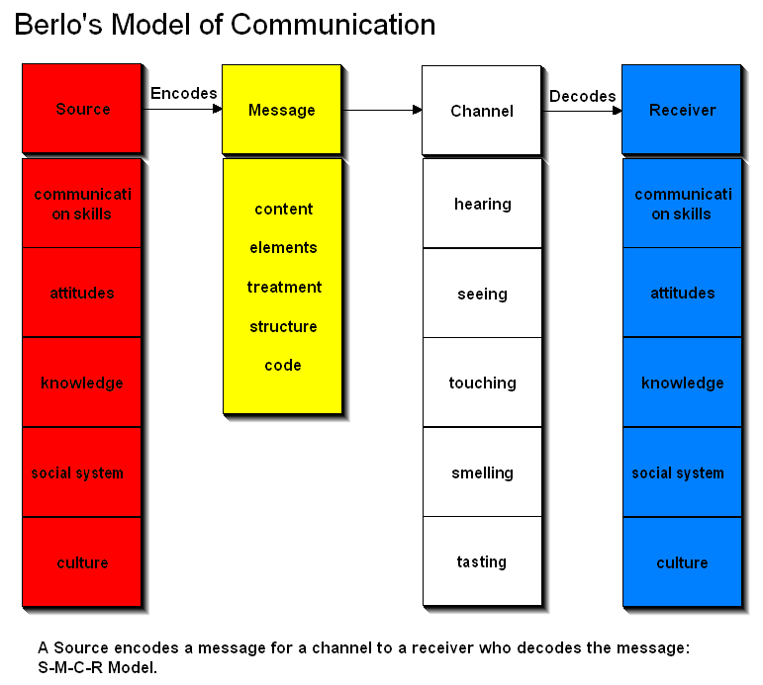
FIGURE 2 BERLO'S MODEL OF COMMUNICATION
[SOURCES: Watanabe et al., 2014]

3. SHANNON AND WEAVER MODEL
This model is the most famous model of communication. This model will explain that this is very important that the sender has to communicate the message to the receiver but because of some issues like medium problem lack of interpretation or any other thing which will turn noise I will not communicate properly (West and Turner, 2018). Another side this is very important that the receiver also give feedback related to their issues at the time of getting some messages for exact details. This identified that Lambeth’s team is not providing feedback related to the messages that will make some issues for effective interaction.
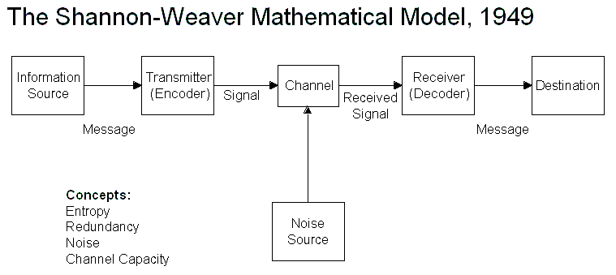
FIGURE 3 SHANNON AND WEAVER MODEL
[SOURCES: Samovar et al., 2017]

3. ISSUES IN THE COMMUNICATION PROCEDURE
Communication is one of the most important procedures in which an individual will share their message or some detail to the receiver by using a different type of strategies. This found that this is not simple as definition show (West and Turner, 2018). There are lots of issues which were faced by any association at the time of communication with a different type of individuals.
PERSONAL INTEREST
This is very important that the executive of the company has to understand the personal interest of each individual so that they will easily get some benefit. Most of the time American manager will not care or listen to issues of individual due to which there was facing some personal problems (West and Turner, 2018). Personal interest is one of the issues of communication.
LACK OF PARTICIPATION
Feedback is one of the most important parts of communication because the employee will give feedback related to their work so that the executive of the company will improve them by using a different type of tactics (West and Turner, 2018). To reduce the lack of participation this is very important that the individual has to attend a different type of business meeting which is very important. in this different type of activities are implemented with the proper respondent and proper feedback.
LACK OF SENSITIVITY
The latest meeting is important because of discussing some sensitive matter. This is very important that all individual must have to understand the sensitivity and control of the emotions. Any details are likely to be managed if the sender or receiver has a different mentality (Bradshaw and Howard 2018).
LACK OF KNOWLEDGE
This was identified that the communication will be successfully done if both receiver and centre have proper skill and knowledge related to the subject. On the other side, the centre must have to convey the message and the receiver have to need some knowledge to understand that message which was taken by the receiver.

4. THE SOLUTION TO OVERCOME THE DIFFERENT TYPE OF BARRIERS TO COMMUNICATION
For making communication more effective this is important that the individual has to mitigate some issues of communication. There are various ways to overcome the issues of communication informal business meeting (Samovar et al., 2017)
BUSINESS PROFESSIONALISM
This was identified that business meeting is very important and highly official. Different type of level of professionalism is taken at the time of conducting the meeting (Bradshaw and Howard 2018). The personal problem will not come in between any particular topic of the meeting. This is very important that the participants have to balance the difference between their personal and professional opinion.
MAKE SURE FEEDBACK MUST BE PROPER
Communication is an establishment of the staying power of all the well beings. This was also identified that effective communication is one of the most important parts for every association to make a bridge a gap between two different types of individual or area. On the other side, all the different type of business operation of any association will conduct through communication which is one of the most important roles in this competitive market (Bradshaw and Howard 2018). In this, all different type of details is needed and transferring of the message and taking feedback on timely is important. This was identified that if effective communication will not be done in any association then all this function will not properly do their work and also not able to achieve their goals.
This is very important that any association must have to master in the art of communication so that they will easily do a different type of operational activity and able to achieve the desired goal (Bradshaw and Howard 2018)

COORDINATION
Communication involves a different type of parties and the coordination between them is also very important. The sender and the receiver must have to understand each viewpoint and try to resolve all the problems as a team member (Bradshaw and Howard 2018).
GOOD LISTENER
This was identified that a good listener is someone who will understand the message and implement the work into their association. This was identified that a good listener can communicate with a different type of individual. Good listening is needed to both receiver as well as standard to make their communication more effective (Burgoon et al., 2016)

CONCLUSION
This report is mainly about the communication which is one of the most important aspects in association to interact or give the few points on the most important details to one person to another person. Communication will fill the gap between two individuals by communicating effective information. In this research project a different type of communication model was discussed where the association have to they've both in a well and proper way. The association was facing lots of issue at the time of interacting with a different type of individual so this is very important that the executive of the company has to conduct the business meeting so that they will make effective communication in this competitive market. At the end of this project, this was identified that effective communication is one of the most important tools to make effective business operation an organization.

REFERENCES
- Bradshaw, S. and Howard, P.N., 2018. The global organization of social media disinformation campaigns. Journal of International Affairs, 71(1.5), pp.23-32.
- Burgoon, J.K., Guerrero, L.K. and Manusov, V., 2016. Nonverbal communication. Routledge.
- Fischer, D., Posegga, O. and Fischbach, K., 2016. Communication barriers in crisis management: A literature review.
- Manojlovich, M., Ameling, J.M., Forman, J., Judkins, S., Quinn, M. and Meddings, J., 2019. Contextual barriers to communication between physicians and nurses about appropriate catheter use. American Journal of Critical Care, 28(4), pp.290-298.
- Samovar, L.A., Porter, R.E., McDaniel, E.R. and Roy, C.S., 2017. Communication between cultures. Nelson Education.
- Wang, N. and Li, B., 2017. A Model of Deceitful Information Communication: Some Views on Theory and Practice of Semantic Information. In Multidisciplinary Digital Publishing Institute Proceedings (Vol. 1, No. 3, p. 127).
- Watanabe, T., Poray, K., So, C. and Menda, R., ADVANCE RESPONSE LLC, 2014. Multi channel, automated communication and resource synchronization. U.S. Patent 8,793,311.
- West, R. and Turner, L.H., 2018. Introducing Communication Theory: Analysis And Appliaction. McGraw-Hill Education,.
- Wright, M. ed., 2016. Gower handbook of internal communication. CRC Press.
- Zimmerman, J. and Sharp, T., 2013. Aristotle Reclaimed. Journal of School Public Relations, 34(4), pp.350-369

