MANAGING PEOPLE

Assessment 2

by Anca Ghizela Hotca
(2021006/BABM Level5T1G1/05.05.2022)

Tutor’s name: Nishi Ramsurrun

Executive Summary
The paper had given important focus on discussing the core concept and drivers of employee engagement within the internal environment of the organization. It also has studied the important of diagnostic tools used for the part of measuring employee engagement in companies. Lastly, it has discussed benefits and role of EVP in organization productivity and profitability.

Table of Contents
Introduction 3
Discussion 4
Figure 1: Employee Engagement in Organization 4
Reviews the Concept and Drivers of Employee Engagement 5
Evaluate Diagnostic Tools to measure Employee Engagement 8
Construct an employee value preposition from the ideas and analysis, including strategies to raise levels of engagement 10
Conclusion 12
Reference 13

Introduction
Employee engagement is the core concept of human resource describing both dedication and enthusiasm and dedication level of the employees towards their job (Akhigbe and Osita-Ejikeme, 2021). Moreover, the engaged employees within the organization gives major priority to their performance. The complete process associated with the function of employee engagement affect all the major aspect of the organization that includes employee turnover, customer experience, profitability and revenue. According to the conducted research within the respective segment it is estimated that 92% of the managers believe engaged employees in the company perform better. The paper will give important focus on discussing the employee engagement drivers along with the diagnostic tools used for the part of measuring the same in the organization.

Discussion
Employee Engagement
Employee engagement within the internal environment of the organization is the workplace approach that results in the accurate and right condition for the employees in the organization in giving their best every day. In this, the employees in the organization remains more committed towards their values and goals and are highly motivated in the area of contributing towards success of the company (Antony, 2018.). The highlighting part is that the system of employee engagement is completely associated with integrity, trust, commitment and communication between the employees associated with the organization. Moreover, effective application of the same will lead to organizational competitiveness and sustainability in the current and future perspectives.
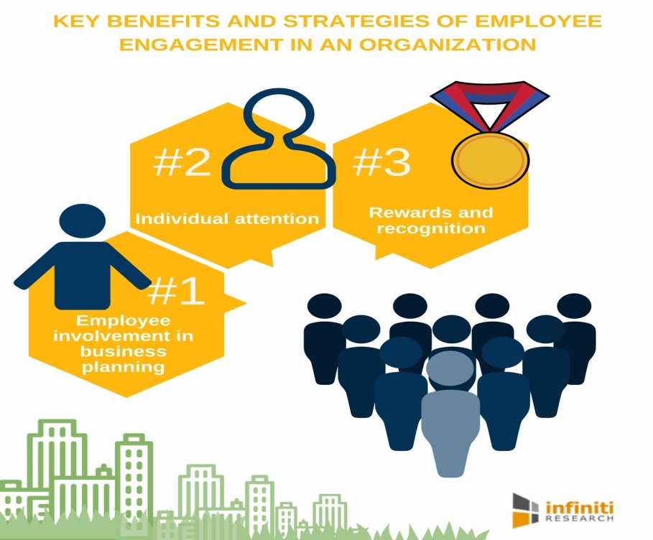
Figure 1: Employee Engagement in Organization
(Source: Chai et al., 2020)

Reviews the Concept and Drivers of Employee Engagement
For the part of improving the system of employee engagement, it is vital for the organization to understand the factors that drives and motivates them to get highly invested towards their job. On the contrary, it is the understandable part that employee engagement in the organization does not contain any mode of universal factors (Chai et al., 2020). On the contrary, the process of employee engagement may vary from organization to organization. However, the respective drivers of employee engagement in the organization also changes over time. It is due to certain external factors such as economic depression and “public health crisis”. During the time of rapid economic, technological and social change it is particularly helpful in returning to the basics along with understanding the factors that enables the people in focusing towards performing well. Some of the major drivers of employee engagement in the organization include:
Drivers of Employee Engagement | Meaningful Work
Drivers of Employee Engagement | Career Growth
Drivers of Employee Engagement | Empowerment
Drivers of Employee Engagement | Belongings
Drivers of Employee Engagement | Recognition
Drivers of Employee Engagement | Leadership
Drivers of Employee Engagement | Fulfilling the working relationship

It is the understandable part that with the increased change in technology, the overall traditional drivers associated with the system of employee engagement in the organization remains to be the same (Chanana, 2021). On the contrary, the modern approach that have been adopted on people along with the system of employee engagement requires increased level of thinking on the respective drivers in personalized manner.
Influencing factors of employee engagement
Employee engagement drivers in the organization are impacted by certain factors that include:
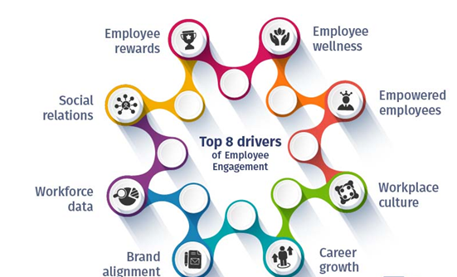
Figure 2: Drivers of Employee Engagement
(Source: Chanana, 2021)
Organizational Culture
Organizational cultures encompass the behaviour and values in shaping and exemplifying the method the method the activities are undertaken. On the contrary, the complete factor associated with the system of culture has increased level of impact on the drivers of employee engagement. However, the process related to organization culture and employee engagement is influenced through the function of management and leadership practices within the internal environment of the organization (Chib, 2019). For example, the organization consistently moving through the phase of innovation, in this they drivers of employee engagement relates to the ability of the employees in speaking and sharing new ideas. On the contrary, the organization culture that is driven by the system of operational efficiency consists of engagement drivers that are associated with execution and collaboration.
Industry
During the point of time the managers operating within the organization is asked regarding their driving factor of employee engagement it completely end on different lists. For example, the employee working with the non-profit organization needs to operate meaningfully along with adhering to the community goals for the part of increasing their engagement towards their job (Edwards-Dandridge et al., 2020). On the other hand, for an autoworker they may give important focus on maintaining and developing relationship and work safety with their colleagues within the organization. Like the organizational culture the core drivers of employee engagement are influenced through the respective industry they are operating with along with the colleagues they are surrounded by.
Career Path
It can be evaluated that both progress and career goals is the other core factor within the organization that highly contributes to the system of employee engagement within the organization. Employees in the organization get completely motivated based on the career goals by different things. For example, the employees within their early stages of career give important prioritization on strong leaders and competitive compensation that helps them in the area of developing their skills.

Evaluate Diagnostic Tools to measure Employee Engagement
Employee engagement is the major segment for discussion among all the organization operating under both domestic and international competition. Under the current competition, with the increased impact of Covid-19 employees in the organization work remotely from their home due to which the system of employee engagement has gained a center stage. According to the made evaluation the engaged employees tends to work harder and perform with the same organization for longer point of time (Motyka, 2018). According to the research conducted from the part of Gallup highlights the organization having increased level of engaged employees make 21% of higher profit along with remaining 17% productive within the internal environment when bringing in comparison with others. Some of the major diagnostic tools used for the part of measuring the system of employee engagement are demonstrated below:
Employee Recognition and Reward Programs
According to the conducted study, it is evaluated that 69% of the employees in the organization works harder during the point of time they feel their efforts have been recognized and appreciated. Moreover, the complete approach associated with employee recognition and rewards are the most effective and competitive technique for the part of identifying the engaged employees within the organization. It is the understandable part that both the factors related to recognition and rewards have direct mode of impact on the system of employee engagement. On the contrary, it will play a beneficial part for the human resource and managers in the organization for evaluating the engaged employee in the company through assessing the employees reward system.
Conducting frequent surveys on employees
In the organization for the part of assessing and measuring the system of employee engagement conducting surveys can be most effective method that can be adopted within the organization. On the contrary, the complete factor associated with the same along with measuring the employee engagement also helps in determining the motivation level of the employees through understanding their opinion (Song et al., 2018). Under this, most importantly two way process of communication is vital for the organization in having the most engaged workforce. Thus, it is the core initiative of the managers and human resource in the organization to sent frequently actionable, small and simple surveys to their employees in the organization asking them regarding their work.
Conducting a one-one session
The positive segment that can be adopted in measuring employee engagement is that the managers and human resource in the organization must conduct one-one session with their employees (Vakola et al., 2018). It is the beneficial strategy that can be adopted under which the employees may feel comfortable to express and share their information. Moreover, the complete process associated with the same should be undertaken within the organization on regular basis such that effective part of the same will bring direct reflection on organization productivity and profitability.
Making smaller focus groups
In larger organization it will be challenging for the management to conduct one-one session with their employees. Under this respective condition the organization can give core focus in the area of developing focus groups. The highlighting part is that under these process members in the same team and different teams can be grouped equally. In this respective situation both the HR and managers in the organization must be prepared with the set of 4-10 questions asking their employees regarding the suitability of the tools they have while working with the company (Wulandari et al., 2020). It will offer accurate idea to the organization regarding the upcoming strategies to be adopted by them for the part of developing their business internal environment. Along with this, it also motivates the employee and keeps the organization functioning more productive.

Construct an employee value preposition from the ideas and analysis, including strategies to raise levels of engagement
Employee Value Preposition (EVP) in the organization includes the benefits and rewards received by the employees for their made performance within the internal environment of the organization. The organization in the market following the system of EVP provides consistent and effective platform to the system of employer experience and branding management. On the contrary, EVP process is the magnet that enhances and attracts the job candidates towards the organization. Some of the core EVP techniques within the organization may include compensation, benefits, career, work environment and culture.
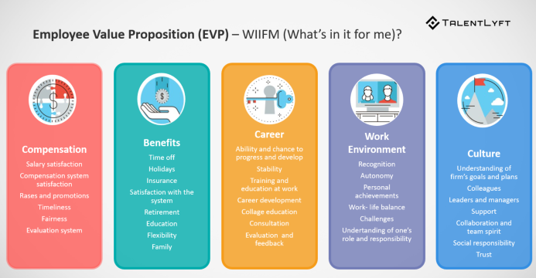
Figure 3: Employee Value Preposition in Organization
(Source: Chib, 2019)
Compensation
Under this, offering better system of compensation to the employees increases their productivity and loyalty towards the organization. Some of the mode of compensation to the employees may include paying the employees medical bills, providing their children attractive facilities. According to the conducted studies it is evaluated that 20% of the employees in the organization remains productive during the point of time they are provided with increased benefits (Vakola et al., 2018). It helps in releasing their stress factor along with enhancing them to perform better with the organization in the current and future perspectives.

Benefits
Some of the benefits offered to the employees in the organization may include insurance plans, Disability insurance, paid vacation, corporate discounts and retirement plans. It is the understandable part that employees in the organization along with demonstrating performance from their part also have strong expectation from the organization in return. Employees want recognition and appreciation for their made effort. It increases their job satisfaction and makes them more dedicated with the company.
Career
In this, the most competitive technique is associated with the initiative by the organization in taking personal interest on the career goals of the employees (Motyka, 2018). The other vital steps are associated with the process of offering adequate development and training for their employees along with rotating their job roles based on their experience and skills
Work Environment
In this, the most important approach is associated with the system of offering increased level of recognition to the employees in the organization. It can be performed through the process of making the employees part of the decision making process of the business. The other segment is related to appreciating and supporting them for their performance. It will help them in building and developing stronger mode of work life balance while working with the company.
Culture
The complete process associated with the same is the combination of developing stronger employee relationship in the organization along with giving the internal teams the autonomy they seeks working on a specified project (Chib, 2019). The other factors include creating positive mode of employee experience, encouraging frequent mode of employee recognition and opening up the system of both communication and transparency in the organization.

Conclusion
It can be concluded that, most importantly two way process of communication is vital for the organization in having the most engaged workforce. Moreover, it is the core initiative of the managers and human resource in the organization to sent frequently actionable, small and simple surveys to their employees in the organization asking them regarding their work. However, factors related to recognition and rewards have direct mode of impact on the system of employee engagement. Besides this, employees in the organization along with demonstrating performance from their part also have strong expectation from the organization in return. Furthermore, employees in the organization get completely motivated based on the career goals by different things. Under this, EVP provides consistent and effective platform to the system of employer experience and branding management. Here, organization culture and employee engagement is influenced through the function of management and leadership practices within the internal environment of the organization.

Reference
Akhigbe, E.A. and Osita-Ejikeme, U.E., 2021. Corporate culture and employee engagement of insurance firms in Rivers State, Nigeria. Research Journal of Management Practice| ISSN, 2782, p.7674.
Antony, M.R., 2018. Paradigm shift in employee engagement–A critical analysis on the drivers of employee engagement. International Journal of Information, Business and Management, 10(2), pp.32-46.
Chai, D.S., Song, J.H. and You, Y.M., 2020. Psychological ownership and openness to change: The mediating effects of work engagement, and knowledge creation. Performance improvement quarterly, 33(3), pp.305-326.
Chanana, N., 2021. Employee engagement practices during COVID‐19 lockdown. Journal of public affairs, 21(4), p.e2508.
Chib, S., 2019. Facilitating employee retention through employee engagement and organization commitment. Journal of Information and Computational Science, 9(9), pp.478-488.
Edwards-Dandridge, Y., Simmons, B.D. and Campbell, D.G., 2020. Predictor of turnover intention of register nurses: job satisfaction or work engagement?. International Journal of Applied Management and Technology, 19(1), p.7.
Motyka, B., 2018. Employee engagement and performance: a systematic literature review. International Journal of Management and Economics, 54(3), pp.227-244.
Song, J.H., Chai, D.S., Kim, J. and Bae, S.H., 2018. Job performance in the learning organization: The mediating impacts of self‐efficacy and work engagement. Performance Improvement Quarterly, 30(4), pp.249-271.
Vakola, M., Petrou, P. and Katsaros, K., 2021. Work engagement and job crafting as conditions of ambivalent employees’ adaptation to organizational change. The Journal of Applied Behavioral Science, 57(1), pp.57-79.
Wulandari, B., Ginting, E.D.J. and Hasnida, H., 2020. The effect of perceived organizational support and employee engagement on readiness to change. International Journal of Progressive Sciences and Technologies, 23(2), pp.24-27.

