Sexual Controversy in Video Games

Introduction

This dissertation proposal is about the oversexualisation in Japanese games and how they compare to games created in the West. This includes America and United Kingdom. These games have very different cultures and views on sexuality in video games and media, to analyse this topic, the cultural differences need to be looked at and applied to various games made in these cultures.

Oversexualisation in Video Games

Video games face a lot of controversy involving sexualisation with female characters, this causes controversy as some game companies make the female characters in the game very ‘sexy’ with tight clothing or very little clothing. This causes controversy because the media, will bring up feminism as points, making women feel insecure as the characters in games are portrayed as sexual objects or are mostly sexy and don’t portray normal women. This controversy has been less prominent in the western culture, however in Japan, these controversies aren’t common and their media don’t see the sexualisation of characters as a problem. However, the main thing to distinguish is ‘over sexualisation’ and ‘acceptable sexualisation’. One article states that acceptable sexualisation is not about a character having big breasts or a model like figure, but its more about what that character does, one example used is that of Lara Croft, who has been known as one of the original over sexualised characters in gaming, due to the large breasts her character had in her original model, however, a lot of women in the world also have large breasts, but that doesn’t make them over sexualised, furthermore, Lara Croft is a “ass kicking heroine” and doesn’t use her good looks to defeat her enemies. (N4g.com, 2013)
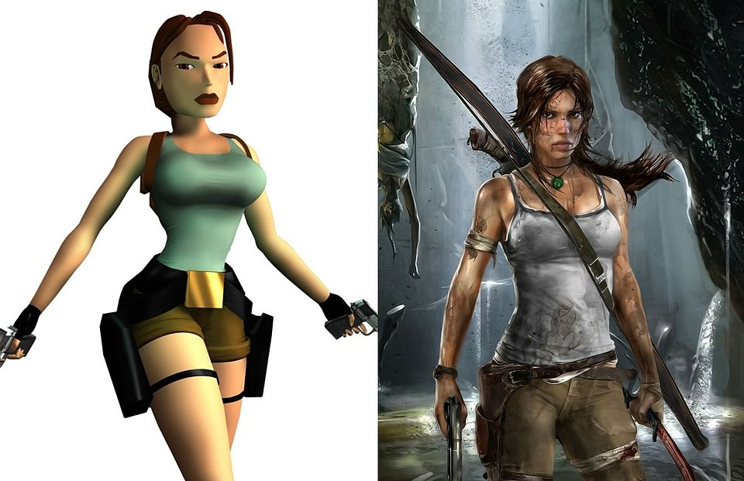
CVC2111, (2014), tomb-raider [ONLINE]. Available at: https://samstromwrit4250blog.files.wordpress.com/2014/12/tomb-raider.jpeg [Accessed 15 May 2018].

This image shows Lara Croft from 1996 and 2014, this image shows Lara’s evolution and shows as the game developed, the character is made to look like any other woman in the world with some sexual appeal, however “Sex appeal in advertising is generally viewed as an effective strategy to attract attention to your brand.” (Kokemuller, n.d.) this shows that sex appeal is used across media and as a form of entertainment, gaming is no exception.

As for Oversexualisation, this is all about deliberately using sex appeal to sell the game in question, this doesn’t mean that having a character that has large breasts and a desirable body shape, is oversexualisation. However, if the game has characters that for no apparent reason are wearing almost no clothing, have overly large breasts, with even more desirable bodies, coupled with sexual appeal with voice lines or animations, this is over sexualisation, as a previously used article stated “However, not much comes close to Dead or Alive Xtreme Beach Volleyball, which takes the well endowed ladies of the Dead or Alive beat 'em up franchise, and puts them on an Island resort along with a change of attire in the form of various skimpy bikini's. If there is such a thing as blatant over sexulisation in gaming, Dead or Alive Xtreme Beach Volleyball took it to a whole new level.” (N4g.com, 2013) this quote is a personal opinion but from images below can be seen as a powerful quote, about oversexualisation in video games.
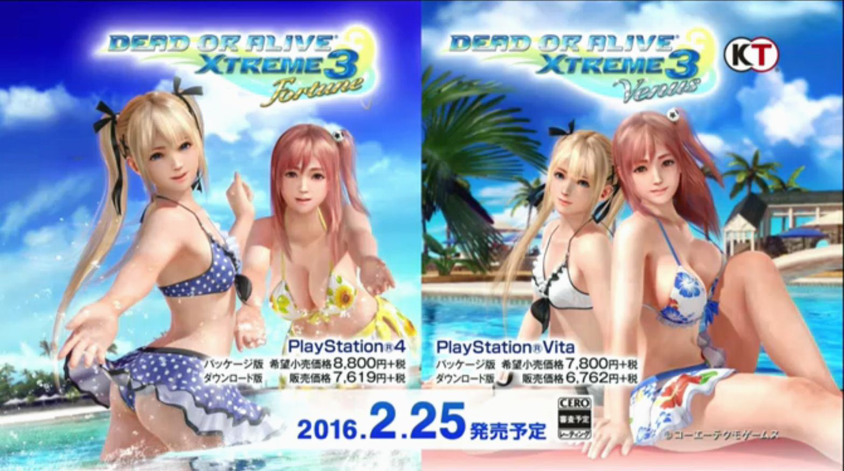
Tecmo Ltd, (2015), dead-or-alive-xtreme-3-10-14-15-1 [ONLINE]. Available at: http://nichegamer.com/wp-content/uploads/2015/10/dead-or-alive-xtreme-3-10-14-15-1.jpg [Accessed 15 May 2018].


Tecmo Ltd, (2015), DOAX3_Fortune_box_cover [ONLINE]. Available at: https://vignette.wikia.nocookie.net/deadoralive/images/8/86/DOAX3_Venus_box_art.png/revision/latest?cb=20160821144552 [Accessed 15 May 2018].

These images are official art and the official box cover art for the games, these female characters are clearly being used as overseualised characters to sell the game, the main focus isn’t on the volleyball aspect, but more on the two main characters splashing water or just with their bikinis on.

Western Games

Western games can face a lot of controversy about female characters in games, and this isn’t just due to oversexualisation, but how women are portrayed in these games, where Japanese culture embraces sexual appeal, western culture will sometimes shy away and censor out light skin showing, however in some games like Grand Theft Auto, the player can pay to get sexual favours from non playable characters that perform animated sexual acts on the player, too which the player can then murder the girl and steal her money. Now, this is a controversial case as GTA’s whole gameplay aspect is being a criminal and murdering people and committing crimes. However, this doesn’t mean that other games don’t portray women as sexual objects or portray them as powerful but still use sexual appeal on those characters. A prime example was used above in Lara Croft, a British made character that’s purpose was to be a male fantasy with the sexual appeal, but more importantly a heroine, creator of Lara Croft, Toby Gard commented in an interview stating “It was never the intention to create some kind of 'page 3' girl to star in Tomb Raider. The idea was to create a female character who was a heroine, you know, cool, collected, in control, that sort of thing.” (Gard, 1998) This quote shows that the creator had no intention of sexualising Lara Croft when creating her, this fact shows that Western games don’t always sexualise characters intentionally, and the base of the game. The media will always have an opinion on women portrayed in video games and will cause controversy when given any chance, and this can harm the creators view on their own games, one example of this is when an American company called Blizzard Entertainment announced a game called ‘Overwatch’, in this game a character had a victory pose of the character called Tracer doing an ‘over the shoulder pose’, this pose was criticised for being out of character and over sexualising the hero for no reason, it didn’t fit her personality and made her just another bland female sex symbol, (Fipps, in McWhertor, 2016), this controversy was responded by the game director Jeff Kaplan, Jeff stated in response “We want everyone to feel strong and heroic in our community. The last thing we want to do is make someone feel uncomfortable, under-appreciated or misrepresented.” (Jeff, in McWhertor, 2016). This shows that these sexualisation claims aren’t the goals the creators are always aim for and some will try to fix the issue when it's brought to attention. This is how the West deals with these situations when faced by the media, below is the pose in question.

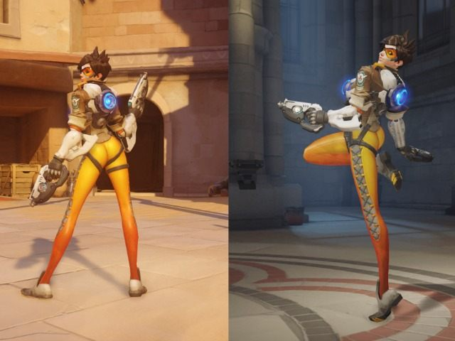
Blizzard Entertainment, (2016), tracer-new-pose [ONLINE]. Available at: http://i0.kym-cdn.com/entries/icons/original/000/020/566/tracer-new-pose.jpg [Accessed 15 May 2018].

This image shows the pose that faced controversy (on the left) and the pose that it was replaced with by the game developers (on the right) this image shows the sexualisation in western culture tends to be dealt with urgency to avoid upsetting fans of their games.

Overall, Western Culture tend to avoid letting their games be riddled with controversy, even though it's almost impossible to escape peoples opinions, game companies in the west will do their best to make their fans happy and censor any controversial content, unless the age rating of the game suggests this kind of behaviour exists, this applies to Grand Theft Auto and the prostitutes in the game.

Japanese Games

Japanese culture is very different from western culture, this is seen through their media. Popular forms of media like their video games and animated TV Shows convey this. One prime example of a game that has high sexual content to sell their games is called Senran Kagura. This video game series is a brawler that uses sexual content to sell their games, the large breasted female characters with over exaggerated sizes are the main focus of the brawler game. The game only has three male characters and only one is playable in the game. The rest of the characters are all female and all have various body sizes and breast sizes, the game itself has the characters clothes getting torn until they’re naked or in their underwear when they take damage. This game has faced lots of controversy in Western culture, however it is also extremely popular in western culture, in an interview with the game creator, Kenichiro Takaki about the sexual content, he stated that “I'm not afraid of adding sexual content into the games, as I would always love to make games that players have been waiting for. I'm more afraid of running out of inspiration or ideas and not being able to create anything that entertains people. As long as I know what I want to create and there're fans waiting for my titles, I have no reason to stop making these games.” (Takaki, K, in Klepek, 2016) This proves that Japanese developers are more than willing to create games with sexual visuals in their characters and animations, Japan faces lots of controversy about this as some video game characters look younger than the legal age of Western culture which faces accusations of pedophilia in the culture and usually is the focus of various articles confronting this style.


Marvelous (2015). Gameplay-Image. [image] Available at: https://i.ytimg.com/vi/ePh3ckbp5KE/maxresdefault.jpg [Accessed 16 May 2018].

This image is a direct screenshot from the game itself, this image is extremely sexualised and shows the differences in game cultures, Japanese companies will happily add gameplay elements of this magnitude and face no controversy in its own culture, however when the games get localised in the West, the culture clashes cause controversy, controversy that the game creators face each time when localising a game.

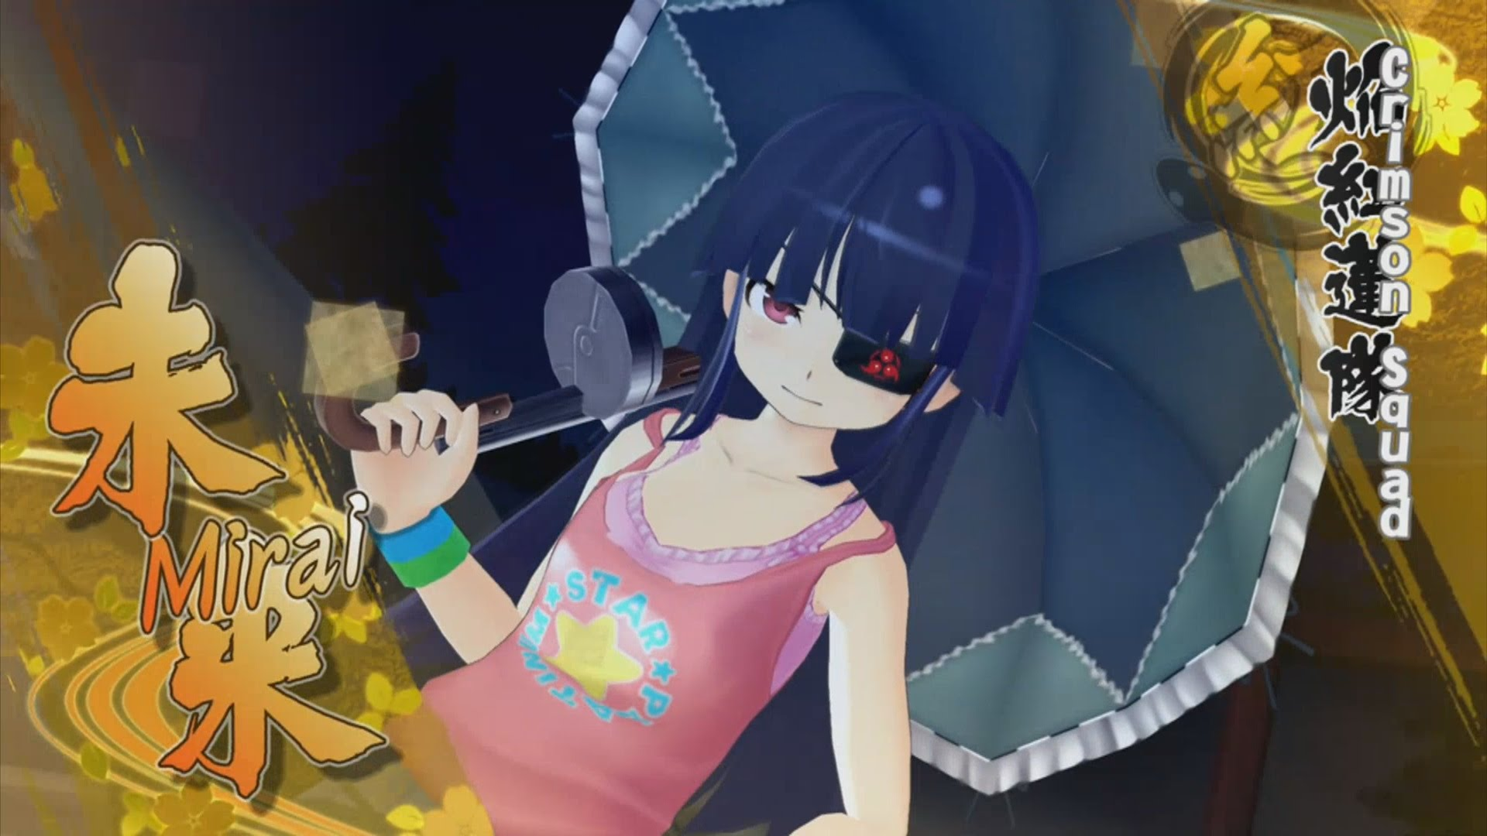
Marvelous (2016). Mirai-Character. [image] Available at: https://i.ytimg.com/vi/wq5izhhJptQ/maxresdefault.jpg [Accessed 16 May 2018].

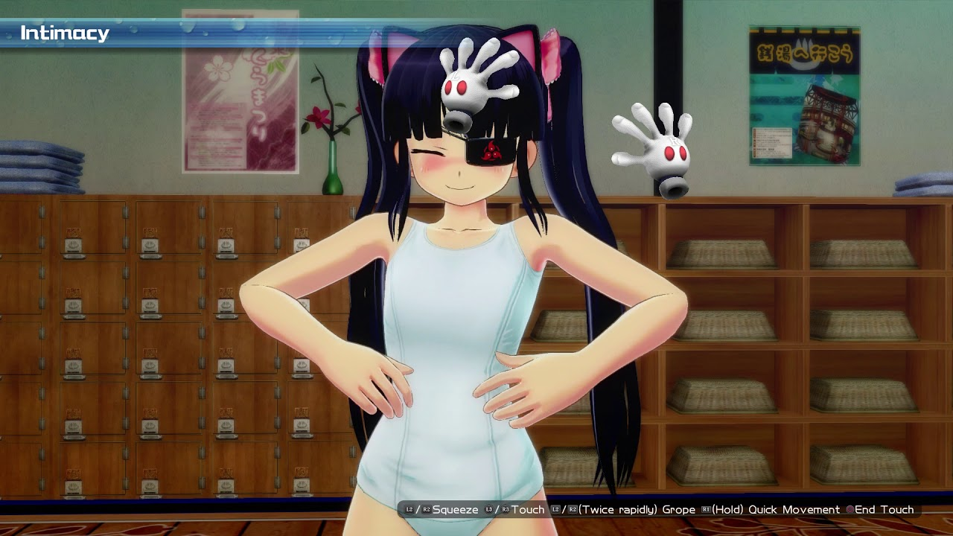
Marvelous (2016). Mirai. [image] Available at: https://i.ytimg.com/vi/OUrpfMvyWFo/maxresdefault.jpg [Accessed 16 May 2018].

Additionally, another instance of over sexualisation in Japanese culture as mentioned above, is the use of underage looking characters, the two above images show a character in the senran kagura series called Mirai, this character is Age 15 and 16 later in the series, this is underage in American culture and in the first timeline is underage in the British culture, however the legal age for sexual consent in Japan is 13, however a law for sexual fornification is 18, this age differences causes controversy as Japan can legally look at younger teenagers and they can be used in media with sexual content as long as the content doesn’t include acts of sexual intercorse, this means the two images above are perfectly ok in Japanese culture, however, these characters also pass through the localisation laws when importing the games. Allowing these characters into Western Culture is what sparks controversy in the media, and conflicts Japanese culture when making video games.

Conclusion

In conclusion, Video Games face a lot of controversy in the media, some bad and some just misunderstood. However, the sexual controversy in Video Games will never disappear as game creators will always use different methods to sell their games and appeal to fans, and sexual appeal is a huge selling point for both men and sometimes women. Furthermore, if a game creator like Toby Gard wants to create a powerful heroine like Lara Croft and gives her a desirable body type or a fit body type as that character would make sense having this body type, the media will always ignore the meaning behind the character and focus mainly on the design and the sexual appeal, and tag it with words like ‘objectify’ and ‘over-sexualised’ which hurts the creators view on their characters. However, these characters like Lara Croft (Tomb Raider), Tracer (Overwatch) and Elena Fisher (Uncharted) usually originate from western game companies like Naughty Dog, Blizzard and Core Design. On the flip side, Japanese game companies like Square Enix or Marvelous and even Game Freak creators of Pokemon face controversy for their female characters as the Japanese culture are often known for over sexualising their characters even if its not their intention, this overall is what causes sexual controversy in the video game industry.

Bibliography

N4g.com. (2013). The portrayal of Women in videogames: Acceptable sexualisation vs over sexualisation.. [online] Available at: http://n4g.com/user/blogpost/zerocrossing/523577 [Accessed 15 May 2018].

CVC2111, (2014), tomb-raider [ONLINE]. Available at: https://samstromwrit4250blog.files.wordpress.com/2014/12/tomb-raider.jpeg [Accessed 15 May 2018].

Kokemuller, N. (n.d.). Examples of How Sex Appeal in Advertising Works. [online] Smallbusiness.chron.com. Available at: http://smallbusiness.chron.com/examples-sex-appeal-advertising-works-60861.html [Accessed 15 May 2018].

Tecmo Ltd, (2015), dead-or-alive-xtreme-3-10-14-15-1 [ONLINE]. Available at: http://nichegamer.com/wp-content/uploads/2015/10/dead-or-alive-xtreme-3-10-14-15-1.jpg [Accessed 15 May 2018].

Tecmo Ltd, (2015), DOAX3_Fortune_box_cover [ONLINE]. Available at: https://vignette.wikia.nocookie.net/deadoralive/images/8/86/DOAX3_Venus_box_art.png/revision/latest?cb=20160821144552 [Accessed 15 May 2018].

Gard, T. (1998). Interview with Toby Gard.

McWhertor, M. (2016). Blizzard is removing a sexualized pose from Overwatch, citing player feedback (update). [online] Polygon. Available at: https://www.polygon.com/2016/3/28/11321138/overwatch-tracer-pose-removal [Accessed 15 May 2018].

Klepek, P. (2016). The Designer Behind 'Senran Kagura' Explains Why His Games Are Full Of Barely Clothed Women. [online] Waypoint. Available at: https://waypoint.vice.com/en_us/article/av3ywa/the-designer-behind-senran-kagura-explains-why-his-games-are-full-of-barely-clothed-women [Accessed 16 May 2018].

Marvelous (2015). Gameplay-Image. [image] Available at: https://i.ytimg.com/vi/ePh3ckbp5KE/maxresdefault.jpg [Accessed 16 May 2018].

Marvelous (2016). Mirai-Character. [image] Available at: https://i.ytimg.com/vi/wq5izhhJptQ/maxresdefault.jpg [Accessed 16 May 2018].

