

Personal Development Portfolio

LCHS4009
Professional Development within Health and Social Care

Student Name: Natasha Rose Ilsley
Student ID: 2506011

Lecturer: Zara Ahmed
Date of Submission:
23rd July 2026

Table of Contents

Introduction 3
Task 1: Curriculum Vitae (CV) for Healthcare Assistant Position 3
Task 2: Personal Statement for Healthcare Assistant (HCA) Position 7
Task 3 8
SWOT Analysis for a Healthcare Assistant (HCA) Role 8
Personal Development Plan (PDP) 9
Task 4: Critical Reflection on the LCHS4009 Component 1 Presentation Using Gibbs' Reflective Cycle 11
Description 11
Feelings 11
Evaluation 12
Analysis 12
Conclusion 12
Action Plan 13
Conclusion 13
References 15
Appendix A: Job Circular / Job Description 17

Introduction
I have prepared this report to help me in my effort to secure a job in the health and social care industry as a Healthcare Assistant (HCA). It includes a professional Curriculum Vitae, a personal statement with details about my professional intentions and skills, a SWOT analysis to analyze my strengths and developmental needs, and a Personal Development Plan (PDP) founded on SMART goals. I end the report with a critical reflection, based on Gibbs' Reflective Cycle, to prove my determination to self-develop, to learn new things and to gain knowledge within the realm of health and social care.

Task 1: Curriculum Vitae (CV) for Healthcare Assistant Position

Natasha Rose Ilsley
Email: natasharse.ilsley@gmail.com
Phone: 07470749167

Personal Profile
An accomplished, altruistic, and well-inspired person pursuing a Certificate of Higher Education (CertHE) in Health and Social Care at the University of Wales Trinity Saint David. I have vast experience in customer service, leadership, and communication, as well as team management because of over a decade of being employed by McDonald's. School attendance has informed me about safeguarding, person-centered care, promoting health, and communicating effectively in health and social care. I am looking to find a Healthcare Assistant (HCA) job in which I will be able to use my transferable skills to deliver safe, compassionate, and high-quality care and conduct my professional development in the healthcare industry.
Education
University of Wales Trinity Saint David
Certificate of Higher Education (CertHE) in Health and Social Care (Currently Completing)
Relevant Modules
- Communication in Health Care
- Safeguarding
- Health Promotion
- Person-Centered Care

Tarlac State University, Philippines
Diploma in BSBA – Major in Marketing Management
Romulo Highway, Tarlac City, 2300, Philippines.

Professional Experience
Second Assistant Manager
Endeavour Restaurants Ltd / McDonald's
April 2019 – September 2025
Key Responsibilities:
- Supervised daily restaurant operations and maintained excellent customer service standards.
- Led and motivated staff while promoting effective teamwork.
- Trained new employees and monitored performance.
- Managed customer concerns professionally and efficiently.
- Ensured compliance with company policies, health and safety regulations, and food hygiene standards.
- Supported scheduling, stock management, and operational planning.

Service Crew
McDonald's Tarlac Hi-Way, Philippines
May 2015 – November 2018
Key Responsibilities
- Delivered outstanding customer service in a fast-paced environment.
- Prepared food and beverages following quality standards.
- Maintained cleanliness and food safety procedures.
- Assisted colleagues to achieve daily operational targets.
- Developed strong communication and problem-solving skills.

Key Skills
- Compassionate and person-centered approach to care
- Excellent verbal and written communication
- Teamwork and collaboration
- Leadership and staff supervision
- Time management and organization
- Problem-solving and critical thinking
- Safeguarding awareness
- Health and safety compliance
- Ability to work effectively under pressure
- Professionalism and adaptability

Achievements
- Progressed from Service Crew to Second Assistant Manager through consistent performance and leadership.
- Developed strong leadership, customer service, and organizational skills while managing teams.
- Successfully balancing higher education with full-time employment, demonstrating commitment, resilience, and effective time management.

Voluntary Experience
Presently, exploring avenues to engage in community health projects and volunteer work to enhance more practical skills and help positively in health and social care provision.
Interests and Hobbies
- Learning about healthcare and professional development
- Reading health and wellbeing literature
- Supporting community wellbeing initiatives
- Team-based activities
- Continuous learning and personal development
References
Available upon request.

Task 2: Personal Statement for Healthcare Assistant (HCA) Position

I am seeking the job of Healthcare Assistant (HCA) since I love people and making a difference in their lives. My career has enhanced my communication, leadership and interpersonal skills, and I am enrolling in a Certificate of Higher Education (CertHE) in Health and Social Care at the University of Wales Trinity Saint David to broaden my knowledge. I also hope to have a successful career in the health and social care field in the long-term by ensuring that I provide friendly and person-centered care to those around me and constantly enhance my knowledge base and practical abilities.
My recent courses have equipped me with a sound knowledge of the concepts of health and social care. The modules that include Communication in Health Care, Safeguarding, Health Promotion, and Person-Centered Care enabled me to acquire important insights into effective communication, how to protect vulnerable people, promote health and wellbeing, and uphold the dignity and autonomy of service users (Glasby, 2026).
In addition to my learning, I have over ten years of practical work experience, working at McDonald's, where I have served as a Service Crew and Second Assistant Manager. These positions have helped me acquire transferable skills which are directly applicable to healthcare (McCarron et al, 2024). Managing teams and resolving customer concerns, overseeing daily operations and working under pressure have enhanced my leadership, problem-solving, organization and decision-making skills.
My main strengths are that I can effectively communicate with people with different backgrounds and work within multidisciplinary teams, be patient and compassionate to support others. My strengths are that I am well organized, reliable and determined to deliver top service by adhering to the dignity and confidentiality of each person. I want to learn and take constructive feedback as well as to gain knowledge and improve my professional practice continuously.

Task 3

SWOT Analysis for a Healthcare Assistant (HCA) Role
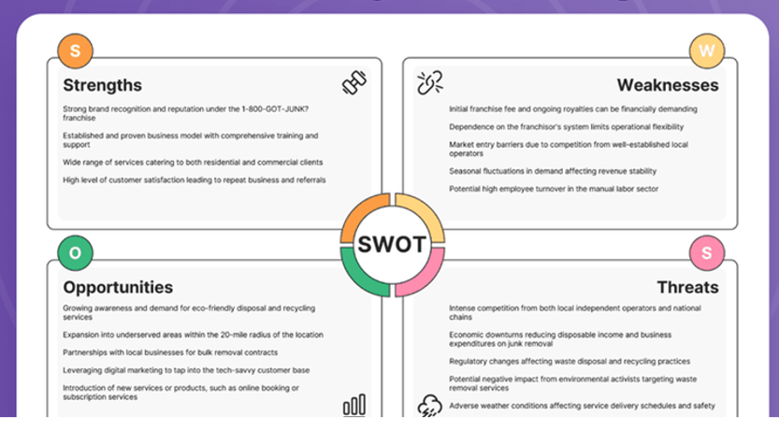
Figure 1: SWOT Analysis
Source: (Gavriliev and Avdeenko, 2023)
Strengths
My best asset is my very strong communication and interpersonal skills, gained during over a decade of consulting at McDonald's. It was where I interacted with individuals of different backgrounds and got to learn how to communicate in a professional manner, solving problems and offering good customer service (Gavriliev and Avdeenko, 2023). This experience as a Second Assistant Manager in leadership has made me even more capable in handling teams, responsibilities and priorities and being calm in difficult situations.
Weaknesses
Though I have quite good transferable skills, I have minimal practical skills in a healthcare environment. I also must build increased confidence to deal directly with patients and to carry out clinical support services. I predominantly have theoretical knowledge as I have yet to finish my qualification (Nightingale, 2024).

Opportunities
The Healthcare Assistant position provides numerous chances of personal and professional growth. My job in the NHS or any other healthcare organization will allow me to acquire valuable working experience and learn alongside experienced healthcare professionals. I will be able to take the Care Certificate, professional training courses, and gain specialist healthcare skills (Thistlethwaite et al., 2023). Career progression routes are also evident, with Senior Healthcare Assistant, Nursing Associate, or Registered Nurse being possible with further education and professional development.
Threats
Work environments are stressful, and they are characterized by high workloads, shortage of staff and emotionally difficult circumstances. Unmanaged, these pressures might impact performance. Healthcare Assistant positions may also be highly competitive, and thus continuous professional development is needed to stay up to date (Al Rashid and Rajagopalan, 2026).

Personal Development Plan (PDP)
Goal 1: Develop Practical Healthcare Skills
SMART Element | Details
Goal | Develop practical healthcare skills and confidence in patient care.
Specific (S) | Complete the Care Certificate, attend healthcare training, and gain practical experience through workplace learning.
Measurable (M) | Complete the Care Certificate, attend required training, and receive positive supervisor feedback.
Achievable (A) | Learn from experienced colleagues and apply skills through regular practice.
Relevant (R) | Practical healthcare skills are essential for delivering safe and person-centered care.
Time-bound (T) | Complete this goal within 12 months, reviewing progress every three months.
Goal 2: Strengthen Professional Communication and Clinical Decision-Making
SMART Element | Details
Goal | Improve communication skills and confidence in clinical decision-making.
Specific (S) | Attend communication workshops, practice simulation exercises, and study NHS guidelines.
Measurable (M) | Complete at least three workshops and receive positive supervisor feedback.
Achievable (A) | Apply communication skills in practice and seek guidance from experienced colleagues.
Relevant (R) | Strong communication and decision-making support safe, person-centred care and effective teamwork.
Time-bound (T) | Achieve this goal within 24 months, reviewing progress every six months.
Goal 3: Continue Professional Development and Career Progression
SMART Element | Details
Goal | Continue professional development and prepare for career progression in healthcare.
Specific (S) | Complete my CertHE in Health and Social Care, attend CPD courses and workshops, and gain practical healthcare experience.
Measurable (M) | Complete all CertHE modules, attend at least four CPD activities, and earn relevant training certificates.
Achievable (A) | Participate in workplace training, online courses, and seek guidance from experienced healthcare professionals.
Relevant (R) | Professional development improves my knowledge, skills, and future career opportunities as a Healthcare Assistant.
Time-bound (T) | Achieve this goal within 24 months, reviewing progress every six months through academic results, training records, and supervisor feedback.

Task 4: Critical Reflection on the LCHS4009 Component 1 Presentation Using Gibbs' Reflective Cycle
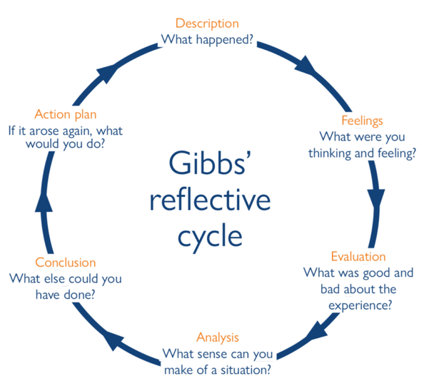
Figure 2: Gibbs' Reflective Cycle
Source: (Gibbs, 1988)

Description
My presentation topic in relation to this module of LCHS4009 was the topic of Critical Thinking in Health and Social Care. The lecture described the nature of critical thinking, its role in health and social care, how this skill is used in professional practice, and the Clinical Reasoning Cycle as a decision-making strategy (Hussain, 2025). I also considered my strengths, areas of improvement, and a plan of personal development. Verbal feedback was given by my lecturer after the presentation. She also remarked that the presentation was well structured, complete and contained the right examples.

Feelings
I was also nervous before going up to present my thoughts; by the end of the presentation, I had shown that I had clearly understood the subject (Gibbs, 1988). The further I moved in the presentation, the more confident I was, being able to understand what I was taught and having prepared before. I was proud that I was able to deliver the topic even without just teaching theory and using practical examples (Mansuroğlu and Davut, 2025). Seeing that I was earning positive remarks from my lecturer made me feel more confident and proved that my preparation had not been in vain. I was a little disappointed, however, when I heard that I had put some extraneous slides in.

Evaluation
I think generally my presentation was very successful. It was well structured logically and explained the key concepts, and it incorporated relevant examples that helped in understanding. The comments made by my lecturer proved that I did a good job by researching and presenting the topic (McCarron et al, 2024). Good skills in preparation and communication were shown through these strengths.
The greatest weakness was the fact that I had additional unnecessary slides. The content was also relevant but not a part of the assessment criteria. This demonstrated that I ought to have re-read the assessment brief before completing my presentation. The integration of extraneous material diminished the overall attention my work had (Hosseinnejad et al., 2022).

Analysis
This experience taught me that to make effective presentations, one must not only possess great knowledge of the subject being presented, but also be keen on assessment requirements. There is no point in writing more material to enhance an assessment which does not address the learning outcomes. The feedback of my lecturer helped me to realize that academic success does not rely on the amount of material presented, but the presentation of the relevant material. Cognition over this experience has additionally revealed the significance of planning, reviewed instructions, and appraising my work prior to submitting it (Blaikie, 2025).

Conclusion
This presentation was an excellent learning process that enabled me to consolidate my knowledge as well as improve my presentation skills. The positive feedback about my content and examples helped me feel encouraged, yet I realized that I should carefully adhere to the assessment guidance. When engaging in other examinations in the future, I will make it a point to ensure the presentation meets the assessment criteria, while maintaining a clear and professional presentation.

Action Plan
To present the work in the future, I will peruse the assessment brief and I will make a checklist, as I will need to check all the sections to ensure that they are fulfilling the learning outcomes. I will also request a tutor or classmate to read my presentation and determine irrelevant material to be included in it (Dhollande et al., 2025).

Conclusion
This report illustrates how I fit into the role of a Healthcare Assistant because it shows my qualifications and working experience, transferable skills, and dedication towards person-centered care. The SWOT analysis and SMART, based on the developmental plan, allow formulating clear objectives for further development, whereas Gibbs' reflective account supplies evidence of my competency to learn from feedback and enhance my professional practice. In general, the report indicates that I am prepared to contribute positively towards services in health and social care as I strive to enhance continuous professional and personal growth.

References
Al Rashid, S. and Rajagopalan, P. (2026) “Integrating personal development programs into medical education,” A path to holistic healthcare training. Asia Pacific Scholar, 11(1), p.82. DOI:10.29060/taps.2026-11-1/ii3600
Blaikie, N. (2025) “Being a reflective practitioner within health and social care settings,” In The Students’ Handbook for Studying Health and Social Care (pp. 221-235). Routledge. DOI:10.4324/9781032619309-20
Dhollande, S., Barnard, C. and Shepheard, J. (2025) “Comparing reflective models within nursing education: Are they fit for purpose?” Teaching and Learning in Nursing. DOI:10.1016/j.teln.2025.05.017
Gavriliev, E. and Avdeenko, T. (2023) October “Towards an Approach to Formulating Personal Development Plan for Developers Based on Competency Framework and Data Mining,” In International Conference on Data Analytics and Management in Data Intensive Domains (pp. 151-163). Cham: Springer Nature Switzerland. DOI:10.1007/978-3-031-67826-4_12
Gibbs, G. (1988) “Learning by Doing: A guide to teaching and learning methods. Oxford: Oxford Further Education Unit.”
Glasby, J. (2026) “Understanding health and social care. In Understanding Health and Social Care. Policy Press.” https://www.researchgate.net/figure/Gibbs-reflective-cycle-Adapted-from-Learning-by-doing-A-guide-to-teaching-and_fig2_315498140
Hosseinnejad, A., Rassouli, M., Jahani, S., Elahi, N. and Molavynejad, S. (2022) “Requirements for creating a position for community health nursing within the Iranian primary health care system: a SWOT analysis,” Frontiers in Public Health, 9, p.793973. https://doi.org/10.3389/fpubh.2021.793973
Hussain, A. (2025) “Crafting success: Personal development plans in GP training,” InnovAiT, 18(10), pp.516-520. https://doi.org/10.1177/17557380251347848
Mansuroğlu, S. and Davut, Ö.E. (2025) “Evaluation of Community‐Based Mental Health Services in the Framework of SWOT Analysis From the Perspective of Health Providers and Service Recipients: A Case Study,” Journal of Evaluation in Clinical Practice, 31(1), p.e14247. https://doi.org/10.1111/jep.14247
McCarron, R., FitzGerald, J.M., Swann, P., Yang, S., Wraight, S. and Arends, F. (2024) “A mixed-methods SWOT analysis of a medical student Balint group programme,” Medical Teacher, 46(1), pp.132-139. https://doi.org/10.1080/0142159x.2023.2239999
Nightingale, F. (2024) “Developing undergraduate engineering students’ soft skills with interdisciplinary personal development planning modules in Chinese transnational education: a case study (Doctoral dissertation, Nottingham Trent University (United Kingdom)).
Thistlethwaite, J., McGirr, L. and Vial, T. (2023) “Developing and evaluating a professional development plan pilot for doctors in unaccredited posts: A pilot study. Health Education in Practice,” Journal of Research for Professional Learning, 6(1), pp.5-22. DOI:10.1371/journal.pone.0289217

Appendix A: Job Circular / Job Description


