Assignment Title: Business Report – Comparison of Two Hospitality Organisations
Student Name: Iulian Vasile Girtu
Student ID: 2133038
Module code: BMIH5007
Module Name: Financial Management for the Hotel Industry
Lecturer Name: Tristan Hawkins

AI Acknowledgement
I acknowledge that on October 5, 2024, I checked my work for spelling errors using Grammarly (https://www.grammarly.com/). Grammarly just provided the document for spelling and grammatical checks; I didn't have to follow any instructions and could choose what I wanted to enter.amidst the problems it raised, to shift and the things I wanted to stay the same.
To be clear, neither the research nor the creation of this challenge involved the use of artificial intelligence (AI) tools. I certify that I haven't asserted any ownership over any content produced by AI. I certify that I have copies of the drafts, notes, and other materials I used, in case I need to provide documentation.

Contents
1. Introduction 2
2. Total Revenue 2
3. Market Position 3
4. Growth Potential 6
5. Financial Commitment to CSR 8
6. Recommendations 11
7. Conclusion 11
8. References 13

Introduction
Hospitality industry is one of the largest industries and plays crucial role for world economy as it focuses on offering accommodation and food as well as entertainment for travelers. This industry is very intense, with players varying from the upscale brands to low-end chains. This report focuses on two key hotel groups: Shangri-La Hotels is an Asian based luxury accommodation brand with hotels all around the world as well UK based Premier Inn, which is currently the biggest hotel chain of the country in terms of budget hotels. The objective of this report is to compare and contrast their aspects of financial performance, market standing, revenue prospects, and CSR attitudes.

Total Revenue
Shangri-La Hotels
For the group, total revenue in the year 2023 posted an impressive result due to the revival of the world travel and tourism industry. Total revenues of the group were raised by 47% and reached the $ 2,2 billion. A lot of this growth was chalked up to the boost in international travel after the pandemic and corresponding demand for luxury products and experiences (Financial Times, 2024). The total revenues have been given a shot its hotels in Asia especially in China recorded significant increases in both occupancy and average daily rates. .

Figure 1Shangri-La Hotel
Another factor that contributed to its stabilisation and improvement of the company’s financial health was a diversified property portfolio consisting of the property under development, retail, and office space. The breakdown of financial data showed that the improvement in hotel operations was the key factor of additional revenues an though the hospitality division contributed to the biggest proportion of Shangri-La’s revenues. Further, successful cost control and greater operating levers also helped in increasing the levels of operating margins. Of these, their high-end assets in gateways cities and leisure travel locations received a boost from the demand rebound. Shangri-La’s robust full-year results demonstrate the firm’s resilience after the pandemic’s negative impact and set the company up for future expansion as worldwide travels regain momentum (Kee et al., 2020).
Premier Inn Hotels
In the year ended 31 December, 2023, Whitbread’s hotel business, Premier Inn, benefited from the uplift in staycation and increased hotel room sell through rates. Premier Inn is one of the most successful brand that offer cheap hotels in UK and this research indicates that the growth of this business has been made possible by the strategic place that this business has benefited from due to the strategic locations that are all over the UK and the increased demand of cheap accommodation in the UK. The company achieved revenues of over £2.5 billion signifying healthy recovery to the levels obtained prior to the pandemic. The growth of Premier Inn was felt mainly by a huge increase in bookings from leisure and business travellers as segments of the hospitality industry bounced back from the COVID impact (Osum, n.d.).
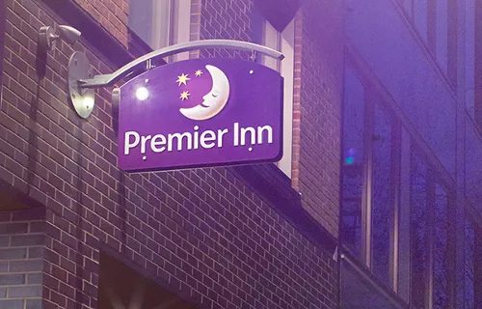
Figure 2 Hotel Premiere Inn
The operations of the company were further underpinned by its strategic growth plans which include the aim to expand the hotel room capacity by a quarter by 2030. It is also an element of an aggressive growth strategy which not only improves its market position in the UK, but also in such countries as Germany, where Premier Inn is growing exceptionally fast. Further, the pricing strategy was also more adaptable and the value-oriented products the brand sold enabled it establish a larger market share in the segment of budget hotels. The increase in revenue and combined with Premier Inn’s strategic position within the market and future growth plans are evidence of its continued resilience and the potential to capitalise on the growth that will take place within the travel market within the coming years.
Comparison of Revenue Strategies
Shangri-La targets business travellers and investors, driving directly from luxury services, perfectly mixed-use developments, and ancillary income sources, while Premier Inn targets mass-market consumers by offering both market growth at lower prices and more effective expansion at significant growth opportunities.

Market Position
Shangri-La Hotels
Shangri-La Group has a leading market position in luxury hotel space, it services Quality hotel, strict service quality and has operations in Asia especially in China, Hong Kong and Southeast Asian countries (Shangri-La Group, 2024). It has affiliate hotels over 100 with brand names such as Shangri-La; Kerry; Traders; and Hotel Jen; providing quality services to its affluent guests and business travellers. Their concentration on great population densities and selected luxury resort areas has established its presence in the luxury hotel market particularly the Asia-Pacific market, where it has earned a large market share (He, 2024).
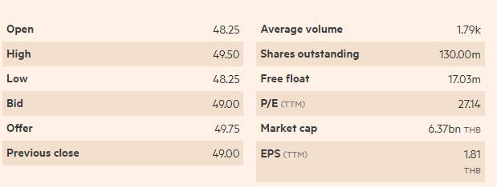
Figure 3 Shangri-La Hotel PCL (SHANG:SET) traded at 49.50, -4.81% below its 52-week high of 52.00, set on Sep 10, 2024 (Source: Financial Times)
Shangri- La competes with other luxury hotels groups including Marriott International, four seasons, Mandarin oriental and others but, has set itself apart through offering oriental hospitality and willingness to work with guests individually. There are also additional service categories such as retail, office, and other combined use & development services, which boost the company’s revenue channels and market stability (George, 2021). After COVID-19 restrictions to travelling ease gradually for arranging leisure and business Tours, this competitor has established brand awareness, excellent hotels and effective loyalty strategies to market it (Chen and Chon, 2016). An ongoing investment in social responsibility and sustainability programmes also complements its market advantage, mainly considering consumers’ environmental consumerism (Bauer, 2017).
Premier Inn Hotels
UK’s Premier Inn is one of the largest and widely preferred economy hotel chains, which occupy a leading position in the country’s economy hotel industry. Premier Inn is one of the largest hotel chains in the UK and part of the international leisure, drinking and dining business, Whitbread PLC being in operation in the country with over 840 hotels and over 82,000 rooms available. It mainly has competition with hotels in its budget segment like Travelodge but is able to sustain competitive advantage with the help of greater number of locations, well-established brand image, and the policy of offering, affordable and quality accommodation to business and leisure travellers. Another factor that enhancing the position of Premier Inn in the market is by their strategic expansion plans to double its room stock by 2030.
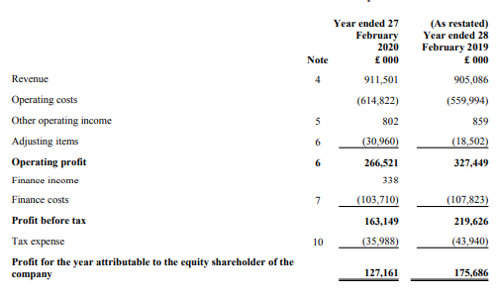
Figure 4 Income Statement 2020 (Annual Report, 2020)
This expansion will consolidate its position in the domestic market additional to boosting its circulation in the global market particularly Germany where Premier Inn is expanding most. Furthermore, the firm has in recent years focused on digital technology in marketing flexibility in pricing structures and mobile responsive bookings, making it act as a key reference to price-conscious tourists. This competitive strategic thrust within the budget hotel segment has allowed Premier Inn remain relevant, dominant market share for the budget hotel establishment and planning on expanding onto Europe.
Comparison of Market Position
Shangri-La stands as one of the leading hotel chains in the luxury segment offering luxurious hotel accommodations along with an individual approach to each client worldwide, but especially in Asia (Shangri-La Asia Ltd. 2022). The foremost prominent name in the United Kingdom’s simple and economical hotels is Premier Inn, known for its numerous numbers of quality hotels. Shangri-La is a leader in the luxury segment while Premier Inn targets and leads the economical segment and both companies offerings are strategic and precise.

Growth Potential
Shangri-La Hotels
There is a potential for growth in Shangri-La Group since it has established itself well in the market, has good strategies of expansion and since travelling is bound to recover globally in the future. The company serves over 100 hotels across Asia, the Middle East, and Europe, so it has good conditions for taking advantage of the growth in the luxury travel and hospitality market in the context of the post Covid-19. Thus, when, and if, international tourist arriv als grow again, Shangri-La has a strong track record and expertise in creating high guest satisfaction to compete effectively in markets such as China, Southeast Asia, and the Middle East.
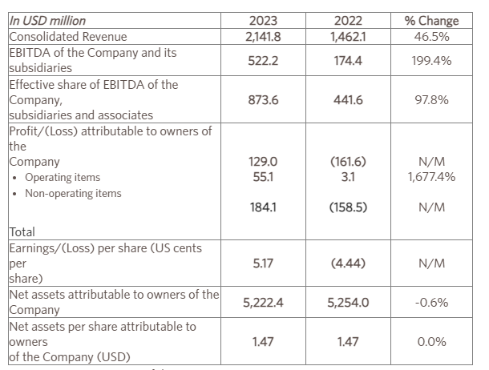
Figure 5 Financial data of 2023 and 2022 (Source: Shangri-La, 2023)
Some New objectives are to include new hotel construction, to increase deal; with the greater penetration into strategic markets, including the introduction of new mixed-use division and luxury residences to complement its core business lines (O’Neill, 2024). Moreover, more concentration is paid to invest in improving its digital platform, and creating loyalty programmes as well as service differentiation to tap the untapped pool to its potential clients such as the high-end travel generation Y clients and business men.
The company also prioritises sustainability and expands the usage of environment-friendly and CSR strategies within Shangri-La. It is believed that this commitment will be good for consumers and investors who are interested in protecting the environment, and will help improve its brand image and its operations in a given market. So, as people start to travel overseas once again, and as a consumer appetite shifts toward the high-end, sustainable integration of hospitality solutions, the company is poised to harness all of these operations to spearhead future growth.
Premier Inn Hotels
The company has demonstrated and outlined tremendous development opportunities with specifically defined expansion and development strategies as the company’s foundation. Premier Inn being one of the biggest budget hotel chains in the UK aims to expand its rooms inventory by 25 percent by 2030. This bold growth strategy seeks to avail itself of increased demand in cheap accommodation both locally and in the global market (Statista, 2022). In the UK, the strategy of Premier Inn to grow its network in faster-growing segments and broaden its choice of hotels in the suburban and city center puts it in a good stead to reap bigger rewards from the rising popularity of staycations. The biggest growth opportunity internationally is the expansion to Germany by Premier Inn. The brand has been gradually expanding its presence in Germany where there is a growing concern for affordable good quality hotels.
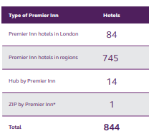
Figure 6 Premier inn portfolio
Copied directly from the UK model, Premier Inn is all set for a decisive intervention in Europe’s hotel industry. Moreover it can be said that Premier Inn has better opportunities in the field with regard to increased technology applicability in hospitality industry. Use of technologies especially in managing bookings through mobile apps will be thought to improve on the guest experience for Tech savvy guests. Acceleration of travel in the post-COVID era makes Premier Inn’s combination of growth and diversification offer a strong growth outlook in both current and emergent opportunities.
Comparison of Growth Potential
Organic growth for Shangri-La can be in terms of geographical diversification and strengthening the luxury portfolio and sustainability as the primary differentiator in attracting the luxury customer segment. Premier Inn plans to expand its capacity by 25% by 2030, with top growth potential in the UK and European economy hotel markets (Statista, 2024).

Financial Commitment to CSR
Shangri-La Hotels
Shangri-La Group has also shown financial commitment to CSR showing that sustainability and social returns are part of business processes across the company. The group has adopted different CSR projects, some of which include environment, social & other relevant causes and sustainable management. To support their strategic CSR initiatives they operate the Shangri-La Sustainability Program devoted to turning their hotels into energy-efficient centers, saving water and Landsberg on waste disposal (Pang, 2020). Have invested a significant amount of capital on these objectives such as the enhancement of hotels’ infrastructure and systems to conform to green building principles and the adoption of renewable power technologies in their hotels.

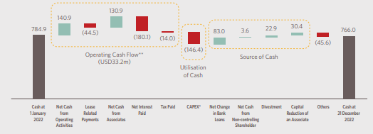
Figure 7 Annual Report 2022
Another CSR strategy developed by the Company is called Embrace and Sanctuary that is aimed at encouraging support of communities and conservation of biologic diversity. Goals of targets are education and health for poor children and long term financial commitments to schools and clinics that are in areas where the group operates (Shangri-La Asia Ltd. 2022). The Sanctuary program was created to to focus on the conservation of biological diversity that is innovation of which Shangri-La funds and provides support for projects related to endangered species and the recovery of natural environments.
Moreover, the group provides resources for staff care and development which focuses on staff relations and employment, workplace diversity, and health. This focus on and practice of CSR is not only good for their brand image, they also appeal to the current societal trends of challenging business organizations to be socially responsible or environmentally conscious.
Premier Inn Hotels
Interestingly Whitbread, where Premier Inn operates, has a clear financial commitment to Corporate Social Responsibility (CSR) which ensures sustainability and community impact becomes an inherent part of business strategy. The organization has made enormous capital expenditure on environmental stewardship by implementing a Force for Good plan, a program that emphasizes sustainable living, employers’ health, and corporate governance (Osum, n.d.). Key commitments include the fight against climate change by changing the company culture to reach net-zero carbon emissions by 2040; enough has already been done in the field of energy management within Premier Inn hotels and the company prefers investing in renewable energy sources.
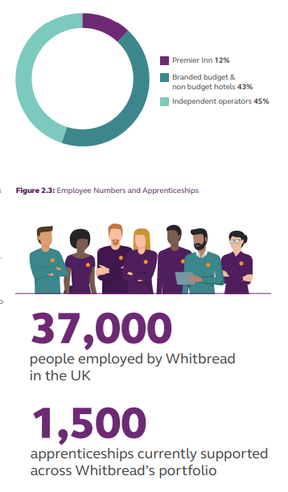
Figure 8 Market Share of Premier Inn
Eco Measures: Currently, Premier Inn has also carried out water conservation programs and energy-efficient lighting and charging points at many of its locations use Electric Vehicle charging points. Further, it has a policy of eradicating the use of plastics and was keen on enhancing recycling in all the hotels that it was operating (Page and Connell, 2020). On the social responsibility front, Premier Inn gives a customer aid to Great Ormond Street hospitals and offers employment both to its customers and employees (Buttle et al., 2021). This company also practises equal employment opportunities and the representation and inclusion of people in the workplace and thus is a good example of the company’s commitment to social justice (Sweney and Mark, 2023). By making these financial expenditure and corporate sustenance, Premier Inn seeks to establish its credible organizational status as corporate organization that and responsible member of the hospitality industry geared towards satisfying the growing demand in market for organizations that are environmentally and socially responsive.
Comparison of CSR Commitments
Organization: Shangri-La has a professional approach to environment and community, luxury, and conservation within their building initiatives and the Embrace and Sanctuary programs. The ‘’Force for Good’’ program under Premier Inn addresses emissions, a net-zero by 2040, environmental friendly practices, diversity and inclusion as well as engagement with the society.

Recommendations
For Shangri-La Hotels, which area to focus on is the continuous growth to other regions and the improvements of their online system. Moreover, there will be an investment in sustainability projects which will attract tourists who are conscious of the environment, and more investors (Gursoy et al., 2022). Accelerating international growth, especially in Europe for Premier Inn, is likely to provide more furniture revenue stream diversity (Wood, 2017). Continued improvement in the products, focusing on their price advantage as well as integration of sustainability factors will further entrench their competitive advantage in the budget hotel market (Bas and Sivaprasad, 2022).

Conclusion
In conclusion, thus two players, namely Shangri-La Hotels and Premier Inn show healthy market positions and coherent strategies. Shangri-La targets the luxurious market and international markets while Premier Inn Specialises in the economy segment. Both need to consider sustainability all over again in order to be competitive and sustainable in the future.

References
Annual Report 2022. Premier Inn Hotels Limited Contents. 4 Oct. 2022.
Bas, T. and Sivaprasad, S., 2022. An Exploratory Insight into the Impact of COVID-19 on the Travel and Tourism Sector: UK Evidence. Bas, T. & Sivaprasad, S.(2022). An exploratory insight into the impact of COVID-19 on the travel and tourism sector: UK evidence. In S. Karabulut (Ed.), Economic and Financial Analysis of Global and National Developments, pp.355-369.
Bauer, T., 2017. Human rights obligations of international hotel chains. In Sustainability in hospitality (pp. 8-24). Routledge.
Buttle, F., Bowie, D., Brookes, M. and Mariussen, A., 2016. Hospitality Marketing. Routledge.
Chen, A.L. and Chon, K., 2016. Transferability of Asian paradigm in hospitality management to non-Asian countries. In Tourism and hospitality management (pp. 143-157). Emerald Group Publishing Limited.
Financial Times 2024, Shangri-La Hotel PCL, SHANG:SET profile - FT.com, markets.ft.com, viewed 4 October 2024, https://markets.ft.com/data/equities/tearsheet/profile?s=SHANG:SET
George, R., 2021. Tourism and Hospitality Marketing Principles. In Marketing Tourism and Hospitality: Concepts and Cases (pp. 3-31). Cham: Springer International Publishing.
Gursoy, D., Buttle, F. and Bowie, D., 2022. Hospitality marketing: Principles and practices. Routledge.
He, K 2024, Shangri-La Returned to Profit in 2023 with 47% Revenue Jump, Mingtiandi, viewed 4 October 2024, https://www.mingtiandi.com/real-estate/finance/shangri-la-returned-to-profit-in-2023-as-revenue-jumped-47-on-travel-recovery/
Kee, D.M.H., Ang, Z.L., Woh, M.T., Soleimani, M., Jayant, J., Quttainah, M.A. and Pandey, R., 2020. Shangri-La Hotels and Resorts’ People and Culture Strategy in Deriving Employee Satisfaction. Advances in Global Economics and Business Journal, 1(1), pp.1-11.
O’Neill, Sean. “Premier Inn to Grow Hotel Room Count by 25% before 2030.” Skift, 30 Apr. 2024, skift.com/2024/04/30/premier-inn-to-grow-hotel-room-count-by-25-before-2030 Accessed 4 Oct. 2024.
Osum. “Premier Inns Market Share: A Force to Be Reckoned with - Osum.” Osum, 11 Mar. 2024, blog.osum.com/premier-inn-market-share. Accessed 4 Oct. 2024.
Page, S.J. and Connell, J., 2020. Tourism accommodation and hospitality services. In Tourism (pp. 216-241). Routledge.
Pang, J.M., 2020. Adopting “East Asian” cultures and themes in hotel branding: a study of the M. Mandarin. Asia Pacific Journal of Tourism Research, 25(10), pp.1085-1097.
Shangri-La Asia Ltd. 2022, Cover Photos: 1. JEN Shenzhen Qianhai by Shangri-La 2. Kerry Hotel, viewed 4 October 2024, https://sitecore-cd.shangri-la.com/-/media/Project/Shangri-La-Group/Investor/Files/Public-Disclosures/Latest-Top-Publications/e0069_230418_AR.pdf
Shangri-La Group 2024, Shangri-La Group, www.shangri-la.com, viewed 4 October 2024, https://www.shangri-la.com/group/media/media_post?post=Shangri-La%20Group%20Releases%202023%20Full%20Year%20Results
Statista 2024, Shangri-La Malaysia: revenue by business segment, Statista, viewed 4 October 2024, https://www.statista.com/statistics/1199674/shangri-la-malaysia-revenue-by-business-segment/
Statista. “Premier Inn Hotel Occupancy Rates 2011-2020.” Statista, 2022, www.statista.com/statistics/739831/premier-inn-hotel-occupancy-rates/. Accessed 4 Oct. 2024.
Sweney and Mark. “Premier Inn Owner Surpasses Pre-Covid Profits as Travellers Seek Deals.” The Guardian, 25 Apr. 2023, www.theguardian.com/business/2023/apr/25/premier-inn-whitbread-pre-covid-profits-deals Accessed 4 Oct. 2024.
Wood, R.C., 2017. Hotel accommodation design. In Hotel Accommodation Management (pp. 46-56). Routledge.

