Introduction to Health & Social Care
Student Name: Abdul Majid
Student ID Number: 2520511
Assignment Title: Component 1
Module code: LCH4003
Lecturer: Vivian Osuchukwu



Ambulance Service

Ambulance Service is one of the parts of the National Health Service that serves the citizens of the United Kingdom with emergency and urgent medical care.

Ambulances operate on regional basis such as the West Midlands Ambulance Service or other ambulance trusts of NHS in England along with the same in Scotland, Wales, and Northern Ireland.

To conclude, the NHS Ambulance Service is the service that offers medical help, medical emergency treatments, and transportation of patients.


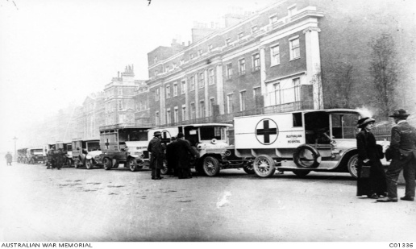

Brief History:
📅 1948 – Ambulance services became part of the newly created NHS.
📅 1974 – Regional ambulance authorities established to improve coordination.
📅 1990s–2000s – Introduction of advanced paramedic training and modern emergency equipment.
📅 2010s–Present – Development of specialist response teams, air ambulances, and digital dispatch systems.


Key Roles
999 Call
↓


Control Centre
↓
Ambulance Dispatch
↓

On-Scene Treatment Hospital / Specialist Care

Current Functions

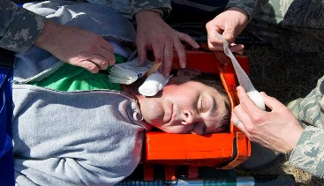

Emergency Response
Responding to:
- Heart attacks
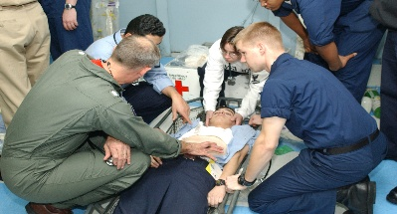

- Strokes
This Photo by Unknown Author is licensed under CC BY-SA
- Severe injuries
- Breathing difficulties
- Road traffic collisions

Challenges Faced by the Ambulance Service
The NHS Ambulance Service gets a huge number of calls each day – both emergencies and non-emergencies. With more aging Brits and seasonal sicknesses, there are more calls in peak times. This spikes demand, adding stress to already busy crews and call centres.
Sometimes ambulances wait outside hospitals because there's overcrowding and a lack of available beds. Patients can't get transferred right away to the emergency department staff due to this issue.



Community Disability Services:
Community disability services in the UK offer a bunch of health and social care helps, like personal care, supported living, and day centres. They also do rehab programmes, give out assistive tech, and run events to help folks mix with others. The goal is to let people with physical, learning, or sensory disabilities live as normal a life as they can in their communities. This push towards community support marks a big change from earlier policies that often-kept disabled people in institutions.
Origins and Historical Context:
Community disability services in the UK started in the post-war era, along with the NHS and welfare state in 1948. Back then, care for disabled folks mainly meant putting them in institutions, like long-stay hospitals, where they were cut off from everyone else. According to Barnes (2012), the prevailing view saw disability through a medical lens, focusing on treating impairments or isolating the person.
Starting in the '60s, people grew unhappy with how confined and inadequate those institutions were. Plus, residents had almost no freedom to make choices for themselves. This sparked protests and advocacy from disabled people fighting for equal rights and more inclusive communities. So, the social model of disability popped up, claiming disability is caused by societal barriers not personal limitations, as (Oliver 1990) explains.
The NHS and Community Care Act of 1990 was a big deal because it made local authorities responsible for assessing care needs and providing community support rather than institutional care (Department of Health, 1990). Then, the Care Act 2014 built on that by boosting rights-based methods, emphasizing wellbeing, prevention, and more personalized care (Department of Health and Social Care, 2014).
How the Service Functions Today:
Now, community disability services work with a bunch of different agencies including local councils, NHS teams, and charities. Social workers team up with OTs, physios, and mental health pros to figure out what folks need and then plan their care together.
These days, there's more focus on person-centred care where people have said in their support via personal budgets or direct payments. So, service users get to pick how and who delivers their care – giving them much more control.
While the system aims to be inclusive, it faces several challenges. Local authorities, facing funding pressures, cut services and tighten eligibility rules. Because of this, many people either wait longer for help or get reduced care. Service differences between regions lead to unequal access, according to Glendinning et al. (2008).
Staffing problems add another layer of difficulty. It's tough to hire and keep caregivers, who struggle with heavy workloads and low pay. This situation affects both the quality and continuity of care. Still, the system is getting better at using tech to aid independence through devices like communication gadgets and telecare systems.
Significance in Enhancing Quality of Life:
Community disability services really boost quality of life by helping people stay independent, respected, and included. They do this by letting folks stay in their homes instead of institutions, which helps keep family ties and friendships strong.
A big advantage is how these services help with everyday tasks like cooking and getting around, giving people more control over their lives. This lines up with the social model of disability, which focuses on removing obstacles from society so that attention isn't just on the person's impairment.
Access to education, jobs, and social events cuts down on loneliness and boosts mental health. Research shows community support makes folks happier and more psychologically sound than putting them in institutions (World Health Organization, 2011).
While there are hurdles, moving toward individualized community care is way better. This reflects a greater focus on equality and human rights, though we need to keep investing for it to work well consistently.
Conclusion
The UK's community disability services have shifted from old-school institutional models to ones focused on individual rights and community inclusion. Although funding issues and staff shortages remain problems, these services still play a key role in boosting quality of life for those with disabilities. This lets them take part more in society, which is super important.

References
Barnes, C. (2012) Disability and the Myth of the Independent Living Movement. Leeds: The Disability Press.
Department of Health (1990) NHS and Community Care Act 1990. London: HMSO.
Department of Health and Social Care (2014) Care Act 2014: Statutory Guidance. London: DHSC.
Glendinning, C., Arksey, H., Jones, K., Moran, N., Netten, A. and Rabiee, P. (2008) ‘Accessing social care: influencing factors and outcomes’, Social Policy & Administration, 42(3), pp. 209–232.
Oliver, M. (1990) The Politics of Disablement. London: Macmillan.
World Health Organization (2011) World Report on Disability. Geneva: WHO.

