University of Wales Trinity Saint David

Securing Successful Study Skills

Ellie Davies
https://uowtsd.sharepoint.com/teams/ECES4012SecuringSuccessfulStudySkills-SwanseaCohort_GRP-EllieDavies/Shared%20Documents/Recordings/New%20channel%20meeting-20231019_110401-Meeting%20Recording.mp4?web=1

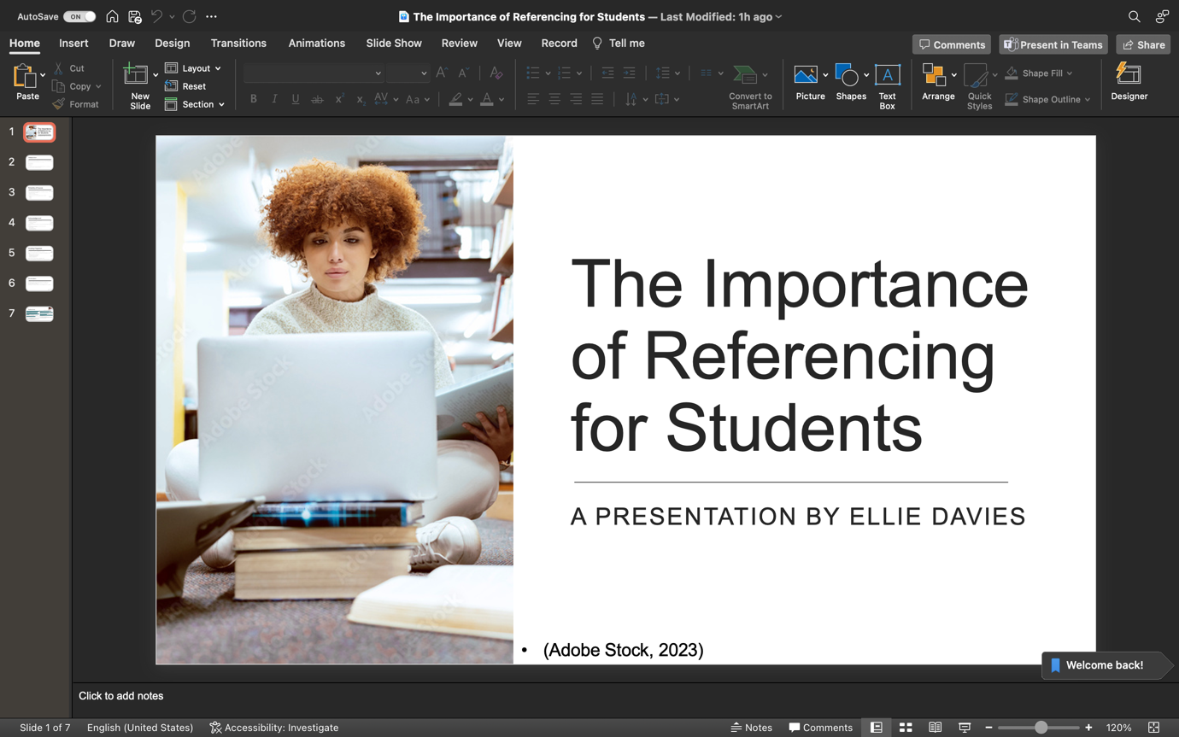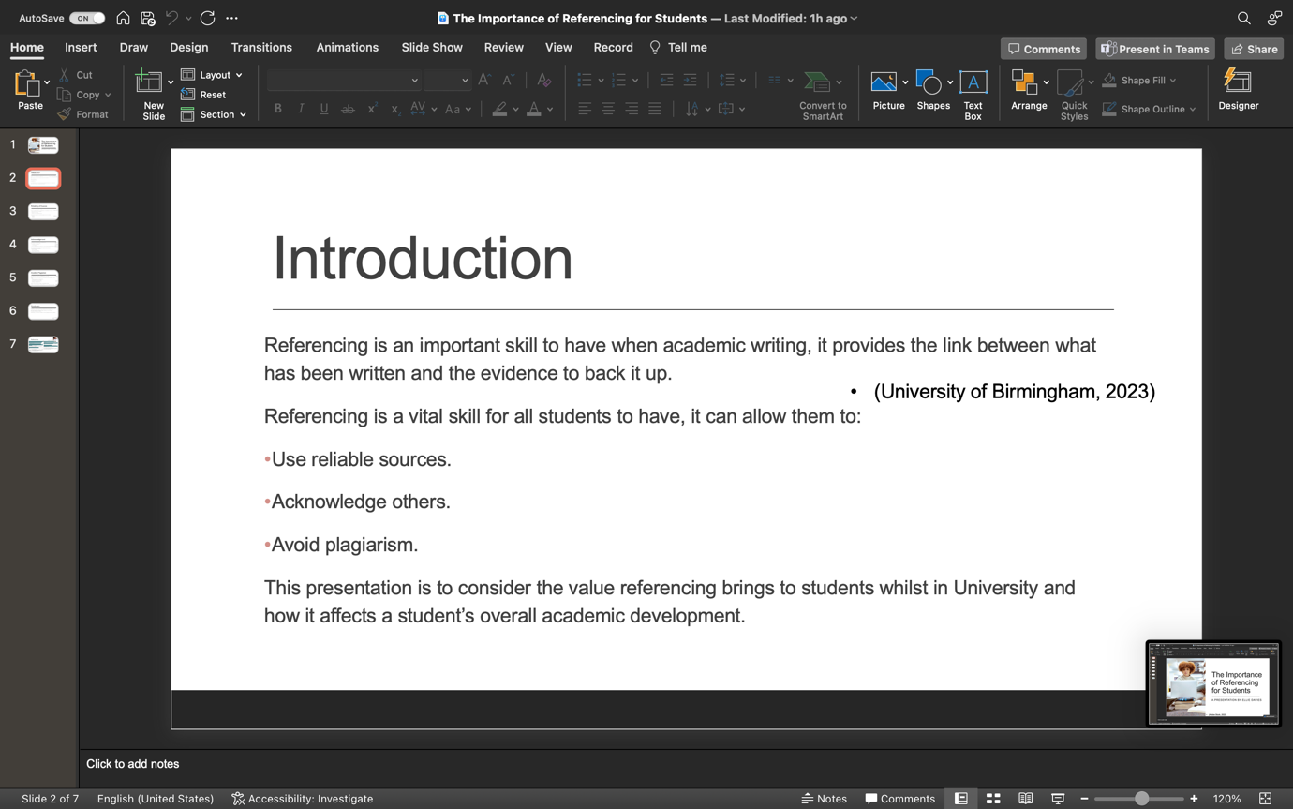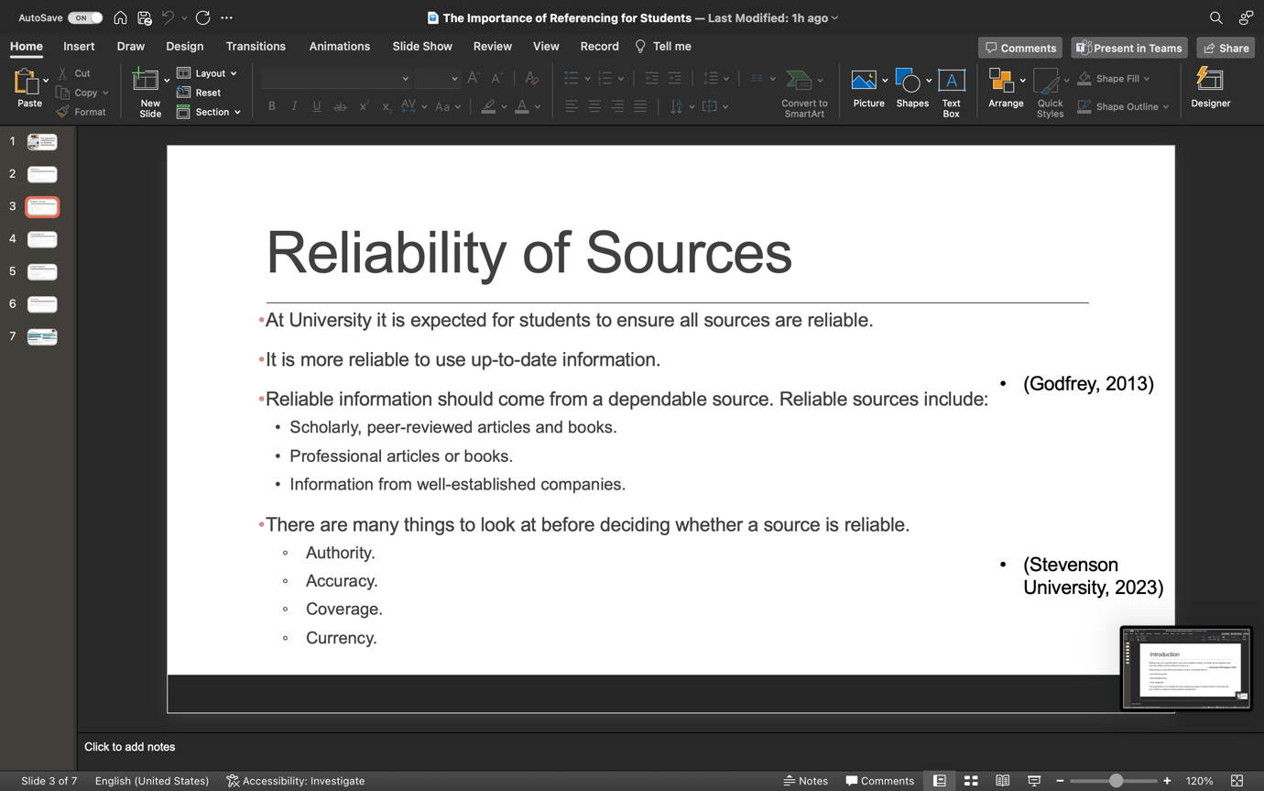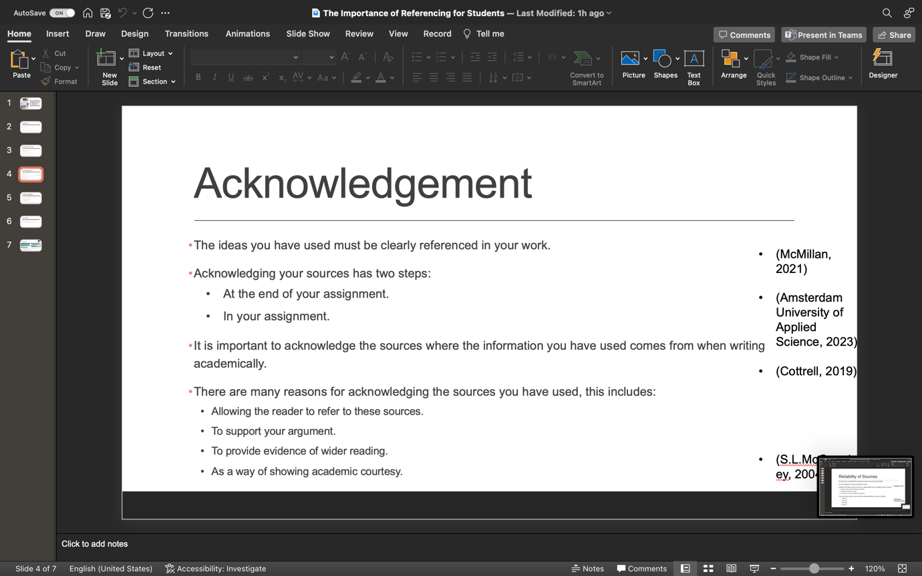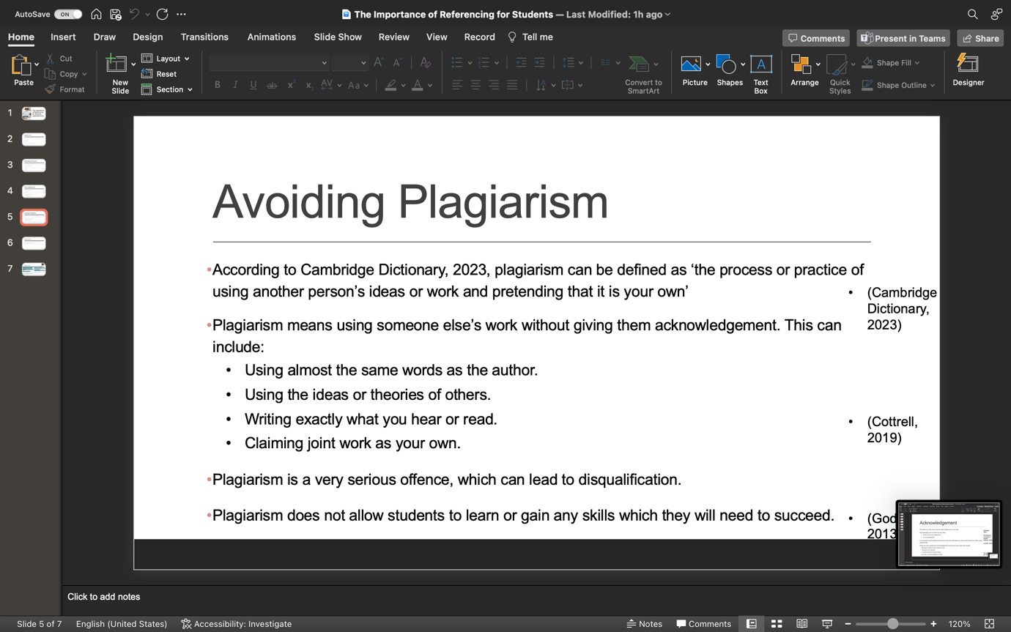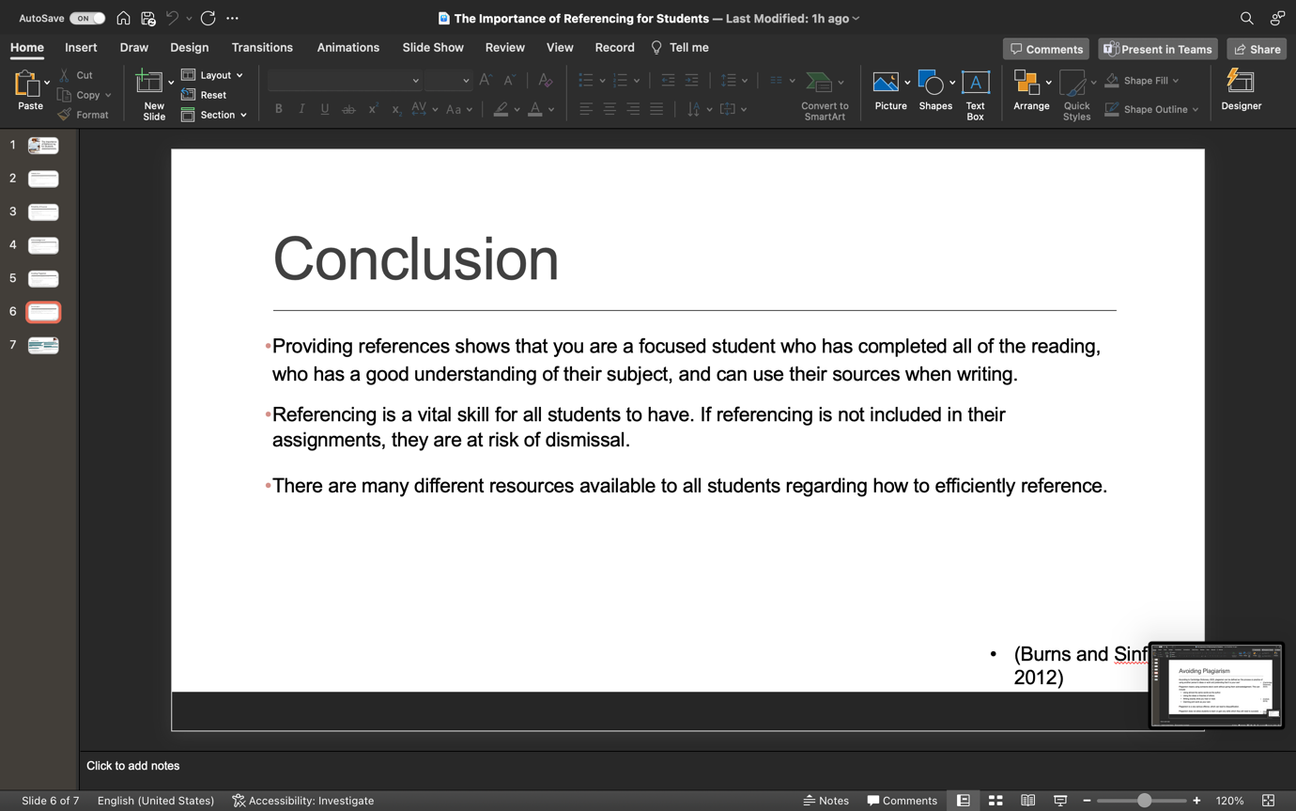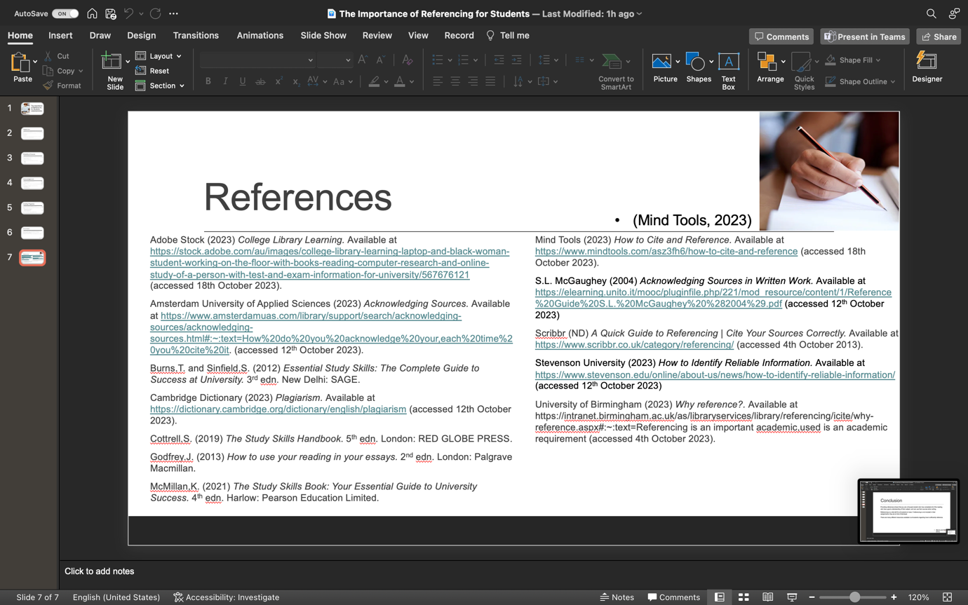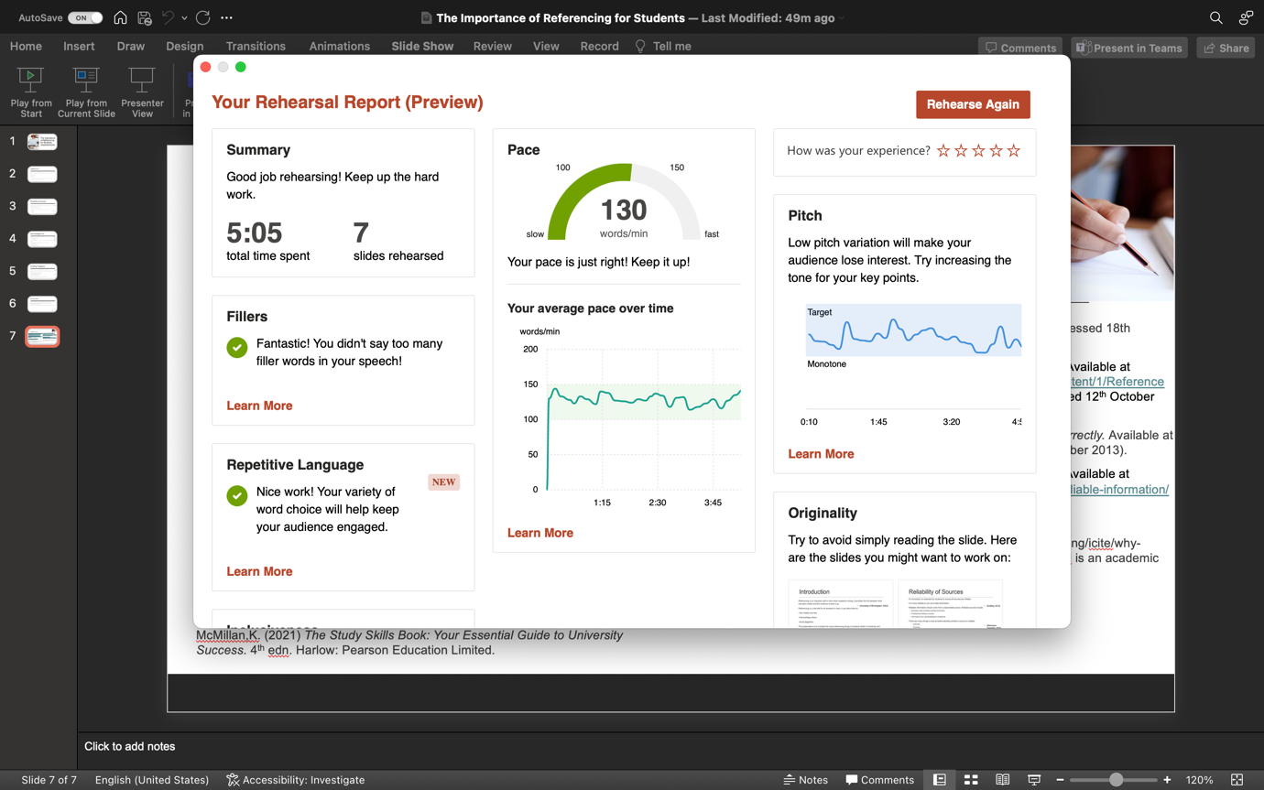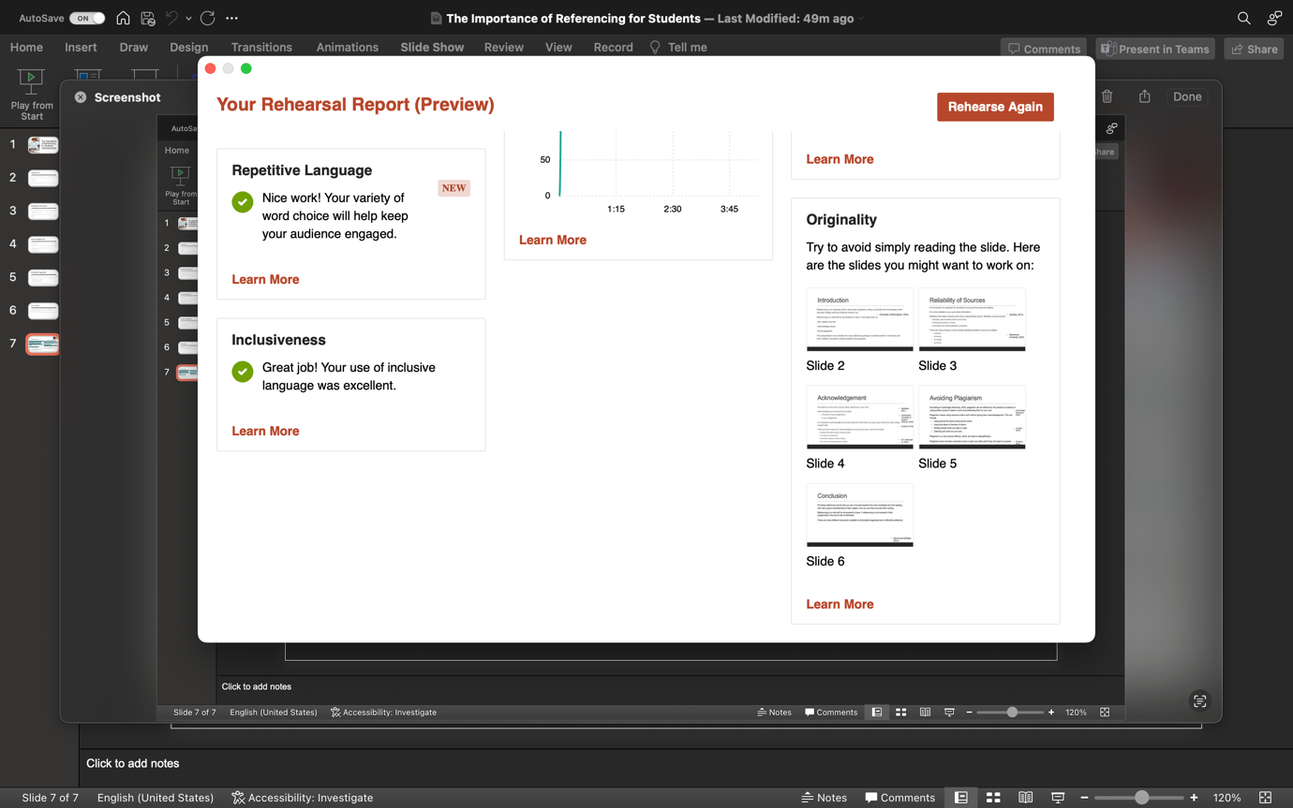

The topic of my reflection was study skills, after deliberating I chose referencing as my chosen skill to write about. Before beginning my presentation, I ensured to undertake a lot of research about my chosen topic to guarantee all the information I was using was relevant and of good quality, this research helped me to explain each title to the best of my ability. I felt confident about carrying out my presentation and I believe that it went very well.
After completing my presentation Microsoft Coach provided a rehearsal report, this report provided me some feedback about how I need to improve on my tone of voice and my originality. Your voice can be considered a vital piece of equipment when doing a oral presentation, it is important to keep your pitch, tone and pace varied in order to emphasise the point you are making. The pitch of your voice should be at whatever level is comfortable, whereas the tone of your voice needs to be as friendly and inviting as possible when conveying information. The tone of your voice should change throughout your presentation to emphasise points that are being made, as mentioned by (Smale,B. and Fowlie,J., 2009). In my presentation, at some points my voice was monotone according to Microsoft Coach, this will not allow the viewer to stay engaged as for many people a monotone voice will cause them to switch off and stop taking in all of the information that is being relayed to them. The tone of your voice is very important when showing different meanings, for example when you would like to show the viewers of your presentation that something is of importance, your voice should slow down and pause to give them time to take the in the important information. The tone of your voice will allow them to know that what you are saying is important, as explained by (Emden,J.V. and Becker,L., 2016). Microsoft Coach also picked up on some originality issues, it stated that on some slides I was ‘simply reading the slide’. It is vital then when presenting you do not just read the slides, as for many people they can already see what is on there, they may not need it to be read out to them. Some people may begin to lose interest if you are relaying information they have just read for themselves, as mentioned by (University of Sussex, 2023). A visual component and a voice are much better communication tools that just reading a piece of text and listening to what is being said, images are a vital component to a good presentation, according to (Presented, 2023).
I faced some challenges when creating my presentation, one challenge was that I had difficulty condensing all the information that I had gathered. McMillan,K. (2021) points out that your presentation should be limited to key words and bullet points, these are your prompts. I found it difficult to reduce my information to pointers as I felt that everything was necessary to my topic. Your presentation slides are not a way to pass on all the information you have about a topic. They are a way of getting the audience’s attention and helping them understand what is being said. It is speculated that too much information displayed at one time can distract the viewer, as explained by (Pritchard,A., 2008). As Smale,B. and Fowlie,J. (2009) state a good introduction helps to grab the audience’s attention, I believe one of my successes were that I had a strong introduction which conveyed all of the necessary information. Another success was having a definite and clear idea of the purpose of each slide. I ensured that all of my slides conveyed a different message, this ensures that the viewer can differentiate between each slide and not get confused by any possible overlapping information, as stated by (Pritchard,A., 2008). I believe that the structure of my presentation was very good, I ensured to tell the audience what they would be learning in the introduction, I then gave all the information in the main body, then I told them what I had already told them in my conclusion. I believe that this is a good way to present as it keeps the viewer engaged and allows them to know exactly what will be presented to them, as explained by (University of Sheffield, 2023)
If I were to do another presentation whilst at University, I would add some key components to ensure my presentation is of a good standard. These things would be adding more images and ensuring good eye contact and body language. It is important ensure that images are included in some of your slides, a presentation which just consists of text and no images to back it up will seem very boring, as described by (McMillan.K., 2021). It is thought that many viewers like something to look at when someone is giving them information. Some of the audience may be visual learners so they will benefit more from having an image or a diagram to look at over pages of text, as explained by (Pritchard,A., 2008). The message you are conveying is likely to be enhanced when using visual aids, they allow you to show the viewer something clearer than you can describe it, according to (Smale,B. and Fowlie.J., 2009). The use of body language and eye contact when presenting is vital, it is okay to move around a little to engage the audience. Hand gestures can be used to emphasise a point you are trying to make and to reinforce the meaning behind what you are showing them, as mentioned by (McMillan.K., 2021). Keeping eye contact with your viewers may help to keep them involved, it may also help to keep them included and engaged when you are talking. To gain the skill of maintaining eye contact and good body language, you must first learn how to speak from the titles of each slide rather than just speaking from a script. If you are staring at your presentation viewers are going to become uninterested in what you are telling them.

Reference List
- Emden, J.V, Becker, L. (2016) Presentation Skills for Students. 3rd edn. Dublin: PALGRAVE.
- McMillan,K. (2021) The Study Skills Book: Your Essential Guide to University Success. 4th edn. Harlow: Pearson Education Limited
- Presented (2023) Why you shouldn’t read from your PowerPoint slides. Available at https://presented.co.uk/should-you-read-from-your-powerpoint-slides/. (accessed: 20th October 2023)
- Pritchard,A. (2008) Studying and Learning and University: Vital Skills for Success in Your Degree. London: SAGE Publications Ltd
- Smale,B. and Fowlie,J. (2009) How to Succeed at University: An Essential Guide to Academic Skills and Personal Development. London: SAGE Publications Ltd
- University of Sheffield (2023) Presentation Skills. Available at https://www.sheffield.ac.uk/academic-skills/study-skills-online/presentation-skills#planning. (accessed 20th October 2023)
- University of Sussex (2023) Presentations, seminars and group work. Available at https://www.sussex.ac.uk/skills-hub/presentations-and-group-work#Delivering. (accessed: 20th October 2023).

