HR Roles and Behavioural Requirements of HR Professionals
Student ID: 1201576
Name: Rachel Thomas

Executive Summary

People who work in the HR profession are seen to be ‘professionals’ in this area. But, what a lot of people do not realise is, that there is a lot of time and effort that goes into individual development.

The CIPD HR profession map clearly sets out the stages of effective people management practice across ten professional areas, illustrating eight fundamental behaviours that support good practice. The map covers every level of the HR profession from Band 1, who are at the start of an HR career, through to Band 4 for the most senior leaders breaking down each behaviour and professional area to reflect what is expected.

The Profession Map is becoming an increasingly used tool within the HR profession, to identify individual behaviours, skills and knowledge outlining opportunities for future development.

Contents
Introduction 2
HR Professionals 2
CIPD HR Profession Map 2
Bands of Professional Competence 3
Core Functions 3
Professional Areas 4
Behaviours 5
New Profession Map 6
Conclusion 6
Recommendations 6
Reference List 6
Bibliography 7

Introduction
Many people class themselves as ‘professionals’ in their line of work. A commonly held viewpoint explained by Lester (2010, p.2) is that a professional is someone who:

“makes proficient use of expert or specialist knowledge ... Such a person need not be a member of an easily defined profession or of a professional association; it is possible to work as a professional from a set of expertise and skills.”

HR Professionals
The CIPD acts as a governing body for the HR profession in the UK and Ireland, and even though membership is not compulsory to the profession unlike Law and Medicine, the creditability level of which, is very high.

Woodhams, Perkins and Wilkinson (2016, p.109) highlight that “knowledge, skills and continuous professional development are at the top of the Human Resources agenda”. Using the CIPD’s HR Profession Map, individuals can identify their strengths and weaknesses, diagnosing areas of developmental need.

CIPD HR Profession Map
The CIPD’s HR Profession Map is a competency-based framework that reflects the stages of effective people management practice across ten professional areas, illustrating eight fundamental behaviours that support good practice. The map covers every level of the HR profession, breaking down each behaviour and professional area to reflect what is expected.
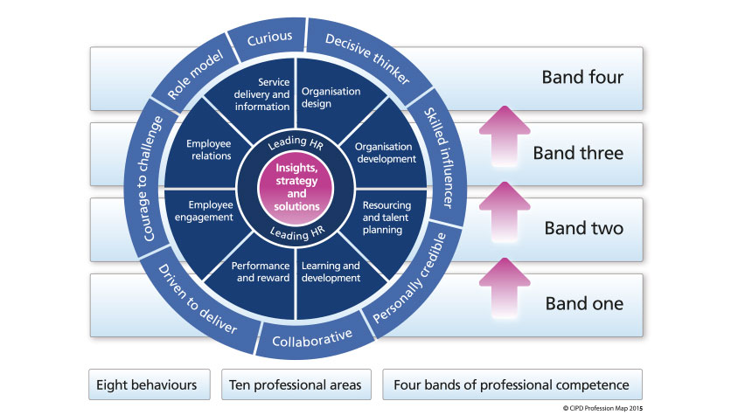
CIPD (2015a)

Bands of Professional Competence
The Profession Map is targeted at HR professionals in Band 1, who are at the start of a HR career, through to Band 4 for senior leaders, breaking down necessary behaviours and responsibilities expected at each level and providing a pathway to focus individual development activities with the view of transitioning into the next band.

These four bands are defined by CIPD (2020b) as “the contribution that professionals make at every stage of their HR career”. In particular:

- Relationships with clients
- Focus of activity performed by HR professional
- Services provided to the client
- Measuring contribution and success

As a HR Assistant, efforts should be made in advising others on HR information, understanding the issues raised along with the consequences and possible outcomes, and to act as an immediate point of contact to achieve client satisfaction.

Core Functions
The core of the Profession Map provides the foundations of HR capability regardless of the role being carried out or the stage of one’s career.

The first core function identifies the knowledge set, skills and behaviours needed to understand the organisation by tailoring strategies and solutions to meet organisational needs. Such information can be obtained through experience working with the organisation, or published reports, internally and externally.

The second core function is built around the need for individuals to act as role models within their department and throughout the organisation, contributing to further HR activities, and specific functions to develop and support others, by mentoring and shadowing, providing information and advice to all when needed.

Professional Areas
In addition to the two core functions, the additional eight professional areas as outlined by the CIPD (2015c) “describe what you need to do (activities) and what you need to know (knowledge) for each area of the HR profession”. Each area can be defined as:

- Organisation Design – Look at the structure and design of organisations, i.e. ensuring that employee levels are appropriate to deliver maximum impact to communities and its stakeholders in the short and long term.

- Organisation Development – Identify capability requirements of the organisation and individuals with managers. Align strategies, people and processes to meet organisational goals.

- Resource and Talent Planning – Identify from staff establishment figures whether the organisation has the right talent and resources to achieve immediate and future strategic goals. Work with Managers to use succession planning data for filling key positions.

- Learning and Development – Build organisational capability and knowledge through training, emphasise a learning culture for future development and career progression.

- Performance and Reward – Deliver events such as ‘Celebrating Success’ to appreciate and encourage the workforce to continue performing to a high standard.

- Employee Engagement – Ensure fulfilment amongst employees within their roles to increase productivity and morale. Clear communication between employee and management when issues arise.

- Employee Relations – Provide procedures that are informative, unpinned by relevant law/legislation such as GDPR.

- Service Delivery and Information – Question and explore concerns raised, providing efficient and effective responses to queries throughout the employee lifecycle, ensuring clear accountability within the team.

Depending on organisational structure and the way that HR functions operate, individuals may only have the knowledge to fit into one professional area. By using the map, individuals can understand the level of knowledge expected of them to carry out their role and help to identify CPD opportunities.

Behaviours
The outer ring of the CIPD profession map identifies and categorises eight behaviours that professionals need to carry out their roles and contribute to organisational success.
Decisive Thinker | Analyses and understands data and information quickly to provide recommendations and make decisions.
Skilled Influencer | Can influence and gain support from stakeholders to achieve the organisations objectives.
Personally Credible | Provides HR advice to bring value to the organisation and stakeholders.
Collaborative | Able to work with a diverse range of people internally and externally.
Driven to Deliver | Has the determination to deliver the best results for the organisation.
Courage to Challenge | Shows the confidence to speak up and challenge decisions.
Role Model | Leads by example. Willingness to help others.
Curious | Continuously seeks to find out further information and understanding of organisational issues, looking for opportunities to test next ideas and innovation.

HR professionals are required to deal with people, unlike industries such as Finance managers, or IT managers where they deal with fixed assets, therefore it is important that they lead by example and set the necessary standards.

New Profession Map
CIPD have since developed an updated profession map, shifting the attention from generic best practice, to values-based decision-making. In the years leading up to the new map, the ways of working have diversified, and therefore, so has the profession map.
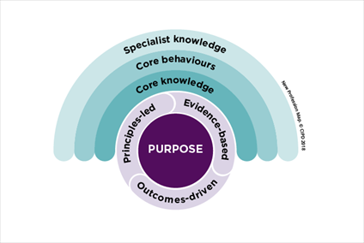
CIPD (2020d)

Conclusion
To conclude, after thorough research into the CIPD profession map, it is a useful tool for someone who works in the HR profession, outlining the skills and knowledge an individual should be working at in their current role, and ways of personal development for career progression.

Recommendations
Based on the previously mentioned findings, the below recommendations should be carried out:

- Individuals working in the HR profession should carry out an assessment of their knowledge and skills on a quarterly basis to identify learning and development opportunities.
- Opportunities should be given to those carrying out a specific role to develop their knowledge and meet the requirements of an additional professional area.

Reference List

CIPD (2020a). The 2013 Profession Map. Available at: https://www.cipd.co.uk/learn/profession-map/2013-profession-map. (Accessed: 02 January 2020)

CIPD (2020b). Bands and Transitions. Available at: https://www.cipd.co.uk/Images/Bands-and-transitions_tcm18-9700.pdf. (Accessed: 02 January 2020)

CIPD (2020c). Professional Areas. Available at: https://www.cipd.co.uk/learn/profession-map/2013-profession-map/professional-areas. (Accessed: 02 January 2020)

CIPD (2020d). The New Profession Map. Available at: https://peopleprofession.cipd.org/ (Accessed: 02 January 2020)

Lester, S. (2010). On Professionals and Being Professional [Online]. Stan Lester Developments. Available at: http://devmts.org.uk/profnal.pdf (Accessed: 07 December 2019)

Woodhams, C., Perkins, G. and Wilkinson, K. (2016) ‘Developing the Knowledge and Skill of the HR Professional’, in Taylor, S. and Woodhams, C. (ed) Studying Human Resource Management. 2nd ed. London: Chartered Institute of Personnel and Development.

Bibliography

CIPD (2015). The Core of the Profession Map. Available at: https://www.cipd.co.uk/learn/profession-map/2013-profession-map/core-areas. (Accessed: 02 January 2020)

CIPD (2015). HR Profession Map. Available at: https://www.cipd.co.uk/cipd-hr-profession/cipd-hr-profession-map/default.html. (Accessed: 02 January 2020)

Johns, T. and Perkins, G. (2016) ‘Developing Professional Practice’, in Taylor, S. and Woodhams, C. (ed) Studying Human Resource Management. 2nd edn. London: Chartered Institute of Personnel and Development.

Peacock, L. (2009). ‘CIPD Reveals HR Profession Map to Replace Old Standards’. Personnel Today. 21 April [Online]. Available at: https://www.personneltoday.com/hr/cipd-reveals-hr-profession-map-to-replace-old-standards/. (Accessed: 02 January 2020)

HR Roles and Behavioural Requirements of HR Professionals
Student ID: 1201576
Name: Rachel Thomas

Executive Summary

Teamwork is becoming increasingly more popular in the workplace, and therefore HR professionals need to ensure that the formation of such teams is correct in order to achieve organisational success.

Using Belbin’s nine team roles model, HR professionals can form teams that are made up of individuals with the right skills and knowledge who fit within the team roles structure. Time must be spent ensuring that individuals get to know each other in the first instance, to eliminate any conflicts, before going through the remaining stages of Tuckman’s five stages of team development.

For teams to be successful, communication between all parties is essential.

Contents
Introduction 3
Teamwork 3
Conclusion 6
Recommendations 6
Reference List 7
Bibliography 7

Introduction
The increasing demands of organisational life means that individuals are having to work as part of a team to assist in accomplishing organisational objectives. Working in a HR department with various functions, it is important that individuals work well together when required. A definition of ‘teams’ is:

“A group of people with a full set of complementary skills required to complete a task, job or project.”
Business Dictionary (2020)

HR professionals are required to work in teams with fellow HR professionals and/or other individuals and groups, exchanging knowledge, skills and information where results could not be reached by individualism alone.

Teamwork
In order that organisations can achieve its goals and objectives, it is important to understand that there are different types of teams within an organisation. Huczynski and Buchanan (2010) identify that teams can take many forms, including:

- Advice teams – Review committees
- Action teams - Negotiating teams
- Project teams – Planning or Research teams
- Production teams – Manufacturing teams

Individuals can be part of more than one team, at one time, carrying out different roles in each. HR professionals not only work solely with others in formal teams, but also with internal and external stakeholders. For example, a HR Assistant in charge of a small team of Clerical Assistants, will be a leader, delegating tasks, ensuring everyone is clear on the requirements. The same HR Assistant in a meeting with Service Directors and Stakeholders will take a back seat, listening to all that is going on, actioning any points raised.

When determining the reasoning behind the formation of teams, managers need to identify suitable individuals to assist, therefore teams can vary significantly in size and structure. The role an individual plays within the team will vary depending on the desired outcome and their function within the HR profession.

Mullins (2010, p.326) explains that the work carried out by individual members in teams and the role they adopt, is influenced by:

- Situational factors, such as requirements of the task, style of leadership, position in the communication network, and
- Personal factors such as values, attitudes, motivation, ability and personality.

As individuals work within a team, they behave in ways that reflect a diverse range of views, skills and interests, leading them to take on a distinctive role. Through vast research, Meredith Belbin identified that each individual in a group, behaves in ways that reflect one of nine distinct roles.
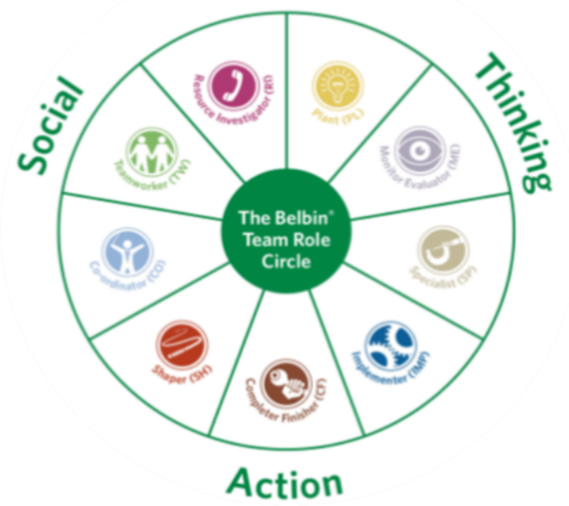
Belbin (2016a)
Resource Investigator | Outgoing, enthusiastic, explores opportunities
Team worker | Co-operative, perceptive and diplomatic
Co-ordinator | Confident, clarifies goals
Plant | Creative, imaginative, solves difficult problems
Monitor Evaluator | Strategic, serious, sees all options
Specialist | Single-minded, provide specialist knowledge and skills
Shaper | Challenging, dynamic, motivated
Implementer | Practical, reliable, efficient
Completer Finisher | Conscientious, searches out errors

Belbin (2016b) recognised that a good balance of characteristics shown, when brought together, would result in team success. He explains that having nine people in a team, is not necessarily how you capture the nine team roles, instead one individual may possess characteristics for one or two of these roles. HR professionals can use Belbin’s nine team roles as a planning strategy when filling vacancies, by assessing the roles within the current team and what is needed for further productivity.

Assigning individuals with specific characteristics, does not necessarily mean that teams will work well together straight away, the efficiency of team performance can be affected by how quickly they move through the five team development stages established by Bruce Tuckman.

Boddy (2011, p.524-5) explains that the ‘forming’ stage is where individuals have been selected to be a part of the team by managers. Workshops may be arranged for members to engage with one another, exchanging ideas to move forward.

As relationships build, and confidence grows, members will put forward their views more openly and forcefully. Disagreements may occur at the ‘storming’ stage.

It may not always be visible that members are unhappy in work or have alternate views. Jarret (2017) defines political behaviour as “a variety of activities associated with the use of influence tactics to improve personal or organisational interests”. This can have a positive and negative effect on the way a team performs. Should an individual want to impress, they will have higher motivation to get things done but may belittle others to make them look better. On the other hand, you may have someone who has no interest in work, or has a strong negative opinion of someone else, and is therefore highly demotivated, trying to cause failure.

The Thomas-Kilmann model, designed by two psychologists, illustrates the two dimensions of behaviour when choosing a course of action in a conflict situation, these are assertiveness and cooperativeness. They suggest that there are five options of conflict resolution:
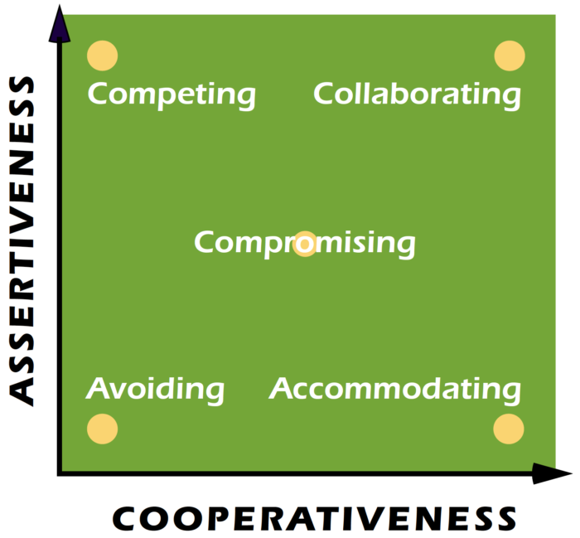
Kilmann Diagnostics (2020)
Competing | wholly assertive and uncooperative approach
Accommodating | unassertive and cooperative approach
Avoiding | unassertive and uncooperative approach
Compromising | assertive and cooperative
Collaborating | believe that there is a solution

It is important that teams overcome these differences, establishing ways to move forward as failure to do will affect their performance.

As conflicts get resolved, the team dynamics change, establishing standards and guidelines to follow, adapting behaviours accordingly. During the ‘norming’ stage, individual roles get defined and responsibilities become clear. Teams begin to plan the project, highlighting targets and deadlines.

Once the team has successfully overcome any differences and have planned how to proceed, in the ‘performing’ stage they can concentrate on carrying out their roles and responsibilities within the team. They work well together and get on with the job to the required standards. Not all teams will get this far.

Adjourning refers to the disbanding of the team because of, for example the completion of the task, or moving onto the next task. Some members feel that reviewing the processes of the project, will form a method of feedback moving forward, however others are happy to walk away.

Conclusion
To conclude, for teams to be successful, they must be made up of several individuals with the right skills and attributes to meet the organisations/project objectives. It is important to remember that not all individuals will get on and conflicts may arise, however it is essential that differences get put aside and focus on getting the task done on time.

Recommendations
Based on the above findings, the below recommendations can be offered:

- Ensure team building exercises are in place to build relationships to eliminate possible conflict
- Make sure individuals have well-defined roles within the team and understand fully what is required of them
- Highlight the importance of communication, especially when dealing with conflict. The more information provided, the clearer the resolution will be

Reference List

Belbin (2016a) ‘The Belbin Team Role Circle’. Available at: https://www.belbin.com/media/2302/belbin-team-role-circle.pdf (Accessed: 05 January 2020)

Belbin (2016b) ‘The Nine Belbin Team Roles’. Available at: https://www.belbin.com/about/belbin-team-roles/ (Accessed: 05 January 2020)

Boddy, D. (2011) Management – An Introduction. 5th edn. Essex: Pearson Education Group

Business Dictionary. (2020) ‘Team’. Available at: http://www.businessdictionary.com/definition/team.html (Accessed: 05 January 2020)

Huczynski, A.A. and Buchanan, D.A. (2010) Organisational Behaviour. 7th edn. London: FT/Prentice Hall.

Jarrett, M. (2019) ‘The 4 Types of Organisational Politics’. Available at: https://hbr.org/2017/04/the-4-types-of-organizational-politics?autocomplete=true. (Accessed: 05 January 2020)

Kilmann Diagnostics (2020) ‘An Overview of the Thomas-Kilmann Conflict Mode Instrument’. Available at: https://kilmanndiagnostics.com/overview-thomas-kilmann-conflict-mode-instrument-tki/ (Accessed: 05 January 2020)

Mullins, L.J. (2010a) Management and Organisational Behaviour. 9th edn. Essex: Pearson Education Limited.

Bibliography

Bird,V. (2020) ‘Belbin and Tuckman: Supporting your team at every stage’. Belbin. 25 July. Available at: https://www.belbin.com/resources/blogs/belbin-and-tuckman/. (Accessed: 05 January 2020)

Boddy, D. (2011) Management – An Introduction. 5th edn. Essex: Pearson Education Group

BrightHR. (2020) ‘Every HR professional knows the value of teamwork, but what about the practicalities?’. Available at: https://www.brighthr.com/articles/culture-and-performance/teamwork/how-hr-can-influence-employee-teamwork/ (Accessed: 05 January 2020)

Cameron, S. (2009) ‘The Business Student’s Handbook – Skills for Study and Employment’. 5th edn. Essex: Pearson Education Limited.

Johns, T. and Perkins, G. (2016) ‘Developing Professional Practice’, in Taylor, S. and Woodhams, C. (ed) Studying Human Resource Management. 2nd edn. London: Chartered Institute of Personnel and Development.

Strategic Human Resources. (2018) ‘Human Resources Teamwork can have Outstanding Results’. Available at: http://www.strategic-human-resource.com/human-resources-teamwork.html (Accessed: 05 January 2020)

TED Talks. (2018) How to Turn a Group of Strangers into a Team. Available at: https://www.youtube.com/watch?v=3boKz0Exros#action=share (Accessed: 05 January 2020)

