

Methods and Search Strategy Academic Poster

Student name: Iqra Mohammad
Student ID: 2325946

Module name: Independent project
Module code: BMHP6020
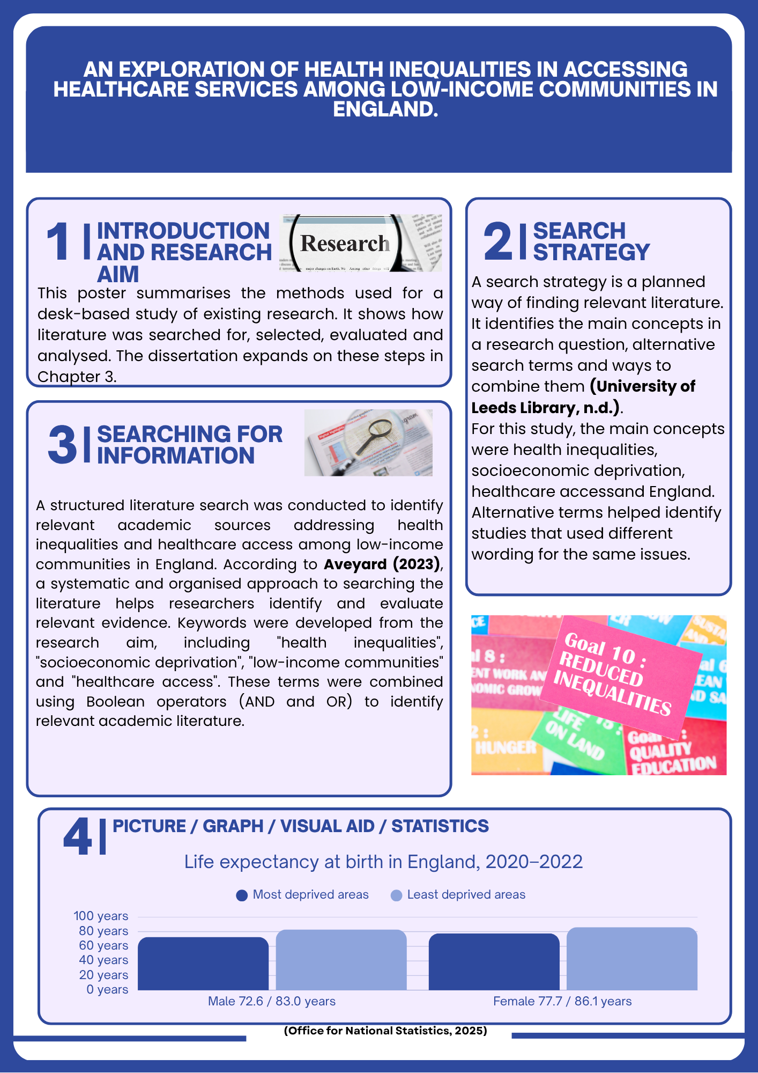
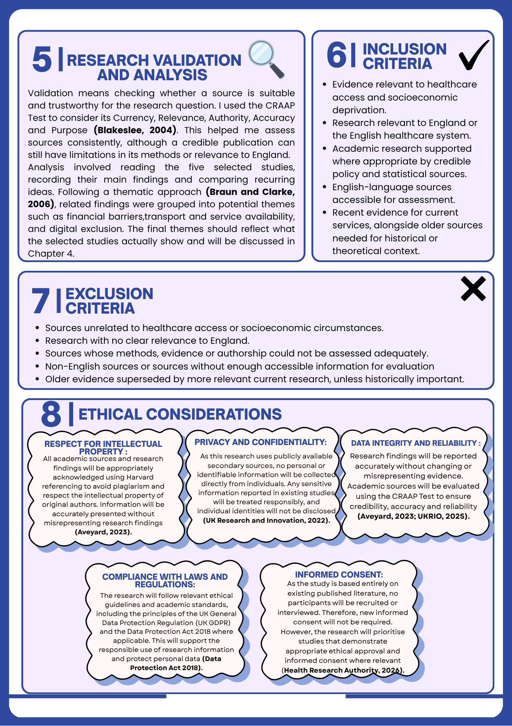

References

Aveyard, H. (2023) Doing a Literature Review in Health and Social Care: A Practical Guide. 5th edn. Maidenhead: Open University Press. Available at: https://www.mheducation.co.uk/doing-a-literature-review-in-health-and-social-care-a-practical-guide-5e-9780335251940-emea-group (Accessed: 12 October 2026).
Blakeslee, S. (2004) ‘The CRAAP Test’, LOEX Quarterly, 31(3), Article 4. Available at: https://commons.emich.edu/loexquarterly/vol31/iss3/4/ (Accessed: 12 October 2026).
Braun, V. and Clarke, V. (2006) ‘Using thematic analysis in psychology’, Qualitative Research in Psychology. Available at: https://uwe-repository.worktribe.com/output/1043060 (Accessed: 12 October 2026).
Great Britain (2018) Data Protection Act 2018, c. 12. London: The Stationery Office. Available at: https://www.legislation.gov.uk/ukpga/2018/12/contents (Accessed: 12 October 2026).
Health Research Authority (HRA) (2022) Guidance for using patient data. Available at: https://www.hra.nhs.uk/covid-19-research/guidance-using-patient-data/ (Accessed: 12 October 2026). Change this on poster
Health Research Authority (HRA) (2026) Applying a proportionate approach to seeking and evidencing informed consent in health and social care research. Available at: https://www.hra.nhs.uk/planning-and-improving-research/best-practice/informing-participants-and-seeking-consent/applying-a-proportionate-approach-to-seeking-and-evidencing-informed-consent-in-health-and-social-care-research/ (Accessed 12 October 2026). Change this on poster
Office for National Statistics (ONS) (2025) Healthy life expectancy by national area deprivation, England and Wales: between 2013 to 2015 and 2020 to 2022. Available at: https://www.ons.gov.uk/peoplepopulationandcommunity/healthandsocialcare/healthinequalities/bulletins/healthylifeexpectancybynationalareadeprivationenglandandwales/between2013to2015and2020to2022 (Accessed : 12 October 2026).
UK Research Integrity Office (UKRIO) (2025) Code of Practice for Research. Available at: https://ukrio.org/ukrio-resources/publications/code-of-practice-for-research (Accessed: 12 October 2026).
University of Leeds Library (n.d.) Develop a search strategy. Available at: https://library.leeds.ac.uk/info/1404/literature_searching/14/literature_searching_explained/4 (Accessed: 12 October 2026).

