

LOCAL INFRASTRUCTURE RECONSTRUCTION

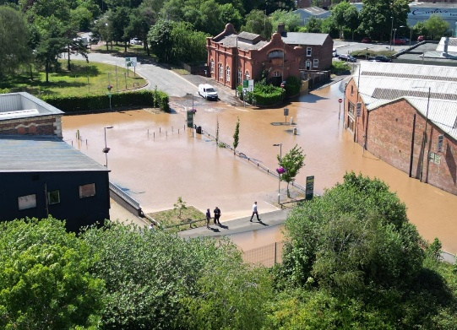
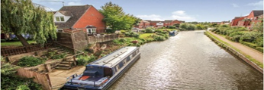
Reconstruction of damaged local infrastructure, including utilities, community buildings, and public services to Kidderminster

GA36b Level 5: PROJECT MANAGEMENT

Name: Tatyana Ivanova
Student Number 2412523
Module code LCLM 5003
Lecturer's Name: Sukhpreet Grewal
Date 26 April 2026

CONTENTS

PART A:
Poster……………………………………………………………………….……..……………..2
PART B:
Reflections on Poster Feedback………………………………………………………………………………………..3
PART C:
Project Management Plan ………………………………………………………..5
- Introduction………………………………………………………………………………….…5
- Project description ……………...…………………………………………………………..6
- Scope……………………………………………………………………………………………7
- Work breakdown structure …………………………………………………..……………..9
- RACI Matrix………………………………………………………………………..………….11
- Quad chart ……………………………………………………………………………………12
- Gant chart ………………………………………………………………………………….…13
- Iron Triangle (Triple Constraint) – 6-Week Crisis Phase ……………………….………………14
- Stakeholders' involvement …………………………………………………….…………15
- Lead Sponsors………………………………………………………………………………….…………..15
- Stakeholder Engagement Strategy ……………………………………………………….………….15
- Stakeholders engagement matrix ………………………………………………………….16
- Allocation of Resources …………………………………………………………….……..17
- Risk Analysis ………………………………………………………………………….……..18
- Conclusion …………………………………………………………………………….……..19
- Reference …………………………………………………………………………………….20
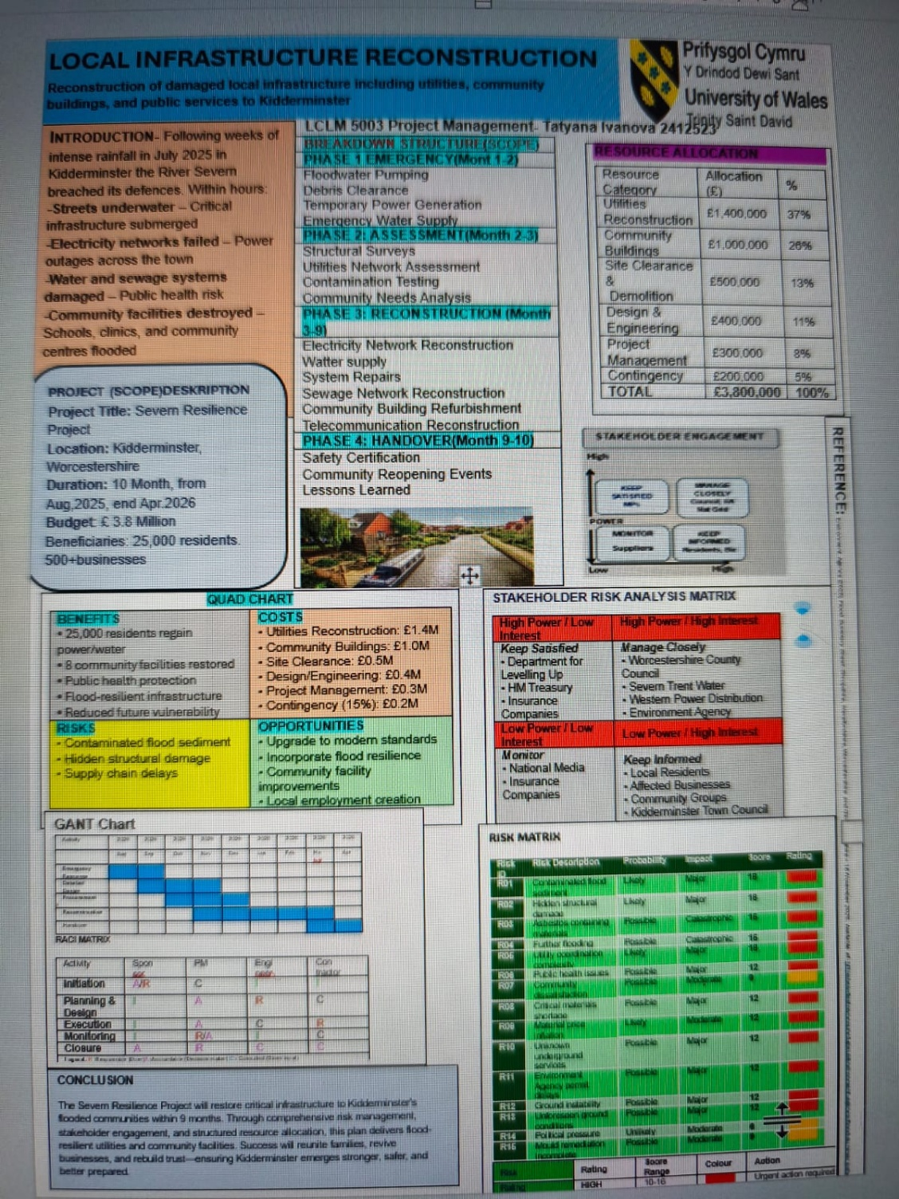
Part A – Poster
Part B: Reflections on Poster Feedback
I received constructive feedback from both my lecturer and colleagues on my poster presentation on the Severn River Resilience Project. While the overall structure and use of project management tools (such as a pie chart, resource allocation table and stakeholder matrix) were generally well received, several critical weaknesses were highlighted that limited their effectiveness as a crisis response plan.

The most significant issue identified by my lecturer was the lack of urgency appropriate for a disaster recovery project. The poster as a whole did not convey the immediate, life-threatening nature of the flooding on the Severn River in July 2025. The crisis response plan needs to prioritise quick, actionable steps rather than resemble a standard academic presentation.

Another key weakness was the inconsistency in the project duration. The project description states a 10-month timeline, but the Gantt chart shows only 9 months. This discrepancy creates confusion about the actual project schedule. Furthermore, the Gantt chart is not detailed enough, especially in the critical first 4-6 weeks. For a disaster recovery project, stakeholders require a clear weekly breakdown of activities rather than broad monthly phases.

Specific sponsors and funding sources are also not clearly identified. Although resource allocation is presented, there is no explicit mention of key partners such as Severn Trent Water, Western Power Distribution, the Environment Agency or central government flood recovery funds. This omission weakens the plan's credibility and feasibility.

Furthermore, insufficient attention is paid to the reopening of the highways and the main transport corridor, which are explicitly permitted recovery activities in the terms of reference. These elements are barely visible, despite their importance in restoring the movement of goods and people.

A risk matrix was introduced, but remains underdeveloped and poorly explained, making it difficult to understand the accountability for all project activities. Similarly, the Risk Matrix is ​​cluttered with small text, which reduces its readability and practical value in a high-stress crisis environment.

Finally, the publication lacks a strong, concise summary or clear project objective at the beginning, and the conclusion is too general. This does not effectively connect the immediate 4-6 week emergency response to the longer-term recovery phase.

In response to this feedback, I will revise the poster by adopting a more urgent, practical tone, clarifying the project timeline, adding a detailed 6-week action plan, explicitly identifying sponsors, and improving the visual clarity of the matrices and Gantt chart. These changes will better align the poster with the requirements of a real-world crisis action plan while maintaining academic rigour.
The poster presentation for the Severn River Resilience Project received constructive feedback from both the instructor and peers. While the overall structure and use of project management tools (such as the quad chart, resource allocation table and stakeholder matrix) were generally well received, several critical weaknesses were highlighted that limited their effectiveness as a crisis response plan.

Part C: Project Management Plan

INTRODUCTION

Heavy rain over several weeks led to the flooding of the River Severn in Kidderminster in July 2025. Within a few hours, parts of the town were flooded, power supplies were cut (including the town’s electricity supply), water and sewerage systems were damaged (creating an immediate risk to public health), and public facilities were flooded or destroyed (including schools, clinics and community centres). The Environment Agency issued “Severe Flood Warnings - Danger to Life”.

This plan outlines a site-specific, time-bound management plan for emergency response and recovery, with an immediate post-crisis recovery operation scheduled within the next six (6) weeks (targeted response time). The plan is to take action to save lives, stabilise and restore critical infrastructure to facilitate transport corridors and work within a full project budget of £3.8 million.

2. Project Description

Project Title: Severn Resilience Project – Rapid Recovery Phase (Crisis Action Plan)
Location: Kidderminster
Duration: 6 weeks (4 August 2025 – 14 September 2025)
Total Project Budget: £3.8 million
Budget for this 6-week phase: £1.3 million
Beneficiaries: 25,000 residents and over 500 businesses
Stakeholders: Company/Organisation names
- Severn Trent Water
- Western Power Distribution
- Environment Agency
- Worcestershire County Council
- Kidderminster Town Council
- Department for Environment, Food & Rural Affairs (DEFRA)
- UK Government Flood Recovery Fund

The plan restores immediate functionality by removing floodwater, providing temporary power and water, reopening the principal transport corridor, and initiating emergency repairs to utilities and community facilities.

3. Scope (in six weeks)

In Scope | Out of Scope
- Floodwater pumping and debris clearance  - Installation of temporary power and emergency water supply  - Structural surveys and contamination testing  - Reopening of the principal transport corridor and key highways  - Emergency repairs to utilities and selected community facilities  - Safety certification of restored areas | - Full permanent reconstruction  - Construction of new regional flood defences  - Long-term maintenance beyond the 6-week period  Scope will be strictly controlled through weekly reviews during the crisis phase.

The Scope section defines what is included and excluded in the Severn Resilience Project. It clearly outlines the project's boundaries to prevent scope creep and keep the focus on urgent recovery needs.
In scope are the restoration of critical utilities (electricity, water, and sewage networks), refurbishment of eight community facilities, emergency response actions, structural and contamination assessments, and flood-resilient upgrades. The project also includes safety certification and community reopening events.
Out of scope are the construction of new regional flood defences, repair of non-local transport infrastructure, and long-term maintenance beyond the nine-month period.
By clearly defining the scope, the project ensures efficient use of the £4.2 million budget and delivers focused, timely recovery for Kidderminster.

4. Work Breakdown Structure (WBS)

SEVERN RSILENCE PROJECT

SAFE COMMUNITY FACILITIES
REOPENED TRANSPORT
STABILRSED AREA
RESTORED BASIC SERVICES

CLEARED STREETS & DERISH FREEE
REOPENED PRINCIPAL TRANSPORT COORDINATOR
EMERGENCY WATER DISTRIBUTION
TEMPORARY PAWER SUPLY OPERATIONAL

FLOODWATER REMOVED
TEMPORARY GENERATORS
WATER TANKERS& PURIFICATION UNITS
MAIN HIGHWAY CLEARED & OPEN

LESSONS LEARNED REPORT
HANDOVER DOCUMENTATION
SAFETY CERTIFICATION
4-5 COMMUNITY FACILITIES TEMPORARILY REPAIRED

The Gantt Chart provides a detailed weekly plan for the critical first 6 weeks after the July 2025 River Severn flood. It focuses on rapid stabilisation and immediate recovery actions.

In Weeks 1–2, the priority is floodwater pumping and debris clearance, alongside temporary power and water supply. Structural and contamination assessments begin in Week 2–3. The reopening of key transport corridors (A456 and A449) is scheduled early to restore movement. Emergency utility repairs begin in Week 3. By Week 5–6, the focus shifts to safety checks and handover preparation.

This 6-week plan emphasises urgency, clear sequencing, and parallel activities to stabilise the situation quickly and lay the foundation for full reconstruction

5. RACI Matrix
Activity | Sponsor | PM | Engineer | Contractor
Initiation | A/R | C
Planning &Design | I | A | R | C
Execution | I | A | C | R
Monitoring | I | R/A | I | C
Closure | A | R | C | C

LEGEND
R = Responsible (Doer)
A = Accountable (Decision-maker)
C = Consulted (Gives input)
I = Informed (Kept updated)
In the Severn Resilience Project, the RACI Matrix ensures that critical tasks, such as floodwater pumping, structural assessments, utility repairs, and reopening transport corridors, are properly assigned. It prevents confusion, overlaps, and delays by clearly showing who does what, who makes decisions, and who must be informed. This tool is essential for effective coordination during the high-pressure post-flood recovery period.

6. Quad Chart
Benefits | Costs | Risks | Opportunities
- 25,000 residents regain basic power and water supply  - Principal transport corridor reopened within 4 weeks  - Public health risks have been significantly reduced  - 4–5 community facilities made temporarily safe  - Foundation laid for long-term flood resilience | - Utilities (temporary + emergency repairs): £650,000  - Site clearance and debris removal: £300,000  - Transport corridor reopening: £150,000  - Project management and safety: £100,000  - Contingency: £100,000 | - Contaminated flood sediment  - Hidden structural damage  - Supply chain delays | - Rapid testing of new temporary solutions  - Early identification of long-term resilience needs  - Strengthened stakeholder collaboration

The Quad Chart on the poster provides a clear strategic overview of the Severn Resilience Project by summarising four key dimensions in a single visual. The Benefits quadrant highlights the positive outcomes, including restored power and water for 25,000 residents, eight refurbished community facilities, and improved flood resilience. The Costs section details the £3.8 million budget allocation, with the largest share (37%) going to utilities reconstruction. The Risks quadrant identifies major threats, including contaminated sediment, hidden structural damage, and supply chain delays. Finally, the Opportunities quadrant outlines potential upgrades to modern standards, enhanced flood protection, and the creation of local employment.

7. Gantt Chart (6-Week Crisis Phase)

Week | 1 | 2 | 3 | 4 | 5 | 6
Floodwater Pumping & Debris Clearance
Temporary Power & Water Supply
Structural & Contamination Assessment
Transport Corridor Reopening
Emergency Utility Repairs
Safety Certification & Handover

The Gantt Chart illustrates a detailed weekly plan for the first six weeks after the July 2025 River Severn flood in Kidderminster. It prioritises immediate emergency actions, starting with floodwater pumping and debris clearance in Week 1. Temporary power and water supply run in parallel, followed by structural and contamination assessments. The reopening of key transport corridors is clearly scheduled early to restore the movement of people and goods. Emergency utility repairs begin after initial assessments. This focused timeline emphasises urgency and task sequencing, providing a clear roadmap for rapid stabilisation during the critical early phase of disaster recovery.

Iron Triangle (Triple Constraint) – 6-Week Crisis Phase

SCOPE
(Clear water, restore basic service, reopen principal transport corridor)

TIME COST
(strict 6 weeks) (£3.8 million)

QUALITY
(Public safety first – no compromises)
Explanation: In this emergency phase, time is the primary constraint. Speed directly affects lives and prevents secondary damage.

8. Stakeholders’ Involvement

Lead Sponsors:

- Severn Trent Water (Water & Sewage)
- Western Power Distribution (Electricity)
- Worcestershire County Council (Overall coordination & highways)
- Environment Agency (Technical and regulatory support)

Stakeholder Engagement Strategy:

- High Power / High Interest (Manage Closely): Worcestershire County Council, Severn Trent Water, Western Power Distribution, Environment Agency
- Daily coordination meetings in Weeks 1–2, reducing to weekly thereafter.

STAKEHOLDER ENGAGEMENT MATRIXES
LOW POWER
LOW INTEREST
LOW POWER
HIGH INTEREST
HIGH POWER
LOW INTEREST
HIGH POWER
HIGH INTEREST

Monitor
Low Priority
Keep Informed
Interested
Keep Satisfied
Important
Manage Closely
Critical

-Kidderminster Town Council
HM Treasury
• Local Residents M Treasury
Severn Trent Water
-Department for Environment, Food & Rural Affairs (DEFRA)

-Community Groups
-Western Power Distribution
-General Public
--UK Government Flood Recovery Fund

-National Media
-Kidderminster Town Council
-Environment Agency
-Insurance Companies
-Affected Businesses

In short, the matrix guides the project team on how much time and what type of communication each stakeholder group requires.

9. Allocation of Resources (£3.8 million total)

Resource Category | Allocation (£) | Percentage | 6-Week Allocation (£)
Utilities Reconstruction | 1,400,000 | 37% | 650,000
Community Buildings & Site Clearance | 1,000,000 | 26% | 300,000
Transport Corridor Reopening | 300,000 | 8% | 150,000
Design & Engineering | 400,000 | 11% | 50,000
Project  Management | 300,000 | 8% | 100,000
Contingency | 200,000 | 5% | 30,000
Safety & Handover | 200,000 | 5% | 30,000
TOTAL | 3,800,000 | 100% | 1,300,000

10. RISK ANALYSIS
Risk | Probability | Impact | Owner(RACI) | Mitigation Strategy
Floodwater pump failure | Medium | High | Contractor(R) | Install backup generator; daily checks
Utility strike (gas/electric) | Medium | High | Lead Engineer (R) | Pre-dig surveys; contact Western Power
Contractor mobilisation delay | Low | Medium | Project Manager(A) | Early procurement; weekly progress meetings
Community complaints (noise/traffic) | High | Low | Community Manager(R) | Daily hotline; advance notices to 25,000 residents
Budget overspend in week 4 | Low | High | Finance Officer(R) | Weekly budget reviews; Sponsor approval for extras

All risks are reviewed every Monday. The Project Manager (Accountable) escalates red risks to the Sponsor immediately. This 6-week focus ensures a safe, on-time launch of floodwater pumping and debris removal.

11. CONCLUSION

The Severn Resilience Project – 6-Week Crisis Action Plan provides a focused, urgent, and structured response to the catastrophic flooding caused by the River Severn in Kidderminster in July 2025. Within hours of the breach, the town faced submerged streets, widespread power outages, damaged water and sewage systems posing serious public health risks, and the destruction of vital community facilities. This plan addresses the immediate crisis by prioritising life-saving actions, rapid stabilisation, and the restoration of basic services for 25,000 residents and over 500 businesses.
Over the six-week period from 4 August to 14 September 2025, the project will deliver critical outcomes: removal of floodwater and debris, installation of temporary power and emergency water supply, structural and contamination assessments, reopening of the principal transport corridor, and initial repairs to key community facilities. With a dedicated budget of £1.3 million from the overall £3.8 million allocation, the plan places strong emphasis on utilities reconstruction (37%) while maintaining tight control through weekly reviews and proactive risk management.
The successful execution of this crisis phase will significantly reduce immediate health and safety risks, restore essential functionality, and create a stable platform for the full 10-month reconstruction programme. Collaboration with key sponsors — Severn Trent Water, Western Power Distribution, Worcestershire County Council, and the Environment Agency — ensures coordinated effort and accountability.
Ultimately, this 6-week Crisis Action Plan is more than an emergency response; it represents the first vital step in rebuilding community resilience. By acting swiftly and effectively, the project will help reunite families, revive local businesses, and restore public confidence. Kidderminster will emerge not only recovered but stronger and better prepared for future climate-related challenges, demonstrating the value of structured project management in post-disaster recovery.

REFERENCES
1. Association for Project Management (2019), APM Body of Knowledge, 7th edn. Princes Risborough: Association for Project Management,(Accessed 22 April 2026)

2. Environment Agency (2020), Flood and coastal resilience: a guide for local authorities, Bristol: Environment Agency,(Accessed 232April 2026)

3. Freeman, R.E. (2010), Strategic management: a stakeholder approach, Cambridge: Cambridge University Press,(Accessed 22 April 2026)

4. Kerzner, H. (2017) Project management: a systems approach to planning, scheduling, and controlling, 12th edn. Hoboken, NJ: John Wiley & Sons(Accessed 22 April 2026)

5. Maylor, H. (2016) Project management, 5th edn. Harlow: Pearson Education,(Accessed 22 April 2026)

6. Office of Government Commerce (2007) Managing successful programmes, 3rd edn. London: The Stationery Office,(Accessed 22 April 2026)

7. Project Management Institute (2021)*A guide to the project management body of knowledge (PMBOK® guide), 7th edn. Newtown Square, PA: Project Management Institute,(Accessed 22 April 2026)

8. Smith, M. and Erwin, J. (2018) 'Role clarity and project success: the RACI matrix revisited', International Journal of Project Management, 36(6), pp. 822-833,(Accessed 22 April 2026)
9. Thorne, C. (2014), Geomorphology and river management: applications of the River Styles framework, Oxford: Blackwell Publishing,(Accessed 22 April 2026)

10. Worcestershire County Council (2022), Worcestershire flood risk management strategy, Worcester: Worcestershire County Council,(Accessed 22 April 2026)

