The analysis of PESTLE and Culture of Uber with 3 ethical dilemmas to resolve.

PREPARED FOR: Yohan Mendis

MODULE CODE: BMSW_5105
MODULE TILTLE: Workplace Culture and its impact on Organisational Efficiency

PREPARED BY:
MOHAMMED ABDUS SALAM STUDENT ID: 1709396
LEARNER GROUP 1

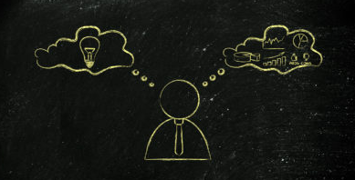

Contents

Introduction: page 3
Analysis of UK’s taxi industry for Uber by using PESTEL: page3
Analysis of Uber organisational culture: page 6
Three ethical dilemmas need to be resolved: page 8
Conclusion: page 9
References: page 10

Introduction:
Every organisation in any industry or sector is operated in an environment that’s why the culture and operation of an organisation are influenced by the environmental factors. Also, the culture of an organisation directly impacts the working efficiency of that organisation. To stay in the competition in the industry an organisation must act upon to adjust itself with those environmental factors that affect the business operation directly or indirectly. According to David N and Robert D. (2000) ‘the culture of the organisation is very important to the success of the organisation. The culture should reflect the environment in which the organisation operates and in a highly competitive and dynamic market, the culture needs to be flexible and adjustable.’ That’s why, the manger or the executive officer need to analyse the environment and the culture of the organisation to ensure the maximum working efficiency. To fulfil the requirement of this assessment this report will be based on analysing the UK’s taxi industry for Uber company by using PESTEL. Also, the report will analyse the culture of Uber taxi company by using cultural web and how the technological changes affect aspects of Uber organisational culture. Furthermore, the report will identify and explain three ethical dilemmas that managers of the Uber company need to resolve.
Analysis of UK’s taxi industry for Uber by using PESTEL:
PESTEL is known as a tool for analysing an organisation’s external environment. Where the organisation’s environment is known as the elements that directly or indirectly affect the organisation’s operation and the strategic decision. Fernando A.C. (2011) referred the business environment to the all external factors which have impact on its activities. Also, the environment of an organisation can be divided into two categories such as: internal environment and external environment. However, the UK’s taxi industry is highly competitive, because of lot of taxi companies are operating in the industry and the external environmental factors influence the industry too. That’s why the following PESTEL analysis for Uber can help the company to make necessary adjustment to stay in the industry and become highly competitive.
- Political factors: The presence of various political institutions and their policies and actions influence the government to make business terms and conditions where a business organisation must adhere those terms and conditions. So, the political factors are known as policies, suggestions, actions, observation etc by different political institutions influence the government decision or force the government to make rule and regulations for businesses. The political stability in a country play a vital role for the investment. That’s why Uber chose to operate in UK’s taxis industry as the political stability is constant in the UK. Also, in the UK it is easier for the taxi organisation to operate in low cost as they don’t need to pay minimum wages and no employment contact for any liabilities as most taxi driver are asked to declare their self as self-employee to the HMRC. Where, Uber being a big company in the UK are taking this advantage that’s why the political parties and traded unions raising their voice against Uber. According to online political editor Bloom, D. (2017) ‘So Uber has become the prime target for MPs and unions who demand it stop undercutting the competition and treat workers fairly’. As a result, the Uber licence is revoked by TFL, but the company appealed in the court. However, the company has the opportunities to adjust its self with the political demands to stay in the industry.
- Economic factors: Economic factors can be referred to a countries rate of employment and unemployment, value of currency in the foreign market, interest rate, average household income, and inflation/deflation etc. Economic growth in a country play a vital role for any business in any industry. Similarly, the economic growth of the UK has influence in the taxi industry. For example, when people have enough money, they will use taxi rather than public transport. However, the economic growth in the UK varies by location or city. That’s why the taxi fare is not same in every city. Also, it is noticeable in some city taxi vehicle are new or not very old where some city has old taxi vehicle. So, the economic growth of a city affects the Uber too. That’s why the Uber company introduced Uber pool where more than one people can go on same taxi which make the fare cheap (Uber Pool 2020), which is one of competitive advantage of the company.
- Socio-cultural factors: Social factor can be referred to those factors that influence the people of a society. Like; cultural view, religious view, habit, disposable income, living style etc. Social factors play very important role for a business to operate. According to Rudani R. B. (2013) ‘social forces carry a notable effect on business operation. Similarly, the cultural factors strongly determine needs, preference, and habit of people. Both social and cultural factors affect employee and consumer behaviour.’ In the UK people have the habit and culture of going out on the weekend night and mostly goes to pub to spend time with friends and family that’s why they don’t take their personal car rather call taxi. This kind of social trend boost the business in the taxi industry. And the Uber taking this opportunities by offering the customer to use the app to book and pay where it is most convenient for the customer as they can track the miles and fare they paid on the following day. Also, various festivals like Christmas, Eid, Diwali, new years evening provide the taxi industry to boost the income too.
- Technological factors: Technological factors can be referred to the technological forces like; electronic gadgets, internet, App, machinery and equipment etc. In this digital era where almost every individual use smart phone and are very used to and most convenient of using e-commerce. That’s why the technology provided the opportunities for the taxi industry to become more competitive. Where introducing of Uber app for using a taxi made the company most competitive in the UK’s taxi industry. According to Knight, S. (2016) Uber app is behind the company’s success where the company worth of $60 and in London every week 30000 people download the Uber app in their phone and order a taxi first time. So, the technological factors impacted positively for the Uber company, but overall UK’s taxi industry was shaken as Uber entered in the industry. However, the technology keep changing and new features are adding or inventing and other taxi company also taking the advantage of technology, which increase the competition in the industry. That why Uber should not rely only on the app system rather the company should introduce alternative booking like, over the phone or website booking system.
- Environmental factors: Environmental factors can be referred to the elements that impact or affect the ecological development of a geological area like: Air pollution, water pollution, global warming, sea level rising etc. Environmental factors directly affect the taxi industry as most air pollution come from the car. That’s almost every single countries in the world are being warned and taking necessary steps to save the environment from pollution. Similarly, UK’s government and some local councils took steps to reduce the pollution. For example, recent introduce of a clean air zone for Birmingham, where certain cars have to pay extra to entered the zone (Birmingham City Council 2020). So, the taxi industry are impacted negatively as the taxi drivers are forced to change their vehicle even its road worthy and passed the MOT. Smilarly, the Uber is making all the drivers to change their vehicles and not taking any drivers with the vehicle that doesn’t meet the governments criteria (Uber 2020).
- Legal factors: Legal factors can be referred to the law and regulations that a business must follow to operate like: trading hours, workplace safety and security, income tax, taxi insurance etc. Legal factors play a vital role for the taxi industry in the UK. Where, every single taxi company must obey the UK’s law. Some time legal factors give opportunities such as self-employment where the taxi company doesn’t need to pay the minimum wages and Uber is taking full advantage of it by recruiting vast number of drivers. But some time it’s become obstacle for the business growth like; only black cab can pick up passengers without any pre booking where other taxi company are not allowed. Also, recent pandemic situation taxi company faced huge losses as COVID-19 break out in the UK and government restricted people going out and facing fine for breaking the lock down role (Evening News 2020). Because of lock down law most of the taxi drivers were not working which impacted the taxi company negatively.
Analysis of Uber organisational culture:
Organisational culture is made up with the rules, regulations, standards, principles, policies, shared values and beliefs, structure. So the organisational culture can be defined as method or approach to achieve the organisational goal which is influence by the factors like individuals beliefs, shared values, structure, employees attitude and behaviour, organisation’s rules, regulations, standards and principles. According to Schein E, H (2016) there are three level of culture in an organisation such as Artifacts, Values and Basic assumption. The greatest level is basic assumption as we understood from our beliefs or past experience’s. Second level is our values which contains standards and principles. Then level one Artifacts which is noticeable elements or assets of the organisation. However, like every other organisation Uber company is also influence by its culture. To better understand the Uber organisational culture Johnson and Scholes’ cultural web model can be used.
According to Johnson, G, Scholes, K, Whittington, R (2009) ‘the cultural web shows the behavioural, physical, and symbolic manifestations of a culture that inform and are informed by taken-for-granted assumptions or paradigm. Which is shown is below figure 1.
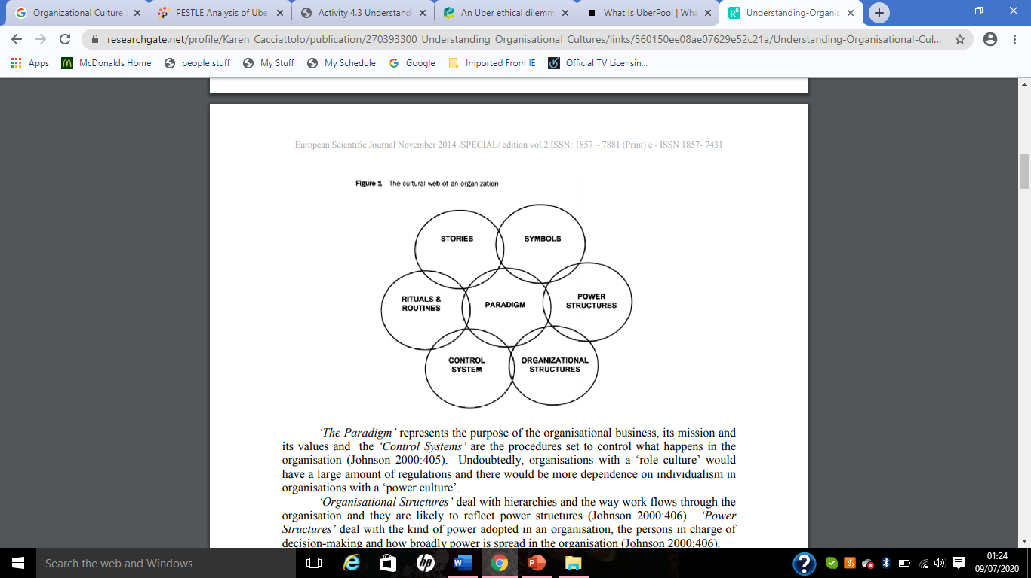
Figure 1: The cultural web. Source: Cacciattolo, K. (2014)
- Stories: The previous experience and people talked about within and outside the organisation known as stories. Uber two-way feedback system by the app can ensure both driver and passenger can leave feedback on each other. Too many negative feedbacks will affect the Uber account where the account may be suspended which apply to both driver and passenger. However, in general overall people talk about Uber and the goodwill of the company increasing day by day. As Uber taxi drivers we talk among ourselves about the company leading the industry and becoming popular day by day.
- Rituals and Routines: The regular behaviour and actions form someone determine how they will behave next and what is expected to happen in certain time. During the rush hour extra taxi needed which is experienced by Uber company, also the drivers know the pay will be higher and will not required to wait long for a trip, and the customer know the long wait for taxi that’s why may book in advance. Also, always strive for meeting the customer expectation.
- Symbols: Physically represents the company or identify the company like logo, dress code, uniform etc. Uber logo is noticeable to public and can be recognise easily. Such symbols are found in every vehicle and app that the customer can notice the taxi easily.
- Organisational Structure: The hierarchy position of the organisation that the orders are followed to accomplish any given task. Uber organisational structure is simple and don’t gave to may layers rather straight line made the company to operate easily. As everything is controlled by app.
- Control System: The process or method of controlling the whole organisation. Like financial control, cost control, quality control, reward and recognition system. The Uber app made it very easy for the company to control its operation.
- Power structure: The key decision maker of the company it could be chief executive officer, whole board of directors, even a head of department. These people play vital role for the company’s decision making process. In Uber company the board of executive officers paly the role of decision making process.
However, the technology is the main player for the current suitable culture in the company. Where the Uber mainly based on its app and the app directly influence the culture of Uber. The technology being used in the company for almost everything from hiring to controlling and operating the whole taxi system by the app. That’s any technological changes or update directly affect the Uber company.

Three ethical dilemmas need to be resolved:
Ethics can be referred to honesty, morality and decency which can ensure all the stake holders act honestly, sensibly and keep their morality high and treat each other fairly. According to Fraedrich, J Ferrell O.C, (2009) majority definitions of ethics links to standards, principles, rules, moral for what is right or wrong action to solve any issue. However, following are the three ethical dilemmas that need to be resolved by the Uber’s managers.
Safety concern: Uber managers should resolve the safety concern by not hiring drivers who may place passenger’s safety at risk. According to the report on BBC news (2019) ‘Uber will not be granted a new licence to operate in London after repeated safety failures. TfL said it had identified a "pattern of failures" in London which put passengers at risk. Which include a change to Uber's systems which allowed unauthorised drivers to upload their photos to other Uber driver accounts. Also, dismissed or suspended drivers had been able to create Uber accounts and carry passengers. This report clearly shows that Uber is not complying with the TfL regulations and putting passengers at risk which is absolutely unethical. I argue that only the driver should be recruited by Uber who can pass a back ground check like: work permit, appropriate licence, criminal record, authorised vehicles with appropriate insurance, proof of address and ID which match the driver profile on the app that a passenger can check if the right driver picking them up.
Under minimum wages and zero hours contract: Uber recruits the drivers on the basis of zero hours contract and hire a vast number of drivers to maximise their commission/profitability. So, the drivers will be paid only for a specific picking up and dropping off passenger on top drivers pay a commission to Uber form their total earning. As a result, all the drivers have to work long hours to meet their income that can cover their cost. Also, they rush to drop off passenger to accept another ride where putting them self and passenger safety at risk. This is unethical behaviour by Uber as the drivers are not getting paid for their actual hours they work. That’s why the Uber’s managers must take necessary steps that a driver can earn the minimum wages per hour they work. That’s why I argue that the company should not hire a vast number of drivers instead the company should hire drivers for required and specific allocated time that allow a driver to earn the minimum wages and keeping their self and passenger safe by not rushing for another job.
Extra fare for red zone: Uber charges its customer extra fare when there is less drivers available or for a busy zone. As the company charge fare for red zone they get extra commission too as the drivers pay the percentage on the total earning. This is unethical as the fare would be less during the quite period or when a lot of drivers available. The Uber’s managers should take it consideration and not charge extra for red zone. That why I argue the company should make a schedule for the drivers with the time allocation where there will be no red zone by ensuring enough drivers available during pick period or charging less commission to the drivers to encourage their presence during the pick period.
Conclusion:
The environmental factors influence the organisational culture and the culture affect the working efficiency of an organisation. That’s why if an environmental factor affects the organisational culture negatively it will influence the working efficiency negatively, on the other hand, if the affect is positive than the working efficiency will increase. That’s why Uber should choose policies, rules and standards that are flexible and can be adjusted when needed as environmental factors are not always stable or fixed. Also, it is essential to maintain the ethical stance of the company that are in favour of its customers and the employees.

References:
- Bloom, D. (2017), Why stripping Uber's licence will be deeply political - and a big victory for unions at Labour conference. Mirror. Published on 22 September 2017, https://www.mirror.co.uk/news/politics/stripping-ubers-licence-deeply-political-11218917. Last access on 05/07/2020.
- Birmingham City Council (2020), A clean air zone for Birmingham, The zone location. https://www.birmingham.gov.uk/info/20076/pollution/1763/a_clean_air_zone_for_birmingham/2. Last access on 02/07/2020
- BBC news (2019), Uber loses licence to operate in London> Published on 25 November 2019. https://www.bbc.co.uk/news/business-50544283. Last access on 05/07/2020.
- Cacciattolo, K. (2014), UNDERSTANDING ORGANISATIONAL CULTURES, European Scientific Journal November 2014 /SPECIAL/ edition vol.2 ISSN: 1857 – 7881 (Print) e - ISSN 1857- 7431
- David N and Robert D. (2000), Advanced Business, Heinemann, 2000.
- Evening News (2020), How much fines for breaking lockdown rules will cost from Wednesday. Published on 11th May 2020. https://www.manchestereveningnews.co.uk/news/uk-news/fines-uk-lockdown-how-much-18231717. Last access on 03/07/2020.
- Fernando A.C. (2011), Business Environment, Pearson Education India 2011.
- Ferrell O.C, Fraedrich, J (2009), Business Ethics, Update: Ethical Decision Making and Cases. Cengage Learning.
- Johnson, G, Scholes, K, Whittington, R (2009), Exploring Corporate strategy. Pearson Education.
- Rudani R. B. (2013), Principles of Management,
Tata McGraw-Hill Education, 2013.
- Knight, S. (2016), How Uber conquered London. The Guardian online news. Published on 27 April 2016. https://www.theguardian.com/technology/2016/apr/27/how-uber-conquered-london. Last access on 02/07/2020.
- Schein E, H (2016), Organizational Culture and Leadership
The Jossey-Bass Business & Management Series. Contributor Peter A. Schein Edition 5, illustrated, reprint, John Wiley & Sons.
- Uber (2020), Vehicle requirement in the UK, https://www.uber.com/gb/en/drive/requirements/vehicle-requirements/. Last access on 03/07/2020.
- Uber pool (2020), together we save, https://www.uber.com/us/en/ride/uberpool/, last access on 03/07/2020.

