Student name: | Simran Jeet singh (2238940)
Programme: | MBA
Module: | Entrepreneurship
Module code: | LCMB7004
Assignment Title | Solar Panel Installation Services
Lecturer: | Vasilios Tavlaridis

Table of Contents
Overview of Business 1
Gap in the Market 1
How Solar Panel Installation Services Addresses the Gap: 3
Proposed Location and Legal Entity of Solar Panel Installation Services 5
Proposed Location: 5
Justification: 7
SWOT Analysis 8
Target Market 10
Strategies to Capture Target Market 11
Financial Plan 13
Potential External Funding Sources 15
Justification for Funding Choices: 16
References: 16

Overview of Business
Recent years have witnessed a global shift toward sustainable and clean energy sources that has propelled rapid expansion in the solar energy industry.
“Between 2010 and 2021, the amount of electricity generated in the U.S. from fossil fuels diminished by 13%, while the amount of electricity provided by renewable resources other than hydro increased by about 250%.” (www.cummins.com, n.d.).

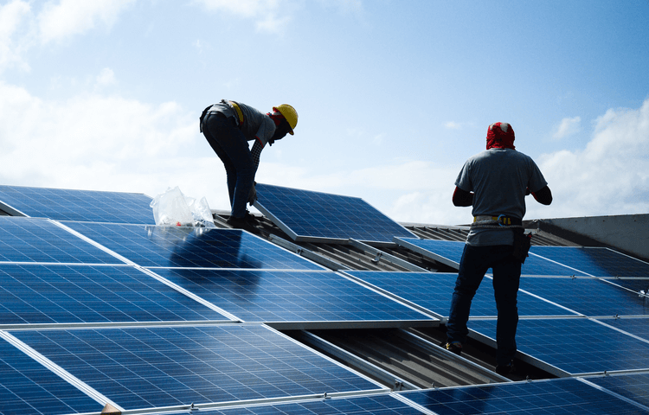

Solar panels are increasingly chosen by businesses and homeowners looking to reduce carbon emissions, lower energy costs, and support a more sustainable future leading to an explosion of demand for Solar Panel Installation Services businesses that capitalize on this emerging demand for sustainable solutions (www.sciencedirect.com, n.d.).

Gap in the Market
In today's rapidly developing renewable energy industry, recognizing market gaps is vital to business success. Solar Panel Installation Services recognizes an enormous market gap for convenient, customer-centric and cost-efficient solar panel installation solutions due to factors like an increasing demand for clean energy sources such as solar PV panels as well as complex installation procedures taking time and requiring outstanding customer care services (solvoltaics.com, n.d.). We specialize in these niche areas so our clients have access to them whenever needed - this gap arises due to various reasons like increased customer demand.

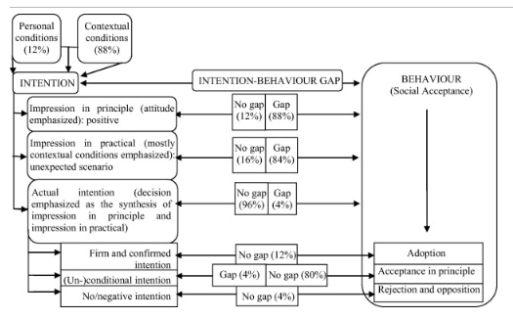
Figure 1: Source (Hai, Moula and Seppälä, 2017)

Complexity of Installation:
Installing solar panels can be a complex and lengthy process for homeowners and businesses alike, including steps such as site evaluation, system design, permit acquisition, equipment procurement, installation and ongoing maintenance. Many potential customers become disenchanted due to this complex technicality involved (Brown et al., 2021).

Existing solar installation companies often take an approach that doesn't meet customer needs and preferences specifically, leaving customers frustrated by not receiving adequate answers to their inquiries and inquiries, leading them to feel dissatisfied and frustrated with the service provided.

Information Overload: Solar energy offers an abundance of information that may overwhelm potential customers. Sorting through technology details, financing options, incentives, and regulations is often complex enough without having to understand all the specifics for themselves in order to make informed decisions.

Ineffective Project Management: Delays and inefficiencies in project management can extend installation timelines, leading to customer dissatisfaction. Poor communication amongst stakeholders may impede installation processes (Brown et al., 2021).

Once solar panels have been installed, customers may experience issues or require maintenance that require assistance. Unfortunately, some service providers only offer limited post-installation support, leaving customers without assistance when needed.

How Solar Panel Installation Services Addresses the Gap:
Solar Panel Installation Services aim to make solar panel installation simpler for customers by offering end-to-end service that includes site evaluation, system design, permit acquisition, equipment procurement, installation and post installation maintenance - our customers can expect an enjoyable experience as we handle every aspect of their project!

Solar Panel Installation Services recognizes that each customer has individual energy needs, preferences and budget constraints that we take into account when offering personalized solutions tailored specifically for individual requirements.

Educational Support: In order to combat information overload, we will offer educational resources and guidance to our customers through our website, brochures and customer service team (DAS, 2019). They will offer clear explanations of solar technology financing options incentives regulatory requirements to enable informed decisions by customers.

Effective Project Management: At Solar Panel Installation Services, we recognize the significance of efficient project management in meeting deadlines and ensuring customer satisfaction (Melito, 2023).. To this end, our focus will be on maintaining effective communication among clients, contractors and permitting authorities in order to expedite installation processes as efficiently as possible.

Comprehensive Post-Installation Services: At Solar Panel Installation Services, our dedication to customer service extends well beyond installation. We provide post-installation support in terms of maintenance, troubleshooting, system upgrades and system troubleshooting you can rely on us to address any issues promptly (DAS, 2019).

Transparency and Communication: Building trust is of utmost importance in the solar panel installation business, which is why Solar Panel Installation Services believes in maintaining open communication with their customers throughout every stage. We will regularly update them regarding project status updates, timelines, or any unexpected challenges we come across so they are kept fully informed at all times.

Quality Assurance: To address issues surrounding installation quality, Solar Panel Installation Services adheres to industry best practices and employs skilled technicians (Melito, 2023). Solar Panel Installation Services places priority on quality assurance to deliver systems that exceed customer expectations.

Competitive Advantages:
Solar Panel Installation Services strives to gain a competitive advantage in the solar energy industry through customer-centric approaches that address market gaps with customized solutions and exceptional customer service. We believe our commitment to streamlining installation processes, offering tailored solutions, and providing exceptional customer support will separate us from competitors.

Proposed Location and Legal Entity of Solar Panel Installation Services

Making the appropriate location and legal entity selection decisions for any business can have a profound effect on its operations and success. Solar Panel Installation Services took great care when choosing their location and legal structure for success.

Proposed Location:

Solar Panel Installation Services has decided to locate its headquarters in Phoenix, Arizona USA due to a number of strategic considerations:

Solar Resource: Arizona is well-known for its abundant sunshine, boasting more than 300 days per year on average. This makes Arizona an ideal location for solar energy projects as the high solar irradiance enhances their energy generation potential and customer satisfaction. Installing panels strategically throughout Arizona ensures optimal system performance and customer satisfaction.

Market Demand: Arizona has witnessed exponential solar energy adoption due to favorable policies, incentives, and an increasing interest among homeowners and businesses for clean energy solutions. Arizona is committed to meeting its renewable energy goals which coincide with Solar Panel Installation Services mission of providing clean energy solutions.

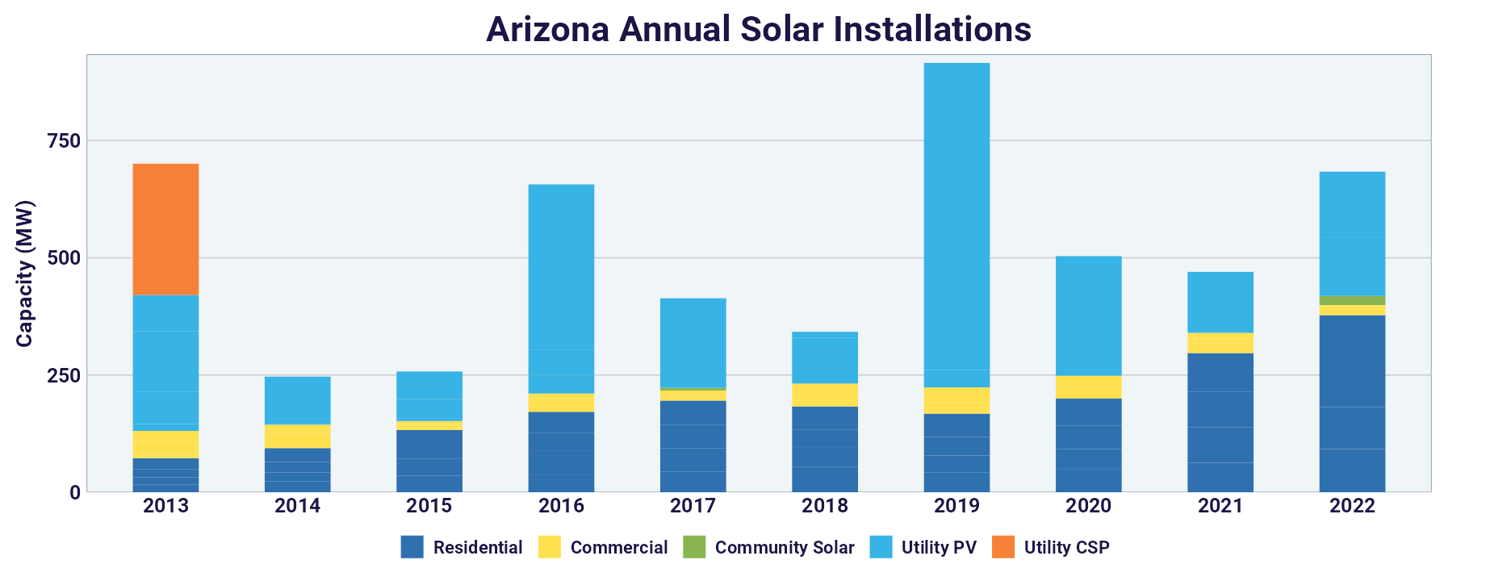
Figure 2: source (SEIA, n.d.)

Proximity to Suppliers: The Phoenix metropolitan area offers easy access to suppliers of solar panels, inverters, mounting systems and other essential equipment. Proximity can help minimize procurement costs while improving operational efficiencies.

Phoenix Renewable Energy Services: offer access to an experienced workforce within the renewable energy industry. Accessing qualified technicians, engineers and project managers is critical in order to deliver top-quality installation services.

Support and Partnerships in Arizona: By establishing itself in Arizona, Solar Panel Installation Services has an opportunity to build strong local relationships and partnerships with solar industry organizations, utilities, and government agencies - building these connections can streamline permit acquisition processes, streamline regulatory compliance procedures and open doors to collaboration opportunities.

Legal Entity:
For Solar Panel Installation Services to operate successfully, they need a legal entity that satisfies a number of key considerations. One such factor is choosing to operate as an LLC:

Limit Liability: An LLC offers many distinct advantages, with limited liability protection being one of them. As members are protected from legal disputes or financial challenges that might affect the business by maintaining separate assets from its liabilities, an LLC protects members from personal financial risk when faced with legal or financial challenges related to it.

Flexible Management Structure: LLCs offer members a great deal of freedom in choosing how they'd like their business run; members can manage it themselves or designate one or more managers to oversee operations on a day-to-day basis. This provides for efficient decision-making and adaptability.

Pass-Through Taxation: LLCs typically enjoy pass-through taxation, which means business profits and losses are reported on individual tax returns rather than being subject to double taxation as occurs with corporations where profits may be taxed both at a corporate and individual level. This helps avoid double taxation which occurs with corporations where profits may be subject to double taxes on both levels.

Simplified Record-Keeping: LLCs offer simpler record-keeping and compliance requirements compared to corporations, helping reduce administrative burdens and associated costs, so resources can be allocated towards core operations of the business.

Ease of Formation: Establishing an LLC is typically straightforward and cost-effective, as it involves less formalities and paperwork than incorporating a corporation.

Justification:

Arizona was strategically selected as the business location because its solar potential is high, making the state an attractive market and resource destination while taking advantage of state solar-friendly policies.

This decision allows Solar Panel Installation Services to deliver efficient and effective services at scale in regions where solar potential exists. It positions Solar Panel Installation Services to serve a growing market while accessing valuable resources within Arizona while capitalizing on its favorable policies towards renewables.

Selecting an LLC as their legal entity provides essential liability protection to its owners, keeping their personal assets separate from business liabilities. Furthermore, an LLC allows for operational flexibility, pass-through taxation and simplified compliance - all which contribute to the effective operation of Solar Panel Installation Services.

SWOT Analysis

Strengths:
The business takes advantage of rising market demand driven by environmental awareness and government incentives. A team with extensive solar technology knowledge enhances service offerings while cost-saving potential and environmental advantages make solar an appealing value proposition. Furthermore, strong partnerships with reliable suppliers help ensure access to superior products (finmodelslab.com, 2023)

Weaknesses:
Solar installations require significant upfront capital investments, which may deter some customers. Furthermore, their business's reliance on government incentives and rebates poses financial risks, while intense competition within the renewable energy sector presents additional difficulties (www.kenresearch.com, n.d.). Solar power production also depends heavily on weather conditions for optimal system efficiency.

Opportunities:
Expanding into untapped markets, adapting technological innovations, offering energy storage solutions and taking advantage of sustainable trends and CSR initiatives present invaluable opportunities (Mazzoni, 2019).

Threats:
Threats can include policy changes that limit affordability, economic downturns affecting customer spending habits, price competition among providers and natural disasters damaging installations; technological disruption necessitating costly upgrades.

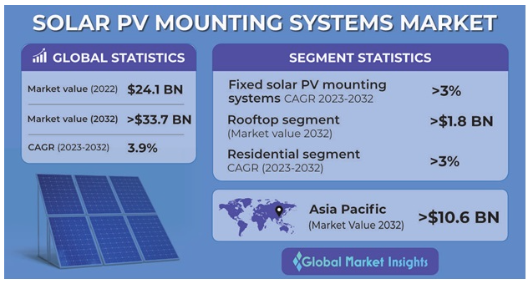

Target Market
Solar Panel Installation Services will focus primarily on residential, commercial, and industrial markets throughout Arizona in the USA (Energy5, n.d.). Their selection is determined by various factors.

Solar Potential in Arizona: Thanks to Arizona's abundant sunshine, Arizona makes an ideal location for installing solar energy panels on residential properties, commercial buildings and industrial facilities alike. Take advantage of its solar potential today.

Market Demand: Solar panel installations in Arizona have seen increasing popularity due to rising environmental awareness, higher utility costs and government incentives aimed at encouraging renewable energy production.

Target Both Sectors to Reduce Risk: Targeting both residential and commercial/industrial customers provides valuable diversification that lowers your reliance on any one customer segment.

Strategies to Capture Target Market
Solar Panel Installation Services will implement various strategies in order to effectively capture their target market:

Establish a Local Presence: Create an effective local presence with offices and showrooms located throughout Arizona. This will increase access to customers while building credibility for your company.

Customized Solutions: Provide tailored solar solutions tailored specifically to the needs and preferences of residential, commercial/industrial and government clients, such as system design, financing options and maintenance plans.

Marketing and Education: Utilize targeted marketing campaigns to raise awareness about the advantages of solar energy installations. Educational workshops and online resources will serve to inform potential customers of this renewable power solution.

Partnerships: Develop strategic alliances with local utilities, government agencies, and environmental organizations in order to take advantage of incentives, rebates, and subsidies available for customers. Work closely with suppliers so as to guarantee an ample supply of high-quality solar panels and equipment.

Quality Assurance: Highlight your use of top-tier solar panels and equipment with warranties to demonstrate system reliability and durability to customers, and highlight successful installations as proof of trustworthiness.

Financing Options: Make solar installations accessible to more customers by offering flexible financing solutions such as leasing, power purchase agreements (PPAs), and low-interest loans. This will make solar more accessible.

After-Sales Service: Provide comprehensive after-sales services that include maintenance, repair and system upgrade capabilities. Prompt customer support and regular maintenance visits will help to ensure customer satisfaction and prolong system longevity.

Compliance: Stay current on local and state regulations regarding solar installations, to give customers confidence that all installations comply with necessary permit and inspection requirements.

Continuous Innovation: Stay informed on technological advancements within solar energy. Implement innovative energy storage solutions and smart monitoring systems into your systems in order to enhance performance.

Community Engagement: Engage with local communities through participation in green initiatives, sponsorships and environmental awareness campaigns to strengthen your company's brand reputation.

Financial Plan
Item | Year 1 | Year 2 | Year 3
Revenue | $500,000 | $800,000 | $1,200,000
Cost of Goods sold | $350,000 | $520,000 | $750,000
Gross Profit | $150,000 | $280,000 | $450,000
Operating Expenses
Salaries and Wages | $60,000 | $100,000 | $140,000
Marketing & Promotion | $20,000 | $30,000 | $40,000
Rent and Utilities | $25,000 | $30,000 | $35,000
Maintenance and Repairs | $15,000 | $18,000 | $20,000
Insurance | $5,000 | $6,000 | $7,000
Miscellaneous Expenses | $10,000 | $12,000 | $15,000
Total Operating Expenses | $135,000 | $196,000 | $257,000
Net Profit Before Tax | $15,000 | $84,000 | $193,000
Taxes | $3,750 | $21,000 | $48,250
Net Profit After Tax | $11,250 | $63,000 | $144,750
Funding Requirement
- Initial Investment | $150,000
- Working Capital | $50,000
Total Funding Needed | $200,000

Potential External Funding Sources
Initially, a personal investment of at least $150,000 will be made by the founder to demonstrate commitment and secure an important portion of funds needed for business expansion.

Bank Loan: To meet its working capital requirement of $50,000, the business may explore applying for a bank loan as one source of financing. Banks provide reliable access to capital for companies with strong business plans and potential. Interest rate and terms must be discussed beforehand and agreed upon when taking out such financing arrangements.

Grants and Incentives: Solar Panel Installation Services will identify any grants or incentives provided by government agencies or environmental organizations to promote renewable energy adoption, which could help offset initial capital expenses.

Future Venture Capital Opportunities: When seeking additional funding for expansion and growth, businesses may look toward outside investors interested in supporting green energy initiatives as additional capital resources.

Justification for Funding Choices:
Personal Investment: Personal investments by founders demonstrate their strong dedication to their business by providing startup capital needed for operations and inspiring confidence among investors and lenders.

Bank Loan: Acquiring a bank loan for working capital can be an advisable strategy, enabling businesses to access necessary funds without giving away equity. A strong business plan and revenue projections make securing such a loan more likely.

Grants and Incentives: Utilizing grants and incentives aligns perfectly with our mission of promoting renewable energy. Leveraging these funds can significantly lower initial capital expenses, making solar installations more accessible to customers.

Investment Capital: Seeking external investors may provide additional capital needed for expansion and scaling operations without incurring debt. This option could allow for faster expansion without incurring excessive financial strain.

References:

solvoltaics.com. (n.d.). Solar Panel Spacing – Gaps In The System And Why They Are Necessary - 2021. [online] Available at: https://solvoltaics.com/solar-panel-spacing-gaps/.

DAS, S. (2019). Solar Panel Installation Guide - Step by Step Process. [online] Electronics Tutorial | Best Electronics Tutorial Website. Available at: https://www.electronicsandyou.com/solar-panel-installation-guide-step-by-step-process.html.

finmodelslab.com. (2023). Crafting a Solar Energy Installation SWOT Analysis: Examples & Samples. [online] Available at: https://finmodelslab.com/products/solar-energy-installation-swot-analysis [Accessed 8 Oct. 2023].

Hai, Md.A., Moula, Md.M.E. and Seppälä, U. (2017). Results of intention-behaviour gap for solar energy in regular residential buildings in Arizona. International Journal of Sustainable Built Environment, 6(2), pp.317–329. doi:https://doi.org/10.1016/j.ijsbe.2017.04.002.

www.greenrhinoenergy.com. (n.d.). Customers and Products in Solar Power | Solar Power Market. [online] Available at: http://www.greenrhinoenergy.com/solar/market/customers.php.

Global Market Insights Inc. (n.d.). Solar PV Mounting Systems Market Size, Report 2023-2032. [online] Available at: https://www.gminsights.com/industry-analysis/solar-PV-mounting-systems-market [Accessed 8 Oct. 2023].
www.sciencedirect.com. (n.d.). Solar Energy - an overview | ScienceDirect Topics. [online] Available at: https://www.sciencedirect.com/topics/earth-and-planetary-sciences/solar-energy.

Brown, M.A., Hubbs, J., Xinyi Gu, V. and Cha, M.-K. (2021). Rooftop solar for all: Closing the gap between the technically possible and the achievable. Energy Research & Social Science, 80, p.102203. doi:https://doi.org/10.1016/j.erss.2021.102203.

Melito, S. (2023). Solar Panels and Rubber Products | Elasto Proxy. [online] Elastoproxy. Available at: https://www.elastoproxy.com/solar-panels-rubber-products/#:~:text=Solar%20panel%20seam%20gaskets%20fill%20the%20gaps%20between%20adjacent%20solar [Accessed 9 Oct. 2023].

www.kenresearch.com. (n.d.). Phoenix Solar AG PS4-Financial and Strategic SWOT Analysis Review - Ken Research. [online] Available at: https://www.kenresearch.com/blog/2016/06/phoenix-solar-ag-ps4/ [Accessed 9 Oct. 2023].

Mazzoni, D. (2019). SWOT analysis of PAYG Solar Home Systems. [online] JSTOR. Available at: https://www.jstor.org/stable/resrep21860.7.

Energy5. (n.d.). The Future is Bright: An In-Depth Look at Phoenix Rapid Rise in Solar Energy. [online] Available at: https://energy5.com/the-future-is-bright-an-in-depth-look-at-phoenix-rapid-rise-in-solar-energy#:~:text=Phoenix%20is%20located%20in%20the [Accessed 10 Oct. 2023].

SEIA. (n.d.). Arizona Solar. [online] Available at: https://www.seia.org/state-solar-policy/arizona-solar.

