Facebook Advert
The Yorkshire Museum
Explore the importance of amulets to the ancient Egyptians. Learn the history of amulets and how they were made.
Come and enjoy an interactive exhibition where you can make your own amulet.
🎟️ Book in advance online or just walk in. >
https://www.yorkshiremuseum.org.uk/.../the-isis-amulet-mould.../
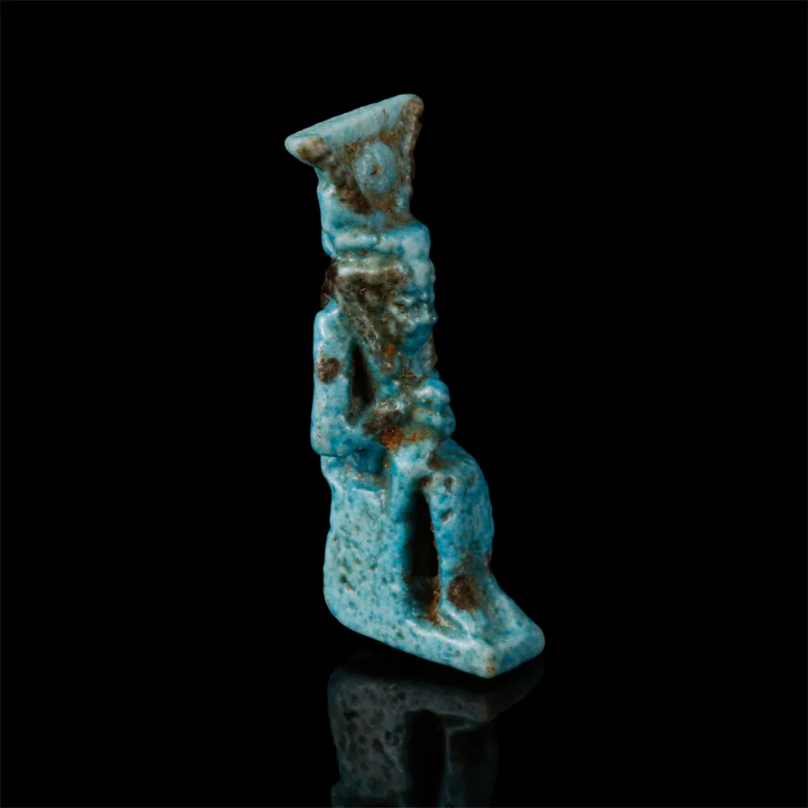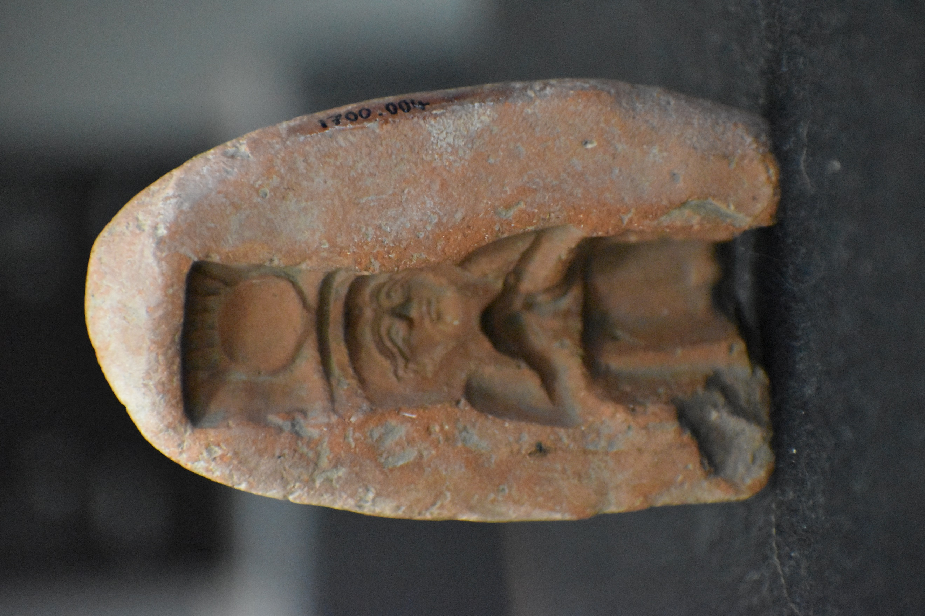

Bibliography
Deacon, J. (2022) Isis amulet mould image, Available at: https://moodle.uwtsd.ac.uk/mod/folder/view.php?id=460843 (Accessed: 09/11/2022)
St James Ancient Art (2022) Egyptian faience Isis and Horus amulet image, Available at: https://www.ancient-art.co.uk/egyptian/egyptian-faience-isis-and-horus-amulet/ (Accessed: 09/11/2022)
Yorkshire Museum (2022) Yorkshire Museum Facebook, Available at: https://www.facebook.com/yorkshiremuseum (Accessed: 09/11/2022)

