The Job that I’ve applied for
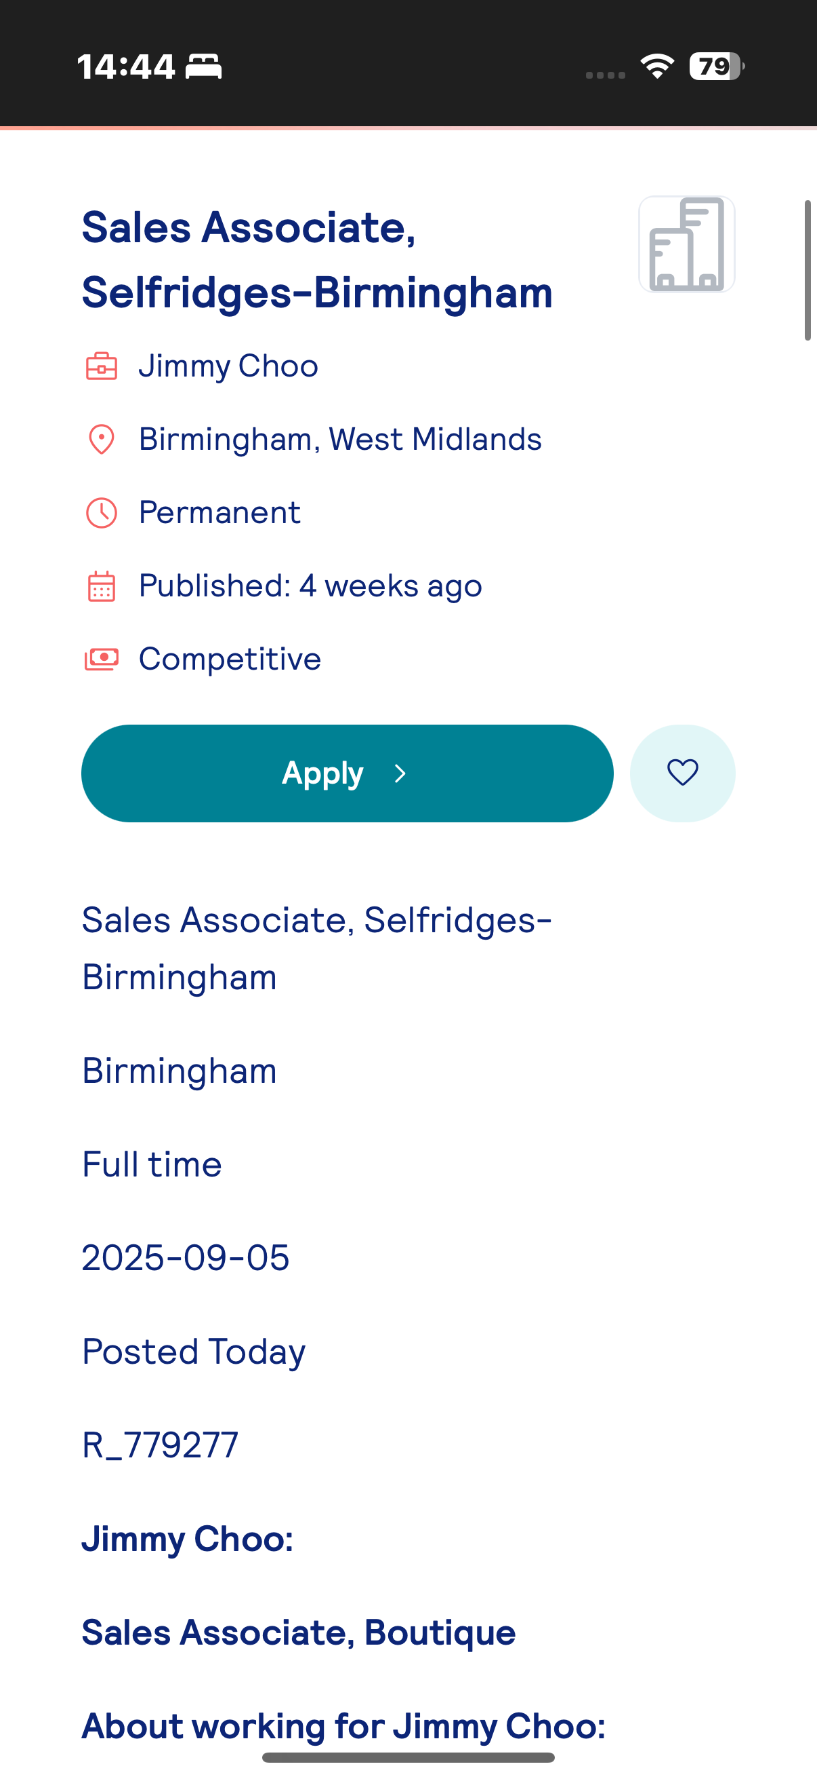
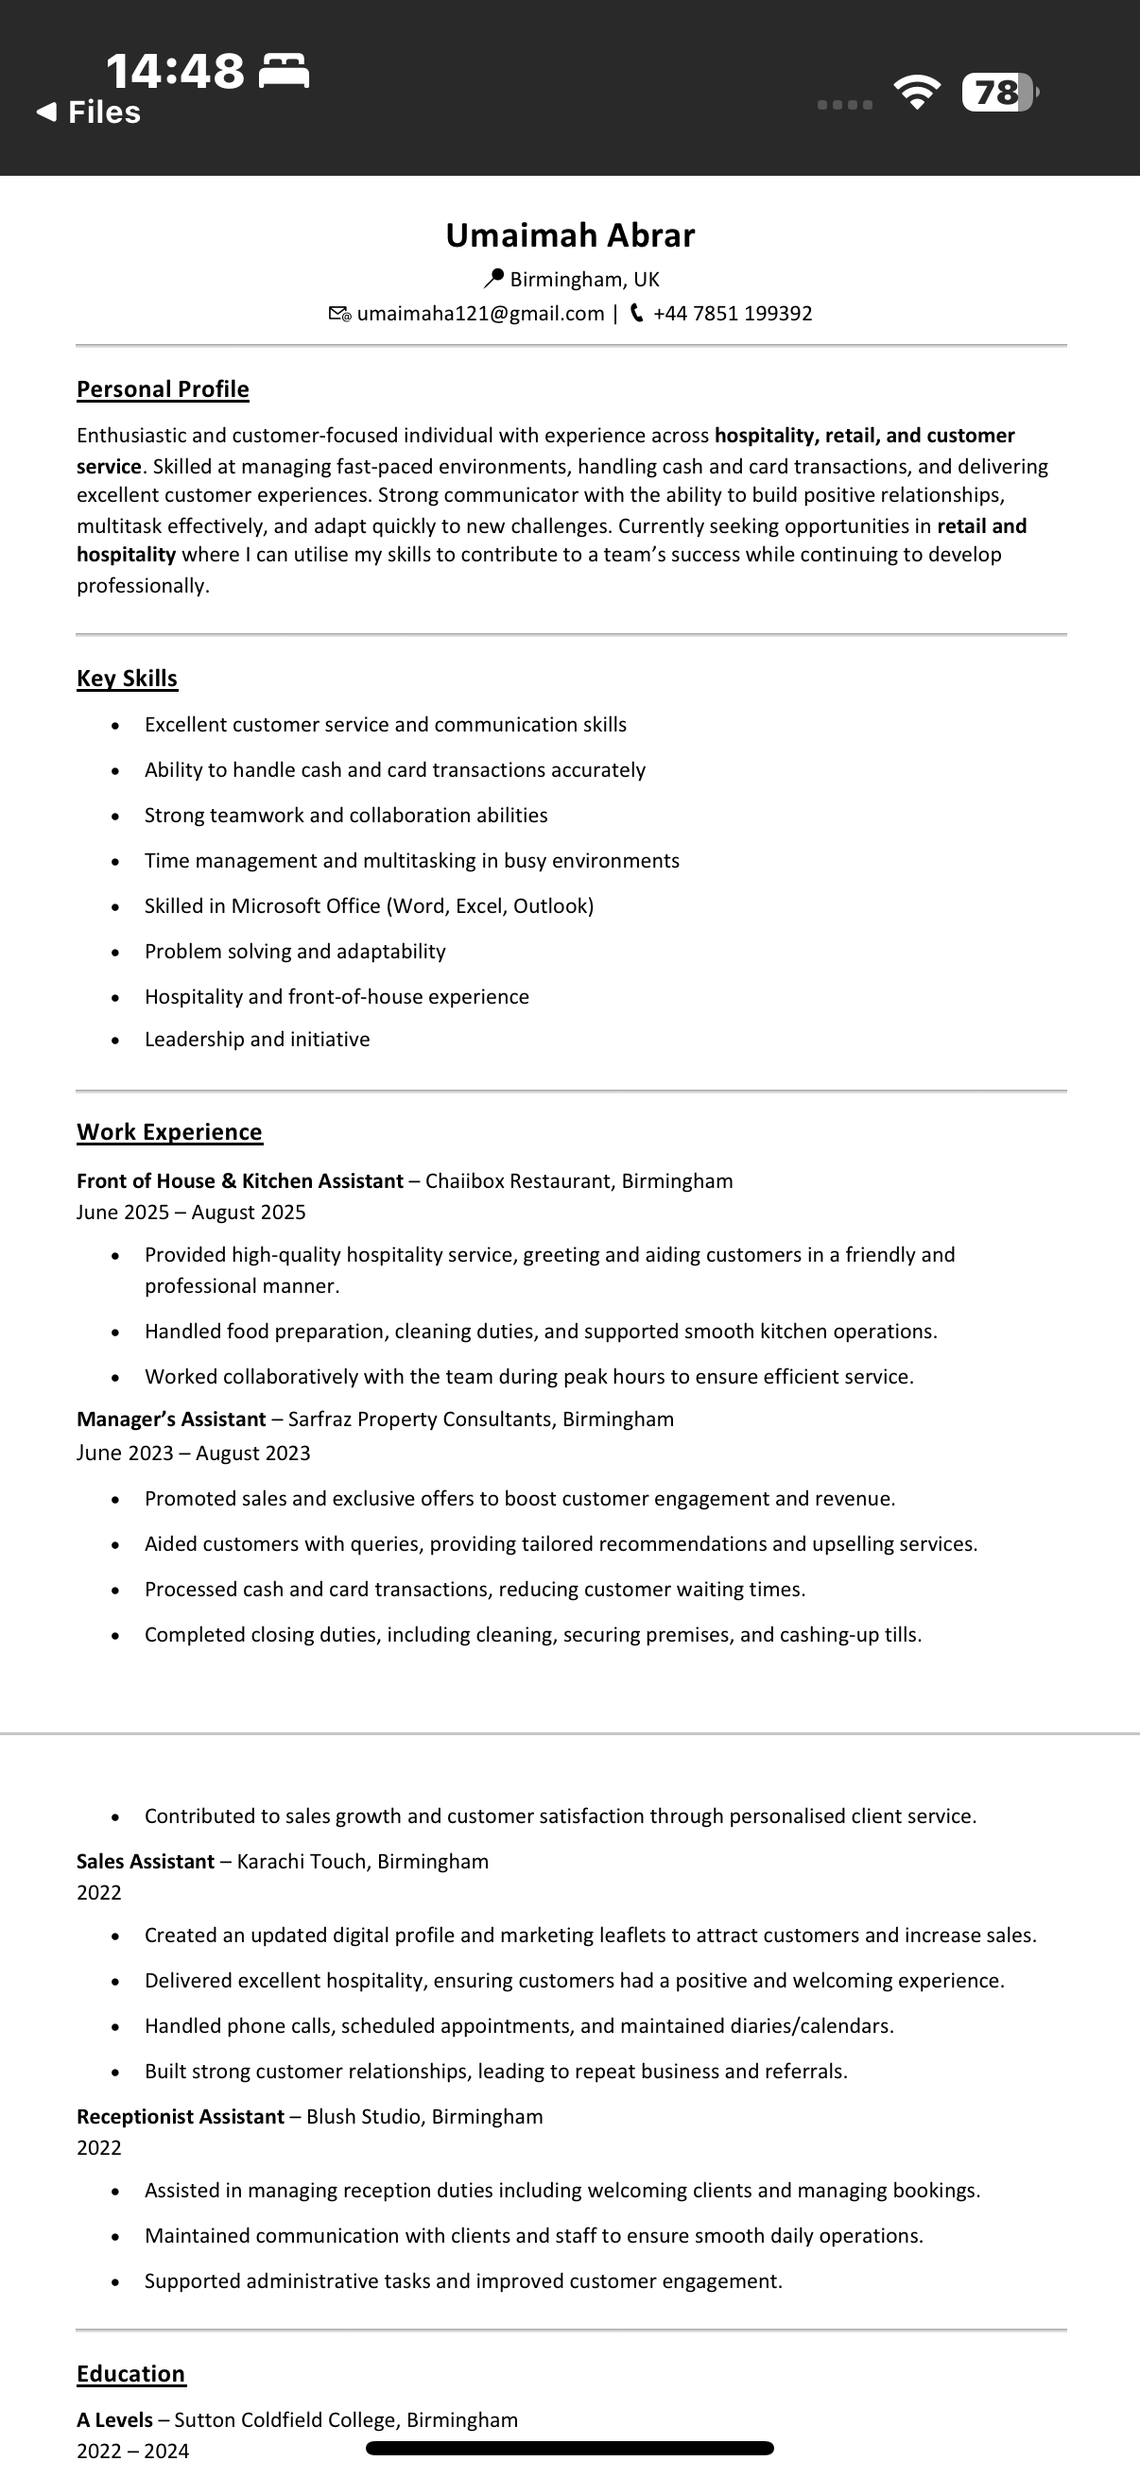
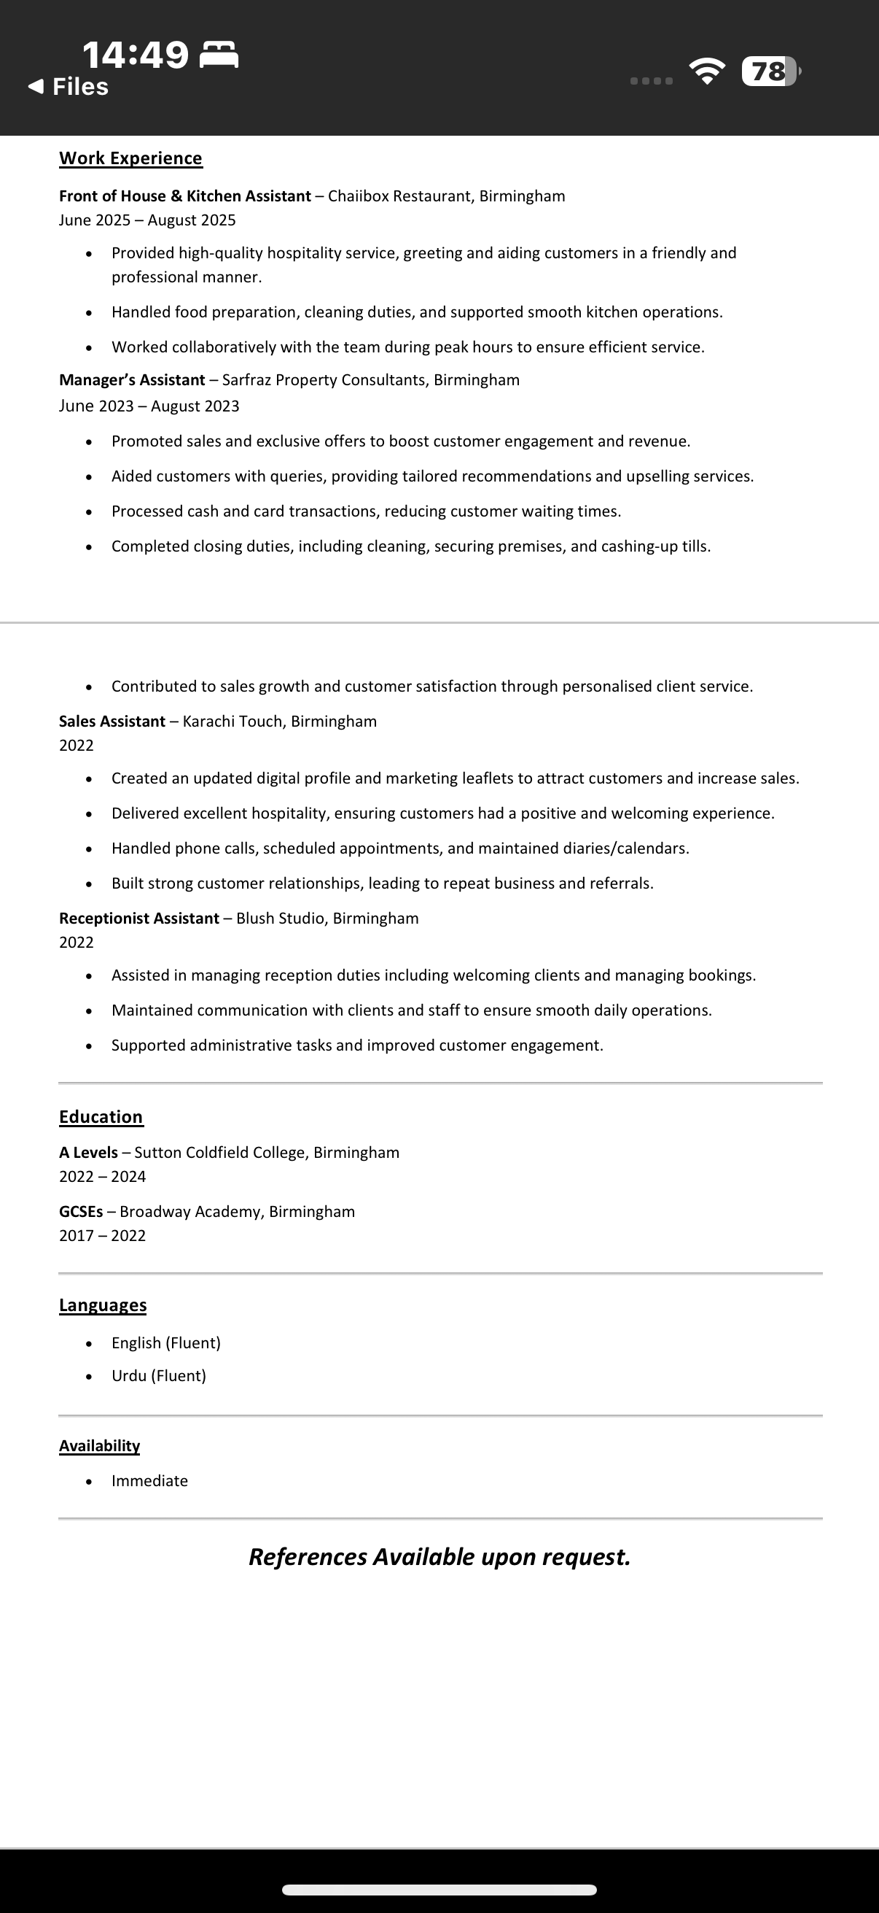
Cover letter
Umaimah Abrar
Birmingham | Umaimaha121@gmail.com | 07851199392

6th October 2025
Dear Hiring Manager,
I am writing to express my interest in the Sales associate position at Jimmy Choo in Selfridges Birmingham. With a strong background in customer service and working in fast paced environments, as well as having a passion for luxury fashion, and a commitment to delivering exceptional client experiences, hence I am eager to contribute to the success of one of the most iconic footwear and accessories brands.
In my earlier role at Karachi Touch, I developed strong customer engagement and styling skills, I was able to meet sales targets consistently, whilst creating returning customers and memorable shopping experiences. I take pride in understanding clients needs, maintaining visual standards, and representing Jimmy Choo with professionalism and enthusiasm.
I would be delighted to bring my energy, enthusiasm, product knowledge, and commitment to excellence to the Jimmy Choo team in Selfridges. Thank you for considering my application, I look forward to the opportunity to discuss how I can contribute to your continued success.

Yours faithfully,
Umaimah Abrar

