
Skills for the Workplace
Module Assignment Submission
Student Name: | Lucy Mansbridge
Student Number: | 1917771
Module No: | BMSK4005
Module Title: | Professional Career Development

Statement of Confirmation of Authentic1ity
By the act of making this submission, the student declares that this is the work of the student named above. The work has not, in whole or in part, been knowingly presented elsewhere for assessment, or where assessment has been built on a previous assessment, this has been identified. Where materials have been used from other sources it has been properly acknowledged. If this statement is untrue, the student acknowledges that an assessment offence has been committed.
Attention is drawn to the plagiarism and unfair practice policies of both the University and of ILM.

Table of Contents
Introduction 4
Section 1: Know how to identify development needs. 4
1.1 Identify learning styles for self and another. 4
1.2 Use a simple technique for identifying development needs for self & another. 6
1.3 The Johari Window 9
1.4 Identify potential barriers to learning for self and another. 11
1.5 Explain how these barriers to learning can be overcome. 12
1.6 Prepare development plans for yourself and another person. 13
Section 2: Recruitment process 14
2.1 Curriculum Vitae 14
2.2 My Job Application 14
2.3 Recruitment process reflection 15
Conclusion 16
References 17
‌ Appendix A 18
Appendix B 19
Appendix C 24
24

Introduction
In this assignment I will begin with section one firstly knowing how to identify learning development needs. I will discuss three different learning styles completing 3 questionnaires for myself and carry out 2 based on my work colleague to see how our styles compare. I will then use a technique known as SWOT analysis to identify development needs for myself and my work colleague, once I have completed this I will focus on the Johari Window again completing one for myself and work colleague. When it comes to learning there are several barriers which I will personally focus on and elaborate on my colleague’s barriers as you will see how our barriers vary due to a difference in lifestyle. Once the barriers have been explained I will then follow this on with how these specific barriers can be overcome. I will also complete two personal development plans again one for each myself and colleague ensuring the SMART objective tool is followed. Section two of my assignment will focus on the recruitment process; I will elaborate on what a CV is and attach one of my own as well as my own personal experience with a recent job application discussing the outcome via a reflection model.

Section 1: Know how to identify development needs.

Identify learning styles for self and another.

Learning styles are what define an individual based on several different factors such as attitude and behaviour. Everyone has a different learning style as not everyone absorbs information and learns the same way. Some people may have a few different learning styles depending on what is required from them whereas some people may have a more dominant learning style which they tend to adhere to all the time regardless. There are several tests/questionnaires an individual can complete to gauge what their learning style is. I have completed two of these for myself and asked a colleague to complete the exact same tests to compare our learning styles.
VARK – Visual, Aural, Read/Write, Kinesthetic
The ‘VARK’ questionnaire was introduced in 1987 by Neil D Fleming, in which he created a questionnaire to help individuals understand and identify their own learning preference. Kharb (2013) believes that one of the downfalls of this questionnaire was the fact that the questionnaire is relatively small suggesting the findings cannot be generalised to everyone as it only analyses one learning style aspect.
I completed the ‘VARK’ questionnaire and here are my findings:
Visual - 6
Aural - 8
Read/Write - 6
Kinesthetic – 10

These results suggest that I learn best by processing information whilst being physically active or engaged so a group activity for example as this would involve active participation, suggesting more of a do things approach to learn as opposed to reading a book to learn or read instructions for example. I do believe this to a certain extent not just when it comes to learning but in everyday life also I tend to jump right into anything for example putting furniture together I tend to just look assess and do as opposed to reading instructions first, basically a hands on approach is taken to learn.

My Colleagues ‘VARK’ results:
Visual - 1
Aural - 1
Read/Write - 4
Kinesthetic – 10
The above results show my colleagues results on completing the ‘VARK’ questionnaire, as you can see, they also score higher in the kinesthetic style of learning and quite low overall with the other learning styles. In regards to myself I scored over 5 with the other learning styles suggesting I used a bit of each learning style as opposed to having one dominant style where as my colleague is definitely showing here signs of their dominant learning style, having a hands on approach when it comes to how they learn.

Honey & Mumford
This learning style was developed in 1986 by Peter Honey and Alan Mumford, inspired from Kolb’s learning style model from which they created their own learning style questionnaire. The outcome of the questionnaire is based on four different styles known as activists, theorists, pragmatists, and reflectors. Rosewell (2005) confirms as per Honey and Mumford that we may follow more than one style depending on what needs to be achieved, suggesting it is important to know your predominant learning style as this can help you put it to best use depending on what needs to be achieved.
On completion of the Honey & Mumford questionnaire I score highly in two areas:
Activist – 16
Pragmatist – 12
Theorist – 9
Reflector - 6
These results are similar to the previous ‘VARK’ questionnaire suggesting again I tend to learn more by doing and being hands therefor this is my predominant learning style as it seems to show through both questionnaires I have completed.

My colleagues Honey & Mumford results:
Pragmatist – 17
Reflector – 14
Theorist – 16
Activist - 8
The above results are the outcome of my colleague completing the Honey & Mumford questionnaire, as you can see, they score quite highly over three learning styles as opposed to me only really scoring high in two areas. Like myself my colleague does score higher in the pragmatist learning style, but on the other hand I also score high in the activist learning style which my colleague does not. These results again suggest a hands-on approach with learning as well as using lots of visuals to also understand.

Dantec
Cathy Dantec produced a learning style which plots the results via a diagram made up of four quadrants, each quadrant based on results will in turn give you an indication of your learning style. Dantec (2006) states that no learning style is better than another but knowing your learning style will make you aware of your own personal preferences which will help you adapt and react in the correct manner if ever faced with a situation which is not compatible with your specific learning style. The outcome for myself when completing this learning style questionnaire suggests I am predominantly an active experimenter; I like to have a hands-on approach when it comes to learning so in a practical environment is where I feel most competent. I have completed and attached a diagram of my findings (Appendix 1)

Use a simple technique for identifying development needs for self & another.

SWOT analysis is a tool that can be used to identify, develop and analyse your strengths, weaknesses, opportunities and threats, helping you to improve on what you do well, be aware of what you lack whilst minimising risks and of course to get the best possible opportunities to achieve success. Grant (2020) believes that SWOT analysis is a good tool to use in business strategy meetings, stating that often the SWOT analysis you begin with can change by the time you get to the end of the meeting, as factors you were unaware of may be brought up via the groups input. I have completed below two SWOT analysis tables, one for myself and one for a work colleague.

SWOT Person 1 - Myself

STRENGTHS  - Over 11 yrs experience  - Approachable  - Work well under pressure  - Friendly team member  - I can adapt to change well  - Work well both independently and also in a team  - Winning customer service representative in 2014  - Currently studying leadership & management, certificate in skills for the workplace | WEAKNESSES  - Presenting to my team  - Being negative if having a bad day with calls, impacts team moral  - I can sometimes be too opinionated
OPPORTUNITIES  - Team manager role  - New starter trainer  - More share allowance if promoted  - Additional training | THREATS  - Can only work certain hours due to family commitments  - Covid  - Other colleagues who are at the same standard as myself  - I work from home which benefits myself but if I wanted to apply for a higher role it would need to be office based.

SWOT Person 2 - Colleague

STRENGTHS  - 5+ year’s experience  - Friendly  - Copes well under pressure  - Can take the lead if needed  - Senior member of staff  - I can take other members weaknesses into consideration | WEAKNESSES  - Does not like being dictated to  - Does not agree with certain procedures.  - Over opinionated
OPPORTUNITIES  - Team leader job role  - Development within other areas of the company  - Recognition for current senior role  - Additional training | THREATS  - Other experienced colleagues  - Covid  - People’s perception of me as I can sometimes be quite straight talking

1.3 The Johari Window

Created in 1955 by Joseph Luft and Harry Ingham the Johari Window is a useful tool broken into four quadrants area, blindspot, façade and the future used to identify and examine your own behaviours in relation to yourself and what other individuals know or don’t know about you. Robio (2015) believes that the Johari Window helps an individual understand more about themselves which inturn creates another level of self-awareness.
- Area – Things known by you, also seen, and acknowledged by others.
- Blindspot – Things that are unknown by you but seen and acknowledged by others.
- Façade – Things that are known by you but unknown by others.
- The Future – Things that are unknown by yourself and others.

Please find below an example of the Johari Window based on my own personal traits.
 | Known to Self | Unknown to Self
Known to Others | AREA  Name  Appearance  Behaviour  Age | BLINDSPOT  Annoying habits  Rude  Inconsiderate  Insensitive
Unknown to Others | FAÇADE  Past  Feelings  Financial situation  Relationship  Mental health | UNKNOWN  The future  Health  Opportunities  Political changes  Financial stability

Please find below and example of the Johari Window based on my colleagues own personal traits.
 | Known to Self | Unknown to Self
Known to Others | AREA  Name  Appearance  Behaviour  Age  Laidback  Organised | BLINDSPOT  Insensitive  Argumentative  Bossy  Conrolling
Unknown to Others | FAÇADE  Past  Feelings  Financial situation  Relationship  Mental health | UNKNOWN  The future  Health  Opportunities  Political changes  Financial stability

1.4 Identify potential barriers to learning for self and another.

Being a mum of three with my third child only being 7 weeks old can be quite challenging to say the least. My older two children both attend full time school, they come home each day with various activities that need completing, whether it be homework, reading or even a dance or gym class that my daughter attends or a rugby training session for my son. Although these are barriers I see it as part and parcel of having a family and ensuring that I give them lots of opportunity to do things that they enjoy helping them grow up to be outgoing and confident individuals. Before I was on maternity leave, I also worked 30 hours a week from home whilst juggling family life as well as enrolling onto this course in February 2020. As well as having a young family everyday chore such as cooking, cleaning, washing all must be done alongside working and studying also. I also believe it is important to make time for yourself for your own mental wellbeing. With the current situation we have found ourselves in with covid 19 we no longer attend university sessions in person instead it is done all online which I personally dislike, I find it really hard to focus and miss the socialising with other students in class. The pandemic has really rocked my confidence with returning back to student life as I have been out of that environment for over 15 years I feel like not only am I starting from scratch but in a completely different environment that I was expecting.
My colleague is also a mother, she has an older child who is in their last year of high school so they are at that age where they enjoy having independence and can be relied on to help out my colleague if needs be, therefore my colleague doesn’t relate to her child causing a barrier as such as she isn’t really relied upon as much as opposed to myself. My colleague however does have a elderly mother who she has to look after in her spare time, whether it be taking her mum shopping or even help out with some cleaning as her mum isn’t capable of carrying out these duties by herself. My colleague does also have to sometimes book time of work if her mum needs to attend hospital appointments, a lot of this can sometimes put a strain on my colleague as she feels as though it all falls on her because other family members are not on hand to help as much. With this my colleague is also a full-time senior of a team in our workplace, they have to ensure they lead by example to their team members as well as other colleagues. The pressure of this job role can sometimes take its toll with the worries she has to take on with her mum and can sometimes find it hard to not bring those worries into the workplace. Although my colleague does not have small children to depend on, she still has a household to run, cooking, cleaning, washing etc as well as working 38.5 hours a week and helping to take care of her mum.

Explain how these barriers to learning can be overcome.

I am very lucky that I have a very large supportive family network around me, my partner firstly is my number one person that I rely on, we work together as a team adhering to strict routine and time management to make life run as smoothly as possible. He is my main support and ensures that I get my time to attend university sessions and will take the children out so I can focus and put my undivided attention into my work. I also ensure I make time during my day when the oldest two children are in school to also catch up on university and to work on any upcoming assignments that are due, this can be quite hard at times as I have the baby who also needs me quite often so find it can be quite stop/start which I can find stops me in my tracks and then I struggle to get my head back into. It is also important that I invest my time into housework whilst the children are in school as I find I can get more done a lot quicker and easier when I just have the baby, I work around my daughters routine so when she has a nap I get everything done that needs doing by the time she wakes. I am very lucky also to have a large family who are always on hand if for example my partner has to work on or do overtime, I can always ask my mum or mother in law to help with the children, I used to feel guilty about this but it is a win, win situation as the children love seeing and being with family members and see it as a treat as opposed to me just needing someone to babysit them. I also feel very supported by my tutor and fellow students, one of the ways we communicate is via a group chat in which we all exchange our knowledge to help each other. I also feel comfortable messaging my tutor privately if I have any concerns or questions regarding the assignment, she is always happy to explain and is very understanding of my situation especially with me missing a few sessions recently with the birth of my daughter. As much as I prefer the classroom environment the fact we are currently learning online at the moment has been a huge bonus for me recently, as I have been able to watch back sessions via Microsoft teams where as if this was all in the classroom I would have really struggled catching up.

My work colleague does not have a large family unit to rely on to help her, she puts her organisation skills to good use when it comes to her work and home life. Due to how organised she has to be to ensure her household duties are complete and her mum is also looked after can sometimes be seen in a negative light in the workplace as she can come across quite bossy but this isn’t done on purpose it is just due to how she is used to working in and out of the workplace. As my colleagues child is quite independent due to them being older she does put rotas in place within the household for herself, partner and child so that they all support and work well together to ensure home life is run smoothly. My colleague is also looking into charities which help look after the vulnerable and elderly in regards to completing their food shop or even just going to sit with them for an hour for a bit of company, this should help release some strain of my colleague so when she does see her mum it’s to spend quality time with her.

  - Prepare development plans for yourself and another person.

Below you will find two personal development plans one is for myself and one is for my work colleague. A pdp is a good way to determine firstly what you want to achieve followed by identifying and developing the skills required in order to achieve your goal with a date in mind of when you want the relevant goal achieved. Spruce (2020) believes a good plan can also benefit you mentally as it helps reduce stress and anxiety. It is important when carrying out a pdp that you ensure it follows gap analysis and the smart objective tool.
S – Specific
M – Measurable
A - Achievable
R - Realistic
T – Timely

What do I want to learn? | What do I have to do? | What support and resources will I need? | How will I measure success? | Target Date for Review
Complete year one of my CertHe skills for the workplace achieving ILM lvl 4 certificate. | Successfully complete 6 modules of the course.  Use a variety of tools such as SWOT, SMART, GO MAD.  Overcome nerves | Attend every lesson, internet, books, support from partner to look after children so I can attend class. Various office programs word, excel etc.  A Laptop. | Feedback from tutor. My assignment marks.  Graduation. Progression onto level 5. | Nov 2020

What do I want to learn? | What do I have to do? | What support and resources will I need? | How will I measure success? | Target Date for Review
I want to be promoted to team manager. | Plan for the interview in advance.  Create a presentation for my interview.  Research example questions that may be asked. | Examples of experience gained.  PowerPoint to complete presentation. | Feedback from the persons interviewing.  Success of obtaining the job role. | March 21

Section 2: Recruitment process

2.1 Curriculum Vitae

A curriculum vitae also known for short a c.v is a document which provides a summary of an individual’s experience based on previous work and academia. This document can be extremely helpful to an employer as it basically gives them the relevant information that they will be looking for when it comes to the recruitment process. When it comes to creating a c.v it is important you make sure it represents you in the best way possible and is relevant to the job you are seeking to get. McGuire (2013) believes producing a good c.v will not only give your audience the best representation of yourself but by doing this and recognising your own value will in turn give a good confident impression to the recruiter. I have successfully completed and attached a copy of my c.v (Appendix B)

2.2 My Job Application

Within my current role at Admiral my role since starting in 2010 has been taking inbound calls as a customer service representative in the renewals sector of the business. When it comes to recruiting for jobs of a senior/manager level the recruitment process is always sent out internally to existing employees, which I believe makes perfect sense as the company already know the person applying for the role already has some sort of background experience and also their own stats to back up as to why they would be suitable for the role in question. With this being said recently a job role came up within my actual department recruiting for a team senior, this role is a step up from what I currently do with the opportunity to then progress on to team manager with further promotions higher up the ranks. I have a lot of experience as I have been in my current job now over 10 years, so I feel that I am more than capable to assist the team manager to successfully run a team. I have completed a covering letter (Appendix C) used in my application process for this specific role.

2.3 Recruitment process reflection

On completion of my job application I will reflect on the whole process via Borton (1970) reflective model which is split into 3 segments ‘What? So What? And Now What?’ this reflective model is fairly straightforward and is easy to implement reflection.
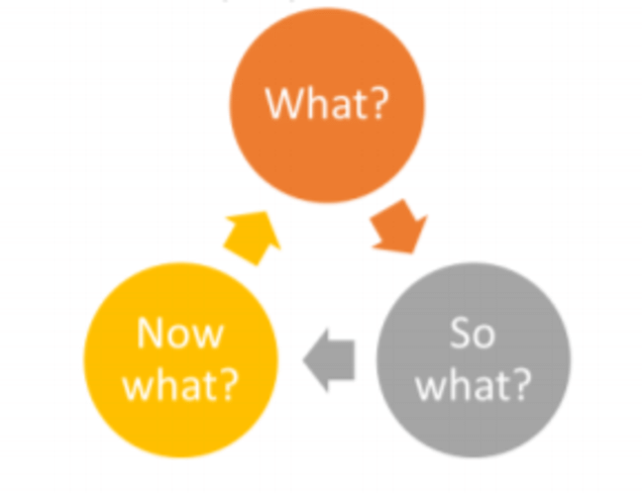

What?
A job vacancy was advertised within my current department recruiting a team senior which is the next role up from my current job title. I had to prepare a presentation answering the question ‘What would you bring to the workplace environment as a team senior?’ I am not the most confident with presentations and as it was in front of not one but two senior members of my department this did make me feel very unnerving. However, I did what was asked I also spoke with other senior’s and asked them for some advice on what they can remember based on their interviews, I was advised to give a lot of examples, so I researched times when I had to step up providing stats of teams I had helped look after.

So What?
On completion of the interview, I come out feeling like a big weight had been lifted, I was extremely nervous, which come across in my interview. The benefit of having the interview with two senior staff members was that they know me on a general day to day basis and know that I am quite outgoing, bubbly, and friendly however under interview settings I do let nerves get the better of me. I felt disappointed with myself for getting so nervous, but it was my first time in an interview setting in 10 years. Unfortunately, due to the number of applicants, I was not successful on this occasion. Feedback was given and the nervousness was thankfully not the reason for me not being successful. Due to only being back full time for a short length of time I am required to keep doing what I am doing to gain more experience and get more examples for the next time a senior job role becomes available. I was advised that I provided an excellent presentation and that even though I was nervous it was presented well and contained all relevant points that the interviewees were looking for.

Now What?
Going forward I will not see the outcome of this process as a negative, I believe next time round I will know what to expect, I will still be extremely nervous, but I know that is just a trait I have and will have to just try my best to keep nerves at bay. I will carry on helping teams stepping up to cover if required and gather more evidence to use as examples for when I reapply for another senior role in the future. When the opportunity arises again to apply for a senior role, I will perhaps do a lot more prep regarding looking at different questions and how they can be answered in a way to best show of what I know and what I can help the department gain, to sell myself as much as possible. I also believe practising presentation skills will also help with my nerves as I have stated it will always be a weakness of mine but practising in front of other colleagues may help for when I reapply and must present again.

Conclusion
In this assignment I have completed three different learning style questionnaires and compared two of these with a colleague. I have also carried out SWOT analysis development needs for us both followed by a Johari Window diagram again for myself and colleague focusing on our own personal attributes. I have also focused on barriers we face when it comes to working/learning and how these can be overcome. I have completed a personal development plan for myself and colleague using the SMART objective tool. The second part of my assignment focuses on a recent job application I made, it covers my c.v, cover letter and information regarding the job role I was applying for, on completion of this my outcome was produced using a reflective model.

References
Borton, T., (1970) Reach, touch, and teach: Student concerns and process education. New York,: Mcgraw-Hill Paperbacks.
Dantec, C. and Mozzon - McPherson, M. (2006). Supporting Independent Learning through Explicit Strategy – Based Training. In: Supporting Independent Language Learning: Issues and Interventions. Berlin: Peter Lang.
Grant, M. (2020). Strength, Weakness, Opportunity, and Threat (SWOT) Analysis. [online] Investopedia. Available at: https://www.investopedia.com/terms/s/swot.asp.
‌Kharb, P. (2013). The Learning Styles and the Preferred Teaching–Learning Strategies of First Year Medical Students. JOURNAL OF CLINICAL AND DIAGNOSTIC RESEARCH. [online] Available at: https://www.ncbi.nlm.nih.gov/pmc/articles/PMC3708205/.
McGuire, L. (2013). Seven benefits of a GREAT CV | Supercharge your job hunt | CV writing. [online] Giraffe CVs. Available at: https://www.giraffecvs.co.uk/seven-benefits-of-a-great-cv/.
‌Rosewell, J. (2005). Learning styles. [online] Available at: https://www.open.edu/openlearn/ocw/pluginfile.php/629607/mod_resource/content/1/t175_4_3.pdf.
Rubio, E. (2015). Increasing Your Self-Awareness: The Johari Window. [online] www.linkedin.com. Available at: https://www.linkedin.com/pulse/increasing-your-self-awareness-johari-window-enrique/ [Accessed 11 Nov. 2020].
Spruce, H. (2020). A Personal Development Plan (PDP) Guide &... [online] The Hub | High Speed Training. Available at: https://www.highspeedtraining.co.uk/hub/personal-development-plan-template/.
‌

‌
‌

‌Appendix A
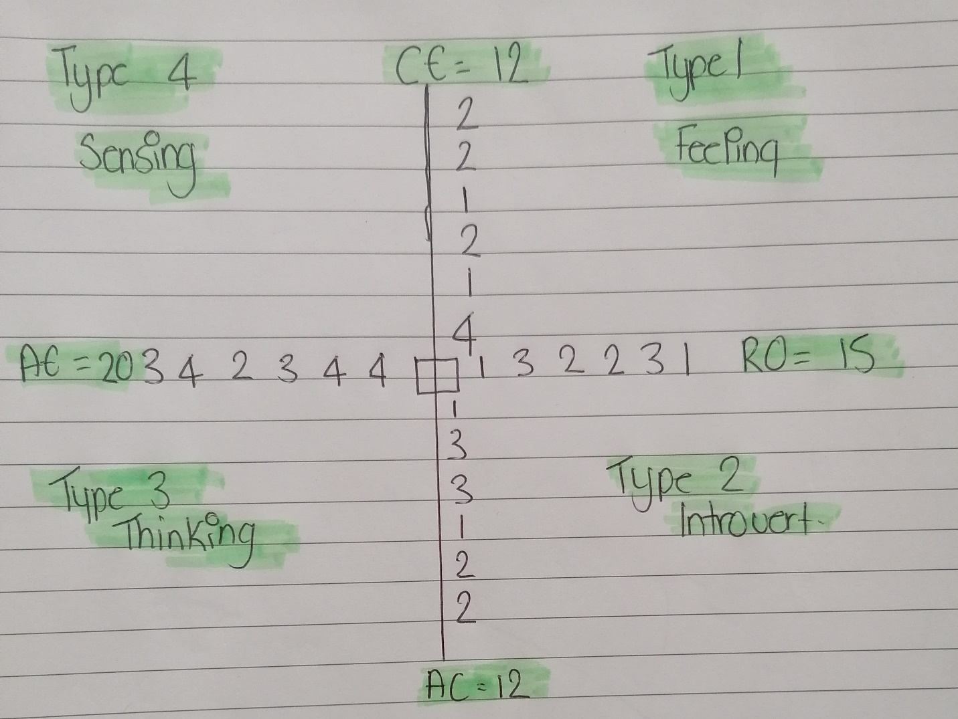

Appendix B
Lucy Mansbridge
Lucymans17@gmail.com
07306307011
Work History |  | Jan 2010 – Present Eui Ltd  Renewals Consultant  Duties:  Working in an inbound call centre, duties included updating customer’s details, making changes, and giving quotes ensuring all necessary information is checked thoroughly to ensure correct prices are quoted. Also retaining customers, as insurance is an extremely competitive industry, I must ensure that fantastic customer service is always given to ensure the customer feels valued to retain their custom for another year. My job role also involved up selling various products which may benefit the customer, customizing it to the customer’s needs so they could understand the full benefit, also ensuring compliance is maintained as this is something which is especially important to ensure all customers are being treated fairly.  Sept 2006 – Nov 2010 Marks & Spencer  Retail Assistant  Duties:  I was based on the menswear department which involved several different roles such as replenishing stock, ensuring the shop floor was clean and tidy and that the clothes were all neatly folded and hung. I would also work on the tills working with customers on a face-to-face basis ensuring they were happy and that they had found everything they were looking for. If an item of stock was not available, I would help the customers by giving them various options such as stock checking other stores, online ordering or offering to have items delivered to the store whatever was easiest for the customer. Working in menswear department taught me experience in measuring for suits also so there was always something different.
Education |  | Mary Immaculate High School 2000 - 2005  Qualifications: GCSE  P. E Grade B  English Literature Grade C  English Language Grade C  Maths Grade D  Geography Grade D  Technology Grade B  Business Grade B  Barry College 2005 - 2006  Qualifications: Diploma Beauty & Holistic Therapies  Additional Qualifications: Key Skills Maths – Pass  English – Pass  I.T - Pass  University of Wales Trinity St David 2019 - present  CertHe Level 4 Certificate in skills for the workplace  Level 4 ILM Leadership and management  ADDITIONAL INFORMATION  I am hardworking and very punctual. I do love to work and like the feeling of being valued. I have a full uk driving license so I can get to other sites to cover with great ease if required. I have been in my current job role as a renewal’s customer service agent for over 10 years, it is a great role however since increasing my hours to full time I feel that I would be much more suited to a senior role based on the knowledge and experience I have gained over the years within my current role I am confident in the work I do and enjoy helping others. I enjoy listening to music, cooking, and attending the gym when I have time. I am an outgoing, bubbly person and love spending time with my family also. I get on with anyone and would also say I am a very approachable easy-going person also.
References |  | References available on request

Appendix C


