Uber drivers are workers and entitled to minimum wage, Supreme Court rules
19 Feb 2021 By Francis Churchill
Judges say current employment laws exist to protect individuals who have “little or no say” over pay and working conditions
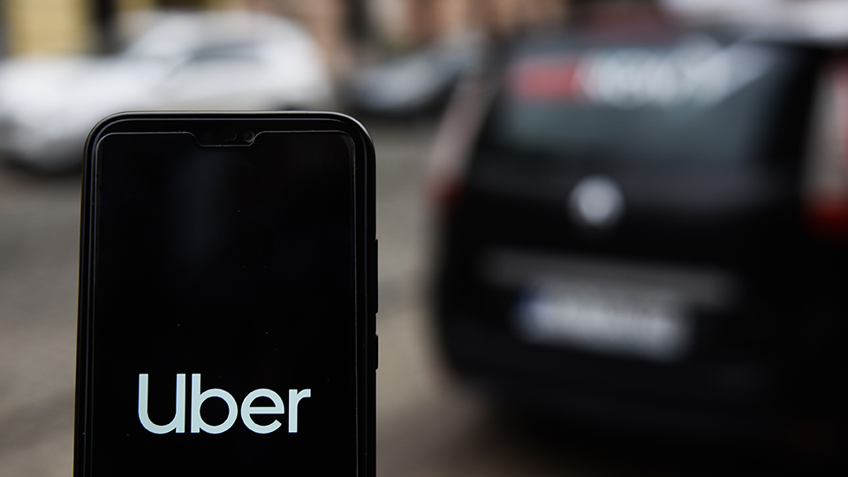
Uber drivers are ‘workers’ and therefore entitled to employment rights including the minimum wage and sick pay, the Supreme Court has ruled, in a judgement that could upend the way the app-based economy works in the UK.
The court unanimously agreed that drivers were working “for and under” Uber, regardless of how the arrangement was written into the contractual agreement, and therefore the relevant employment legislation applied – bringing to end a five year legal battle over the issue.
“It is wrong in principle to treat the written agreements as a starting point in deciding whether an individual is a ‘worker’,” the court said, finding that in reality the service provided by drivers was “very tightly defined and controlled by Uber” and that drivers were “in a position of subordination and dependency in relation to Uber”.

- Government failed to ensure gig workers’ health and safety, High Court finds
- European court issues ‘worker’ status clarification in Yodel tribunal case
- Gig workers caught in ‘app trap’ without skills development, says think tank

The court added that the purpose of employment legislation was “to give protection to vulnerable individuals who have little or no say over their pay and working conditions” because they are dependent on a person or organisation that controls their work.
“The legislation also precludes employers, frequently in a stronger bargaining position, from contracting out of these protections,” the judges said.
The case was originally brought before an employment tribunal by former Uber drivers James Farrar and Yaseen Aslam, who won the case in October 2016. Uber appealed the decision, but the High Court upheld the ruling in December 2018. Today’s Supreme Court judgement was the ride hailing app’s last appeal.\

Get more HR and employment law news like this delivered straight to your inbox every day – sign up to People Management’s PM Daily newsletter

Paul Jennings, partner at Bates Wells and one of the lawyers acting for the claimants, described the ruling as a “clear and powerful restatement of the importance of basic employment protections”, and said the judgement would shape future cases on the gig-economy.
“The ruling strikes at the heart of Uber’s business model. We anticipate there will be a significant class action against Uber,” he said. “As a business, it will need to reflect very carefully on the implications of the judgement.”
Michael Powner, partner at Charles Russell Speechlys, added the ruling “clearly sent a warning” to other businesses using these types of app-based platforms that the current employment legislation exists “to give protection to vulnerable individuals who have little or no say over their pay and working conditions.
“[The ruling] has wide-ranging implications for all those working in the gig economy, such as couriers and delivery drivers, and will make it much harder for companies engaging people via digital platforms to assert that they are self-employed whatever their contractual documentation says,” he said.
As well as confirming Uber drivers are entitled to employment rights, including rest breaks and holiday pay, Powner added that the judgement confirmed drivers were working from the time they turn the app on and they are ready to accept bookings.
Alan Lewis, partner with Constantine Law, said the ruling could go as far as impacting more than five million workers in the UK. The judgement “has emphasised the need to rely less on the written contractual terms and more on what happens in reality,” he said, adding that businesses will need to ask questions including: Who controls what goes on? Who takes the financial risk? Who supplies the equipment? And can the individual appoint a substitute to carry out the work?
Several organisations are now calling on the government to reform employment law. Andy Chamberlain, director of policy at self-employed trade body IPSE, said the judgment had shown the law as it stands was not working.
“With the pandemic still raging and its financial impact ever more visible, it is more urgent than ever that struggling people who should technically be classed as workers get the rights they deserve,” said Chamberlain. “To bring this about – and protect the freedom of legitimately self-employed people – we urge government to write a definition of self-employment into law.”
Farrar, who is general secretary of the App Drivers & Couriers Union as well as one of the co-lead claimants in the case, also called for legislative change.
“Uber drivers are cruelly sold a false dream of endless flexibility and entrepreneurial freedom. The reality has been illegally low pay, dangerously long hours and intense digital surveillance,” he said. “The government must urgently strengthen the law so that gig workers may also have access to sick pay and protection from unfair dismissal.”
Uber has long argued that drivers were self-employed and that it only acts as a booking agent and a payment platform.
The firm has said the ruling would not affect all of its drivers in the UK. “We respect the court’s decision which focused on a small number of drivers who used the Uber app in 2016,” Jamie Heywood, the firm’s Northern and Eastern Europe general manager, said. “We are committed to doing more and will now consult with every active driver across the UK to understand the changes they want to see.”

