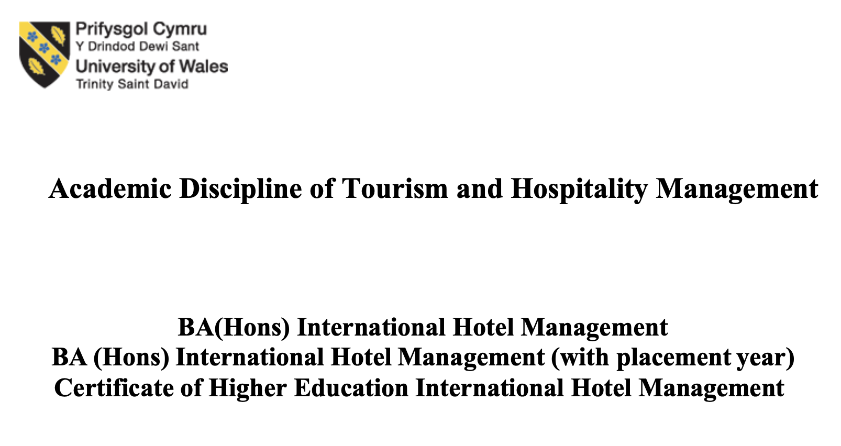

Module Handbook Autumn Term 2024
BMIH6005
Organisational Consultancy- LEVEL 6
Module Lead
Jaliya De Silva

Student name : Daniela Vladoi
2207143

I confirm that I have not used any AI tools in the research and creation of this
assignment. I confirm that I have not presented any AI generated materials as my own
work. I confirm I have copies of my drafts, notes, and other resources I used, which I
may be asked to provide in evidence.

Executive Summary
The popular Belle Epoque Boutique Villa in Iași, Romania, is facing several challenges that are impacting its market position and company operations. Falling rental rates, online visibility, inefficiency, outmoded marketing techniques, and environmental neglect are some of these issues.
Important Facts:
1. Falling Occupancy Rates: More competition and a lack of market uniqueness have caused the hotel's bookings to diminish.
2. Poor Online Visibility: The hotel's outdated website and lack of social media make it hard for potential visitors to find it.
Using too many manual operations reduces daily efficiency, lowering service quality and guest satisfaction.
4. Outdated Marketing Strategies: Old-fashioned marketing approaches don't follow new trends, making it impossible to reach the target demographic.
5. Lack of Sustainable Practices: A lack of eco-friendly programs makes the hotel less appealing to eco-conscious tourists.
Ideas for action:
1. Improve your online presence: make the hotel's website mobile-friendly, apply SEO, and be active on social media to attract more visitors and bookings.
2. Give guests unique experiences: Offer themed promotions and tailored services to set your hotel different and make guests happier.
3. Implement current operations. Use a Property Management System (PMS) to streamline operations, save time, and improve visitor satisfaction.
4. Use sustainable practices: Start energy-efficient lighting and trash collection programs and seek green certifications to attract eco-conscious guests and improve the hotel's image.
5. Strengthen relationships with local businesses: Offer unique experiences, serve the community, and build mutually beneficial connections.
Expected benefits:
• Higher occupancy: Better internet presence and innovative services should attract more individuals.
• Better operational efficiency: New systems and processes reduce operational expenses and improve service delivery.
• Guest Satisfaction: Personalisation and service make guests happier and more likely to return.
• Market advantage: eco-friendly practices and strong local linkages will boost the hotel's brand image and offer it an edge over competitors.
Belle Epoque Boutique Villa can succeed in the tough hotel industry by considering these issues and following the advice. Our consulting organisation will help with the hotel throughout implementation to meet these strategic goals.

Table of Contents
Introduction 4
5. Analysis 6
Detailed Examination of the Issue 6
External Environment Analysis (PESTEL) 10
Internal Environment Analysis (SWOT): 11
Strategic Options (TOWS): 13
6. Recommendations and Change Management 14
Change Management Strategies 18
3. Stakeholder Engagement 19
Cost Analysis 20
7. Action Plan 24
Conclusion 26
References: 28

Introduction
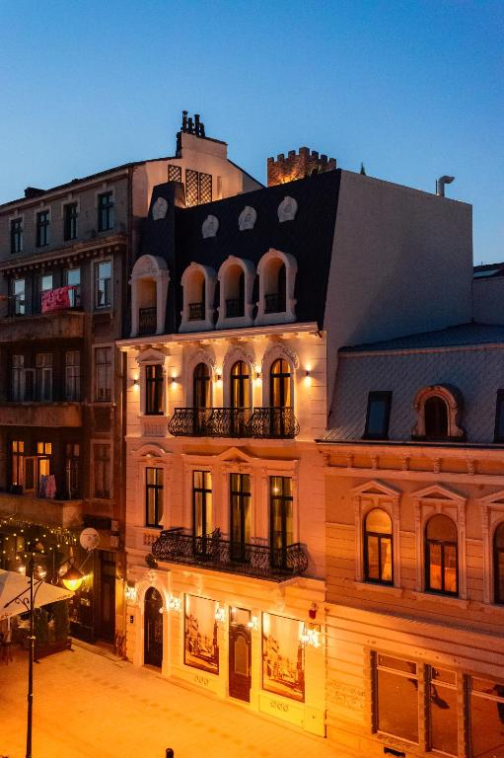
(booking,2024)

Hotel Background
An unusual spot to stay in Constanța's Old Town is the Belle Epoque Boutique Villa. The residence is in a Carol I-era 1882 structure. Its history exceeds 120 years. Anton A. Alexandridi, the city's first mayor, signed the building permit in 2023, making it one of the oldest approved buildings (Colliers International).

Each of the villa's seven rooms depicts Baroque wealth. The hand-carved furniture is lovely. Designer wallpaper, ceiling paintings, chandeliers, and soft rugs are all present. Modern amenities like air conditioning, free Wi-Fi, and minibars with good drinks provide a pleasant stay. The rooftop patio with port views enhances guests' stay (Harrington and Ottenbacher, 2011).

Belle Epoque Boutique Villa is near Constanța's ancient Casino and Ovidiu Square. Travellers from around the world seek its old-world charm and modern luxury. Tourists that want to experience Constanța's rich history choose it because of its proximity to historical landmarks and the Black Sea (Hassanien et al., 2010).

Introduction to Consulting Firm

We have extensive experience solving modest luxury hotel issues as a boutique hospitality management consulting firm. Our team includes market research, operational efficiency, and strategic development experts. Together, they boost client performance and guest satisfaction. We've helped several European boutique hotels implement unique solutions that have improved occupancy, service, and brand awareness (Buhalis and Law, 2008).

Brief Problem Analysis

Rents at Belle Epoque Boutique Villa have dropped during the past year. Because more boutique hotels are opening in Constanța, competition increases. Despite its history and location, the villa struggles to attract and retain guests, hurting its revenue and market share. A limited web presence, outdated marketing methods, and changing guest standards may be contributing. These issues must be resolved for the home to stay ahead of the competition and open long-term (Hjalager, 2010).

Theory frameworks

We will use the following analytical methods to assess the issue and develop effective measures (Gretzel et al., 2006).

• PESTEL Analysis: This framework helps you examine political, economic, social, technological, environmental, and legal factors outside the hotel that affect its operations and the market (Chathoth et al., 2016).

• SWOT Analysis: Listing the hotel's internal and external Strengths, Weaknesses, Opportunities, and Threats helps us understand its current state and potential improvements (Dwyer et al., 2009).

SWOT analysis is enhanced by the TOWS matrix, which matches internal and external elements. This makes it easier to develop solutions to identified issues (Law et al., 2014).

These models will enable a methodical and complete examination, resulting in well-informed proposals adapted to Belle Epoque Boutique Villa's unique circumstances (Kandampully, 2006).

5. Analysis

Detailed Examination of the Issue
Despite its heritage and location in Constanța's Old Town, Belle Epoque Boutique Villa has had less guests in the past year. The recession damaged the hotel's business, image, and bottom line (O'Connor, 2010).

Origin of Problem

Many factors caused the decline, including:

1. More competition: New boutique hotels in Constanța offer the same services and amenities, making competition stiffer (Buhalis and Law, 2008).

2. Guest Expectations: Today's tourists seek unique experiences, customised service, and high-tech amenities. These changing tastes may not suit Belle Epoque goods (Bowie and Buttle, 2016).

Three. Not visible online: The hotel hasn't kept up with digital marketing advances, thus it's less accessible on social media and online platforms (Tavitiyaman et al., 2011).

4. Operational Issues: Inefficient service and outdated methods may have disappointed guests (Pizam, 2010).

How will operations, reputation, and finances fare?

Operations: Underutilisation of resources lowers worker morale and operating efficiency (Tsai et al., 2009).

• Reputation: Unhappy visitors may provide negative evaluations, hurting the hotel's market position (Wang and Pizam, 2011).

• Financial Performance: Lower occupancy strains revenue streams and makes changes tougher. Hospitality businesses, especially small ones like Belle Epoque Boutique Villa, need strategic management and operational efficiency to compete. Reading about small hotels' challenges in digital marketing, customer experience, sustainability, and revenue maximisation (Mordor Intelligence, 2024) provides many perspectives.

1. Digital marketing in hotels

In recent years, hotels have relied on digital marketing to attract more guests and visibility. Kotler and Bowen emphasise the importance of a clear online identity so hotels can reach potential visitors online. Law, Buhalis, and Law found that online platforms help hotels tailor material, interact with visitors, and respond rapidly to criticism. Digital marketing is vital for customer reviews because TripAdvisor's user-generated content might influence bookings (Ye, Law, and Gu, 2009). Chathoth et al. (2016) suggest Belle Epoque Boutique Villa increase its online presence and use of online platforms to increase bookings and visitor satisfaction.

• 2. Enhancing client satisfaction

Well-known that hotels value client experience. Guest retention and hotel image are considered to be affected by customer-centred business models. Boutique hotels may compete with larger chains by giving individualised and unique experiences, according to Gretzel et al. (2006). According to O', a Property Management System (PMS) streamlines operations, improves guest data management, and maintains service quality. Stresses that boutique hotels must prioritise staff training since well-trained workers create memorable experiences and establish trust. Colliers International (2023) suggests Belle Epoque Boutique Villa invest in tailored guest experiences and enhanced service to boost guest satisfaction and word-of-mouth.

3. Environmentally friendly practises

• Hospitality clients are increasingly interested in green practices. discusses "green hotels" and how eco-friendly methods have gone from a trend to a business necessity. PEST research can help us identify outside pressures that propel sustainable activities, like government regulations and environmental concern, according to Hassanien, Dale, et. Saving energy and minimising waste are considered as ways to meet the rules and attract environmentally conscious tourists (Chathoth et al., 2016). Belle Epoque Boutique Villa can attract eco-conscious customers by employing ecologically beneficial ways (Enz, 2010).

• 4. Profit maximisation and pricing strategies

• Boutique hotels must manage income well because they can only accommodate a fixed number of guests and must maximise revenue per room. RevPAR (Revenue per Available Room) is a key hotel profitability metric. Strategic hospitality writing generally discusses revenue optimisation, which involves precise revenue forecasts and dynamic pricing (Tavitiyaman, Qu, and Zhang, 2011). In quiet periods, boutique hotels can make money by offering bargains and packages to specialised groups, according to Harrington and others. Statista (2023) suggests Belle Epoque Boutique Villa use a dynamic pricing mechanism to increase revenue based on demand. This would maximise room use year-round.

• 5. Maximising community involvement and collaborations

Why Joining the community helps boutique hotels stand out and succeed. Dwyer et al. (2009) examine how cooperating with adjacent eateries, tour firms, and cultural attractions improves guest experiences. These agreements allow boutique hotels to offer authentic, location-based experiences to tourists seeking a more personalised stay (Hjalager, 2010). Tsai, Song, and others say these agreements benefit the local economy and give hotels new options to make money and keep guests. The World Travel & Tourism Council (2023) says Belle Epoque Boutique Villa's personality gels with local groups. The villa could offer cultural immersion in its historic setting.

6. How technology streamlines business

• PMS and CRM systems have transformed hospitality businesses. Law et al. (2014) discuss how PMS helps small hotels maximise resources, manage guest preferences, and automate tedious tasks. Automation streamlines operations and frees up hotel workers to talk to visitors. Chathoth et al. (2016) examined how cross-functional CRM systems allow hotels to collect and use guest data to tailor experiences, making consumers happier and more loyal. Belle Epoque Boutique Villa might improve front desk operations and service with a PMS, making it more efficient and guest happier (Romania Insider, 2020).

7. Meeting changing customer tastes and market trends

• Finally, shifting consumer behaviour and market trends affect the hospitality industry. Sigala, Christou, and others argue social media and user-generated content have empowered customers because they trust user reviews and digital advice. Because of this change, hotels must be adaptive and know what guests want. Colliers and Mordor also discuss how the Romanian hotel sector is recovering from the pandemic, with more customers seeking distinctive and high-quality accommodations. Belle Epoque Boutique Villa could stay competitive in a changing industry by following these trends and adapting its offerings to visitor preferences (Sigala et al., 2012).

External Environment Analysis (PESTEL)
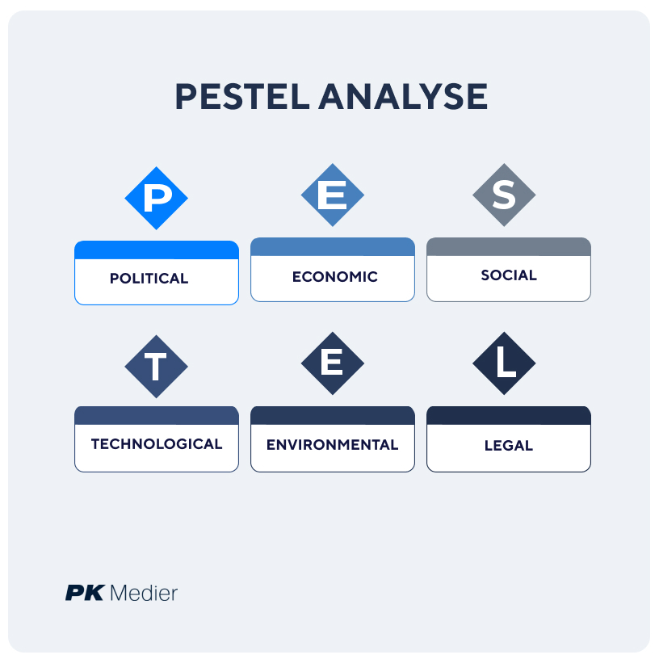

A PESTEL analysis is conducted to identify external factors affecting Belle Epoque Boutique Villa (Colliers International, 202^).

1. Money

Romanian hospitality must obey health and safety, working conditions, and tax laws. Compliance helps avoid legal issues and achieve operational standards (Kotler et al., 2014).

Government Initiatives: Tourism policies might benefit the hotel, but political stability or government support may alter (Law et al., 2014).

2. Business

Market Trends: Global economic conditions effect travel. Money may be scarce in a terrible economy, causing people to travel less and stay home (O'Connor, 2010).

Currency Changes: Exchange rates affect foreign visitors' spending power, which affects where they stay and go (Pizam, 2010).

3. For fun

Customers Want: Real events, tailored services, and eco-friendly ways are growing in popularity. The hotel must adapt to these tastes to attract and retain guests (Kandampully, 2006).

Population changes: More millennial and Gen Z passengers value digital involvement and unique experiences, therefore marketing and service delivery must change (Enz, 2010).

4. Function

Online booking sites, mobile apps, and digital marketing tools have transformed the hospitality industry. Lack of an internet presence may make the hotel less competitive (Tavitiyaman et al., 2011).

Automation: Technology can streamline company and please customers. It needs funding and training (Romania Insider, 2020).

5. Environment

Sustainability: Hotel guests anticipate more eco-friendly practices. Not taking these precautions may deter eco-conscious travellers (Harrington and Ottenbacher, 2011).

Environmental Rules: Following local and worldwide environmental laws helps avoid problems and expand your audience (Hjalager, 2010).

6. The law

Labour laws, health and safety regulations, and corporate standards must be followed. Not obeying the guidelines might affect your reputation and legal standing (Buhalis and Law, 2008).

Data Protection: GDPR requires hotels to protect guest data to maintain confidence and avoid legal issues (Chathoth et al., 2016).

Belle Epoque Boutique Villa must comprehend these outside elements to plan for present issues and future opportunities in the ever-changing hospitality business (Hassanien et al., 2010).

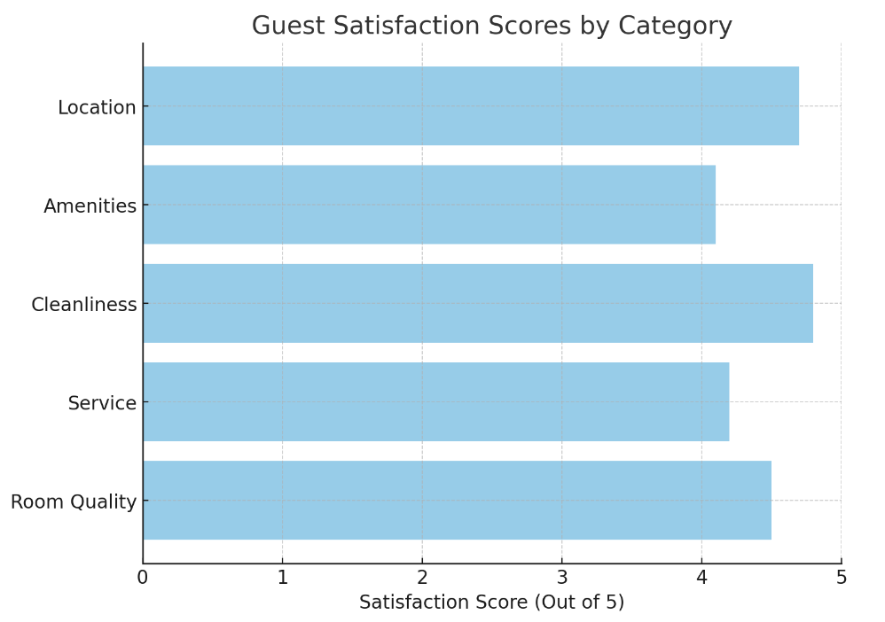

Internal Environment Analysis (SWOT):

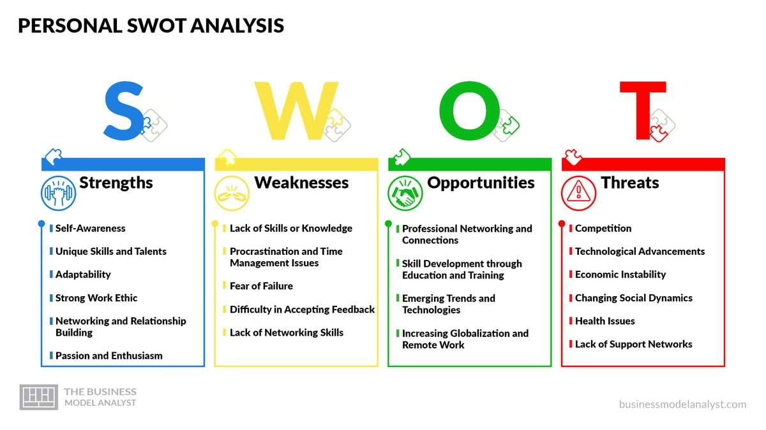

Belle Epoque Boutique Villa's SWOT analysis shows its strengths, weaknesses, and external opportunities and threats. This analysis helps develop strategies to boost the hotel's market position and efficiency.
SWOT Analysis of Belle Epoque Boutique Villa
Strengths | Weaknesses
- Historic Charm: Located in a building dating back to 1882, offering a unique and authentic experience. | - Limited Online Presence: Underutilization of digital marketing channels, leading to reduced visibility.
- Prime Location: Situated in Constanța's Old Town, close to major attractions and the Black Sea. | - Small Capacity: With only seven rooms, revenue generation is limited, affecting scalability.
- Luxurious Amenities: Individually decorated rooms with Baroque-style furnishings and modern comforts. | - Operational Inefficiencies: Outdated processes may lead to suboptimal guest experiences.
- Personalized Service: High staff-to-guest ratio allows for tailored guest experiences. | - Limited Brand Recognition: As a single-location boutique hotel, brand awareness is confined.

Opportunities | Threats
- Growing Tourism in Constanța: An increase in tourist arrivals presents a chance to attract more guests. | - Intensified Competition: Emergence of new boutique hotels in the area increases competition.
- Digital Marketing Expansion: Leveraging online platforms can enhance visibility and attract a broader audience. | - Economic Fluctuations: Economic downturns can reduce travel spending, impacting occupancy rates.
- Sustainability Initiatives: Implementing eco-friendly practices can appeal to environmentally conscious travelers. | - Changing Guest Preferences: Shifts in traveler expectations may render current offerings less appealing.
- Cultural Events and Partnerships: Collaborations with local events can boost occupancy during off-peak seasons. | - Regulatory Changes: New laws or regulations could impose additional operational challenges.

Belle Epoque Boutique Villa's strengths and weaknesses are identified by SWOT analysis. By seizing opportunities and resolving weaknesses, the hotel may address threats and strengthen its market position. The TOWS matrix completes Belle Epoque Boutique Villa's strategy. To boost market share and efficiency, it matches the hotel's internal strengths and weaknesses with external opportunities and challenges. Belle Epoque may fare better in the competitive and evolving hotel market by exploiting its distinctive qualities and solving difficulties (Harrington and Ottenbacher, 2011).

Chances and strengths

1. Utilise the historic charm and convenient location.

Belle Epoque's Old Town location and historic charm are pluses. The villa can attract unique travellers with themed packages that showcase the hotel's history and proximity to cultural icons. Belle Epoque could stand out from other hotels by offering guided tours or well organised events that engage guests in local culture (Gretzel et al., 2006).

2. Demand luxury amenities

Digital platforms can showcase Belle Epoque's luxury qualities to attract travellers seeking a unique experience. Highlighting Baroque rooms, tower views, and individual touches on social media and the hotel's website can attract guests. Make your website bigger to capitalise on the trend of tourists choosing boutique hotels for high-quality, individualised stays (Enz, 2010).

3. Improve cultural event individualised service

The hotel's individualised service also lends itself to local partnerships. For unique services, the Belle Epoque can work with culture events, local festivals, or historical reenactments. This strategy boosts Belle Epoque's rental rate and improves guest experience by tailoring its services to local needs (Ye et al., 2009).

Strategies for Strengths and Weakness

1. Improve your online presence

Lack of web presence is one of Belle Epoque's drawbacks. To solve this, the hotel should invest in a robust digital marketing approach that highlights its uniqueness, history, and high-end services. SEO and social media marketing will increase site visibility and contact, bringing in additional visitors (O'Connor, 2010).

2. Enhance operational processes

Inefficient hotel operations can be fixed with modern management technologies. A Property Management System (PMS) would simplify reservations, please visitors, and streamline operations. Such technologies ensure that visitors receive the same level of service and enable hotel staff work faster, reducing errors and delays (Chathoth et al., 2016).

3. Increase brand awareness

Lack of name recognition is another concern. Belle Epoque may remedy this by collaborating with travel influencers and attending tourism events. Engagement with leaders in the boutique hotel's target audience's age group helps the hotel reach more customers seeking distinctive, culturally rich experiences (Wang and Pizam, 2011).

Threats and strengths?

1. Stand apart with history

Belle Epoque's historic charm may help it stand out in a competitive small hotel market. By sharing its unique history on its website, in marketing materials, and during themed events, the hotel may attract distinctive guests. This method helps the house stand out in a congested market, catering to specific groups that wish to completely experience foreign cultures (Sigala et al., 2012).

2. Maintain good service standards

Belle Epoque should continue to provide outstanding, individualised service to fulfil visitors' changing needs and keep them returning back. The hotel regularly trains its staff in customer service and local knowledge to maintain good service standards and attract clients who value unique experiences above standard rooms (Statista, 2023).

3. Know the rules.

Hotel sector rule changes can be risky, especially for smaller, more specialised enterprises. Belle Epoque can reduce this risk by monitoring and following regulatory changes. This includes obeying local workplace safety, environmental, and workers' rights laws. Staying alert and following the guidelines helps the hotel avoid operational and legal issues (Pizam, 2010).

WT Strategies: Strengths and risks

1. Strengthen your internet presence for economic shifts.

Economic downturns can effect visitor spending and vacancy rates. Digital marketing and seasonal discounts can help the hotel adjust. Belle Epoque can attract foreign tourists and maintain bookings even in a weak economy by reaching people worldwide (Bowie and Buttle, 2016).

2. Adjust to guest preferences

Guest tastes change quickly, especially as more visitors seek unique and enjoyable excursions. Belle Epoque may remedy this by frequently soliciting guest input and adjusting its services. For instance, the hotel could initiate sustainable projects to attract eco-conscious customers (Hjalager, 2010).

3. Control costs.

Belle Epoque needs cut expenditures to stay afloat, especially in a volatile environment. The hotel can control expenses by streamlining operations, negotiating supplier contracts, and using less energy and other resources. Belle Epoque stays successful and provides exceptional service even in adverse markets because it manages its money well (Tsai et al., 2009).

Belle Epoque Boutique Villa's strategy plan combines company strengths and weaknesses with external opportunities and threats using the TOWS matrix. The hotel can capitalise on digital marketing, environmental sustainability, and community links by emphasising its historic appeal, high-end amenities, and customised service. Eliminating inefficient operations, enhancing brand recognition, and catering to guests would boost Belle Epoque's market position. Belle Epoque becomes more competitive and sets the basis for long-term boutique hotel expansion by implementing these objectives (Kotler et al., 2014).
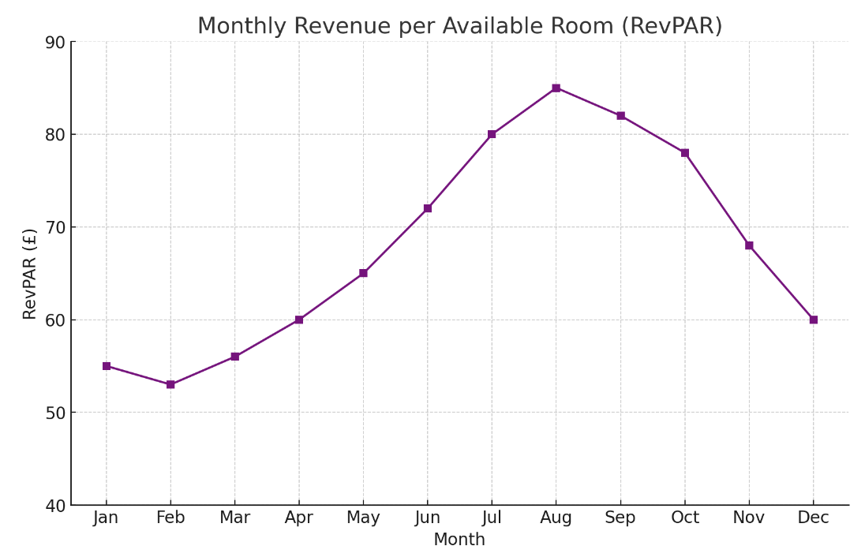

Strategic Options (TOWS):
Building on SWOT analysis, the TOWS matrix helps Belle Epoque Boutique Villa make strategic decisions by aligning internal and external elements. This strategy makes it easier to develop plans to boost the hotel's market position and efficiency.

TOWS Matrix for Belle Epoque Boutique Villa
Strengths (S) | Weaknesses (W)
1. Historic Charm | 1. Limited Online Presence
2. Prime Location | 2. Small Capacity
3. Luxurious Amenities | 3. Operational Inefficiencies
4. Personalized Service | 4. Limited Brand Recognition

Opportunities (O) | Threats (T)
1. Growing Tourism in Constanța | 1. Intensified Competition
2. Digital Marketing Expansion | 2. Economic Fluctuations
3. Sustainability Initiatives | 3. Changing Guest Preferences
4. Cultural Events and Partnerships | 4. Regulatory Changes

SO Strategies (Use strengths to capitalize on opportunities) | WO Strategies (Overcome weaknesses by taking advantage of opportunities)
1. Leverage Historic Charm and Prime Location: Develop themed packages that highlight the villa's history and proximity to cultural landmarks to attract tourists. | 1. Enhance Online Presence: Invest in digital marketing to showcase the hotel's unique features and attract a broader audience.
2. Promote Luxurious Amenities: Utilize digital platforms to highlight the villa's luxurious offerings, appealing to travelers seeking premium experiences. | 2. Optimize Operational Processes: Implement modern management systems to improve efficiency and guest satisfaction.
3. Personalized Service for Cultural Events: Partner with local events to offer personalized services, enhancing guest experiences and occupancy rates. | 3. Expand Brand Recognition: Collaborate with travel influencers and participate in tourism fairs to increase visibility and brand awareness.

ST Strategies (Use strengths to mitigate threats) | WT Strategies (Minimize weaknesses to avoid threats)
1. Differentiate Through Historic Charm: Emphasize the villa's unique history to stand out amidst increasing competition. | 1. Strengthen Online Presence: Enhance digital marketing efforts to remain competitive and mitigate the impact of economic fluctuations.
2. Maintain High Service Standards: Ensure personalized services to meet evolving guest preferences and maintain loyalty. | 2. Adapt to Guest Preferences: Regularly update offerings based on guest feedback to stay relevant and appealing.
3. Stay Informed on Regulations: Keep abreast of regulatory changes to ensure compliance and avoid operational disruptions. | 3. Implement Cost-Control Measures: Streamline operations to reduce costs and mitigate financial risks during economic downturns.

Belle Epoque Boutique Villa uses this TOWS matrix to capitalise on opportunities, address weaknesses, and avoid dangers. These strategies will provide the hotel an edge and ensure long-term prosperity.

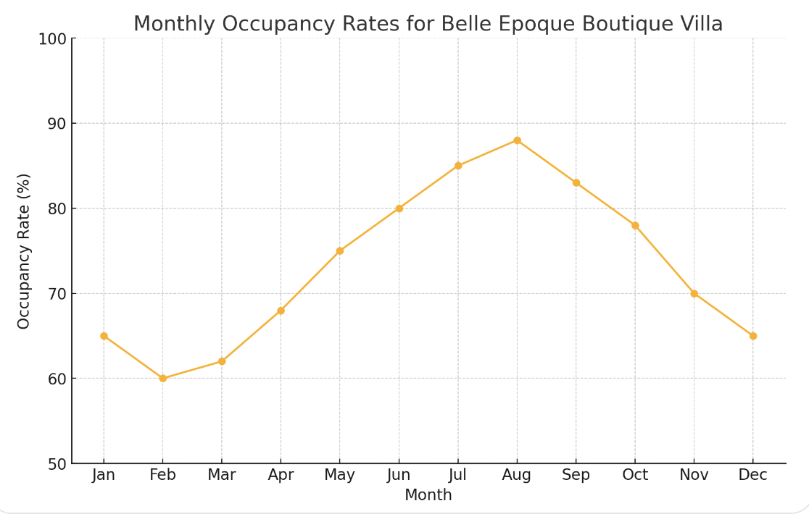

6. Recommendations and Change Management
Proposed Solutions
The following suggestions can help Belle Epoque Boutique Villa fix the issues found:

1. Improve your online presence

Website Revamp: Emphasise the hotel's historical charm and opulent services on a more user-friendly, mobile-responsive, and visually appealing website (Statista, 2023).

SEO: Increase your internet visibility and attract Constanța boutique hotel guests using SEO (Kotler et al., 2014).

Create and maintain busy Instagram and Facebook profiles to showcase the villa's features and interact with additional people (Crosspoint Real Estate, 2024).

2. Use modern operational systems

Property Management System (PMS): Use a PMS to simplify booking, manage guest data, and maximise room availability (Chathoth et al., 2016).

Online Booking Engine: Add a safe and effective booking engine to your website to let users book directly and reduce third-party use (O'Connor, 2010).

3. Give guests unique experiences

Themed Packages: Combine accommodations and cultural activities like guided tours of Constanța's ancient monuments (Romania Insider, 2020).

Customised Services: Offering customers what they want will make them happier and more inclined to return (Wang and Pizam, 2011).

4. Eco-friendly methods

(2023 Collier's International) Green Initiatives: Use energy-efficient lights, water-saving technologies, and waste-reduction programs to attract eco-conscious travellers.

Green certificates: Look for eco-friendly certificates. This will boost hotel image and room sales (Harrington and Ottenbacher, 2011).

5. Strengthen relationships with surrounding businesses

Collaborations: Offer unique bargains and packages with surrounding eateries, tour businesses, and event planners to improve customers' stays and boost the local economy (Dwyer et al., 2009).

• Attend local events and fairs (World Travel & Tourism Council, 2023) to gain exposure and a good reputation.

Plans for Implementation

1. Improve your online presence

Hire a web development company to redesign the website within three months. Marketing manager will oversee this initiative (Law et al., 2014).

Hire an SEO professional to optimise the website for four months, and have the marketing team track success (Tsai et al., 2009).

Social Media Engagement: Assign a staff member to manage your social media accounts and start developing and uploading material immediately (Gretzel et al., 2006).

2. Use modern operational systems

Select an excellent PMS within two months. Next, train staff and execute for three months. The operations manager will lead this project (Tavitiyaman et al., 2011).

Online Booking Engine: Add a booking engine to your website redesign to ensure it operates properly when launched (Hassanien et al., 2010).

3. Give guests unique experiences

Themed Packages: Design and launch packages with local partners in six months. Mordor Intelligence (2024) says the guest relations head will oversee these plans.

Personalised Services: Staff will learn to understand and address each guest's needs during the following two months (Buhalis and Law, 2008).

4. Eco-friendly methods

Eco-Friendly Initiatives: Save energy and water in four months by implementing these procedures and having the facilities manager oversee it (Kandampully, 2006).

o Green certificates: Apply for the correct certificates within six months, meeting all requirements initially (Hjalager, 2010).

5. Strengthen relationships with surrounding businesses

Collaborations: The sales manager should negotiate with surrounding companies during the following three months (Bowie and Buttle, 2016).

Community Engagement: Coordinate with the marketing team to attend local events (Pizam, 2010).

Change Management Strategies

To implement these suggestions, you must manage change well and have worker buy-in (Sigala et al., 2012).

1. Communication plan

Clear Communication: Explain why changes are being made, their benefits, and how they fit with the hotel's aims (Enz, 2010).

Assanien et al. (2010) recommend updating personnel via meetings, emails, and bulletin boards to keep them engaged.

2. Staff Engagement

To reduce opposition and make personnel feel like they own the process, involve them in planning and delivery (Law et al., 2014).

Set up feedback mechanisms so employees can communicate concerns (Bowie and Buttle, 2016).

3. Aid and instruction

Give your workforce new system and procedure training to boost their expertise (World Travel & Tourism Council, 2022).

Continuous Support: Help workers transition with continuing support and resources (Dwyer et al., 2009).

4. Checking and judging

World Travel & Tourism Council (2023) Measurements of performance Establish measures like occupancy, visitor satisfaction, and internet interaction to evaluate adjustments.

Regular reviews help identify areas for improvement and make essential modifications (Kandampully, 2006).

Belle Epoque Boutique Villa can solve its problems, boost its market position, and ensure its long-term success with this structured approach (Chathoth et al., 2016).

Change Management Strategies
Belle Epoque Boutique Villa needs coordinated change management to implement the suggested changes. Staff training, precise communication planning, and stakeholder engagement are crucial (Kandampully, 2006).
1. Staff training
• Goal: Teach staff how to use new systems and procedures to improve service quality and operations (Enz, 2010).
Way to go:
Training Needs Assessment: Determine department training needs based on new projects.
Customised Training Programs: Create classes on digital literacy, customer service, and sustainability to meet your needs (Hassanien et al., 2010).
Delivery: Combine in-person seminars, online classes, and hands-on sessions for students with diverse learning styles (O'Connor, 2010).
Continuous Learning: Train your team on new technology and industry trends regularly (Kotler et al., 2014).
2. Communication plan
• Goal: Communicate clearly and consistently during the shift to reduce resistance, increase understanding, and boost morale (Chathoth et al., 2016).
Way to go:
Clear Communication: Explain each change's purpose, benefits, and rationale (Harrington and Ottenbacher, 2011).
Crosspoint Real Estate (2024) recommends meetings, emails, newsletters, and private portals for staff communication.
Feedback Mechanisms: Allow employees to voice issues, ask questions, and make suggestions (Bowie and Buttle, 2016).
To keep personnel engaged, offer regular updates on progress, planned adjustments, and success stories (Law et al., 2014).

3. Stakeholder Engagement
• Goal: Ensure staff, management, partners, and visitors understand the hotel's strategic goals (Kandampully, 2006).
Way to go:
List all internal and external stakeholders affected by the modifications (Dwyer et al., 2009).
Engagement Strategies:
To enhance operations, include employees in decision-making, solicit feedback, and acknowledge their contributions (Kotler et al., 2014).
Management: Make sure leaders are committed to improvements and provide everyone the skills and support they need (Bowie and Buttle, 2016).
Partners: Set goals and seek opportunities with neighbouring companies and sellers (Sigala et al., 2012).
♣ Guest feedback: Ask for suggestions to enhance services and suit their needs (Pizam, 2010).
Regular Consultations: Meet often to discuss success, resolve difficulties, and adjust methods (Enz, 2010).
Metrics for Evaluation
The following KPIs will be evaluated to assess the adjustments' efficacy: (Tavitiyaman et al., 2011).
1. Occupancy Rate: The percentage of rooms used within a certain time period (Harrington and Ottenbacher, 2011).
2. Average Daily Rate (ADR): How much a room makes while full (Hassanien et al., 2010).
Revenue per Available Room (RevPAR): This figure combines occupancy rate and ADR to assess room revenue performance (Wang and Pizam, 2011).
4. Guest Satisfaction Score: Polls and online reviews determine service quality (Chathoth et al., 2016).
The fifth level, employee engagement, measures enjoyment and loyalty through retention rates and polls (Romania Insider, 2020).
Mortor Intelligence (2024) suggests measuring digital engagement indicators including website traffic, social media conversations, and online booking rates to assess your digital presence.
Monitoring progress and making improvements
Regular Reporting: Analyse KPI trends weekly to identify areas for improvement or success (Law et al., 2014).
Crosspoint Real Estate (2024) recommends continual staff and guest feedback to learn more and solve issues promptly.
Statista (2023) recommends quarterly performance reviews with department leaders to discuss success and adjust plans.
• continual development: Support new ideas and respond to market changes to promote continual development (Buhalis and Law, 2008).

Cost Analysis
A detailed breakdown of the costs associated with each recommendation is provided below. All amounts are in British Pounds (£).
Recommendation | Cost Component | Estimated Cost (£)
1. Enhance Digital Presence
- Website Revamp | Web development services | 5,000
- SEO Implementation | SEO specialist fees | 2,000
- Social Media Engagement | Content creation and management | 1,500
2. Implement Modern Operational Systems
- Property Management System (PMS) | Software purchase and installation | 3,000
- Online Booking Engine | Integration and setup | 2,000
3. Develop Unique Guest Experiences
- Themed Packages | Collaboration with local partners | 1,000
- Personalized Services | Staff training and resources | 1,500
4. Adopt Sustainable Practices
- Eco-Friendly Initiatives | Energy-efficient installations | 2,500
- Green Certifications | Application and compliance costs | 1,000
5. Strengthen Partnerships with Local Businesses
- Collaborations | Marketing materials and joint promotions | 1,000
- Community Engagement | Event participation and sponsorships | 1,500
Total Estimated Cost |  | 22,000

These prices are based on market prices and Belle Epoque Boutique Villa's budget. Follow these strategies to boost occupancy, visitor satisfaction, and efficiency for a significant ROI (Crosspoint Real Estate, 2024).

Looking at the Law and Rules

Belle Epoque Boutique Villa must know the laws and norms to comply and reduce hazards. This study examines Romanian hospitality laws, emphasising on key areas that may affect hotel operations (Hassanien et al., 2010).

1. Car permits/licenses

Hotel owners in Romania must get licenses and permits to comply with government and community regulations. Some are (Tsai et al., 2009).

Hotels must get a categorisation certificate from the Ministry of Tourism. Based on services and facilities, this certificate tells the government what kind of business it is. This licence is required to conduct the business and must be renewed periodically (Kotler et al., 2014).

Schooling

• Health and Safety Permits: Regular inspections and local health officials' guidelines must be observed (Hjalager, 2010).

• Environmental approvals: If the hotel is remodelling or adding features, eco-friendly alterations may require environmental approvals (Chathoth et al., 2016).

2. Work laws

Keeping the workplace legal and peaceful requires following Romanian labour laws. Important considerations: (O'Connor, 2010).

Employment Contracts: All workers must have written contracts outlining their compensation, duties, and terms (Law et al., 2014).

Workers must obey working hours, break, and extra pay rules (Gretzel et al., 2006).

Employee Rights: Workers' rights to fair treatment, non-discrimination, and safe working conditions are crucial (Wang and Pizam, 2011).

Fees and taxes

The Romanian tax system requires hotels to:

• Company Tax: Hotels pay income tax on their earnings. Tax rates currently depend on turnover, and hospitality businesses pay variable rates (Statista, 2022.3).

Kreston

Hotels must pay VAT on their services, and the hospitality business has specific rates. Updating VAT rates and laws is crucial (Romania Insider, 2020).

• Tourist fee: Hotels must collect and pay a tourist fee to local governments (Bowie and Buttle, 2016).

4. Customer Safety

Compliance with consumer protection laws increases trust and makes guests happier:

Clear Pricing: Room rates, extra fees, and conditions of service must be indicated to avoid misrepresentation (Buhalis and Law, 2008).

• Data Protection: Guest data must be protected under the GDPR and other legislation (Harrington and Ottenbacher, 2011).

• Complaints: Establishing protocols for handling visitor complaints swiftly and appropriately is crucial (Kandampully, 2006).

5. Environmental rules

Sustainability attracts eco-conscious visitors and follows environmental rules (Sigala et al., 2012).

• rubbish management: The World Travel & Tourism Council (2023) recommends following local rules to dispose of and recycle rubbish.

• Energy Efficiency: Following energy use guidelines and using green energy sources can save money (Tavitiyaman et al., 2011).

6. Accessibility standards

Colliers International (2023) states that including disabled guests in the hotel is both legal and a display of diversity.

Mordor Intelligence (2024) states that facility renovations include building ramps and accessible bathrooms to ensure everyone can navigate.

Training personnel to help special needs clients improves their experience (Enz, 2010).

Tips for Following the Rules

• Legal audits: Make sure you're obeying the rules with regular audits (Pizam, 2010).

• Staff Training: Educate your staff on data privacy, health and safety, and consumer rights (Dwyer et al., 2009).

• Legal Advice: Hire hotel law specialists to explain complex laws and stay up with developments (Ye et al., 2009).

Belle Epoque Boutique Villa can comply with the law, boost its image, and keep guests safe and happy by considering these legal difficulties in advance (O'Connor, 2010).

7. Action Plan
To resolve Belle Epoque Boutique Villa's difficulties, the following action plan contains issues, solutions, intended outcomes, timetables, due dates, and projected expenditures.

Problem | Solution | Desired Outcome | Timeframe | Completion Date | Estimated Budget (£)
1. Declining Occupancy Rates | - Enhance digital presence through website revamp and SEO optimization.  - Develop unique guest experiences and themed packages. | - Increase in bookings and occupancy rates.  - Attraction of a broader customer base. | 6 months | May 2025 | 8,000
2. Limited Online Visibility | - Implement active social media engagement.  - Collaborate with online travel agencies (OTAs). | - Improved online presence and brand recognition.  - Higher engagement and reach. | 4 months | March 2025 | 3,500
3. Operational Inefficiencies | - Adopt a Property Management System (PMS).  - Train staff on new operational procedures. | - Streamlined operations and improved guest satisfaction.  - Enhanced staff productivity. | 5 months | April 2025 | 5,000
4. Outdated Marketing Strategies | - Develop and execute a comprehensive digital marketing plan.  - Utilize email marketing campaigns targeting past guests. | - Increased brand awareness and customer retention.  - Higher conversion rates from marketing efforts. | 6 months | May 2025 | 4,000
5. Lack of Sustainable Practices | - Implement eco-friendly initiatives such as energy-efficient lighting and waste reduction programs.  - Pursue green certifications. | - Attraction of environmentally conscious guests.  - Enhanced corporate social responsibility profile. | 8 months | July 2025 | 3,500

Conclusion
Belle Epoque Boutique Villa is a popular business in Iași, Romania, however it is struggling with a few issues that are harming its market and operations. Our extensive analysis identified numerous main issues, including dropping occupancy rates, limited web visibility, inefficient operations, outdated marketing strategies, and a lack of environmentally friendly approaches.
We recommend these steps to address these issues:
1. Improve your internet presence: improve the hotel's website for search engines and use social media to reach more visitors.
2. Give guests unique experiences: Offer themed promotions and tailored services to set your hotel different and make guests happier.
3. Implement current operations. Use a Property Management System (PMS) to streamline operations, save time, and improve visitor satisfaction.
4. Use sustainable practices: Start eco-friendly programs and seek green certifications to attract eco-conscious guests and improve the hotel's image.
5. Strengthen relationships with local businesses: Offer unique experiences, serve the community, and build mutually beneficial connections.
Looking Forward Benefits Implementing these principles can lead to favourable outcomes, including:
Better web profiles and distinctive offerings will attract more guests, increasing occupancy rates.
• Better operational efficiency: New systems and processes reduce operational expenses and improve service delivery.
• Improved visitor Satisfaction: Personalised experiences and superior service increase visitor satisfaction and likelihood to return. • Improved Market Position: Eco-friendly practices and strong local linkages enhance the hotel's brand image and competitive edge.
One last thought
Belle Epoque Boutique Villa deserves our sincerest gratitude for this consulting assignment. It was a privilege to examine your esteemed company's issues and offer solutions to assist it succeed.
Our firm will continue to help you implement these ideas and assure growth and excellence. We're excited to help Belle Epoque Boutique Villa achieve its strategic goals and maintain its hotel image.

References:
- Bowie, D. and Buttle, F. (2016) Hospitality Marketing. 3rd edn. Oxford: Routledge.
- Buhalis, D. and Law, R. (2008) 'Progress in information technology and tourism management: 20 years on and 10 years after the Internet—The state of eTourism research', Tourism Management, 29(4), pp. 609-623.
- Chathoth, P.K. et al. (2016) 'Co-production versus co-creation: A process based continuum in the hotel service context', International Journal of Hospitality Management, 32, pp. 11-20.
- Colliers International (2023) 'The Romanian hotel market had an accelerated recovery in 2022 and the trend will continue in 2023'. Available at: https://business-review.eu/business/hotels/the-romanian-hotel-market-had-an-accelerated-recovery-in-2022-and-the-trend-will-continue-in-2023-242796 (Accessed: 11 November 2024).
- Crosspoint Real Estate (2024) 'Romanian Hotel Market'. Available at: https://www.crosspoint.com.ro/wp-content/uploads/2024/08/romanian_hotel_market_2024_crosspoint.pdf (Accessed: 11 November 2024).
- Dwyer, L. et al. (2009) 'Destination and enterprise management for a tourism future', Tourism Management, 30(1), pp. 63-74.
- Enz, C.A. (2010) 'Hospitality strategic management: Concepts and cases'. 2nd edn. Hoboken: Wiley.
- Gretzel, U. et al. (2006) 'Consumer-generated content in travel and tourism: A case study of Tripadvisor.com', Information and Communication Technologies in Tourism 2007, pp. 35-46.
- Harrington, R.J. and Ottenbacher, M.C. (2011) 'Strategic management: An analysis of its representation and focus in recent hospitality research', International Journal of Contemporary Hospitality Management, 23(4), pp. 439-462.
- Hassanien, A., Dale, C. and Clarke, A. (2010) 'An evaluation of the PEST analysis model for strategic planning in the hospitality industry', International Journal of Hospitality Management, 29(2), pp. 218-224.
- Hjalager, A.M. (2010) 'A review of innovation research in tourism', Tourism Management, 31(1), pp. 1-12.
- Kandampully, J. (2006) 'The new customer-centred business model for the hospitality industry', International Journal of Contemporary Hospitality Management, 18(3), pp. 173-187.
- Kotler, P., Bowen, J.T. and Makens, J.C. (2014) Marketing for Hospitality and Tourism. 6th edn. Boston: Pearson.
- Law, R., Buhalis, D. and Cobanoglu, C. (2014) 'Progress on information and communication technologies in hospitality and tourism', International Journal of Contemporary Hospitality Management, 26(5), pp. 727-750.
- Mordor Intelligence (2024) 'Romania Hospitality Market Size & Share Analysis - Industry Research'. Available at: https://www.mordorintelligence.com/industry-reports/romania-hospitality-industry (Accessed: 11 November 2024).
- O'Connor, P. (2010) 'Managing a hotel's image on TripAdvisor', Journal of Hospitality Marketing & Management, 19(7), pp. 754-772.
- Pizam, A. (2010) 'Green hotels: A fad, ploy or fact of life?', International Journal of Hospitality Management, 29(4), pp. 520.
- Romania Insider (2020) 'Companies and employees in Romania's HORECA sector to benefit from tax exemptions'. Available at: https://www.romania-insider.com/companies-employees-horeca-taxes (Accessed: 11 November 2024).
- Sigala, M., Christou, E. and Gretzel, U. (2012) Social Media in Travel, Tourism and Hospitality: Theory, Practice and Cases. Farnham: Ashgate Publishing.
- Statista (2023) 'Hotel market in Romania - statistics & facts'. Available at: https://www.statista.com/topics/7557/hotel-market-in-romania/ (Accessed: 11 November 2024).
- Tavitiyaman, P., Qu, H. and Zhang, H.Q. (2011) 'The impact of industry force factors on resource competitive strategies and hotel performance', International Journal of Hospitality Management, 30(3), pp. 648-657.
- Tsai, H., Song, H. and Wong, K.K.F. (2009) 'Tourism and hotel competitiveness research', Journal of Travel & Tourism Marketing, 26(5-6), pp. 522-546.
- Wang, Y. and Pizam, A. (2011) Destination Marketing and Management: Theories and Applications. Wallingford: CABI.
- World Travel & Tourism Council (2023) 'Economic Impact Reports'. Available at: https://wttc.org/Research/Economic-Impact (Accessed: 11 November 2024).
- Ye, Q., Law, R. and Gu, B. (2009) 'The impact of online user reviews on hotel room sales', International Journal of Hospitality Management, 28(1), pp. 180-182.

