An examination of the word length effect.

The word length effect had its first systematic exploration by Baddeley, Thomson, Buchanan in 1975. This phenomenon has found that words that are shorter and take less time to pronounce are recalled better on an immediate recall test than opposed to longer words that take more time to pronounce. According to Baddeley’s phenological loop hypothesis, Memory will decay over a period of a few seconds unless it has been revived by articulacy rehearsal. This phenomenon led to support a major working section within our short-term memory, the phenological loop. To this day, the word length effect has been recognised as the “best remaining solid evidence” (Cowan,1995, p42) within the existence of short-term memory systems and the important phenological loop. The phonological loop deals with spoken written and spoken information that is the subdivided into the phonological store. The phonological store will process the speech and will then store the words that we hear or read for one to two seconds. It will then rehearse and store verbal information from the phonological store.
Cowan (1992) has argued the fact that Baddeley’s recall may be true but can also depend on the speed of some short-term memory search process. The memory search would differ from the rehearsal with that search would not be requiring covert articulation and would continue to proceed with the same rate, regardless of the length of the word but perhaps being based on a lexical representation. Cowan et al conducted three experiments containing different participants but keeping the words the same. Throughout the experiment, they would change the order of the words and a forward and backwards recall method was used. The end results provided more evidence to support Baddeley’s phonological loop model.
Ellis and Hennelly (1980) conducted a series of experiments. These experiments demonstrate that’s bilingual subjects such as Welsh digits take longer for articulation than the English equivalent. This difference is parallel of a finding that the digit span in Welsh is much smaller than what it is in English. This brings an explanation as to why Welsh children on the digit span of the Welsh children’s intellectual scale are much more reliably less than for those of the same age American children that were tested on a similar test. These findings lead to a theory that mental calculation within the Welsh language will be considerably more difficult that In English. This finding accords with the phenomenon proposed by Baddeley and hitch (1974) and it has shown that translation towards the language of preference is much faster that of that in the reverse direction.

Hypothesis
Participants will recall more short words and less long words (one-tailed)
Methodology
Design
A related-subjects design was used. There was one independent variable with two conditions: the length of the words presented (long or short). There was one dependent variable: the number of words recalled. Participants took part in both conditions of the experiment.

Participants
A convenience sample of thirty-four participants completed both conditions of this study: 2 were male, and 32 were female. Ages ranged from 18 to 49 years (Median = 25.36, SD = 3.41 years). The participants were all undergraduate students from West Wales. All participants were naive to the purpose of the experiment.
Materials
- 15 Long words and 15 Short words (see appendix 1)
- Paper
- Pen
- Large interactive white board
- Blue background/white word
- 72 ariel
- 2 seconds between each word

Procedure
See appendix 2.
Results
The following results present the findings for the difference between long word and Short word memory recall with the word length effect.
Chart 1
Median scores for long or short words
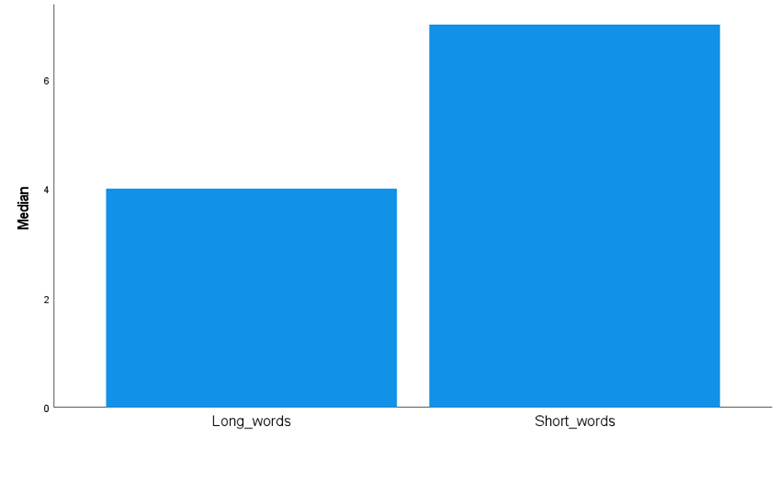
Chart one shows that short words were recalled more than long words.
The median score for long words was 4 (SD=1.35) The median score for short words was 7 (SD=2.75)
To examine if the median scores for both conditions are significantly different to the probability of .05, the non-parametric Wilcoxon statistical test was carried out. A Wilcoxon signed-rank test showed a significant difference between the long and short word conditions (Z = 4.98, p <.001). Median recall scores for short words were significantly better than for long words (Median: and respectively).
The results indicate that the hypothesis that participants will recall significantly more short words than long words was supported and provides support for the Word length effect.
See appendix 3 for the SPSS raw data and appendix 4 for the SPSS outputs.

Appendices
Appendix 1- Long and short words
Table 1- Long and short words table.
Condition 1 – Long Words | Condition 2 – Short Words
Transaction | Desk
Forgiveness | Leap
Physician | Mood
Proximity | Tank
Constitution | Rules
Rationalise | Roof
Interaction | Mend
Deductions | Snap
Representation | Tomb
Impatiently | Slow
Reinstate | Tape
Intimidating | Rack
Disorganised | Snore
Understanding | Lose
Illuminate | Paid

Appendix 2- procedures
Standardised procedures
To ensure that all participants have the same experience, researchers should ensure that they are all tested:
- In the same place, with the same equipment and materials placed in the same way.
- Under the same conditions, so the level of lighting, noise and heat remains the same for all
participants.
- At roughly the same time of day, as people may behave differently if tested at nine o'clock in the morning rather than five o'clock at night.
- Given identical standardised instructions in exactly the same way.
Standardised Instructions: these are given in the chosen location and there may be more than one set for different (IV) conditions of the investigation. The standardised instructions are important, as each participant must receive the same instructions, so they understand what to do in the study. Also, it ensures that each participant is treated the same and should help eliminate experimenter effects. You can read the instructions to the participant(s) or let them read the instructions themselves.

Standardised procedure for the word length effect study
An opportunity sample of students was used. Presumptive consent was gained.
The following instructions were presented verbally:
- Participants were asked to sit quietly facing the projector screen situated on the wall in front of them.
- You will take part in a short memory task.
- Please ensure that you have a pen and paper in front of you.
- Can you all see the screen and text on the power point clearly?
- You will be presented with 2-word lists – consisting of 15 words each.
- Following the first list – you will be asked to write any words remembered from the list (in any order). The next 15 words were presented in the same way.
- Participants received the long words first followed by the short words. They had 90 seconds to recall and write down the words from list one and list two.
- Words were presented in the middle of a blue screen every 2 seconds, for 1 second.
- The font was Arial, white, size 72.
- Participants were thanked for their participation.
- Participants were fully debriefed regarding the aim and hypotheses of the experiment.
Following the making of the accuracy of recalled words, raw data was analysed using a Wilcoxon signed-rank test on SPSS 26.

Appendix 3 - Raw data
Table 2 – Number of words recalled.
Long words |  | Short words
2 | 5
5 | 6
3 | 5
1 | 3
3 | 2
4 | 6
1 | 4
5 | 4
7 | 8
3 | 4
6 | 12
4 | 9
2 | 6
3 | 5
4 | 9
5 | 11
4 | 7
4 | 8
2 | 6
3 | 7
3 | 10
4 | 7
5 | 12
3 | 6
2 | 4
5 | 9
4 | 11
5 | 6
4 | 8
3 | 9
4 | 11

Appendix 4 – SPSS outputs
Chart 1 – Median scores to long and short words.

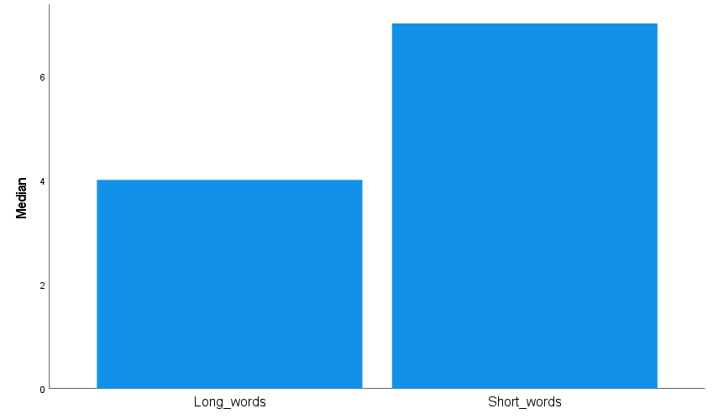

Table 3 – Test statistics.

 | Short_words - Long_words
Z | -4.981^{b}
Asymp. Sig. (2-tailed) | <.001
a. Wilcoxon Signed Ranks Test
b. Based on negative ranks.

Table 4 – Descriptive statistics.
Descriptive Statistics
 | N | Mean | Std. Deviation | Minimum | Maximum | Percentiles
 |  |  |  |  |  | 25th | 50th (Median) | 75th
Long_words | 34 | 3.74 | 1.355 | 1 | 7 | 3.00 | 4.00 | 5.00
Short_words | 34 | 7.35 | 2.751 | 2 | 12 | 5.00 | 7.00 | 9.00

Table 5 – Ranks

Ranks
 |  | N | Mean Rank | Sum of Ranks
Short_words - Long_words | Negative Ranks | 2ª | 3.50 | 7.00
Short_words - Long_words | Positive Ranks | 32^{b} | 18.38 | 588.00
Short_words - Long_words | Ties | 0^{c}
Short_words - Long_words | Total | 34
a. short words < Longwords
b. short words > Longwords
c. short words = Longwords

Appendix 5- Consent form


Centre for Psychology and Counselling

Study Consent Form
I understand that this research study is being carried out by a 3rd year Psychology Student for their dissertation, and that taking part in this study will involve looking at words appearing on the screen then writing down as much as I can remember.
This study will take approximately 10 minutes to complete.
I understand that participation in this study is voluntary, and I am free to withdraw participation during or at the end of the study without giving a reason. I understand that once I leave the study, I will not be able to withdraw my data, as it will be anonymised. I am aware that if I have concerns about the study, I can discuss these concerns with the researcher at any time during or after the study. I understand that I will be provided with the contact details of the research supervisor at the end of the study, should I have any concerns.
I understand that the information provided by me will be held confidentially, with a code assigned in place of my name. These data will be stored indefinitely in accordance with the Data Protection Act.
I also understand that at the end of the study I will be provided with a debrief form and the opportunity to discuss any issues with the researcher.

I, ___________________________________(NAME) consent to participate in the study conducted by Zoe french, Centre for Psychology and Counselling, University of Wales Trinity Saint David, under the supervision of Charlotte Greenway.

Participant Signature:________________________________________________
Date:___________________
Name and signature of researcher taking consent.
___________________________________________________________________

Appendix 6- Debrief Sheet

Centre for Psychology and Counselling

Study Debrief Sheet
Word length effect

Thank you for taking part in the study.

The aim of this study was the word length effect. We specifically wanted to find out whether short or long words were recalled more times.

If you wish to withdraw your data from the study, you must tell the researcher now. After this point, all of your data will be anonymised, and we will not be able to trace it back to you.

If taking part in this study has raised any questions, please speak to the researcher Zoe French at 2218434@student.uwstd.ac.uk or contact the academic supervisor Charlotte Greenway c.greenway@uwtsd.ac.uk

Thank you once again for taking time to participate in this study.

Zoe French
BSc Applied Psychology
University of Wales Trinity Saint David

Appendix 7- Information sheet

Centre for Psychology and Counselling

Study Information Sheet
This document provides key information regarding the study and provides details about what will be expected of you as a participant. Therefore, please read this information carefully before providing consent to take part.
During this study you will be required to do the following:
- Look at the words appearing on the screen.
- When you hear the word “recall” write down as many words as you can remember
- When you hear “pen down”, put your pen down and do not write any more.
At the end of the study you will be debriefed by the researcher and you will be provided with the study debrief sheet.
If you have any questions, please ask the researcher now.
If you are happy to take part in this study, please read and sign the consent form.

References
Cowan, N., Baddeley, A. D., Elliott, E. M., & Norris, J. (2003). List composition and the word length effect in immediate recall: a comparison of localist and globalist assumptions. Psychonomic bulletin & review, 10(1), 74–79.
Ellis, N.C., & Hennelly, R.A. (1980). A bilingual word‐length effect: Implications for intelligence testing and the relative ease of mental calculation in Welsh and English. British Journal of Psychology, 71, 43-51.
Gross, R. (2020). Psychology, the Science of Mind and Behaviour. (8th ed.)
Jalbert, Neath, I., Bireta, T. J., & Suprenant, A. M. (2011). When Does Length Cause the Word Length Effect? Journal of Experimental Psychology. Learning, Memory, and Cognition, 37(2), 338–353.
Neath, I., Nairne, J.S. Word-length effects in immediate memory: Overwriting trace decay theory. Psychon Bull Rev 2, 429–441 (1995). https://doi.org/10.3758/BF03210981

