Developing Professional Practices

Name: Emma Thomas

CIPD Membership Number: 52087709

Developing Professional Practice – M2X8986

Student Number: 0201743

Word Count - 2893

Date: 14/11/2018

I declare that this assignment is my own work and that any information obtained from books and other sources have been appropriately referenced.

Signed: Emma Thomas.................................. Date: 14/11/2018.........................

Contents
Cover Page .............................................................................................................................p1
Activity 1: The requirements of effective and efficient HR professional...............................p3
1.2..............................................................................................................................p3
1.2..............................................................................................................................p4
1.3..............................................................................................................................p4
Activity 2: Group Dynamics and conflict resolution .............................................................p5
2.1.............................................................................................................................p5
2.2.............................................................................................................................p6

Activity 3: Project Management, Problem Solving, Influencing, persuading and negotiating .............................................................................................................................................p7
3.1............................................................................................................................p7
3.2............................................................................................................................p7
3.3............................................................................................................................p9
Activity 4: Self-assessment, PDP & Reflection....................................................................p10
Reference list......................................................................................................................p14

Activity 1: The requirements of effective and efficient HR professional
1.1
Chartered Institute of Personnel Development (CIPD) is the professional body for the world of Human Resources and is the recognised benchmark within the field. Becoming a member of the association requires a commitment to continuous professional development (CPD) and for members to follow its code of professional conduct.

To support members CPD, in 2009 the CIPD introduced HR Professional Map, see Figure 1. The map is a tool, available to members, which sets out the competencies required to be a HR Professional. The map was developed in view of the changing the world of HR. In 2009 Jackie Orme, the chief executive of CIPD at the time, told Personnel Today that “The HR profession is changing. More will be required of the HR professional of the future, and today’s practitioners need to be equipped with the capabilities to meet these demands. Roles are more diverse, career paths more complicated and the capacity to impact on the strategic future of the business greater than ever before” (Peacock, 2009).

The map is designed to support professionals at all levels and the CIPD recognise that no two HR departments are the same. It was developed by a combination of both HR generalists and HR specialist form public, private and third sectors from the UK and internationally. It is for this reason that the map is broken down into 3 key elements, Behaviours, Competency Bands and Professional Areas.

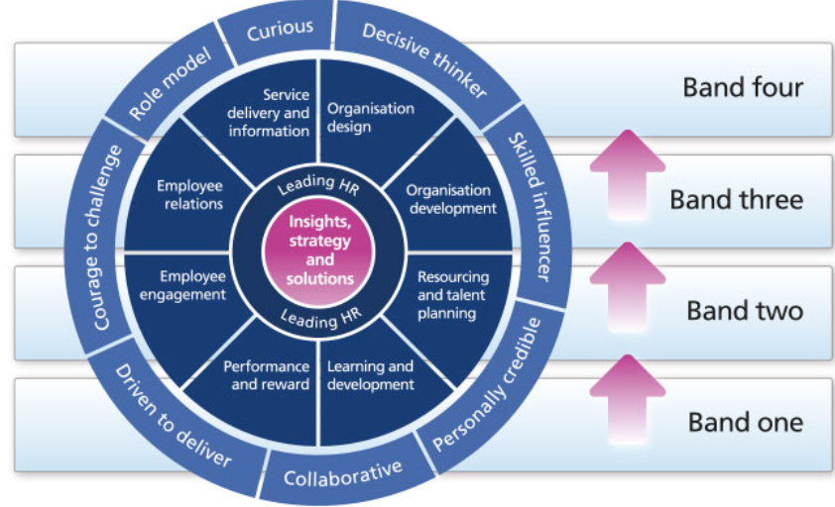
Figure 1 The CIPD‘s 2013 Professional map.

Table 1 Description of the key elements of the CIPD map

Element | Number of | Description
Professional area | 10 | Describes the main areas within HR, what needs to be known and done for each. Two areas are considered core and are at the centre of the map, 1.Insight, strategy and solutions and 2.Leading HR, these are relevant to all HR professionals regardless of geographical location, role or stage of career. These areas are relevant to the organisations and development of strategy. Other areas – Organisation design, Organisation development, Resource & talent planning, Learning & development, Performance reward, Employee engagement, Employee relations and Service delivery & information Each area spans the four bands of professional competence.
Behaviours | 8 | Describes the behaviours HR professional need to carry out their activities, Decisive thinker, Skilled influencer, Personally credible, Collaborative, Driven to deliver, Courage to challenge, Role model and Curious. Each behaviour spans the four bands of competence.
Bands | 4 | The four bands of professional competence define the contribution that professionals make at every stage of their HR career in line with 10 professional areas and the 8 behaviours, helping to provide a clear pathway to focus development by progressing through the bands.

The map can be used by individuals to evaluate themselves and understand the stage individuals are at, what they need to do to progress and even suggest reading to support development, see Table 1. CIPD members have a dashboard with their map, this give a summary, development actions, reading & research and events and courses.
1.2 & 1.3
Employee engagement
According to the CIPD employee engagement is a new concept related to motivation and they suggest that employers should consider empowering employees to make decisions and shape their jobs, provide effective channels for employee voice, ensure the fair treatment of employees and support for well being, and create key communication strategies to keep employees informed, and reinforce purpose and vision of the organisation. To achieve this requires effort form all areas of an organisation, including leaders at all levels (CIPD, 2017). There are strong links between high performance and high engagement. Employees who feel engaged often experience greater job satisfaction.
Performance and reward
According to ACAS reward is a key tool for securing talent and determining our relationship and behaviours at work. Pay and benefits have considerable effect on the efficiency of an organisation. The right reward packages can be highly influential in increasing engagement and productivity of employees, also the ability of an organisation to retain and recruit talent. Dr Jonathan Trevor believes that a strategic approach means organisational objectives are aligned with effort and secure desired behaviours. He continues by stating that complex pay scales and reward schemes can be perceived as unfair and explains the importance of employees understanding their reward schemes and the ways in which they benefit (ACAS, 2018).
Curious
The CIPD map detail describes curious as being future focused, inquisitive and open minded (CIPD, 2018). For a HR professional this can often mean gaining a greater understand of the business for example understanding future growth with enable the development of recruitment strategies to develop or the possibility of reviewing the benefits package to assist with productivity.

In an article in HR Magazine Michael Moran (Moran, 2013) expands on this further explaining the importance of being aware not just of your organisation but also of the industry and sector and the economic environment in which it operates to enable HR professionals to contribute to driving the business forward and recognising challenges. Asking questions is key, being aware of the marketplace and customers. If you understand your products and the markets you are better placed to provide and recognise resourcing requirements. This creates an equal footing to align with other professional managers.

Activity 2: Group Dynamics and conflict resolution
2.1 - Group Dynamics

Group Dynamics is the interactions and behaviours of people with a group format and explains the effects of roles and the group as a whole. One model of team/group formation is the Tuckman’s Team Development Model. This model works around the 5 key areas Forming, Storming, Norming, Performing and Adjourning. These 5 areas tend to apply to most teams without them even realising however Tuckman believed that an understanding of these 5 areas would help the effectiveness and more quickly develop a team.

The Forming stage is at the very beginning of the team’s establishment. It is the time when individuals are trying to find their best fit within the group. They rely on direction and guidance. It’s the time when objectives will be learned and understanding of the purpose. The team will need to agree who will do what, and individuals may be reserved. At this point output of productivity will be low due to the unclear structure and lack of definition. The role of the manager/leader at this point would be to direct and motivate the team, team building. To clearly communicate the vision and mission of the team/group, and to set objectives.

The Storming stage is when ideas are bounced around, problems are addresses and group/team members begin to understand their individual roles. At this point the team become more confident. The efficiency/productivity will begin to slowly increase at this point. The leader/manager will need continue to provide clear communication. Ensure any conflicts are resolved. Provide training or coaching and will need to be quite direct with the team/group.

Norming stage is when teams/groups become more cohesive. They will have a better understanding of their individual role which will enable them to quickly solve any problems raised as a team. At this stage efficiency and productivity should increase rapidly. The leader/managers role will be more of an overview, monitoring, of the project to ensure the smooth running. They will need to provide support where necessary.

The Performing stage is when problems have been overcome and members of the team/group are knowledgeable of their individual roles and the team objective. At this stage efficiency and productivity are at the optimum level with all team/group members working well together. The leader/manager no longer needs to stand over individuals and is able to delegate but at the same time must ensuring that all goals and objectives are aligned within the team. At this point it is important for the appropriate praise to be given.

The Adjourning stage was added to Tuckmans model following his review in 1970’s. Adjourning stage tends to come on the completion of a project. At this point the team should feel accomplished and want to celebrate but at the same time may lack in future direction. The productivity and effectiveness will have slowed now and should just involve tying up loose ends. The leader/manager responsibility will now be to provide support, recognition and praise (Business Balls, 2018).

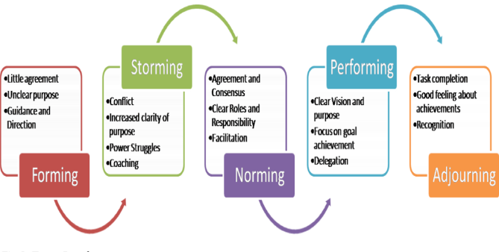
Figure 2 Bruce Tuckmans Team Development Model 1975
2.2 Conflict resolution
When group dynamics breakdown it is generally due to come kind of conflict. This can be due to ideas or issues – substantive conflict, personnel relations and emotions – affective conflict, or methods and process – procedural conflict. It is important to quickly identity conflict and efficienty resolve problems in the correct way.
In these situations it is important to be professional by listening carefully to all parties, be transparent in finding solutions that all parties are happy with.
By encouraging open communication within a group, this may need advance training, when conflicts arise all parties should be able to explain the problem while the other parties have the respect to listen. The HR professional should listen from an impartial perspective, and having reviewed all the information provided, should then influence firm solution.
HR professionals must be authentic and fully understand the situation. By showing genuine care of both the people involved and the outcome, trust can be formed. HR needs to understand all perspectives looking for core problems and the actual needs. Once all these areas are understood HR will be in a position that enables the communication of options of negotiations that will lead to positive resolution of the conflict.

Activity 3: Project Management, Problem Solving, Influencing, persuading and negotiating.

3.1

Our organisation, Aber Instruments (ABER), is an employee owner business. In the first quarter of 2017 an offer was made to the Board to buy the company. The Board kept the offer to themselves while they worked hard in understand the implication that offer could have to each of the employees and also understanding if the offer was a viable one. The Board rejected the decision before informing the rest of the company. The Board informed the company and also decided that ABER needed to be better prepared for future offers and similar scenarios, such as; would we ever move the business from Aberystwyth? A decision was made to form a Guiding group that would consult with all the employees. We used a consultant and specialist in employee ownership, Chris Heald, has a guide. Individual volunteers to be part of the group. I was one of 6. We sat and discussed how we would proceed and decided that each individual within the business would have a consultation with one member of the guiding group, some of these were 1:1 some were small groups. Individuals had the opportunity to select the Guiding group member they wished to talk to. A time table was devised and 1.5 hours of time/resource allocated for each individual. We had a timeline to complete the task by the second week in January. This then allowed the group time to analyse the data.

All the data was collected around key questions. The group then faced the task of compiling the data to make some sense and understanding of what the majority wanted out of the company for the future. We had to ensure this was completed with outcomes by March 2018. Firm decisions were made such as:
- The company was not for sale and could only be sold in exceptional circumstances with a majority agreement.
- The core business was to remain in Aberystwyth but should expand into other countries if it will benefit the company.
- The decision was made to create an employee council to represent the views of the employees and to hold the Board accountable.
To make these changes we needed to prepare in advance of the AGM to change the articles. All employees voted.

3.2

ABER has recently purchased a new building with the intention of splitting the whole team between the two sites, both of which are located on the Science Park. The plan was for Production to remain in the old building, which will undertake a huge face lift and for Accounts, HR, R&D, IT, Marketing, Technical Support and Sales to move across to the shiny new building thus creating a divide of the team. We are concerned that we face a potential problem of reduced working relationships across departments, a fall in output, conflict, miscommunication, increase in disciplinarians and high staff turn over all as a result of the change. The problem will of course be a permanent one if action is not taken to prevent and address the issues.

The problem has been one of prevention. The company holds a whole company meeting on the first Wednesday of every month. This was originally at 10 am, but had to be adjusted to 2 pm due to opening our US office and the time difference. Everyone attends. This is a real tool with regards to communicating up to date relevant information to all staff and makes sure everyone is inclusive of the activities of the business. This is very important to an employee owned company.

The scope of the problems is as the Company continues to grow we face the possibility of a lack of alignment in objectives; this could fall due to poor communication surrounding our shared values. ABER is notorious for its close, friendly, family values and its open and approachable atmosphere, employee ownership is key to this. There is a real danger that balance may be lost along with a lack of employee engagement.
Also it has been noticed that there is increasingly becoming a ‘them and us’ culture with the Production team, they distance themselves at break times and don’t tend to join in on non compulsory team building, there is a real lack of participation and up take of events. Their interactivity is limited with the members of their team.

This was more noticeable since planning has been discussed for the refit of the Production department. This has become evident a following recent discussion with the Production Manager. Production would like the refit to enable them to have all facilities on site e.g. a shower block and a canteen (not just a kitchen). They are feeling resentful that the upper level of unit 5 (Production site) will be rented out and feel the space is required for them for the facilities mentioned above. They do not wish to walk the short distance across the road to the new building for the above mentioned facilities. I do agree that rain is also a factor in this. Production feels hard done by. The Production Manager was genuinely concerned about the ‘them and us’ culture rising.

McKinsey 7 S’s framework (1982) was useful to me as it discusses key area of my problem.
Shared Values – ABER’s core values are at the heart of everything that we do and our Guiding Principals high light this
Staff – the happiness of staff and the work that they do is a key function of the company values
Skills – The valuable skills that employees obtain within the company is key to our success.
Style – The leadership that we use to handle the situation
Systems – What changes can we make to the daily activities and procedures to engage the Production team and ensure they feel a sense of worth?
Structure – who reports to who?
Strategy – the plans implemented to ensure productivity remains a constant and doesn’t drop.

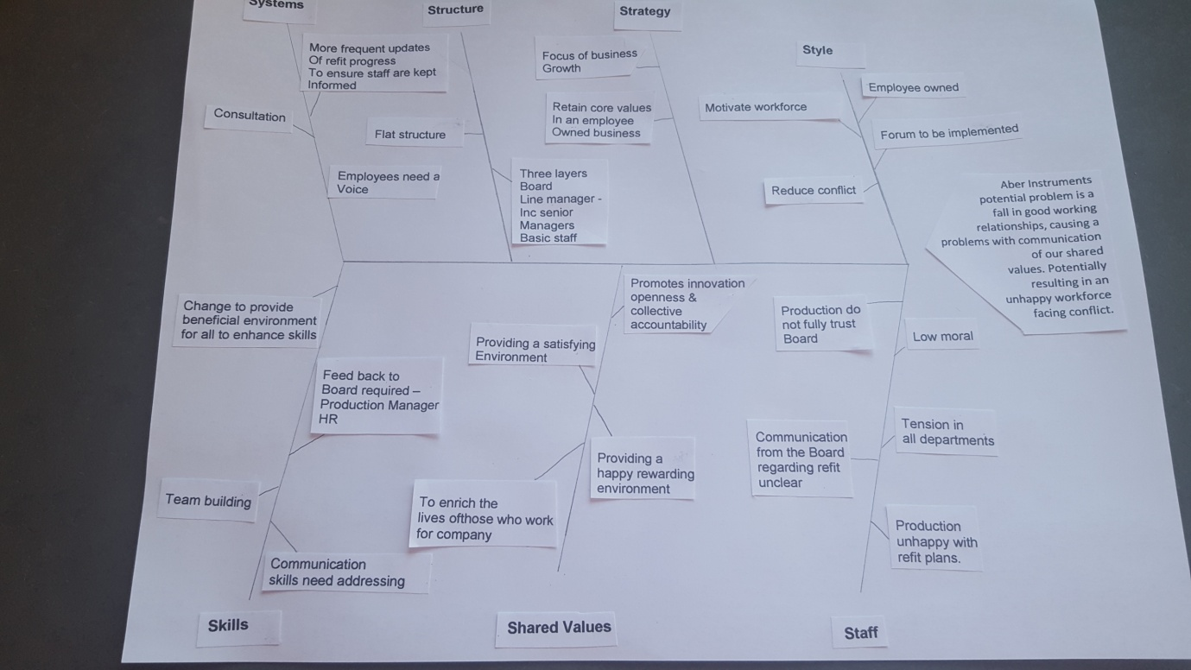

Figure 3 Fishbone diagram devised from the 7 S’s
To help resolve the problem and full understand the situation I compiled a Fishbone diagram (Ishikawa) also know as a cause and effect diagram, Figure 3 (Mindtools, 2018) in conjunction with my 7’s to identify possible causes of the problem. I looked at 3 options problem solving:
- The implementation of an Employee Forum
- 1:1 with each individual and feed back to the board
- Bring in an external employee engagement consultant.
I created an un-weighted, Table 2, grid analysis to assist me with this.

Table 2 Un-weighted Grid analysis

Factors | Time | Cost | Effort / HR | Moral | Total
Options
Implement Employee Forum | 3 | 5 | 4 | 5 | 17
One to ones with each individual resulting in feedback to board | 1 | 2 | 1 | 3 | 7
External employee engagement consultant. | 2 | 1 | 1 | 2 | 6

Key 1-5
1 – Unsatisfactory
2 – Fair
3 – Good
4 – Very Good
5 – Excellent

The results of the un-weighted grid analysis table point toward the implementation of an Employee forum within ABER. The process is quick, low costly, will boost moral by providing a voice and is low effort for staff and HR.
We aimed to launch the forum by January of the New Year. The intention is to provide the employees with a voice where they can continue to be consulted over change and debate issues which may affect working relationships. The forum will enable employees to direct questions as well as bring ideas to the board which will require justification if not agreed with.

3.3

I was recently asked by Careers Wales if we would consider hosting 43 year 10 pupils from Tergaron School to raise their awareness and understanding of the world of work. Before I could agree I sought the buy in from the Management team as I needed the support and engagement from each department and departmental members to discuss individual roles etc. I knew that the idea of 43 15 year olds when we are only a company of 40 would seem daunting so I had to influence by appeal to their emotions. We discussed that often children don’t get the opportunity to experience the world of work these days and that the experience would be invaluable to some but not all. I explained that we had the opportunity and duty to inspire children to be their best at school by providing them with a visual to aspire. It worked and they all agreed!

We have been reviewing the maternity policy which is currently in line with SMP. The topic has been addressed in the Employee Council. As the Council has no directors and is not responsible for any financial budget they viewed the policy purely from a user friendly perspective and has not considered the consequences of an overly financially generous (see appendix...) policy. I had to bring my business head to the table with the discussions. I asked the Chair requested that everyone consider what the aims and purpose should be so enable further negotiations. I had to remind some members that we also have a flexible working policy that would address some points (trades). We negotiated on time off for mother and periods of full pay that go above and beyond SMP.
Ultimately the decision does fall with the Board to approve the policy.

When I began my employment with ABER I had previously worked with an intranet system. I could see the implementation of a similar system would be a huge benefit to the employees and departments. I spent may hours with the then Technical Director (now MD) showing and explaining (persuading) the benefits of implementing an intranet system. We have offices (some home) in Cardiff, Abergavenny, Bolton, Washington DC and California, plus may employees have the ability to work from home should they wish. Today we employ a member of staff who has created a bespoke system tailored to exactly ABER need. It filters information from Sage 200 and is an amazing, invaluable communication tool. And employee with retain his role to maintain the system providing an extra job in the local economy.

Activity 4: Self-assessment, PDP & Reflection

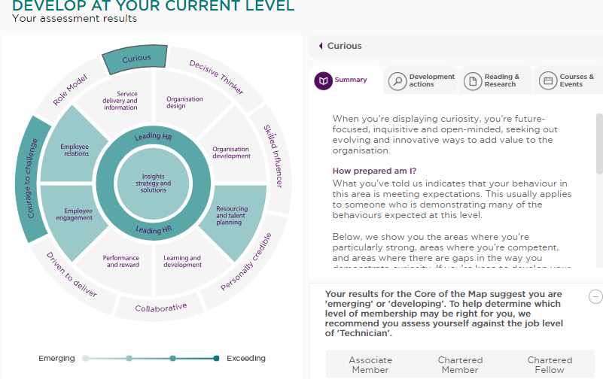

Self assessment

Using CIPD’s professional map I assets myself against Resource and Talent Planning. I have identified gaps in:
- my approach to succession planning and talent management.
- ensuring interviewers are fully trained
- effective delivery of induction and role transition
- exit processes

To address the gaps in this area I will need to:
- Work more closely with local schools and universities
- Address internal training requirements to manage internal talent potential.
- Work with manager and external training facilitators to ensure best practice interviewing
- Review current induction programs for improvement and address induction on new roles internally.
- Asses exit processes.

Table 3 PDP
EMMA THOMAS – 2019 PERSONAL DEVELOPMENT PLAN
Specific Objective | Measurement | Attainable | Relevance | Time Frame | Achieved? Y/N
Create a workforce plan for the next 1-2 year timescale to tackle any talent or capability gaps. | Completed plan. | To be developed in line with ABER strategy and Management team approval | Forward planning to lead in resourcing, prioritising diversity, organisational need. | December 2018
Build relationships and forge links with local schools and Universities to recruit and address talent requirements. Increase networking skills. | Once strong relationships have been created.  Visits | Yes given our geographical area, | Build on personal credibility. Benefit by addressing future growth and provide local jobs in line with ABER Guiding Purpose. | March 2019 – ongoing.
Utilise and review PDP’s with all staff quarterly to address training need and harness internal talent potential. | To successfully grow the company organically. Report to ML and each individual. | Yes, working with staff and line managers.  Review budgets for training cost and time resource | Continued support of staff development plans to ensure business objectives are met. | Quarterly - ongoing
Gain insight into HR from other companies’ perspective. To evaluate best practice of management training for interviewing. | Visit Gripple – Emma Hibert | Yes, arranged with Emma Hibbert. | Gain knowledge to improve ABER staff quality of employment and management credibility. | Jan 2019
Attend Employment Law updates | On attendance. | Book on to next seminar. | Ensure I am updating and maintaining knowledge with regards to HR legislation. | Feb 2019
Complete CIPD training level 5 and continue to level 7 | UWTSD | Must complete level 5 first. Time to be given during working week | Complete the scope of information needed to perform role to quality standard with recognised best practice. | L5 – June 2019  L7 - 2021

Reference list
ACAS, 2018. Reward: Getting it right. [Online]
Available at: http://www.acas.org.uk/index.aspx?articleid=3612
[Accessed 11 November 2018].
Business Balls, 2018. Tuckman-forming-storming-norming-performing-model. [Online]
Available at: https://www.businessballs.com/team-management/tuckman-forming-storming-norming-performing-model/
[Accessed 13 11 2018].
CIPD, 2017. Employee engagement and motivation. [Online]
Available at: https://www.cipd.co.uk/knowledge/fundamentals/relations/engagement/factsheet
[Accessed 11 Novemeber 2018].
CIPD, 2018. Curious. [Online]
Available at: https://www.cipd.co.uk/Images/Curious_tcm18-9673.pdf
[Accessed 11 November 2018].
Mindtools, 2018. Cause and Effect Analysis. [Online]
Available at: https://www.mindtools.com/pages/article/newTMC_03.htm
[Accessed 11 11 2018].
Moran, M., 2013. HR needs to harness curiosity. HR Magazine , p. 1.
Peacock, L., 2009. CIPD reveals HR profession map to replace old standards. [Online]
Available at: https://www.personneltoday.com/hr/cipd-reveals-hr-profession-map-to-replace-old-standards/
[Accessed 11 November 2018].

