Practical test Analysis of Systems requirements

Contents
Context Level Diagram 3
System Level 4
Entity Relationship Diagram 5

Context Level Diagram

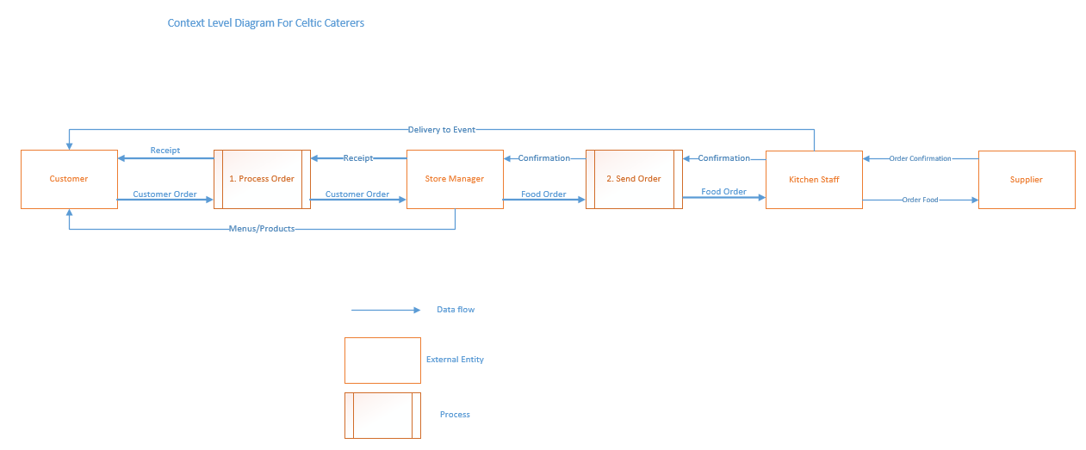
This is the context level diagram that I have designed for the Celtic Caterers.
In this diagram, I have added external entities. The external entities are the ones who will interact with the system, the external entities in this diagram are Customer, Store Manager and Kitchen Staff. In-between the processes and the external entity are arrows which are the data flow to show what information is going into.

System Level
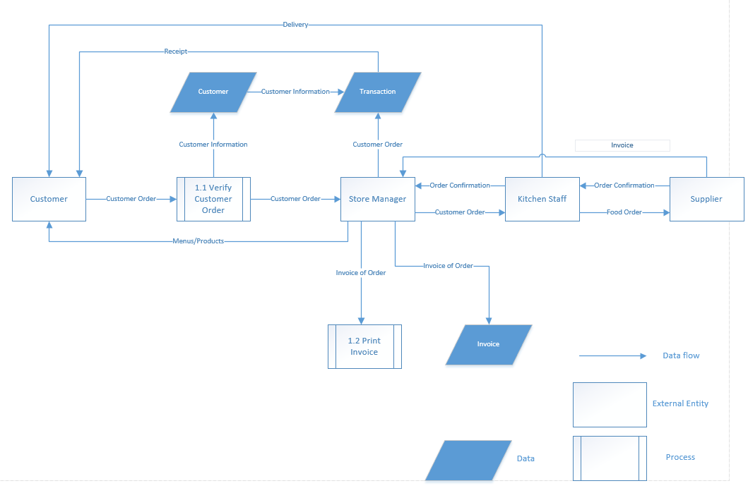
This is the system level diagram that I have designed for Celtic Caterers.
The customer makes the order and it will need to be processed/verified then the order will be sent to the store manager, the store manager will be in charge of sending the customer’s order to the kitchen staff and also printing also store the invoice of the whole order.
The customer is also in charge of looking at the offers and then sending the customer the offers that the company is doing.
The kitchen staff is responsible for ordering the food that they need in order to do what the customer has ordered.
During the process, the transaction has been made by the customer and the receipt would be given back to the customer and also what would have been done is the delivery of the order to the customer.
The suppliers job is to send back an invoice to the store manager and the store manager also add the invoice to that into the data store.

Entity Relationship Diagram
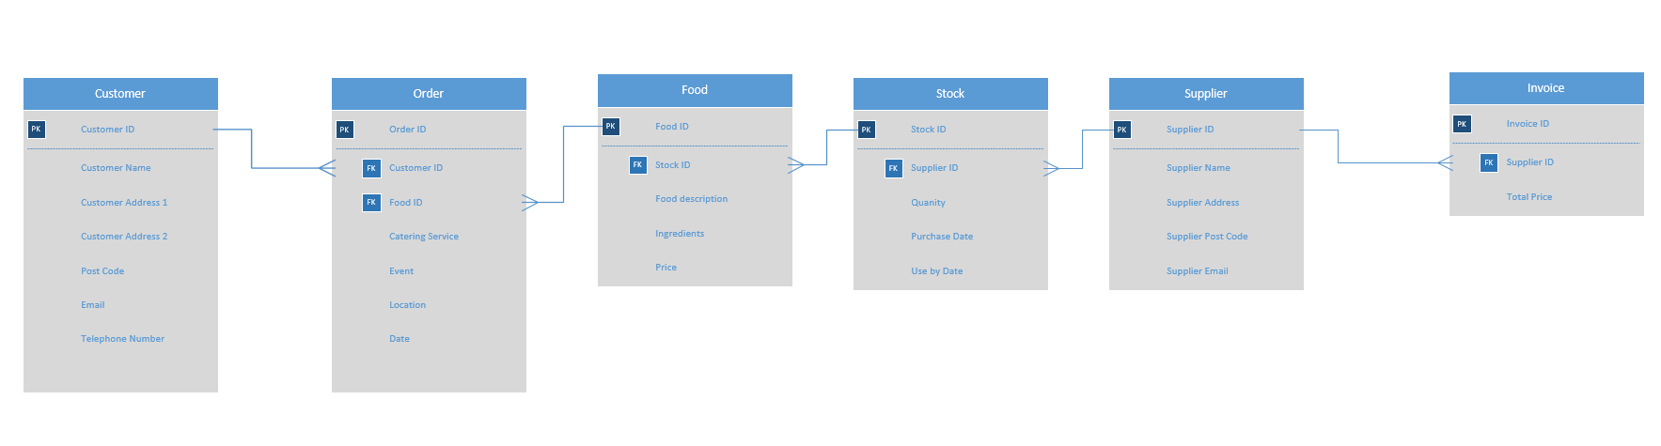
This is the entity relationship diagram that I have made for the Celtic Caterers company.
Each of the tables all have a primary key in each one of them and foreign keys in some of the tables so some of the tables have a relationship with each other.

