Student name: Dumitru Marinela
Student number: 2242721
Module code: BMIH4002
Lecturer: Ka Po Chong

“A Memorable Dining Experience Menu for a Special Occasion”
Contents
Part 1 3
New Restaurant Concept & Menu for “A Milestone Celebration Event” 3
Restaurant Concept 3
Target Audience 3
Reasoning Behind Menu Choices. 4
Part 2 4
Trinity Restaurant Menu 4
References 7

Part 1

New Restaurant Concept & Menu for “A Milestone Celebration Event”
This brief provides the prominent highlights of a new restaurant proposed to be opened in the Hotel Trinity's Hotel Chain. The brief write-up contains quick yet effective discussions about the restaurant’s concept, the audience it will target, and the reason behind choosing the items on the menu.

Restaurant Concept
Hotel Trinity has been among the leading 4-star hotels in Wells. The hotel boasts across the foods and beverages industry with its premium offerings such as quality rooms equipped with free WiFi, Free breakfasts, a pool, a business centre, room services, and laundry services. Alongside this, the addition of a restaurant covering French, British, and Italian offerings is needed. However, there is a significant growth rate of new businesses in the food and beverages industry (Cousins, 2020).
The addition of this restaurant is based on the belief that it will amplify the overall business of Hotel Trinity. Also, it will make the entire group of the hotel prominent among the new and former customers (Zutshi, 2019). Planning, organising, directing, and controlling food and widespread beverage options are the foundational pillars of food and beverage management (Davis, 2018). Therefore, this restaurant would also follow these approaches promptly and take its progress to new heights.

Target Audience
Businesses in the food and beverage industry keep altering their service operations and management styles (Johnston, 2012). As a result, the entire food and beverage industry is becoming quite competitive. Therefore, this restaurant will also adopt and implement thoughtful strategies to pick the right and accurate segment of the audience, which resonates with the actual vision of the restaurant.
Since Hotel Trinity frequently operates in the areas of Ireland, the UK, Europe, the US and beyond this new restaurant will target the audience from these places. However, targeting the corporate-class individuals staying at the hotel for business meetings and occasions would be the best decision. The engagement of these individuals in the food and beverage businesses is always found as high (Motarjemi, 2014). Therefore, a menu for a milestone celebration event will resonate with them.

Reasoning Behind Menu Choices.
The reason behind the selection of Italian, French and British category dishes as the prominent items of the menu is the diverse targeted audience. Hotel Trinity frequently deals with the Irish, French, Britain, and European people. Therefore, including the French, Italian, and British choices in the menu of this new hotel is a wise decision, which will not only help to resonate with these individuals but will also make this restaurant the solution for those who are seeking different cultural dishes in one place.

Part 2

Trinity Restaurant Menu
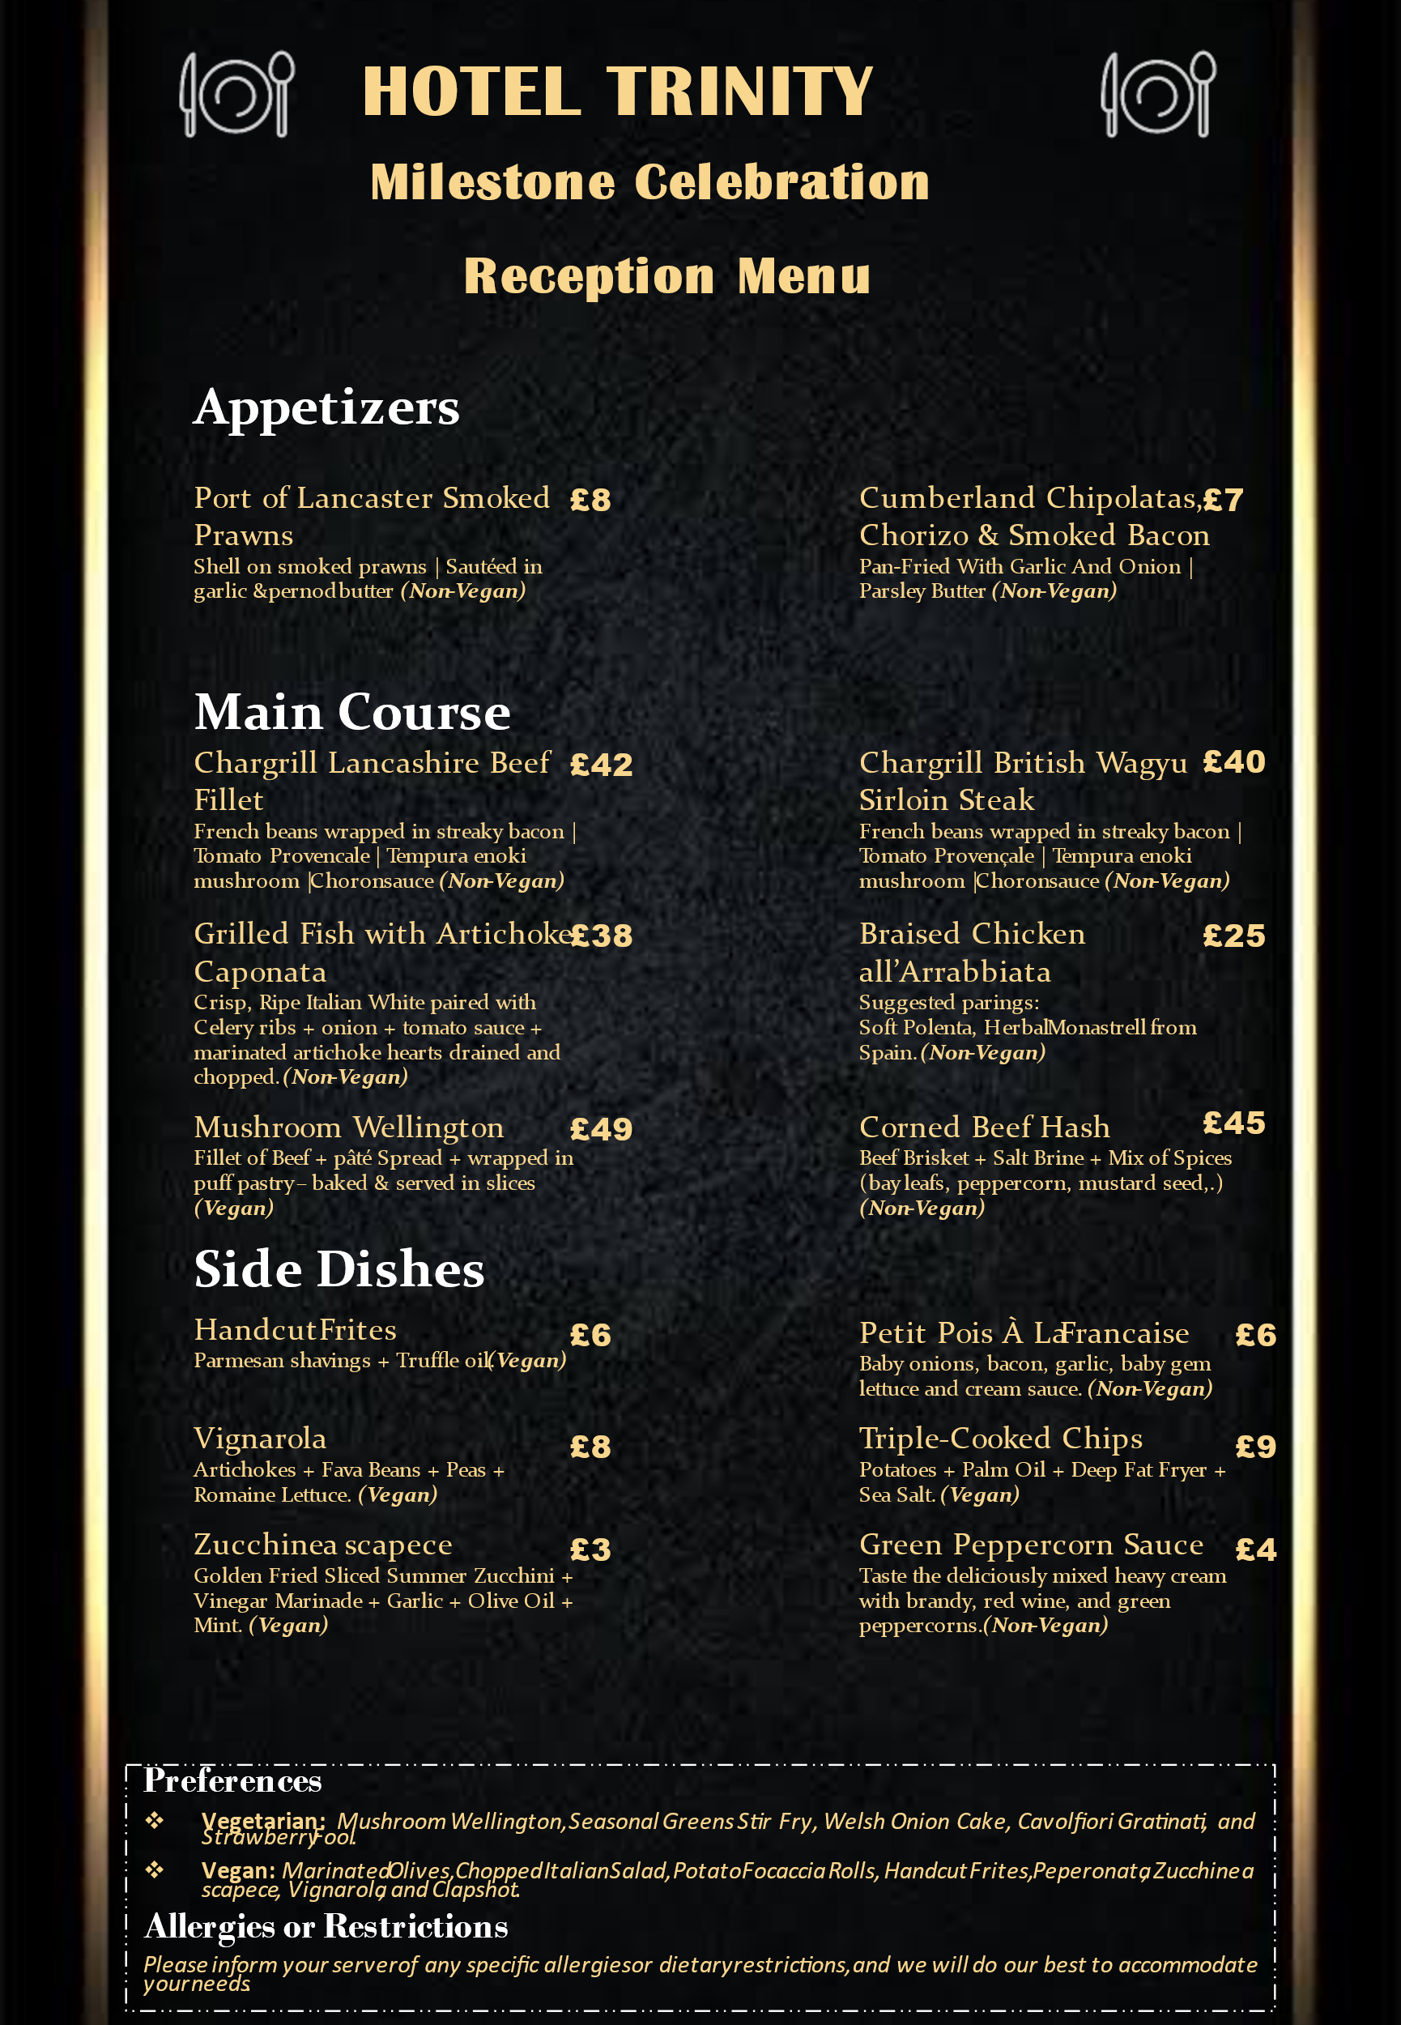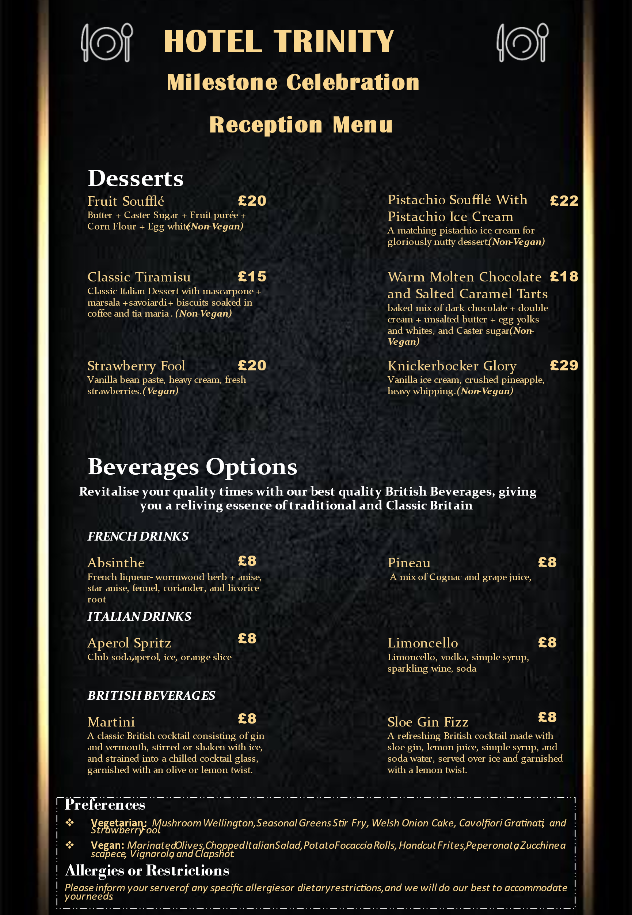

References
Cousins, J. (2020) Food and beverage service. 9th ed. London: Hodder Education Group.
Davis, B. et al. (2018) Food and Beverage Management. 6 edn London: Routledge.
Fakih, K., Assaker, G., Assaf, A.G. and Hallak, R., 2016. Does restaurant menu information affect customer attitudes and behavioral intentions? A cross-segment empirical analysis using PLS-SEM. International Journal of Hospitality Management, 57, pp.71-83.
Filimonau, V. and Krivcova, M., 2017. Restaurant menu design and more responsible consumer food choice: An exploratory study of managerial perceptions. Journal of cleaner production, 143, pp.516-527.
Filimonau, V., Lemmer, C., Marshall, D. and Bejjani, G., 2017. Restaurant menu re-design as a facilitator of more responsible consumer choice: An exploratory and preliminary study. Journal of Hospitality and Tourism Management, 33, pp.73-81.
Huang, Y., Theis, D.R., Burgoine, T. and Adams, J., 2021. Trends in energy and nutrient content of menu items served by large UK chain restaurants from 2018 to 2020: an observational study. BMJ Open, 11(12), p.e054804.
Johnston, R. (2012) Service operations management: improving service delivery. 4th ed. Harlow, England: Pearson.
Krobath, D.M., Masters, W.A. and Mueller, M.P., 2021. Association Between Restaurant Menu Item Descriptions and Their Nutrient Content. American Journal of Preventive Medicine, 60(2), pp.232-240.
Lesser, L.I., Wu, L., Matthiessen, T.B. and Luft, H.S., 2017. Evaluating the healthiness of chain-restaurant menu items using crowdsourcing: a new method. Public health nutrition, 20(1), pp.18-24.
Motarjemi, Y and Lelieveld, H (2014) Food safety management: a practical guide for the food industry. Illustrated edition. Amsterdam: Academic Press.
Ozdemir, B. and Caliskan, O., 2015. Menu design: A review of literature. Journal of Foodservice Business Research, 18(3), pp.189-206.
Peters, K. and Remaud, P.H., 2020. Factors influencing consumer menu-item selection in a restaurant context. Food Quality and Preference, 82, p.103887.
Robinson, E., Jones, A., Whitelock, V., Mead, B.R. and Haynes, A., 2018. (Over) eating out at major UK restaurant chains: observational study of energy content of main meals. bmj, 363.
Theis, D.R. and Adams, J., 2019. Differences in energy and nutritional content of menu items served by popular UK chain restaurants with versus without voluntary menu labelling: A cross-sectional study. PLoS One, 14(10), p.e0222773.
Zutshi, A. (2019) ‘How to develop well-informed and assured teams to embed food safety compliance in the UK catering and hospitality industry’, Perspectives in Public Health, 139(6), pp. 294–295.

