Management Economics
LCBB5003
Student Name: Kristina Ivanova
Student ID: 2020522

Table of Contents
Description of the business 2
Identify Demand and Market Equilibrium 2
Indicate demand is more elastic or more inelastic 6
Referencing 8

Description of the business
The McDonald's Corporation seems to be a centralised multinational corporation which competes in the oligopoly fast food industry around the world by providing a variety of products. These merchandise include French fries, the McChicken burger, Filet-O-Fish, numerous different chickens, and sweets including Mcflury, sundaes, and other similar items. Nonetheless, for the purposes of this particular piece of writing, we came to the conclusion that the McChicken cheeseburger would be the most appropriate item to give as an example (Mcdonald, 2020).

Richard and Maurice McDonald, who were brothers, laid the groundwork for what would later become McDonald's in San Bernardino, California, in the year 1955 (Mcdonald, 2020). In 1982, Kuala Lumpur became home to the very first McDonald's restaurant to open in all of Malaysia. At this time, McDonald's is responsible for the management of 282 locations around the country, which collectively serve 14.5 million consumers on a monthly basis. It would appear from this data that McDonald's Corporation has seen tremendous annual growth in Malaysia. According to McDonald's Annual Report (2019), the fast food chain is currently operating in 119 countries across the globe, with a total of 38, 695 locations.

The income of the business comes from sales made at company-owned eateries as well as fees collected from franchisees who run their own restaurants. According to McDonald's 2019 Annual Report, this company generated an overall of $9.069 billions in retained earnings during the fiscal year, representing an increase of 12.1 percent compared to 2018.
Until now, McDonald's has exceeded its organization's values, which was "To be our consumers' favourite restaurant and dining experience and beverage," by concentrating on obtaining a competitive advantage in terms of quickness in satisfying the customer needs, reduction in costs, and conducting business that are both nutritious and flavorful. Additionally, McDonald's maintains its business position as the most significant fast-food restaurant, which serves roughly 70 million customers a day every day, by preserving stringent quality standards. In light of this, the purpose of this study is to attempt to offer a comprehension of difficulties relating to microeconomic variables. As a result, it casts light on McDonald's and the McChicken burger as an essential component of the investigation (Mcdonald, 2020).

Identify Demand and Market Equilibrium

The Demand Curve

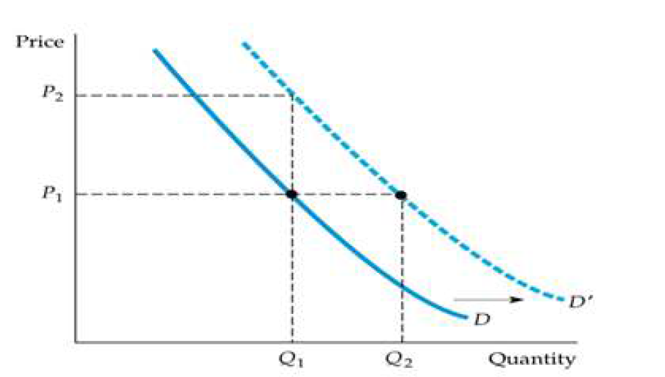
Figure 1: The demand Curve

The demand curve illustrates the amount of product that consumers are willing to purchase in relationship to the cost per unit. This may be seen by looking at figure 1, which would be located above, and seeing how the quantity demanded is sloped in a downward direction. Customers could only be prepared to buy one amount of burgers if the pricing of a McChicken burger was set at P2. However, if the price of each individual unit of a particular product were reduced to its absolute lowest possible level, consumers' intentions to make purchases would change significantly (P1). As was seen before, consumers are prepared to purchase two amounts of a burger if indeed the price, which is currently fixed at P2, is reduced to P1. When the price of a McChicken hamburger, for example, is set at $4, buyers will only be ready to purchase one piece. Customers will be thrilled to purchase two burger if indeed the price is reduced from $4 to $3, but now it is too high. The above demand curve, which is founded on economics, may be used as a depiction that the number of McChicken hamburgers required by consumers has an inverse connection with both the pricing of such items in a general sense. This is because consumers are willing to pay more money for more burgers (Mcdonald, 2020).

Factors affecting demand side
Other factors, such as the cost of the merchandise or service, the income of the consumer, the price of other products or services that are connected to the one being purchased, the requirements of the customers, and also the consumer's preferences, all play a role in the quantity of the product or service that is desired by the purchaser. These factors are key contributors to the potential for the demand curve on oil and gas to be shifted (Mcdonald, 2020). We need to make the assumption that everyone of the additional factors that determine demand are fixed before we can comprehend how strongly each of these factors affects overall demand. For the sake of analysing, say, how the preferences of clients influence the purchase intention for McChicken Burgers, we will suppose that the retail price of the product, the wealth of customers, and any other factors that may play a role in this demand remain unaffected. In economics, this notion of holding all other variables unchanged is referred to as "ceteris paribus," which literally translates to "other things being equal."

Price of Goods and Services
The pricing of products and services represents one of the most important elements influencing the sales of a product, as previously stated (Mcdonald, 2021). The price of a McDonald's hamburger is susceptible to any departure from of the marketplace equilibrium state owing to the fact because McDonald's burger has numerous replacements supplied by global firms like Subway and Burger King, as well as various local manufacturers (Mcdonald, 2021). To avoid being priced out of the market, people may choose to purchase hamburgers first from rival companies described above rather than from McDonald's if their prices rise significantly. But, on the contrary hand, the cost of a McDonald's hamburger drops, the demand for the product rises, regardless of other factors. Figure 1 shows a visual representation of this.

Consumer Income
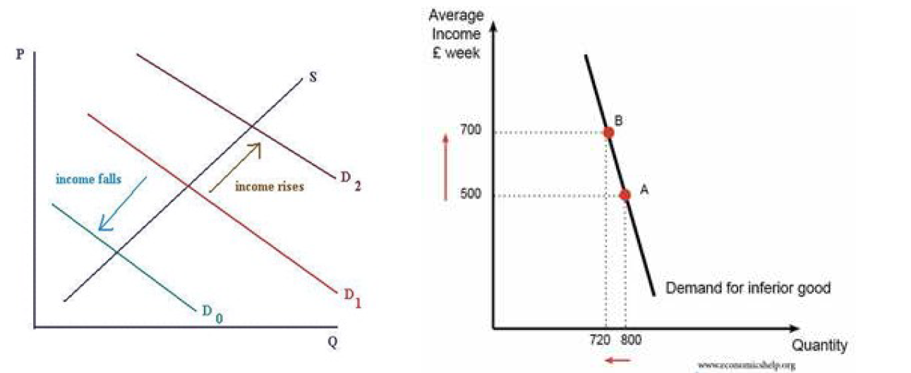
Figure 2: Income Effect

Consumption is also influenced by a person's level of income. The link between customer revenue and the amount desired, in contrast to the price of products and commodities, might change based on the kind of items. Income and demand are intimately linked in the case of regular items, such as consumer durables, leisure/leisure activities, and technological products. Just on left in Figure 2, a graph depicting the link between increasing consumer income and just a rise in product demand reveals this connection. A reduction in the amount requested for subpar items is illustrated in the graph here on right of figure 2, which means that the curve is moving left as income rises. Need-to-have items like cereal and rice are prime instances of subpar products (Mcdonald, 2021).

Because McDonald's is notorious for its cheap, quick, and unhealthy meals, the McDonald's cheeseburger is considered a lower-quality item. As a result, the desire for McDonald's burgers gradually decreases as consumer income rises. Healthier foods are more expensive than bad ones, and here is why. Likewise, while incomes drop, so does the frequency with which individuals eat at McDonald's, the low-cost fast food chain (Mcdonald, 2021).

Price of related goods and services
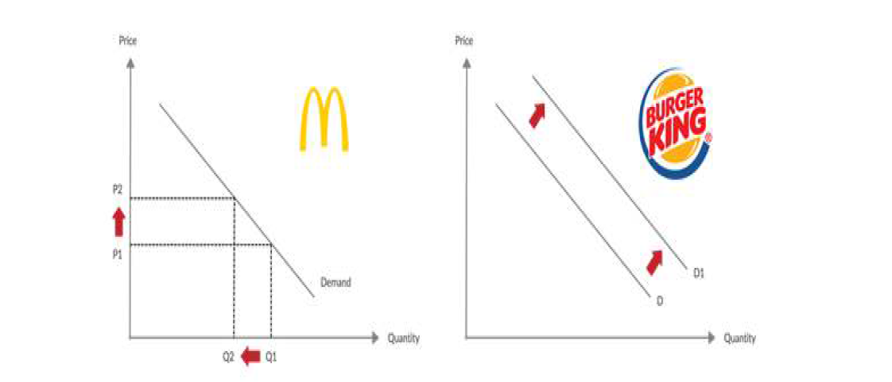
Figure 3: Price of related goods

The pricing of associated products and services is another important factor that has a significant role in determining the demand for McChicken burgers in Malaysia. Products that are similar might either serve as a replacement or as a complement to one another. Because when price of a replacement goes up, there is a corresponding increase in demand for many other commodities (Mcdonald, 2021). For instance, the burger sold at McDonald's may stand in for the cheeseburger sold at Burger King. As shown in Figure 3, the amount requested of McChicken burgers will decrease as the price of a McChicken burger goes up. Despite this, there is a growing demand for hamburgers from Burger King since their products are an excellent stand-in for others that are unavailable. Although this may be the case, complementary commodities are not the same as items that may be substituted for one another in that the demand for other products rises as the price of complementary goods falls. For instance, when there is a drop in the price of chicken, there is a corresponding rise in demand for McChicken burgers (Mcdonald, 2021).

Customer Expectation
The term "customer expectation" refers to a pattern of behaviours or activities that a person is anticipating from their interactions with a certain business. The demand curve may be shifted in a variety of ways depending on the customers ’ expectation (Mcdonald, 2021). For example, buyers who believe that the price of such a McChicken burger would drop in the near future may hold off on purchasing the product until it is available at a lower cost. In this particular example, there is a decrease in demand for McChicken burgers, which causes the demand to move to the left. Inside a similar vein, customers who believe that the price of a McChicken hamburger would increase in the not-too-distant distant will purchase the item right away. This will result in a significant increase in demand on McChicken burgers and a rightward change of the demand curve (Mcdonald, 2021).

Customer Taste
The term "consumer taste" signifies the extent to which a consumer is content with a collection of products. Since McChicken and burgers from Burger King represent replacement items that fulfil the very same demands, the happiness that Malaysians get from eating McChicken will decrease the pleasure that they get from eating burgers from Burger King. A consumer's preference may be a less ephemeral factor, but it is nonetheless capable of having a significant influence on how the demand curve for an item moves (Mcdonald, 2018).

Indicate demand is more elastic or more inelastic
In general, the price elasticity of the company ’s products and services in the categories of meals and beverages that do not contain alcohol is less than one. In addition, the consumption of food outside from someone's residence is factored into the analysis, which gets the elasticity closer to just one (Mcdonald, 2018).

The price elasticity for food sold at fast food restaurants often receives scores between 0.7 and 0.8 on a scale from 0 to 1. One alternative explanation of this elasticity may be that it indicates that now the demand for such beverage or food is extremely receptive to changes from price. If there is a one percent growth in pricing, then it is anticipated that there will be a 0.8 % to 0.7 percent fall in demand (Mcdonald, 2018).

There is a lot of elasticity in the demand for McDonald's items. Demand may understand the different types there in near term as a direct result of price shifts brought about by the plan of the company or just by governmental impacts including such taxation as well as subsidy programs (Mcdonald, 2018). Consumers do not need to make a significant time investment in the brand throughout order to start receiving value from it (Mcdonald, 2018).

In addition, they do not develop a considerable connection to the beverages and food that are provided, to the extent that they are unable to reduce the frequency of their expenditures or switch to the alternative items. In point of fact, the availability of a wide variety of alternatives helps to make the market for the company's products and services more elastic.

The unpredictable nature of customer demand for such company's goods puts it in a precarious position in the marketplace (Carpantier and Vermeulen, 2021). At the very same time, the level of food quality that is supplied by the corporation is a cause of worry for many different stakeholder organisations that are working toward the goal of influencing healthy eating decisions in the general population (Lye and Mcdonald, 2021). As a result, McDonald's business will continue to be susceptible to external factors that have an impact on the prices of its commodities and the demand for those things (Mcdonald, 2018).

Because of the growing incidence of behavioural disorders such as diabetes and obesity amongst the general populace, consumers and medical associations across different countries are calling for limitations and levies on fast food businesses to recompense for their harmful impact on society (Mcdonald, 2018).

However, the manner in which recommendations are put into practise varies greatly from country to country (Mcdonald, 2018). Although McDonald's is currently not confronted with a significant shift in policy that substantially hinders its business strategy, the corporation is conscious of the possible threat that such a legislative move could bring to it's own profitability and therefore is taking precautions to avoid it (Mcdonald, 2018).

In general, the numerous nations in which McDonald's operates provide their goods with a wide range of challenges, including those posed by shifting technical norms, shifting social norms, the shifting retail environment, shifting government regulations, and shifting economic variables (Lye and Mcdonald, 2021).

The foods and beverages that may be purchased at whatever McDonald's restaurant are considered standard goods, and indeed the demand and availability curves for these commodities adhere to the market norms that are in place. When demand stays the same or grows, a higher price usually results in a larger supply being made available (Carpantier and Vermeulen, 2021).

On the other side, research price elasticity of demand demonstrated that when all other aspects of the marketplace are assumed to be constant, an increase in pricing is accompanied by a reduction in demand. This was found to be the case (Carpantier and Vermeulen, 2021). When consumers' income rises, so does the quantity of McDonald's goods they buy and consume (Carpantier and Vermeulen, 2021).

People who have lost their jobs or seen a downturn in their enterprises and consequently have less discretionary income tend to purchase only the quantities that are really necessary or they will forego certain purchases altogether when the economy is in a difficult state. As a result, there is a positive income elasticity associated with the things that McDonald's sells (Carpantier and Vermeulen, 2021).

The dollar menu's most popular products, such as burgers, may only be consumed to a certain extent before people opt for more expensive menu items viewed as more healthful. When the burger is becoming an inferior product, its income elasticity increases inelastic, making it less appealing to consumers.

Pricing Policy to Choose
The pricing points including average prices of the company's food and beverage items are outlined within the context of this component of the marketing mix. The objective is to set pricing in such a way as to achieve maximum growth in both profit margins and overall sales volume. McDonald's employs a number of different pricing schemes, including the following combinations:

- Pricing approach based on bundling
- Pricing approach based on psychological research

McDonald's uses a pricing structure known as "price bundling" in which it provides meals packages as well as other special packages at rates that seem to be lower than the prices of something like the individual items when bought separately (Carpantier and Vermeulen, 2021). Consumers, for instance, have the option of purchasing either a Happy Meal or maybe an Additional Value Meal in order to achieve the best possible combination of expense as well as price of the product. On the other side, psychological cost - based pricing the creation of pricing which give the impression of being more inexpensive than they actually are. For example, rather than increasing the price of either a meal up to the closest dollar, it might be priced at $ .99. Because customers consider the company's food goods to be more affordable as a result of this price approach, consumers are more likely to acquire those products. Because of this, this component of McDonald's marketing strategy emphasises the significance of package pricing as well as psychological pricing so order to entice consumers to purchase additional products (Carpantier and Vermeulen, 2021).

When selling combination meals that seem to be cheaper than purchasing a cheeseburger or beverage a prix fixe menu, McDonald's makes extensive use of the pricing strategy known as "bundling." Customers have a greater incentive to buy more things in order to get the most value out of their purchase now that the pricing has been reduced. In addition to combination dinners, meal times are another option for businesses who want to persuade their consumers to increase their spending. Many of the products on the menus are indeed priced in some kind of a strategic manner, utilising pricing including $.95 or $.99 rather than rounding up to the next dollar. Customers get the impression that the prices of the products have been reduced, which encourages consumers to complete more purchases (Carpantier and Vermeulen, 2021).

Referencing
McDonald, I.M., 2020. Macroeconomic Policy to Aid Recovery after Social Distancing for COVID‐19. Australian Economic Review, 53(3), pp.415-428.

McDonald, J.F., 2021. Rethinking Macroeconomics: A History of Economic Thought Perspective. Routledge.

McDonald, L., 2018. Household coping behavior and its contribution to resilience to global macroeconomic shocks in Vanuatu and Solomon Islands. Review of Development Economics, 22(4), pp.e185-e201.

Carpantier, J.F. and Vermeulen, W.N., 2021. Success and failures of sovereign wealth funds: on the macroeconomic performance, time-varying objectives and first liquidations of sovereign wealth funds. In Handbook of Sustainable Politics and Economics of Natural Resources (pp. 242-260). Edward Elgar Publishing.

Lye, J.N. and McDonald, I.M., 2021. Can loss aversion shed light on the deflation puzzle?. Review of Keynesian Economics, 9(1), pp.11-42.

