The Rights of the Child: Inclusion and Diversity
An inclusive educational culture “creates a secure, accepting, collaborating and stimulating school in which everyone is valued, as the foundation for the highest achievement of all pupils” (Booth & Ainscow, 2002, pg8). Education needs to adopt a flexibility in its approach to aid how different pupils learn, while creating an inclusive atmosphere. One size certainly does not fit all. “Difficulties in learning often arise from an unsuitable environment, inappropriate groupings of pupils, inflexible teaching styles, or inaccessible curriculum materials.” (DfES, 2004, pg28). Teachers who do not teach in a manner inclusive of various needs are at risk of allowing pupils to suffer and not learn in a way that is beneficial to them. Inclusive education is paramount to ensure that each pupil has the best opportunity to learn in a way that suits them best, without their additional learning needs making them stand out. It is the role of educators to discover and unlock the gateways of learning on an individual level.
This research document will focus on dyslexia within the classroom. The reason for being upon discussion, each member of the research group had experienced children with dyslexia within the classroom and it was interesting to discover the various approaches used in relation to aiding these pupils, both good and bad. With dyslexia being multi-faceted, with many symptoms and various preferred ways to support pupils, we decided to investigate this further.
In relation to the education system, The Warnock report, 1978, noticeably aimed to highlight the importance of the need for specialist teaching and played an important part in the Education Act 1981. Within the report, it highlighted that the was a special educational need if there was -
- the need for the provision of special means of access to the curriculum, including specialist teaching techniques;
- the need for the provision of a special or modified curriculum; and
- the need for particular attention to the social structure and emotional climate in which education takes place
(Warnock, 1978, pg94)
Interestingly, in 2005, (as cited in Special Educational Needs, 2007), Warnock reviewed her report and identified what she believed were various flaws and claimed that mainstream education for pupils with various special educational needs would face bullying and as a result, smaller specialist schools should be introduced as opposed to inclusion within mainstream schools.
Through the years, these Acts have developed and evolved to suit the current educational climate. Within Wales, until 2017, Special educational Needs (SEN) was the term used. Most recent changes occurred in February 2017, with the Welsh Assembly Government changing the terminology used, adopting the term Additional Learning Needs (ALN), creating a “Draft Additional Learning Needs Code” in order to provide a more up to date code. Their vision is to provide a “fully inclusive education system where all learners have equity of access to education that meets their needs and enables them to participate, benefit from, and enjoy learning” (Welsh Assembly Government, 2017, pg 1). According to the act,
A child of compulsory school age or person over that age has a learning difficulty or disability for the purposes of the Act if he or she:
- has a significantly greater difficulty in learning than the majority of others of the same age 19; or
- has a disability for the purposes of the Equality Act 2010, which prevents or hinders them from making use of facilities for education or training of a kind generally provided for others of the same age in mainstream maintained schools or a FE.
(WAG, 2017, pg 31)

As noted, the particular learning need being researched within this essay is Dyslexia. The term itself is hard to define given that there are various different aspects to the condition, and the difficulties faced can differ extremely. First identified as ‘word blindness’, it was during the late 1800s that symptoms of dyslexia were identified. In 1972, the British Dyslexia Association was founded but interestingly, it was only when ‘The Code of Practice’ (Department for Education and Employment, 1994) was published, that the term Dyslexia was officially recognised (Lawrence, 2009,) albeit as a given example of a ‘Specific learning difficulty’ (SpLD), which dyslexia is also refereed to as, coming under a general umbrella. SpLD refers to difficulties with how information is learned and processed. This can affect varying intellectual abilities and vary in severity form each individual. As well as dyslexia, SpLD also refers to dyscalculia, developmental coordination disorder (DCD) (sometimes known as dyspraxia), attention deficit hyperactivity disorder (ADHD) and Specific language impairment (SLI) as noted in the ‘Specific Learning Difficulties Framework’ published by WAG in 2015. Dyslexia itself is hard to define given that there are many differing aspects. Due to this, there is not one universal definition, which can cloud peoples understanding and judgements of the learning difficulty. Even within Wales, different Local Education Authorities adopt various definitions, encouraging further confusion. The most frequently used, by 19 of the 22 LEAs, however, is that of the British Psychological Society, which states
Dyslexia is evident when a child continues to demonstrate great difficulty in acquiring accurate and fluent word reading and/or spelling over a period of time. This focuses on literacy learning at the word level and implies that the problem is severe and persistent despite appropriate learning opportunities. It provides the basis for a staged process of assessment through teaching. (As cited in Hall, 2009, Pg7)
It is interesting to discover that within the ‘Current Literacy and Dyslexia Provision in Wales - A report on the benchmarking study’ research document produced in 2012, it states that there is an avoidance of identifying pupils as having ‘Dyslexia’ and instead refers to pupils having ‘Specific literacy difficulties, or ‘dyslexic tendencies’. The report also states that “a ‘diagnosis’ is not necessary to access additional provision” (WAG, 2012, pg 5). This is somewhat alarming, the move away from pursuing an official diagnosis. This may prevent pupils from accessing the support they need, and therefore preventing an inclusive and accessible education.

This research was conducted by myself, along with 3 fellow Year 2 BA Primary Education with QTS students, studying in UWTSD. Through various meetings, we compiled a questionnaire that we believed would give us an insight into dyslexia within the classroom. Within the questionnaire, we decided it would be beneficial to incorporate both open and closed questions. Open questions allow for the participants to offer and expand upon their own viewpoints, and provide a better insight, resulting in qualitative data. However, there are also benefits within the questionnaire for closed questions as the data produced is easy to compare and contrast as it is quantitative data. We ensured that the questionnaire adhered to strict University ethics policy and the General Data Protection Regulation (GDPR), 2018 and ensured all responses would remain anonymous. After reviewing the questionnaire ourselves and deeming it appropriate, it was then examined by the module lead who deemed it acceptable to distribute. Collaboratively, we discussed distribution options available, including via post/email or interviews. “Questionnaires are economical, in the sense that they can supply a considerable amount of research for a relatively low cost in terms of materials, money and time” (Denscombe, 2010, pg 169). Distribution via Email, therefore, was the most economical option as it resulted in no costs and enabled rapid distribution. As the questionnaire was produced using google forms, it was easy to send via email to various schools that we had previously attended during bridging week/placements. As a result, their anonymous replies were returned via input using google forms. The questionnaire was distributed to both Primary and Secondary schools to achieve a varying perspective of dyslexia throughout a child’s education.

Results

As a group, we sent the questionnaire via email to 11 primary schools. We also chose to distribute the questionnaire to a secondary school to offer some insight into transition and to see if we could learn more. These schools were across 3 different LEA’s; Carmarthenshire, Swansea and Neath Port Talbot.
Our questionnaire received 15 responses. Initially disappointed with the response rate, a larger response would have provided a greater insight into dyslexia in the classroom. However, a response of 15 is beneficial as it provides data to analyse and discuss.
Disappointingly, responses only came from Carmarthenshire (66.7%) and Swansea (33.3%), meaning we had no replies from Neath Port Talbot (Appendix 1). This is unfortunate, as clearly there is a lack of insight regarding that particular LEA meaning we cannot discuss and compare or contrast that data. We gave the schools 2 weeks to reply before sending out the questionnaire again to possibly remind schools to distribute them, but this still amounted in no reply from NPT.

It was deemed vital to determine who we had actually gained responses from, in regard to the respondent’s position within the school.

Figure 1 – A pie chart showing the position within the school of the responders
As seen in Figure 1, 15 members of staff holding various positions within the school completed the questionnaire. Data has therefore been gathered from a wide range of staff who all have varying insights into dyslexia within the classroom, producing a variety of data.
Apart from Nursery, responses were gathered from staff who had interacted with pupils from every year group from reception to year 8 and above, with Year 5 being the year that had been taught or supported the most (Appendix 2). By understanding a range of year groups again only benefits the responses received.
In determining what school setting the responders worked within, it was found that the majority (46.7%) was the Primary sector which encompasses both Foundation Phase and Key Stage 2. 6.7% worked solely within the Foundation Phase within a primary school while 20% worked within Key stage 2 in the primary sector. The remaining 26.7% work within a Secondary school setting (Appendix 3). Unfortunately, no responses were gained from any specialist schools.
Given the differing language used in relation to dyslexia, it was deemed valuable to determine what terminology was used within the schools, given that there are discrepancies over how dyslexia is addressed. Dyscalculia has been added here to provide an awareness regarding later questions.

Figure 2 – A bar chart to show the terminology used within schools
The results have provided an interesting insight, given that previous research into dyslexia in the ‘Current Literacy and Dyslexia Provision in Wales - A report on the benchmarking study’ states that there should be an avoidance of using the term dyslexia. However, the research via this questionnaire shows that 53.3% do still use the term dyslexia. This highlights the issues over the non-clarity of terminology. 40% use the preferred terminology of SpLD while 6.7% stated that either dyslexia, dyscalculia or SpLD would be used depending on the circumstances. It is interesting to see that no one used the term dyscalculia, suggesting that this is referred to as a specific learning difficulty, whereas clearly dyslexia is referred to in its own right as well as SpLD. Within the responses, in relation to those within the secondary sector, it can be seen that 75% use the term SpLD. This adds to confusion when the transition is made from primary to secondary school as pupils’ dyslexic difficulties may be referred to as different things. Consistency is key to ensure that there is clarity in relation to the terminology
93.3% of respondents have had experience of pupils who had displayed signs of dyslexia, with only 1 stating that they had not (Appendix 4). Given that dyslexia affects 1 in 10 of the population (Hornsby 1988, Lawrence, 2009) it is to be expected. 60% of respondents stated that they had worked with pupils displaying signs of dyscalculia, (Appendix 5), suggesting it is not as prominent or possibly as obviously detected/diagnosed as dyslexia.

Figure 3 – A bar chart to show how many pupils with dyslexia respondents have had contact with
Research shows that, other than the one person who has had no contact with pupils displaying signs of dyslexia, respondents have had contact with several pupils displaying signs of dyslexia. 26.7% asked had contact with over 20 pupils displaying the signs which is a significant amount.

Figure 4 – A bar chart showing the number of pupils with a dyslexia diagnosis
From discussing pupils displaying signs of dyslexia, it was interesting to discover how many had an actual diagnosis of dyslexia. Alarmingly, 40% had not been diagnosed with dyslexia. This reflects the previous research which states that Wales is moving away from pupils acquiring an actual diagnosis. What needs to be examined further is if that is, in fact, detrimental to the pupils and does it leave them without adequate support in the classroom given that this official diagnosis is not in place. Some believe that there are benefits from diagnosis and having a label. “If after an assessment a child is told that he is dyslexic and is given a positive explanation of what it means, he knows that he is not stupid and that he is not lazy” (Pollock and Waller, 1994, pg3) and as a result, they can see this as a turning point as it can provide answers and instil confidence in these pupils.
Investigating dyscalculia further (Appendix 6), the research showed that 66.7% claimed no pupils they had come into contact with had a diagnosis of dyscalculia, with the remaining 33.3% stating that either some or very few did have a diagnosis of dyscalculia. The reason for so few being diagnosed mirrors the complexity of dyscalculia itself. “If dyscalculia, like other specific leaning difficulties has a spectrum or continuum of levels of difficulty, then…’When does the difficulty become significant enough to earn the label ‘dyscalculia’?” (Reid 2009, pg 128).
33.3% stated that pupils with a diagnosis of dyscalculia did not also have a dyslexia diagnosis (Appendix 7). 24.9% stated that it was either not applicable, or they were unsure/not sure if they had both dyscalculia and dyslexia. 41.7% said that either some or very few pupils had a diagnosis of the two. While it is common for pupils with dyslexia to struggle with aspects of mathematics, it does not always mean that they will necessarily have dyscalculia. Similarly, not all pupils with dyscalculia have dyslexia, as in fact they can have good language and memory skills but still struggle with mathematical concepts (Kosk, 1974 in Lawrence)

Figure 5 – A bar chart showing the average a pupil receives a dyslexia diagnosis

When asked what the average age of diagnosis of dyslexia is among the diagnosed pupils, the most common answer is 9 – 11 with 42.9%. That is alarming as the majority are not getting diagnosed early enough to have sufficient support in place, or perhaps dyslexia has gone undetected or labelled as something else. An interesting insight was an individual’s answer to the question. Given the option to write their own answer, one claimed ‘Obtaining a diagnosis is virtually impossible – more likely to be diagnosed with dyslexic tendencies’. This again is in line with previous research which identified a move away from an official diagnosis. It raises the question of why is this the case and is this detrimental to the pupils? The earlier the diagnosis, the earlier individual support can be put in place. “Early help should encompass work on phonological skills and awareness. A learning programme should be multisensory, highly structured and systematic” (Bidwell, 2016, pg 67). If this early diagnosis is not achieved, surely this puts pupils at risk of being lost within the system, treated as slow learners as opposed to those in need of specific, additional support. While it is certainly not suggested that there is either a prevention for or a cure of dyslexia, “early identification can lessen the long term effect of the symptoms when it is accompanied by appropriate remediation, sympathetic understanding and an awareness that there may be weaknesses and lateness in acquiring fundamental life skills.” (Ott, 1997, p25). Ott goes on to state that early intervention has a positive impact on any emotional/behavioural issues that may arise.
An important aspect to focus on was what dyslexia training have these members of staff actually received.

Figure 6 – A pie chart showing what dyslexia training respondents have received

The most popular response with 35.7% was in school on the job training. Within “Current Literacy and Dyslexia Provision in Wales - A report on the benchmarking study”, 2012, it states that “Although there is movement towards empowering teachers and other classroom staff with the skills needed to identify and support dyslexic pupils at the school level, this relies upon a well-trained, capable cohort of teachers” (WAG, 2012, pg10). The report later raises concerns that this creates a ‘culture of dependence’ which refers to teachers developing an over reliance on more confident and/or specially trained teachers, suggesting more efficient, confidence building training is required.
Only 7% of respondents said that they received training in university or college which would mean they arrived at their post within the school with some training on dyslexia. However, concerns are raised among LEAs within the above document that newly qualified teachers are not well enough equipped to deal with pupils with dyslexia, again suggesting that more training needs to be provided before NQTs enter schools.
Alarmingly, with a combined percentage of 28.5%, respondents stated that they either received no training/none or were unsure of what training they had received. Given that we found that 93.3% of respondents had experience of working with pupils with dyslexia, the percentage with no training or being unsure what training they had is of great concern. It proves that within schools, there are staff with no training on how to best recognise and support pupils in need of additional support, despite of being confronted with these issues within their classrooms. Provisions need to be put in place to ensure that every single member of staff in contact with pupils with dyslexia has the relevant training. However, as the above report highlights, the issue of funding is preventing adequate training. “At the same time as the local authorities are trying to raise the level of expertise in the schools, the sources of funding relied upon are diminishing, making it difficult for training programmes to continue” (WAG, 2012, pg39)

Given the various definitions and various symptoms of dyslexia, it was interesting to determine what traits were most obvious.

Figure 7 – A bar chart detailing what aspects of dyslexia are identified within pupils

According to the research conducted, difficulty with spelling was the most common aspect identified. Every participant highlighted that each pupil that showed aspects of dyslexia, had difficulty with reading, spelling and memory. Given that ‘dys’ meaning absence and ‘lexia’ meaning language means the word dyslexia means an absence of language, issues with memory can be overlooked. The least significant aspects were difficulties with concentration and also number. This is interesting as links with dyslexia and number problems are often made, as it is claimed “most dyslexic pupils experience a degree of difficulty with at least some aspects of maths learning, and usually with the acquisition of maths facts” (Kay and Yeo, 2003, pg 11). However, struggling with these particular aspects does not suggest that pupils lack intelligence. Gardner’s theory of multiple intelligences (1983) claim that there are 8 intelligences, and despite having difficulties with the linguistic aspect, does not necessarily suggest that they would lack ability in the other intelligences, in fact quite the opposite, as they may have a particular strength in another area/s. The eight intelligences are linguistic, mathematical, spatial, kinaesthetic, musical, interpersonal, naturalist and logical/mathematical (cited in Pound, 2006).

When asked specifically what the most significant aspect was (Appendix 8), 66.7% stated that the most obvious aspect was spelling, followed by 20% deciding upon reading. 6.7% chose memory along with 6.7% choosing concentration. No one chose difficulties with number as the most obvious aspect.
Pupils with dyslexia can sometimes be deemed to be more creative. “Dyslexic children who struggle with analytic, left brain processing, often excel in right brain, artistic perceptions. Such abilities if directed to creative activities, can have a dynamic effect on learning” (Reid, 2009, pg 246). This research showed 1/3 of respondents said that dyslexic pupils were sometimes more creative, 1/3 said that they were occasionally more creative while 1/3 stated that they held no opinion over the statement (Appendix 9). When asked if they wished to elaborate, it is interesting to note one reply which states that ‘ It depends on the child, I don’t think you can say that they are more creative because they are dyslexic or that they have to find other ways of communicating so they display more creativity - it is a personality trait’. This perspective in interesting as it goes against some claims to the contrary.

With a variety of resources available, it was deemed appropriate to determine which of those used were most popular, and also, to see if these resources were used by the whole class to promote inclusivity, within groups, individually, or not used at all.

Figure 8 – A bar chart detailing what resources are used to aid pupils with dyslexia
The 5 we decided to ask about were resources that we had experienced within teaching placements. While all were most commonly used on an individual basis, it can be noted that both coloured paper and coloured fonts were, in some schools, used for the whole class. When the resources are used for the class on the whole, it helps ensure that pupils do not stand out and are not alienated. On an individual basis, reading rulers were most commonly used to aid pupils with their reading and not losing their place within a written piece. Other resources shared were the use of ‘Dyslexia friendly reading books with a cream page and larger gaps between the lines’ and also ‘Specialised reading books, coloured spectacles and overlays’. When asked to elaborate, 1 response stated that support is tailored to the needs of the individual child. This is encouraging to see that pupils are aided with resources that suit them best. “Differentiation can occur in the content of the learning, in the process of the learning and/or in the outcome of the learning” (Spooner, 2011: 69). These differentiated processes aid pupils to perform to the best of their ability.

92.9% claim that the resources have a positive impact on the classroom with the remaining 7.1% claiming that they have no impact at all (Appendix 10). No one stated the resources had a negative impact. While it is encouraging to see that the majority find a positive impact, there is still room for improvement. Clearly there is not one resource that is best, so more needs to be done to discover how to ensure that 100% of staff find there is a positive impact. The respondent stating there was no impact was a teaching assistant within the secondary sector which said pupils had used coloured paper, coloured fonts, reading rulers and tilted desks all on an individual level. Perhaps this related to one pupil who took a dislike to standing out by using these resources or perhaps it was the fact that they were older that they didn’t engage with the resources as much. There is an argument here that perhaps it is more beneficial to use these resources on a whole class basis to avoid those with dyslexia feeling stigmatised and standing out which some may find difficult and embarrassing. A 2013 OECD report suggests that:
Learning cannot – and should not – be understood as a purely cognitive activity: practitioners need to be aware of and responsive to students’ emotions and motivations in order for successful learning to happen… They need to feel competent to do what is expected of them and learn better when they experience positive emotions. (pg165)
Ensuring that these children feel that they have equal opportunities and face no discrimination in relation to their additional learning needs is paramount. Equality ensures each child has an “equal opportunity to make the most of their talents and develop to their fullest potential, and that no child has to endure poor life chances because of discrimination” (Children’s Commissioner for Wales, 2007, pg9)

To conclude, the research has provided a beneficial triangulation between research, literature and practice. Combined, it provides a better overall understanding of dyslexia within the classroom. In relation to the questionnaire, clearly there are further questions raised, which given more in-depth thought, we could have included had we pre-empted the answers that we may have received. In particular, it would have been interesting to gain some qualitative data relating to the viewpoints of dyslexia diagnosis and also the training regarding if it was adequate. In relation to some of the questions, the data received isn’t defined enough and it could be argued that there needed to be more clarity in the answer options. Also, 2 questions which could have drawn comparison have differing grouping of age ranges as answer options, so that again clouds the ability to form exact comparisons between the results. Despite this, I believe that the questionnaire has been beneficial to learning more in relation to dyslexia in the classroom.
What is pleasing to see is a variety of respondents in relation to positions within the school, and as a result, this produces a wide range of viewpoints. All bar one respondent had experience of pupils with dyslexia. Concerning is the continued confusion regarding terminology, based on the guidelines set by WAG and what is actually happening in school. This creates discrepancies which can add to the confusion not only among schools, but among pupils and their families.
The age of diagnosis is another alarming aspect. Most were diagnosed between the ages of 9-11 which suggests that early diagnosis and interventions are not taking place. This does possibly reflect the move away from needing a diagnosis, but more research is needed into determining if that is detrimental to the pupils. The lack of prior training is also a point to focus on as training is essential, given 93.7% of participants have had experience of working with 1 or more pupils with dyslexia. Resources used tend to be on an individual level on the whole, however this can detract from an inclusive learning environment by making pupils stand out for their differences. In relation to Donaldson’s principles of the new curriculum, he stated that the new curriculum should be “inclusive: easily understood by all, encompassing an entitlement to high-quality education for every child and young person and taking account of their views” (Donaldson, 2015, pg14). The entitlement to high quality education is vital and to enable this, all pupils should have any necessary resources to aid their learning. In particular, article 29 of United Nations Convention of the Rights of the Child (UNCRC) states that all children’s education should develop each child’s personality, talents and abilities to the fullest. Each child with additional learning needs has this right and schools have a responsibility to ensure these rights are adhered to.

Reference List

Bidwell, V (2016) The Parents guide to Specific Learning difficulties – Information, advice and practical tips. London: Jessica Kingsley Publishers.

Booth, T and Ainscow, M (2002) Index for Inclusion-Developing learning and participation in schools. Centre for studies on inclusive education

Children’s Commissioner for Wales (2007) The Right Way – A children’s rights approach for education in Wales. Swansea: CCFW

Denscombe, M (2010) The Good Research Guide 4th Ed. Berkshire: Open University Press

DfES (1981) Education Act 1981. Department for Education and Employment, London, HMSO
Available at: http://www.legislation.gov.uk/ukpga/1981/60/enacted
(Accessed 18/04/2019)

DfES (1994) Code of Practice.
Available at: http://www.legislation.gov.uk/uksi/1994/1414/made
(Accessed 18/03/2019)

DfES (2004) Removing Barriers to Achievement: The Government Strategy for SEN. Nottingham: DfES

GOV.UK (2018) A Guide to the General Data Protection Regulation
Available at: https://www.gov.uk/government/publications/guide-to-the-general-data-protection-regulation
(Accessed 11/02/2019)

Hall, W (2009) Dyslexia in the Primary School. Exeter: Learning Matters

Hornsby, B (1988) Overcoming Dyslexia. London: Macdonald Optima

Kay, J and Yeo, D (2003) Dyslexia and Maths. London: David Fulton Publishers

Lawrence, D (2009) Understanding Dyslexia – A guide for Teachers and Parents. Berkshire: Open University Press

OECD (2013) Innovative Learning Environments Educational Research and Innovation. OECD Publishing

Ott, P (1997) How to Detect and Manage Dyslexia – A reference and resource manual. Oxford: Heinemann Educational Publishers

Pollock, J and Waller, E (1994) Day-to Day Dyslexia in the Classroom. London: Routledge

Pound, L (2006) How Children Learn. London: Practical Pre-School Books

Reid, G (2009) The Routledge Companion to Dyslexia. London: Routledge

Special Educational Needs (2007) Warnock and SEN.
Available at: https://www.specialeducationalneeds.co.uk/warnock--sen.html
(Accessed 05/04/2019)

Spooner, W. (2011) The SEN Handbook for Trainee Teachers, NQTs and Teaching Assistants. Abingdon: Routledge.

UNICEF (1990) United Nations Convention of the rights of the Child UNICEF

Warnock, M., 1985. St Catherine's College Seminars: The Warnock report. British medical journal (Clinical research ed.)

Welsh Assembly Government (2012) Current literacy and dyslexia provision in Wales - A report on the benchmarking study. Cardiff: WAG

Welsh Assembly Government (2017) Draft Additional Learning Needs Code. Cardiff: WAG

Welsh Assembly Government (2015) Specific learning difficulties framework. Cardiff: Wales

Appendices
Appendix 1
The following shows a summary of the results to the question “What local authority do you work for?”. The results show that we had no responses from Neath Port Talbot schools that we sent the questionnaire to.
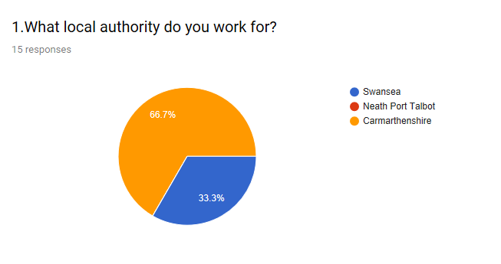
Appendix 2
This shows the responses to the question “Over the past 3 years, what year groups have you taught/supported?”. This was asked to determine what year groups staff have experience of. As the results here show, other than nursery, there is experience of every year group among our respondents.
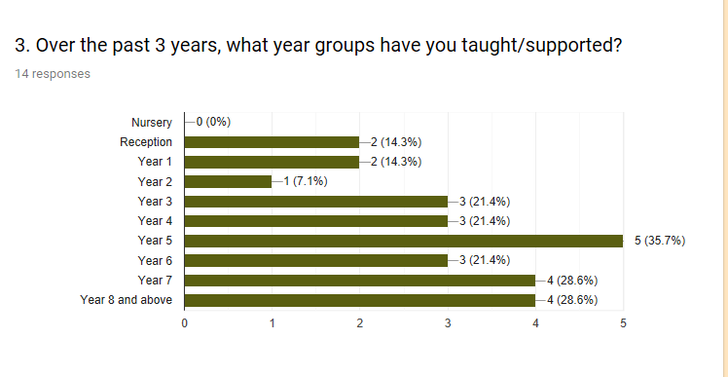

Appendix 3
Appendix 3 shows the results received in relation to the what school setting the respondent’s worked in.

Appendix 4
Appendix 4 shows the results to the question “Have you had any contact with any pupils that have displayed signs of dyslexia?”. This was deemed vital to discuss as we wanted to determine how many respondents had experience of pupils with dyslexia. Having such a high percentage claiming that they have had contact with pupils with dyslexia is beneficial to this essay.
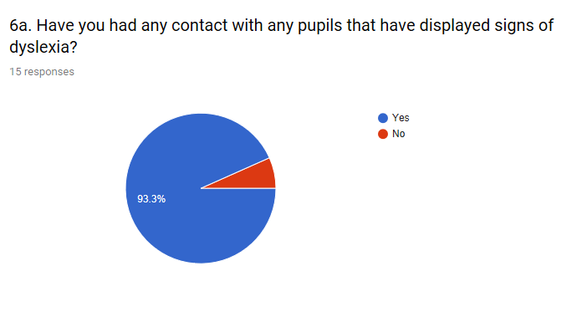

Appendix 5
This shows the summary of results obtained for the question, “Was there also any pupils displaying signs of dyscalculia?”. As we can see, 60% stated that they had knowledge of 60% of pupils displaying signs of dyscalculia.
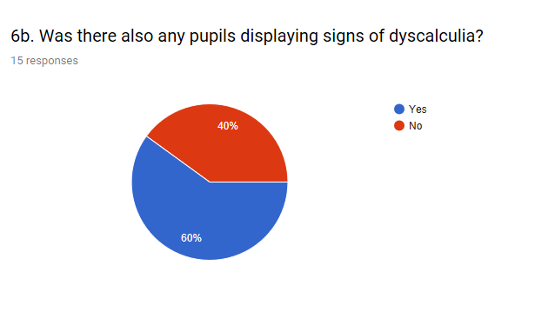
Appendix 6
The following questioned examined if any pupils had a dyscalculia diagnosis.
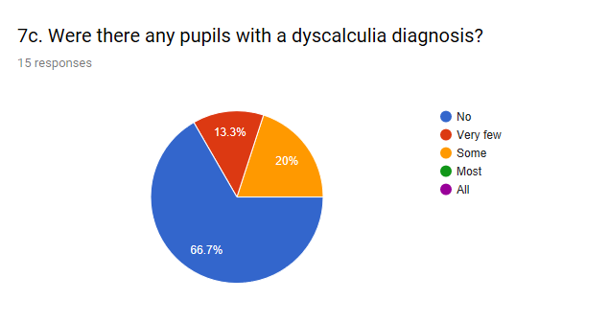

Appendix 7
The following looks at pupils who have both a dyslexia and a dyscalculia diagnosis. It was interesting to determine it there was a significant link between the two or if they were more exclusive of one another. According to this research, it can be concluded that within the sample the link between the two is insignificant.
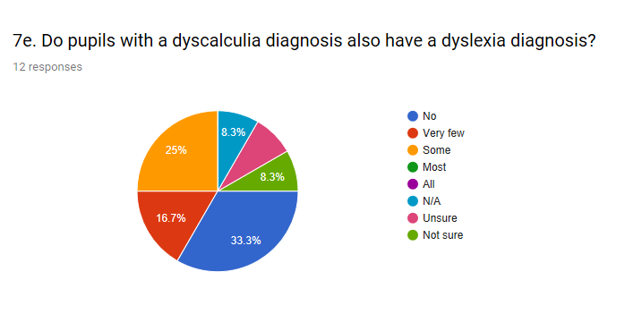

Appendix 8
Following on from asking what signs the pupils with dyslexia displayed, it was helpful to discuss which was the most obvious traits overall. As seen, spelling was deemed the most obvious aspect, with no one stating number.
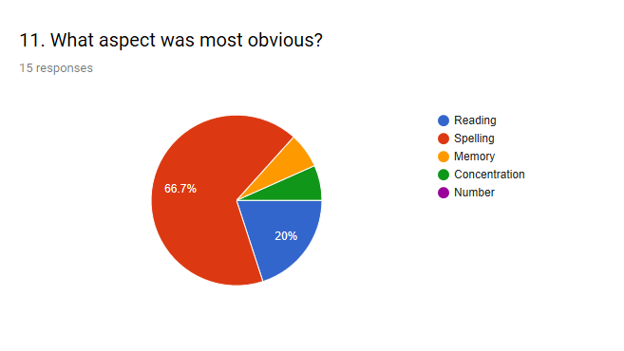

Appendix 9
Some research suggests that dyslexic pupils can be more creative, so it was decided to ask this question. The results did not highlight any significant increase in creativity.
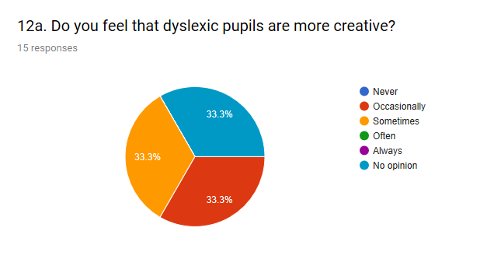

Appendix 10
It was deemed important to see the impact that the use of the various resources available actually had within the classroom. While no one said there was any negative impact, some stated that there was no impact, which suggests more needs to be done to ensure these resources have an impact on pupils within the classroom.



