Introduction to Web and Database Concepts
Steven Moon – 1904741

Table of Contents

Introduction
This report will review a hand coded website in HTML and show the creators understanding of accessibility and optimisation of the website. The report will also then evaluate the website for usability and accessibility and highlight potential improvements that could be made.

Requirements
The website being reviewed in this report is that of “Moon Furniture” which is a website designed to highlight woodworking projects undertaken by the owners and provide inspiration for others who enjoy building custom furniture. The website is also designed to allow for custom orders to be placed with the owners t increase revenue. The target audience for this website are those who are familiar with other woodworking websites of those using youtube as a platform. The site is likely only to be relevant to those who already have an interest in the company through other marketing materials and those wishing to purchase a custom piece of furniture.
Implementation
Below is a set of screenshots from the final website with a brief description of each pages purpose in the overall site.
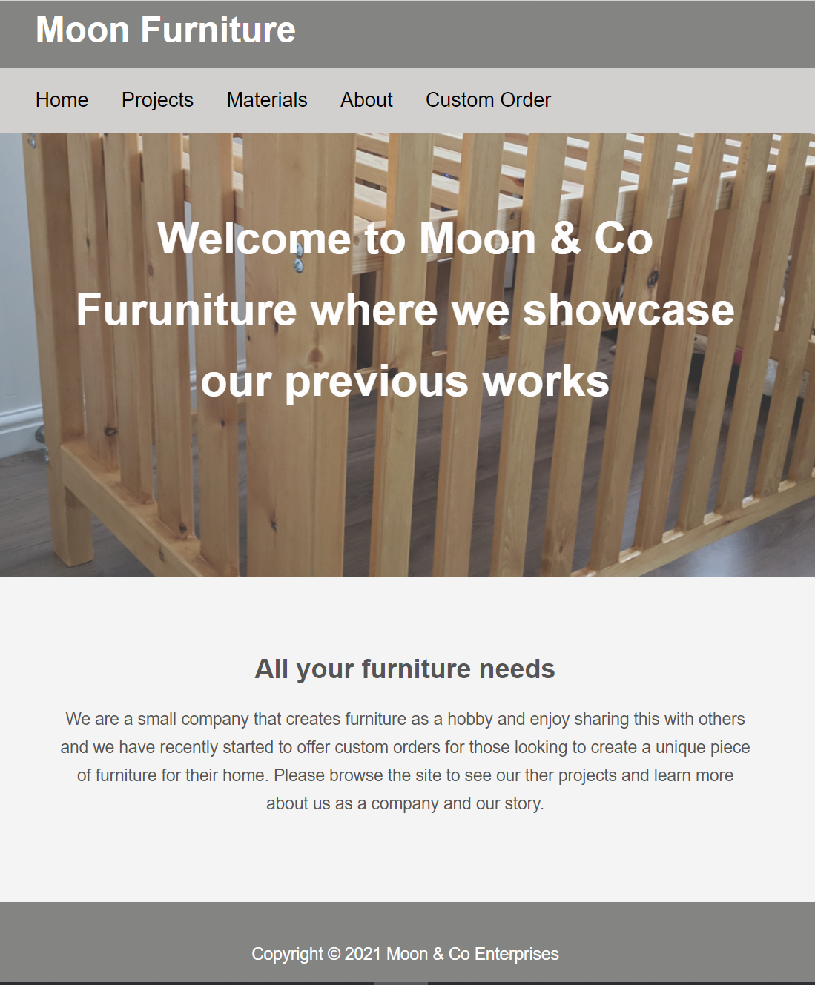
The above page is the landing page of the site and is designed to allow for easy navigation of the site and introduces the purpose of the site and a brief introduction of the company.
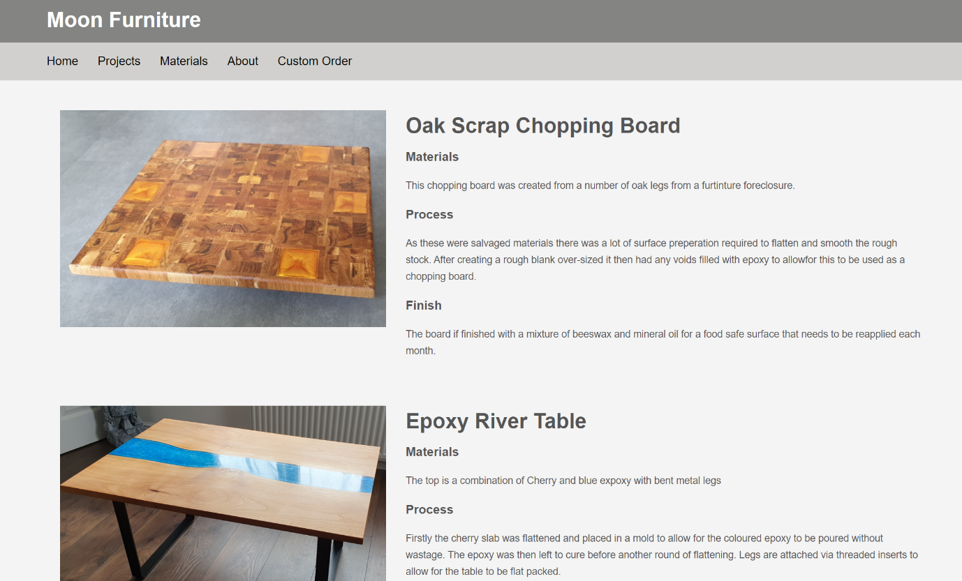
The second image above shows a cropped section of the Products page of the website which shows the previous projects of the company and describes the process of building the piece and how it is finished.
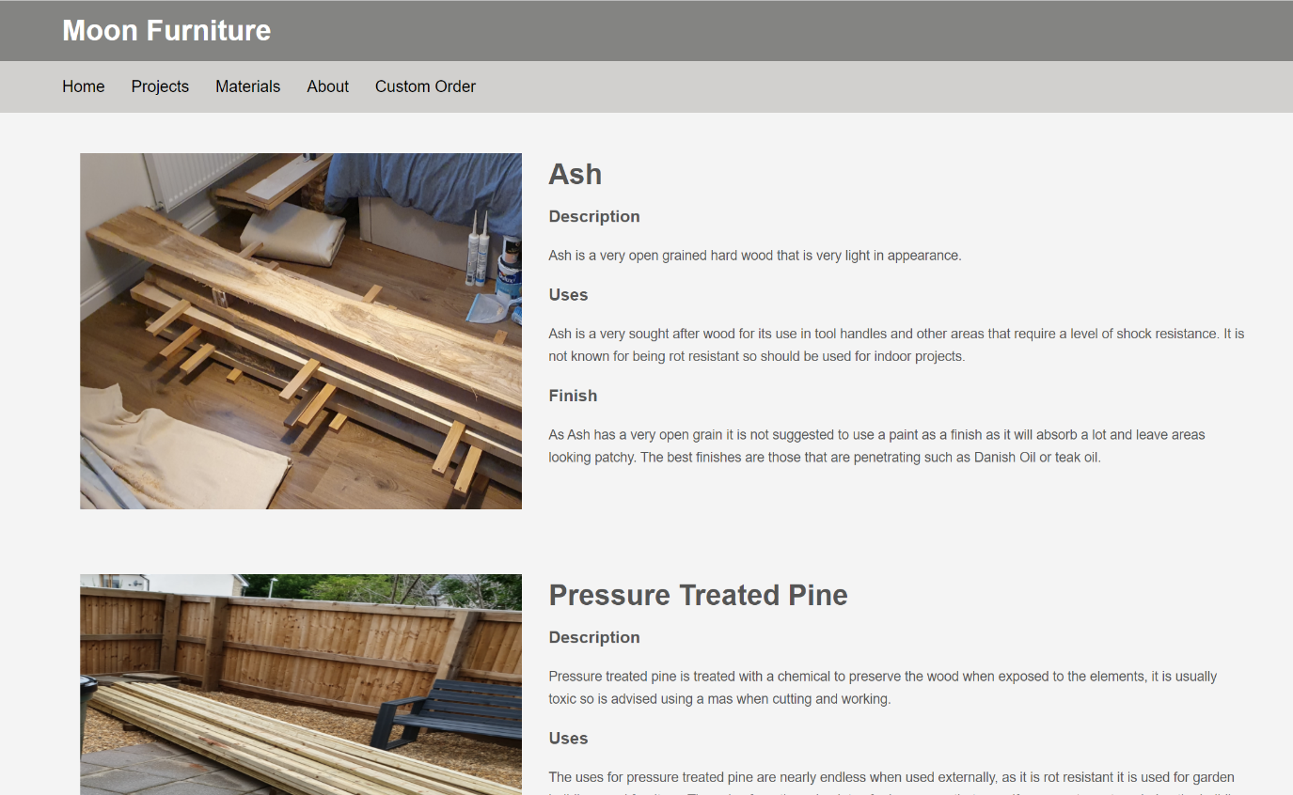
This image is of the Materials page which is used by the creator to show the various materials used in the construction of the previous projects and also the intended uses for those materials should the browser wish to request a custom order.
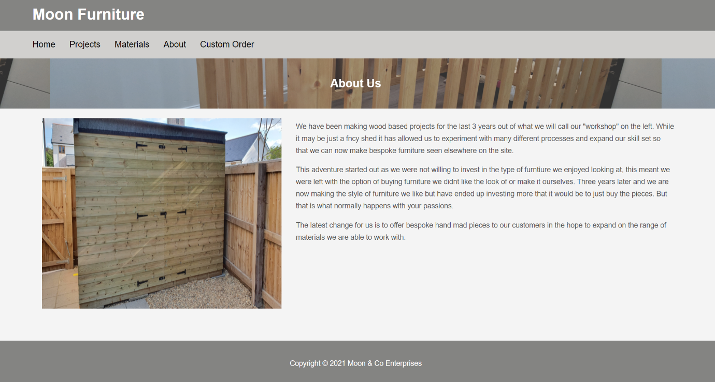
The above page highlights the history of the company and provides a small amount of background information for the browser of the site to understand the story behind the company.
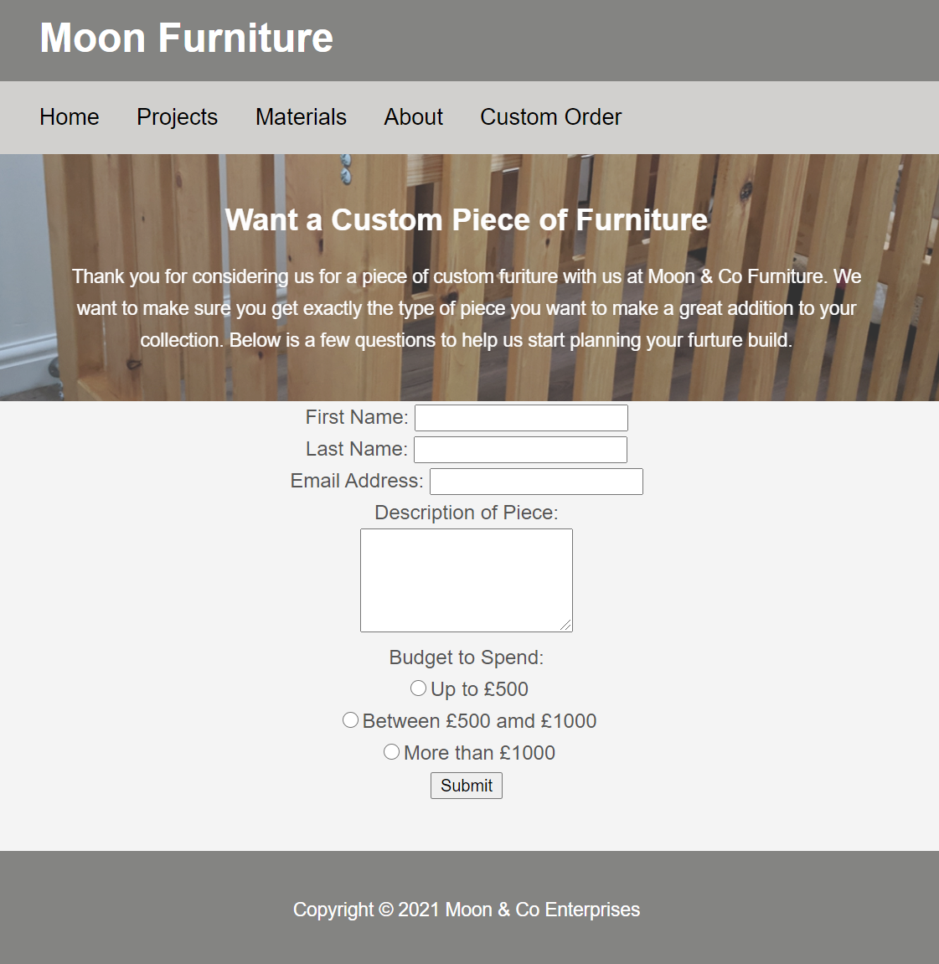
The final page of the site allows for the browser to place a custom order for a piece of furniture.
Website HTML Validation
Using a HTML validation tool [1] for the index page of the website only highlighted three potential issues that would require fixing. The first of these warnings is to add a language attribute to the start of the HTML file to ensure the correct language is used when interpreting the website. The other two errors were to use the h1 tag only for the header area rather than in the body of the page. After testing the HTML on various browsers the h1 element tag did not cause any problems with rendering the page in the intended way.
Website CSS Validation
When attempting to validate the main CSS file for the website using the W3 validation tool [2] the creator was presented with two errors. Both these errors were due to the use of “#black” as a colour tag rather than a hexadecimal value. This was fixed easily within the CSS file with the hexadecimal value of #000000.
Evaluation
Usability
Accessibility
Search Engine Optimisation
Search engine optimisation is a key part of any web development tasks being undertaken with the view of driving traffic and revenue to a website. The purpose of SEO is to display the website to the biggest audience by having it rank highly on numerous search engines like Google. The importance of this is highlighted by a Forbes article [3] that suggests up to 92% of sites being clicked on via the search results are on the first page with only 6% of overall traffic selecting a page from the second page of the results. This very high proportion of traffic going to sites on the first page shows the requirement for a successful website returning on the first page in order to increase business for the site. Google [4] provides numerous documents on how small improvements to a websites coding can enhance the search results for the site. These range from the use of additional text files that tell the google search bots which pages can be crawled easily without causing errors which reduce the score of the overall site. One easy way highlighted in the documentation is to use keywords within the alternative tags of any images to allow for the search engine to score the website higher as it is able to interpret the images. This type of optimisation can be seen within the website created for this report on the “Materials” page which provides an alternative tag for each of the images. Another optimisation that can be seen on the site is the use of headers for each web page that provide a description of the content that can then be used by google to rank the result. Other SEO techniques that could be implemented on the website would be to use meta tags within the HTML to allow this text to be displayed on google search results so that browsers can understand the content of the site before clicking into the page, this does however bring risks if used incorrectly as filling this with keywords will result in google ranking the page lower in results due to the spamming nature of this method.
The website being reviewed in this report would be unlikely to score well in search rankings due to a number of factors that could be implemented if the site were to go live to the public and the author wish to increase the rankings. One of the first elements that would need to be considered is the use of links from other websites that send traffic to the authors site as this increases the trust Google places in the site as highlighted in the developer tools [4]. The other major improvement that could be made to the site on all pages is the use of alternate tags for images and also meta data being made clear so that the search engine can understand the website, this type of information would have to be added to all of the sites pages to allow for the greatest amount of information to be gathered.
Usability
Another important aspect of web design is to ensure that the end product is easy to use and understand, this area of web design encompasses a wide arrange of disciplines and is key to the success of the final website. One example of usability being incorporated into the authors website is the use of a navigation pane at the top of each web page that allows for the skipping of various navigation menus, the importance of this is highlighted in a report by the Department of Health and Human Services in the United States [5] and forms part of the guidelines that are required when designing a website for the US government. Another area of usability to consider when coding a website would be to follow a familiar layout and design as other sites that operate within the same arena as the one being created, this type of design allows users to quickly identify where items are located on the page and navigate around easily without having to become familiar with a completely new design layout. The site being discussed within this report uses a similar layout to that of Foureyes Furniture [6] which is another site that operates in the custom furniture creation and highlights other projects although from other contributors in this case. As it follows a similar pattern to this site it allows new users who are likely to have browsed this type of site before to easily navigate around the site and find the key information quickly.
Accessibility
As more content moves onto a digital format and is based exclusively on-line accessibility in web design becomes more important and wider ranging as it needs to accommodate a growing list of issues. These issues range from audio-based deficiencies to sight of cognitive impairments. Whilst a majority of accessibility was created for those with permanent impairment W3.org [7] highlights that the improvements made for this cohort of the population also benefits those with temporary impairments such as broken bones or issues with the current situation they find themselves in. As accessibility in design is so crucial many organisations have grouped together to create standards that can be applied, one such standard that applies in this instance is Web Content Accessibility Guidelines (WCAG) which is currently at version 2.1 [8]. Some areas highlighted in the WCAG documents that centre around non-text based information have not been implemented within the authors site such as having text based alternatives for many of the images within the site or areas of code that allow assistive programs to ignore certain decorations within the sites pages, this could be implemented within the final code before going live to improve the overall accessibility of the site.
One area of the WCAG guidelines that have been implemented within the site is the use of consistent navigation items across each page, this is achieved using the navigation bar at the tope of each page. An improvement that could be made to the site in future is the introduction of a dynamic navigation menu that follows the user as they scroll down the webpage to ensure they are always quick and easy to access.
Another key component of creating an accessible website is to consider colour contrast of image and text elements. Using a contrast checker such as one provided by ACART Communication [9] allows the author to review the elements present on the index page of the site. Checking the title of the page results in a fail in most areas of contrast apart from text of a size 18pts or greater, this means that for WCAG this meets requirement for the title but not for the footer of the page. The obvious improvement to the site in this instance would be to change the background colour that allows for greater contrast at the lower text size. Using the same site for the other text elements on the site result in a pass in every aspect of WCAG so would be appropriate when going live with this site.
There are other tools that can be used to validate websites for their compliance with WCAG such as those provided by WAVE [10] which provide a more complete look at a sites coding and provides this feedback in a graphical manner to allow the author to quickly identify issues and provide fixes for the different areas. Using this tool for the Projects page of the site results in the below output.
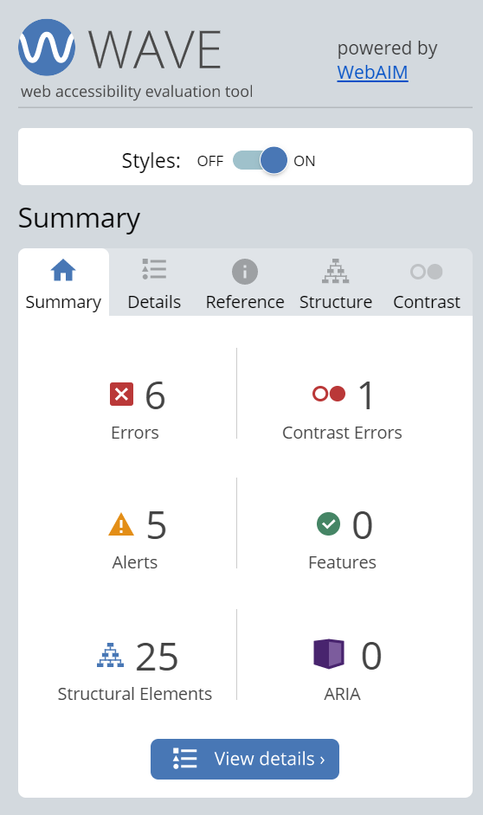
Using this tool the developer is also able to drilldown into a more granular level as to why each error presents an issue and also a potential fix to be implemented in order to resolve.
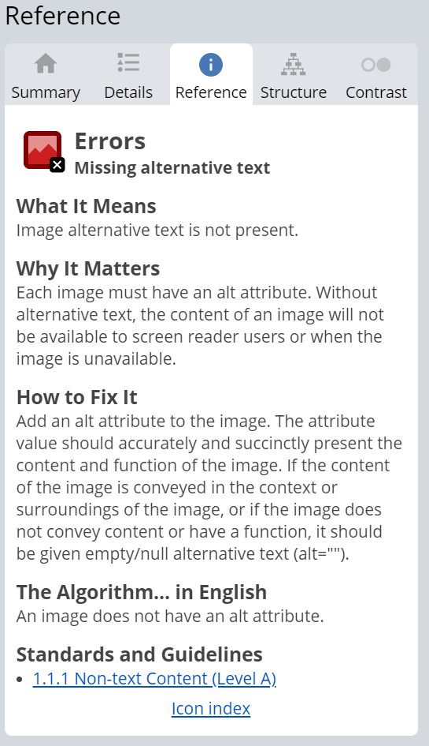
Using the above an improvement that is required is the use of alternate tags for the images for the use of accessibility tools such as screen readers etc.
Conclusion
Taking the website as a whole it could be considered to meet a number of the accessibility criteria but fall short in some areas such as some text elements contrast. It also has some poor areas when considering search engine optimisations that would need to be addressed before the site were to be made viewable by the public. The report also highlights the importance of web design and an understanding of various subject matters that impact a websites ability to be used and the utility it offers to the end user.

References

[1] | "Nu HTML Checker," [Online]. Available: https://validator.w3.org/nu/#file. [Accessed 02 04 2021].
[2] | "W3C CSS Validation Service," [Online]. Available: http://jigsaw.w3.org/css-validator/validator. [Accessed 02 04 2021].
[3] | K. Shelton, "The Value of Search Results Rankings," Forbes, 30 10 2017. [Online]. Available: https://www.forbes.com/sites/forbesagencycouncil/2017/10/30/the-value-of-search-results-rankings/. [Accessed 02 04 2021].
[4] | Google, [Online]. Available: https://developers.google.com/search/docs/beginner/seo-starter-guide. [Accessed 02 04 2021].
[5] | U. S. G. P. Office, "Research-based Web Desgn & Usability Guidelines," 2 ed., US Department of Health and Human Services, 2006.
[6] | F. Furniture. [Online]. Available: https://www.foureyesfurniture.com/. [Accessed 06 04 2021].
[7] | "Introduction to Web Accessibility," 05 06 2019. [Online]. Available: https://www.w3.org/WAI/fundamentals/accessibility-intro/#:~:text=Web%20accessibility%20means%20that%20websites,contribute%20to%20the%20Web. [Accessed 06 04 2021].
[8] | WCAG, "Web Content Accessibility Guidelines," 05 06 2018. [Online]. Available: https://www.w3.org/TR/WCAG21/. [Accessed 06 04 2021].
[9] | ACART Communication, "Contrast Checker," [Online]. Available: https://contrastchecker.com/. [Accessed 06 04 2021].
[10] | WAVE. [Online]. Available: https://wave.webaim.org/. [Accessed 06 04 2021].

Appendices
CSS Style Sheet
body{
background-color:#f4f4f4;
color:#555;
font-family:Arial, Helvetica, san-serif;
font-size:16px;
line-height:1.6em;
margin:0;
}

.container{
width:90%;
margin:auto;
overflow:hidden;
}

#main-header{
background-color:#848482;
color:#fff;
}
#navbar{

background-color:#D1D0CE;
color:#000000;
}

#navbar ul{
padding:0;
list-style:none;
}

#navbar li{
display:inline;
}

#navbar a{
font-size:18px;
padding-right:25px;
}

a{
color:black;
text-decoration: none;
}

a:hover{
color:blue;
}

p{
font-size:15px;
}

form{
text-align:center;
margin-top:40px;

}

#main-footer {
background:#848482;
color:#fff;
text-align:center;
padding:20px;
margin-top:40px;
}

#main{
float:right;
width:60%;
padding:10px;
box-sizing: border-box;
}

#imagearea{
float:left;
width:40%;
background:none;
color:#fff;
padding:20px;
box-sizing: border-box;
}

#minor{
float:left;
width:100%;
background:none;
color:#000000;
padding:20px;
text-align:center;
box-sizing: border-box;
}

#custom{
float:left;
width:100%;
background:none;
color:#fff;
padding:20px;
text-align:center;
box-sizing: border-box;
background-image:url("images/title.png");
background-size: 1280px;
opacity:0.8;
background-position:center;
}

#showcase{
background-image:url("images/title.png");
background-size: 1280px;
opacity:0.8;
background-position:center;
height:400px;
/*min-height:200px;*/
margin-bottom:30px;
text-align:center;
}

#showcase h1{
color:#fff;
font-size:40px;
line-height:1.6em;
padding:30px;
}

@media(max-width:600px){
#main{
width:100%;
float:none;
}

#sidebar{
width:100%;
float:none;
}

#navbar li{
display:block;
}

}

Index HTML
<!DOCTYPE html>
<html>
<head>
<meta charset="utf-8" />
<title>Moon Furniture</title>
<link rel="stylesheet" type="text/css"
href="style.css">
</head>
<body>
<header id="main-header">
<div class="container">
<h1>Moon Furniture</h1>
</div>
</header>

<nav id="navbar">
<div class="container">
<ul>
<li><a href="index.html">Home</a></li>
<li><a href="projects.html">Projects</a></li>
<li><a href="materials.html">Materials</a></li>
<li><a href="about.html">About</a></li>
<li><a href="contact.html">Custom Order</a></li>
</ul>
</div>
</nav>

<section id="showcase">
<div class="container">
<h1>Welcome to Moon & Co Furuniture where we showcase our previous works
</h1>
</div>
</section>

<div class="container">

<aside id="minor">
<h1>All your furniture needs</h1>
<p>We are a small company that creates furniture as a hobby and enjoy sharing this with others and we have recently started to offer custom orders for those looking to create a unique piece of furniture for their home. Please browse the site to see our ther projects and learn more about us as a company and our story.
</p>
</aside>
</div>

<footer id="main-footer">
<p> Copyright &copy; 2021 Moon & Co Enterprises</p>
</footer>
</body>
</html>
Projects HTML
<!DOCTYPE html>
<html>
<head>
<meta charset="utf-8" />
<title>Moon Furniture</title>
<link rel="stylesheet" type="text/css"
href="style.css">

<style>

</style>

</head>
<body>
<header id="main-header">
<div class="container">
<h1>Moon Furniture</h1>
</div>
</header>

<nav id="navbar">
<div class="container">
<ul>
<li><a href="index.html">Home</a></li>
<li><a href="projects.html">Projects</a></li>
<li><a href="materials.html">Materials</a></li>
<li><a href="about.html">About</a></li>
<li><a href="contact.html">Custom Order</a></li>
</ul>
</div>
</nav>

<br>

<div class="container" id="group">
<div id="imagearea">
<img src="images/choppingboard.png" width=100% height=90%>
</div>
<div id="main">
<h1>Oak Scrap Chopping Board</h1>
<h3>Materials</h3>
<p>This chopping board was created from a number of oak legs from a furtinture foreclosure.</p>
<h3>Process</h3>
<p>As these were salvaged materials there was a lot of surface preperation required to flatten and smooth the rough stock. After creating a rough blank over-sized it then had any voids filled with epoxy to allowfor this to be used as a chopping board.</p>
<h3>Finish</h3>
<p>The board if finished with a mixture of beeswax and mineral oil for a food safe surface that needs to be reapplied each month.</p>
</div>
</div>

<br>

<div class="container" id="group">
<div id="imagearea">
<img src="images/rivertable.png" width=100% height=90%>
</div>
<div id="main">
<h1>Epoxy River Table</h1>
<h3>Materials</h3>
<p>The top is a combination of Cherry and blue expoxy with bent metal legs</p>
<h3>Process</h3>
<p>Firstly the cherry slab was flattened and placed in a mold to allow for the coloured epoxy to be poured without wastage. The epoxy was then left to cure before another round of flattening. Legs are attached via threaded inserts to allow for the table to be flat packed.</p>
<h3>Finish</h3>
<p>The cherry is finished with danish oil with the epoxy being polished using high grit sandpaper and automotive polishing compound.</p>
</div>
</div>

<br>

<div class="container" id="group">
<div id="imagearea">
<img src="images/tissuebox.png" width=100% height=90%>
</div>
<div id="main">
<h1>Wooden Tissue Box</h1>
<h3>Materials</h3>
<p>The top of this box is a mixture of end grain ash and sapele with the sides being solid walnut.</p>
<h3>Process</h3>
<p>The top was offcuts from an end grain chess board that were re-sawn thinner to be used within this tissue box. The sides were a simple box joined using rabbit joinery.</p>
<h3>Finish</h3>
<p>The box was originally finished in danish oil but has since been re-finished with beeswax and mineral oil to return the item to its orginal luster.</p>
</div>
</div>

<br>

<div class="container" id="group">
<div id="imagearea">
<img src="images/tvstand.png" width=100% height=90%>
</div>
<div id="main">
<h1>Oak and Metal TV Stand</h1>
<h3>Materials</h3>
<p>The top is a thick piece of brown oak from Somerset with the legs being welded metal box section</p>
<h3>Process</h3>
<p>The top was rough sawn when collected and too wide for a planer, this was flattening with a hand place over a number of hours before the cracks were stabalised with clear epoxy. The legs were welded together using a TIG welder before being ground down to a smooth finish.</p>
<h3>Finish</h3>
<p>The top is finished with danish oil and a top coat of hard furniture wax. The base is sprayed using a black hammerite for longevity.
</div>
</div>

<br>

<div class="container" id="group">
<div id="imagearea">
<img src="images/weddingbox.png" width=100% height=90%>
</div>
<div id="main">
<h1>Oak Wedding Jewlery Box</h1>
<h3>Materials</h3>
<p>Kiln dried oak was used for this box with the hardwear being aged brass for a vintage look.</p>
<h3>Process</h3>
<p>The box is constructed using half lap joinery to create a long lasting piece of equipment that can be used for many years. The box was constructed in one complete piece before being sawn in half to create the hinged area.</p>
<h3>Finish</h3>
<p>The finish applied in this instance was a base of teak oil and a top layer of hard furniture wax.</p>
</div>
</div>

<footer id="main-footer">
<p> Copyright &copy; 2021 Moon & Co Enterprises</p>
</footer>

</body>
</html>
Materials HTML
<!DOCTYPE html>
<html>
<head>
<meta charset="utf-8" />
<title>Moon Furniture</title>
<link rel="stylesheet" type="text/css"
href="style.css">

<style>

</style>

</head>
<body>
<header id="main-header">
<div class="container">
<h1>Moon Furniture</h1>
</div>
</header>

<nav id="navbar">
<div class="container">
<ul>
<li><a href="index.html">Home</a></li>
<li><a href="projects.html">Projects</a></li>
<li><a href="materials.html">Materials</a></li>
<li><a href="about.html">About</a></li>
<li><a href="contact.html">Custom Order</a></li>
</ul>
</div>
</nav>

<br>

<div class="container" id="group">
<div id="imagearea">
<img src="images/ash.png" alt="ash wood" width=100% height=400px>
</div>
<div id="main">
<h1>Ash</h1>
<h3>Description</h3>
<p>Ash is a very open grained hard wood that is very light in appearance.</p>
<h3>Uses</h3>
<p>Ash is a very sought after wood for its use in tool handles and other areas that require a level of shock resistance. It is not known for being rot resistant so should be used for indoor projects.</p>
<h3>Finish</h3>
<p>As Ash has a very open grain it is not suggested to use a paint as a finish as it will absorb a lot and leave areas looking patchy. The best finishes are those that are penetrating such as Danish Oil or teak oil.</p>
</div>
</div>

<br>

<div class="container" id="group">
<div id="imagearea">
<img src="images/pressuretreated.png" alt="pressure treated pine" width=100% height=400px>
</div>
<div id="main">
<h1>Pressure Treated Pine</h1>
<h3>Description</h3>
<p>Pressure treated pine is treated with a chemical to preserve the wood when exposed to the elements, it is usually toxic so is advised using a mas when cutting and working.</p>
<h3>Uses</h3>
<p>The uses for pressure treated pine are nearly endless when used externally, as it is rot resistant it is used for garden buildings and furniture. They also form the sole plates for houses so that even if some water enters during the building phase it is not of a concern.</p>
<h3>Finish</h3>
<p>As this timber is already treated with a chemical for rot resistance the reason to add additional finish is for asthetic reasons so is often painted or stained to match other furniture in the garden.</p>
</div>
</div>

<br>

<div class="container" id="group">
<div id="imagearea">
<img src="images/pine.png" alt="pine" width=100% height=400px>
</div>
<div id="main">
<h1>Planed Pine</h1>
<h3>Description</h3>
<p>Pine is an open grained softwood with a very yellow appearance when finished.</p>
<h3>Uses</h3>
<p>The uses for planed pine are numerous and is often used in trim applications for houses and in more affordable furniture. As it is a softwood it is not generally used for hand cut joinery applications due to the fibres crushing and leaving a poor finish.</p>
<h3>Finish</h3>
<p>Due to its open pours pine takes stain very well and due to its yellow colour when finished many choose this route to allow for a wide application for the furniture piece.</p>
</div>
</div>

<br>

<div class="container" id="group">
<div id="imagearea">
<img src="images/oak.png" alt="oak hardwood" width=100% height=400px>
</div>
<div id="main">
<h1>Oak</h1>
<h3>Description</h3>
<p>Oak is a very sought after wood due to its very recognisable colour and grain pattern that is often associated with long lasting furniture pieces.</p>
<h3>Uses</h3>
<p>The uses for oak vary greatly from traditional timber framing of houses and barns to long lasting furniture such as pughs in churches. It is also a favoured wood for furinture pieces due to being very recognisable to the average consumer.</p>
<h3>Finish</h3>
<p>Oak can be finshed in a variety of ways but is most often finished with a water based varnish to give a nice satin sheen and long lasting protection.</p>
</div>
</div>

<footer id="main-footer">
<p> Copyright &copy; 2021 Moon & Co Enterprises</p>
</footer>

</body>
</html>
About HTML
<!DOCTYPE html>
<html>

<head>
<meta charset="utf-8" />
<title>Moon Furniture</title>
<link rel="stylesheet" type="text/css"
href="style.css">
</head>
<body>
<header id="main-header">
<div class="container">
<h1>Moon Furniture</h1>
</div>
</header>

<nav id="navbar">
<div class="container">
<ul>
<li><a href="index.html">Home</a></li>
<li><a href="projects.html">Projects</a></li>
<li><a href="materials.html">Materials</a></li>
<li><a href="about.html">About</a></li>
<li><a href="contact.html">Custom Order</a></li>
</ul>
</div>
</nav>

<section id="custom">
<div class="container">

<h1>About Us</h1>
<p>
</p>
</div>
</section>

<div class="container" id="group">
<div id="imagearea">
<img src="images/workshop.png" width=100% height=400px>
</div>
<div id="main">
<p>We have been making wood based projects for the last 3 years out of what we will call our "workshop" on the left. While it may be just a fncy shed it has allowed us to experiment with many different processes and expand our skill set so that we can now make bespoke furniture seen elsewhere on the site.</p>
<p>This adventure started out as we were not willing to invest in the type of furntiure we enjoyed looking at, this meant we were left with the option of buying furniture we didnt like the look of or make it ourselves. Three years later and we are now making the style of furniture we like but have ended up investing more that it would be to just buy the pieces. But that is what normally happens with your passions.</p>
<p>The latest change for us is to offer bespoke hand mad pieces to our customers in the hope to expand on the range of materials we are able to work with.</p>
</div>
</div>

<footer id="main-footer">
<p> Copyright &copy; 2021 Moon & Co Enterprises</p>
</footer>
</body>
</html>
Contact HTML
<!DOCTYPE html>
<html>

<head>
<meta charset="utf-8" />
<title>Moon Furniture</title>
<link rel="stylesheet" type="text/css"
href="style.css">
</head>
<body>
<header id="main-header">
<div class="container">
<h1>Moon Furniture</h1>
</div>
</header>

<nav id="navbar">
<div class="container">
<ul>
<li><a href="index.html">Home</a></li>
<li><a href="projects.html">Projects</a></li>
<li><a href="materials.html">Materials</a></li>
<li><a href="about.html">About</a></li>
<li><a href="contact.html">Custom Order</a></li>
</ul>
</div>
</nav>

<section id="custom">
<div class="container">

<h1>Want a Custom Piece of Furniture</h1>
<p>Thank you for considering us for a piece of custom furiture with us at Moon & Co Furniture. We want to make sure you get exactly the type of piece you want to make a great addition to your collection. Below is a few questions to help us start planning your furture build.
</p>
</div>
</section>
<form>

First Name: <input type="text">
<br>
Last Name: <input type="text">
<br>
Email Address: <input type="email">
<br>
Description of Piece:<br><textarea name="descript" rows="5" columns="50"></textarea>
<br>
Budget to Spend:<br>
<input type="radio">Up to £500<br>
<input type="radio">Between £500 amd £1000<br>
<input type="radio">More than £1000<br>
<input type="Submit"><br>

<footer id="main-footer">
<p> Copyright &copy; 2021 Moon & Co Enterprises</p>
</footer>
</body>
</html>

