menagement economics
Assessment 1
Module: Management Economics
Module Code: LCBB5008
Lecturer: Dr Taye Osadiya
Student: Lachezar Dimitrov
Student ID: 1915922

[Company Name] | [Company Address]

Table of Contents
INTRODUCTION 2
DISCUSSION 2
SOLVING THE CHALLENGES 7
RELEVANCE OF DEMAND AND SUPPLY DURING PANDEMIC 9
ELASTICITY 10
INELASTICITY 11
LAWS OF SUPPLY AND DEMAND 13
CONCLUSION 14

INTRODUCTION

The Covid-19 pandemic has emerged as an unprecedented global disruptor, reshaping the economic landscape with far-reaching consequences. Its impact on global economies transcends mere health crises. It created intricate webs of challenges that reverberate across sectors and nations (Verachia, 2020). The pandemic's cascading effects have disrupted supply chains, altered consumer behaviors and prompted swift and varied policy responses from governments worldwide.
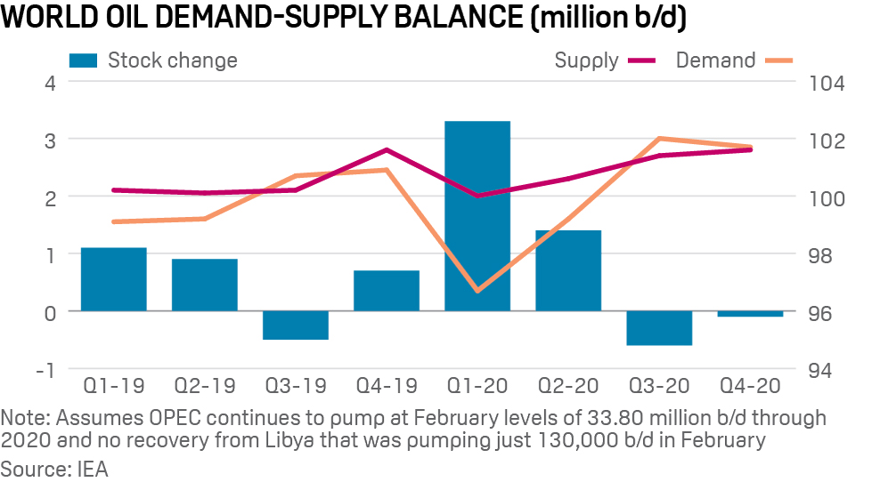
This multifaceted transformation has implications for international trade, financial markets and the very fabric of economic interdependence. As the world grapples with the aftermath of this global health crisis, understanding the intricate ways in which the pandemic has influenced and continues to shape economies on a global scale becomes imperative. This exploration seeks to delve into the multifaceted dimensions of the Covid-19 impact, scrutinizing the nuanced economic shifts and strategic responses employed by nations and businesses alike in navigating these uncharted territories.

DISCUSSION

The economic tremors induced by the Covid-19 pandemic propelled numerous businesses towards insolvency, primarily attributable to acute financial constraints. Emblematic of this financial strain were prominent entities such as Debenhams, succumbing to insolvency in December 2020 amid declining sales (Butler, 2020). Flybe, a regional airline, faced exacerbated financial difficulties due to diminished air travel demand, resulting in administration and operational cessation in March 2020. The hospitality sector witnessed Carluccio's demise, while Cineworld temporarily shuttered theaters in response to financial struggles. Further exemplifying this trend, Laura Ashley, a venerable British retailer, filed for administration in March 2020, stating a critical lack of funds as a determining factor. These instances show diverse industries grappling with financial fallout of the pandemic, highlighting imperative for financial resilience and adaptability in navigating complexities of turbulent economic landscapes.

The Brexit decision compounded challenges, intensifying uncertainties and disruptions in supply chains. Combining with the ongoing pandemic, this convergence resulted in palpable supply shortages. A critical driver shortage, influenced by Brexit-related uncertainties and pandemic disruptions, was exacerbated as EU drivers left the UK. The Road Haulage Association reported an alarming shortage of 100,000 HGV drivers in the UK by mid-2021, leading to delays, increased transportation costs, and supply chain inefficiencies (Roberts, 2021). A survey by the Chartered Institute of Procurement & Supply revealed two-thirds of UK businesses experienced delays in receiving goods from the EU due to new customs procedures and regulatory changes post-Brexit. The resultant uncertainty prompted businesses to reassess and reconfigure supply chain strategies, adding complexity and costs. These instances underscore the intricate dynamics and challenges faced by businesses in navigating the evolving global landscape during the pandemic and Brexit.
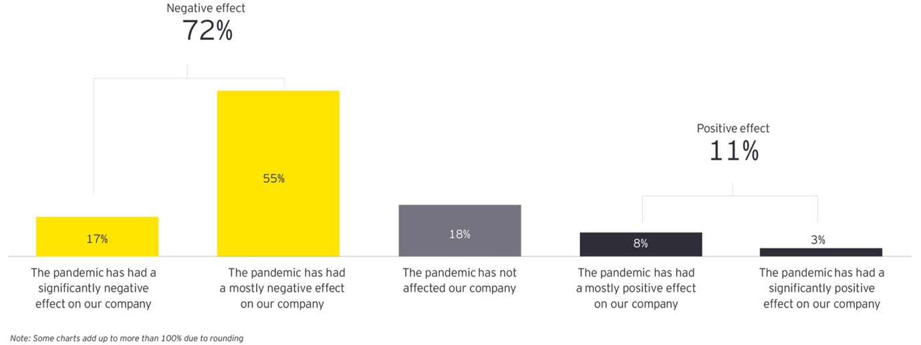

According to the study by Nylænder & Pedersen (2021), disruptions caused by the pandemic led to an imbalance between supply and demand. The study emphasizes that while demand for certain goods soared due to changing consumer behaviors, the supply chain faced unprecedented challenges, resulting in shortages. Moreover, the "Global Supply Chain Resilience Report 2021" by the Business Continuity Institute highlights how disruptions caused by the pandemic exposed vulnerabilities in supply chains. The report emphasizes that even industries experiencing increased demand struggled to cope with the simultaneous breakdowns in logistics and distribution channels.
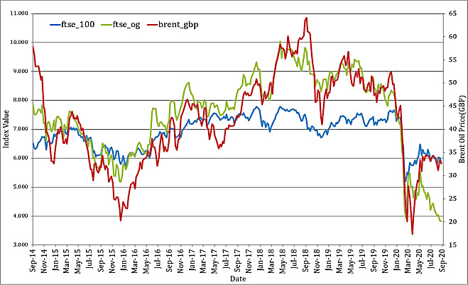

The surge in fuel prices in the United Kingdom over the tumultuous period from 2019 to 2021 encapsulates the volatile trajectory of the oil market. Commencing at an average of $61.06 per barrel in 2019, the onset of the Covid-19 pandemic in 2020 precipitated a historic drop, with Brent crude plummeting to $19.33 per barrel in April (Wheeler et al., 2020). As global economies began recovering in 2021, oil prices rebounded to $68.39 per barrel by May. The UK, heavily reliant on imported oil, experienced the reverberations of these fluctuations. Supply chain shortages, compounded by driver shortages and logistical disruptions, precipitated a swift escalation in fuel costs. UK petrol prices surged to an average of 130.1 pence per liter in October 2021, amplifying challenges for both businesses and consumers.
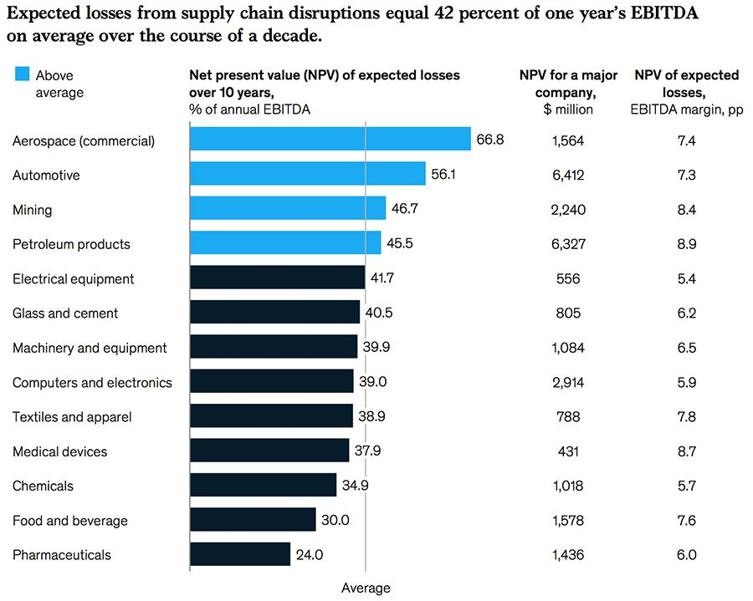

Corporations swiftly adapted to unprecedented challenges through strategic operational adjustments. Google facilitated remote work, offering financial aid for home office setups and flexible hours (Pichai, 2021). Amazon prioritized health with stringent protocols in fulfillment centers. Restaurants embraced takeout, employing digital platforms and contactless methods. Apple, reliant on global supply chains, diversified suppliers and increased safety stock. Walmart expanded e-commerce, emphasizing contactless payments and online groceries. Dyson pivoted to ventilator production during shortages. However, paradoxes surfaced as heightened demand coexisted with unexpected shortages, attributed to logistical challenges in global supply chains. The surge in demand for essentials, home entertainment, and health-related products such as PPE revealed a disconnect with the constrained supply chain. Disruptions caused by factory closures, transportation restrictions, and workforce shortages, hindered the timely delivery of goods.

SOLVING THE CHALLENGES

The multifaceted challenges brought about by the Covid-19 pandemic and concurrent economic uncertainties have necessitated innovative solutions across industries. Several real-world examples illustrate the diverse strategies adopted by businesses to address these challenges

- In the UK, the government responded by implementing various measures, including financial support packages, regulatory adjustments, and initiatives to boost economic resilience. The Coronavirus Job Retention Scheme (furlough scheme) provided financial aid to businesses, mitigating the impact of reduced consumer spending (OECD, 2020).

- Many governments globally, including the UK adjusted Covid-19 restrictions based on the evolving situation. One compelling example is the United Kingdom's phased easing of restrictions in mid-2021. In the third quarter of 2021, the UK's Gross Domestic Product (GDP) exhibited a robust growth rate of 1.3%, marking a significant recovery from the contractions witnessed during strict lockdowns (ONS, 2021).

- Retailers and manufacturers implemented sophisticated shortage management systems to optimize inventory and address supply chain disruptions. This involved leveraging data analytics and AI-driven tools to predict demand fluctuations and ensure efficient resource allocation.

- In response to the pandemic, Toyota's collaboration with suppliers bolstered resilience. Despite industry challenges, Toyota's fiscal year 2021 global sales revenue reached around 27.2 trillion JPY (248 billion USD). Closer ties facilitated just-in-time practices, containing costs and contributing to an operating income of about 2.2 trillion JPY (20 billion USD) (Statista, 2023).

- Tesco's 2020 sustainability drive in the food sector cut food waste by 17%, a significant 87,500 metric tons reduction. This aligns with environmental goals and translates to both ecological benefits and cost savings, showcasing the dual impact of Tesco's innovative waste reduction strategies on sustainability and economic efficiency.

- Global corporations like Nike reevaluated and enhanced their supply chain resilience. By investing in digital technologies and diversifying sourcing, they aimed to minimize disruptions, ensuring a consistent supply of products despite global uncertainties.

- Communication played a pivotal role in addressing uncertainties. Companies like Microsoft maintained transparent communication with stakeholders, including customers, employees, and investors, to provide timely updates on operational changes and strategies.

The contemporary business landscape marked by the profound disruptions of the Covid-19 pandemic and economic uncertainties emphasises the paramount importance of key organizational capabilities. The ability to innovate, collaborate, and strategically respond has emerged as a linchpin for businesses navigating these unprecedented times. Innovation serves as a catalyst for adaptation allowing organizations to creatively address challenges, explore novel solutions, and redefine operational paradigms. Collaborative efforts of both internally and externally foster resilience by leveraging collective insights, expertise, and resources to surmount complex obstacles.

RELEVANCE OF DEMAND AND SUPPLY DURING PANDEMIC
The intricate interplay of demand and supply dynamics holds a central significance in determining the trajectories of businesses, especially in the face of the intricate challenges presented by the Covid-19 pandemic. These economic forces exert a profound influence on various facets of organizational strategies and market responses, showcasing their pivotal role in navigating the complexities of the current global landscape.
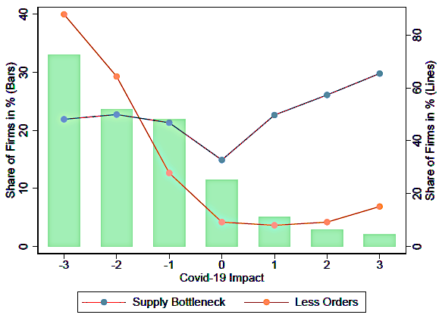
Amid the pandemic, industries adeptly utilized demand and supply strategies to navigate the volatile market conditions. Airlines implemented dynamic pricing models, tailoring fares in real-time based on travel restrictions and surges in demand, optimizing revenue amidst uncertainties. E-commerce platforms, exemplified by Amazon, engaged in fierce price competition, leveraging scale and efficient supply chains to offer competitive pricing, influencing consumer choices in a cost-sensitive environment. Amazon's robust demand and supply strategy, coupled with heightened online shopping demand during the pandemic, facilitated significant market share growth and increased productivity. Fast-food chains, such as Domino's, strategically adapted marketing approaches to resonate with evolving consumer preferences during lockdowns (Pisal, 2021). Emphasizing contactless delivery and promotions, they aligned with pandemic-induced shifts in consumer behavior. In the healthcare sector, biotech companies developing Covid-19 vaccines capitalized on heightened demand, attracting substantial investments through Initial Public Offerings (IPOs). The urgency surrounding pandemic solutions created favorable conditions for these companies to raise significant capital accentuating the profound impact of demand dynamics on financial markets.

In essential sectors like healthcare and logistics, companies responded to the challenges of the pandemic by augmenting wages to retain and motivate workers, ensuring a steadfast workforce and addressing labor shortages for sustained productivity. Pharmaceutical firms adeptly managed risks linked to raw material supply by diversifying suppliers and implementing contingency plans, ensuring uninterrupted production of vital medications amid global uncertainties. Semiconductor manufacturers, grappling with a global chip shortage, adapted strategies to align with evolving market demands. Industry leaders like Intel collaborated with suppliers to expedite production, effectively addressing shortages and underscoring the significance of agile supply chain management in dynamic markets. These practical instances vividly illustrate the pervasive impact of demand and supply dynamics across diverse industries, underscoring their crucial role in shaping organizational strategies and influencing market outcomes amid the intricate challenges presented by the Covid-19 pandemic.

ELASTICITY

During the COVID-19 pandemic, the UK's fuel market witnessed notable volatility, offering a tangible illustration of the elasticity of demand for fuel. In the pandemic's initial phase, stringent lockdowns caused a substantial drop in economic activity, leading to a sharp decline in fuel demand. With widespread restrictions and a slowdown in industrial and travel activities, the need for transportation fuel plummeted. This demonstrated an elastic response, where fluctuations in fuel prices resulted in a proportionately larger reduction in demand. Consumers, grappling with economic uncertainties, significantly cut back on fuel consumption. As the UK gradually lifted restrictions and economic activities resumed and fuel prices rebounded. However, the demand did not immediately surge in tandem indicating a persistent elastic response. Consumers, possibly influenced by ongoing uncertainties, displayed sensitivity to fuel price changes, showcasing the lingering impact of elasticity in shaping consumption patterns.
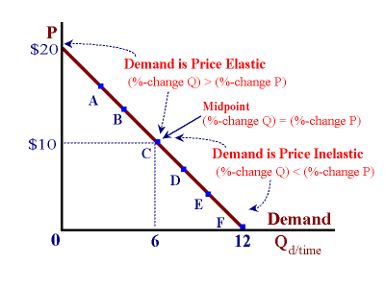
Elasticity of demand offers pivotal advantages, exemplified by the UK's fuel market. During the initial COVID-19 phase, elastic demand allowed fuel providers to dynamically adjust prices, optimizing revenue amidst changing demands. This adaptability extended to taxation policies as higher fuel taxes during periods of increased demand were implemented, leveraging consumers' responsiveness (. The market signals were evident in the UK's fuel sector where fluctuations in demand served as vital indicators guiding strategic decisions amid economic uncertainties.
Elasticity as observed in the UK's fuel market poses notable drawbacks too. Revenue volatility is evident where fluctuations in fuel prices might not linearly correspond to demand changes creating uncertainty in revenue forecasts. Consumer sensitivity during economic downturns showcased by reduced fuel spending, impacts the fuel sector and contributed to job losses. Intense market competition in elastic markets exemplified by price wars among fuel providers leading to decreased profit margins challenged sustainable operations during economic uncertainties.

INELASTICITY

In the UK during the COVID-19 pandemic, the inelasticity of demand for fuel was evident, signifying consistent purchasing habits despite price fluctuations. Certain segments of the population and critical industries exhibited stable fuel demand. Essential services, including emergency responders and delivery operations, faced inelastic demand due to limited alternatives and the essential nature of their operations. For instance, ambulances, police vehicles, and delivery trucks maintained relatively constant fuel demand despite fuel price variations. This inelasticity was further emphasized by individuals with essential jobs or limited public transportation options, as their fuel consumption showed little alteration despite price fluctuations. The economic impact was significant, as these inelastic demand sectors contributed to stable revenue for the fuel industry and underscored the critical role of fuel in maintaining essential services during challenging periods.
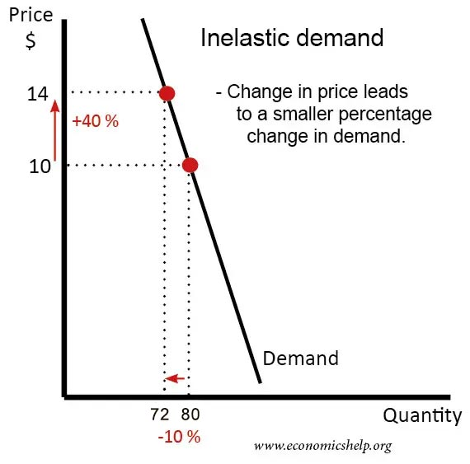

Inelasticity of demand presents several advantages that were observed in the UK's fuel sector. Firstly, it ensures revenue stability by offering businesses a more predictable income stream even if fuel prices rise. The resilience of essential services, like emergency responders and critical infrastructure benefits from inelastic demand by maintaining operations without significant disruption during challenging periods (Erias and Iglesias, 2022). Moreover, businesses can maintain a price premium in an inelastic market that allowed fuel providers to sustain higher prices without a substantial decrease in the quantity demanded. This strategic advantage becomes particularly beneficial during periods of increased production costs or supply chain disruptions ensuring the financial viability of fuel providers.

Inelasticity of demand, exemplified in the UK's fuel sector, brings forth certain disadvantages too. It places a burden on consumers particularly during economic hardships as rising fuel prices result in increased expenditures with limited alternatives. This limitation in consumer choice can hinder the adoption of more sustainable or cost-effective alternatives, potentially impeding progress in cleaner energy sources and fuel efficiency initiatives. Additionally, market rigidity may prevail in inelastic markets, discouraging innovation and efficiency improvements within the fuel industry, as stable demand provides less incentive for providers to explore environmentally friendly or cost-effective solutions.
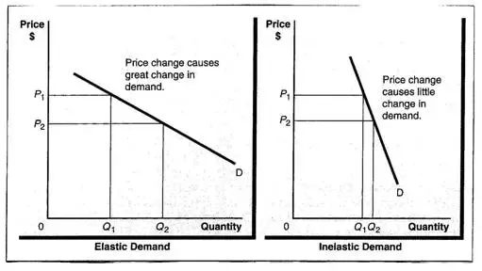

LAWS OF SUPPLY AND DEMAND

The laws of supply and demand are fundamental in economic principles that reverberate through various goods and services shaping market dynamics with real-world implications for organizations during the COVID-19 pandemic. As remote work and online learning surged during lockdowns, there was an increased demand for laptops and tablets. Manufacturers facing production constraints due to supply chain disruptions tried to maintain unchanged supplies. Consequently, prices escalated due to heightened demand creating a profitable scenario for electronics manufacturers.
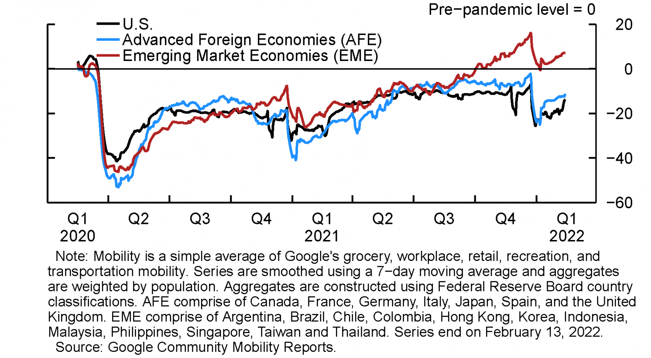
The fashion industry experienced decreased demand for non-essential items during lockdowns. Retailers with unchanged inventories faced the challenge of attracting consumers. To stimulate demand, prices decreased showcasing the impact of decreased demand on pricing strategies. The housing market witnessed increased supply as construction projects continued during the pandemic. However, with unchanged demand particularly in areas with economic uncertainties housing prices remained stable. This scenario demonstrated how increased supply did not necessarily translate to higher prices in a market with unchanged demand. The global semiconductor shortage disrupted the automotive industry leading to decreased supply of new vehicles. With unchanged consumer demand particularly in regions heavily reliant on car travel, prices surged due to the limited availability of new cars illustrating the impact of decreased supply on pricing dynamics.
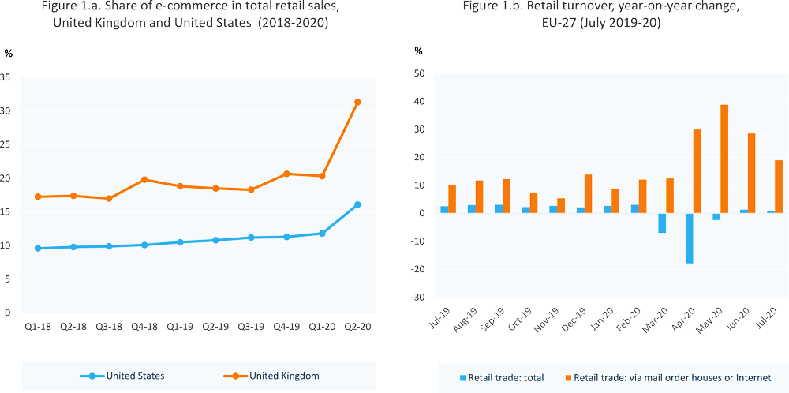

CONCLUSION
The multifaceted impact of the COVID-19 pandemic on global economies has illuminated the pervasive influence of supply and demand dynamics. Across sectors, from fuel to consumer electronics and housing, the laws of supply and demand have dictated market responses. Real-world examples underscore the necessity for adaptability in navigating dynamic market scenarios. As organizations grapple with economic uncertainties, understanding and strategically responding to these fundamental economic principles become paramount. The ability to innovate, collaborate, and strategically respond has proven instrumental in navigating these unprecedented times, emphasizing the enduring relevance of supply and demand dynamics in shaping market outcomes and organizational strategies.

REFERENCES
- Verachia, A. (2020). Disruption Amplified: Reset. Rewire. Reimagine Everything. Jonathan Ball Publishers.
- Wheeler, C., Baffes, J., Kabundi, A., Kindberg-Hanlon, G., Nagle, P. and Ohnsorge, F. (2020). Adding Fuel to the Fire Cheap Oil during the COVID-19 Pandemic. [online] Available at: https://documents1.worldbank.org/curated/en/284371594670190475/pdf/Adding-Fuel-to-the-Fire-Cheap-Oil-during-the-COVID-19-Pandemic.pdf.
- Nylænder, L.C. and Pedersen, F. (2021). The Impact of COVID-19 on Global Supply Chains. openarchive.usn.no. [online] Available at: https://openarchive.usn.no/usn-xmlui/handle/11250/2783828.
- BCI (2021). Supply Chain Resilience Report 2021 Contents. [online] Available at: https://www.thebci.org/static/e02a3e5f-82e5-4ff1-b8bc61de9657e9c8/BCI-0007h-Supply-Chain-Resilience-ReportLow-Singles.pdf.
- Butler, S. (2020). Debenhams set to close all stores with possible loss of 12,000 jobs. The Guardian. [online] 1 Dec. Available at: https://www.theguardian.com/business/2020/dec/01/debenhams-close-stores-jobs-department-store-jd-sports.
- Roberts, G. (2021). Shortage of HGV drivers exacerbated as UK economy bounces back. [online] www.fleetnews.co.uk. Available at: https://www.fleetnews.co.uk/news/truck-news/2021/07/08/shortage-of-hgv-drivers-exacerbated-as-uk-economy-bounces-back [Accessed 5 Dec. 2023].
- OECD (2020). Job retention schemes during the COVID-19 lockdown and beyond. [online] OECD. Available at: https://www.oecd.org/coronavirus/policy-responses/job-retention-schemes-during-the-covid-19-lockdown-and-beyond-0853ba1d/.
- Pichai, S. (2021). A hybrid approach to work. [online] Google. Available at: https://blog.google/inside-google/life-at-google/hybrid-approach-work/.
- ONS (2021). GDP and events in history: how the COVID-19 pandemic shocked the UK economy - Office for National Statistics. [online] www.ons.gov.uk. Available at: https://www.ons.gov.uk/economy/grossdomesticproductgdp/articles/gdpandeventsinhistoryhowthecovid19pandemicshockedtheukeconomy/2022-05-24.
- Statista (2023). Toyota Annual Revenue 2019 | Statista. [online] Statista. Available at: https://www.statista.com/statistics/262752/total-net-revenues-of-toyota/.

