Activities Week 4:
Activity 1: Three views on the purpose of a business (3 hours)
You will be expected to take part in an online debate which will focus on a variety of views on the purpose of a business. The briefing paper with questions can be accessed via Moodle.
Group activity 2: [RED]™ Pt. 1 (2.5 hours)
You will be required to read this case study and answer the questions in groups.
Group activity 3: [RED]™ Pt. 2 – Stakeholder Mapping (2.5 hours)
Having answered the above questions, you will be required to:
- In groups identify and map out the stakeholders of RED.
- Individually identify and map out the key stakeholders within your own organisation
Activity 4: Undertaking a cultural analysis (2.5 hours)
You’re going to undertake a cultural analysis of your own organisation or an organisation familiar to you.
Activity 5: Interview with Erich Schmidt on business culture, technology and social issues (1.5 hours)
Listen to this interview given by Google’s Executive Chairman.

Activity 1: Online debate - Three views on the purpose of a business (3 hours)
You will be required to access the briefing paper entitled ‘Three views on the purpose of business’ from Moodle, read it carefully and before conducting this online debate you will need to have read the following short articles also accessible via Moodle:
- Friedman, M., ‘The social responsibility of business is to increase its profits’, New York Times Magazine, 13 September (1970)
- Handy, C., ‘What’s a business for?’, Harvard Business Review, vol. 80, no. 12, December (2002), pp 49-55
- Make notes as you go along and save to your personal blog.
Also listen to this podcast relating to the book entitled ‘The New Capitalists’, Davies, Lukommik and Pitt-Watson, Harvard Business School Press, 2006. Click on the link below
- http://blogs.hbr.org/ideacast/2006/11/harvard-business-ideacast-18-t.html
- Make notes as you go along and save to your personal blog.
Then at a pre-arranged day/time as agreed by the whole cohort or indeed in your self-selected groups, using the discussion forum debate the 2 questions posed on the briefing paper.
Group activity 2: [RED]™ Pt. 1 (2.5 hours)
You will find the case study entitled [RED]™ on Moodle. You should then read the following instructions:
- Read the case study carefully
- In your self-selected groups using the discussion forum you should discuss and then respond as a group to the case study questions. Individually make notes of any relevant research undertaken, but as a group you should decide the best format of communicating your findings to the entire cohort via Moodle. Making sure you communicate where to find the information to the rest of your cohort.

Group activity 3: [RED]™ Pt. 2 – Stakeholder Mapping (2.5 hours)
Now as a group, produce an analysis of all of the stakeholders associated with [RED] ™. In so doing you should:
- produce a clear diagram utilising Mendelow’s mapping matrix depicting the key stakeholders in each quadrant of the matrix
- differentiate between those stakeholders who are contractual (i.e. they have a legal relationship with the organisation) and those who are community stakeholders (i.e. they do not have the same level of legal protection)
- which stakeholders have greatest influence
You should present your findings in a series of power point slides which you can upload to Moodle.
Then individually repeat the above exercise but this time you should produce a stakeholder analysis of your own organisation or one familiar to you. This time you should summarise all notes taken for this exercise so far and together with your diagrams upload to your personal blog, also include a personal reflection of the usefulness of the analysis conducted in informing strategy.

Activity 4: Undertaking a cultural analysis (2.5 hours)
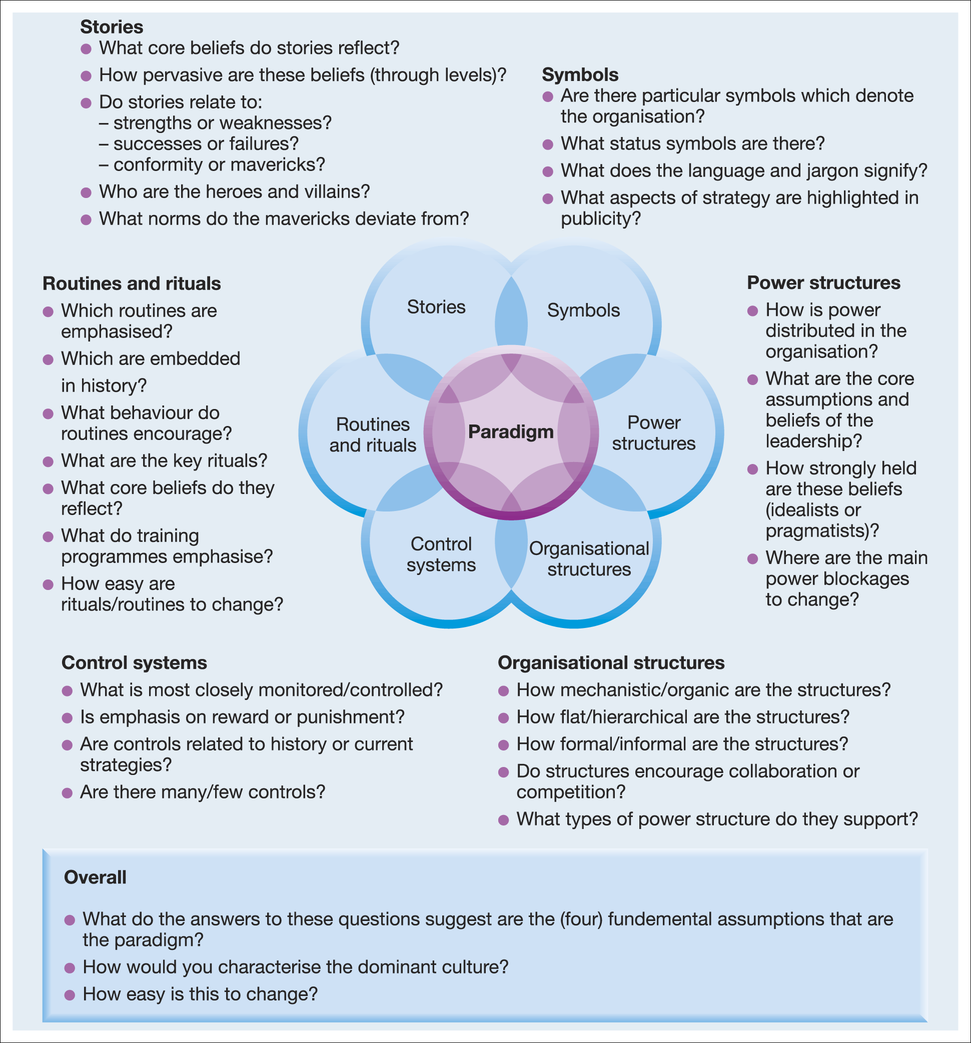
- Using the framework of the Cultural Web you are now going to undertake a cultural analysis of your own organisation or one familiar to you. You should use the questions in the above diagram to guide you through the analysis.
- Upon completion you should either produce a poster or a power point slide of your analysis which should then be uploaded to Moodle using a repository for the entire group to view and compare with their own.
- In your self-selected groups you should then choose one of your cultural analyses and as a group using the discussion forum discuss the 3 overall questions above applied to your chosen organisation

Activity 5: Interview with Erich Schmidt on business culture, technology and social issues (1.5hours)
Click on the link below and listen to the interview given by Erich Schmidt, Google’s executive chairman to McKinsey consultancy.
- https://www.mckinseyquarterly.com/wrapper.aspx?ar=2796&story=true&url=http%3a%2f%2fwww.mckinseyquarterly.com%2fEric_Schmidt_on_business_culture_technology_and_social_issues_2796%3fpagenum%3d1%23schmidt&pgn=ersc11_exhibit
Make notes as you listen and think about what you have learnt during this session and how it can relate to Google. Consider the following questions:
- What do you think is the dominant culture of Google?
- What do you think are the symbols of power?
- To what extent does the organisation’s culture inform strategy?
- How does the organisation respond to social issues?
To obtain a clearer picture you might like to view this fun video of Googleplex (Google’s HQ).
- http://www.youtube.com/watch?v=eFeLKXbnxxg

